6# Volume Spread Analysis

Volume indicator analysis
Submit by Forexstrategiesresources
Volume is the major indicator for the professional trader.
You have to ask yourself why the members of the self-regulated Exchanges around the world like to keep true volume information away from you as far as possible. The reason is because they know how important it is in analysing a market!

The significance and importance of volume appears little understood by most non-professional traders.
Perhaps this is because there is very little information and limited teaching available on this vital part of technical analysis. To use a chart without volume data is similar to buying an automobile without a gasoline tank.

Where volume is dealt with in other forms of technical analysis, it is often viewed in isolation, or averaged in some way across an extended timeframe.
Analysing volume, or price for that matter, is something that cannot be broken down into simple mathematical formulae...read pdf

To see Indicators, Templete and manual PDF file.
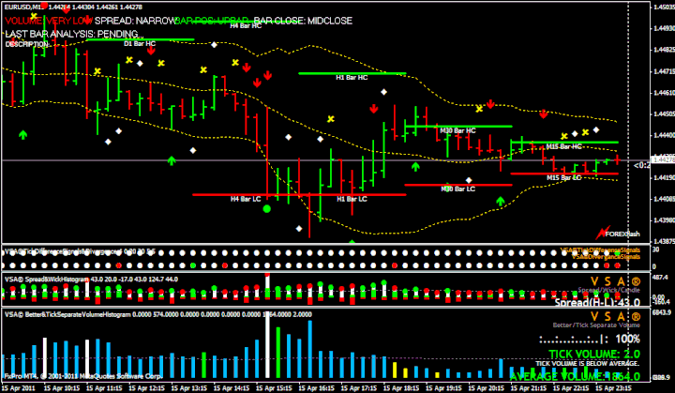

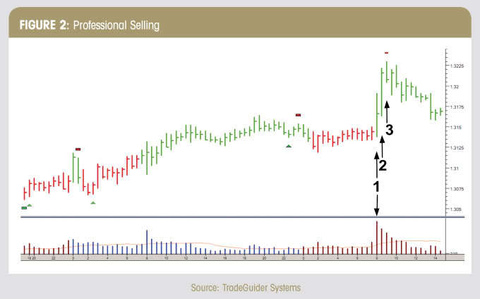

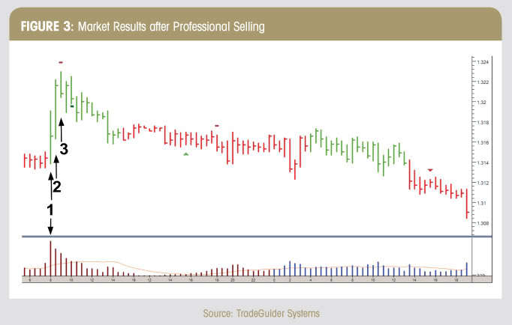


VSA Complete with PDF Manual
Trading System
VSA Complete with PDF Manual.rar
compressed file archive 582.4 KB
Download

forex Trading System
VSA BASICS.pdf
Adobe Acrobat Document 664.6 KB
Download
VSAc .rar
compressed file archive 583.7 KB
Download

vsa-fxbrain
vsa-fxbrain-zip.zip
Compressed Archive in ZIP Format 30.4 KB
Download
VSA indicator
VSA indicator.zip
Compressed Archive in ZIP Format 3.1 KB
Download
Vsa New
Vsa New.rar
compressed file archive 70.6 KB
Download

The better volume indicator
Better_Volume_Indicator.pdf
Adobe Acrobat Document 321.6 KB
Download
Better Volume indicators
Better Volume indicators- for the last version metatrader 4
Final version free.rar
compressed file archive 74.5 KB
Download

Update by joy22 25/04/2014

The Better Volume indicator uses a combination of bid/ask volume and range to identify
Volume Climax, High Volume Churn and Low Volume bars.
 Market tops are characterized by Volume Climax Up bars, High Volume Churn and Low
Volume Up bars (also called Testing).
 Market bottoms are characterized by Volume Climax Down bars, High Volume Churn
and Low Volume Down bars (Testing).
 Pullbacks, in either up or down trends, are similar to market topping or bottoming
patterns, but shorter in duration and with simpler volume patterns.
 The Better Volume indicator works in all markets and for all time frames – but is
particularly useful for tick charts.

Share your opinion, can help everyone to understand the forex strategy.

Comments: 7

- #8
Name: *
Message: *
The Privacy Policy applies. *

* Required fields
- #7
Vums (Monday, 05 March 2018 10:25)
Hi thank you for great job I really appreciate. But can you give me the download link for the VSA rectangle S and D trend indicator thosebred and green rectangles.Thank you
- #6
omakao (Thursday, 22 October 2015 03:47)
can we get some advice on how to install ?? should we download all the files ?
by the way, i've tried to download the manual PDF, but came up with a message cannot read file broken, :(
thanks
- #5
Tradeking (Thursday, 23 April 2015 11:46)
Hi all , please can anyone who has tried this system share some of its comments here. Is it profitable or not
- #4
venu (Monday, 08 September 2014 02:56)
Joy
Can you please share a swing volume indicator , where we can set the reversal value say by 5, 10, 15 pips etc?. If it can show the swing lines and also the cumilative volume amount and the number of bars in the swing it would really be awesome. I am sorry i am not a coder , hence the request.
If you see weiswave indicator you will understand what i mean
Thanks for sharing and really like the passion you have for these , wish you all the success
- #3
Sebastian (Tuesday, 29 April 2014 16:20)
Thank you, I will try see how it works in the BackTesting.
- #2
Admin (Friday, 25 April 2014 17:57)
thanks, to joy 22 for the upgrade.
- #1
khaled (Friday, 16 August 2013 03:49)
thanks so much > i will try VSA with my demo account and i wish it will work good
83# Forex Profit Monster
132# Swing Strategy I - Forex Strategies - Forex Resources - Forex
87# Buy-Sell alert Trend - Forex Strategies - Forex Resources ...
67# FX Chaos - Forex Strategies - Forex Resources - Forex
104# Center of Gravity - Forex Strategies - Forex Resources - Forex
60# Gundurowo - Forex Strategies - Forex Resources - Forex ...
123# ATR Channels Strategy - Forex Strategies - Forex Resources
84# Gold Miner - Forex Strategies - Forex Resources - Forex ...
18 Black Diamond Forex
102 # Green Fire - Forex Strategies - Forex Resources - Forex ...

HOME

Privacy Policy | Cookie Policy
VAT 02680220593
Log out | Edit

This website uses cookies. This website uses cookies to give you the best online experience. Please let us know if you agree by clicking on the “Accept” option below. If you’d like to find out more about the cookies we use and set your individual cookie preferences, please review our Cookie Policy. More details here: Cookie Policy
Cookie PreferencesDeclineAccept
Contribute a better translation

Original text

