Artificial Intelligence

Abstract of AI

Artificial intelligence (AI) refers to what information about the language structure being transmitted to the machine: It should result in a more intuitive and faster solution, based on a learning algorithm that repeats patterns in new data.

It is the science and engineering of making intelligent machines, especially intelligent computer programs. It is related to the similar task of using computers to understand human intelligent, but AI does not have to confine itself to methods that are biologically observable while no consensual definition of artificial intelligence (AI) exits. AI is broadly characterized as the study of computations that allow for perception. Reason and action. This paper examines features of artificial intelligence, introduction and definitions of AI, applications, growth and achievement.

Artificial Intelligence

Artificial intelligence (AI) refers to what information about the language structure being transmitted to the machine: It should result in a more intuitive and faster solution, based on a learning algorithm that repeats patterns in new data.

Artificial intelligence is the simulation of human intelligence processes by machines, especially computer systems. Specific applications of AI include expert systems, natural language processing, speech recognition and machine vision.

Types of AI

There are two types of AI-

1. Narrow or Weak (AI)
2. Strong (AI)

Weak AI—also called Narrow AI or Artificial Narrow Intelligence (ANI)—is AI trained and focused to perform specific tasks. Weak AI drives most of the AI that surrounds us today. ‘Narrow’ might be a more accurate descriptor for this type of AI as it is anything but weak; it enables some very robust applications, such as Apple's Siri, Amazon's Alexa, IBM Watson, and autonomous vehicles.

Strong AI is made up of Artificial General Intelligence (AGI) and Artificial Super Intelligence (ASI). Artificial general intelligence (AGI), or general AI, is a theoretical form of AI where a machine would have an intelligence equaled to humans; it would have a self-aware consciousness that has the ability to solve problems, learn, and plan for the future. Artificial Super Intelligence (ASI)—also known as superintelligence—would surpass the intelligence and ability of the human brain. While strong AI is still entirely theoretical with no practical examples in use today, that doesn't mean AI researchers aren't also exploring its development. In the meantime, the best examples of ASI might be from science fiction, such as HAL, the superhuman, rogue computer assistant in 2001: **A Space Odyssey**.

Two subfields of AI

Deep learning and Machine learning

Since deep learning and machine learning tend to be used interchangeably, it’s worth noting the nuances between the two. As mentioned above, both deep learning and machine learning are sub-fields of artificial intelligence, and deep learning is actually a sub-field of machine learning.

Deep learning is actually comprised of neural networks. “Deep” in deep learning refers to a neural network comprised of more than three layers—which would be inclusive of the inputs and the output—can be considered a deep learning algorithm. This is generally represented using the following diagram:

The way in which deep learning and machine learning differ is in how each algorithm learns. Deep learning automates much of the feature extraction piece of the process, eliminating some of the manual human intervention required and enabling the use of larger data sets. You can think of deep learning as "scalable machine learning" as Lex Fridman noted in same MIT lecture from above. Classical, or "non-deep", machine learning is more dependent on human intervention to learn. Human experts determine the hierarchy of features to understand the differences between data inputs, usually requiring more structured data to learn.

"Deep" machine learning can leverage labeled datasets, also known as supervised learning, to inform its algorithm, but it doesn’t necessarily require a labeled dataset. It can ingest unstructured data in its raw form (e.g., text, images), and it can automatically determine the hierarchy of features which distinguish different categories of data from one another. Unlike machine learning, it doesn't require human intervention to process data, allowing us to scale machine learning in more interesting ways.

Machine Learning (ML) is a subset of Artificial Intelligence (AI), defined as a computer's ability to learn from data by using algorithms to **i**mitate intelligent human behavior of decision making and predictions.

There are three main groups of algorithms in ML:

1. Supervised learning,
2. Unsupervised learning
3. Reinforcement learning (RL)

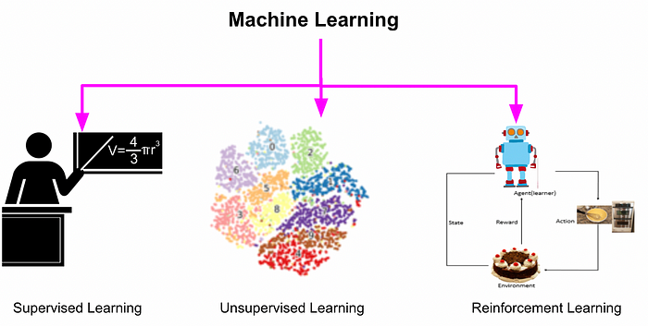

**Supervised Learning**

*You are learning python using manuals and online tutorials by following the code examples. Supervised learning is where you learn python by understanding its features by practicing the examples that act as labeled data and then using the knowledge acquired to write python programs for unseen use cases.*

# Unsupervised Learning

A child playing with toys can arrange them by identifying patterns based on colors, shapes, sizes, or just based on their interests. The kid discovers new ways to cluster the toys without needing external supervision is similar to unsupervised learning.

# Reinforcement Learning

A chef explores different ingredients by exploring and experimenting with different recipes in the hope of creating that perfect recipe that wows everyone. This is similar to Reinforcement Learning, where the chef tries a variety of actions like trying different ingredients in different proportions to progressively favors those that appear to taste the best.

Artificial Intelligence Applications

There are numerous, real-world applications of AI systems today. Below are some of the most common examples:

* **Speech recognition:** It is also known as automatic speech recognition (ASR), computer speech recognition, or speech-to-text, and it is a capability which uses natural language processing (NLP) to process human speech into a written format. Many mobile devices incorporate speech recognition into their systems to conduct voice search—e.g., Siri—or provide more accessibility around texting.
* **Customer service:**  Online virtual agents are replacing human agents along the customer journey. They answer frequently asked questions (FAQs) around topics, like shipping, or provide personalized advice, cross-selling products or suggesting sizes for users, changing the way we think about customer engagement across websites and social media platforms. Examples include messaging bots on e-commerce sites with virtual agents messaging apps, such as Slack and Facebook Messenger, and tasks usually done by virtual assistants and voice assistants.
* **Computer vision:** This AI technology enables computers and systems to derive meaningful information from digital images, videos and other visual inputs, and based on those inputs, it can take action. This ability to provide recommendations distinguishes it from image recognition tasks. Powered by convolutional neural networks, computer vision has applications within photo tagging in social media, radiology imaging in healthcare, and self-driving cars within the automotive industry.
* **Recommendation engines:** Using past consumption behavior data, AI algorithms can help to discover data trends that can be used to develop more effective cross-selling strategies. This is used to make relevant add-on recommendations to customers during the checkout process for online retailers.
* **Automated stock trading:**Designed to optimize stock portfolios, AI-driven high-frequency trading platforms make thousands or even millions of trades per day without human intervention.

**Last but not least,** AI holds the key to unlocking a magnificent future where, driven by data and computers that understand our world, we will all make more informed decisions. These computers of the future will understand not just how to turn on the switches but why the switches need to be turned on.

Experiment and assignment feedback: Install anaconda and gym environment. Create my own environment and name python-> 