In this part, we are going to install Hadoop (single node pseudo- distributed mode)

There is different recommended version of software such as Ubuntu 20.04, JDK8, Hadoop 3.X

For my system, I personally prefer Ubuntu 20.04

Ubuntu Linux 20.04 LTS (Focal Fossa) is **a free, customizable, coherent OS that's easy to install**.

Ubuntu is a Linux distro based on Debian. It is suitable for cloud computing, servers, desktops, and internet of things (IoT) devices.

Now, we are going to install ubuntu 20.04 on our virtual box in my windows operating system

Virtual box is a tool which will unable you to run different operating system virtually on your host operating system. In this case, my host operating system is windows 10. I am going to install virtual box on my windows 10 operating system.

If we want to install virtual box then, we need to go to a browser then search by name which is virtual box. There will appear virtual box.org then click it and follow to download step by step. 

After downloading, once you will have the virtual box on your windows operating system then, it will show an appearance which is oracle virtual box manager.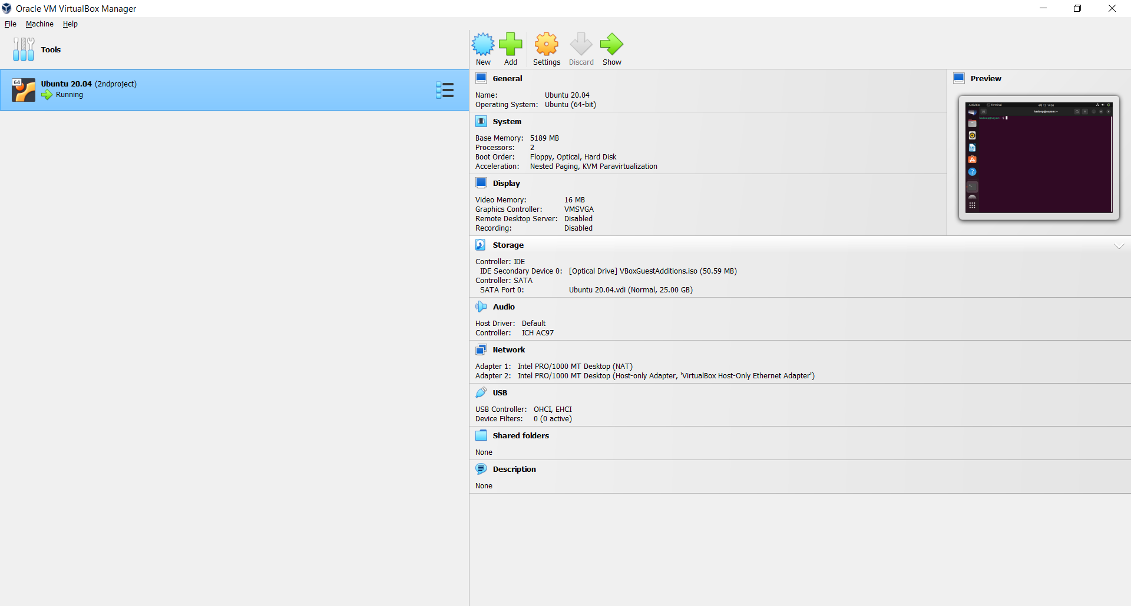

Next step, we need to dowaload IOS file which is required to install ubuntu on our virtual box.

For dowaloading, go to a browser and serach Ubuntu 20.04 version 

After downloading, first of all, click on new button of virtual box and provide the name of my new machine. Next, we have to follow up some instructions to set it up on the system. We have to set IOS file on the system.

After setting up everything, we have to click on start button to start ubuntu. We have to set a user name and a password to open it every single time. Finally, we will see our ubuntu desktop. 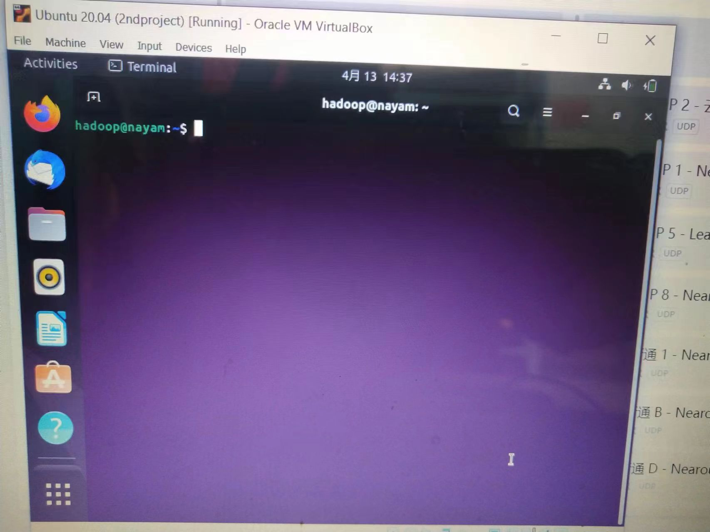

This is my Ubuntu desktop

Lets move on for hadoop: we have to follow some command to install hadoop on the syatem