SHRI VAISHNAV VIDYAPEETH VISHWAVIDYALAYA
Shri Vaishnav Institute of Information Technology

Ref. No.: SVIIT/2026/01/80
Date: 13/01/2026

NOTICE
Minor Project Documentation — GapLens Skill Diagnostic Platform

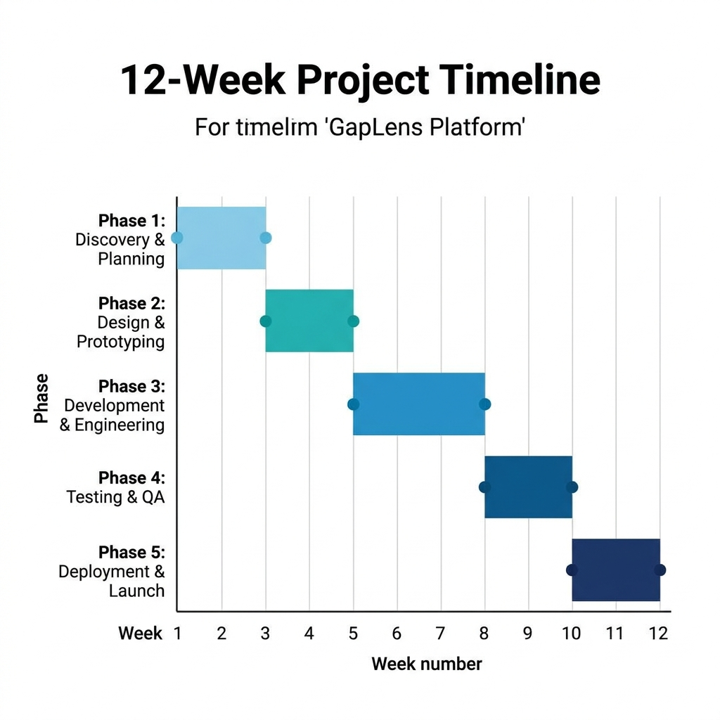
Figure 1: 12-Week Project Timeline

1. Project Overview
GapLens is an AI-powered skill diagnostic and career gap analysis platform. It identifies skill gaps between a student's current abilities and industry requirements, then recommends personalized upskilling resources using YouTube API and Google Gemini AI.
Project Title: GapLens — Skill Diagnostic & Employment Platform
Technology Stack: Python 3.14 · Flask · MongoDB · GridFS · Google OAuth · Gemini AI · YouTube API · Tailwind CSS
Roles: Student · Recruiter · Admin
Version Control: GitHub — github.com/NAYAN-014/Gaplense-

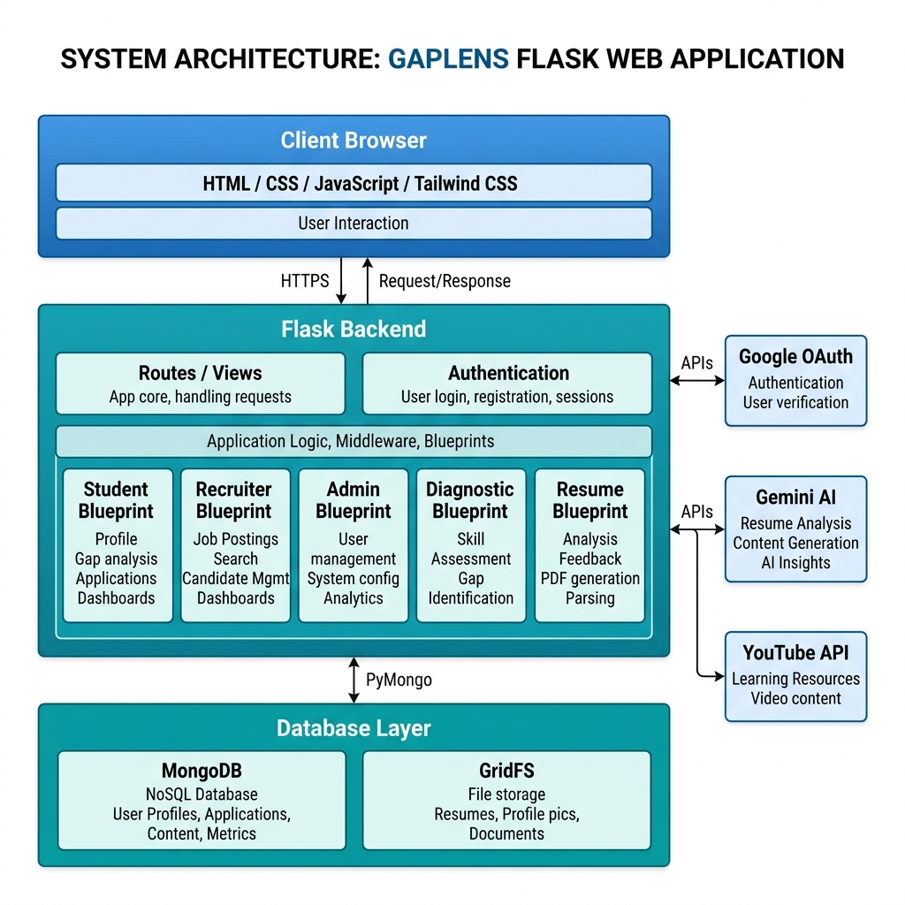
Figure 2: System Architecture — Flask Blueprints, MongoDB, External APIs

2. UML Diagrams
2.1 Use Case Diagram
Defines system boundaries and interactions between actors (Student, Recruiter, Admin) and system functionalities.
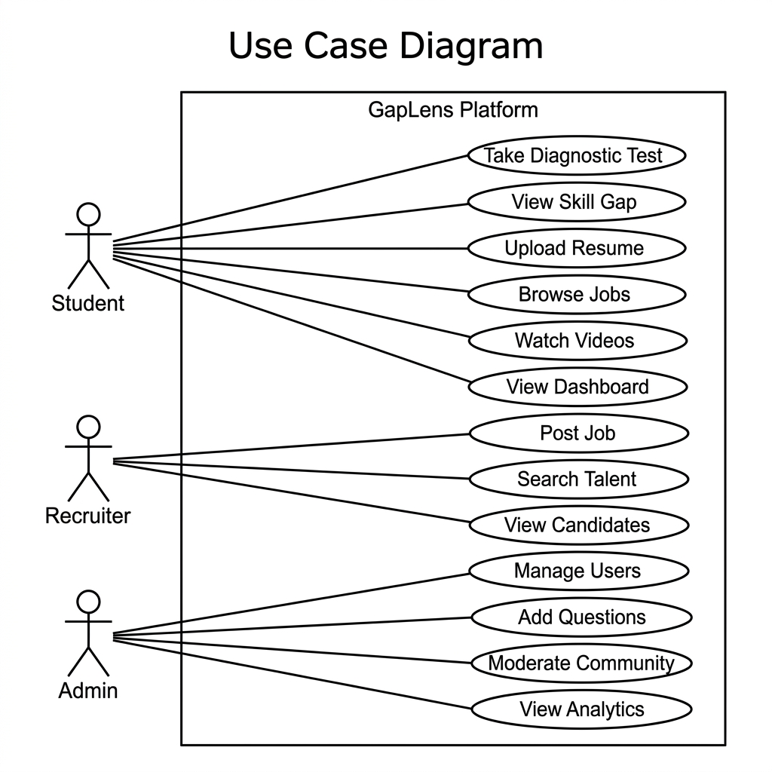
Figure 3: Use Case Diagram — All Roles

2.2 Class Diagram (Domain Model)
Shows all domain entities, their attributes, methods, and relationships. Key classes: User, Assessment, Result, Job, Resume, CommunityPost.
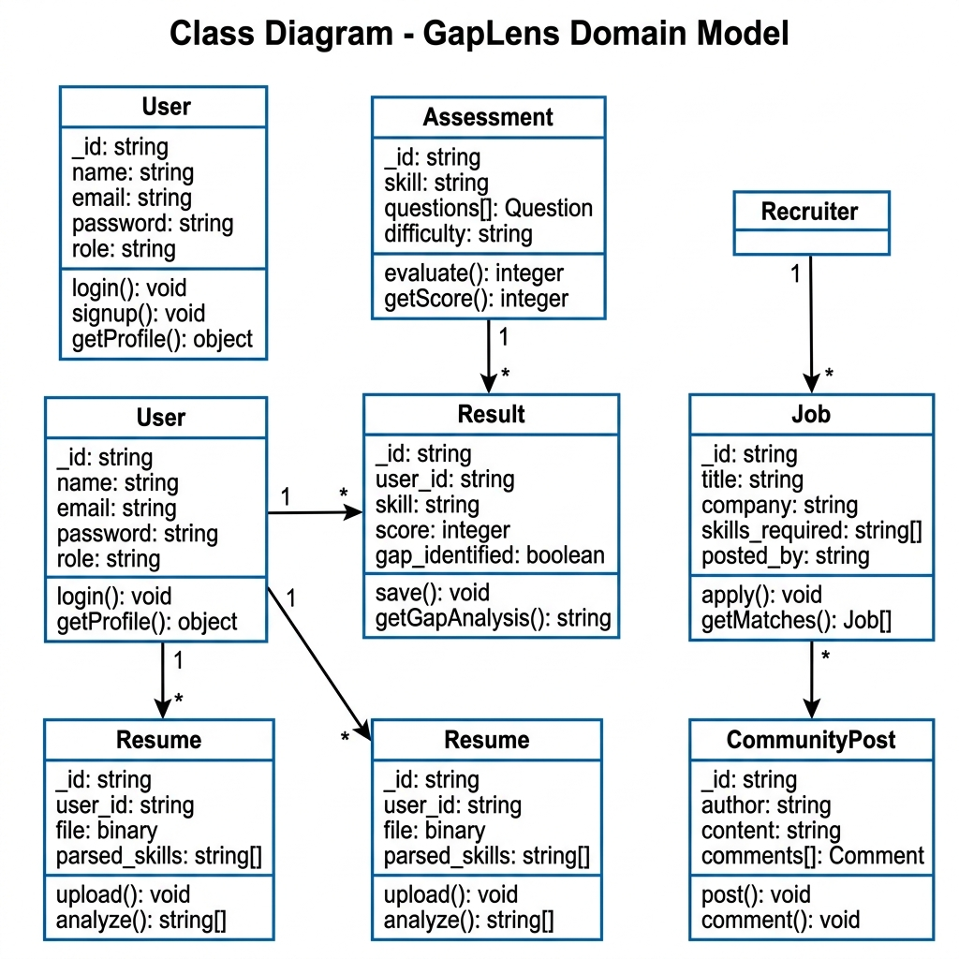
Figure 4: Class Diagram — GapLens Domain Model

2.3 Sequence Diagram — Diagnostic Test Flow
Shows how the Student, Browser, Flask Backend, MongoDB, and Gemini AI interact during a diagnostic test session.
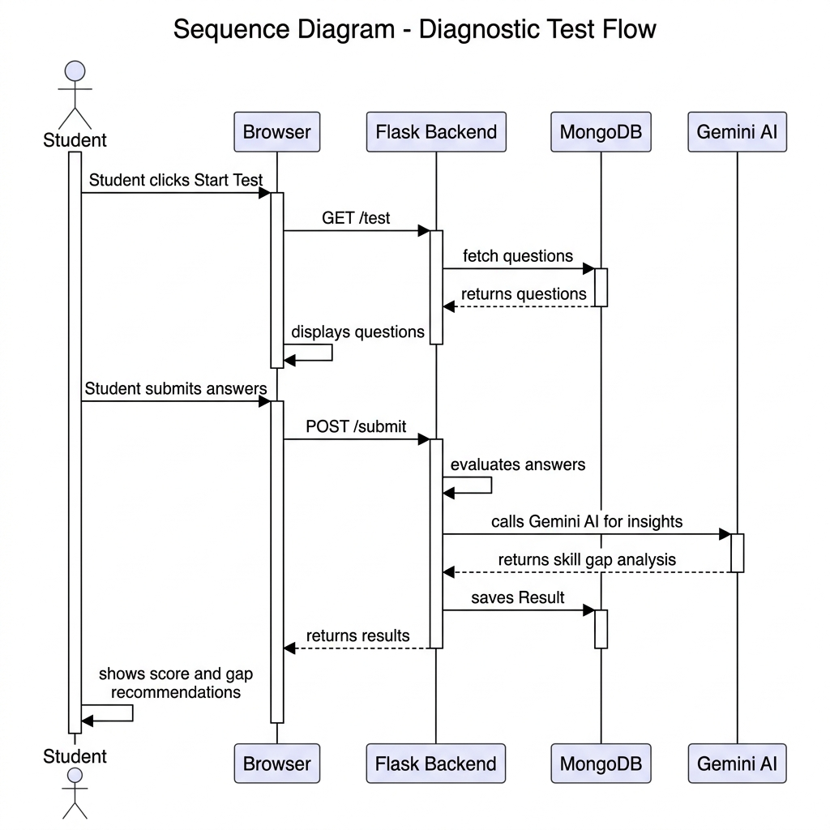
Figure 5: Sequence Diagram — Diagnostic Test Flow

3. Minor Project Timeline
Phases | Date
Phase 1: Planning & Requirement Analysis (Weeks 1–2)
Focus: Defining the scope, setting up infrastructure, and identifying functional requirements.
● Week 1: Project Initiation  ○ Form teams and define the problem statement.  ○ Tooling: Set up Jira boards (Scrum/Kanban), create Backlog, initialize Git repositories.  ○ Deliverable: Project Vision document and initial Product Backlog. | 19–24 January  2026
● Week 2: Functional Modeling  ○ Identify Actors and Use Cases.  ○ UML Deliverable: Use Case Diagram — To define system boundaries.  ■ Use Case Descriptions: Detailed text for each primary flow.  ○ Tooling: Map Use Cases to Jira User Stories. | 26–31 January  2026
Phase 2: Object-Oriented Analysis (Weeks 3–4)
Focus: Understanding the "What" of the system without focusing on implementation.
● Week 3: Static Analysis  ○ Identify domain entities and their relationships.  ○ UML Deliverables:  ■ Object Diagram: Model specific instances and data snapshots.  ■ Initial Class Diagram (Domain Model): Attributes and relationships (1:1, 1:N, M:N). | 02–07 February  2026
● Week 4: Dynamic Analysis  ○ Model how the system reacts to events.  ○ UML Deliverable — Activity Diagram: Model complex business logic and parallel workflows. | 09–14 February  2026
Phase 3: Object-Oriented Design (Weeks 5–7)
Focus: Defining the "How" — architecture, patterns, and component interactions.
● Week 5: Interaction Modeling  ○ UML Deliverable — Sequence Diagram: Detailed logic showing how objects communicate over time to fulfill a use case. | 16–21 February  2026
● Week 6: Detailed Class Design & Packaging  ○ Apply SOLID principles and Design Patterns.  ○ UML Deliverables:  ■ Detailed Class Diagram: Including methods, visibility, and interfaces.  ■ Package Diagram: Organizing classes into logical modules/subsystems. | 23–28 February  2026
● Week 7: System Architecture  ○ UML Deliverables:  ■ Component Diagram: Visualizing physical modules (API, Database, UI).  ■ Deployment Diagram: Mapping software components to hardware/nodes (Cloud, Servers). | 02–07 March  2026
Phase 4: Implementation & CI/CD Integration (Weeks 8–10)
Focus: Coding, version control, and automated pipelines.
● Week 8: Sprint 1 — Core Features  ○ Develop core logic based on the Class and Sequence diagrams.  ○ Git Strategy: Use branching (Feature branches → Develop → Main). | 09–14 March  2026
● Week 9: CI/CD Pipeline Setup  ○ Configure GitHub Actions or GitLab CI.  ○ Automate build triggers on every git push. | 16–21 March  2026
● Week 10: Sprint 2 — Integration  ○ Develop UI and connect to the database.  ○ Jira: Move stories to "In Progress" and "Testing." | 23–28 March  2026
Phase 5: Testing & Deployment (Weeks 11–12)
Focus: Quality assurance and final delivery.
● Week 11: Testing Phase  ○ Unit Testing: (JUnit, PyTest) ensuring methods work as intended.  ○ Integration Testing: Testing the flow between components.  ○ Tooling: Integrate test reports into the CI/CD pipeline. | 30 March–  04 April 2026
● Week 12: Deployment & Final Review  ○ Finalize the Deployment Diagram to match the production environment.  ○ Deploy to staging/production (Heroku, AWS, or Azure).  ○ Project Demo and handover. | 06–11 April  2026

4. CI/CD Pipeline
The project uses GitHub Actions for continuous integration. On every git push to the main branch, the pipeline automatically runs tests (PyTest), validates imports, and deploys to the staging environment.
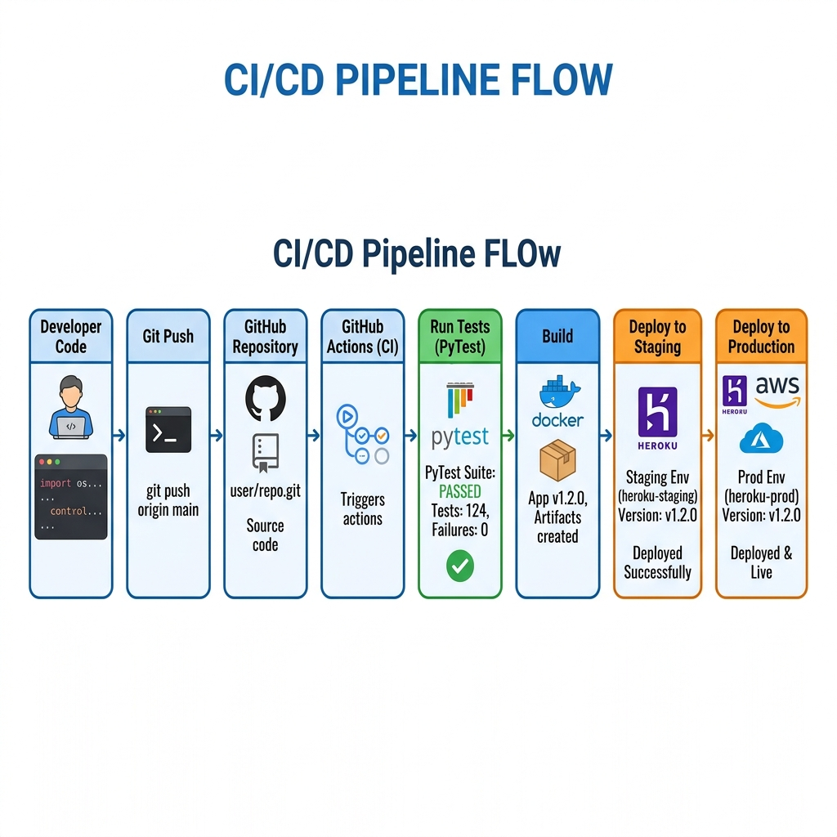
Figure 6: CI/CD Pipeline — Automated Build, Test & Deploy Flow

4.1 Git Branching Strategy
● main — Production-ready code only
● develop — Integration branch for tested features
● feature/* — Individual feature development branches

5. Project Folder Structure
GapLens/
├── run.py ← Entry point
├── main/app.py ← Flask app factory
├── other/ ← config.py, extensions.py
├── routes/ ← auth, student, recruiter, admin, diagnostic, resume
├── core/ ← utils.py, seed_questions.py
├── static/css/ ← style.css
├── static/img/ ← logo.png
├── templates/ ← base.html, auth/, student/, recruiter/, admin/, test/
└── docs/ ← Project_Documentation.md, GapLens_Project_Plan.docx

6. Technology Stack
Layer | Technology | Purpose
Backend | Flask (Python 3.14) | Web framework with Blueprint modular routing
Database | MongoDB + GridFS | NoSQL storage for users, results, resumes
Auth | Google OAuth (Authlib) | Single Sign-On + local session management
AI / ML | Google Gemini AI | Skill gap analysis and AI insights generation
Recommendations | YouTube Data API v3 | Fetch curated learning videos per skill gap
Frontend | Tailwind CSS + Jinja2 | Responsive UI with dark/light mode support
Deployment | GitHub + Heroku / AWS | Version control and cloud deployment

GapLens Platform • Minor Project Documentation • SVIIT • 2026

