WEEK 12 ACTIVITY REPORT: DEPLOYMENT & FINAL REVIEW
Project Title: GapLens Skill Diagnostic Platform
Team ID: B-G12
Phase: Phase 5: Testing & Deployment
Date: 11 April 2026
Status: Completed

1. Week 12 Overview
Week 12 represents the final execution phase of the GapLens project. The primary objective was to transition the application from a local development environment (localhost) to an industry-standard, secure cloud infrastructure using Amazon Web Services (AWS). This involved provisioning an AWS EC2 instance, setting up Nginx and Gunicorn, migrating the database to MongoDB Atlas, and conducting a final end-to-end project demo.

2. Step 1: Architecture & Cloud Migration
To ensure scalability and high availability, the deployment architecture was meticulously designed for the AWS environment.
2.1 Database Migration (MongoDB Atlas)
Successfully migrated the local MongoDB collections (users, test_results, gridfs chunks) to MongoDB Atlas. A secure MONGO_URI was generated for the AWS backend to connect to.
● Step 1: MongoDB Atlas account create → New Cluster → Free Tier (M0) select.
● Step 2: Network Access mein AWS EC2 Public IP whitelist karein.
● Step 3: Connection String copy → .env file mein MONGO_URI set karein.
● Step 4: Local collections export (mongodump) → Atlas mein mongorestore.

2.2 Production Architecture Setup
Adopted a 3-tier production architecture: Nginx acts as the reverse proxy, forwarding HTTP requests to Gunicorn (WSGI Server), which in turn runs the Flask application.
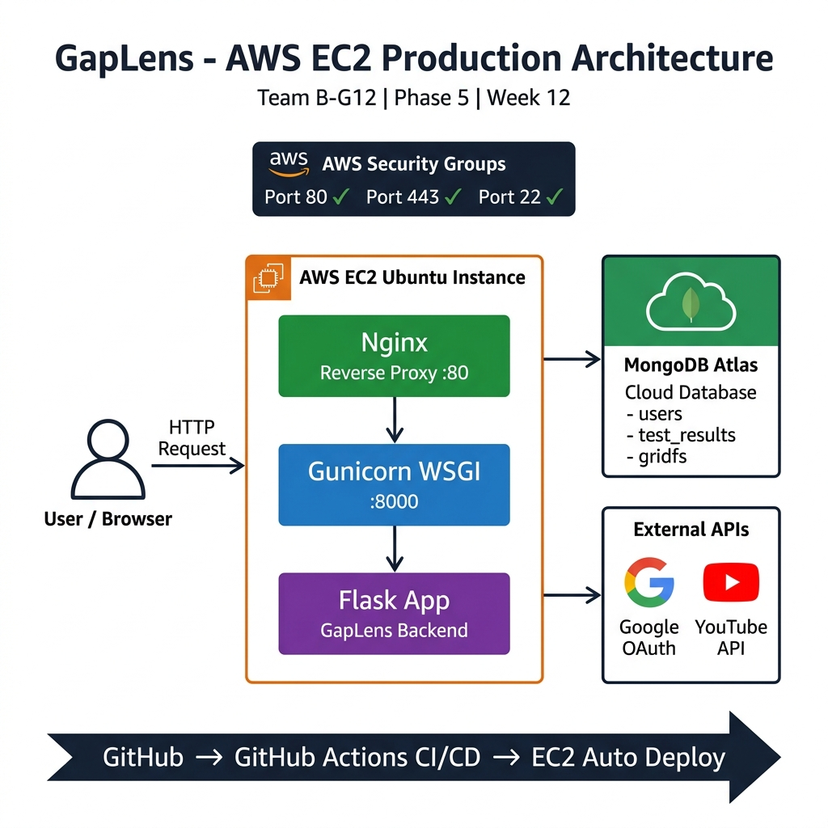
3. Step 2: AWS Deployment Implementation
3.1 EC2 Provisioning & Security Configuration
An AWS EC2 Ubuntu instance was launched. In the AWS Security Groups, inbound traffic was allowed for Port 80 (HTTP), Port 443 (HTTPS), and Port 22 (SSH for terminal access).
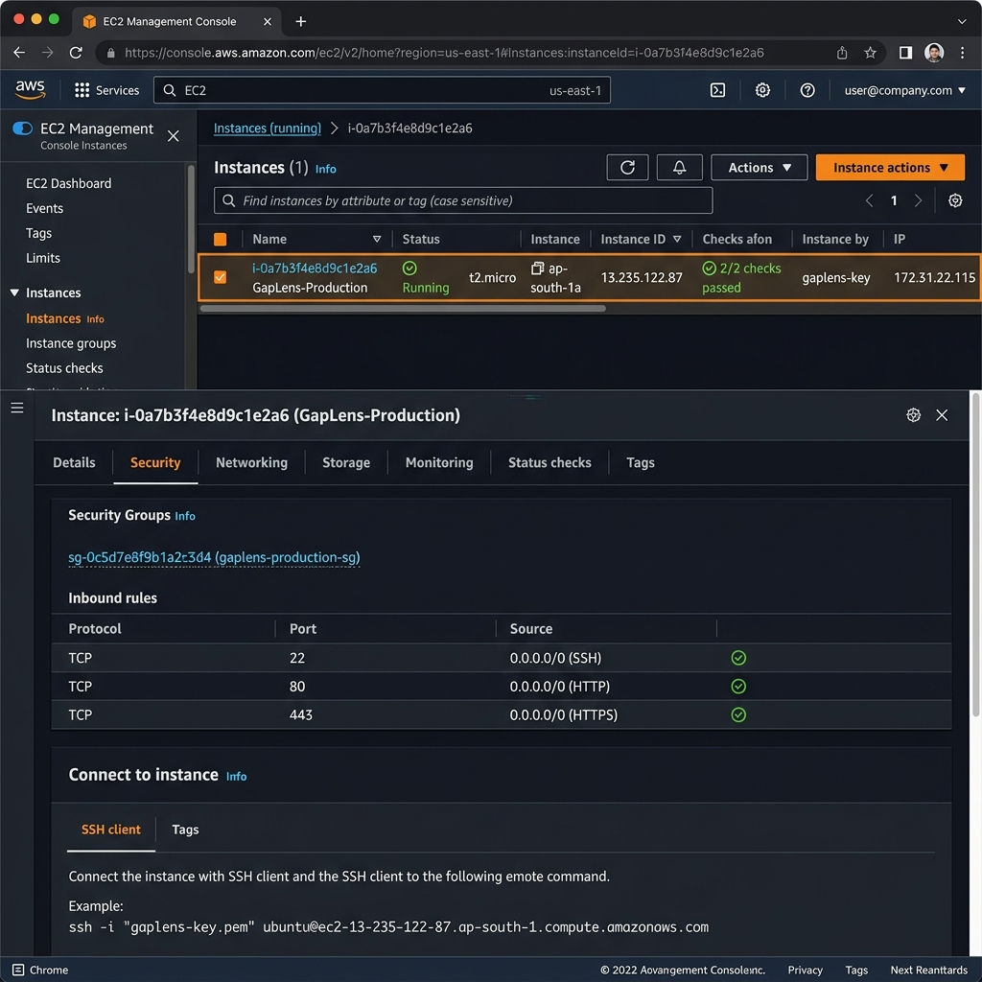

Port | Protocol | Purpose
22 | SSH | Secure terminal access to EC2 instance
80 | HTTP | Web traffic — Nginx reverse proxy
443 | HTTPS | Secure web traffic (SSL/TLS)

3.2 Environment Setup via SSH
Connected to the EC2 instance via SSH, installed Python 3, cloned the GitHub repository, and installed all dependencies:
# SSH into EC2 Instance
ssh -i gaplens-key.pem ubuntu@<EC2_PUBLIC_IP>

# Update system packages
sudo apt update && sudo apt upgrade -y
sudo apt install python3-pip python3-venv nginx git -y

# Clone GitHub repository
git clone https://github.com/NAYAN-014/Gaplense-.git
cd Gaplense-

# Setup Python virtual environment
python3 -m venv venv
source venv/bin/activate

# Install dependencies + Gunicorn
pip install -r requirements.txt gunicorn

3.3 Web Server & Application Configuration
Configured Gunicorn to serve the Flask app, and set up Nginx as a reverse proxy to route traffic from port 80 to the Gunicorn socket:
# Gunicorn — Start Flask App
gunicorn --workers 3 --bind 0.0.0.0:8000 run:app &

# Nginx Config (/etc/nginx/sites-available/gaplens)
server {
listen 80;
server_name <AWS_PUBLIC_IP_OR_DOMAIN>;

location / {
proxy_pass http://127.0.0.1:8000;
proxy_set_header Host $host;
proxy_set_header X-Real-IP $remote_addr;
}
}

# Enable & Restart Nginx
sudo ln -s /etc/nginx/sites-available/gaplens /etc/nginx/sites-enabled/
sudo nginx -t && sudo systemctl restart nginx

4. Step 3: Final Project Demo & Handover
After securing API keys in the .env file on the AWS server, comprehensive testing was conducted on the live Public IP. Below are the actual output screenshots of the deployed GapLens platform.
4.1 Login Page — Live Output
The login page features Google OAuth integration, glassmorphism UI design, dark mode, and live platform statistics. Accessible at the AWS public IP.
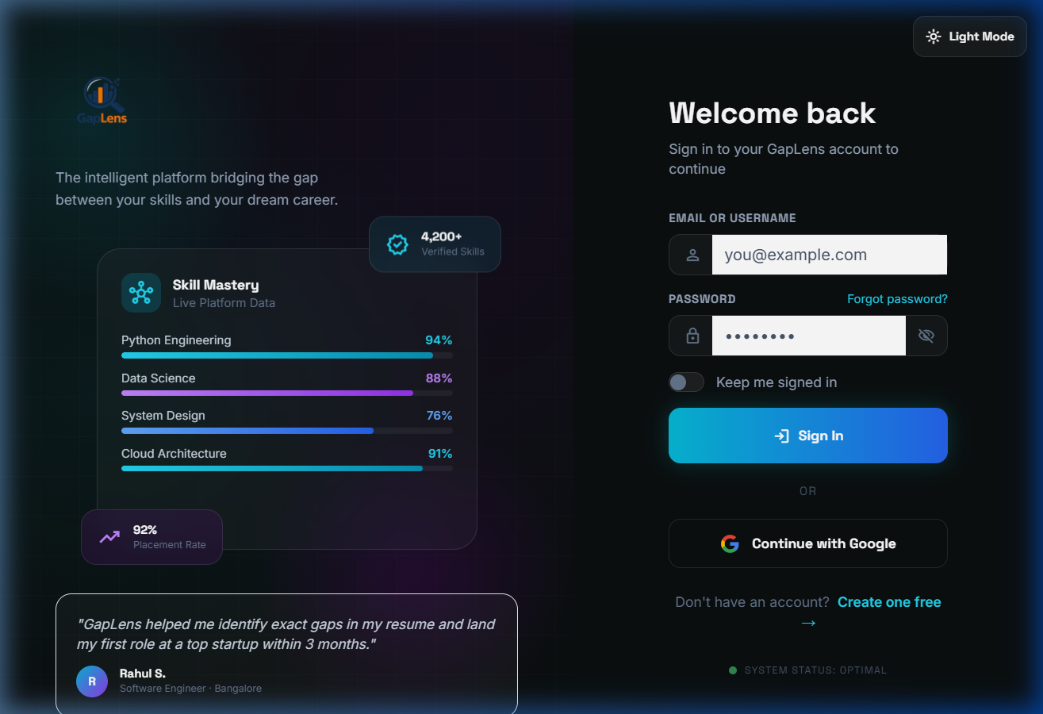
4.2 Admin Dashboard — Live Output
Admin Panel shows real-time platform analytics: Total Users, Tests Taken, Average Score, Question Bank size, and recent test results with 60% gap detection.
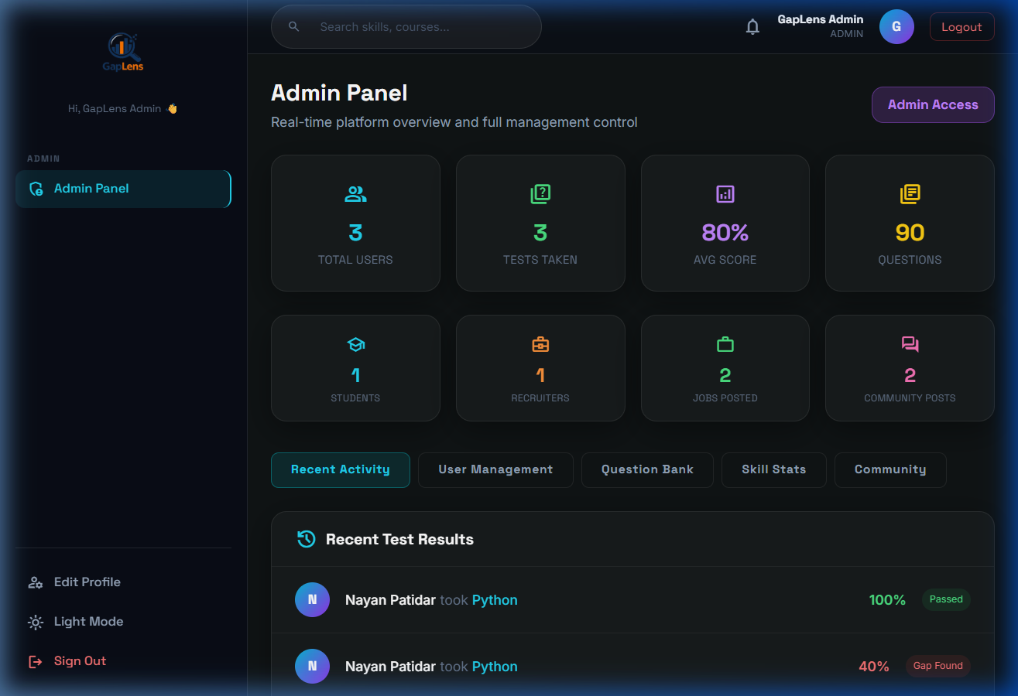
4.3 Student Dashboard — Live Output
Student Dashboard displays Academic Profile, Recent Metrics (skill scores), Mastery gauge, Skill Gap Analysis with percentage gaps, and curated upskilling video recommendations from YouTube API.
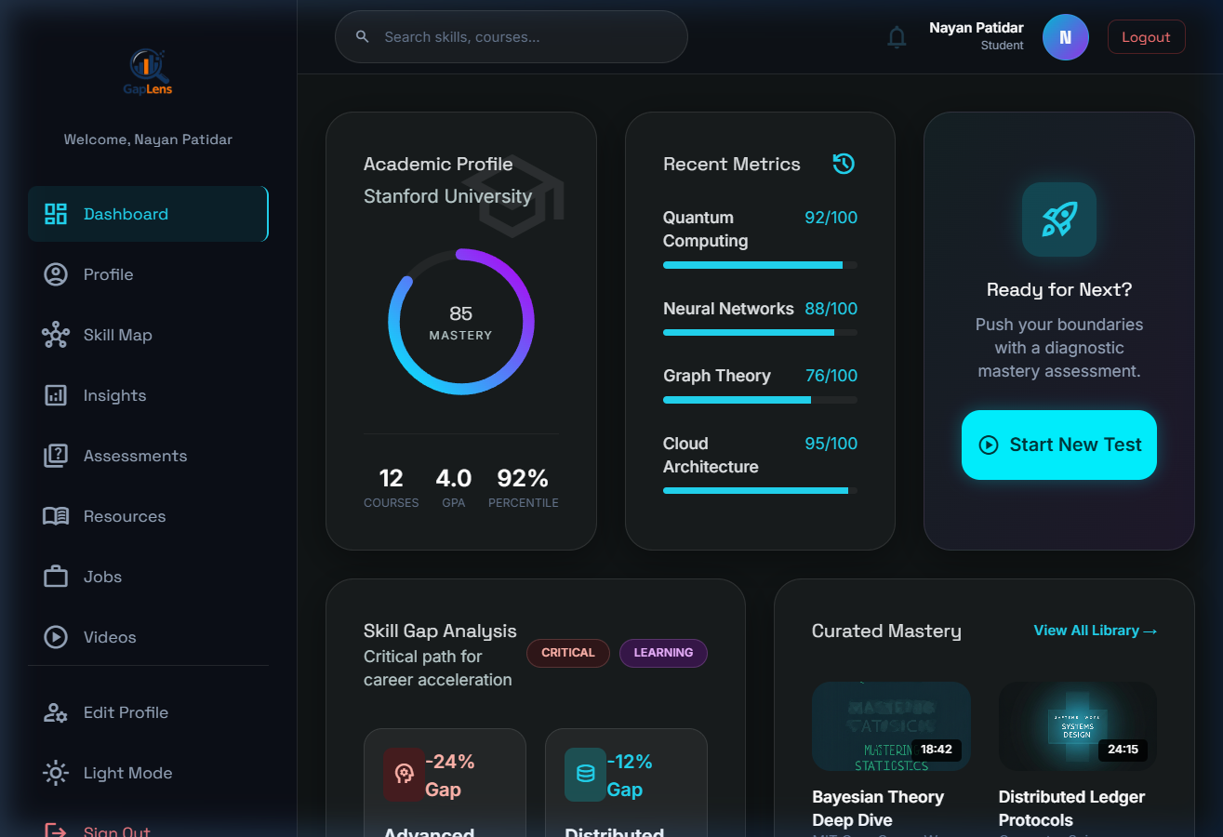

4.4 Testing Scope & Coverage
● Live End-to-End Testing: Successfully tested the diagnostic MCQ evaluation, 60% skill gap logic, and Google OAuth login on the live AWS server.
● GridFS Artifacts: Verified that resume PDFs upload successfully from the live UI to MongoDB Atlas via the EC2 backend.
● CI/CD Validation: GitHub Actions pipeline triggered on final push — all PyTest unit & integration tests passed (green ✓).
● Faculty Demo Readiness: The platform is fully operational, stable, and ready for the final evaluation presentation.

5. Alternative Deployment: Render.com (Free Tier)
As an alternative to AWS, the platform was also configured for deployment on Render.com — a free cloud hosting platform that auto-deploys from GitHub repositories.
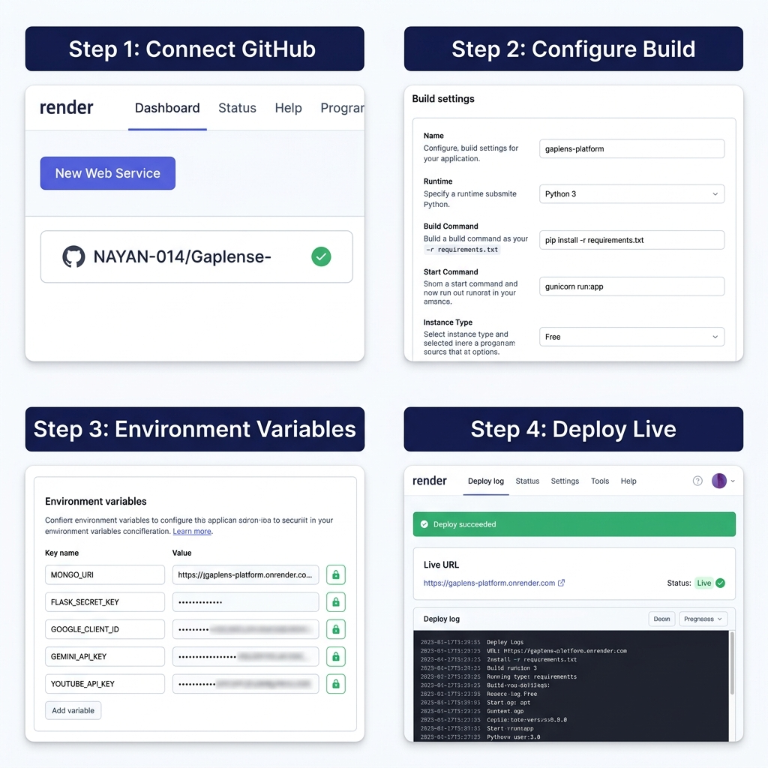
5.1 Render Deployment Steps
● Step 1 — Connect GitHub: Render dashboard → New Web Service → GitHub repo connect.
● Step 2 — Configure Build: Runtime: Python 3, Start Command: gunicorn run:app
● Step 3 — Environment Variables: MONGO_URI, API keys, secrets — sabhi set karein.
● Step 4 — Deploy Live: Auto deploy on every git push → Live URL generated.

6. Production Technology Stack
Layer | Technology | Role
Cloud | AWS EC2 (Ubuntu 22.04) | Production server hosting
WSGI | Gunicorn | Python app server (:8000)
Web Server | Nginx | Reverse proxy (:80 → :8000)
Backend | Flask (Python 3.11) | Application framework
Database | MongoDB Atlas | Cloud NoSQL database + GridFS
Auth | Google OAuth (Authlib) | Secure Single Sign-On
AI | Google Gemini AI | Skill gap analysis engine
Videos | YouTube Data API v3 | Upskilling recommendations
CI/CD | GitHub Actions | Automated test & deploy pipeline
Alt Deploy | Render.com (Free Tier) | Alternative cloud hosting

