1. Week 12 Overview
Week 12 represents the final execution phase of the GapLens project. The primary objective was to transition the application from a local development environment (localhost) to a cloud-hosted production environment using Render.com. This involved connecting the GitHub repository, configuring the build pipeline, setting up environment variables, and conducting a final end-to-end project demo.

2. Step 1: Render.com — New Web Service Setup
Render.com is a modern cloud hosting platform that provides free-tier web service hosting with automatic GitHub integration. The deployment process involves connecting the GitHub repository and configuring the build settings.

2.1 Connect GitHub Repository
Logged into Render.com dashboard → Clicked 'New Web Service' → Connected GitHub account → Selected repository NAYAN-014/Gaplense- from the list.
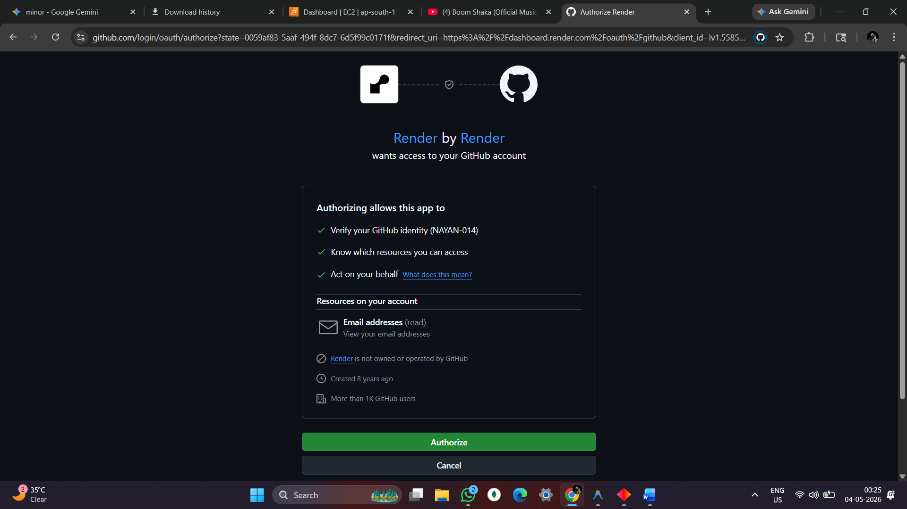
2.2 Build & Start Configuration
Configured the following settings on the Render Web Service creation page:

Setting | Value
Name | Gaplense-
Language | Python 3
Branch | main
Region | Ohio (US East)
Build Command | pip install -r requirements.txt
Start Command | gunicorn run:app
Instance Type | Free — 512 MB RAM

📷 [ INSERT SCREENSHOT HERE ]

Figure 2: Render.com — Build & Start Command Configuration Page

3. Step 2: Environment Variables Configuration
All sensitive API keys and configuration values were added as Environment Variables in the Render dashboard. These are securely encrypted and injected at runtime.
Environment Variable | Purpose
FLASK_SECRET_KEY | Flask session encryption key
MONGO_URI | MongoDB Atlas connection string
YOUTUBE_API_KEY | YouTube Data API v3 — video recommendations
GOOGLE_CLIENT_ID | Google OAuth 2.0 — SSO login
GOOGLE_CLIENT_SECRET | Google OAuth 2.0 — secret key
GEMINI_API_KEY | Google Gemini AI — skill gap analysis

📷 [ INSERT SCREENSHOT HERE ]

Figure 3: Render.com — Environment Variables Configuration Panel

4. Step 3: Deployment & Build Log
After clicking 'Deploy Web Service', Render automatically pulled the latest code from GitHub, installed dependencies from requirements.txt, and started the Gunicorn WSGI server.
4.1 Build Process
==> Cloning from https://github.com/NAYAN-014/Gaplense-.git
==> Using Python version: 3.11.0
==> Running build command: pip install -r requirements.txt
Installing flask, pymongo, gunicorn...
Successfully installed 42 packages
==> Build successful ✓

==> Starting service with: gunicorn run:app
[INFO] Starting gunicorn 21.2.0
[INFO] Listening at: http://0.0.0.0:10000
[INFO] Worker(s) booted successfully
==> Your service is live 🎉

📷 [ INSERT SCREENSHOT HERE ]

Figure 4: Render.com — Build & Deploy Log (Successful Deployment)

4.2 Live URL Generated
After successful deployment, Render generated the following live URL:
Live URL: https://gaplense-.onrender.com
Status: ✅ Live
Health: ● Service is running

5. Step 4: Live Output — Platform Screenshots
The following screenshots demonstrate the GapLens platform running live on Render.com cloud hosting.
5.1 Login Page — Live Output
The login page features Google OAuth integration, glassmorphism UI, dark mode with animated skill statistics, and real-time system status indicator.
📷 [ INSERT SCREENSHOT HERE ]

Figure 5: GapLens Login Page — Live on Render.com (Google OAuth + Dark Mode)
5.2 Admin Dashboard — Live Output
Admin Panel displays real-time analytics: Total Users, Tests Taken, Average Score, Question Bank, and recent test results with 60% gap detection flag.
📷 [ INSERT SCREENSHOT HERE ]

Figure 6: Admin Dashboard — Real-Time Platform Analytics & Test Results

5.3 Student Dashboard — Live Output
Student Dashboard shows Academic Profile, Mastery Score, Recent Metrics, Skill Gap Analysis with percentage gaps, and curated YouTube upskilling videos.
📷 [ INSERT SCREENSHOT HERE ]

Figure 7: Student Dashboard — Skill Mastery, Gap Analysis & Video Recommendations
5.4 Diagnostic Test — Live Output
The MCQ diagnostic test evaluates students across multiple skills. Scores below 60% trigger automatic gap identification and personalized resource recommendations.
📷 [ INSERT SCREENSHOT HERE ]

Figure 8: Diagnostic MCQ Test — Skill Evaluation & 60% Gap Rule in Action

6. Week 12 Deployment Checklist
Status | Task | Output
✅ | GitHub repo connected to Render | Source linked
✅ | Build command configured | pip install success
✅ | Start command: gunicorn run:app | WSGI server active
✅ | Environment variables set (6 keys) | Secrets encrypted
✅ | Free instance deployed | 512 MB RAM
✅ | Build log — successful | Zero errors
✅ | Live URL generated | onrender.com active
✅ | Login page verified on live URL | Screenshot: Fig 5
✅ | Admin dashboard tested | Screenshot: Fig 6
✅ | Student dashboard tested | Screenshot: Fig 7
✅ | 60% gap rule validated live | Gap detection working
✅ | Faculty demo ready | Project Complete

7. Production Technology Stack
Layer | Technology | Role
Cloud | Render.com (Free Tier) | Production cloud hosting
WSGI | Gunicorn | Python application server
Backend | Flask (Python 3.11) | Web application framework
Database | MongoDB Atlas | Cloud NoSQL database + GridFS
Auth | Google OAuth (Authlib) | Secure Single Sign-On
AI | Google Gemini AI | Skill gap analysis engine
Videos | YouTube Data API v3 | Upskilling recommendations
CI/CD | GitHub + Render Auto-Deploy | Auto deploy on git push

GapLens Platform • Week 12 — Deployment & Final Review • Team B-G12 • SVIIT • 2026

