**A Comparative Study of Machine Learning for Predicting Multiple Diseases**

This research is presented to the Department of Computer Science and Engineering at Jahangirnagar University as a partial fulfillment of the requirement for the degree of Bachelor of Science and Engineering.

***Submitted By***

**Mehadi Hasan**

Exam Roll: 180696

**Sohanur Rahman**

Exam Roll: 1806

***Supervised By***

**Dr. Israt Jahan**

Professor

Department of Computer Science and Engineering

Jahangirnagar University.



DEPARTMENT OF COMPUTER SCIENCE AND ENGINEERING

JAHANGIRNAGAR UNIVERSITY.

SAVAR, DHAKA 1342.

MAY-2023

**Abstract**

Our everyday lives' most crucial aspect is how well we are mentally and physically. Heart disease, diabetes, and pneumonia are merely a few of the health issues that have recently become more common in our daily lives and in the field of healthcare. And this expenses humanity an enormous quantity of time. Based on the available data, machine learning can be used to detect such situations. The work, which is called "Multiple Disease Prediction" attempts to demonstrate how machine learning can be used to model the collection of data. The model is then applied to identify if a person is suffering from the disease or not. We employed a variety of methods, including decision trees, K-nearest neighbors (KNN), support vector machines (SVM), naïve bayes, and linear regression. Results of these algorithms are compared using their accuracy, precision, recall, and F1-score. The confusion matrix is used to plot the ROC curve. The technique with the best accuracy, precision, recall, and F1-score is taken into consideration for determining the optimum algorithm for illness detection after these algorithms are compared for accuracy, precision, recall, and F1-score.

# Declaration

The project work **" A Comparative Study of Machine Learning for Predicting Multiple Disease"** iscompleted at Department of Computer Science and Engineering, Jahangirnagar University is unique and conforms to the university's regulations.

We are aware of the University's plagiarism policy and certify that no component of this project has been plagiarized or previously submitted for the granting of any degree or diploma.

----------------------------------- ------------------------------------

**Mehadi Hasan** **Sohanur Rahman**

Exam Roll: 180696 Exam Roll: 1806

-----------------------------

**Dr. Israt Jahan**

Professor, Department of Computer Science and Engineering.

# Acknowledgement

All thanks and praise are due to Allah, who made it possible for us to complete this project successfully with the help of his heavenly blessing.

We are grateful to Dr. Israt Jahan, our esteemed supervisor, who is a professor in the department of computer science and engineering at Jahangirnagar University, for her patient counsel, astute direction, insightful instruction, and creative suggestion throughout the project's duration. This undertaking would not be possible without her invaluable aid. She has consistently been a source of inspiration and encouragement for us to put in a lot of effort.

Finally, we had want to give a shout-out to all of our friends who are truly dear to our hearts. We will never be willing to find the perfect words to express our gratitude to our loving parents, who have committed moral support and fortification in the completion of the project.

**Contents**

1. **Introduction 1**
2. **Problem Definition and Algorithm 3**

2.1 Task Definition . . . . . . . . . . . . . . . . . . . . . . . . . . . . . . . . . . . . . . . . . . . . 3

2.2 Algorithm Definition . . . . . . . . . . . . . . . . . . . . . . . . . . . . . . . . . . . . . . . 4

2.2.1 Decision Tree Algorithm . . . . . . . . . . . . . . . . . . . . . . . . . . . . . . . . 4

2.2.2 K-Nearest Neighbor Algorithm . . . . . . . . . . . . . . . . . . . . . . . . . . . 4

2.2.3 Support Vector Machine Algorithm . . . . . . . . . . . . . . . . . . . . . . . 5

2.2.4 Naïve Bayes Algorithm . . . . . . . . . . . . . . . . . . . . . . . . . . . . . . . . . 6

2.2.5 Logistic Regression Algorithm . . . . . . . . . . . . . . . . . . . . . . . . . . . . 7

1. **Experimental Evaluation 8**
   1. Methodology . . . . . . . . . . . . . . . . . . . . . . . . . . . . . . . . . . . . . . . . . . . . . . . . 8

3.1.1 Experimental Dataset . . . . . . . . . . . . . . . . . . . . . . . . . . . . . . . . . . . . 10

3.1.2 Performance Evaluation Metrics . . . . . . . . . . . . . . . . . . . . . . . . . . . 15

3.2 Results . . . . . . . . . . . . . . . . . . . . . . . . . . . . . . . . . . . . . . . . . . . . . . . . . . . . . 19  
  
 3.3 Discussion . . . . . . . . . . . . . . . . . . . . . . . . . . . . . . . . . . . . . . . . . . . . . . . . . . 25

1. **Related Work 26**

**5 Future Work 28**

**6 Conclusion 29**

**List of Figures**

**1.1** Diagram of a Credit Card Fraud Detection Model . . . . . . . . . . . . . . . . . . . . . . . . . . . . . . . 2

**3.1** Approached Credit Card Fraud Detection System . . . . . . . . . . . . . . . . . . . . . . . . . . . . . . . 9

**3.1.1.1** Sample Dataset for Credit Card Fraud Detection Model . . . . . . . . . . . . . . . . . . . . . . . 10

**3.1.1.2** Graphing the Age of Credit Card by Gender . . . . . . . . . . . . . . . . . . . . . . . . . . . . . . . 12

**3.1.1.3** Frequency Distribution of Credit Card’s Customer Gender . . . . . . . . . . . . . . . . . . . . . 12

**3.1.1.4** Gender Distribution of Customers as a Pie Chart . . . . . . . . . . . . . . . . . . . . . . . . . . . . . 13

**3.1.1.5** Frequency Distribution of Credit Card Age . . . . . . . . . . . . . . . . . . . . . . . . . . . . . . . . . 13

**3.1.1.6** Age Distribution of Credit Card as a Pie Chart . . . . . . . . . . . . . . . . . . . . . . . . . . . . . . 14

**3.1.1.7** Visual Illustration of Two Outputs with the Numbers 0 and 1

Indicating Whether They Are Legitimate or Fraudulent . . . . . . . . . . . . . . . . . . . . . . . 15

**3.1.2** A 22 Confusion Matrix . . . . . . . . . . . . . . . . . . . . . . . . . . . . . . . . . . . . . . . . . . . . . . . . 18

**3.2.1** Classification Report for Decision Tree Algorithm . . . . . . . . . . . . . . . . . . . . . . . . . . . . . 19

**3.2.2** ROC Curve for Decision Tree Algorithm . . . . . . . . . . . . . . . . . . . . . . . . . . . . . . . . . . . . 20

**3.2.3** Classification Report for K-Nearest Neighbor Algorithm . . . . . . . . . . . . . . . . . . . . . . . . 20

**3.2.4** ROC Curve for K-Nearest Neighbor Algorithm . . . . . . . . . . . . . . . . . . . . . . . . . . . . . . 21

**3.2.5** Classification Report for Support Vector Machine Algorithm . . . . . . . . . . . . . . . . . . . 21

**3.2.6** ROC Curve for Support Vector Machine Algorithm . . . . . . . . . . . . . . . . . . . . . . . . . . 22

**3.2.7** Classification Report for Naive Bayes Algorithm . . . . . . . . . . . . . . . . . . . . . . . . . . . . . 22

**3.2.8** ROC Curve for Naive Bayes Algorithm . . . . . . . . . . . . . . . . . . . . . . . . . . . . . . . . . . . . 23

**3.2.9** Classification Report for Logistic Regression Algorithm . . . . . . . . . . . . . . . . . . . . . . . 23

**3.2.10** ROC Curve for Logistic Regression Algorithm . . . . . . . . . . . . . . . . . . . . . . . . . . . . 24

**List of Table**

**3.3** A comparative result of our proposed model using machine learning algorithm **25**

**Chapter 1**

**Introduction**

Fraud detection is the process of taking the required steps to avoid the fraudulent acquisition of money or property. Making a transaction on someone's credit card without their permission is illegal. Credit card fraud is on the rise around the world, with the number of fraudulent transactions has increased vastly in recent years.

Credit card fraud detection using Machine Learning is a technique that requires data analysis and the creation of a model that is capable of detecting and stopping fraudulent transactions. In the actual world, detecting fraudulent transactions completely is a difficult undertaking because fraudsters update their methods on a frequent basis. However, utilizing machine learning techniques will offer us with an optimal model that can effectively identify fraud transactions, hence improving the credit card system and financial safety.

We can learn about a robust credit card fraud detection system with a feedback system based on machine learning approaches from this project. The classifier's detection rate and performance are improved as a result of this feedback strategy. Analyze the performance of several classification algorithms on a totally imbalanced credit card fraud database, including Decision Tree (DT) classifiers, K-Nearest Neighbors (KNN), Support Vector Machine (SVM), Naive Bayes (NB) and Logistic Regression approaches.

The proposed model is graphically displayed in our credit card fraud detection project. Our program reads a credit card dataset generated using the BankSim transaction simulation software.

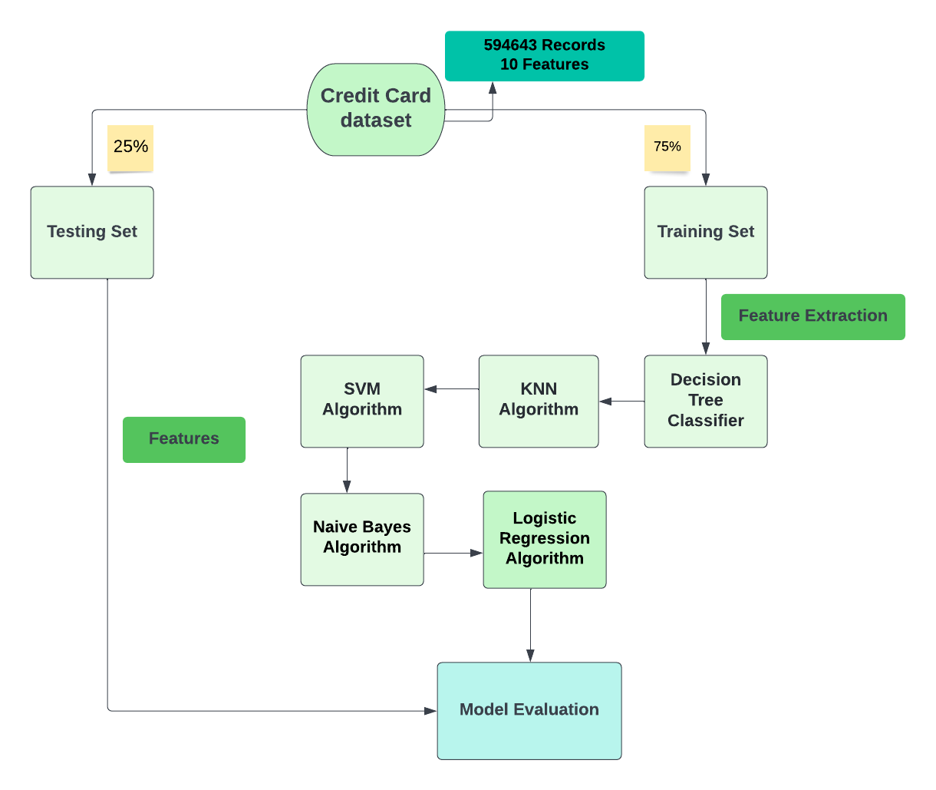

**Figure 1.1:** Diagram of a credit card fraud detection model

This is the method we propose for evaluating the model.

**Chapter 2**

**Problem Definition and Algorithm**

**2.1 Task Definition**

When someone uses another person's credit card or account details to make unauthorized purchases or obtain funds through cash advances, this is known as credit card fraud. Credit card fraud does not only occur online; it also occurs in physical stores. By spotting potentially fraudulent use of credit cards in your payment environment as a business owner, you can avoid severe hassles and unfavorable exposure.

Modeling previous credit card transactions with understanding of those that proved out to be fraudulent is part of the Credit Card Fraud Detection Problem. The algorithm is used to see if a single transaction is fraud or not. Our purpose is to identify all suspicious transactions while lowering the amount of incorrect fraud classifications.

Our project's dataset was collected from kaggle and will be used as the project's input. With 10 features, there are 594,643 lines of data in our database, with 587,443 regular payments and 7,200 fraudsters. BankSim transaction simulation software was used to generate the data. As this is a randomized simulation, the results will not be identical to the original data.

The goal of this project is to detect credit card fraud. For this, the most crucial aspect in this circumstance is the money. In recent years, many consumers have lost money as a result of fraudulent transactions. So, in the actual world, utilizing machine learning techniques to solve this fundamental problem is a really interesting challenge.

**2.2 Algorithm Definition**

Machine learning is a set of algorithms and mathematical models that allow a computer system to learn from its previous experiences without having to be told what to do. Learning is concerned with the actions of a computer that mimic those of humans, as well as the enhancement of learning through past data analysis. It's also interested in developing a data-driven system that's more adaptive and predictive. Here are a few examples of machine learning algorithms.

**2.2.1 Decision Tree Algorithm**

A Decision Tree is a form of supervised learning[1] approach that can be used to solve issues like regression and classification. It has the ability to operate with discrete and numerical data. Starting with the root of the tree and spreading on succeeding branches till reaching the leaf node, it shows a tree-like architecture with nodes and branches. The dataset's characteristics are represented by the internal node, while the set of rules are represented by the branches, and the problem's solution is shown by the leaf nodes. Identifying malignant and non-cancerous cells, as well as generating car-buying suggestions to clients, are examples of real-world applications of decision tree algorithms.

ID3, CART, J48, NB Tree, REP Tree and more data mining methods are available. Tree structure is a general principle of an algorithm that has been frequently used to represent classification models. For tree growth, most decision tree induction techniques use a greedy top-down recursive partitioning strategy.

**2.2.2 K nearest neighbors Algorithm**

The supervised learning technique K-Nearest Neighbor can be utilized for both classification and regression issues. This method assumes that the new piece of data and the current data points are comparable. Based on their relationship, the new information points are assigned to the most comparable categories. Because that retains all accessible datasets and classifies each new instance using K-neighbors, it is also known as the lazy learner algorithm. Any distance metric will determine the distance among data sets, and the new instance will be assigned to the category with the greatest commonalities. Depending on the requirements, the distance measure might be minkowski, euclidean, hamming or manhattan.

**Implementation in Steps:**

**Step-1:** Calculate the Cosine Similarity of each document.

A o B = x1*x2 + y1*y2

dist(A,0) = sqrt((xa-x0)^2 + (ya-y0)^2) == |A|

As a result,

cos t = A o B/|A|x|B = sim(A,B).

**Step-2:** Loop

i) Select a Centroid

ii) Compare findings

iii) Continue if sim(A,B)Threshold is exceeded;

**Step-3:** Retrieve Cluster

**2.2.3 Support Vector Machine Algorithm**

Support Vector Machine (SVM) is a supervised learning tool for regression and classification problems. It is, however, largely used to tackle problems with categorizing. SVM is used to create a decision boundary or set of points that divides data into numerous classifications.

The technology is named a support vector machine because support vectors are the data sets that help define the higher dimensional space. SVM may be used for face identification, image classification, drug development, and many other forms of work.

**Pseudo code:**

• Importing all of the necessary packages

For example, import pandas as pd.

• SVM defense

**STEP-1:** Start

**STEP-2:** Reading the dataset # reads the pd.read.csv dataset (file name)

**STEP-3:** Cleaning and preparation of data. Relevant Data is resized as normal and fraudster classes, with normal = 0 and fraudster = 1 in the normal and fraudster classes, respectively.

• Data is under saturated;

• Data is scaled (null values are deleted); and data is normalized

• Using the split () function on the training phase, the data is split into two sets: training dataset and testing dataset.

**Step-4:** Train the dataset with the Support Vector Machine algorithm.

• classifier.predict () # is an SVM classifier that forecasts whether or not a transaction is fraud.

**Step-5:** Computing the number of fraudulent and genuine transactions, and also recall, precision, and accuracy, and placing the findings in the proper places.

**STEP-6:** Stop

**2.2.4 Naive Bayes Algorithm**

The supervised learning algorithm Naive Bayes classifier is used to generate predictions based on the item's worth; the method is called Naive Bayes as it is based on the Bayes theorem and follows the naive assumption that the variables are independent of one another.

The Bayes theorem is predicated on conditional probability, which is the chance of event (A) happening if event (B) has already happened.

The equation for Bayes theorem is given as: P(A|B)=

**2.2.5 Logistic Regression Algorithm**

To predict categorical data or discrete outcomes, logistic regression employs a supervised learning approach. The output of the logistic regression technique can be 0 or 1, Yes or No, Red or Blue and so on and it can be utilized in machine learning for classification challenges[1].

Logistic regression is different from linear regression in that it is used to resolve the classification task and forecast discrete values, while linear regression has been used to address the regression problem and forecast continuous values.

Rather than fitting the line of best fit, it creates an S shaped curves around 0 and 1. The thresholds concept is used in the S shaped curve, which is also known as a logistic function. Any value that is larger than or equal to the limit will be set to 1; any number which is less than or equivalent to the limit will be set to 0.

**Chapter 3**

**Experimental Evaluation**

The methodology, results, and discussions from our credit card fraud detection study are covered in this section. We used this evaluation technique in our data collecting since it handled both categorical and numerical data. There are 594643 records in our data set, with 10 different features. The data set was separated into two categories during the implementation phase. The training set is one of these two types, while the testing set is the other. To create a more efficient model, we utilized 75% of the data set to train and 25% of the data set for the test. The model was built using machine learning techniques such as Decision Tree (DT), K Nearest Neighbors (KNN), Support Vector Machines (SVM), Naive Bayes (NB) and Logistic Regression. The best at identifying the abnormality was the Support Vector Machine (SVM).

**3.1 Methodology**

A goal-based evaluation methodology underpins our approach to detecting credit card fraud. Goal-based evaluations assess whether or not objectives have been met. Machine learning algorithms will extract data from two different sources in the fraud detection system. One is a new transaction initiated by the users, and the other is a credit card data set from the chosen bank. After that, the dataset is divided into two sections: a training and testing set. 75 percent of the data was utilized for training, while 25 percent was used for testing. It's critical to properly train the data set so that if a new fraudulent transaction occurs, the algorithm can recognize it immediately and send a warning to the credit card authorities. [2]

Graphic representation of our project design is drawn below:

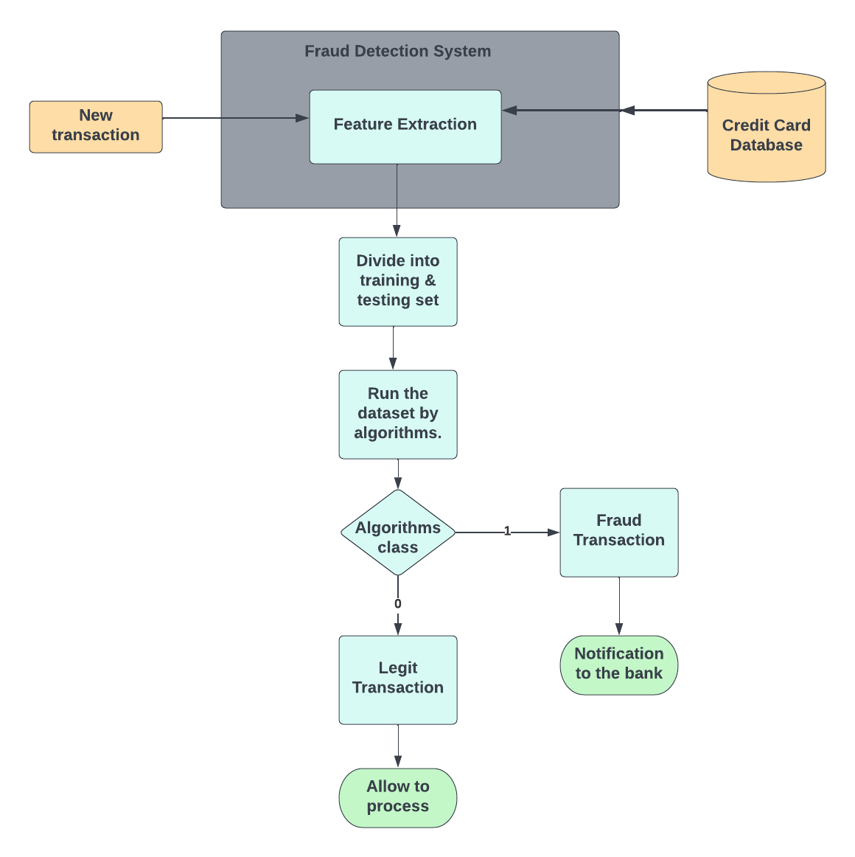

**Figure 3.1:** Approached credit card fraud detection system

**3.1.1 Experimental Dataset**

We used a dataset called fraudData.csv in our credit card fraud detection using machine learning study. We use the dataset as an ideal one for the goal of identifying fraud so that we may construct a perfect model that can reliably predict future fraudulent transactions.

This project makes use of a Kaggle dataset that includes 594,643 pieces of data, 587,443 genuine transactions, and 7,200 fraudsters and ten features. BankSim transaction simulation software was used to generate the data. Here's where the sample set with several entries is mentioned.

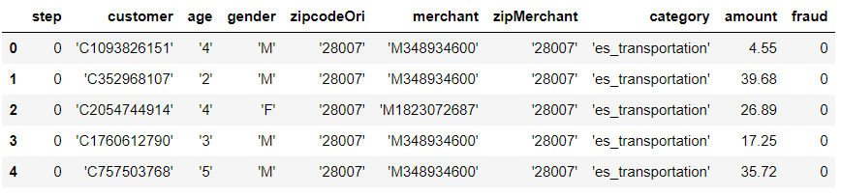

**Figure 3.1.1.1:** Sample Data set for credit card fraud detection model

The data collection has a total of ten features. Eight of these characteristics are independent variables, while one is a dependent variable. The terms "independent set" and "dependent set" are mentioned here.

**Independent variables**

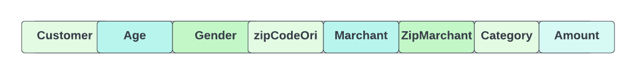

**Dependent variables**

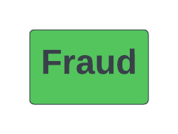

Seven out of the eight independent variables are categorical data. Using the python matplotlib library, we attempted to characterize some of them. Using matplotlib, we plotted the age and gender attributes of the data set to compare them. Except for the transaction amount attribute, the remaining seven categorical data must be converted to numerical data because machine learning algorithms cannot work with categorical data because they lack a numeric value.

We used some of the encoding techniques available in Python to transform categorical data to numeric data. Ordinal encoding and label order encoding are the encoding methods applied. Here is a graphic representation of certain categorical attributes.

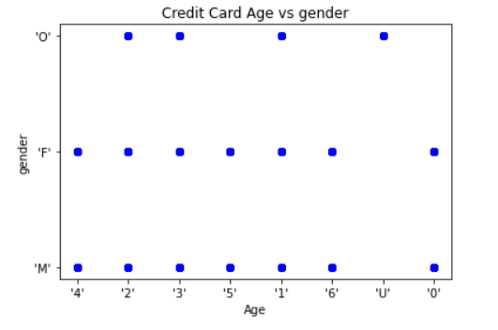

**Figure 3.1.1.2:** Graphing the age of credit cards by gender

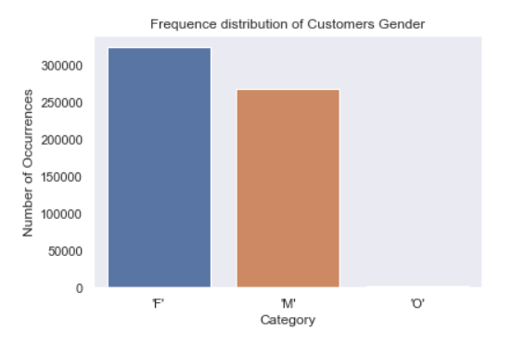

**Figure 3.1.1.3:** Frequency distribution of credit card’s customer gender

We also used a pie chart to show the percentage of different gender types in the dataset.

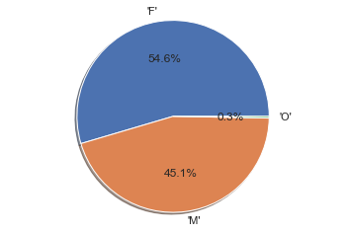

**Figure 3.1.1.4:** Gender distribution of customers as a pie chart

The age of the credit card is another crucial feature we used in our dataset. The credit card dataset contains a total of eight different types of outcomes. They are a numeric value ranging from 0 to 6, as well as a category value 'U,' which denotes an unused credit card.

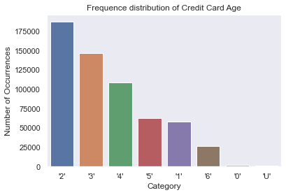

**Figure 3.1.1.5:** Frequency distribution of credit card age

In the dataset, there is also a pie chart that shows the percentage of different credit card age categories.

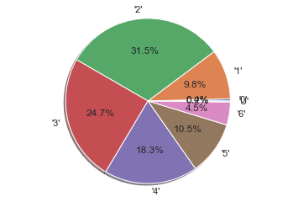

**Figure 3.1.1.6:** Age distribution of credit card as a pie chart

Because our Kaggle database has 594,643 sets of data with 10 characteristics, including 587,443 legitimate transactions and 7,200 fraudsters, it's a big deal.

We attempted to categorize them into two groups: 'legit' and 'fraud'. Legitimate transactions have a class of 0 and fraudulent transactions have a class of 1. Then we categorized them as 'LEGIT' and 'FRAUD' and used a histogram to visually illustrate them. Below is a visual illustration of the two classes legit and fraud.

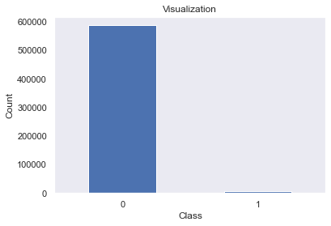

**Figure 3.1.1.7:** Visual illustration of two outputs with the numbers 0 and 1

Indicating whether they are legitimate or fraudulent.

**3.1.2 Performance Evaluation Metrics**

The performance of a machine learning model can be measured. They can present us with the progress of our machine learning algorithms, as well as a numerical value to go with it. A performance metric is required for all machine learning models, whether linear regression or classification. Whenever a new transaction occurs in our project, we will determine if it is fraudulent or not. The machine learning algorithm will provide us with both a predicted and real value. By comparing these two, we can obtain the confusion metrics, which is a performance evaluation indicator. Accuracy, precision, recall, f1-score, ROC curve, and other metrics can be used to describe the end outcome.

To characterize a categorization problem, a variety of phrases are utilized as performance evaluation metrics. We need a metric that compares discrete classes in some way because classification models produce discrete output. Categorization Metrics assess a model's performance and tell us whether the classification is excellent or poor, but they do it in diverse ways.

So, in order to assess Classification models, we'll go over the following measures in depth:

* Accuracy
* Precision
* Recall
* F1-score
* Confusion Matrix
* AUC-ROC Curve.

**Accuracy**

One of the evaluation metrics is accuracy. For each class, the percentage of correctly categorized examples among all the testing examples is:

%

**Precision**

Precision is a metric that measures how many correct positive predictions have been made. The ratio of accurately predicted true positives divided by the total number of true positives predicted is used to compute it[3].

**Recall**

Recall is also known as true positive rate. The percentage of cases of the positive class that are well-classified among all positive examples. Recall is averaged when considering a multi-class classification problem[3].

**F-1 Score**

Because the F1 score is indeed the mean of precision and recall, precision and recall are given equal weight. As a result, for unbalanced classification problems, this metric, which takes values between 0 and 1, is frequently considered an acceptable by default metric[3]. The metric is constructed using the following equation as the overall average of precision and recall:

**Confusion Matrix**

A Confusion matrix is indeed an N-by-N matrix used to assess the effectiveness of a classification algorithm, where N is the number of class labels. The matrix compares actual class labels to the predictions of the machine learning model[3]. As shown below, we used to have a two-by-two matrix containing four values:

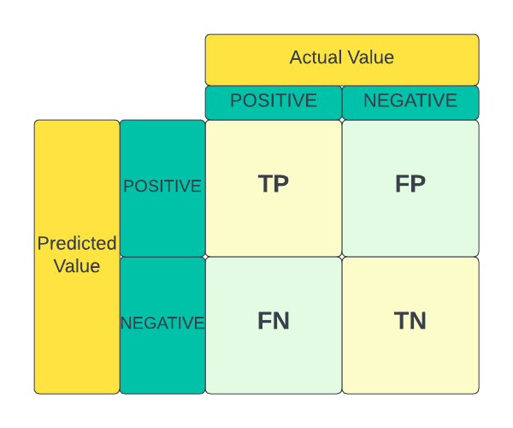

**Figure 3.1.2:** A 22 Confusion Matrix

**AUC-ROC**

Receiver Operating Curve or “ROC Curve” is a graph that depicts how a classification model works at various levels of categorization. Here on curve, 2 parameters are mapped: True Positive Rate (TPR) and False Positive Rate (FPR).

"AUC" is the abbreviation for "Area under the ROC Curve." AUC, in other words, assesses the full two-dimensional partially obscuring the entire ROC curve (imagine integral calculus) across (0, 0) to (1, 0). (1, 1).

**3.2 Results**

We utilized five distinct machine learning techniques, divided into two groups: classification and regression. They are included here, along with the results of each algorithm's classification report.

**i. Decision Tree Algorithm**

We have 99.4% accuracy in detecting credit card fraud using the decision tree method. It's a fantastic result.

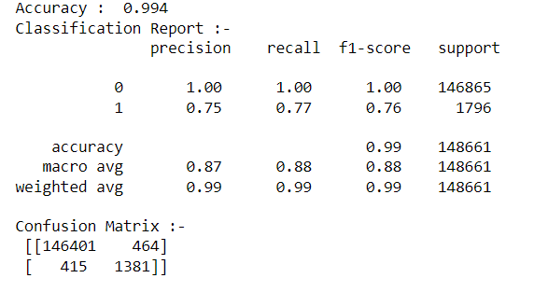

**Figure 3.2.1:** Classification report for Decision Tree Algorithm

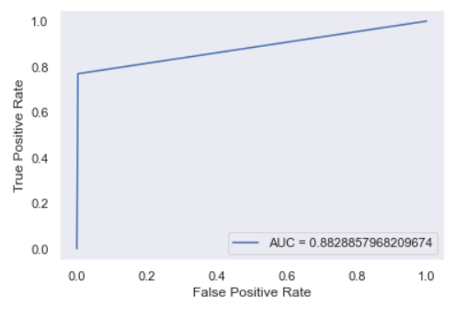

**Figure 3.2.2:** ROC Curve for Decision Tree Algorithm

**ii. K-Nearest Neighbor algorithm**

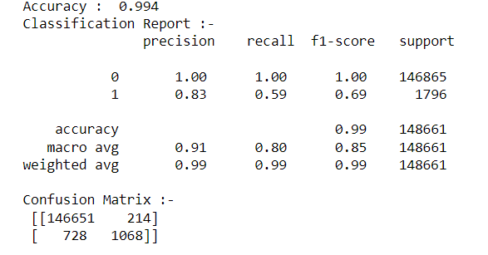

**Figure 3.2.3:** Classification report for K-Nearest Neighbor Algorithm

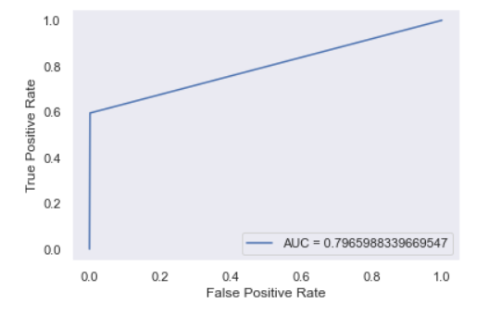

**Figure 3.2.4:** ROC Curve for K-Nearest Neighbor Algorithm

**iii. Support Vector Machine Algorithm**

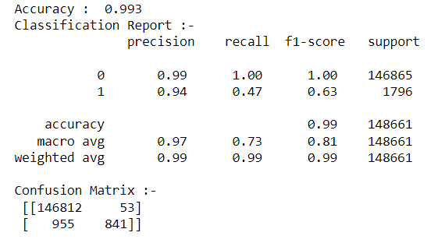

**Figure 3.2.5:** Classification report for Support Vector Machine Algorithm

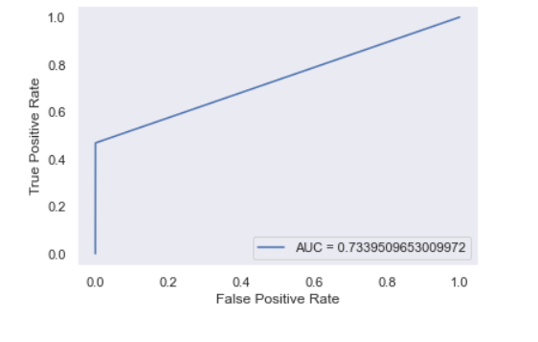

**Figure 3.2.6:** ROC Curve for Support Vector Machine Algorithm

**iv. Naive Bayes Algorithm**

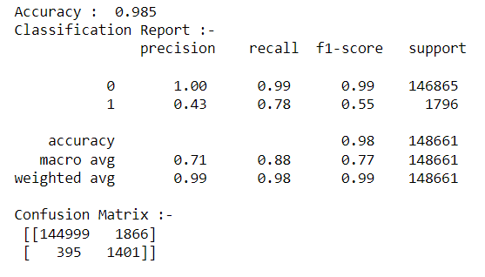

**Figure 3.2.7:** Classification report for Naive Bayes Algorithm

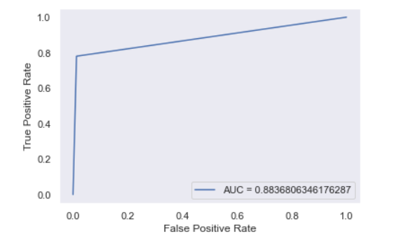

**Figure 3.2.8:** ROC Curve for Naive Bayes Algorithm

**v. Logistic Regression Algorithm**

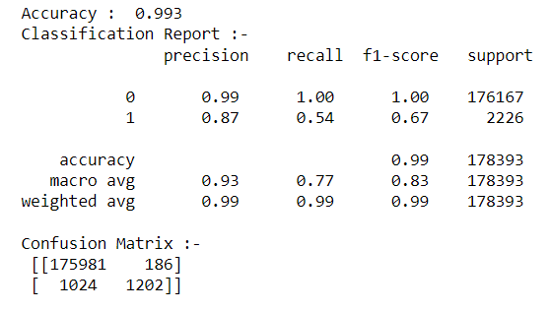

**Figure 3.2.9:** Classification report for Logistic Regression Algorithm

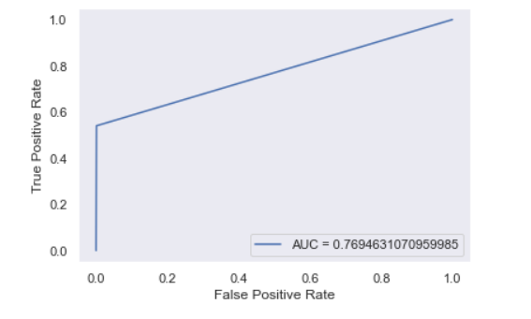

**Figure 3.2.10:** ROC Curve for Logistic Regression Algorithm

That's all there is to the five algorithms we employed to detect credit card fraud in our project. Our data collection is significantly unbalanced, with over 98 percent of legitimate transactions and only 2 percent of fraudulent transactions.

As a result, when we utilize these algorithms, we receive a wide range of results. In comparison to the actual value, all of these algorithms yield the number of true positive and true negative rates. The accuracy score and precision of the algorithms are calculated using these rates.

**3.3 Discussion**

The hypothesis we offered in our study is really well-fitting. Because our data set is well-trained, and we applied a new machine learning technique, we were able to detect fraud transactions with a better rate of accuracy. The data set we used is severely unbalanced, with just 7200 fraudulent transactions out of 594,643 total. That is why we attempted to use an algorithm that would deliver a greater rate of accuracy.

We gain 99.4 percent overall accuracy using the decision tree technique, but only 75 percent precision when detecting fraudulent transactions. We get about 85 percent fraud transaction precision using the KNN algorithm, 94 percent fraud transaction precision using SVM, 43 percent fraud transaction precision using naive bayes, and 87 percent fraud transaction precision using logistic regression.

As a result, decision trees, KNN, Naive Bayes, and logistic regression algorithms did not work any better in the face of a highly skewed dataset. However, when dealing with a severely unbalanced credit card fraud data set, the SVM algorithm performs substantially better. As a result, we can put the SVM algorithm in charge of detecting credit card fraud in the real world.

A comparative result of our proposed model is mentioned here:

|  |  |  |  |  |  |  |
| --- | --- | --- | --- | --- | --- | --- |
| **Model** | **Accuracy** | **Precision** | **Recall** | **F1-Score** | **Support** | **AUC** |
| Decision Tree | 99.4% | 75% | 77% | 76% | 1796 | 88.28% |
| KNN | 99.4% | 83% | 59% | 69% | 1796 | 79.65% |
| SVM | 99.3% | 94% | 47% | 63% | 1796 | 73.39% |
| Naïve Bayes | 98.5% | 43% | 78% | 55% | 1796 | 88.36% |
| Logistic Regression | 99.3% | 87% | 54% | 67% | 2226 | 76.94% |

**Table 3.3:** A comparative result of our proposed model using machine learning algorithm

A comparison of the results of our suggested model using five different classification and regression algorithms. Among these algorithms, SVM has a greater precision rate and a higher accuracy rate. As a result, our model can determine if a new transaction is fraudulent and send a message to the card issuer.

**Chapter 4**

**Related Work**

In this section, we go through some of the earlier work that has been done on Fraud Detection.

Machine learning techniques play a critical role in a variety of efficient data processing domains, one of which is the detection of card fraud. Several ways for detecting fraud were recommended in prior studies, including supervised methods, unsupervised methods, and a hybrid strategy; this necessitates knowing some technology involved in recognizing credit card fraud, as well as a deeper understanding of the sorts of card fraud. Many other solutions were proposed and tested. The majority of them will be discussed in the following paragraphs.

Yashvi Jain, Namrata Tiwari, Shripriya Dubey, and Sarika Jain researched SVM, ANN, Hidden Markov Model, Bayesian Networks, KNN, Fuzzy Logic system and Decision Trees in 2019. In their research, they discovered that the algorithms k-nearest neighbor, decision trees, and SVM provide a medium level of accuracy. Fuzzy Logic and Logistic Regression have the lowest accuracy of all the methods. Neural networks, naive bayes, fuzzy systems, and KNN all have a high detention rate. The LogisticRegression, SVM, decision trees have a high detection rate at the middle level. Both ANN and Nave Bayesian Networks outperform each other across all parameters. It is highly expensive to train these people. Each algorithm has a unique set of parameters. They give great results with one type of dataset, but they produce horrible results with another type of dataset.[1]

The work of Navanushu Khare and Saad Yunus Sait on decision trees, random forests, support vector machines (SVM), and logistic regression was published in 2018. They had to deal with a dataset that was considerably biased. Accuracy, sensitivity, specificity, and precision are used to evaluate performance. Overall accuracy of Logistic Regression is 97.7%, Decision Trees is 95.5 percent, Random Forest is 98.6%, and SVM classifier is 97.5 percent, according the statistics. Among the various ways, they determined that the Random Forest approach has the highest accuracy and is the best algorithm for detecting fraud. They also revealed that the support vector machine (SVM) approach has a data imbalance problem and performs poorly in detecting credit card fraud.[1]

Developments in E-Commerce and Communication technology, according to Altab Althar Taha and Sareef Jameel Malbery, have created credit card usage a far more frequent mode of payment, and transactional fraud is on the rise. Researchers used the high optical support vector machine, which combines Bayesian-based high energy optimization with parameter adjustment of the light gradient boosting machine (LightGBM). They employed a real-world public dataset that included both fraudulent and non-fraudulent transactions in their technique. Their suggested approach exceeded other strategies in terms of accuracy when compared to other techniques. The suggested system achieves a 98.40 percent accuracy, a 92.88 percent area under the receiver operating characteristics curve (AUC), a 97.34 percent precision, and a 56.95 percent F1-score.[4]

Debachudamani Prusti and Santhnu Kumar Rath designed an application employing machine learning methods such as decision trees, K-nearest neighbor (KNN), multilayer perceptron (MLP), and support vector machine to determine the accuracy in fraud detection (SVM). They proposed a model that included decision trees, support vector machines, and k-nearest neighbor algorithms. They used two web-based protocols for successful data exchange across several diverse platforms: simple object access protocol (SOAP) and representational state transfer (REST). They used the accuracy metric to compare the results of machine learning algorithms. The support vector machine (SVM) outscored other algorithms by 81.63 percent, while the hybrid system they presented had an accuracy of 82.58 percent.[4]

Because fraud detection must be very flexible in order to track the continuous growth of fraud over time and the appearance of unknown anomalies, H.Tran and K.P.Tran used anomaly detection techniques for credit card fraud detection. As data-driven techniques, they recommended a T2 control chart and a one-class support vector machine OCVM with optimum kernel parameter selection. The approach was tested utilizing a huge real-time data set of online e-commerce transactions from European credit card holders, which contained a total of 284807 non-fraud transactions. Simulators were also used to create fraudulent transactions, with 284000 transactions used for training and 200 fraud and non-fraud transactions used for testing. To examine the outcomes obtained by the techniques, they used accuracy, F1-score, Recall (DR), FPR, and Precision matrices. The experimental results show that OCVM surpasses the T2 flowchart with accuracy of 96.6 percent, FPR of 8.5 percent, and F-score of 100 percent. The two proposed techniques, on the other hand, have shown that they can accurately detect credit card fraud with a low false rate.[5]

**Chapter 5**

**Future Work**

Based on the results of the above research, we were unable to achieve our aim of 100 percent accuracy in fraud detection, indicating that there is still space for improvement. For detecting fraud, machine learning techniques are applied, although the results are not accurate.

There are certain approaches that can be used to correctly identify credit card fraud. As a result, implementing deep learning algorithms will improve the accuracy of detecting credit card fraud.

Another alternative for improvement is to expand the amount of the dataset; this would enhance the precision of the used algorithm. These will provide considerably more precise results. As an outcome, more data will almost certainly enhance the model's effectiveness in fraud prevention while also reducing the false positive rate. However this needs support (by giving more personal information about users) from the banks themselves.

**Chapter 6**

**Conclusion**

As credit cards carry not only money but also intellectual property, credit card fraud is a serious crime. To lessen the severity of this criminal crime. Machine learning can be a useful tool for detecting fraudulent transactions. We applied several classification and regression algorithms in our credit card fraud detection project. These algorithms give us a considerably greater level of accuracy in detecting fraudulent transactions. Because the SVM algorithm reacts significantly better in response to our severely imbalanced dataset, it fared the best among these algorithms.

The SVM (Support Vector Machine) technique gives a 99.3 percent accuracy rate and a 94 percent precision rate in the fraud class. In the actual world, that is a far higher accuracy rate for detecting fraud transactions. When a new transaction occurs, it will be processed using our proposed machine learning model, which will use the SVM method to determine if the transaction is fraudulent or not.

We may not be able to detect fraud transactions with 100% accuracy, but we can use these datasets in conjunction with real-world data. After that, we can reach 100% accuracy by integrating some machine learning techniques. Despite the fact that credit card data is confidential, different banks will not provide their genuine credit card user data set.

**Bibliography**

[1] R. Tyagi, R. Ranjan, and S. Priya, “Credit Card Fraud Detection Using Machine Learning Algorithms,” *Proc. 5th Int. Conf. I-SMAC (IoT Soc. Mobile, Anal. Cloud), I-SMAC 2021*, no. Iciccs, pp. 334–341, 2021, doi: 10.1109/I-SMAC52330.2021.9640822.

[2] S P Maniraj, Aditya Saini, Shadab Ahmed, and Swarna Deep Sarkar, “Credit Card Fraud Detection using Machine Learning and Data Science,” *Int. J. Eng. Res.*, vol. 08, no. 09, pp. 110–115, 2019, doi: 10.17577/ijertv8is090031.

[3] N. K. Trivedi, S. Simaiya, U. K. Lilhore, and S. K. Sharma, “An efficient credit card fraud detection model based on machine learning methods,” *Int. J. Adv. Sci. Technol.*, vol. 29, no. 5, pp. 3414–3424, 2020.

[4] A. RB and S. K. KR, “Credit card fraud detection using artificial neural network,” *Glob. Transitions Proc.*, vol. 2, no. 1, pp. 35–41, 2021, doi: 10.1016/j.gltp.2021.01.006.

[5] H. Najadat, O. Altiti, A. A. Aqouleh, and M. Younes, “Credit Card Fraud Detection Based on Machine and Deep Learning,” *2020 11th Int. Conf. Inf. Commun. Syst. ICICS 2020*, no. Section IX, pp. 204–208, 2020, doi: 10.1109/ICICS49469.2020.239524.