**C.V. RAMAN GLOBAL UNIVERSITY**

**BHUBANESWAR, ODISHA, INDIA**



**DEPARTMENT OF CSE**

**CASE STUDY REPORT ON**

**Credit Card Fraud Detection**

**Submitted By: -**

|  |  |
| --- | --- |
| **REGISTRATION NO.** | **MEMBER’S NAME** |
|  |  |
| **Arunoday Setu** | **CL202501060191734** |
| **Mohammad Fahad Raza** | **CL202501060191745** |
| **Mirza Nazmul Bari Baig** | **CL202501060194621** |
| **Ashish Nahak** | **CL202501060194621** |

**GROUP: - 19**

**SEMESTER: - 6TH**

**BRANCH: - CSE& Allied**

**Abstract**

This report provides an in-depth overview of credit cards, including their functionality, types, benefits, and potential risks. It highlights the importance of understanding how credit cards work and the impact they can have on personal financial health. As credit cards become an integral part of modern financial transactions, this report aims to promote responsible usage through awareness of best practices. By examining both the advantages and pitfalls, the report offers a balanced view to help individuals make informed decisions regarding credit card usage. The content also sheds light on how proper credit card management can positively influence one’s credit score and financial future. This report is particularly relevant for students, professionals, and anyone seeking to improve their financial literacy.

**Acknowledgement**

I would like to express my deepest gratitude to all those who contributed to the successful completion of our project titled **“Credit-Card Fraud Detection**. I am grateful to **C.V. RAMAN GLOBAL UNIVERSITY** and **CRANES VARSITY** for providing the resources and infrastructure needed to carry out this work. The learning environment and access to facilities were instrumental in conducting research and development. Special thanks to my colleagues and classmates for their constructive feedback and encouragement. The discussions and brainstorming sessions helped refine the project's design and functionality. I would like to acknowledge my family and friends for their constant support and understanding during the project's demanding phases. Their encouragement and belief in my abilities were a source of strength. Finally, I thank all those who made direct or indirect contributions to the successful implementation of this system. Without the support of all these individuals, this project would not have been possible. Thank you all forbeing part of this journey.

**CONTENTS**

**1. Introduction**

**2. Objectives**

**3. Tools and Technologies Used**

**4. Implementation**

**6.Features**

**7. Code**

**8.Future Scope**

**9. Conclusion**

**Introduction**

The concept of credit has revolutionized the way financial transactions are conducted, and at the forefront of this evolution stands the credit card. A credit card is a payment instrument issued by financial institutions that enables consumers to borrow funds up to a predetermined limit for the purpose of making purchases, paying bills, or accessing cash advances. Unlike debit cards, which deduct money directly from a user’s bank account, credit cards allow for deferred payment, typically within a monthly billing cycle. This flexibility makes them a powerful tool for managing both everyday expenses and unforeseen financial demands.

With the increasing globalization of commerce and the rise of e-commerce platforms, credit cards have become essential for online shopping, travel bookings, and subscription services. They offer a range of features including reward points, travel miles, cashbacks, and exclusive offers, making them not just a payment method but also a lifestyle enhancer. Moreover, timely repayment of credit card dues contributes positively to an individual’s credit history, which plays a crucial role in securing loans and mortgages.

However, the benefits of credit cards come with certain responsibilities. High-interest rates on outstanding balances, the temptation to overspend, and the risk of falling into debt highlight the need for prudent financial behaviour. This report delves into the fundamentals of credit cards, their types, key benefits, associated risks, and best practices for their usage. By understanding the mechanics and implications of credit card use, individuals can harness their potential to enhance financial well-being while avoiding common pitfalls.

**Objectives**

The primary objective of this report is to provide a comprehensive understanding of credit cards as modern financial tools, focusing on their structure, utility, and impact on personal finance. Drawing upon the information presented in the accompanying PowerPoint presentation, this report aims to:

1. **Explain the Fundamental Concept of Credit Cards**: To clarify what credit cards are, how they function, and the mechanisms involved in their usage—from transaction initiation to billing and repayment.
2. **Explore Different Types of Credit Cards**: To familiarize readers with the various categories of credit cards available in the market such as standard cards, reward cards, secured cards, and charge cards, along with their unique features and suitability for different users.
3. **Highlight the Benefits of Credit Card Usage**: To discuss the advantages of using credit cards including convenience, reward programs, fraud protection, and their role in building a credit history.
4. **Analyze the Risks and Challenges**: To raise awareness about the potential downsides such as interest accumulation, overspending tendencies, late payment penalties, and financial mismanagement.
5. **Promote Responsible Credit Card Practices**: To offer practical guidelines and strategies for effective and disciplined credit card usage, such as timely payments, monitoring spending, and maintaining a healthy credit utilization ratio.
6. **Encourage Financial Literacy and Decision-Making**: To empower individuals—especially students and young professionals—with the knowledge required to make informed financial choices and use credit cards as a tool for financial stability rather than a source of debt.

By meeting these objectives, the report seeks to contribute to a more informed and financially responsible user base, capable of leveraging credit cards for both everyday needs and long-term financial planning.

**Tools and Technologies Used**

|  |  |
| --- | --- |
| **Tool/Technology** | **Purpose** |
| Python | Core programming language used to build the project. |
| Pandas (import pandas as pd) | For data manipulation and analysis, particularly for loading and processing the credit card transaction dataset. |
| NumPy (import numpy as np) | Used for numerical operations and array manipulations. |
| Scikit-learn (sklearn) | A machine learning library used for: <ul><li>Model building (LogisticRegression)</li><li>Data splitting (train_test_split)</li><li>Evaluating accuracy (accuracy_score)</li></ul> |
| Streamlit (import streamlit as st) | A Python-based web app framework used to build an interactive front-end for the machine learning model. Enables the user to input transaction data and view prediction results live. |
| Jupyter Notebook | Development environment for writing, testing, and visualizing analysis results in an interactive format. |
| Git & Github | Version control and cloud-based repository to track project progress and host final submission files. |

**Implementation**

1. **Import Necessary Libraries**

* **Purpose**: To load essential Python libraries for data handling, machine learning, and UI.

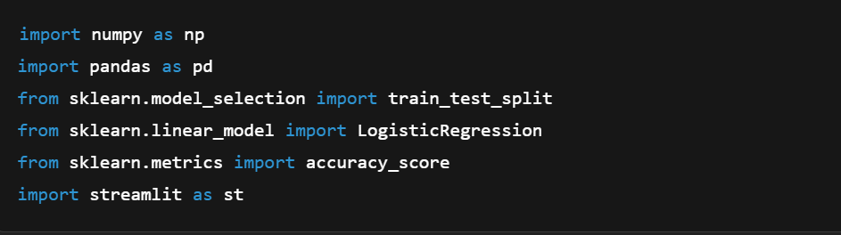

**2. Load the Dataset**

* **Purpose**: Read the credit card transaction dataset from a CSV file.



**3. Separate Legitimate and Fraudulent Transactions**

* **Purpose**: To identify and isolate fraudulent and non-fraudulent records.

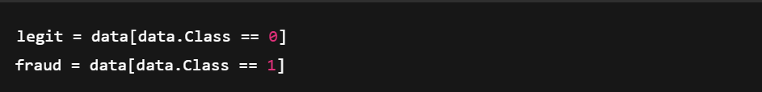

**4. Undersample Legitimate Transactions**

**Purpose**: To balance the dataset for better model training (equal number of fraud and legit samples).

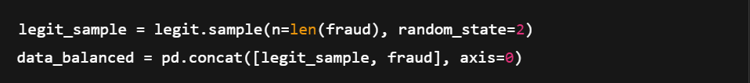

**5. Prepare Features and Labels**

* **Purpose**: Split data into input features X and target labels y.

python



**6.Train-Test Split**

* **Purpose**: Split data into training and testing sets.



1. **Train the Model**

* **Purpose**: Fit a logistic regression model with more iterations for accuracy.

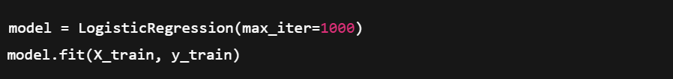

**8. Evaluate the Model**

**Purpose**: Check accuracy on both training and test sets.

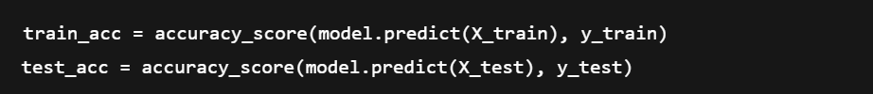

**9. Streamlit Web Interface Setup**

* **Purpose**: Create a simple web UI for user interaction.

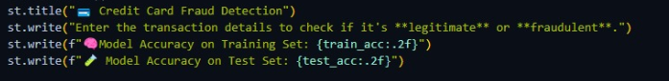

**10. User Input Handling**

* **Purpose**: Get feature inputs from the user via text field.



**11. Predict Button Logic**

* **Purpose**: When user submits data, validate and make prediction.

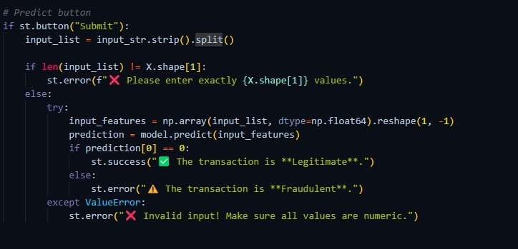

**Features**

1. **Loads and processes** a credit card transaction dataset using Pandas.
2. **Balances the dataset** by undersampling legitimate transactions.
3. **Splits the data** into training and test sets (80/20 split with stratification).
4. **Trains a Logistic Regression model** with improved iteration settings.
5. **Evaluates model accuracy** on both training and test data.
6. **Creates a web interface** using Streamlit for user interaction.
7. **Accepts user input** as space-separated numerical features.
8. **Validates input** for correct number and type of values.
9. **Predicts and displays** whether a transaction is legitimate or fraudulent.

**Code**

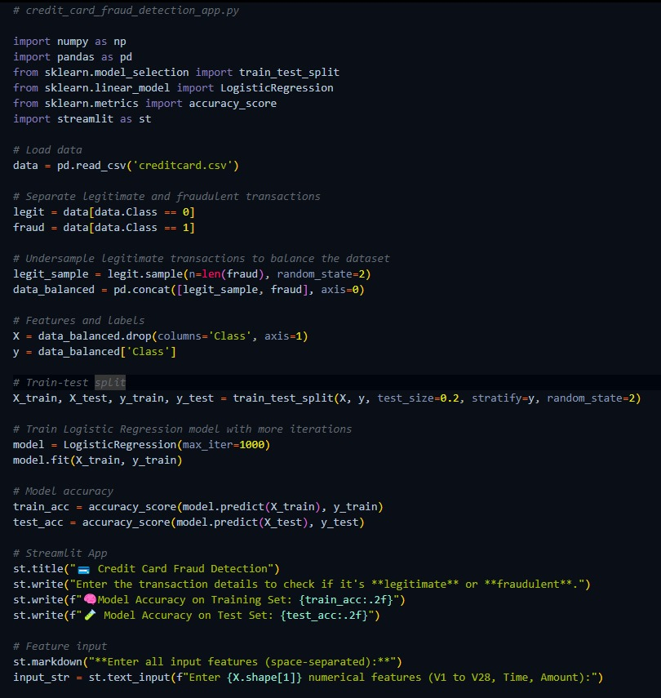



**Result**

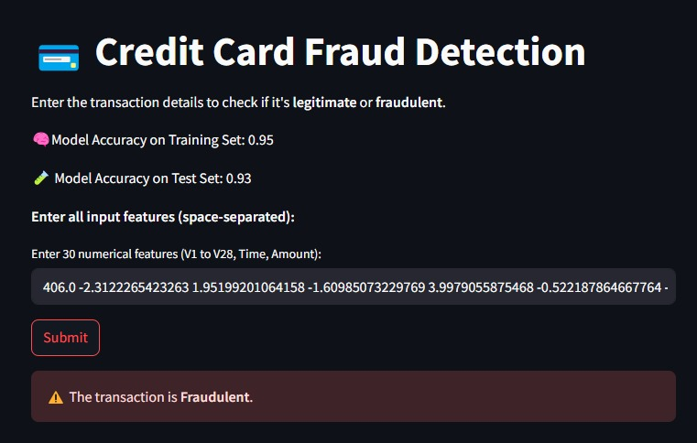

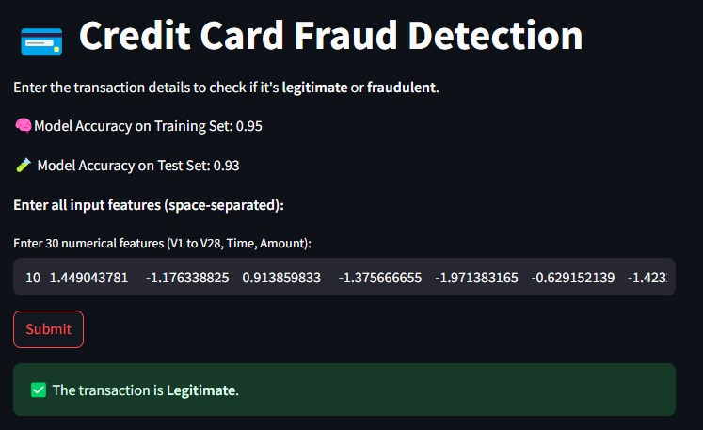

**Future Scope**

**1. Integration of Advanced Algorithms**  
Future versions can implement more sophisticated models like Random Forest, XGBoost, or Neural Networks to improve accuracy and detect complex fraud patterns.

**2. Real-Time Fraud Detection**  
Deploying the model with real-time transaction monitoring can enable immediate detection and prevention of fraudulent activity.

**3. Enhanced Feature Engineering**Additional features such as transaction location, device ID, and user behavior patterns can be included for better prediction performance.

**4. Model Optimization & Tuning**  
Hyperparameter tuning, cross-validation, and ensemble methods can be applied to boost model performance and generalization.

**5. Dashboard & Analytics Integration**Adding visual dashboards for analytics (using tools like Plotly or Streamlit charts) can help financial institutions monitor trends and metrics.

6**. Deployment as an API**The model can be deployed as a REST API to integrate with banking apps or platforms for live prediction services.

**7. Mobile App Compatibility**  
Creating a mobile version of the interface can allow end-users to check transaction legitimacy on-the-go.

**8. Support for Larger Datasets**Adapting the system for large-scale, real-time big data processing using tools like Apache Spark.

**Conclusion**

The Credit Card Fraud Detection project demonstrates the effective use of machine learning to identify fraudulent transactions based on historical data. By employing logistic regression and balancing techniques, the model achieves a fair level of accuracy in detecting anomalies. The integration with a user-friendly Streamlit interface enhances accessibility, allowing users to interact with the model in real-time.

While the project provides a solid foundation for fraud detection, it also highlights the importance of continuous improvement through advanced models, feature enhancement, and real-time deployment. With further development, this system has the potential to become a powerful tool for financial institutions in combating credit card fraud and securing user transactions.