Arjun Narale

=====================================

Adding tool Path

Java

Git

Maven

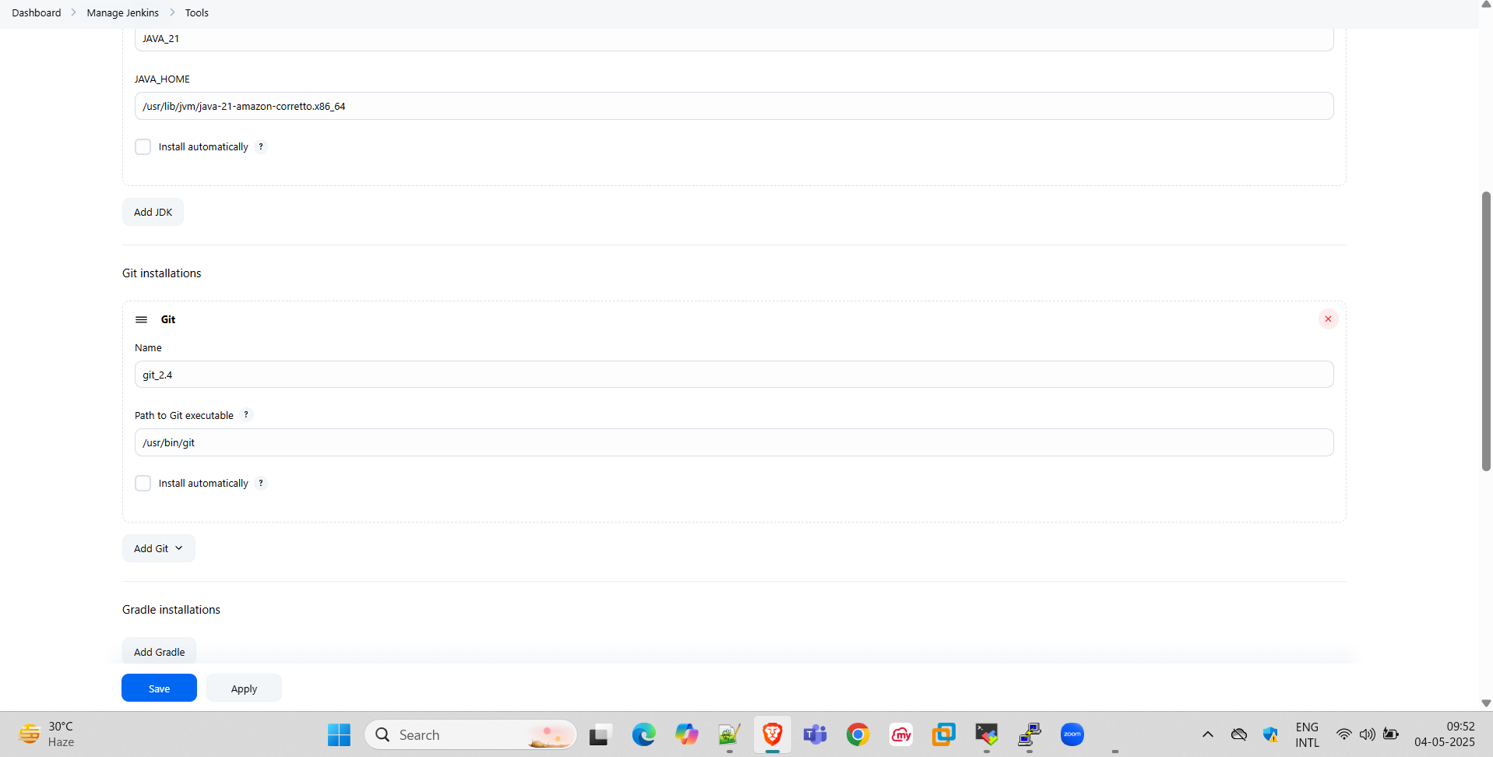

Adding Plugins

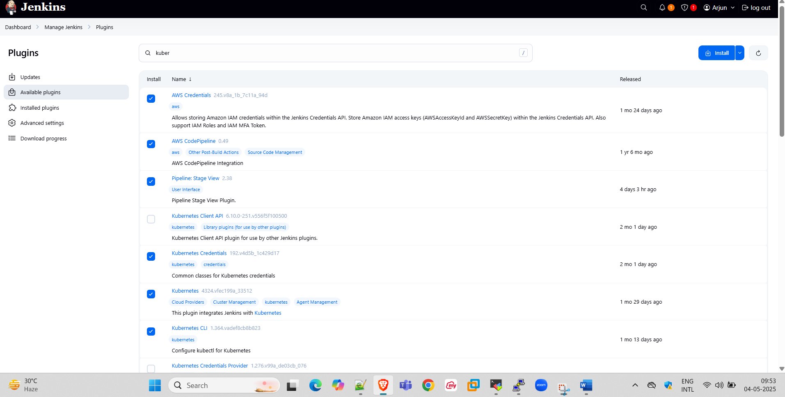

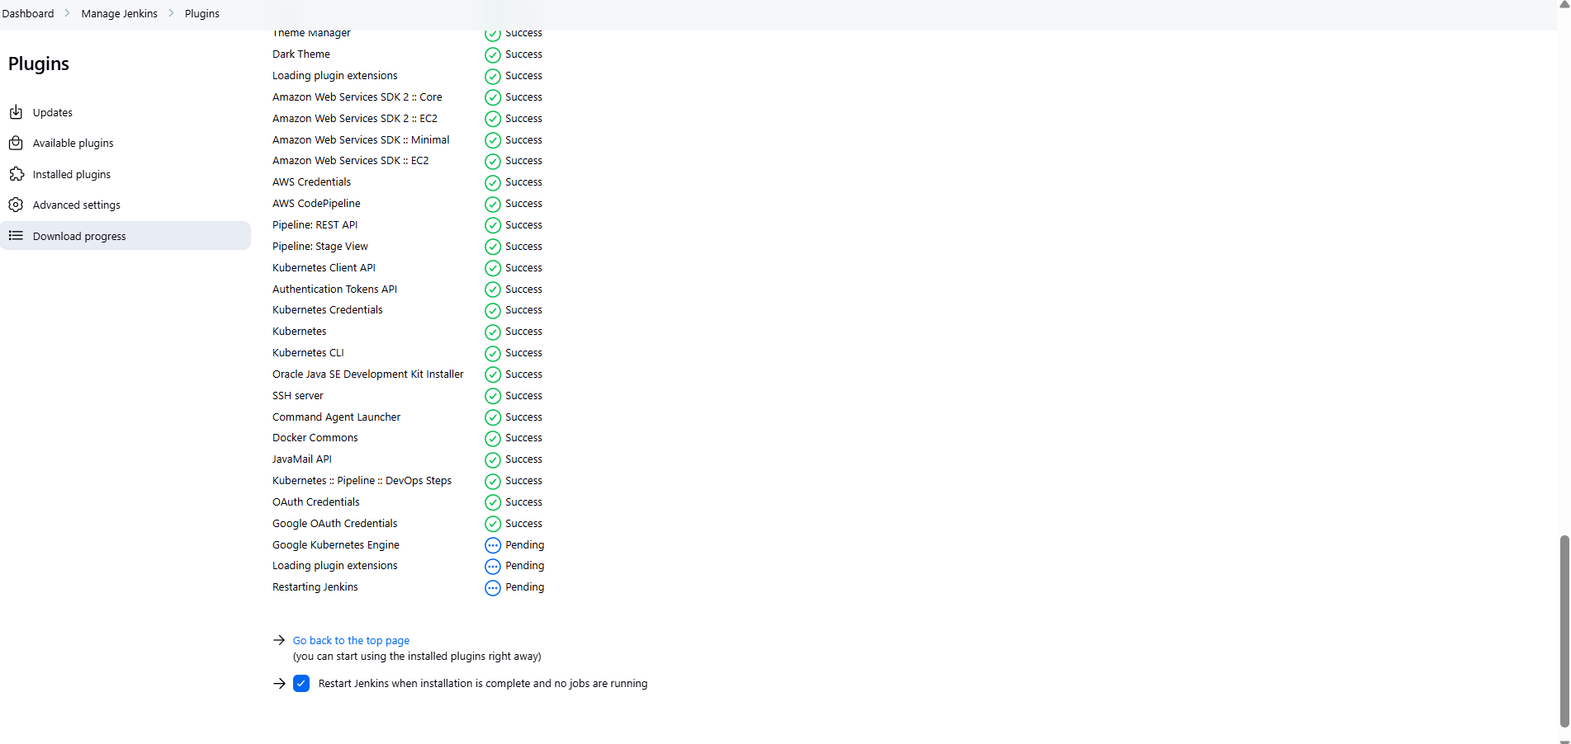

Ping -c 5 google.com >> /tmp/logs.txt

Job run

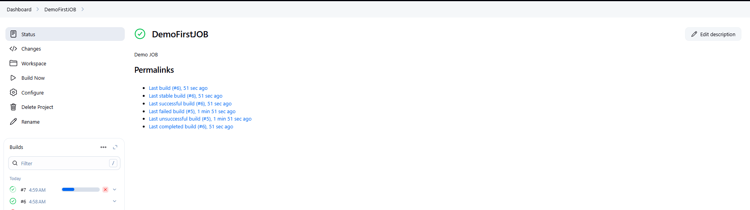

Hello world job

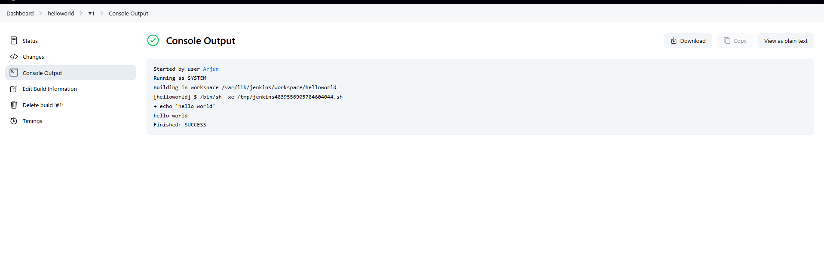

Shutting down Jenkins server

