HW 11 Queries and Screen dumps



Select name from Instructors where CWID = ‘98763’

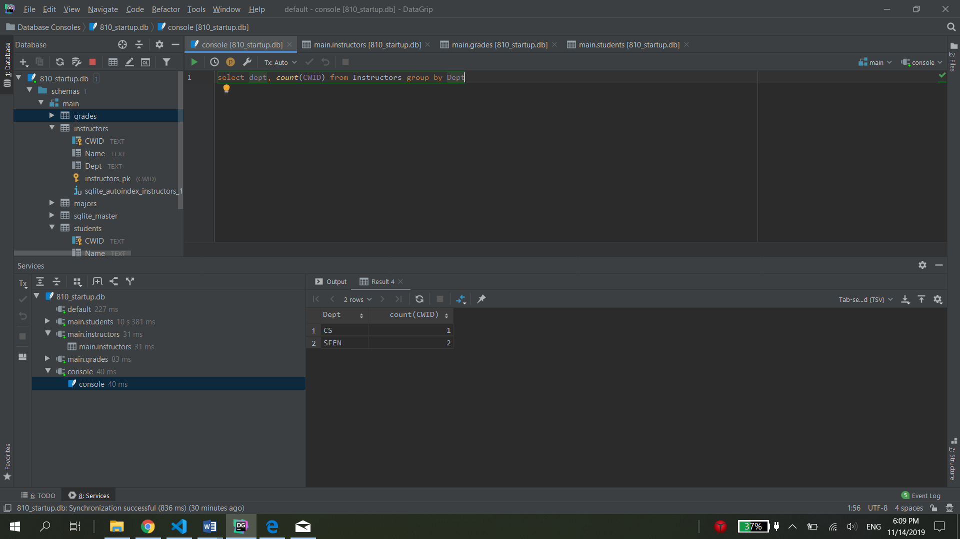

Select dept, count(CWID) from Instructors group by Dept

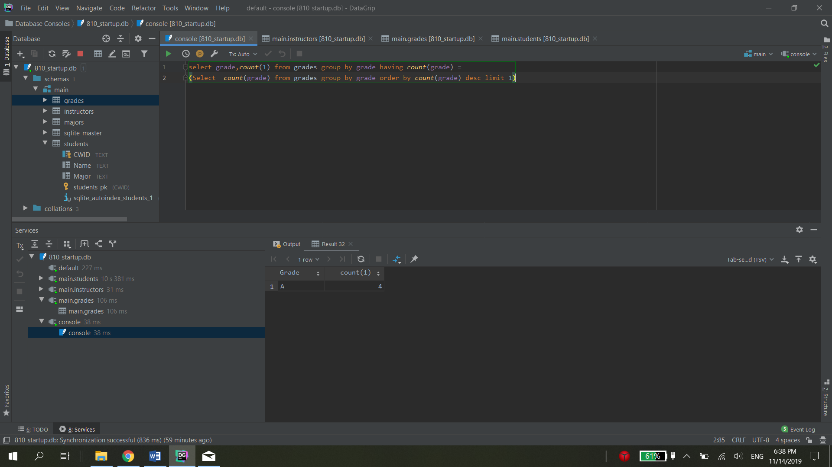

select grade,*count*(1) from grades group by grade having *count*(grade) =  
(Select *count*(grade) from grades group by grade order by *count*(grade) desc limit 1)

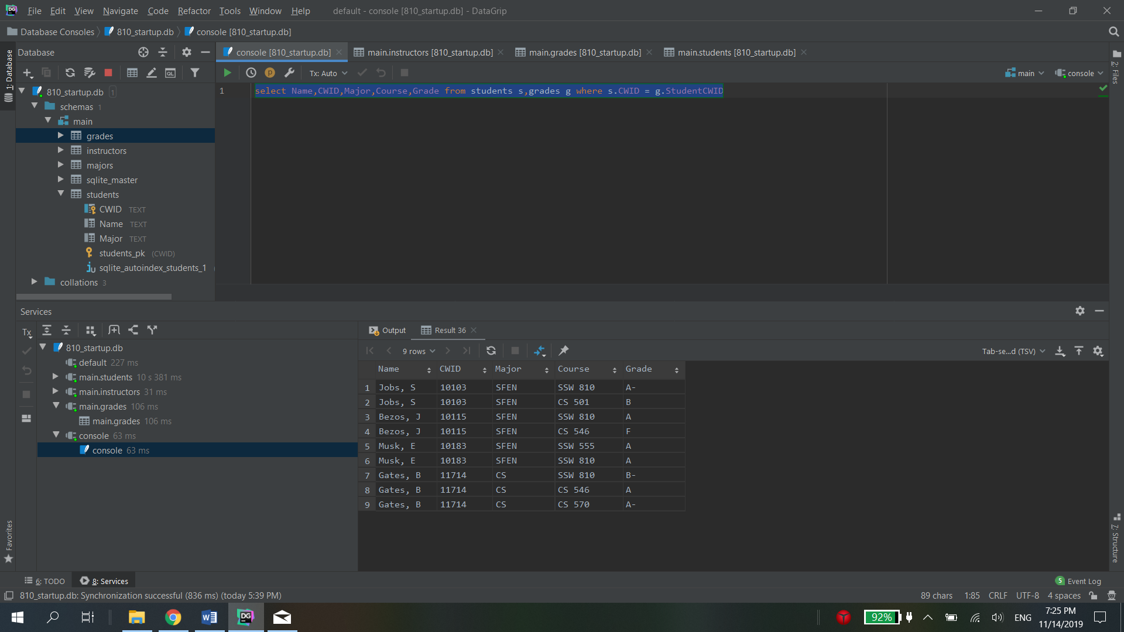

select Name,CWID,Major,Course,Grade from students s,grades g where s.CWID = g.StudentCWID



select Name from students s,grades g where s.CWID = g.StudentCWID and Course = "SSW 810"

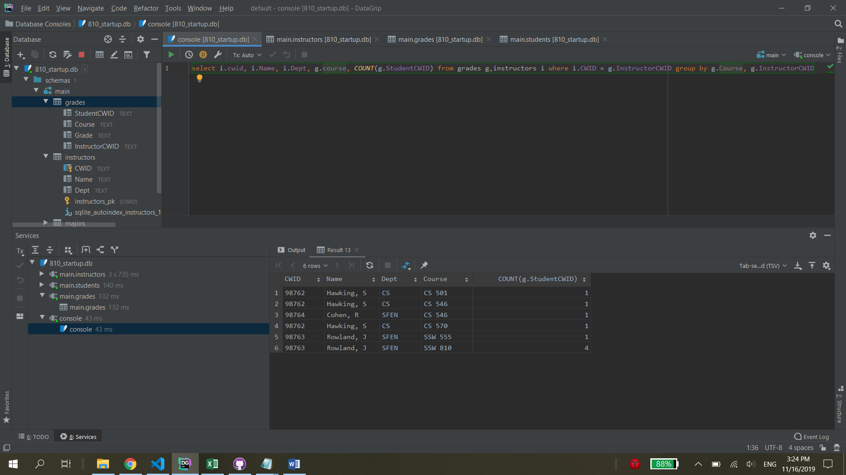

select i.cwid, i.Name, i.Dept, g.course, *COUNT*(g.StudentCWID) from grades g,instructors i where i.CWID = g.InstructorCWID group by g.Course, g.InstructorCWID