Weekly Report
Name: Vasanthan P Month: August
Role: Trainee Developer Date:24/08/2026 to 28/08/2026

Task : Talk Tamila
Description:
- Built and completed the talktamila Influencer page.
- Fully completed the talktamila Freelance page.
- Optimized the codebase by refactoring icons, buttons, and utility functions into standalone reusable assets.
- Refined the admin panel dashboard by updating its mobile and tab responsiveness
Technology:
Frontend: Next js , Tailwind css

Status: Completed
Screenshot:
1)Influeucer page
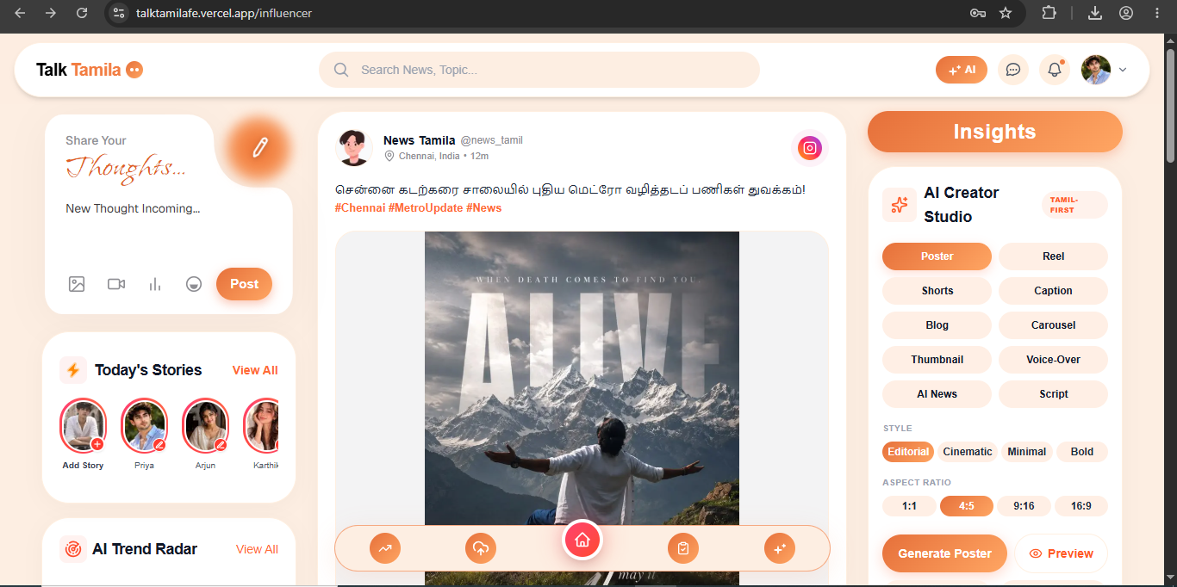

2)Freelance Page
