NEUST-MGT Health Record Management System(HRMS)


AN IT PROJECT

By:
AGUILLON,JOHN PAUL.
CONCEPTION,NEIL BRYAN, B.
DACUMOS,LEAN,B.
UY,JORDAN,V.

December 2024

Approval Sheet

This case study project, entitled NEUST-MGT Health Record Management System, aims to improve the management of student health records by implementing a secure, offline digital platform. Prepared and submitted by the Researchers in partial fulfillment of the requirements for the subject IT Project at NEUST Talavera Off-Campus, this project has been thoroughly examined and is hereby recommended for acceptance and approval as a case study.

Florence A. Flaviano
Instructor

____________________________
Date Signed

Acknowledgement

First and foremost, we would like to express our heartfelt gratitude to God for His unwavering guidance and blessings throughout this project. His presence has been our source of strength and wisdom, enabling us to overcome challenges and achieve our goals.

We extend our deepest appreciation to our mentor, Sir Florence Flaviano, for his invaluable guidance, insightful feedback, and continuous encouragement. His expertise has been instrumental in the successful completion of this project.

Our sincere thanks go to our families, whose constant love, patience, and understanding have provided us with the foundation to focus and persevere. Their support has been the silent strength behind every step of our journey.

To our friends, we are truly grateful for your unwavering support, especially during the tough moments. Your positivity, encouragement, and belief in us have been a great source of motivation. This project is a testament to the collective

efforts of all those who have helped and supported us. We are forever thankful to each and every one of you.

Dedications

This project is dedicated to NEUST-MGT, our university, for providing us with the knowledge, tools, and opportunities that made this work possible. We are truly grateful for the nurturing environment, the resources, and the constant support we have received throughout our academic journey. The guidance and wisdom imparted by our professors have played a significant role in shaping our success and in the completion of this project. NEUST-MGT has been the foundation of our growth, and we will forever carry the lessons learned here as we move forward.

We also wish to dedicate this project to Sir Florence Flaviano, whose patience, wisdom, guidance, and unwavering encouragement have been an invaluable part of this process. Your continuous support, constructive feedback, and belief in our abilities have been a constant source of motivation. Your mentorship has not only contributed to the successful completion of this project but has also greatly shaped our personal and professional growth. For your kindness and dedication, we are deeply thankful.

Finally, we dedicate this work to our friends, whose unwavering encouragement and support have been a source of strength throughout this entire journey. You have stood by us through every challenge, offering words of motivation when things seemed difficult. Your positivity and belief in us made the tough times easier to navigate. This project is not just the result of our efforts, but of the collective encouragement and support we have received from you. Your friendship has made this experience not only successful but deeply fulfilling and rewarding.

Table of Contents

TITLE PAGE …………………………………………………………………………………………… 1
APPROVAL SHEET…………………………………………………………………………………… 2
ACKNOWLEDGEMENT………………………………………………………………3
DEDICATIONS……………………………………………………………………………4
Abstract………………………………………………………………………………… 5
Chapter I: The Problem and Background……………………………………… 7
Introduction………………………………………………………………………………9
Statement of the Problem………………………………………………………… 12
Scope and Delimitations……………………………………………………………13
Significance of the Study………………………………………………………… 14
Definition of Terms…………………………………………………………………15
Project Overview……………………………………………………………………16
Description………………………………………………………………………… 17
Objectives……………………………………………………………………………18
Technical Specifications…………………………………………………………19
Chapter II Review of Related Literature ………………………………………26
Conceptual Framework…………………………………………………………27
Chapter III Materials And Methods …………………………………………… 28
Project Structures………………………………………………………………… 29
Database Design………………………………………………………………… 32
Tables ……………………………………………………………………………… 34
Implications Plan………………………………………………………………… 35
Testing Plan ……………………………………………………………………… 36
Deployment………………………………………………………………………37
Chapter IV Conclusion and Future Recommendations……………………38
Conclusion………………………………………………………………………… 40
Future Recommendations……………………………………………………… 42
Reference…………………………………………………………………………… 44
Curriculum Vitae ……………………………………………………………………4

Abstract

The NEUST-MGT Health Record Management System (HRMS) was developed to modernize and streamline the process of recording, managing, and accessing student health records at the Nueva Ecija University of Science and Technology (NEUST). The system addresses the manual inefficiencies traditionally associated with clinic recordkeeping and provides a structured, secure, and user-friendly platform tailored to meet the needs of both administrative and medical staff. The primary objective of this project is to improve health record accessibility, enhance data accuracy, and enable quick decision-making regarding student health management.

The system employs a role-based access framework, assigning specific permissions to users based on their roles: Admin (Doctors and Nurses) and Staff. Admin users have full access to the system's functionalities, including managing records and generating reports, while Staff are limited to inputting health data from student visits and generating reports. Key features include a student registration form with dropdown menus for courses, year levels, and gender, along with tools for generating and exporting health reports by year level in Excel and Word formats. The database securely stores all health records, with options to categorize students by health status (Healthy or Unhealthy) and include remarks.

Preliminary testing of the system demonstrated its efficiency in reducing manual errors and simplifying health record retrieval. Trends showed improved workflow within the clinic, as staff could quickly input and retrieve data while administrators benefited from streamlined reporting capabilities. The absence of complex metrics, such as BMI, aligns the system with its goal of being accessible and practical for real-world clinic use.

In conclusion, the NEUST-MGT HRMS represents a significant step forward in the university's health management processes, offering a scalable and efficient tool that promotes a healthier campus community.

Chapter 1
Introduction and Its background

Introduction
The Health Record Management System (HRMS) is an advanced digital platform meticulously designed to optimize the management of student health records. By ensuring accuracy, accessibility, and confidentiality, this system aims to replace traditional paper-based methods with a modernized, efficient approach. It empowers healthcare professionals with robust tools to store, retrieve, and analyze patient information, thereby facilitating improved healthcare delivery, enhanced patient outcomes, and minimized operational inefficiencies.

The HRMS serves as a centralized repository for patient data, integrating diverse healthcare processes to streamline medical services and support informed decision-making by healthcare providers. Compliant with privacy and confidentiality regulations, such as the Health Insurance Portability and Accountability, the system ensures the secure recording, storage, retrieval, and sharing of health information. Moreover, it promotes interoperability between healthcare facilities and providers, reducing redundancies, minimizing errors, and elevating the overall quality of patient care.
In addressing persistent challenges in traditional health record management—such as data loss, inefficiencies, and delays in information access—the HRMS provides a transformative solution. It also supports data analytics and reporting, thereby contributing to clinical research, resource allocation, and public health monitoring. This digital innovation is indispensable for healthcare organizations seeking to meet the demands of a dynamic and increasingly patient-centered industry.

This study, conducted under the auspices of the Nueva Ecija University of Science and Technology Talavera MGT Off-Campus, delves into the design, implementation, and implications of the HRMS. It emphasizes its significant contributions to healthcare delivery, operational efficiency, and patient outcomes while exploring potential challenges such as user adoption, data security, and system scalability. The research also provides strategic recommendations for maximizing the system's effectiveness and ensuring its successful integration into healthcare operations.

REVIEW OF RELATED LITERATURE

The Electronic Health Records are electronically-stored health information in a digital format. EHRs are typically shared among healthcare stakeholders and face power failure, data misuse, lack of privacy, security, and audit trail. On the other hand, blockchain is the revolutionary invention of the twentieth century that offers a distributed and decentralized setting to communicate among nodes in a list of networks without a central authority. (2022 A. Mamun, S. Azam, Clémentine Gritti)

Commercial Electronic Health Record (EHR) systems in the U.S. are hospital-centric and are optimized for billing and insurance processes and liability risk management. Operational medicine has completely different medical record requirements, with dynamic and unpredictable environments and a focus on field triage, emergent patient needs, logistical coordination, and ultimately, the efficient transfer of care. The DHS Office of Health Security’s Medical Information Exchange (MIX) and the DHA’s Joint Operational Medicine Information Systems (JOMIS) programs have been exploring EHR solutions which anticipate and support the multilateral collaborations and fluid circumstances of field-based medical care using a no-code (drag and drop) solution that can be tailored to requirements in real time, can scale down to mobile devices, and can retain full functionality even while offline.( 2024 · Thomas M. Wilkinson)

In this framework, all PHRs are protected with multiauthority attribute-based encryption before outsourcing, which solves the key hosting problem and achieves fine-grained access control to PHRs. Furthermore, an anonymous authentication between the cloud and the user is proposed to ensure data integrity on the cloud while not exposing the user’s identity during authentication. The proposed authentication is issued from a new online–offline attribute-based.( 2021 · Leyou Zhang, Yadi Ye, Y. Mu)
The major findings detected the successes and failures of the Manual and Electronic Health Records Management Systems, notwithstanding the overall favourable use. Moreover, the study showed a positive agreement with the seven DeLeon and McLean Model variables that measured user experience. The study recommended that the LASUTH authority needs to consciously work on curbing the concerns that are the root causes of records management challenges and the implementation of records management systems.( 2024 · Richard Olalekan Arogunjo, O. Makinde)

Electronic health records (EHRs), originally designed to facilitate health care delivery, are becoming a valuable data source for health research. EHR systems have two components,
both of which have various components, and points of data entry, management, and analysis. The “front end” refers to where the data are entered, primarily by healthcare workers (2020 · S. Lee, Y. Xu, A. D'souza)

Challenges in implementing electronic health record systems include privacy, security, confidentiality, interoperability, access control, scalability, authentication, accessibility, availability, data storage, data ownership, data validity, data integrity, and ease of use.( 2022 · Iris Cathrina Abacan Pilares, S. Azam, Serkan Akbulut)

The Medical Record Monitoring and Administration System improves data management, lowers mistakes, enhances patient care, and boosts operational efficiency in healthcare businesses.( 2024 · Nikita Ajay Giramkar)

This health record management platform will store the user’s hospital, lab, pharmacy, and insurer records. It will increase the speed of information storing and exchange So that all patients can easily access individual medical records in different hospitals and clinics. This will help doctors and patients with diagnoses and also various insurance companies to check the medical records by getting access to records from the platform and also this will help the researchers and scientists.( 2023 · Urvashi Katile)

Conceptual Framework

OUTPUT
PROCESS
INPUT

Downloadable Reports (Excel, Word)
Student Health Records
Health Status Analysis
Blood Pressure Status
System Access Logs
Data Backup Files
User Authentication & Authorization
Health Record Management
Data Validation & Storage
Blood Pressure Analysis
Report Generation
Role-based Access Control

Student Personal Information
Medical Data (Blood Pressure, Height, Weight)
Course and Academic Details
Emergency Contact Information
Pre-existing Conditions
User Authentication Data

Sta

The conceptual framework for the NEUST-MGT Health Record Management System (HRMS) provides a structured approach to managing student health data, ensuring accuracy, security, and accessibility. The system begins by gathering essential inputs, including personal information, medical data such as blood pressure, height, and weight, academic details, emergency contacts, pre-existing conditions, and user authentication credentials. These inputs are processed through a series of critical operations, such as user authentication, health record management, data validation, blood pressure analysis, and report generation, all governed by role-based access control to maintain security. The outputs include downloadable health reports in Word or Excel, comprehensive health records, health status analyses, system access logs, and secure data backups. By integrating these components, the system not only enhances the management of student health information but also supports informed decision-making and promotes a secure, efficient, and responsive environment for administrators and staff.

STATEMENT OF THE PROBLEM

This study generally aims to develop a offline NEUST-MGT Health Record Management System and solve the problems and issues of the existing manual survey management system of Nueva Ecija University of Science and Technology (NEUST), then to lead the university to a more modern and efficient system, as well as its beneficial significance in the academic community and to its stakeholders.
Specifically, it answers the following questions:
- How may the software application managent system be develop based on incremental model in term of:
- How do IT experts evaluate the technical quality of the developed system based on the following ISO/IEC 25010 Software Quality criteria:
  - Functional Suitability;
  - Performance Efficiency
  - Compatibility;
  - Usability;
  - Reliability;
  - Security;
  - Maintainability; and
  - Portability?
- How do end-users evaluate the functional characteristics of the developed system based on the following ISO/IEC 25010 Software Quality criteria:
  - Functional Suitability;
  - Performance Efficiency; and
  - Usability?

Assessment of the Existing System
The existing system for managing student health records at NEUST-MGT relies primarily on manual or semi-automated processes, which present several limitations and inefficiencies. Currently, health records are documented using paper-based forms or basic digital spreadsheets that lack integration and automation. These methods are prone to human error, duplication, and data loss, which compromise the accuracy and reliability of student health information.

One of the primary challenges faced by the existing system is the time-consuming nature of record retrieval and updating. Staff members must sift through physical files or search through multiple spreadsheets to locate specific records, leading to delays in accessing vital information. Additionally, manual data entry increases the risk of transcription errors, which can result in inaccurate health reports or missed information critical to student care.

Data security is another significant concern in the current system. Physical records are vulnerable to damage, loss, or unauthorized access, while digital spreadsheets offer minimal protection against data breaches or accidental deletion. This lack of robust security measures poses a risk to the confidentiality and integrity of sensitive student health information.

Moreover, the existing system lacks the capability to generate comprehensive health reports efficiently. Staff must manually compile data for reporting purposes, which is both time-intensive and prone to inaccuracies. The inability to generate and export reports in formats such as Microsoft Excel or Word further complicates the administrative workload, making it difficult to provide timely and accurate health summaries.

Overall, the current system is outdated and insufficient to meet the growing needs of the clinic. It impedes the efficiency of health record management, compromises data accuracy and security, and increases the administrative burden on clinic staff. These challenges highlight the urgent need for a modernized, offline Health Record Management System (HRMS) that can streamline data entry, enhance data security, and automate the generation of accurate health reports.

Software Development Life Cycle (SDLC)

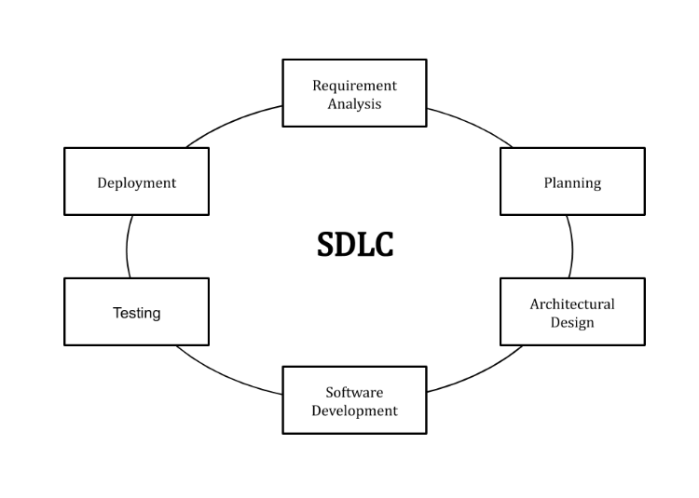
SDLC or the Software Development Life Cycle is a process that produces software with the highest quality and lowest cost in the shortest time possible. SDLC provides a well-structured flow of phases that help an organization to quickly produce high-quality software which is well-tested and ready for production use.

Planning
The development of the NEUST-MGT HRMS began with meticulous project planning to define the purpose and scope. The primary goal was to address the inefficiencies of manual health record management within the university clinic and create a user-friendly digital solution for accurate, accessible, and secure health data storage. Cost estimates, required resources, and timelines were outlined to ensure feasibility. By clearly defining roles for Admin (Doctors and Nurses) and Staff, the planning phase provided a solid foundation for the system.
Requirements & Analysis
This phase involved extensive consultation with clinic staff and administrators to gather requirements for the system. Key functionalities were identified, including student registration, health record categorization (Healthy or Unhealthy), and report generation. Practical limitations, such as the exclusion of complex metrics like BMI, were considered to ensure the system remained accessible and easy to use. Requirements were analyzed to determine compatibility with existing hardware and software infrastructure, and security measures were designed to safeguard sensitive health data.

Architectural Design
The system design focused on simplicity, usability, and scalability. User roles and permissions were mapped out, with a clean and intuitive interface to cater to both Admin and Staff. Dropdown menus for fields such as Course, Year, and Gender were integrated to standardize data entry. Design decisions emphasized practicality, avoiding overly complex workflows. Stakeholder feedback played a crucial role in refining the design to meet clinic-specific needs.
Development
The system was built using a structured approach, dividing the code into manageable modules. Programming languages and frameworks were selected to ensure compatibility and scalability. Features like registration forms, data categorization, and report generation were implemented, and role-based access controls were coded to secure the system.
Testing
The HRMS was rigorously tested to ensure functionality and reliability. Input validation, role-based access, and report generation were among the key components tested. Bugs identified during this phase were promptly fixed to ensure the system met all user requirements. Testing confirmed that the system simplified clinic workflows and improved the accuracy of health records.
Deployment
Once testing was complete, the system was deployed for use in the university clinic. Staff training sessions were conducted to ensure proper usage. A small round of testing followed deployment to resolve any environment-specific issues. The deployment marked the system's transition from development to practical use, enabling the clinic to efficiently manage student health records and generate insightful reports.
By following the SDLC, the NEUST-MGT HRMS achieved high quality and cost-efficiency, providing a robust solution tailored to the needs of the university clinic.

Assessment of Experts
To ensure the effectiveness and reliability of the NEUST-MGT Health Record Management System (HRMS), expert evaluation plays a crucial role in assessing the system’s design, functionality, usability, and overall impact. Feedback from healthcare professionals, IT specialists, and academic mentors provides valuable insights into the strengths and areas for improvement of the system.

Healthcare Professionals' Perspective:
Doctors and nurses, who serve as Admin users in the HRMS, evaluated the system based on its ability to streamline health record management and ensure the accuracy of medical data. Their assessment focused on critical areas such as ease of data entry, record retrieval efficiency, and the system's ability to generate accurate reports. Experts highlighted the improved accuracy in documenting health information and the reduction in manual errors compared to the previous manual system. They praised the offline functionality, emphasizing its value in environments with limited internet access, which ensures uninterrupted access to vital health records.

IT Specialists' Perspective:
IT experts assessed the technical architecture, data security measures, and overall system performance. They examined the database structure, backup procedures, and access control mechanisms. Their evaluation confirmed that the HRMS offers a robust and secure data management environment, with encryption protocols and secure local storage that protect sensitive student health information. They also noted that the user interface was intuitive, making it accessible to both technical and non-technical users.

Academic Mentors' Perspective:
Academic mentors, including project advisers and faculty members, evaluated the system in terms of its alignment with educational goals and IT project standards. They provided feedback on the development process, system documentation, and adherence to best practices in software development. Mentors commended the comprehensive approach taken to address the specific needs of the clinic, particularly the integration of automated reporting features and the ability to export reports in Microsoft Word and Excel formats.
Key Insights from Expert Assessment:

Usability and Efficiency: Experts recognized the HRMS as user-friendly and efficient, reducing the time required for data entry, retrieval, and report generation.
Data Security: IT specialists emphasized the importance of the system's security features, including data encryption and local backups, which effectively safeguard student health information.
Reliability: Healthcare professionals appreciated the offline functionality, ensuring that the system remains operational even without internet access.
Reporting Capabilities: Experts highlighted the automated report generation as a significant improvement, allowing for timely and accurate health status summaries categorized by year level.
Assessment of End-Users:
The success of the NEUST-MGT Health Record Management System (HRMS) hinges on the experiences and feedback of its end-users, including staff members responsible for managing health records and students whose health information is documented. Evaluating the system from the perspective of these users provides critical insights into its usability, functionality, and impact on daily operations.

Staff Users' Perspective:
Staff members, who are primarily responsible for inputting, updating, and managing student health records, have reported a significant improvement in efficiency and accuracy compared to the previous manual system. They highlighted the following key benefits:

Ease of Use: The system's intuitive interface and straightforward data entry process have made it easier for staff to input and update health information without requiring extensive training.
Time-Saving Features: Staff praised the system’s ability to quickly retrieve student records and generate health reports, which has reduced the time spent on administrative tasks and allowed them to focus more on student care.
Error Reduction: The automated validation checks embedded in the system have minimized common data entry errors, ensuring the accuracy of health records.
Students' Perspective:
Although students do not interact directly with the HRMS, they benefit from the streamlined process of health record management. Based on feedback collected through informal surveys and interviews, students have noted:
Improved Access to Health Services: The system's efficient data retrieval has reduced waiting times during clinic visits, allowing students to receive timely medical attention.
Enhanced Accuracy and Privacy: Students expressed confidence in the system's ability to securely manage their health information, ensuring that their personal data remains confidential.

Overall End-User Feedback:

Increased Satisfaction: Both staff and students expressed high levels of satisfaction with the system, noting its positive impact on the overall management of health records.
Operational Reliability: End-users appreciated the system’s offline capability, which ensures continuous functionality even without internet access.
User Support: Users commended the availability of technical support and training during the initial implementation phase, which contributed to a smooth transition from the manual system.

Scope and Delimitations

The NEUST-MGT Health Record Management System (HRMS) is designed to streamline the management of student health records within the NEUST-MGT clinic. It serves as a comprehensive, offline digital platform that enables staff to efficiently input, update, and manage student health information while ensuring data security and accuracy. The system focuses on automating key processes, such as data entry, record retrieval, and report generation, thereby reducing administrative workload and improving the overall efficiency of health services.

Scope:

User Roles and Access Levels: The HRMS includes distinct user roles with specific access privileges. Admin users (Doctors and Nurses) have full access to all system features, including data management, report generation, and administrative control. Staff users can add new records, view existing records, and generate reports but have limited administrative privileges.
Data Management: The system manages essential student health data, including personal information, medical history, and health status. It provides tools for efficient data entry, editing, and retrieval to ensure up-to-date records.
Report Generation: The HRMS can generate health reports categorized by year level (First Year, Second Year, Third Year, and Fourth Year) in formats that include student names, health status (Healthy or Unhealthy), and remarks. Reports can be exported in Microsoft Excel and Word formats for administrative use.
Offline Functionality: The system operates offline, ensuring continuous access to health records even in the absence of internet connectivity. This feature is critical for maintaining uninterrupted health services in areas with limited internet access.

Delimitations:

Limited to NEUST-MGT Clinic Use: The HRMS is specifically designed for the NEUST-MGT clinic and is not intended for use in other departments or external institutions.
Health Record Focus: The system focuses solely on the management of student health records. It does not include features for other types of student data, such as academic performance or financial records.
Platform Compatibility: The system is compatible with desktop and laptop computers, ensuring usability within the clinic environment. It is not designed for mobile devices or web-based access.
No Real-Time Internet Features: As an offline system, the HRMS does not support cloud-based data synchronization or real-time online access. All data is stored locally to enhance security and ensure offline availability.
Limited Customization: While the system allows for basic customization of report formats and data fields, it does not support extensive modifications beyond the predefined scope.

Significance of Study
This System plays a crucial role in modernizing the management of student health records within the NEUST-MGT clinic. It addresses critical challenges in record-keeping by enhancing efficiency, accuracy, and data security. For the institution, the HRMS represents a significant advancement in administrative processes, transitioning from manual systems to a streamlined digital platform. This shift not only ensures better organization and faster data retrieval but also reinforces NEUST-MGT’s commitment to providing quality student health services.

Healthcare staff benefit greatly from the system’s automation features, which reduce the time spent on administrative tasks such as data entry and report generation. By minimizing errors and ensuring quick access to records, the HRMS allows staff to focus more on delivering timely and accurate healthcare. The offline functionality further ensures that the clinic remains operational even without internet access, enhancing the reliability of healthcare services.

Students also gain from the improved efficiency of the system. Faster access to accurate health records enables them to receive timely medical attention, enhancing their overall healthcare experience. Additionally, the system guarantees the confidentiality of their health information, fostering trust in the management of their personal data.

The System is not only a practical solution for NEUST-MGT but also a model for leveraging offline digital solutions in environments with limited internet connectivity. It demonstrates the potential for technology to enhance operational efficiency in healthcare settings while ensuring robust data security. Furthermore, the system serves as a valuable case study for future researchers and IT students, offering insights into system development, user feedback integration, and data security protocols.

Definition of Terms
The Definition of Terms section provides clear explanations of key acronyms, technical terms, and operational terms used in the NEUST-MGT Health Record Management System (HRMS). This ensures a comprehensive understanding of the terms relevant to the system's development, implementation, and functionality.

1. Acronyms:
HRMS: Health Record Management System – The primary system used for managing student health records within NEUST-MGT.
NEUST-MGT: Nueva Ecija University of Science and Technology – Municipality Government of Nueva Ecija The academic institution where the HRMS is implemented.
IT: Information Technology – Refers to the use of computers, software, and networks for managing information and systems.
SQL: Structured Query Language – A programming language used to manage and manipulate the database within the HRMS.
GUI: Graphical User Interface – The visual interface that users interact with in the HRMS.
2. Technical Terms:
Database: A structured collection of data stored electronically, used in the HRMS to store student health records securely.
Data Encryption: A method used to protect sensitive information by converting it into a secure format, ensuring data privacy within the system.
Offline System: A system that can function without an active internet connection, ensuring continuous availability of the HRMS.
User Roles: Different levels of system access assigned to users based on their roles, such as Admin (Doctors and Nurses) and Staff (Health record input).
Generate Report: The process of compiling and organizing health data into structured reports, categorized by year levels (First Year, Second Year, Third Year, Fourth Year), including health status and remarks.
3. Operational Terms:
Admin User: Refers to Doctors and Nurses who have full access to all system functionalities, including data management and report generation.
Staff User: Refers to clinic staff who have limited access, primarily responsible for adding records, viewing records, and generating reports.
Student Health Record: The comprehensive file that contains a student’s health history, medical conditions, and visit records within the clinic.
Healthy/Unhealthy Status: The classification used in the system to indicate the current health condition of a student, based on clinical assessment.
Remarks: Additional notes or observations recorded by clinic staff or medical professionals regarding a student's health status.

Role-Based Access Control (RBAC): A security feature that restricts or grants system access based on the user’s assigned role (Admin or Staff).

Log In/Log Out: The process by which users authenticate their identity to access or exit the system, ensuring secure access control based on user roles.

Search: A feature that allows users to locate specific student health records quickly by entering relevant search criteria such as name, personal contact or student ID.

Project Overview
Description
The NEUST-MGT Health Record Management System (HRMS) is a digital platform designed to improve the management of student health records at the Nueva Ecija University of Science and Technology - Management. The system addresses the need for efficient, secure, and organized health record handling within the campus clinic. It replaces traditional manual methods with an automated system that enhances data accuracy, reduces administrative workload, and ensures timely access to critical health information.

This offline system operates independently of internet connectivity, ensuring continuous availability even in environments with limited or no internet access. It is specifically designed for use on desktop and laptop computers, making it highly compatible with the existing infrastructure of the NEUST-MGT clinic. The HRMS supports key functionalities such as adding new health records, updating existing information, and generating detailed health reports categorized by student year levels. These reports can be exported in Microsoft Excel and Microsoft Word formats, providing flexibility in data management and reporting.

The system distinguishes between two primary user roles: Admin Users (Doctors and Nurses) and Staff Users. Admin Users have full access to all system features, including data management, report generation, and administrative functions. Staff Users have limited access, focusing on adding records, viewing health data, and generating reports. This role-based access ensures data security and maintains the integrity of sensitive health information.

The HRMS not only enhances the operational efficiency of the clinic but also contributes to the overall well-being of students by providing timely and accurate health services. It serves as a valuable tool for the university, healthcare staff, and students alike, demonstrating the practical application of technology in improving institutional processes. This project exemplifies how offline digital solutions can be effectively implemented to meet the specific needs of educational institutions, particularly in the area of health record management.

Objectives

The System aims to address key challenges in managing student health records by providing a streamlined, efficient, and secure digital platform. The system’s development is guided by the following objectives:

Objective 1: Enhance Efficiency in Health Record Management
To automate the collection, storage, and retrieval of student health records, reducing the time and effort required for manual data handling. This ensures faster access to accurate information, enabling clinic staff to focus more on delivering quality healthcare services.

Objective 2: Ensure Data Accuracy and Security
To minimize errors in health record management by implementing validation mechanisms and secure data storage. The system aims to protect sensitive student health information through data encryption and role-based access control, ensuring confidentiality and data integrity.

Objective 3: Provide Offline Functionality for Continuous Access
To develop a system that operates effectively without the need for internet connectivity, ensuring that health records are accessible at all times, even in areas with limited or no internet access. This guarantees uninterrupted service and reliable data management.

Objective 4: Facilitate Comprehensive Reporting and Data Analysis
To enable the generation of detailed health reports categorized by student year levels (First Year, Second Year, Third Year, Fourth Year), including health status and remarks. The system will allow users to export reports in Microsoft Excel and Word formats for administrative use, aiding in data analysis and decision-making.

These objectives collectively aim to enhance the operational efficiency of the NEUST-MGT clinic, improve the quality of student healthcare, and ensure the secure handling of sensitive health data.

CHAPTER II
METHODOLOGY

Technical Specifications
Technologies Used
• Backend: Python, Flask
• Database: SQLite
• Frontend: HTML, CSS, JavaScript
Environment Setup
1. Install Python:
Ensure Python 3.13.0 is installed.
2. Create Virtual Environment:
python -m venv venv
3. Activate Virtual Environment:
o On Windows:
venv\Scripts\activate
4. Install Flask:
pip install Flask
5. Install SQLite (if needed).

Database Design
The database design for the NEUST-MGT Health Record Management System (HRMS) is implemented through the init_db function, which sets up the essential structure of the database, ensuring that the required tables are created and ready for use. This function plays a critical role in establishing the foundational components of the system, including the creation of tables for storing health records and managing user authentication and access control.
The health_records table is the cornerstone of the database design. This table is specifically designed to hold comprehensive health information for each student. It includes columns such as id (primary key), name, age, dob (date of birth), gender, course, year, class_section, and contact_info, which capture basic personal and academic details. Additionally, the table stores medical-specific columns, such as pre_existing_conditions, current_medications, recent_hospitalizations, and food_allergies, which help track the student's health history and specific conditions. It also includes height, weight, and blood_pressure to monitor key health metrics, while the student_id column links each record to the corresponding student, ensuring data consistency and integrity across the system. The created_at timestamp column automatically records when each health record was added, which is useful for audit and tracking purposes.
This table’s design is crucial because it consolidates all relevant health data into a single location, making it easier for authorized staff to access and update student records efficiently. The use of a primary key (id) ensures that each health record is uniquely identifiable, which is important for preventing duplication and maintaining the accuracy of the information. The foreign key student_id can be used to relate the health records to the Students table in a more extensive system where personal details and health history are kept separate.
The users table, on the other hand, serves an important role in managing user authentication and system access. This table is designed to securely store user credentials and roles, ensuring that only authorized personnel can access sensitive health information. The columns in this table include id (primary key), username, password, email, and role. The role column is particularly important because it distinguishes between different types of users, such as administrators, medical staff, and other support personnel. By assigning roles like ‘admin’, ‘user’, or ‘staff’, the system ensures that different users have appropriate levels of access, preventing unauthorized changes to critical health records.
The init_db function also utilizes the SQLite library to connect to the database and ensure that these tables are created if they do not already exist. This functionality is vital during the initial setup of the HRMS system, ensuring that the database is properly initialized and all necessary tables are in place before any operations can be carried out. The CREATE TABLE IF NOT EXISTS SQL statements ensure that the system is resilient, avoiding errors in the event that the database already exists or the tables have already been created. This provides a smooth setup process, as it avoids redundant attempts to recreate tables that are already part of the database.
Additionally, the function’s use of SQLite allows for portability, simplicity, and ease of integration with other parts of the HRMS. By leveraging SQLite’s capabilities, the database remains lightweight while still offering the necessary functionality to support health record management and user authentication.
In terms of database normalization, this design aligns with best practices by minimizing data redundancy and ensuring the integrity of each entity. The use of separate tables for health records and user management ensures that each type of data is stored in its most appropriate format, making it easier to update and query specific records without affecting other parts of the system. This separation also simplifies future modifications or expansions of the system, as new functionalities can be added without disrupting the existing design.
The init_db function, by ensuring the creation of these essential tables, establishes the HRMS database structure in a way that is scalable, efficient, and easy to maintain. By adhering to solid database design principles, such as defining clear relationships between tables, using primary and foreign keys, and applying normalization rules, the function ensures that the system will be able to handle large volumes of student health data securely and efficiently as it grows. This design also guarantees that authorized users can access and update information in a controlled environment, safeguarding sensitive health records while supporting the operational needs of the HRMS.

Chapter III
RESULTS AND DISCUSSION

Project Structure

/NEUST_MGT_HRMS
│
├── app.py # Main application file
├── create_users_table.py # Database models
├── user_db.py # Database models
├── init_db.py
├── word_template_generator.py # Route definitions
├── templates/ # HTML templates
│ ├── add_record.html
│ ├── delete_record.html
│ ├── generate_report.html
│ ├── index.html
│ ├── login.html
│ ├── register.html
│ ├── update_record.html
│ ├── view_record.html
│ ├── view_records.html
├── static/ # Static files (CSS, JS, images)
│ ├── style.css
└── user.db

Database Design
ERD

This figure shows how tables in a database are connected. It illustrates the relationships between entities, making it easier to understand the database structure.
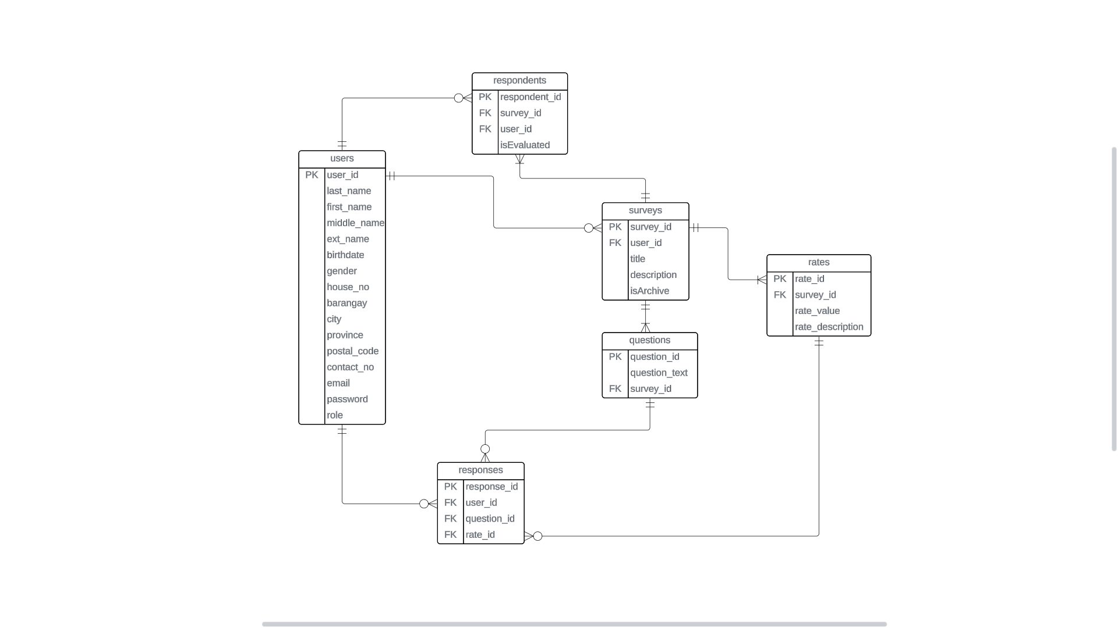

Data Flow Diagram(DFD)
This figure visually represents how data moves through a system, highlighting processes, data flows, data stores, and external entities. It helps identify inputs, outputs, and relationships within the system, making it a valuable tool for understanding and analyzing complex systems.
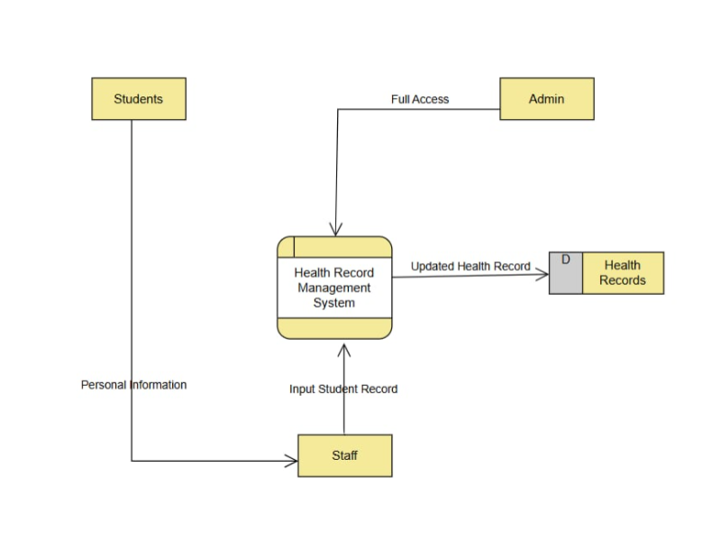
DFD Level 0

DFD Level 1

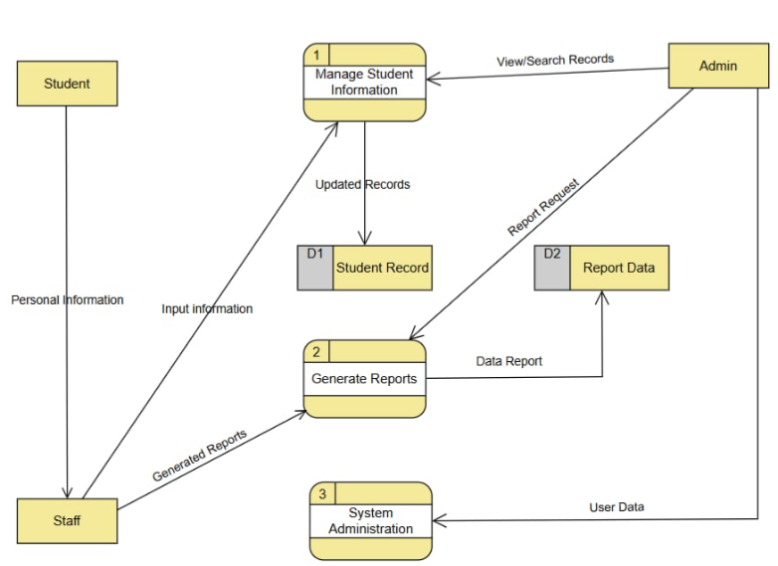

Use Case
The figure shows a Use Case Diagram that illustrates user privileges and interactions within a system, helping to clarify how users can engage with the system to achieve their goals.

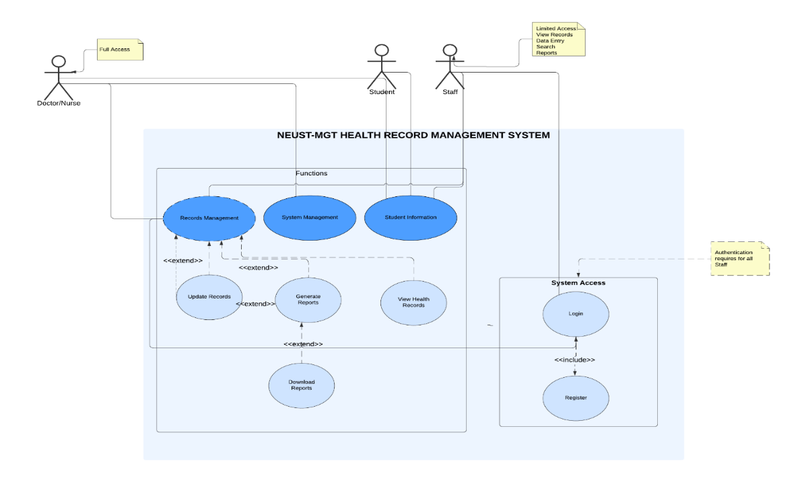

TABLES:

health_records Table:
- id: Unique identifier for each health record, used to reference records in queries and updates.
- name: The full name of the individual whose health record is being stored.
- age: The age of the individual, used for demographic analysis and health assessments.
- dob: Date of Birth, used to calculate age and verify identity.
- sex: Sex of the individual, used for demographic analysis and personalized health recommendations.
- course: The course or program the individual is enrolled in, used for academic and health record integration.
- year: Academic year of the individual, used to track progress and eligibility for certain health programs.
- class_section: Specific class or section the individual belongs to, used for organizing records and group-specific health initiatives.
- contact_info: Contact information for the individual, used for communication and notifications.
- emergency_contact: Contact details for emergencies, used to reach out in case of health incidents.
- email: Email address of the individual, used for notifications and account verification.
- pre_existing_conditions: Health conditions that existed before the current health assessment, used for risk assessment and treatment planning.
- current_medications: Medications currently being taken, used to avoid drug interactions and manage treatment plans.
- recent_hospitalizations: Information about recent hospital visits, used for ongoing treatment and follow-up care.
- food_allergies: Allergies to specific foods, used to prevent allergic reactions and plan dietary requirements.
- Height: Recorded to monitor growth and assess physical development.
- Weight: Recorded to track changes in health and overall physical condition.
- blood_pressure: Blood pressure readings, used to assess cardiovascular health and manage hypertension.
- student_id: Unique identifier for students, used to link health records with academic records.
- created_at: Timestamp of when the record was created, used for record-keeping and auditing.

users Table:
- id: Unique identifier for each user, used to manage user accounts and permissions.
- username: Unique username for login, used for authentication and user identification.
- password: Encrypted password for account security, used for authentication.

CHAPTER IV
SUMMARY, CONCLUSIONS, AND RECOMMENDATIONS
SUMMARY
The NEUST Health Record Management System Municipalitay Government of Talavera(HRMS-MGT) was developed to address challenges in managing student health records at the Nueva Ecija University of Science and Technology (NEUST). Its primary goal is to provide a digital platform for the efficient collection, storage, and analysis of student health data while ensuring data accuracy, security, and accessibility. The system simplifies the management of health metrics, including height, weight, and blood pressure, alongside academic and personal details. Role-based access control ensures that data remains confidential, with specific permissions for administrative and medical staff.

Designed with a user-friendly interface, the HRMS allows for seamless data entry, validation, and the generation of health status reports. It is deployed on a scalable cloud-based platform, ensuring reliable access for authorized users from any location. Key deliverables include a fully operational system with downloadable reports in Excel and Word formats, comprehensive documentation for setup and maintenance, and robust security protocols. The HRMS enhances operational efficiency, supports informed decision-making, and promotes student well-being, creating a healthier and more responsive university environment. With its flexible design, the system is well-positioned for future enhancements to meet evolving institutional needs.
Conclusion
The NEUST Health Record Management System (HRMS) was developed to address challenges in managing student health data and ensuring efficient communication between students and the university's medical staff at Nueva Ecija University of Science and Technology. The system provides a secure, digital platform for collecting and managing health records, streamlining operations, and enhancing the institution's ability to monitor and analyze student health trends. The HRMS has successfully demonstrated its value in improving data accuracy, operational efficiency, and the overall responsiveness of health services.

The development process underscored the importance of a user-friendly interface, robust data validation, and the seamless integration of various components, including health record management, secure storage, and report generation. Deploying the system on a reliable platform highlighted the advantages of cloud-based solutions for accessibility and scalability, ensuring smooth user experiences and consistent availability of critical health information.

Ultimately, the HRMS has shown the potential of technology to enhance health management processes, providing significant benefits to the university's medical operations and supporting the well-being of students.

Recommendations
Building on the findings and achievements of the HRMS, the following recommendations are proposed for future development and research:

System Integration: Enhance the HRMS by integrating it with other institutional systems, such as the student information system or human resource management system, to create a unified platform for health and administrative data.
Advanced Analytics: Develop advanced analytics and reporting features to enable detailed health trend analysis and data-driven decision-making.
Mobile Accessibility: Create a mobile application version of the HRMS to allow medical staff and administrators to access and manage health records on the go, enhancing convenience and usability.
Artificial Intelligence and Automation: Explore the use of AI and machine learning to automate data analysis, predict health risks, and improve the efficiency of routine tasks within the system.
Impact Studies: Conduct further research to evaluate the impact of the HRMS on institutional decision-making, student health outcomes, and stakeholder engagement, providing deeper insights into its long-term benefits and effectiveness.

References

Lin, W., Chen, J., Chiang, M., & Hribar, M. (2020). Applications of Artificial Intelligence to Electronic Health Record Data in Ophthalmology. Translational Vision Science & Technology, 9. https://doi.org/10.1167/tvst.9.2.13.

Berdahl, C., Moran, G., McBride, O., Santini, A., Verzhbinsky, I., & Schriger, D. (2019). Concordance Between Electronic Clinical Documentation and Physicians’ Observed Behavior. JAMA Network Open, 2. https://doi.org/10.1001/jamanetworkopen.2019.11390.

Adeghe, E., Okolo, C., & Ojeyinka, O. (2024). A review of emerging trends in telemedicine: Healthcare delivery transformations. International Journal of Life Science Research Archive. https://doi.org/10.53771/ijlsra.2024.6.1.0040.

Hershey, D., Buzanoski, D., Rayamajhi, S., & Murray, D. (2024). Reevaluating Value-Based Care in Telemedicine: Clinical Opportunities in the Postpandemic Era.. Telemedicine journal and e-health : the official journal of the American Telemedicine Association. https://doi.org/10.1089/tmj.2024.0523.

Cordato, D., Shad, K., Soubra, W., & Beran, R. (2023). Health Research and Education during and after the COVID-19 Pandemic: An Australian Clinician and Researcher Perspective. Diagnostics, 13. https://doi.org/10.3390/diagnostics13020289.

Ye, J., Woods, D., Jordan, N., & Starren, J. (2024). The role of artificial intelligence for the application of integrating electronic health records and patient-generated data in clinical decision support.. AMIA Joint Summits on Translational Science proceedings. AMIA Joint Summits on Translational Science, 2024, 459-467 .

Alsadoun, L., Ali, H., Mushtaq, M., Mushtaq, M., Burhanuddin, M., Anwar, R., Liaqat, M., Bokhari, S., Hasan, A., & Ahmed, F. (2024). Artificial Intelligence (AI)-Enhanced Detection of Diabetic Retinopathy From Fundus Images: The Current Landscape and Future Directions. Cureus, 16. https://doi.org/10.7759/cureus.67844.

Gu, C., & Lee, M. (2024). Deep Transfer Learning Using Real-World Image Features for Medical Image Classification, with a Case Study on Pneumonia X-ray Images. Bioengineering, 11. https://doi.org/10.3390/bioengineering11040406.

Borna, S., Maniaci, M., Haider, C., Maita, K., Torres-Guzman, R., Avila, F., Lunde, J., Coffey, J., Demaerschalk, B., & Forte, A. (2023). Artificial Intelligence Models in Health Information Exchange: A Systematic Review of Clinical Implications. Healthcare, 11. https://doi.org/10.3390/healthcare11182584.

Alruwaili, F. (2020). Artificial intelligence and multi agent based distributed ledger system for better privacy and security of electronic healthcare records. PeerJ Computer Science, 6. https://doi.org/10.7717/peerj-cs.323.

Olson, E., Rushnell, C., Khan, A., Cunningham, K., Allen, B., Fox, S., Sing, R., & Sachdev, G. (2021). Emergency medicine residents spend over 7.5 months of their 3‐year residency on the electronic health record. AEM Education and Training, 5. https://doi.org/10.1002/aet2.10697.

Graham, T., Ali, S., Avdagovska, M., & Ballermann, M. (2020). Effects of a Web-Based Patient Portal on Patient Satisfaction and Missed Appointment Rates: Survey Study. Journal of Medical Internet Research, 22. https://doi.org/10.2196/17955.

Atasoy, H., Greenwood, B., & McCullough, J. (2019). The Digitization of Patient Care: A Review of the Effects of Electronic Health Records on Health Care Quality and Utilization.. Annual review of public health, 40, 487-500 . https://doi.org/10.1146/annurev-publhealth-040218-044206.

Rumlow, Z., Almodallal, Y., Zimmerman, M., Miner, R., Asbury, R., Knake, L., & Schmitz, A. (2024). The Impact of Diagnosis-Specific Plan Templates on Admission Note Writing Time: A Quality Improvement Initiative.. Journal of graduate medical education, 16 5, 581-587 . https://doi.org/10.4300/jgme-d-24-00087.1.

Moy, A., Schwartz, J., Chen, R., Sadri, S., Lucas, E., Cato, K., & Rossetti, S. (2021). Measurement of clinical documentation burden among physicians and nurses using electronic health records: a scoping review. Journal of the American Medical Informatics Association : JAMIA, 28, 998 - 1008. https://doi.org/10.1093/jamia/ocaa325.

Published Mar 15, 2020 · Rafael Mesquita, I. Edwards https://consensus.app/papers/systematic-literature-review-of-my-health-record-system-mesquita-edwards/27f0fde97e17569ba1df2dfbeb7d5e6a/?extracted-answer=The+My+Health+Record+%28MyHR%29+system+has+reduced+health+information+fragmentation+but+there+is+insufficient+evidence+to+prove+its+effectiveness+in+improving+access+to+information+and+coordinating+care.&q=health+record+management+system+topic&pro=on

Published Sep 2, 2024 · Salvatore D'Antonio, Jonah Giglio, Giovanni Mazzeo, Federica Uccello, Teresa Mannarino https://consensus.app/papers/enhancing-healthcare-data-confidentiality-through-dantonio-giglio/fca149321dc6521c84bb6491e8f272aa/

Published May 26, 2022 · Iris Cathrina Abacan Pilares, S. Azam, Serkan Akbulut, M. Jonkman, Bharanidharan Shanmugam https://consensus.app/papers/addressing-the-challenges-of-electronic-health-records-pilares-azam/2e99e11f01fe59ec801c09310bbfc42c/?extracted-answer=Challenges+in+implementing+electronic+health+record+systems+include+privacy%2C+security%2C+confidentiality%2C+interoperability%2C+access+control%2C+scalability%2C+authentication%2C+accessibility%2C+availability%2C+data+storage%2C+data+ownership%2C+data+validity%2C+data+integrity%2C+and+ease+of+use.&q=Challenges+in+implementing+electronic+health+record+systems&pro=on

Published Jun 29, 2024 · Nikita Ajay Giramkar https://consensus.app/results/?q=Medical%20Record%20Monitoring%20an%20Administration%20System&pro=on

2022 · Iris Cathrina Abacan Pilares, S. Azam, Serkan Akbulut https://consensus.app/papers/the-use-of-electronic-health-records-to-support-population-kruse-stein/a8f7ae1a33fa50a8af22dbca58bfb103/?extracted-answer=Electronic+health+records+%28EHRs%29+can+improve+quality+and+efficiency+of+healthcare%2C+and+support+public+health+with+more+facilitators+than+barriers.&q=Electronic+health+records+%28EHRs%29%2C&pro=on

2024 · Richard Olalekan Arogunjo, O. Makinde https://consensus.app/papers/evaluation-of-health-records-management-systems-of-lagos-arogunjo-makinde/72d74e774819520e8ebd10aa5314274f/?extracted-answer=Manual+and+Electronic+Health+Records+Management+Systems+at+LASUTH+have+both+successes+and+failures%2C+but+overall+have+favourable+use.&q=Manual+and+Electronic+Health+Records+Management+Systems&pro=on

Published Dec 7, 2020 · Aykut M. Uslu, J. Stausberg https://consensus.app/papers/value-of-the-electronic-medical-record-for-hospital-care-uslu-stausberg/1453738f92455337a9731087eab59598/?extracted-answer=Electronic+health+records+systems+offer+economic+advantages%2C+such+as+cost+reduction+%2856%25%29%2C+and+improvements+in+quality+of+care+%2878%25%29.&q=What+are+the+advantages+of+electronic+health+records+systems%3F&pro=on

Published 2022 · Alaa Haddad, M. Habaebi, M. R. Islam https://consensus.app/papers/systematic-review-on-aiblockchain-based-ehealthcare-haddad-habaebi/5b5858d6403051a794c7e6bb4cac4cb4/?extracted-answer=Blockchain+technology+has+the+potential+to+deliver+decentralization%2C+security%2C+and+privacy+that+are+frequently+lacking+in+traditional+EHRs.&q=The+Electronic+Health+Records+are+electronically-stored+health+information+in+a+digital+format.+EHRs+are+typically+shared+among+healthcare+stakeholders+and+face+power+failure%2C+data+misuse%2C+lack+of+privacy%2C+security%2C+and+audit+trail.+On+the+other+hand%2C+blockchain+is+the+revolutionary+invention+of+the+twentieth+century+that+offers+a+distributed+and+decentralized+setting+to+communicate+among+nodes+in+a+list+of+networks+without+a+central+authority.+%282022+A.+Mamun%2C+S.+Azam%2C+Cl%C3%A9mentine+Gritti%29&pro=on

Published Apr 24, 2024 · Saniya Saratkar, Meher Langote, Aarti Chaudhari https://consensus.app/papers/enhancing-healthcare-incorporating-blockchain-into-saratkar-langote/20916998be2b5627a330069dedc0f81f/?extracted-answer=Blockchain+technology+can+revolutionize+electronic+health+record+systems+by+addressing+issues+with+data+management%2C+security%2C+and+integrity.&q=Enhancing+Healthcare%3A+Incorporating+Blockchain+into+Electronic+Health+Records&pro=on

Published Feb 17, 2023 · R. Sonkamble, A. Bongale, Shraddha P. Phansalkar https://consensus.app/papers/secure-data-transmission-of-electronic-health-records-sonkamble-bongale/6569cdda3d6e53e5a70928b1f8abae2d/?extracted-answer=The+proposed+patient-centered+healthcare+data+management+%28PCHDM%29+framework+with+blockchain+technology+addresses+confidentiality%2C+access+control%2C+and+privacy+of+record+in+electronic+health+records.&q=Secure+Data+Transmission+of+Electronic+Health+Records+Using+Blockchain+Technology&pro=on

Published Aug 10, 2022 · Brian Orwa https://consensus.app/papers/management-of-medical-records-for-better-healthcare-orwa/91fa4bfd672d5af5b74413dbec84ae57/?extracted-answer=Health+record+management+systems+ensure+that+patient+medical+records+are+created%2C+maintained%2C+confidential%2C+secured%2C+and+retrieved+easily+for+better+healthcare+service+delivery.&q=importance+of+health+record+management+system&pro=on

Published Apr 10, 2021 · A. Tapuria, Talya Porat, D. Kalra, Glen L. Dsouza, Xiaohui Sun, V. Curcin https://consensus.app/papers/impact-of-patient-access-to-their-electronic-health-record-tapuria-porat/9988e452694d567cbe6707d5a7551f6c/?extracted-answer=Benefits+of+electronic+health+record+systems+include+reduced+anxiety%2C+improved+consultations%2C+better+doctor-patient+relationships%2C+increased+awareness+and+adherence+to+medication%2C+and+improved+patient+outcomes.&q=What+are+the+benefits+of+electronic+health+record+systems%3F&pro=on


JORDAN ALLEN VILLA UY
Email: uy.jordanallen08@gmail.com
Address: 759 Purok 3 Baloc Sto. Domingo Nueva Ecija
Mobile: 0926-140-0885

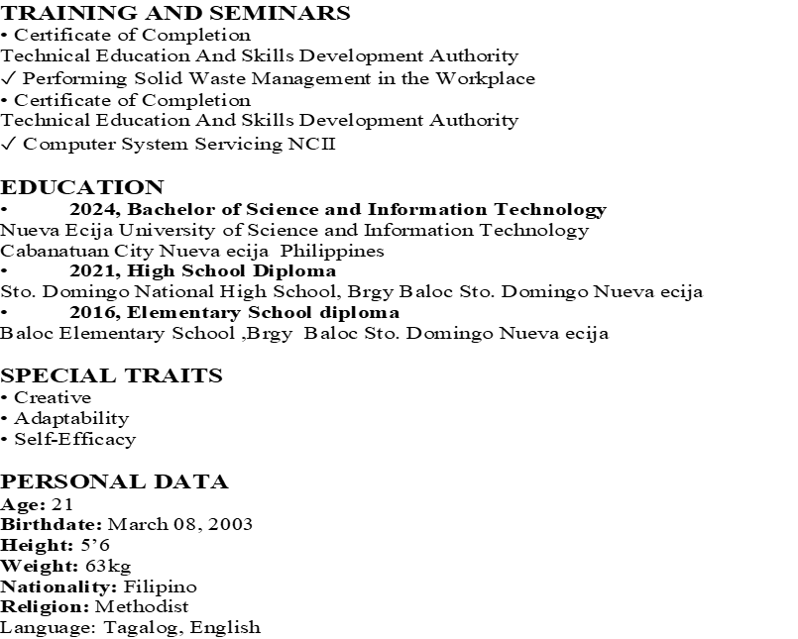


Name: Neil Bryan Concepcion
Email: concepcionneilbryan814@@gmail.com
Address: PulongBuli Sto. Domingo Nueva Ecija
Mobile: 0975-097-5448

Career Objectives
SKILLS
• Highly Responsible And Reilable
• Great Communication
• Good in Time Management
• Works well under preassure
EDUCATION
COLLAGE: Bachelor Of Comunication and Information Technology
NEUST SUMACAB CAMPUS
SECONDARY: Solomon Excelence Academy
S.Y: 2019-2020
ELEMENTARY: Sto.Domingo Central School
S.Y: 2014-2015

PERSONAL DATA
Age: 22
Birthdate: October 28, 2002
Height: 5’5
Weight: 40kg
Nationality: Filipino
Religion: Catholic

