Program:

import java.util.*;

class Main
{
public static void main(String args[])
{
Scanner nameai = new Scanner(System.in);
System.out.println("Hello...user.. \n please give a name...for me");
String ainame = nameai.nextLine(); // taking the name of ai form user
Scanner namemy = new Scanner(System.in);
System.out.println("Oh..ok..my name is "+ainame+"\n...nice..and thank you❤🌹😊..\n May i know your name?");
String myname = namemy.nextLine();//taking the user for user by using scanner object
System.out.println("Hm..so my name is "+ainame+" "+"and your's is"+" "+myname);
System.out.println(" ");
int loop = 0; // here the we have started the loop and we give as the line
System.out.println("What do you like to do? "+myname);
System.out.println(" ");
do{ // printing the this message for user to make understand what this program contains
System.out.println("1 for Calculate");
System.out.println("2 for Play game");
System.out.println("3 for Nothing");
Scanner choose = new Scanner (System.in);
String option = choose.nextLine();
String option1 = option.toLowerCase();
switch(option1){ // do the function which enterd by the user
case "1" : // for 1 do the calucation part of user entere numbers
System.out.println("So you want me to Calculate?..Ok, as you wish. \ntell me the first number:");
Scanner number = new Scanner(System.in);
int x = number.nextInt(); // taking the frist no from user
System.out.println("Now, give me the second number:");
int y = number.nextInt(); // taking the second no from user
System.out.println("Which operation do you want to choose?");
System.out.println("1 for Addition");
System.out.println("2 for Subtraction");
System.out.println("3 for Multiplication");
System.out.println("4 for Division");
Scanner operation = new Scanner(System.in);
String o = operation.nextLine();
String o1 = o.toLowerCase();
switch(o1){
case "1": // if the user end 1 doing addition
int sum = x + y;
System.out.println("You chose Addition.The sum of "+x+" and "+y+" is "+x+y);
System.out.println("Just kidding 😝. The sum of "+x+" and "+y+" is "+sum);

break;
case "2":
int diff = x - y;
System.out.println("You chose Subtraction.The difference of "+y+" from "+x+" is "+diff);
break;
case "3":
int pro = x*y;
System.out.println("You chose Multiplication. The product of "+x+" and "+y+" is "+x+y);
System.out.println("JK. The product is "+pro);
break;
case "4":
try{
double qou = x/y;
System.out.println("You chose Division. The quotient of "+y+" from "+x+" is "+qou);
}
catch(ArithmeticException e){
System.out.println("number divide by 0 is not allowed ");
}
break;
default:
System.out.println("Please enter valid input "+myname+"! 🤗");
break;
}

}
switch(option1){
case "3":
System.out.println("So you want to end this conversation?");
Scanner end = new Scanner(System.in);
String endhere = end.nextLine();
String enh = endhere.toLowerCase();
if(enh.equals("yes")){
System.out.println("Ok im ending this conversation. Anyway it was nice to talk to you "+myname+" hope to see you soon🤗");
loop++;
break;/*if the user don't want to the talk
with the ai we simply terminate the program
*/
}

case "2": // of the user enter the 2 option user wants the game with ai
System.out.println(" ");
System.out.println("Want to play a game? Which game do you want?");
System.out.println(" ");
System.out.println("1 for Quiz");
System.out.println("2 for Number guessing game");
System.out.println("3 for Truth or dare");
System.out.println("<= Back..");
Scanner game = new Scanner(System.in);
String playgame= game.nextLine();
String play1 = playgame.toLowerCase();
switch (play1){
/* according the user entered options ai do the some functions
so we give as the switch as the block
*/

case "1":
System.out.println("Ok lets start");
System.out.println("Who is the father of java?");
Scanner fj = new Scanner(System.in);
String faj = fj.nextLine();
String faja = faj.toLowerCase();
switch (faja){
case "james gosling": // we are checking the user enterd right
System.out.println("You are absolutely correct!.The father of java is James Gosling...");
break;
case "gosling":
System.out.println("You are correct. The father of java is James Gosling..");
default: // other wise if the user enters wrong answer also we provide the correct answer
System.out.println("Check your answer or the spelling of it. Anyway the correct answer is James Gosling...now another question");
break;
}
System.out.println("Now lets begin the next question..are you ready?");
Scanner ready = new Scanner(System.in);// now here the next question
String redy = ready.nextLine();
String reddy = redy.toLowerCase();
if(reddy.equals("yes")){ // here yes is used for accepting from the user there are Reddy or not
System.out.println("Ok...next question..which language is used to build Android apps?");
}
String ja = fj.nextLine();
String va = ja.toLowerCase();
if(va.equals("java")){
System.out.println("You are rigth again!! the answer is Java of course!!");
}else{
System.out.println("Please check your answer or the spelling of it "+myname+"..I may give you another question..");
}
System.out.println("Ready for next question "+myname+"?");
String eee = ready.nextLine();
String el = eee.toLowerCase();
if(el.equals("yes")){
System.out.println("Ok...which programming language do you think was used to make me? (no cheating)");
}
String jav = fj.nextLine();
String aa = jav.toLowerCase();
if(aa.equals("java")){
System.out.println("You got it right..you found it easy didn't you?");
}else{
System.out.println("NOOO! YOU CANT DO THAT TO ME..this programm is obviously written in java..not "+jav+" hmm.. but i will give you another question.");
}
System.out.println("This is the last question..."+myname+"...who is my creator? (now dont tell me it is java..😂 this may be a tough one)");
String sk = fj.nextLine();
String mid = sk.toLowerCase();
if(mid.equals("Basha")){ // here the program of the author prrint the for it
System.out.println("🎉 🎊");
System.out.println("Congrats "+myname+("! you are truly a master to know my creator's name!!"));
System.out.println("QUIZ HAS ENDED");
}else{
System.out.println("Haa! you lost!! i knew that you dont know his name "+myname+" his name is Basha. .");
System.out.println("QUIZ HAS ENDED");
}
}
switch(play1){
case "3": // now here tue Play with user truth or dare
System.out.println("So you want to play truth or dare?");
String td = namemy.nextLine();
String tda = td.toLowerCase();
if(tda.equals("yes")){
System.out.println("1 for Truth \n or \n 2 for Dare?");
String tod = namemy.nextLine();
String trod = tod.toLowerCase();
/*we are the converting the what ever entere the user to
convert in lower case it easy to comperstion to it
*/
switch (trod){
case "1":
System.out.println("Ok..here you go...Who was your first crush? 😜");
String truth = namemy.nextLine();
String tru = truth.toLowerCase();
System.out.println(tru+" was your first crush? hmm nice name!");
break;
case "2":
System.out.println("I dare you to you is follow me on insta NB.Basha god of thunder");
break;
}
System.out.println("Truth or dare has ended...");

}else{
System.out.println("Redirecting to main menu..");
}
break;
case "back":
System.out.println("Going back to the main menu..");
System.out.println(" ");
break;

case "2": // now here the play game with ai is number guessing game
System.out.println("Ok lets start...think of a number..did you thought?(..Type yes to continue..)");
Scanner think = new Scanner(System.in);
String yes = think.nextLine();
String ye = yes.toLowerCase();
if(ye.equals("yes")){
System.out.println(" ");
System.out.println("Now multiply it by 2. Done?(..Type yes to continue..) ");
// here the instructing the user
}
else{
System.out.println("I said you to type Yes");
}

String a = think.nextLine();
String b = a.toLowerCase();
if(b.equals("yes")){

System.out.println(" ");
System.out.println("now add 10 to it.Done?(..Type yes to continue..) "); // here the instructing the user
}
else{
System.out.println("I said you to type Yes");
}
String c = think.nextLine();
String d = c.toLowerCase();
if(d.equals("yes")){

System.out.println(" ");
System.out.println("After that, make it half...Done?(..Type yes to continue..) ");
}
else{
System.out.println("I said you to type Yes");
}
String e = think.nextLine();
String f = e.toLowerCase();
if(f.equals("yes")){

System.out.println(" ");
System.out.println("After that subtract it to the number you thought first. Done?(..Type yes to continue..) ") ; // here the instructing the user
}
else{
System.out.println("I said you to type Yes");
}
String g = think.nextLine();
String h = g.toLowerCase();
if(h.equals("yes")){

System.out.println(" ");
System.out.println("So now im going to think....i know the number...i can see it....");
System.out.println("...");
System.out.println("You got answer as 5..am i right?");
//here we are printing the ans waht ever the think the no
}

else{

System.out.println("I said yout to type yes");
break;

}

}

}
{

}
if(!option1.equals("calculate") && !option1.equals("play game") && !option1.equals("nothing") ){
// if the user don't enterd the what ever the about menu display the this proper message like this

}
else{
System.out.println("I dont understand. Please check your command and type it again");
}
if(!option1.equals("calculate") && !option1.equals("play game") && !option1.equals("nothing") ){
// if the user don't enterd the what ever the about menu display the this proper message like this

}
else if
(loop==0){
/* if the operation done we are the display
the what yo do the next if user the with the interested
*/
System.out.println(" ");
System.out.println("What else would you like to do? "+myname);
System.out.println(" ");

}

}while(loop==0); // we are tarminator the program

}

}
Test cases:
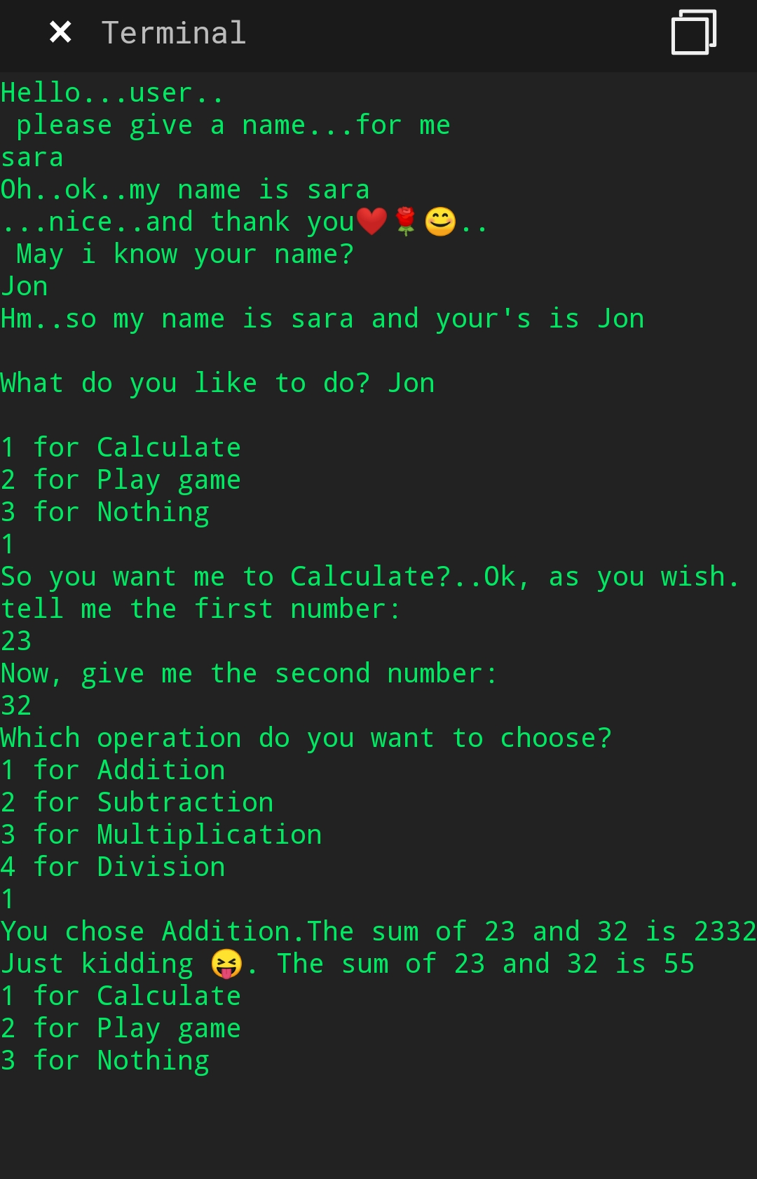

Case2:
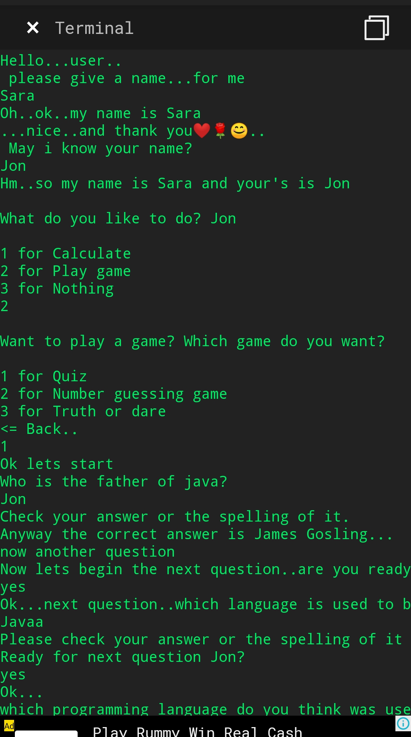
Case 3:
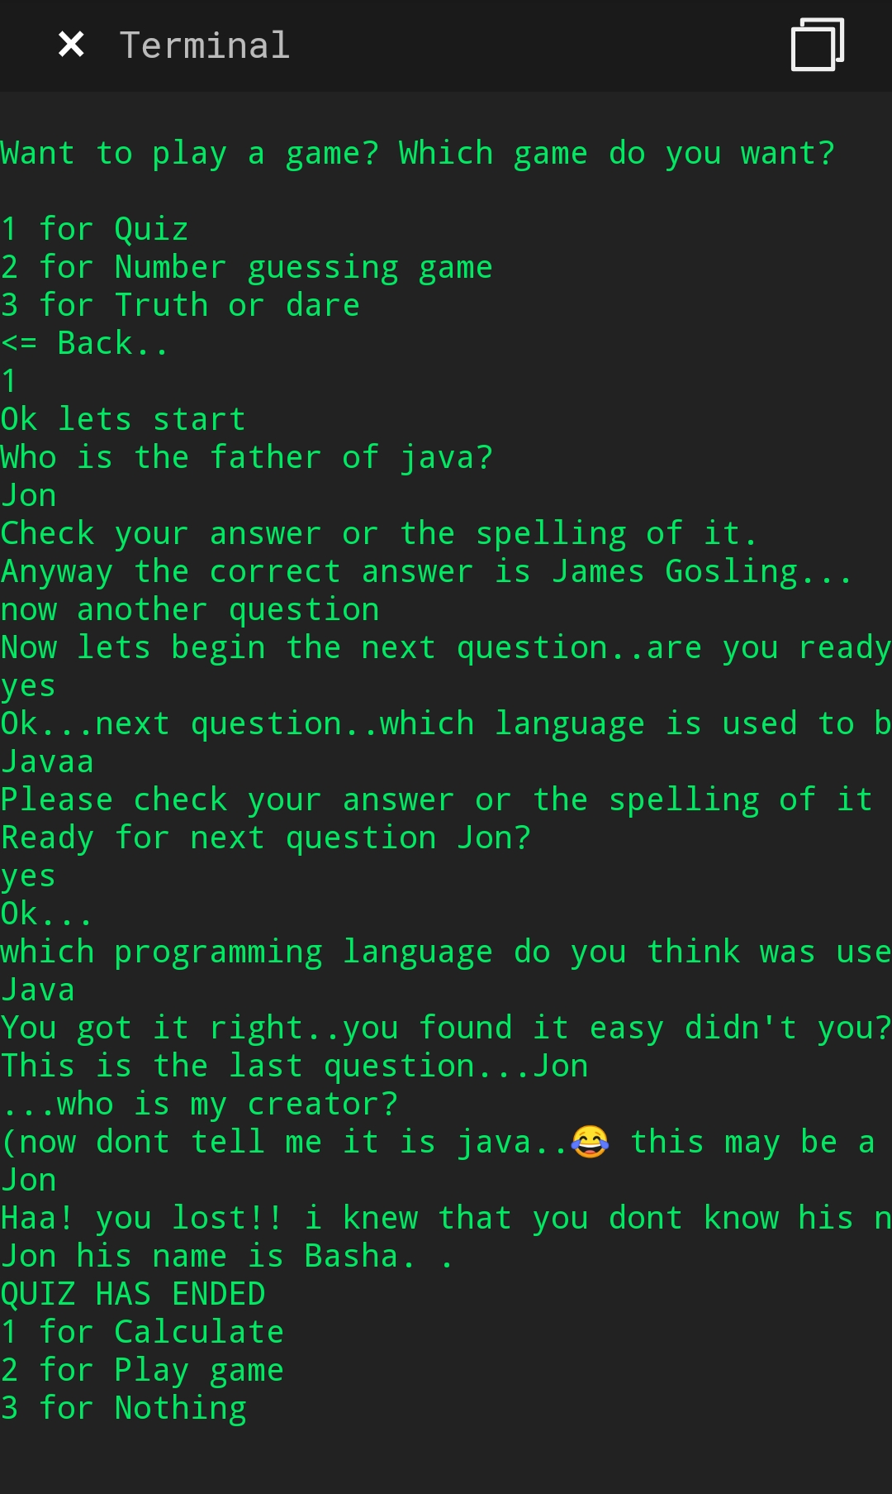
Case 4:
