Statistical Orbit Determination Homework 5
Square Root Information Filter
A Square Root Information Filter was programed following the steps provided in the book and applied to the same data that has been used for previous homework assignments. The state estimation errors with a 3-sigma covariance bound with no state noise compensation results are provided below.
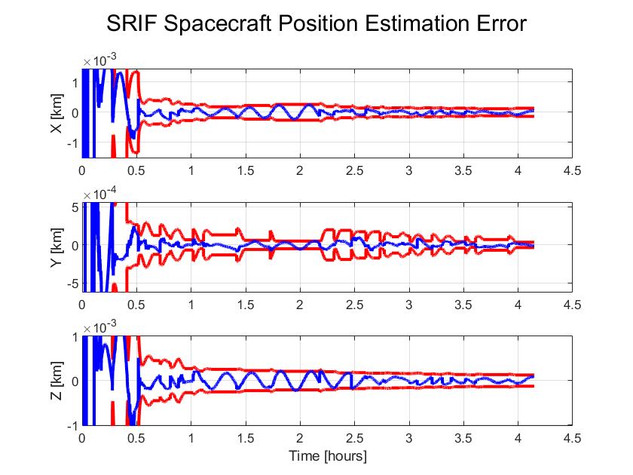
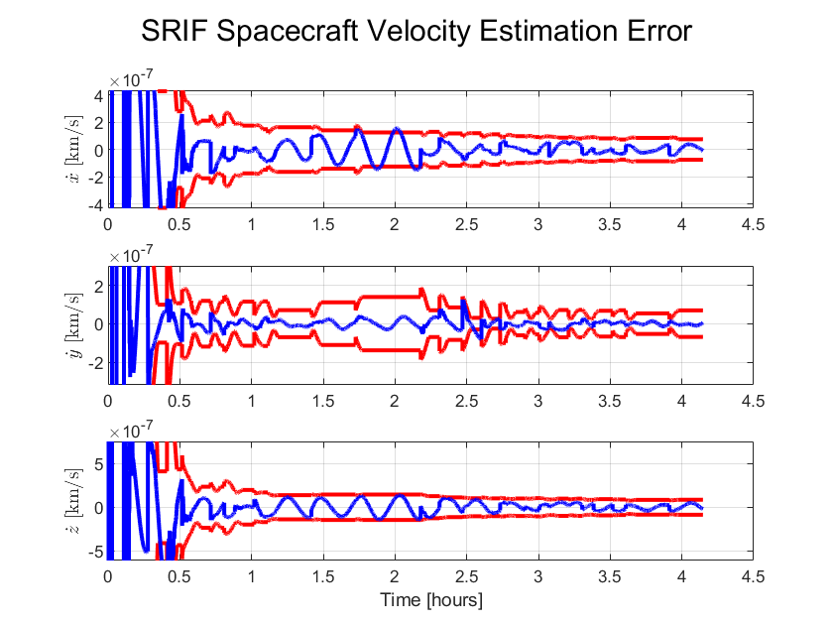
These results should be similar to the results obtained from running the LKF with the same data. The results from the LKF are provided below to show that they are in fact similar.
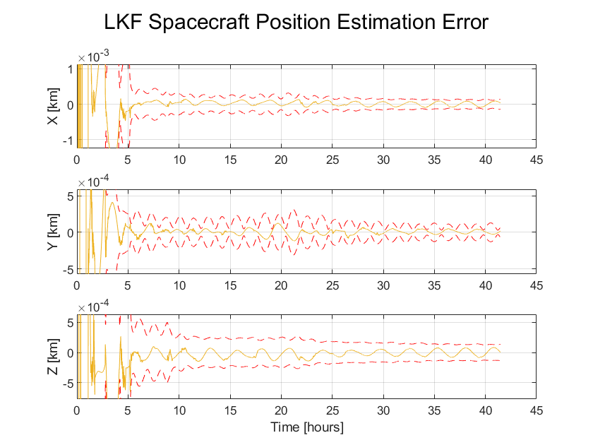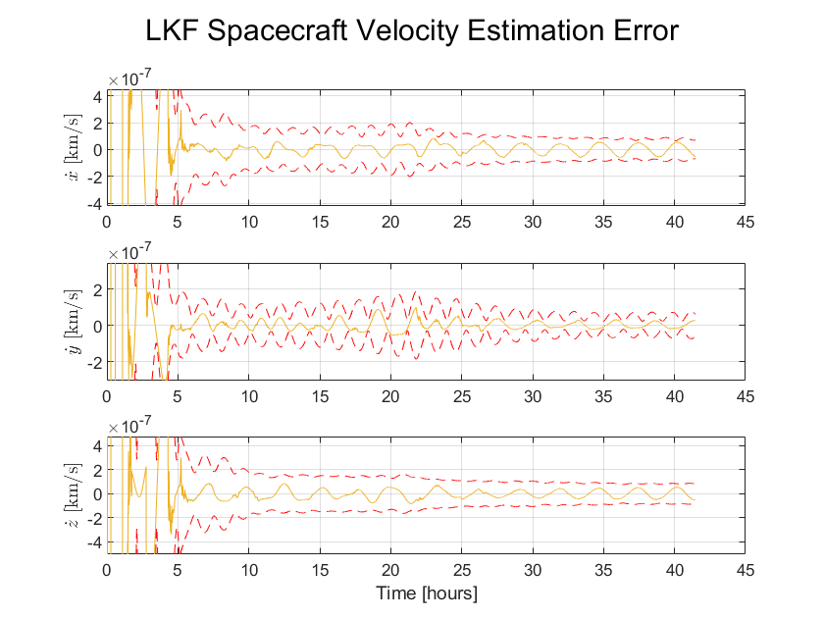
The estimation errors for both the LKF and SRIF are of similar magnitude which is expected.

Next, the SRIF was tested using Equation 5.10.23 which does not force the update of the inverse square root of the covariance to be upper triangular. The results of doing this are provided below.
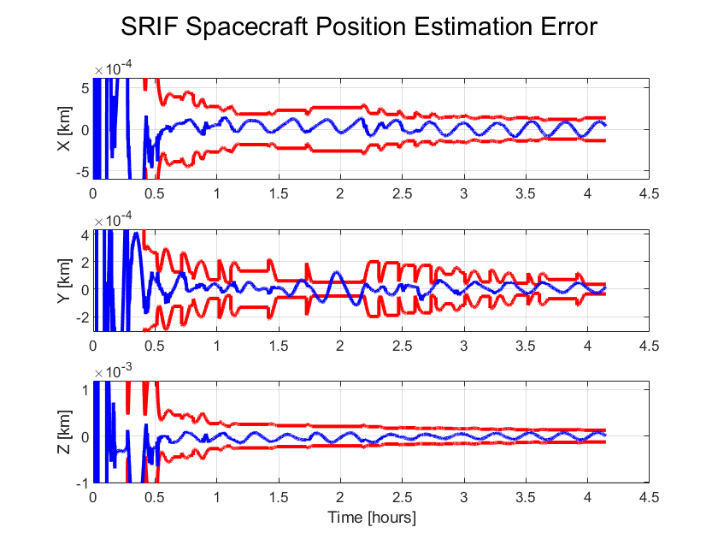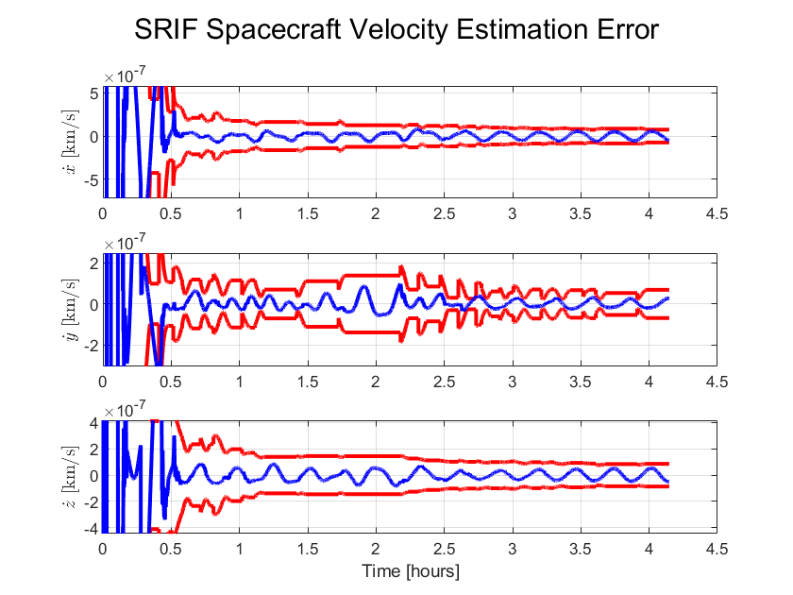
There seems to be no large change when doing this. Maybe the filter has a slightly harder time keeping the estimation error within the uncertainty bounds than before. I think by not forcing it to be upper triangular, some of the numerical stability gets lost and this could be why it performs slightly worse.

Mismatched Dynamics and Process Noise
The SRIF was also run with only a J2 dynamics model, but the observations were simulated with J2 and J3. The results of doing this with the SRIF are shown below.
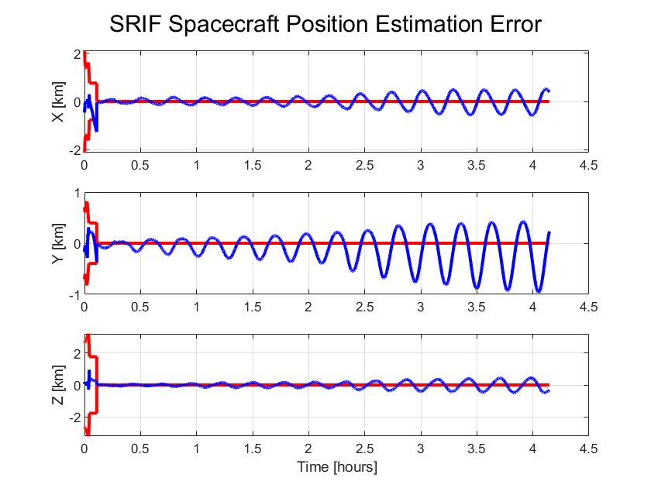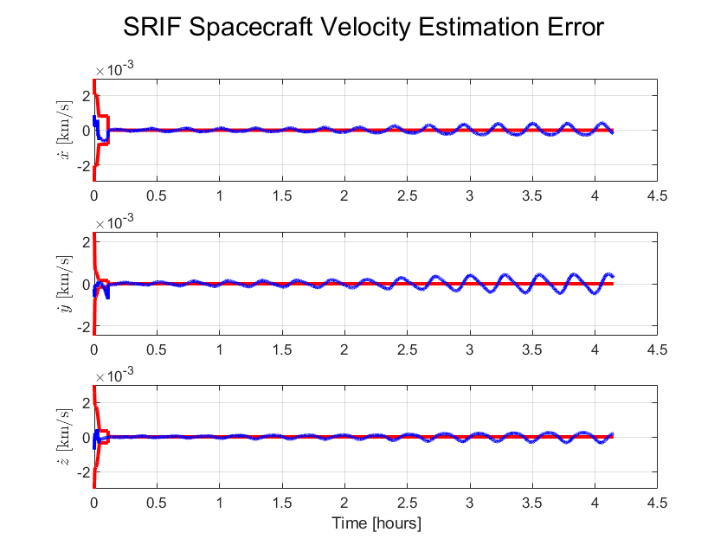
These results are expected and look very similar to when this was done with the LKF. Now, State Noise Compensation is added to the SRIF to compensate for the unmodeled dynamics.
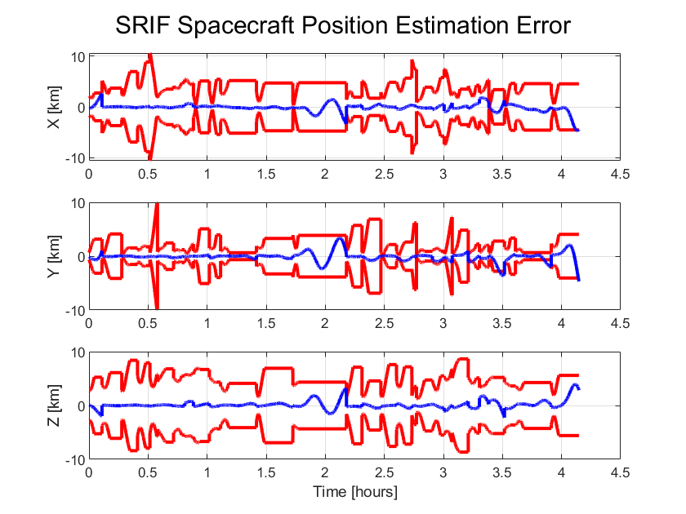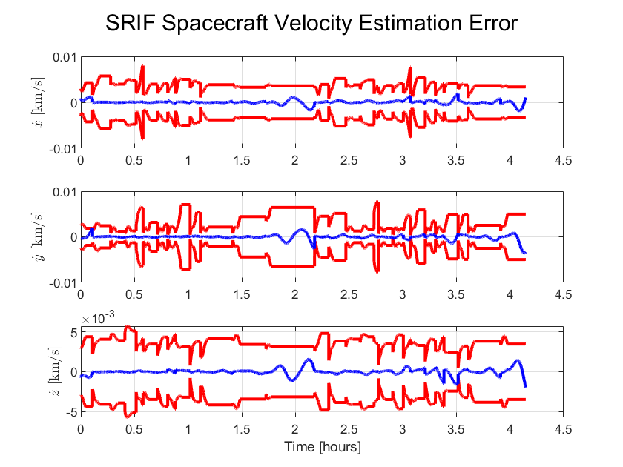
With the added State Noise, the filter can better estimate the state of the spacecraft which is expected. The results from doing this with the LKF are also shown below.
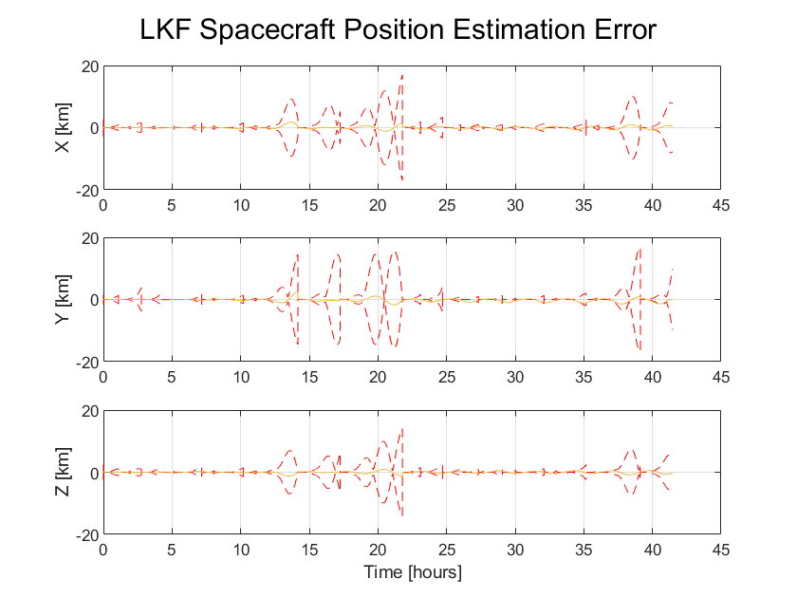
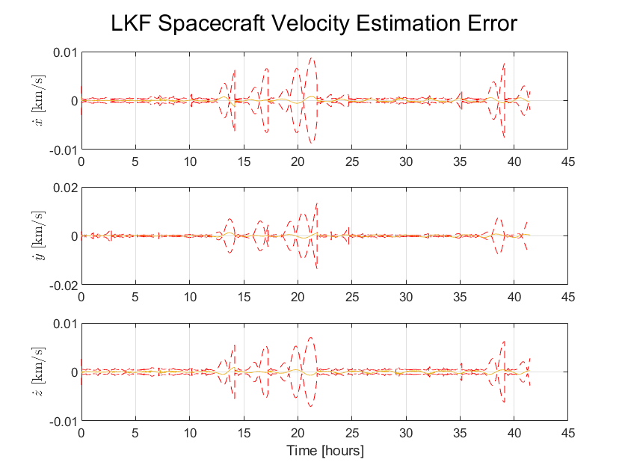
The LKF seems to have large spikes during the observation gaps whereas the SRIF seems to usually maintain a more similar uncertainty bound throughout the simulation. I have both filters cutting off SNC during observation gaps. Both still struggle at moments to stay within the uncertainty bounds, but are able to perform much better with the addition of SNC.

