**Raspberry Pi**

**Initial O/S Install and Configuration**

**Version 1b**

**Document History**

**Version 1 - 09/15/2019 - Initial Document  
Version 1a - 09/19/2019 - Minor Updates Performed  
Version 1b - 09/22/2019 - Added install images**

**Introduction**

This document consists of the following sections:

* What you will need
* Preparing the microSD card
* Installing Raspbian image on the microSD card
* Initial install and configuration of Raspbian
  + Full Version
  + Lite Version
* Raspbian O/S Updates
* Raspbian Network Configuration (Static IP / Wired Ethernet)
* Disabling WiFi and Bluetooth

**What you will need:**

HDMI cable and monitor/display with HDMI connector  
USB keyboard and mouse for initial configuration  
MicroSD card reader/writer

32GB microSD Card (Recommended Sandisk)  
<https://www.amazon.com/gp/product/B06XWMQ81P/ref=oh_aui_detailpage_o00_s00?ie=UTF8&psc=1>

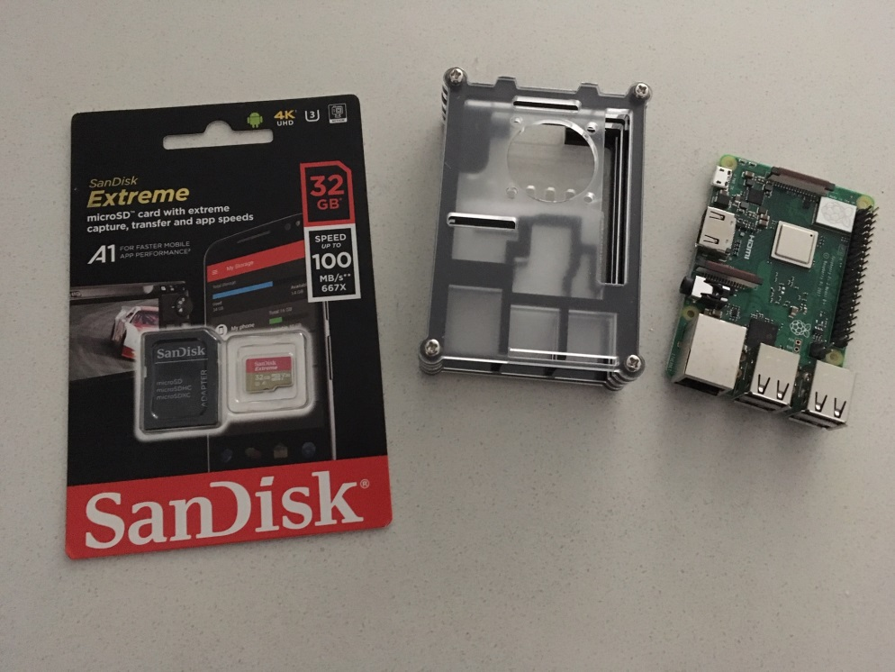

**Preparing the microSD Card**

**Format the microSD Card**

Install the microSD card in your computer or microSD card adapter. I have a small USB card reader/writer by IOGEAR that works well:

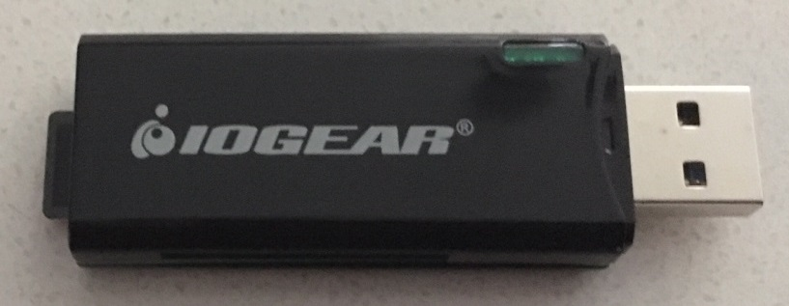  
  
**Download the SD Card formatter software**

<https://www.sdcard.org/downloads/formatter_4/>

This program formats the microSD card but leaves the “protected” part of the card alone.

The program works well and should only show SD media in the “Select card” list, so you shouldn’t be able to accidentally wipe out a hard disk. In either case, just make sure the right device is selected.

Quick format is good. Then click the Format button.  
  
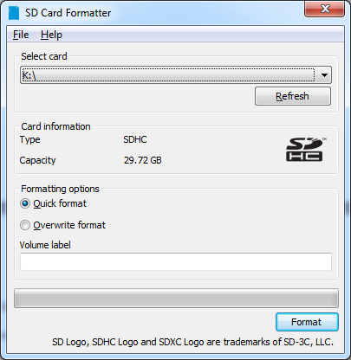

**Installing Raspbian image on the microSD Card**

Raspbian is the name of the operating system that runs on the Pi. It is based on Debian Linux. As of this writing, the current version is Raspbian is “Buster”. The name is based on the underlying release of Debian. Raspbian based on Debian version 7 was known as “Wheezy”, version 8 was known as “Jessie”, and version 9 was known as “Stretch”.

**Download Raspbian**

Raspbian releases are available at <https://www.raspberrypi.org/downloads/raspbian/>

We will use the NOOBS (New Out Of The Box Software) installer to install Rasbian on the microSD card.

Download the NOOBS zip file from <https://www.raspberrypi.org/downloads/noobs/>

Read the descriptions and choose between NOOBS or NOOBS Lite. I tend to download NOOBS so I have an image of Raspbian locally and new installs can be done locally without having to retrieve files over the internet again. Downloading the NOOBS installer can take quite a bit of time (almost an hour) based on how busy the server is.

Verify you have a valid copy of the NOOBS installer after the download completes by validating the SHA-256 key that is provided on the web page with the NOOBS zip file. (Valid as long as the web page hasn’t been hacked too).

I like the following program. It is a great, easy to use tool for checking multiple versions of SHA and MD5.

<http://raylin.wordpress.com/downloads/md5-sha-1-checksum-utility>

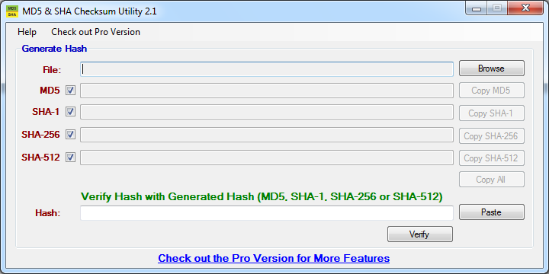

Click on browse to find and select the NOOBS zip file that you downloaded. It’ll kick off and start calculating when you select the file. We’re really interested in just the SHA-256 line, and could unselect the checkboxes for the others, but I leave it alone, it doesn’t take that long.

Finally, after calculations, the screen will end up like this:

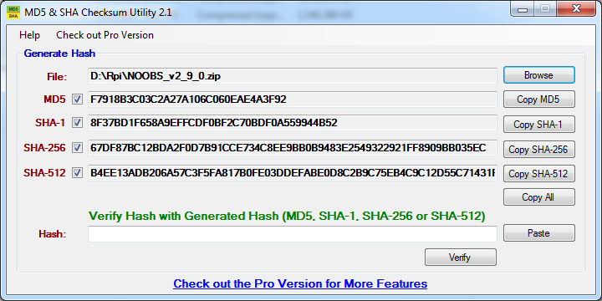

Cut and paste in the key from Raspbian’s website into the Hash: field and you’ll have:

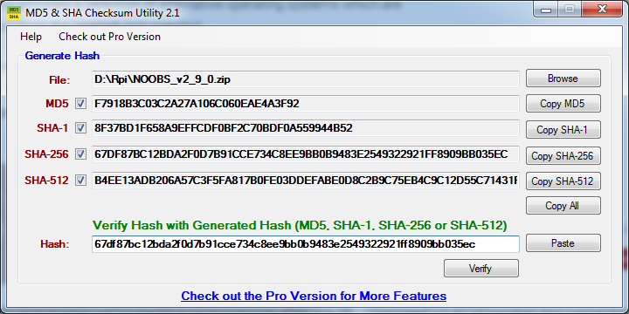

The SHA-256 key from the web page and the SHA-256 calculation from the downloaded file can be compared character by character. The easier way is to hit the “Verify” button and it will compare the Hash value with the generated Hashes from the downloaded file.

If all looks good, you’ll get a window like the below. If not, verify you have copied the hash value correctly from the web page. If that doesn’t work, try downloading the zip file again. The SHA-256 hash should match to make sure we don’t have a compromised image.

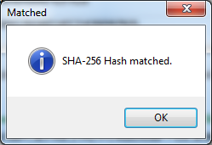

Now you can extract the zip file directly to the microSD card. Be careful here. Most unzip programs create a directory and place the files inside of it. All of the files and directories from the zip file must be at the top level on the microSD card, not within a directory. I tend to extract the zip file to the hard disk, select all the files and directories that were extracted, and then copy them to the microSD card.

You can now “eject” the microSD card or adapter from the computer.

**Initial Load of Raspbian onto the microSD Card**

Connect the keyboard, mouse, HDMI cable, network cable, and then power to the Raspberry Pi. Now insert the microSD card into the slot on the Pi. If you connect a network cable at this point, the Pi will attempt to obtain an IP address from DHCP, go out to the internet, and find other system images it can install.

When NOOBS loads without network access, it should provide you with two options (if you downloaded the NOOBS and not the NOOBS Lite zip file earlier):

Raspbian Full  
LibreELEC-RPi2

If you are connected to a network connection, you will see more such as:

Raspbian Full  
 LibreELEC-RPi2  
 Raspbian Lite  
 Data Partition  
 OSMC-Pi2  
 Windows 10 IoT Core  
 TLXDS

You will see a screen like this:

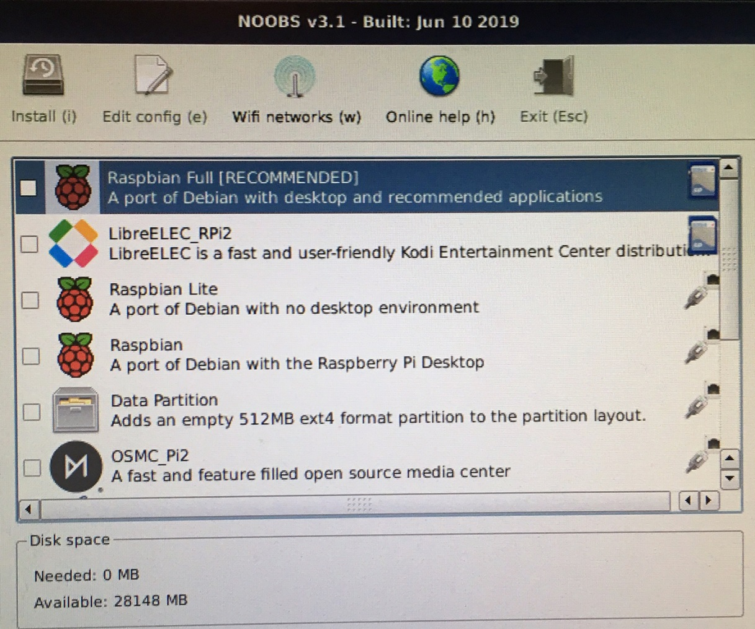

If you will need the graphical desktop, select Raspbian Full [RECOMMENDED] then click install, otherwise select Raspbian Lite for a minimal install. Set the language at the bottom of the screen to your preferred language (mine is English(US)).



Click yes to the warning that you are about to overwrite data on the microSD card if it appears.

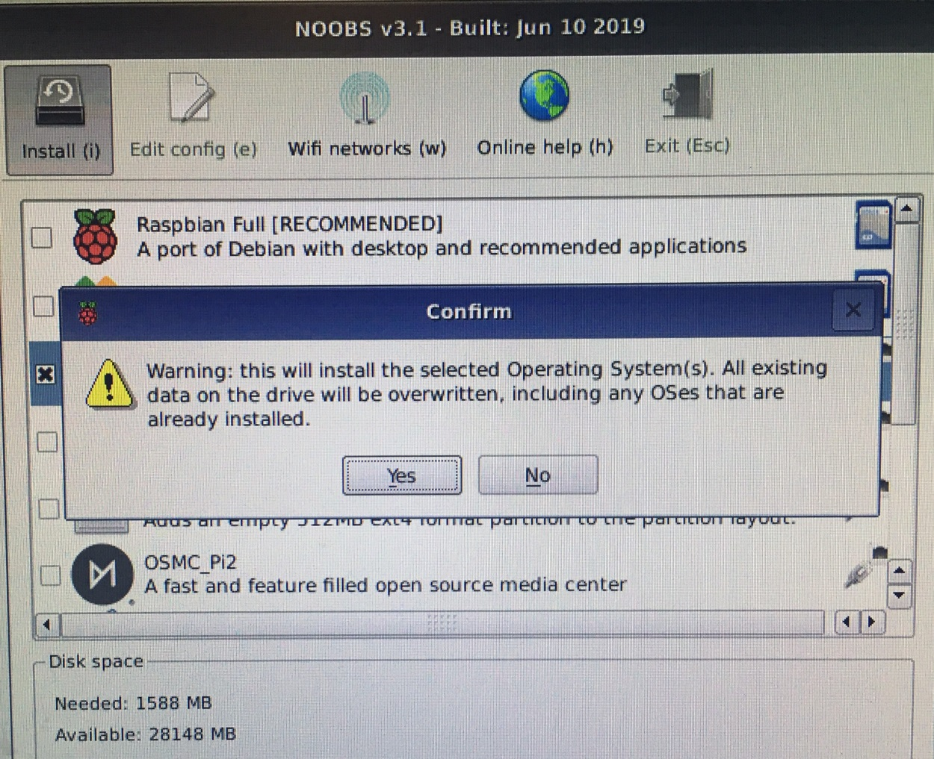

The install will now start. Based on the image downloaded (NOOBS vs NOOBS Lite) and the image selected, the install time will be shorter if the image is local on disk versus the installer retrieving the image over the internet.

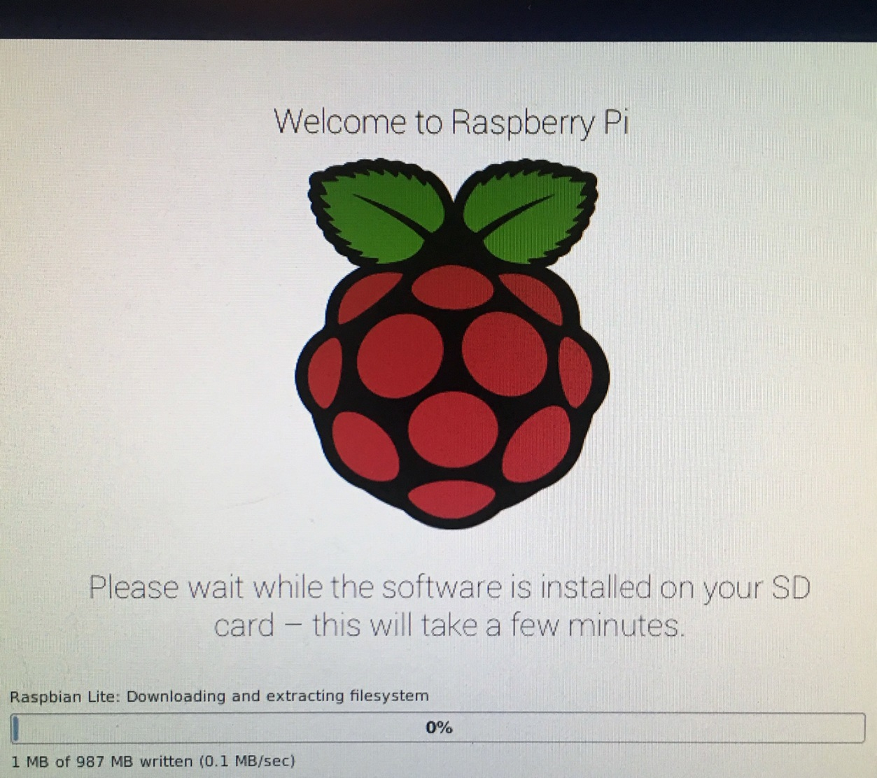

When complete, it should open a window saying the OS(es) installed successfully. Click Ok and the Raspberry Pi will reboot.

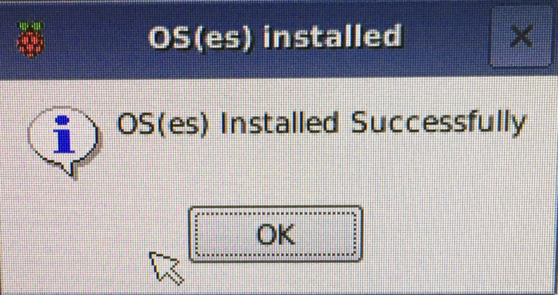

**Initial Configuration of Raspbian**

Based on the image you selected, you will customize the Raspbian installation in different ways. I will briefly cover the basics for the Raspbian Full and Raspbian Lite installs below.

**Initial Configuration of Raspbian Full installation**

After the Pi reboots, it will load the GUI desktop and walk you through some initial configuration tasks. Press “Next” to get started. You will set the language and location.

The Pi has a default userid of “pi” and default password of “raspberry”. The next screen will have you set the new password for the pi user.

The next screen asks you if you want to join a wireless network. If you want to join a wireless network, you can do that here. I have my Pi wired with Ethernet, so I do “Skip”.

The next option will ask you if you want to install updates. Click “Skip” here. We will do this later. If you had connected the network cable and used DHCP earlier, you could install updates (should be fine). But if you didn’t, then you won’t have a network connection.

The next screen will tell you the install is complete and to click Reboot.

When the reboot completes, the GUI will load. Click on the Raspberry symbol on the top left of the screen.

From the menu, select Preferences, then Raspberry Pi Configuration.

On this screen:

Change the hostname to your preference.  
 For Auto Login, I unclick the box so it prompts me for a userid and password.  
 Modify any other settings you deem necessary.

Select the Interfaces tab on the top

Enable SSH  
 Modify any other settings you deem necessary.

You can go through the other tabs, but everything should be good. Click Ok. You will be prompted to reboot for the changes to take effect. Click Yes to reboot now.

**Initial Configuration of Raspbian Lite installation**

After the pi reboots, you should be at a login prompt. Enter “pi” for the userid and “raspberry” for the initial password. You should be greeted with a “pi@raspberrypi:” login prompt.

Change the default password by running the passwd command. You will be prompted for the current password (raspberry), and then for what you want to change the password to.

Now, enter “sudo raspi-config” to enter the configuration menu. This allows you to set settings that would be done through the GUI if you had installed the graphical image.

Scroll down to “Network Options” and hit enter. Select Hostname” and hit enter. An informational window on what characters are allowed may be displayed. Hit enter. Select a new hostname and hit enter.

Scroll down to “Localisation Options” and hit enter. Scroll down to “Change Timezone” and hit enter. Select your country. I am picking “US”. Hit enter. Select your region. I am selecting “Central”. Hit enter.

Select “Interfacing Options” and hit enter. Select “SSH” and hit enter. Select “Yes” to enable the SSH server and hit enter. If you did not change the default password earlier, you will receive a warning that you will be creating a security vulnerability (since everyone will know or can find the default password). The SSH server should be enabled. Hit enter. Hit escape to return to the command prompt (you can also select Finish and hit enter).

Now let’s reboot to pick up the new settings. Run “sudo reboot”. When the system restarts, you should see the new hostname on the login prompt. Log in with the “pi“ user and the new password you selected.

**Raspbian O/S Updates**

Make sure you have a network connection at this point (via wired or wireless).

Now run “sudo apt-get update” to update the system package list.

Now run “sudo apt-get dist-upgrade” to install updates to the system since the image was made.

Once the upgrade is completed, run “sudo reboot” to restart the system. When the pi reboots, log in as the pi user.

**Raspbian Network Configuration (Static IP / Wired Ethernet)**

If you want to use DHCP then you don’t need to modify the dhcpcd.conf file.

If you want to assign a static IP to the Raspberry Pi then you’ll either need to configure your DHCP server to reserve an IP for the Pi, or set a static IP on the Pi.

Here are the instructions to set a static IP on the Raspberry Pi (this is the route I take):

Modify /etc/dhcpcd.conf file using your favorite editor (“sudo vi /etc/dhcpcd.conf”)

You should only need to modify a few lines near the bottom of the file.

Uncomment (remove the # from the start of the line) the interface line for the adapter you are using.  
Uncomment the static ip_address line and set it to the IP you want.  
Uncomment the static routers line and set it to the proper router for your network.  
Uncomment the static domain_name_servers line and set the proper values.

Before (I am modifying the interface lines for eth0):

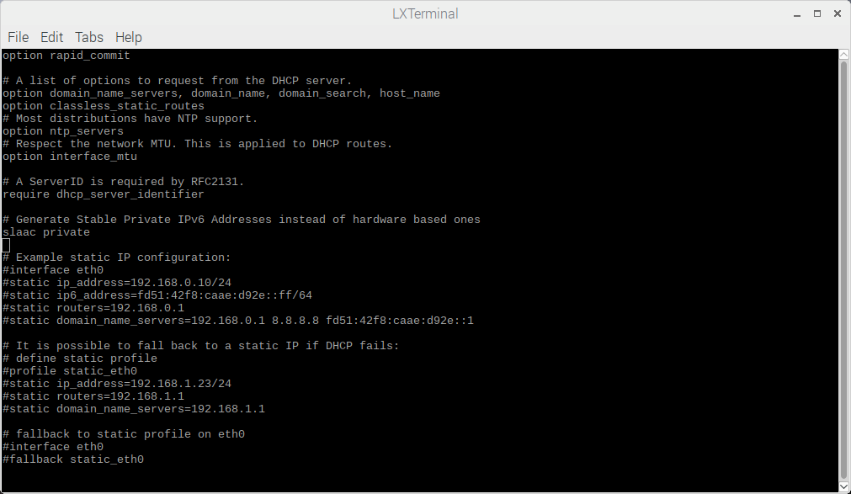

After:

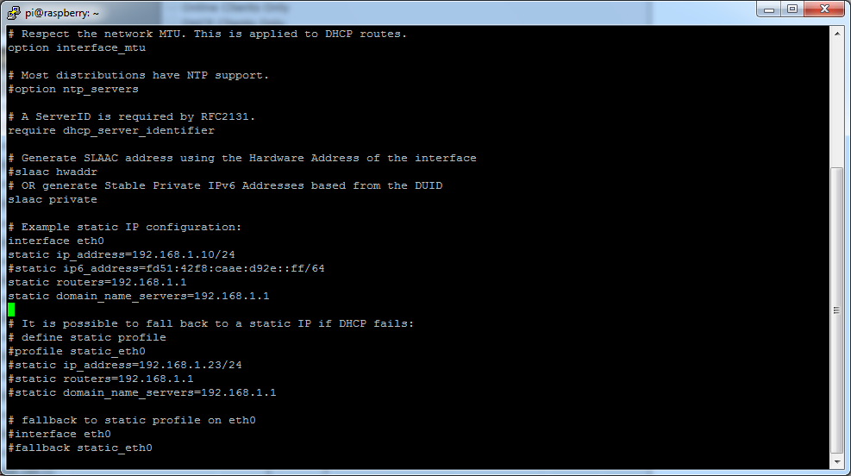

**Disabling WiFi and Bluetooth**

I try to run systems on a wired connection versus wireless. I also disable Bluetooth where it makes sense. Disabling these features saves CPU cycles and electricity (good if you’re running off battery). It also helps to secure the system if they are not needed.

To disable WiFi and Bluetooth, the following two commands need to be added to the /boot/config.txt file. If you want WiFi or Bluetooth, then don’t add the associated line.

Add the following two lines to the bottom of /boot/config.txt using the echo command. We have to switch to root here as sudo doesn’t like the append operator (>>). Make sure you use the double quotation marks.

sudo su -  
echo “dtoverlay=pi3-disable-wifi” >> /boot/config.txt  
echo “dtoverlay=pi3-disable-bt” >> /boot/config.txt

Reboot for changes to take effect.

“sudo reboot”

During the status messages on reboot, you will see a FAILED message as it can’t configure Bluetooth since it was turned off above (if you did turn it off).

Run “ifconfig” and you should now see only two interfaces configured, eth0 and lo0. Verify eth0 has the proper IP address if you set it statically, or the proper IP address if it’s retrieving it via DHCP.