**Smraza 9 Layer**

**Raspberry Pi Case Build**

**Version 1 - 9/17/2019**

**Introduction**

This document consists of the following sections:

* What you will need
* Construction of the Smraza Case

**What you will need:**

Screwdriver (#2 Phillips tip)  
Socket set (with 5.5mm socket)  
HDMI cable and monitor/display with HDMI connector  
USB keyboard and mouse for initial configuration  
32GB microSD Card (optional)

Raspberry Pi (Recommended Cana Kit. Comes with AC adapter)  
<https://www.amazon.com/gp/product/B07BC6WH7V/ref=oh_aui_detailpage_o01_s00?ie=UTF8&psc=1>

Raspberry Pi Case (Comes with fan and heat sinks)  
<https://www.amazon.com/gp/product/B07C9R4T3M/ref=oh_aui_detailpage_o01_s00?ie=UTF8&psc=1>

32GB microSD Card (Recommended Sandisk)  
<https://www.amazon.com/gp/product/B06XWMQ81P/ref=oh_aui_detailpage_o00_s00?ie=UTF8&psc=1>

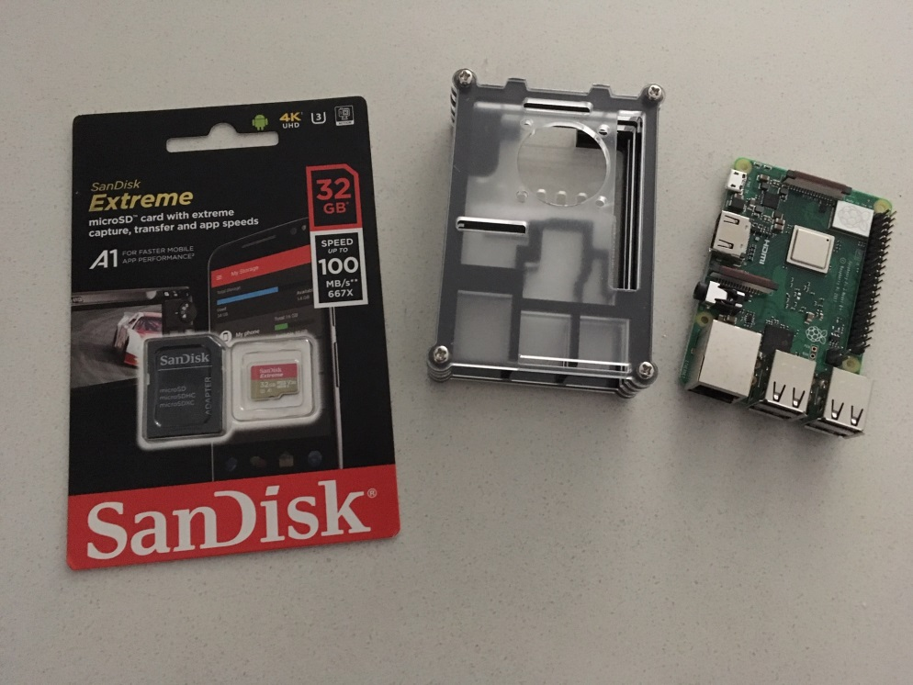

**Construction of the Smraza Case**

Smraza has a great small instruction sheet they include with the case. Follow their instructions as they are straight forward. I do have a few suggestions below while you’re putting the case together. The most important part is do NOT apply the heat sinks at the beginning. Also, make note on the location of the wires coming out of the fan. Both of these items are addressed below.

The microSD card is fragile and should not be installed until after the case is put together (and after the O/S has been loaded on the card, covered in another document).

This information is based on the 9 layer case.

Perform the first 5 steps, which will have you stack the first 4 layers of the case.

Now, use layer 4 as a guide on how to line up and apply the heat sinks to the top of the board. There is one 14mm heatsink that goes over the processor and a 9mm heat sink that goes over the graphics chip (I believe it’s the graphic chip). People have had issues in the past placing the heat sink and then layers 4 and 5 don’t fit. As long as you get the heat sinks fairly well centered on the chips, you’ll be just fine. The issue isn’t with the 14mm heat sink over the processor, it’s the tight space and the 9mm heat sink for the graphics chip.

I remove layer 4 before putting on the heat sinks (just to make it easier to get at the chips) and then replace it to make sure layer 4 fits properly. Gently peel off the blue plastic to expose the adhesive on the heat sinks. Apply the 9mm and 14mm heat sinks.

The Canakit ships with one 14mm and one 9mm heatsink, so if you goof one of the ones above, you can use one of the ones from the Canakit. The Canakit heat sinks will be left over at the end of the process.

Complete steps up to and including installing the fan. I’ve been connecting the fan to provide 3.3V for low speed, not 5.0V for high speed since I don’t think I’m putting a major load on the pi’s. Notice where I put the corner location with the wires coming out of the fan. This seems to help later to use up the slack in the wires.

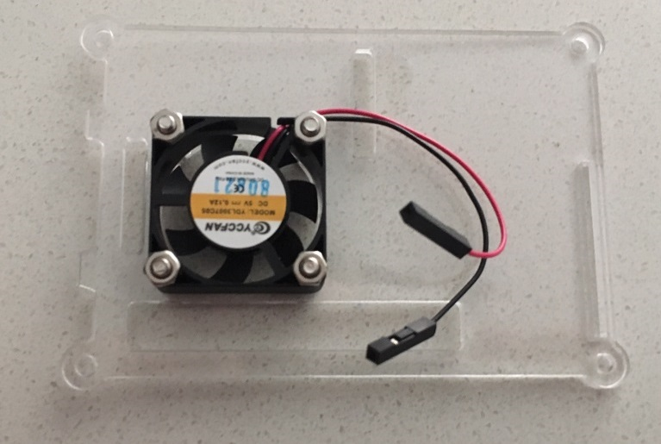

Now, install the four screws to hold the Pi case together, but not the nuts, and then flip the case over. Now we can remove the bottom layer, keeping the stack still together, and install the final 14mm heat sink on the LAN chip and make sure it lines up. I ALWAYS have to bias this heat sink a bit to one side on this one. Get a good look for how the LAN chip falls under the hole in the bottom layer. That’ll show how you need to line up the heat sink. Now apply the heat sink and place the bottom layer back.

Finally, tighten the nuts onto the screws per the instructions. Double check and make sure your black and red wires are on the proper pins on the board.

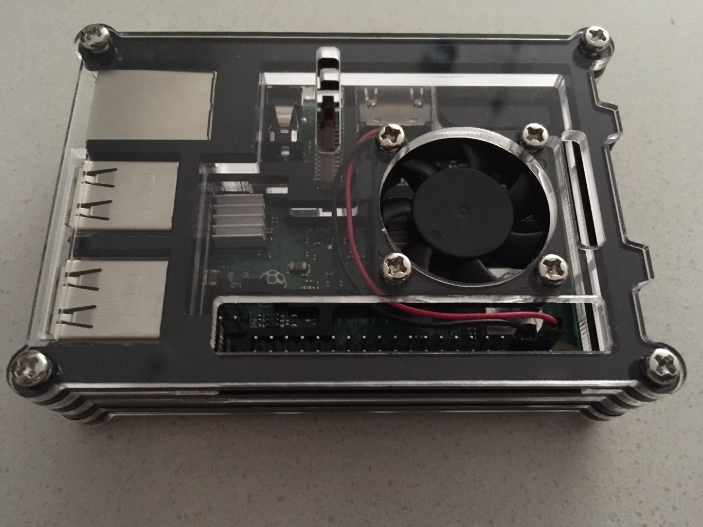

You’ll notice in the image, with the way I did my fan install, it uses up a lot of the wire slack for the fan power, and keeps it off the top of the processor and out from below the fan blades.

Congratulations! You have now completed the Smraza case build.