Mould Temperature
Monitoring And Controlling System

Prepared for
AGI Glasspac - AGI Greenpac Limited
Glass Factory Rd, Bhuvanagiri, Telangana 508116
Installation Site - AGI Speciality Glass
Bhongir

Prepared by
INSTRON TECHNOLOGIES LLP
SHOP NO. 08, PRIYADARSHINI INDUSTRIAL SOCIETY,
PLOT NO 165/1/10, T BLOCK, MIDC, BHOSARI,
PUNE-411 026, MAHARASHTRA, INDIA

Signatures:

We, the undersigned, hereby acknowledge that the document has been reviewed and approved according to the criteria outlined in this document.

For Customer:-

- Project Head:
Signature:

- Project Manager:
Signature:

- Project Manager:
Signature:

Date:

For InstronTechnologies:


- Sales Head: Dhananjay M. khond
Signature:


- Project Manager: Kishor Jagtap
Signature:


- Project Manager: Pawan Dhumane
Signature:

Date: 7th Nov 2024

CONTENT

- System Architecture
- System Layout
- Network Architecture
- Application Usage
  - Scope 1 - Mould Temperature Monitoring And Controlling System
  - Scope 2 - HMI Screen development and Data logging in USB
- Network
- Communication Between Devices
- Remote Support
- Customer Scope
- System Maintenance (only if applicable)
- Documentation is to be provided by ITLLP

- 1. System Architecture-

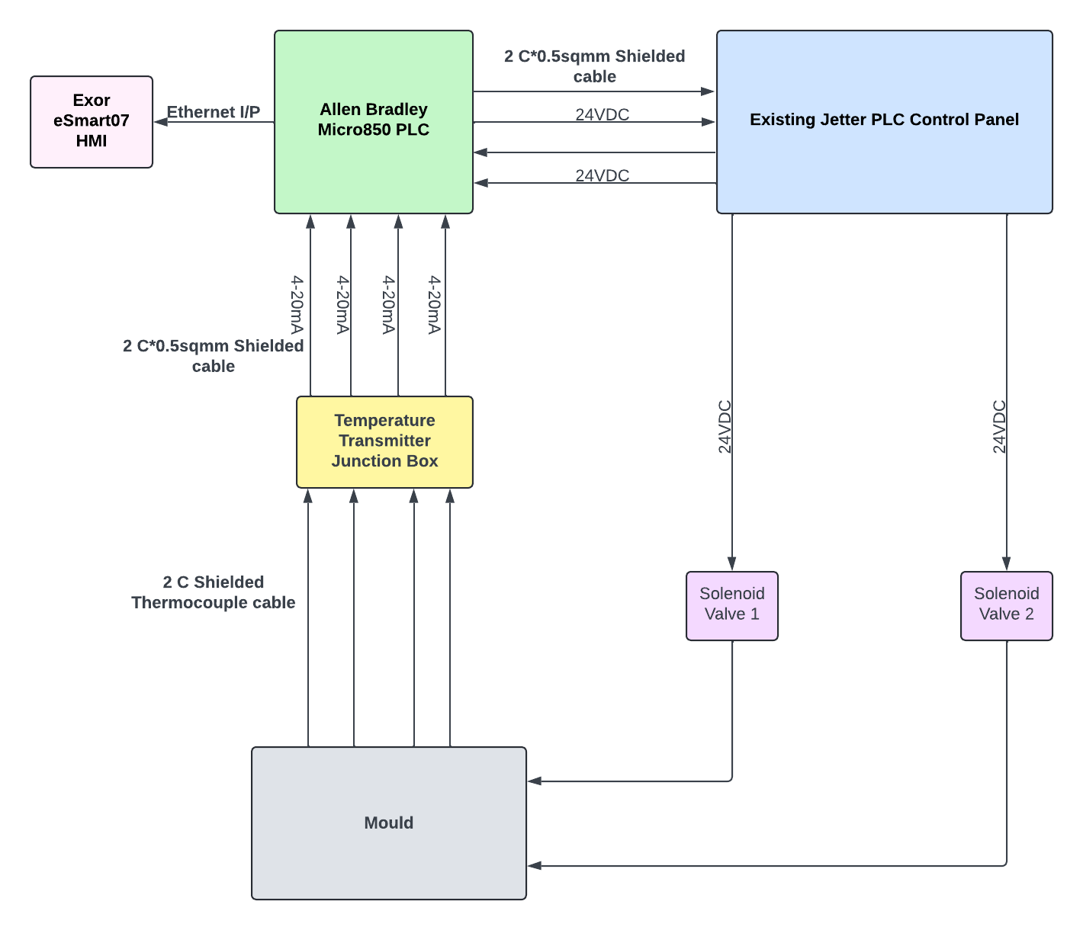

Note :
- We are getting two inputs from Jetter PLC to Allen Bradley PLC
- Two outputs are given from Allen Bradley PLC to Jetter PLC to operate the Solenoid Valves

- 2. System Layout-

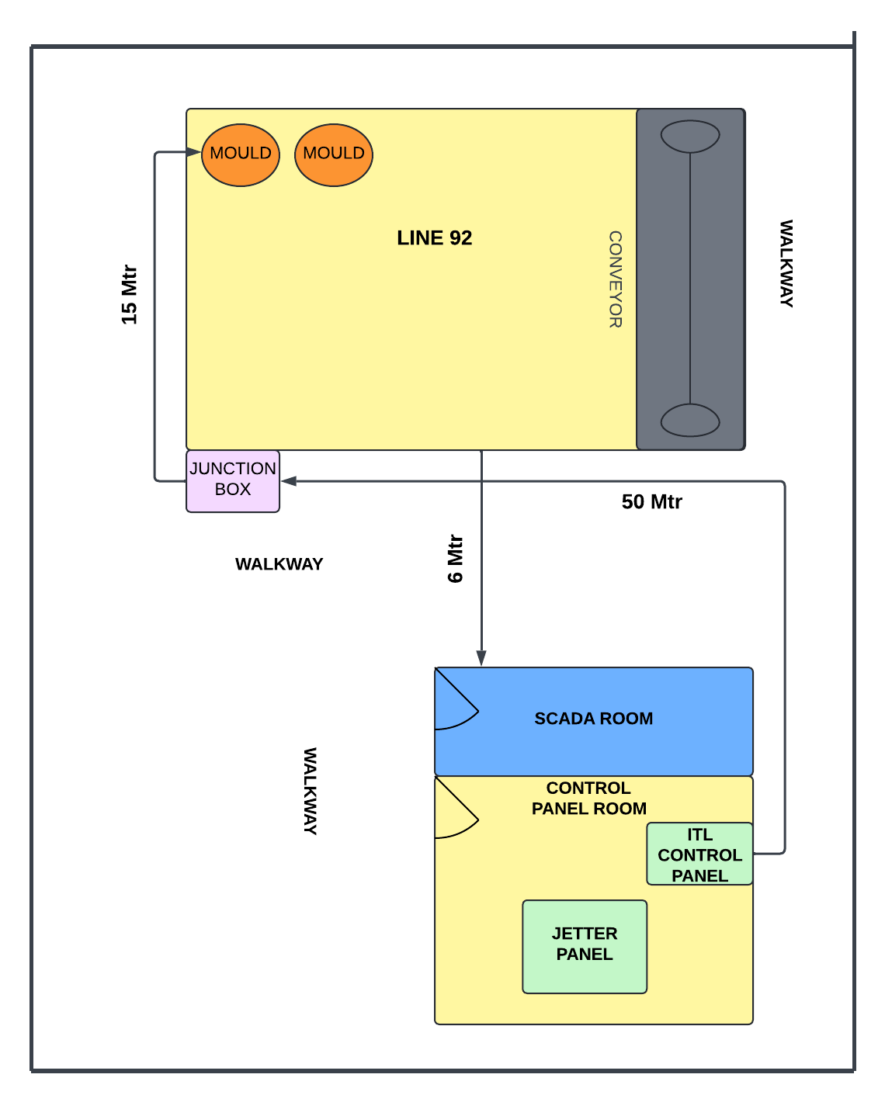

- 3. Network Architecture -

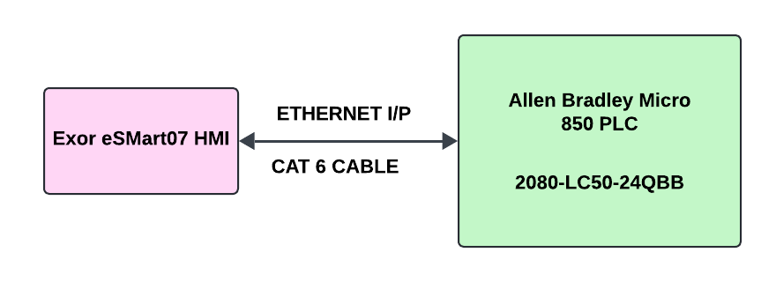

- 4. Application Usage -
- Hardware supply
Hardware
- Control panel - 1 No.- Area Classification: Safe/Non-hazardous
- Junction box (For Thermocouples transmitter)- 1 No.
- Exor HMI - 7” (eSMART 07)
- PLC- Allen Bradley Micro 850( 2080 LC50 24QBB)
- Thermocouple - K type - 4 Nos with cable. Temperature range - 0-1200 deg C
- Transmitter: Isolated - 4 Nos.(Novus TxIsoRail)
- 1 Pair 2C* 0.5sqmm shielded cable (50 Meter -2C shielded For Each transmitter - 4 Nos - 200 Mtr)
(10 Meter-2C shielded for each of two trigger input and two Digital output -4 Nos - 40 Mtr)
- Total cables length: 300 meters
- Heat Sleeve - 20 Mtrs

- Site Activity
Site Work
- Termination inside panel
- Onsite logic checks, trials
- Training & Handover
- Supervision of activities

- Operation -

1.TE-101 and TE-102 monitor the temperature of the mould on the left front and rear sides and operate Solenoid Valve SOV-1, while TE-103 and TE-104 monitor the temperature of the mould on the right front and rear sides and operate Solenoid Valve SOV-2.

2. The operator sets the Temperature Setpoint for the left-hand and right-hand sides of the mould halves, as well as the Cooling Time Setpoint on the HMI.
The Cooling Time Setpoint is in seconds, with a maximum limit of 10 seconds. This limit can be configured during site commissioning.

3. When a signal is received from the jetter PLC panel, the control logic checks if the current temperature of at least one thermocouple from either the left or right mould halves exceeds the respective setpoint.

4. If the temperature of either side exceeds the setpoint, a command is sent to turn ON the corresponding valve. The valve will activate if any of the two temperatures, either left or right side halves—exceeds the setpoint.

5. If the temperatures for both halves are below the respective setpoint, no command will be generated, and the respective valve will not operate.

6. Once the valve is open, it will remain open until either the cooling timer completes or the temperatures of both corresponding thermocouples falls below the respective setpoint, whichever occurs first.

7. If the valve is already open and a subsequent command signal is received from the Jetter PLC Panel, no action will be taken, and the cooling timer will not reset.

- The following conditions are given below :

Sr.No. | Condition | SOV1
1 | TE101<SP1 and TE102<SP1 | OFF
2 | TE101>=SP1 and TE102<SP1  (Till cooling time not complete) | ON
3 | TE101<SP1 and TE102>=SP1  (Till cooling time not complete) | ON
4 | TE101>=SP1 and TE102>=SP1  (Till cooling time not complete) | ON
5 | Cooling Timer Complete  (Along with any of ON conditions, i.e. Sr.No. 2 or 3 or 4 or 5) | OFF

Sr.No | Condition | SOV2
1 | TE103<SP2 and TE104<SP2 | OFF
2 | TE103>=SP2 and TE104<SP2  (Till cooling time not complete) | ON
3 | TE103<SP2 and TE104>=SP2  (Till cooling time not complete) | ON
4 | TE103>=SP2 and TE104>=SP2  (Till cooling time not complete) | ON
5 | Cooling Timer Complete  (Along with any of ON conditions, i.e. Sr.No. 2 or 3 or 4 or 5) | OFF

- 5. Network:

- NA

- 6. Communication Between Devices:

  - Protocols used for device communication
    - Ethernet/IP
    - Hardwired signals

- 7. Remote Support:

  - NA

- 8. Customer Scope :

- Customer Scope :
- Tool work on the Mould for the provision of Thermocouple Installation
- Thermocouple mounting on Mould
- Control Panel Mounting
- JB mounting
- Cable laying
- If Extra Cable trays are required, procurement and installation
- Temperature Data Analysis

- 9. System Maintenance(Only if applicable):
  - Scheduled maintenance tasks and frequency.
    - 6 Month(checkup and report)

- 10. Documentation to be Provided by ITLLP:

- Quality documentation(PO, Invoice, test certificates, Warranty certificates)
- SOW
- User Manual
- Basic Engineering document
1) IO Summary
2) IO List
3) Load calculation
4) BOM
5) Cable schedule
6) Spare list

