**Research Paper/Document**

Project Title: Smart Dustbin

Team ID: Team_3744

Team Leader Name: Nachiket Patil

Team Member Names: Prathamesh Posa

Team Leader Email: nachiketpatil4642@gmail.com

Institute name: S.S Agrawal Institute of Engineering and Technology.

**Abstract:**

The smart dustbin project is aimed at creating an efficient waste management system by implementing advanced technology. The project involves the development of a dustbin equipped with sensors and a microcontroller that can detect the level of waste in the bin and notify the relevant authorities when the bin is full.

The smart dustbin will also be able to sort the waste into different categories and compact it, reducing the frequency of collection and transportation.

The project aims to promote environmental sustainability by reducing the amount of waste sent to landfills, minimizing littering, and promoting recycling.

The smart dustbin can be implemented in various settings, including public spaces, residential areas, and commercial buildings, to create a more efficient and sustainable waste management system.

**Introduction:**

The smart dustbin project is an innovative solution aimed at addressing the growing waste management challenges faced by communities worldwide. With the rapid growth in urbanization and industrialization, the amount of waste generated has increased significantly, leading to environmental pollution and health hazards. Traditional waste management systems have proved to be inefficient, leading to overflowing bins, littered streets, and overfilled landfills. The smart dustbin project is designed to overcome these challenges by introducing an intelligent waste management system that leverages advanced technology.

The project involves developing a dustbin equipped with sensors, microcontrollers, and other electronic components that can detect the level of waste in the bin and sort it into different categories. The smart dustbin can also compact the waste, reducing the frequency of collection and transportation. Additionally, the project aims to promote environmental sustainability by promoting recycling, reducing littering, and minimizing waste sent to landfills.

The smart dustbin can be implemented in various settings, including public spaces, residential areas, and commercial buildings, creating a more efficient and sustainable waste management system. The project aligns with the United Nations Sustainable Development Goals (SDGs), particularly SDG 11, which aims to make cities and human settlements safe, resilient, and sustainable.

**Circuit Diagram:**

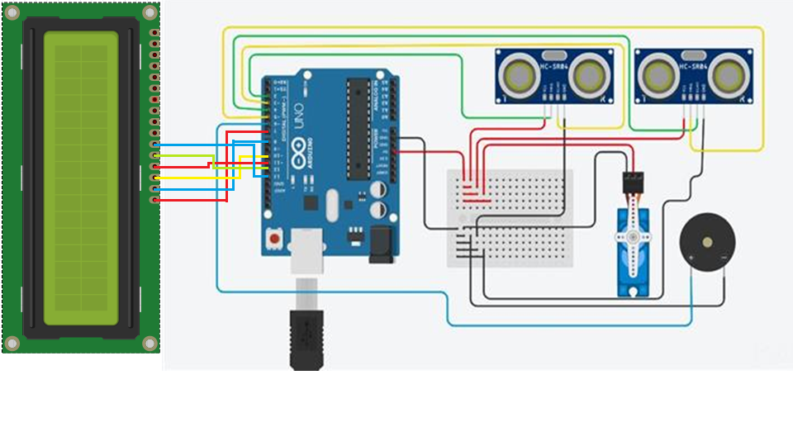

**Technologies:**

The smart dustbin project leverages various advanced technologies to create an efficient and sustainable waste management system. Some of the technologies used in the project include:

1. **Sensors:** The smart dustbin is equipped with sensors that can detect the level of waste in the bin, allowing the system to determine when the bin needs to be emptied.
2. **Microcontrollers:** The system uses microcontrollers to process data from the sensors and control the operations of the smart dustbin.
3. **Internet of Things (IoT):** The smart dustbin is connected to the internet, allowing it to send data to a central server and receive commands from authorized personnel.
4. **Artificial Intelligence (AI):** The system uses AI algorithms to sort the waste into different categories, such as recyclable and non-recyclable waste, and determine the appropriate disposal method.
5. **Robotics:** The smart dustbin can be equipped with robotic arms that can pick up and sort the waste automatically, reducing the need for manual intervention.
6. **Cloud Computing:** The data collected from the smart dustbins can be stored in the cloud, allowing authorized personnel to access it from anywhere in the world and make informed decisions.

The combination of these technologies creates an intelligent waste management system that can reduce waste, promote recycling, and create a more sustainable environment.

**Results:**

1. **Improved efficiency:** The smart dustbin can detect when it needs to be emptied, reducing the frequency of collection and transportation. This can lead to cost savings and a more efficient waste management system.
2. **Reduction in littering:** With the implementation of smart dustbins, littering can be minimized since people are more likely to use a bin that is available and not overflowing.
3. **Promoting recycling:** Smart dustbins can sort the waste into different categories, making it easier to recycle materials and reduce the amount of waste sent to landfills.
4. **Better public health:** Efficient waste management reduces the risk of pests and disease spread, improving public health.
5. **Environmental sustainability:** The reduction in waste sent to landfills, promotion of recycling, and minimization of littering contributes to environmental sustainability.

Overall, the implementation of smart dustbins can lead to a more efficient, sustainable, and healthier environment for communities, promoting the well-being of both people and the planet.

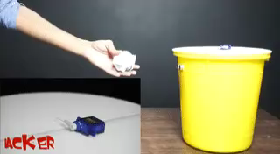

**Top of Form**

**Conclusion:**

The smart dustbin project is an innovative solution that can address the challenges of traditional waste management systems. The project leverages advanced technologies, such as sensors, microcontrollers, IoT, AI, and robotics, to create an intelligent waste management system that can detect when the bin needs to be emptied, sort waste into different categories, and promote recycling. The implementation of smart dustbins can lead to several positive outcomes, including improved efficiency, reduction in littering, promotion of recycling, better public health, and environmental sustainability.

The smart dustbin project aligns with the United Nations Sustainable Development Goals, particularly SDG 11, which aims to make cities and human settlements safe, resilient, and sustainable. The project can be implemented in various settings, including public spaces, residential areas, and commercial buildings, creating a more efficient and sustainable waste management system.

In conclusion, the smart dustbin project is a crucial step towards creating a cleaner, healthier, and sustainable environment for communities. By adopting this innovative solution, we can reduce the impact of waste on the environment, promote recycling, and ensure the well-being of both people and the planet.

**Future Scope:**

The smart dustbin project has tremendous future scope as it can be further improved and expanded to address the challenges of waste management. Some of the future scope of the project include:

1. **Integration with smart city initiatives:** The smart dustbin project can be integrated with smart city initiatives, allowing for a more comprehensive and coordinated approach to waste management.
2. **Use of renewable energy**: The smart dustbin can be powered by renewable energy sources such as solar power, reducing the carbon footprint of the system.
3. **Mobile applications**: The development of mobile applications can enable citizens to locate the nearest smart dustbin, monitor the bin's status, and report any issues or problems.
4. **Big data analytics:** The data collected from smart dustbins can be analyzed using big data analytics to identify trends, optimize waste collection, and improve overall efficiency.
5. **Remote monitoring and control:** The system can be remotely monitored and controlled, allowing authorized personnel to manage the waste management system from anywhere in the world.
6. **Autonomous vehicles:** The waste collection vehicles can be equipped with autonomous technology, allowing for more efficient and precise waste collection.

These future scope of the project can take the smart dustbin project to the next level and create a more efficient and sustainable waste management system. With continued innovation and development, the smart dustbin project has the potential to revolutionize waste management and create a cleaner, healthier, and more sustainable environment for future generations.

**Reference:**

**“Smart Dustbin using Arduino”**

<https://www.electroniclinic.com/smart-dustbin-using-arduino-ultrasonic>