Hands-on Training on Tax Analysis and Tax Expenditures
Dhaka, Bangladesh
April 26–29, 2026
Note: All participants are requested to bring their laptops for the training.
Instructor: Professor Sebastian S. James, Duke University

Day 1: April 26 (Sunday) – Introduction & Overview
Time | Topic
10:00 am – 10:30 am | Opening remarks & introductions (Syed Khaled Ahsan, World Bank)
10:30 am – 11:00 am | Participant presentations on Bangladesh tax performance (VAT, Customs, Direct Taxes) + Q&A and pre-assessment
11:15 am – 12:30 pm | Benchmarking Bangladesh tax performance and case study
1:30 pm – 2:15 pm | Python installation and microsimulation model setup
2:30 pm – 3:30 pm | VAT policy: principles, structures, and trade-offs

Day 2: April 27 (Monday) – VAT and PIT
Time | Topic
10:00 am – 11:15 am | VAT policy analysis and VAT Expenditures using Bangladesh VAT microsimulation model
11:30 am – 12:30 pm | Bangladesh VAT tax gap model and expenditure estimation
1:30 pm – 2:15 pm | Personal income tax (PIT) policy: design and equity
2:30 pm – 3:30 pm | PIT policy analysis and PIT Expenditures using microsimulation model

Day 3: April 28 (Tuesday) – CIT, Tax Incidence and Revenue Forecasting
Time | Topic
10:00 am – 11:15 am | Corporate income tax (CIT) policy and international issues
11:30 am – 12:30 pm | CIT policy analysis and CIT Expenditures using microsimulation model
1:30 pm – 2:15 pm | Distributional analysis: Gini coefficient and Kakwani index
2:30 pm – 3:30 pm | Revenue forecasting and tax expenditure forecasts estimation

Day 4: April 29 (Wednesday) – Policy Simulation (Half-Day)
Time | Topic
10:00 am – 12:30 pm | Policy simulation exercise (VAT, PIT, CIT) and tax reform recommendations

About the Instructor
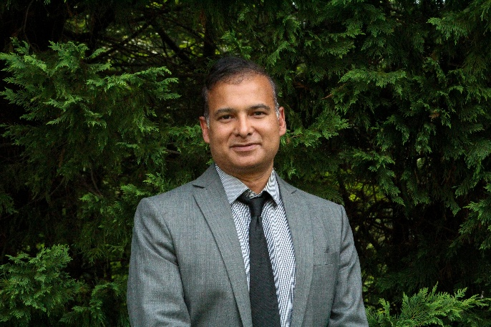 | Sebastian S. James  Professor of Public Policy, Duke University  Education  Ph.D., Harvard University (2007)  M.P.A., Harvard University (2004)  B.S., Indian Institute of Technology, Delhi (1993)  Sebastian S. James is Professor of Public Policy at the Sanford School of Public Policy at Duke University. He previously served as a Senior Economist at the World Bank, where he worked for over fifteen years. At the World Bank, he advised governments across Africa, Asia, Latin America, the Middle East, and Eastern Europe on tax policy and tax administration, with a focus on economic growth and fiscal sustainability. His work also spans the intersection of tax policy with investment, inequality, and climate change, and his research on tax incentives has been widely influential. Prior to joining the World Bank, he was a member of the Indian Revenue Service, where he held senior roles in tax administration and policy from 1996 to 2002.

