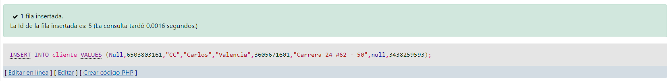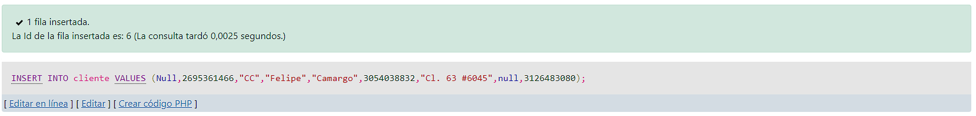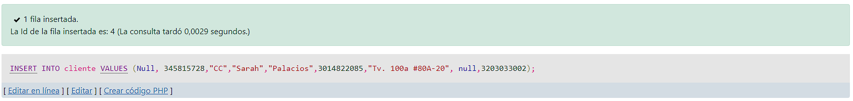

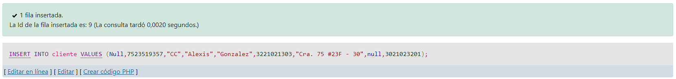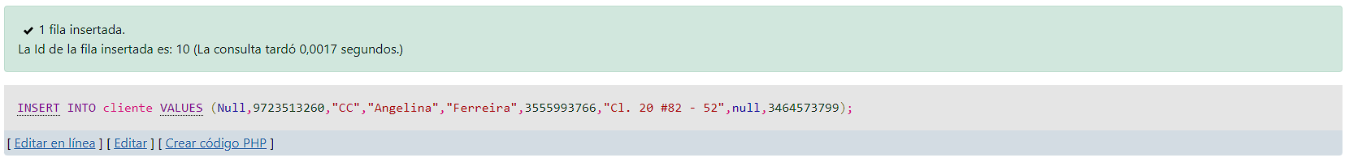

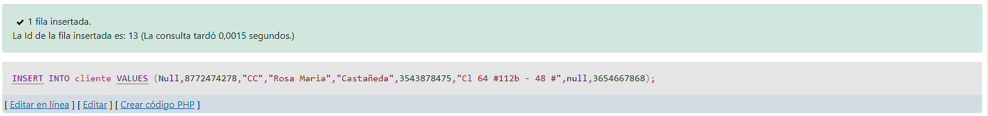

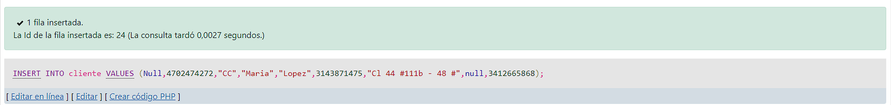

[INSERT](http://localhost/phpmyadmin/url.php?url=https://dev.mysql.com/doc/refman/8.0/en/insert.html" \t "mysql_doc) INTO cliente [VALUES](http://localhost/phpmyadmin/url.php?url=https://dev.mysql.com/doc/refman/8.0/en/miscellaneous-functions.html%23function_values) (Null, 345815728,"CC","Sarah","Palacios",3014822085,"Tv. 100a #80A-20", null,3203033002);

[INSERT](http://localhost/phpmyadmin/url.php?url=https://dev.mysql.com/doc/refman/8.0/en/insert.html) INTO cliente [VALUES](http://localhost/phpmyadmin/url.php?url=https://dev.mysql.com/doc/refman/8.0/en/miscellaneous-functions.html%23function_values) (Null,6503803161,"CC","Carlos","Valencia",3605671601,"Carrera 24 #62 - 50",null,3438259593);

[INSERT](http://localhost/phpmyadmin/url.php?url=https://dev.mysql.com/doc/refman/8.0/en/insert.html) INTO cliente [VALUES](http://localhost/phpmyadmin/url.php?url=https://dev.mysql.com/doc/refman/8.0/en/miscellaneous-functions.html%23function_values) (Null,2695361466,"CC","Felipe","Camargo",3054038832,"Cl. 63 #6045",null,3126483080);

[INSERT](http://localhost/phpmyadmin/url.php?url=https://dev.mysql.com/doc/refman/8.0/en/insert.html) INTO cliente [VALUES](http://localhost/phpmyadmin/url.php?url=https://dev.mysql.com/doc/refman/8.0/en/miscellaneous-functions.html%23function_values) (Null,5647241751,"CC","Moises","Barreto",3132195879,"Ak. 70 #74-52",null,3122062645);

[INSERT](http://localhost/phpmyadmin/url.php?url=https://dev.mysql.com/doc/refman/8.0/en/insert.html) INTO cliente [VALUES](http://localhost/phpmyadmin/url.php?url=https://dev.mysql.com/doc/refman/8.0/en/miscellaneous-functions.html%23function_values) (Null,4883680336,"CC","Bruno","Perales",3312111111,"Av. Boyacá #53-12",null,3232233321);

[INSERT](http://localhost/phpmyadmin/url.php?url=https://dev.mysql.com/doc/refman/8.0/en/insert.html) INTO cliente [VALUES](http://localhost/phpmyadmin/url.php?url=https://dev.mysql.com/doc/refman/8.0/en/miscellaneous-functions.html%23function_values) (Null,7523519357,"CC","Alexis","Gonzalez",3221021303,"Cra. 75 #23F - 30",null,3021023201);

[INSERT](http://localhost/phpmyadmin/url.php?url=https://dev.mysql.com/doc/refman/8.0/en/insert.html) INTO cliente [VALUES](http://localhost/phpmyadmin/url.php?url=https://dev.mysql.com/doc/refman/8.0/en/miscellaneous-functions.html%23function_values) (Null,9723513260,"CC","Angelina","Ferreira",3555993766,"Cl. 20 #82 - 52",null,3464573799);

[INSERT](http://localhost/phpmyadmin/url.php?url=https://dev.mysql.com/doc/refman/8.0/en/insert.html) INTO cliente [VALUES](http://localhost/phpmyadmin/url.php?url=https://dev.mysql.com/doc/refman/8.0/en/miscellaneous-functions.html%23function_values) (Null,1056457567,"CC","Irina","García",3848843546,"Cra. 101 #23-42",null,3988398865);

[INSERT](http://localhost/phpmyadmin/url.php?url=https://dev.mysql.com/doc/refman/8.0/en/insert.html) INTO cliente [VALUES](http://localhost/phpmyadmin/url.php?url=https://dev.mysql.com/doc/refman/8.0/en/miscellaneous-functions.html%23function_values) (Null,7646358956,"CC","Roberto","Castaño",3988577333,"a 63-89, Cra. 112 #63-51",null,3944943476);

[INSERT](http://localhost/phpmyadmin/url.php?url=https://dev.mysql.com/doc/refman/8.0/en/insert.html) INTO cliente [VALUES](http://localhost/phpmyadmin/url.php?url=https://dev.mysql.com/doc/refman/8.0/en/miscellaneous-functions.html%23function_values) (Null,8772474278,"CC","Rosa Maria","Castañeda",3543878475,"Cl 64 #112b - 48 #",null,3654667868);

[INSERT](http://localhost/phpmyadmin/url.php?url=https://dev.mysql.com/doc/refman/8.0/en/insert.html) INTO cliente [VALUES](http://localhost/phpmyadmin/url.php?url=https://dev.mysql.com/doc/refman/8.0/en/miscellaneous-functions.html%23function_values) (Null,4702474272,"CC","Maria","Lopez",3143871475,"Cl 44 #111b - 48 #",null,3412665868);

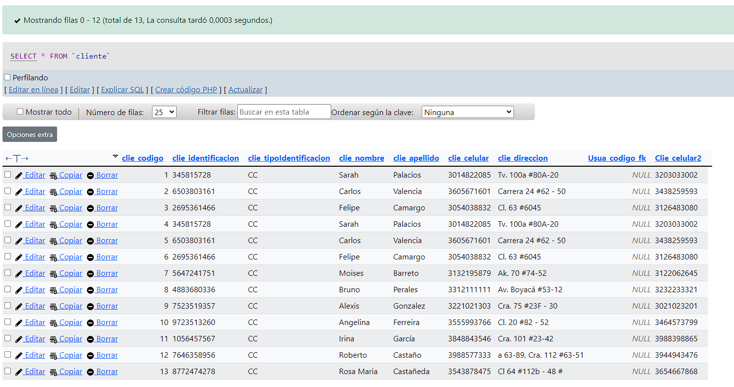

[SELECT](http://localhost/phpmyadmin/url.php?url=https://dev.mysql.com/doc/refman/8.0/en/select.html" \t "mysql_doc) \* FROM cliente  
  
  
Update  
  
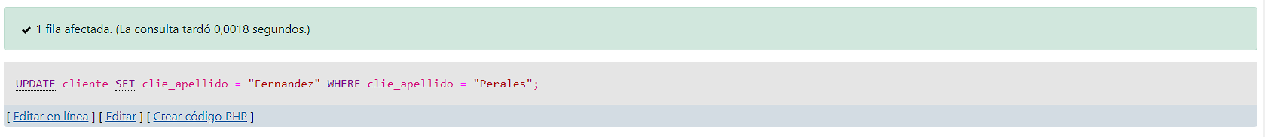  
  
[UPDATE](http://localhost/phpmyadmin/url.php?url=https://dev.mysql.com/doc/refman/8.0/en/update.html" \t "mysql_doc) cliente [SET](http://localhost/phpmyadmin/url.php?url=https://dev.mysql.com/doc/refman/8.0/en/set.html) clie\_apellido = "Fernandez" WHERE clie\_apellido = "Perales";

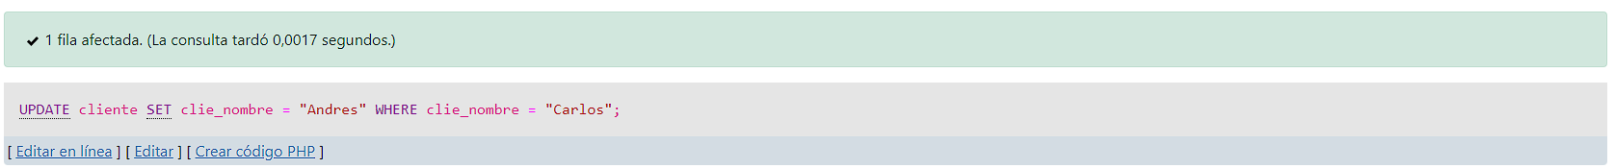  
  
[UPDATE](http://localhost/phpmyadmin/url.php?url=https://dev.mysql.com/doc/refman/8.0/en/update.html" \t "mysql_doc) cliente [SET](http://localhost/phpmyadmin/url.php?url=https://dev.mysql.com/doc/refman/8.0/en/set.html) clie\_nombre = "Andres" WHERE clie\_nombre = "Carlos";

Delete   
  
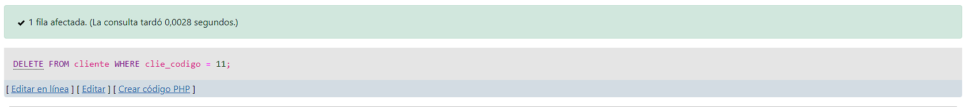

[DELETE](http://localhost/phpmyadmin/url.php?url=https://dev.mysql.com/doc/refman/8.0/en/delete.html" \t "mysql_doc) FROM cliente WHERE clie\_codigo = 11;

Consultas generales y especificas:

[SELECT](http://localhost/phpmyadmin/url.php?url=https://dev.mysql.com/doc/refman/8.0/en/select.html) \* FROM cliente WHERE 1;

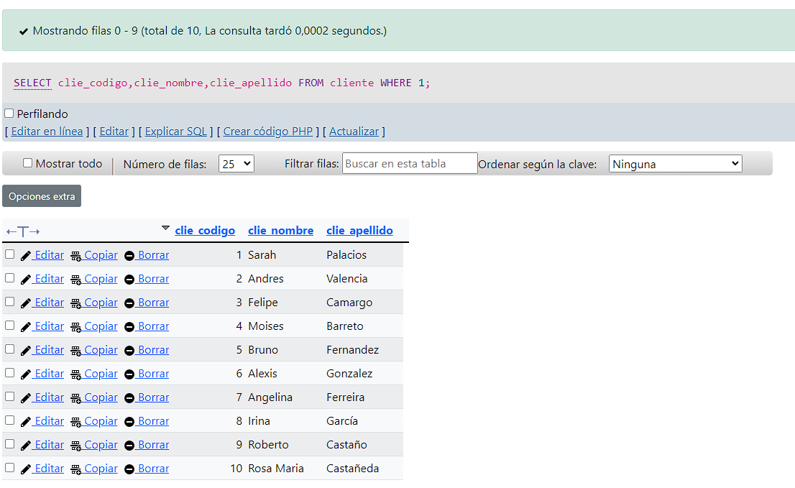

[SELECT](http://localhost/phpmyadmin/url.php?url=https://dev.mysql.com/doc/refman/8.0/en/select.html) clie\_codigo,clie\_nombre,clie\_apellido FROM cliente WHERE 1;

Inner Join  
[SELECT](http://localhost/phpmyadmin/url.php?url=https://dev.mysql.com/doc/refman/8.0/en/select.html) \* FROM venta INNER JOIN Cliente ON venta.Clie\_codigo\_fk = cliente.clie\_codigo;

[SELECT](http://localhost/phpmyadmin/url.php?url=https://dev.mysql.com/doc/refman/8.0/en/select.html) \* FROM cliente INNER JOIN usuario ON cliente.Usua\_codigo\_fk = usuario.Usua\_codigo;

[SELECT](http://localhost/phpmyadmin/url.php?url=https://dev.mysql.com/doc/refman/8.0/en/select.html) \* FROM producto INNER JOIN detalle\_venta ON producto.Prod\_codigo = detalle\_venta.Prod\_codigo\_fk;

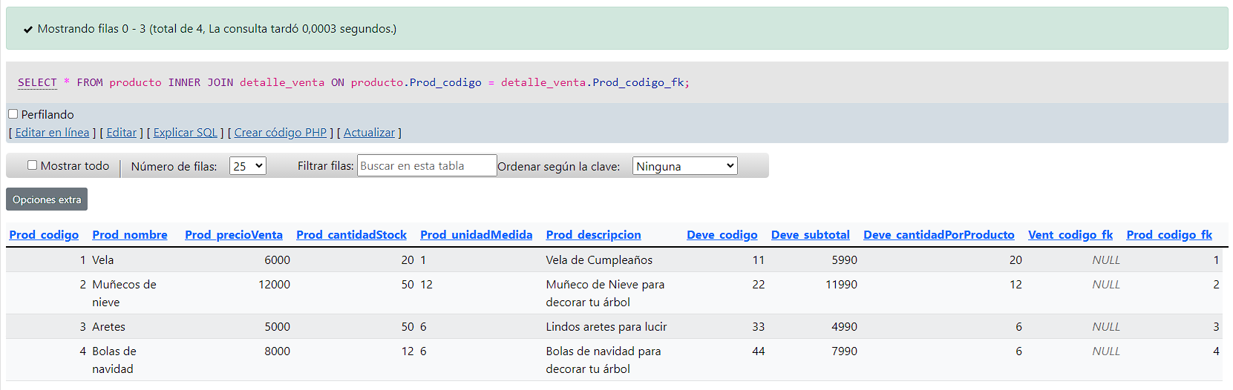

Procedimiento almacenado

CREATE PROCEDURE cliente () SELECT clie\_codigo,clie\_nombre,clie\_apellido,clie\_celular FROM cliente WHERE 1;

[CALL](http://localhost/phpmyadmin/url.php?url=https://dev.mysql.com/doc/refman/8.0/en/call.html) cliente ();