**Round 2**

### Experiment: Balancing of multiple masses in multiple planes

**1. Story Outline:**

In most of the machineries, rotating components are very common. For any given rotating component, it is required that the centre of gravity coincide with the axis of rotation. However, this may not always be possible due to various factors such as manufacturing defects, wear and tear, environmental conditions, addition of parts etc., causing eccentricity. The eccentricity results in vibrations within the component and may finally cause failure. This eccentricity in the rotating component is considered to be unbalance in force and moment, and needs to be balanced by additional forces and moments leading to minimum vibration.[1]

The balancing of rotating mass in multiple plane along the length of a shaft is a particular case of unbalance. An experiment is carried out to calculate additional masses required for balancing the unbalanced force and moment and their angular position. The purpose of the experiment is to take an unbalanced system with rotating masses and adjust the radii of the two outer masses, calculate their mass and angular positions in order to achieve a balanced system.[1]

**2. Story:**

**2.1 Set the visual stage description:**

The experiment consists of a rotating shaft with two unbalanced masses in different planes, in Front view and Side view, both on the left-hand side of the simulator. The values of the unbalanced masses, their radii of rotation, angular positions and distance between their planes of rotation can be controlled by slider knobs available on the right-hand side of the simulation window.

Front view consists of a rotating shaft represented in blue colour, two rotating unbalanced masses represented in blue colour, rigid rods connecting the unbalanced masses to the shaft represented in magenta colour. The supports of the shaft are represented in yellow colour.

In side view visualisation, the radii of rotation or the lengths of the rigid rods in magenta colour as well as the angle between them can be seen as per the values set by the user. In front view visualization, the distance between the planes of the rotating masses can be seen as per the value set by the user.

Upon submission of the calculated balancing masses and their position, the masses and rigid rods appear in both the views. The balancing masses are represented in brown colour and rigid rods are represented in green colour. The answers are also displayed at the bottom of the simulation window. The angle between each link can be seen after the simulation is paused with the help of coloured arc between the links and the value of which is displayed on the top of the screen.

**2.2 Set User Objectives & Goals:**

* State the reasons for balancing of rotating mass
* Describe conditions to be satisfied to achieve balance in rotating bodies, understand its working and uses.
* Apply the mathematical equations acting on the rotating body.
* Examine and compare the calculated values with the simulation.
* Evaluate how change in mass and position can improve the balance of the rotating body.
* Attempt assessment questions.

**2.3 Set the pathway activities:**

**2.4 Set Challenges and Questions/Complexity/variation**

**Pre-test:**

1. What are the necessary conditions in order to have a complete balance of the several revolving masses in different planes? Which of the following statements are correct?
2. The couples about the reference plane must balance
3. The forces in the reference plane must balance
4. The statement B
5. The statement A
6. The statements A & B
7. None of the above

Answer: C

1. Rotation in different planes require the balancing of-
2. Force
3. Moment
4. Both
5. None of these

**Answer:** C

1. Cause of unbalance-
2. Eccentricity
3. Moment of inertia
4. Angular of Velocity
5. Large diameter of rotor

**Answer:** A

1. Which of the following statements is correct about the balancing of a mechanical system?  
   A) If it is under static balance, then there will be dynamic balance also  
   B) If it is under dynamic balance, then there will be static balance also  
   C) Both static as well as dynamic balance have to be achieved separately  
   D) None of the mentioned

**Answer:** C

**Post-test:**

1. Which of the following statements are associated with complete dynamic balancing of rotating systems?
2. The system is automatically statically balanced.
3. Resultant couple due to all inertia forces is zero.
4. Centre of masses of the system lies on the axis of rotation.
5. Support reactions due to forces are zero but not due to couples.
6. A, C and D only
7. A, B, C and D
8. B, C and D only
9. A, B and C only

Answer: a

### An important assumption made by this technique of calculating balancing of masses is that:

1. vibration amplitude is inversely proportional to the force producing the vibration
2. vibration amplitude is equal to the force producing the vibration
3. vibration amplitude is proportional to the force producing the vibration
4. None of the above

Answer: c

1. Rotation in different planes require the balancing of-
2. Force
3. Moment
4. Both
5. None of these

**Answer:** C

1. Gear box is an example of-
2. Balancing in one plane
3. Balancing in different plane
4. Reciprocating balancing
5. None of these

**Answer:** B

1. In balancing of multiple mass in multiple plane, the net force and moment should be-
2. Net force > net moment
3. Net moment > net force
4. Net force = 0, net moment ≠ 0
5. Net force = 0, net moment = 0

**Answer:** D

1. A rotating shaft carries four masses A, B, C and D which are radially attached to it. The mass centres are 30 mm, 38 mm, 40 mm and 35 mm respectively from the axis of rotation. The masses A, C and D are 7.5 kg, 5 kg and 4 kg respectively. The axial distances between the planes of rotation of A and B is 400 mm and between B and C is 500 mm. The masses A and C are at right angles to each other. Find for a complete balance,

1. the angles between the masses B and D from mass A,

2. the magnitude of mass B.

A)162.5° and 9.24 kg

B) 175.5° and 10.24 kg

C) 152.5° and 9.5 kg

D) 160° and 10.24 kg

Answer (A)

1. Four masses m1, m2, m3 and m4 are 200 kg, 300 kg, 240 kg and 260 kg respectively. The corresponding radii of rotation are 0.2 m, 0.15 m, 0.25 m and 0.3 m respectively and the angles between successive masses are 45°, 75° and 135°. Find the position and magnitude of the balance mass required, if its radius of rotation is 0.2 m.
2. 110 kg and 250.44°
3. 116 kg and 201.48°
4. 120 kg and 240.11°
5. 122 kg and 200°

Answer: (B)

**2.5 Allow pitfalls: NA**

**2.6 Conclusion:**

Time required to perform the virtual experiment.

The approximate time required to understand the procedure to perform the experiment would take about 5 min. The time required to enter the input variables and calculate the unbalanced masses is 15 min. Thus, if the calculated answers are correct, the total time required to perform the experiment will be around 20 min.

**2.7 Equations/formulas:**

Consider m1 and m2 to be the unbalanced masses of a rotating shaft with distances r1 and r2 from its axis of the rotation. The angle between them is θ1 and distance between their planes is l1. If ra and rb are the given distances of the balancing masses from the axis of rotation, la and lb are the distances of their rotating planes from the plane of mass m1, then the balancing masses ma and mb can be calculated by considering force and moment equilibrium, assuming that the rotational speed ‘’ of the shaft is constant.

For balancing of masses, the sum of all the forces and moments should be equal to zero.

**(i) Forces:**

**(ii) Moment:**

SOURCE:Theory-of-Machines-14th-ed-Khurmi-2005 (2)

**3. Flowchart:**

**4. Mindmap:**

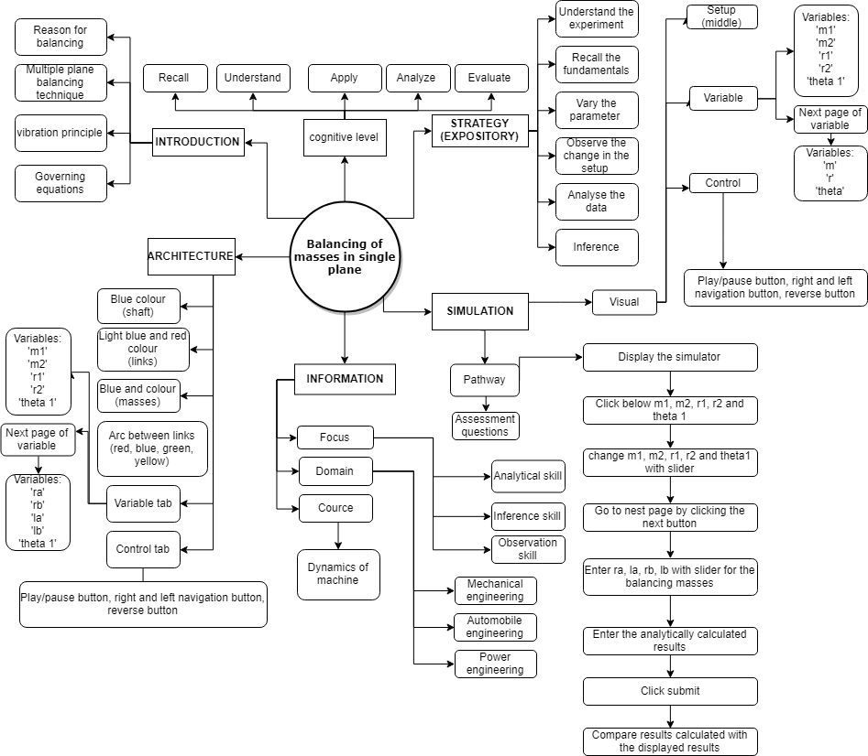

**5. Storyboard:**

* 1. In the simulation window, the front view and side view of a rotating shaft with two unbalanced masses in different planes are displayed.
  2. There are pointers given on right side of the screen for choosing the values of input variables, viz., two unbalanced masses on the shaft (m1, m2), their radii of rotation (r1, r2), relative angular position (theta1) and distance between their planes (l1). The variables can be set by moving the slider left or right. After setting these variables, it is required to move on to the next pane by clicking on navigation button at the bottom right corner.

* 1. After moving on to the next pane, the radii and positions of the balancing masses have to be entered by adjusting the pointer. After setting the values, it is required by the user to calculate the values of balancing masses and their angular position.

* 1. Once the values of masses and their angular position from the previous step are calculated, the user needs to navigate to the next pane, enter the values in the boxes provided, balancing masses with their angular positions is displayed instantly.

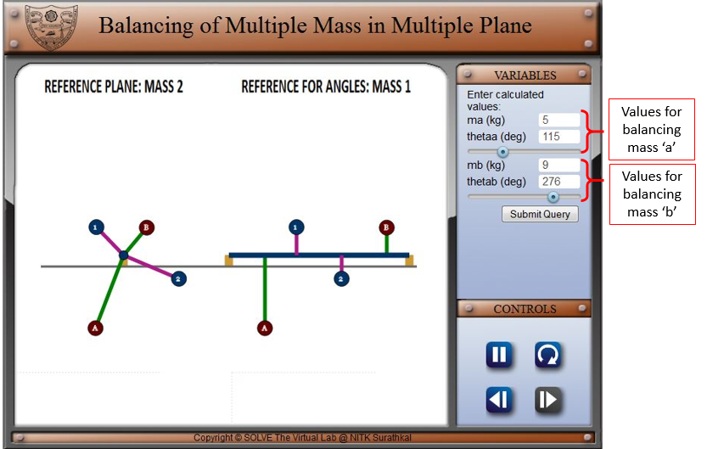

1. Click on the submit button to submit the results and press play/pause button to pause the simulation, direction change button to reverse the direction of rotating masses.

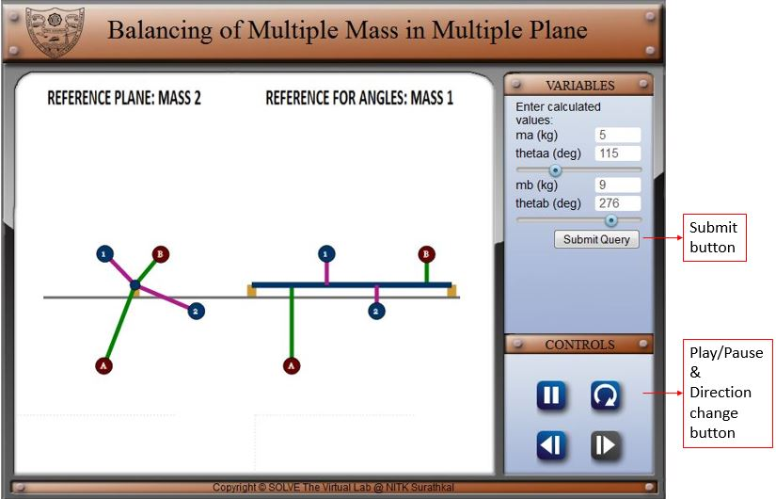

* 1. Further, it can be noted that, the correct values of balancing masses and their angular positions as calculated by the system is also displayed at the bottom of the simulation window.

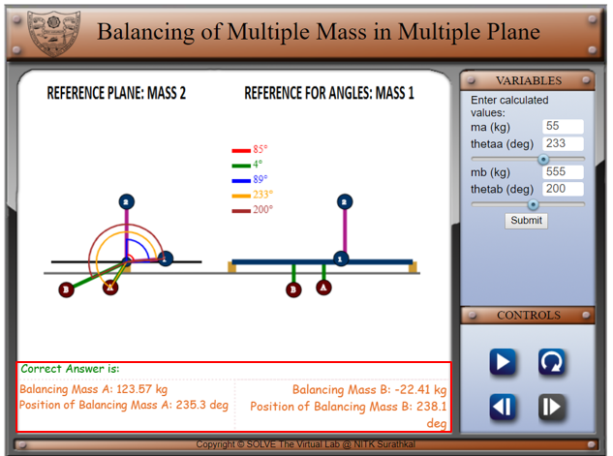

**REFERENCE:**

[1] Theory-of-Machines-14th-ed-Khurmi-2005 (2)