# 1.远程依赖

Add it in your root build.gradle at the end of repositories:

**allprojects {**

**repositories {**

**...**

**maven { url 'https://www.jitpack.io' }**

**}**

**}**

Step 2. Add the dependency

**dependencies {**

**implementation 'com.github.NBXXF:xxf_styles:1.0.0'**

**}**

# 2.标准色

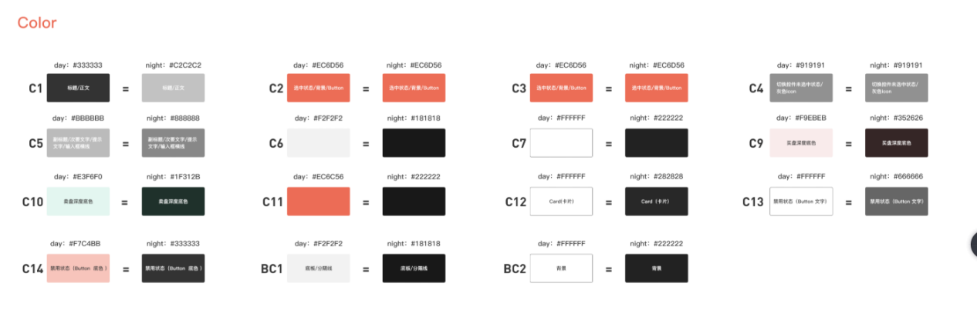

<**color name="C1"**>#333333</**color**>  
<**color name="C2"**>#EC6D56</**color**>  
<**color name="C3"**>#EC6D56</**color**>  
<**color name="C4"**>#919191</**color**>  
<**color name="C5"**>#BBBBBB</**color**>  
*<!--线的颜色-->*<**color name="C6"**>#F2F2F2</**color**>  
<**color name="C7"**>#FFFFFF</**color**>  
<**color name="C9"**>#F9EBEB</**color**>  
<**color name="C10"**>#E3F6F0</**color**>  
<**color name="C11"**>#EC6D56</**color**>  
<**color name="C12"**>#FFFFFF</**color**>  
<**color name="C13"**>#FFFFFF</**color**>  
<**color name="C14"**>#F7C4BB</**color**>  
*<!--背景色-->*<**color name="BC1"**>#F2F2F2</**color**>  
<**color name="BC2"**>#FFFFFF</**color**>

# Button

# EditText

# 分割线

# Tab

# Segment

# 单选按钮

# 多选按钮