Solution: Your first React Native component

Overview
In the preceding exercise, you created a reusable React component for the Little Lemon mobile app. Here is the solution code for the exercise to assist you on your learning journey.

Procedure

Step 1: Create Footer Component
Create a LittleLemonFooter and LittleLemonHeader component in the new files within the components folder.
This component will print the text needed for the footer.

components/LittleLemonHeader.js
import * as React from 'react';
import { View, Text } from 'react-native';

export default function LittleLemonHeader() {
return (
<View>
<Text>
Welcome to Little Lemon
</Text>
</View>
);
}

components/LittleLemonFooter.js

import * as React from 'react';
import { View, Text } from 'react-native';

export default function LittleLemonFooter() {
return (
<View>
<Text>
All rights reserved by Little Lemon, 2022{' '}
</Text>
</View>
);
}

Step 2: Style Header and Footer Component
Below you'll find the code used to style the header and footer component.
…
export default function LittleLemonFooter() {
return (
<View
style={{
backgroundColor: '#F4CE14',
marginBottom: 10,
}}>
<Text
style={{
fontSize: 18,
color: 'black',
textAlign: 'center',
}}>
All rights reserved by Little Lemon, 2022{' '}
</Text>
</View>
);
}
…
export default function LittleLemonHeader() {
return (
<View style={{ flex: 0.2, backgroundColor: '#F4CE14' }}>
<Text style={{ padding: 40, fontSize: 30, color: 'black' }}>
Welcome to Little Lemon
</Text>
</View>
);
}

Step 3: Call Header and Footer Component from App Component
Finally, you’ll need to call the footer component from the App component by applying the following code:
import * as React from 'react';
import { View } from 'react-native';
import LittleLemonHeader from './components/LittleLemonHeader'
import LittleLemonFooter from './components/LittleLemonFooter';
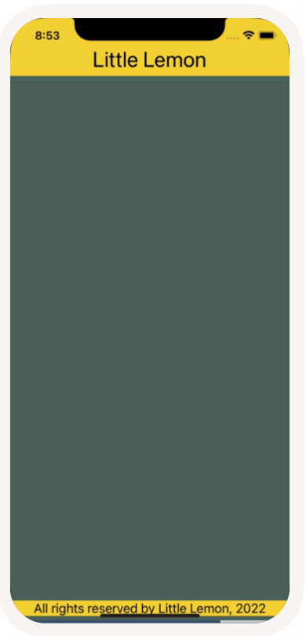
export default function App() {
return (
<>
<View
style={{
flex: 1,
backgroundColor: '#495E57',
}}>
<LittleLemonHeader />
</View>
<View style={{ backgroundColor: '#495E57' }}>
<LittleLemonFooter />
</View>
</>
);
}
The code above produces the following output on the emulator:

