Nicole Model

* Create US structure based on the US EPA’s integrated planning model (IPM)
  + 64 zones
* NREL ATB 2021 Cost Assumptions with Moderate Cost case and Market Financial scenario
  + Except NGCCS – Conservative cost case – 90% capture rate assumed
  + WACC – 4.5%
  + Capital Recovery Period – 20 yrs
    - NG, Batteries – 15 yrs
    - Nuclear – 40 yrs
  + Regional Cost multipliers from EIA’s Annual Energy Outlook (2021)
* Power Sector Technology Details
  + 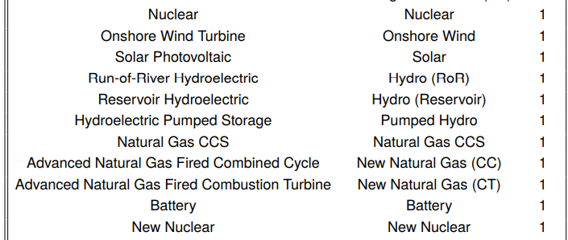
  + 
  + ^^^ All tech with only one type
  + 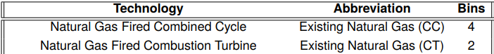
  + 
  + ^^^ Tech with multiple bins
  + New Tech
    - NGCC, NGCT, NGCCS, Battery, New Nuclear, New Utility PV, New Onshore, New Offshore
* Hydrogen Tech Details
  + 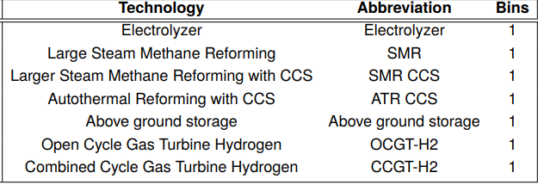
* Carbon Capture Sector Details
  + 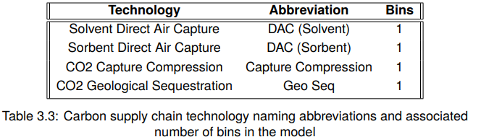
* Bio Energy Tech
  + 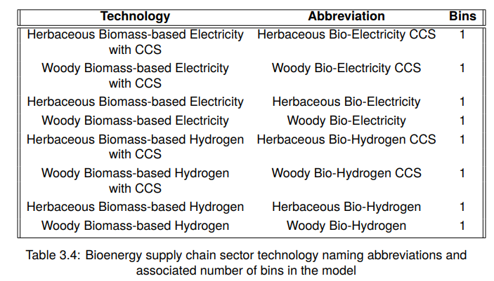
* Extra Notes
  + Lifetime extensions for Nuclear based on IRA
  + Lifetimes for NG based on ReEDS inputs
  + PHS has a charge/discharge eff. Of 86.6% - max stor duration of 200 hrs
* Brownfield power sector characteristics
  + 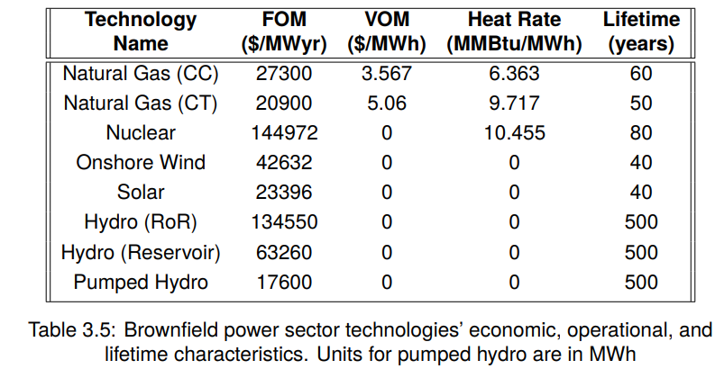

VRE Info

* Hourly Capacity factor profiles, interconnection costs, and max capacity for greenfield solar and wind in each model region using Brown and Botterund
  + Historical weather data from 2007-2013 from NSRDB and WIND Toolkit
  + Divide region into 4x4km grids, get hourly windspeeds and irradiance and use them to get hourly capacity factors using power curves from selected technology types
    - 100-m Gamesa:G126/2500 turbines for wind
    - 1-axis-tracking panels for solar (which type?)
  + Recompile regions based on weight of an area (scaled with land use limits)
* Interconnection Costs per bin are scaled using annualized transmission costs and developable area multiplied by areal density per technology
* ROR Hydro and Offshore CF’s
  + PowerGenome – adjusts EIA data for monthly hydro cf using a 2 week rolling average
    - Removes sharp edges month to month
  + Offshore CF’s are from Vibrant Clean Energy? – 2012 weather year

Greenfield Tech’s

* Costs + Operational features of tech taken for 2045 yr
  + 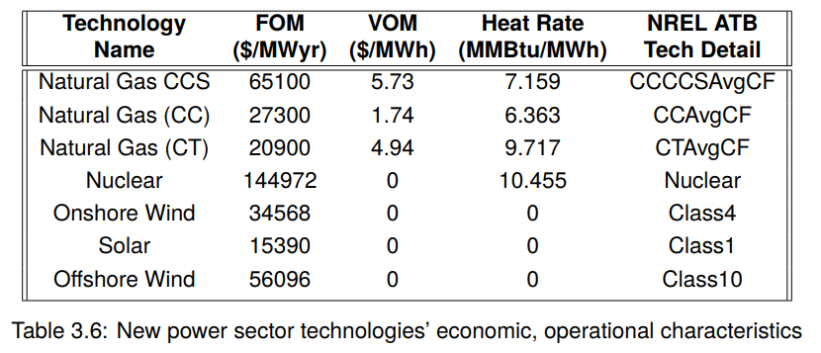
  + Battery technology has a FOM of 4633.55 $/MWyr and 2823.34 $/MWhyr. It is assumed to have a charge/discharge efficiency of 92.0%, a minimum storage duration of 1 hour, and a maximum storage duration of 200 hours
* Electrolyzer characteristics are from the IEA’s Future of Hydrogen report and are assumed to have a lifetime of 20 years; the FOM is calculated based on stack replacement[30]. Characteristics for all other hydrogen generators are based on NETL’s 2022 assessment and are assumed to have a lifetime of 25 years[39]. Hydrogen gas to power technology characteristics in Table 3.8) are based on NREL ATB 2021[7]. Compressor and storage characteristics in Table 3.9 are from Argonne National Laboratory analysis[47].
  + 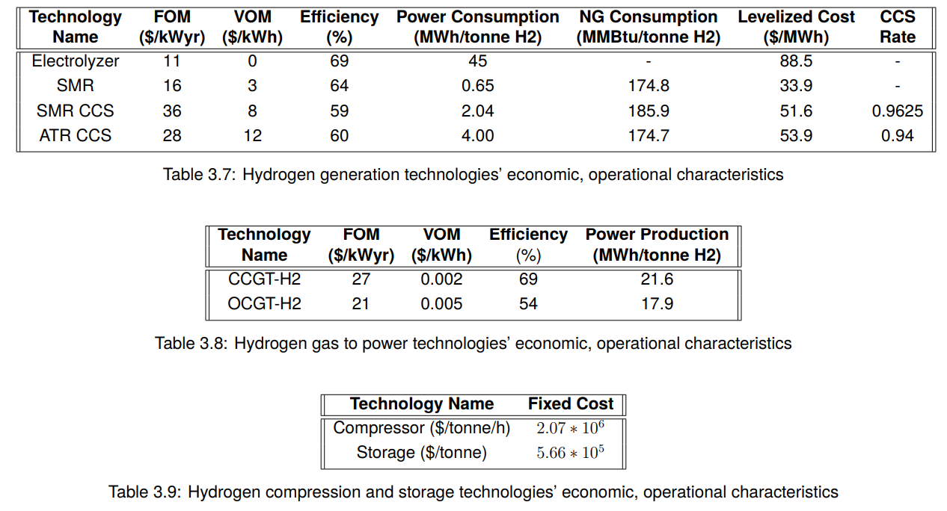
* Carbon supply chain costs and parameter assumptions are included in Table 3.10. The levelized cost of CO2 capture assumes electricity costs 60 $/MWh, natural gas costs 4.4 $/MMBtu natural gas, and a capacity factor of 90%. DAC characteristics are based on NETL’s 2022 Direct Air Capture Studies[33, 34]. Geological sequestration characteristics are from a National Academics of Sciences, Engineering, and Medicine consensus study report[45].
  + 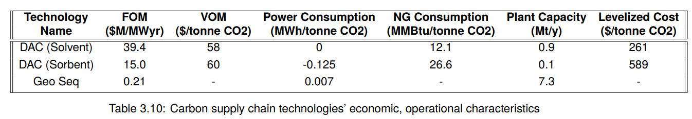
* Bioenergy supply chain costs and parameter assumptions are included in Table 3.11 and are based on analysis from researchers at Princeton[22]. The levelized cost of bioenergy assumes woody biomass costs 135 $/tonne, herbaceous biomass costs 143 $/tonne, and a capacity factor of 90%. The cost of CO2 capture is calculated by the difference between the levelized cost of bioenergy with and without CCS divided by the amount of CO2 captured.
  + 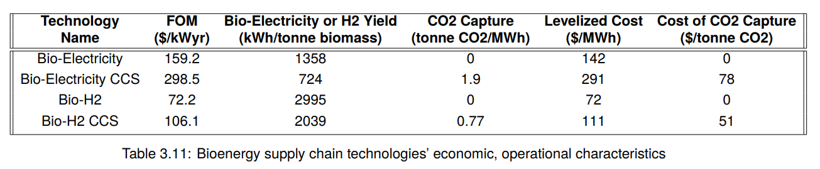
* Fuel
  + EIA AEO 2020 report
  + Nuclear Fuel Cost – 0.73 $/MMBtu
  + NG Emissions – 0.05306 tons/MMBtu (Form EIA-923)
  + 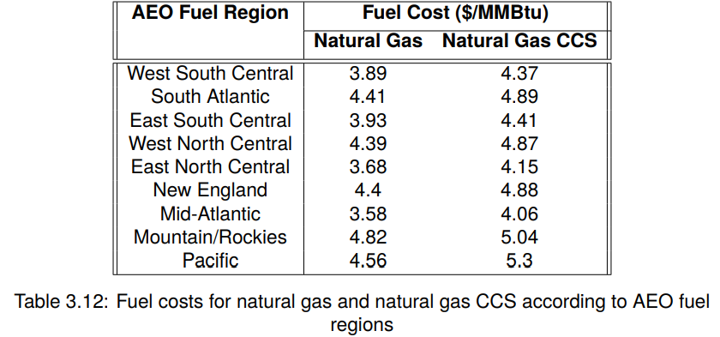
* CF
  + 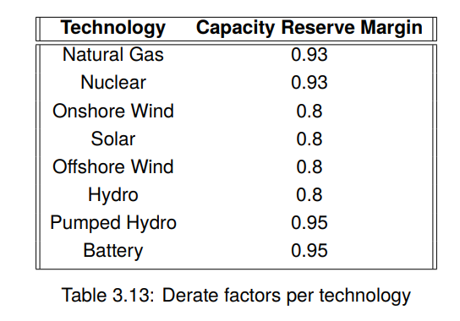
  + 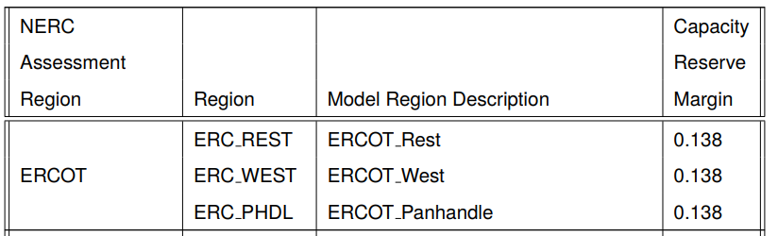
* Electricity Demand
  + EFS – 2050 end-use electricity demand under high electrification and moderate tech advancement
    - Repeated 7 times
  + We convert the state-level load to the county-level load by population; specifically, we use the proportion of county population to state population from 2021 US Census Bureau data[15]. Since county boundaries map to IPM regional boundaries, we obtain IPM-level load by summing the county-level load of counties within each IPM region.
* Hydrogen Demand
  + High electrification for 2050 – Same county based method used as in Electricity Demand
    - Princeton NZA

Transmission

* Existing EIA IPM infrastructure
  + Pipeline for hydrogen and carbon is assumed to have the same mapping
  + Maximum allowable capacity addition to existing transmission calculated as multiplies of existing capacity
  + Line length in miles is calculated as the distance between centroids of regions
    - Line loss = 0.01 / 100 miles
    - Transmission Cost ($/MW/mile) – based on data for ReEDS regions
      * Converted to IPM from EIA from weighted area of overlap between two regional levels
    - Derating – 0.95
* Hydrogen Pipelines
  + 1.39 $M/mile and a power requirement of 0.29 MWh/tonne
* CO2 pipelines
  + Investment Cost of $2.65 M/mile, FOM of 0.21 $M/yr, capacity of 10 Mt/yr