Local Admins domain Policy

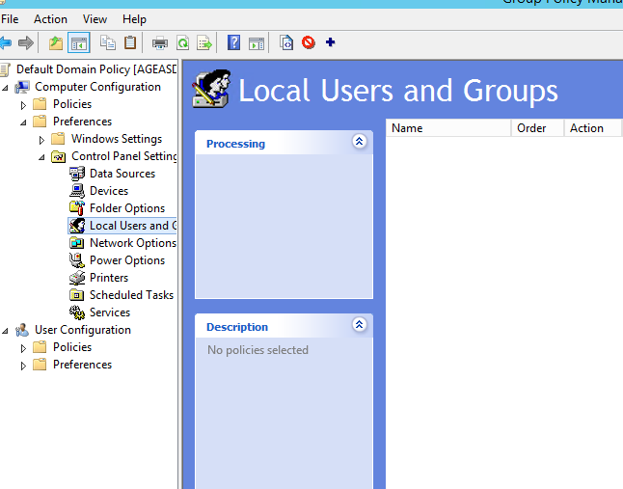

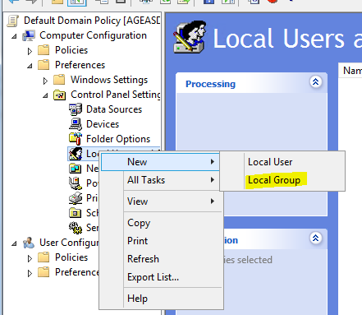

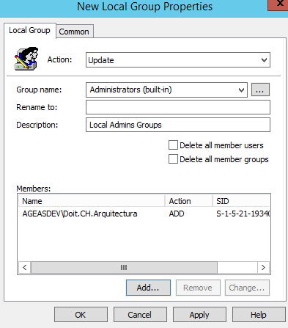

Validação policy (noutro posto)

C:\>net localgroup administrators

Alias name administrators

Comment Administrators have complete and unrestricted access to the computer/domain

Members

-------------------------------------------------------------------------------

ageasadmin

AGEASDEV\Domain Admins

The command completed successfully.

C:\>gpupdate /force

Updating policy...

Computer Policy update has completed successfully.

User Policy update has completed successfully.

C:\ net localgroup administrators

Alias name administrators

Comment Local Admins Groups

Members

-------------------------------------------------------------------------------

ageasadmin

AGEASDEV\Doit.CH.Arquitectura

AGEASDEV\Domain Admins

The command completed successfully.