Ping An Bank (000001.SZ) FY2025 Earnings Update
Rating: HOLD | Price Target: RMB 12.50

Executive Summary
Ping An Bank reported FY2025 results on March 20, 2026, with both revenue and net profit declining year-over-year, broadly in line with the weak sector backdrop. Revenue of RMB 131.4bn missed consensus by ~4.0%, while net profit of RMB 42.6bn missed by ~3.0%. The bank continues to navigate a challenging rate environment with NIM compression, but showed encouraging signs on asset quality stabilization and cost discipline.

Key Takeaways
- Revenue miss on NIM pressure: FY2025 revenue fell 10.4% YoY to RMB 131.4bn, below consensus of RMB 136.9bn, dragged by NIM contraction to 1.78% (-9bps YoY)
- Profit resilient on provision release: Net profit declined 4.2% YoY to RMB 42.6bn, supported by a 17.9% YoY reduction in credit impairment losses
- Asset quality stable: NPL ratio ticked down 1bp YoY to 1.05%; retail NPLs improved with mortgage NPL at 0.41%
- Balance sheet expansion muted: Total assets grew 2.7% YoY to RMB 5.93tn; loan growth slowed to 0.5% as the bank prioritizes quality over quantity
- Valuation remains depressed: Trading at 0.48x P/B and 5.0x P/E with a ~6% dividend yield; downside appears limited but re-rating catalysts are lacking

Results Snapshot
Metric | Actual | Consensus | Beat/Miss
Revenue (RMB bn) | 131.4 | 136.9 | -4.0%
Net Profit (RMB bn) | 42.6 | 43.9 | -3.0%
NIM (%) | 1.78 | 1.82 | -4bps
NPL Ratio (%) | 1.05 | 1.06 | -1bp

Detailed Results Analysis

Revenue: Double-Digit Decline on NIM Compression
FY2025 operating revenue of RMB 131.4bn declined 10.4% YoY, a slight improvement from the 10.9% drop in FY2024 but still reflecting significant top-line pressure. The miss versus consensus (RMB 136.9bn) was driven primarily by weaker-than-expected net interest income.

- Net interest income: RMB 88.0bn (-5.8% YoY), accounting for 67% of total revenue. NIM compressed 9bps to 1.78%, reflecting the industry-wide loan repricing cycle and LPR cuts.
- Non-interest income: RMB 43.4bn (-18.5% YoY), weighed by weak wealth management fees and reduced credit card commissions. However, bond trading gains provided partial offset.
- Quarterly trajectory: Q4 revenue of RMB 30.8bn was the weakest quarter, down 12.4% YoY, suggesting no clear inflection yet on the top line.

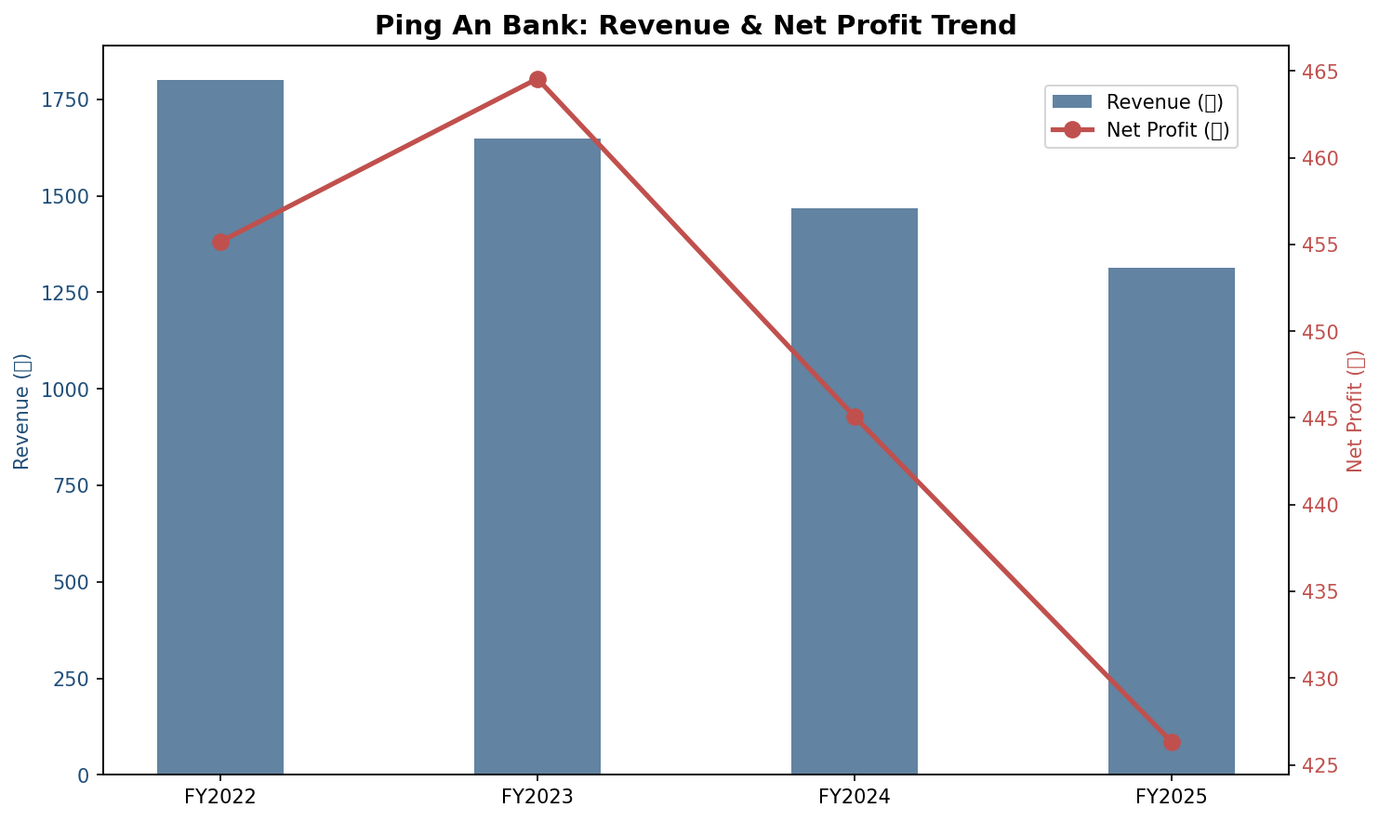

Profitability: Cost Cuts and Provision Release Offset Revenue Weakness
Net profit of RMB 42.6bn declined 4.2% YoY, matching the FY2024 pace. While disappointing versus consensus (RMB 43.9bn), the bank demonstrated disciplined cost and risk management.
- Cost-to-income ratio: Rose modestly to 29.06% (+1.4pp YoY), as the bank invested in technology and streamlined operations while revenue contracted faster.
- Credit impairment: Dropped 17.9% YoY to RMB 40.6bn, releasing RMB 8.9bn of provisioning buffer. This was the single largest contributor to profit resilience.
- ROE: Estimated ~9.2%, down from prior years but still respectable within the sector. ROA held at 0.76%.

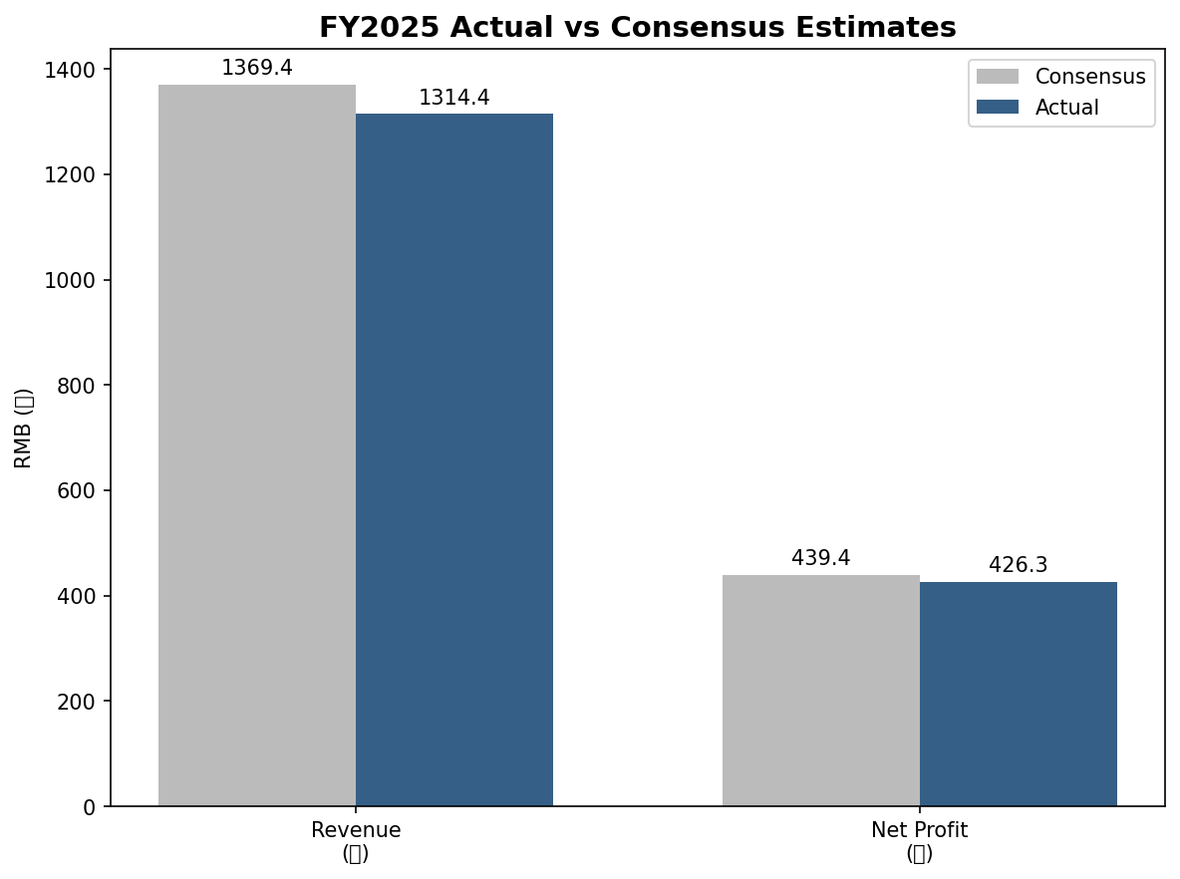

Asset Quality and Balance Sheet

Asset Quality: Stabilizing but Not Out of the Woods
Asset quality was a relative bright spot. The NPL ratio improved 1bp YoY to 1.05%, while the provision coverage ratio declined 29.8pp to 220.9% as the bank released excess reserves.
- Retail loans: Personal loan NPL ratio improved to 1.32% (-7bps YoY), with mortgage NPL at a low 0.41%. Credit card NPL remained elevated at 2.40% but stable.
- Corporate loans: Corporate NPL ticked up slightly; real estate-related exposures remain a key watch item given sector stress.
- Write-offs: The bank wrote off RMB 170.7bn of NPLs in FY2025 and recovered RMB 9.4bn of distressed assets, with cash recovery at 97.3%.

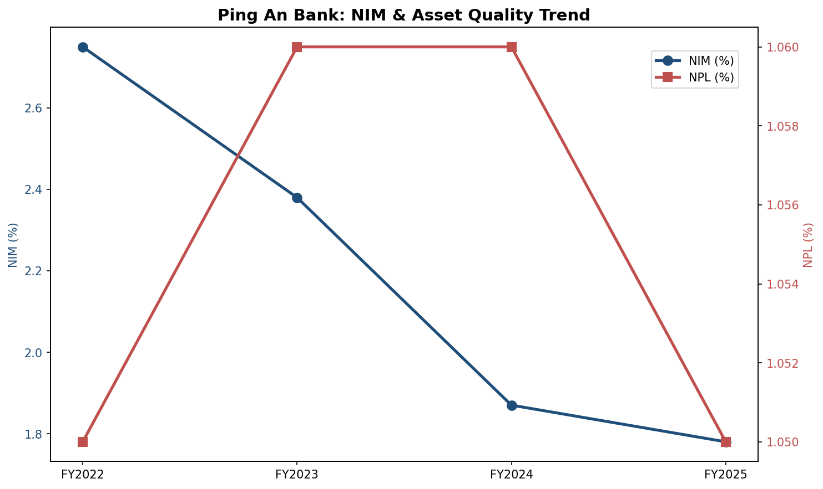

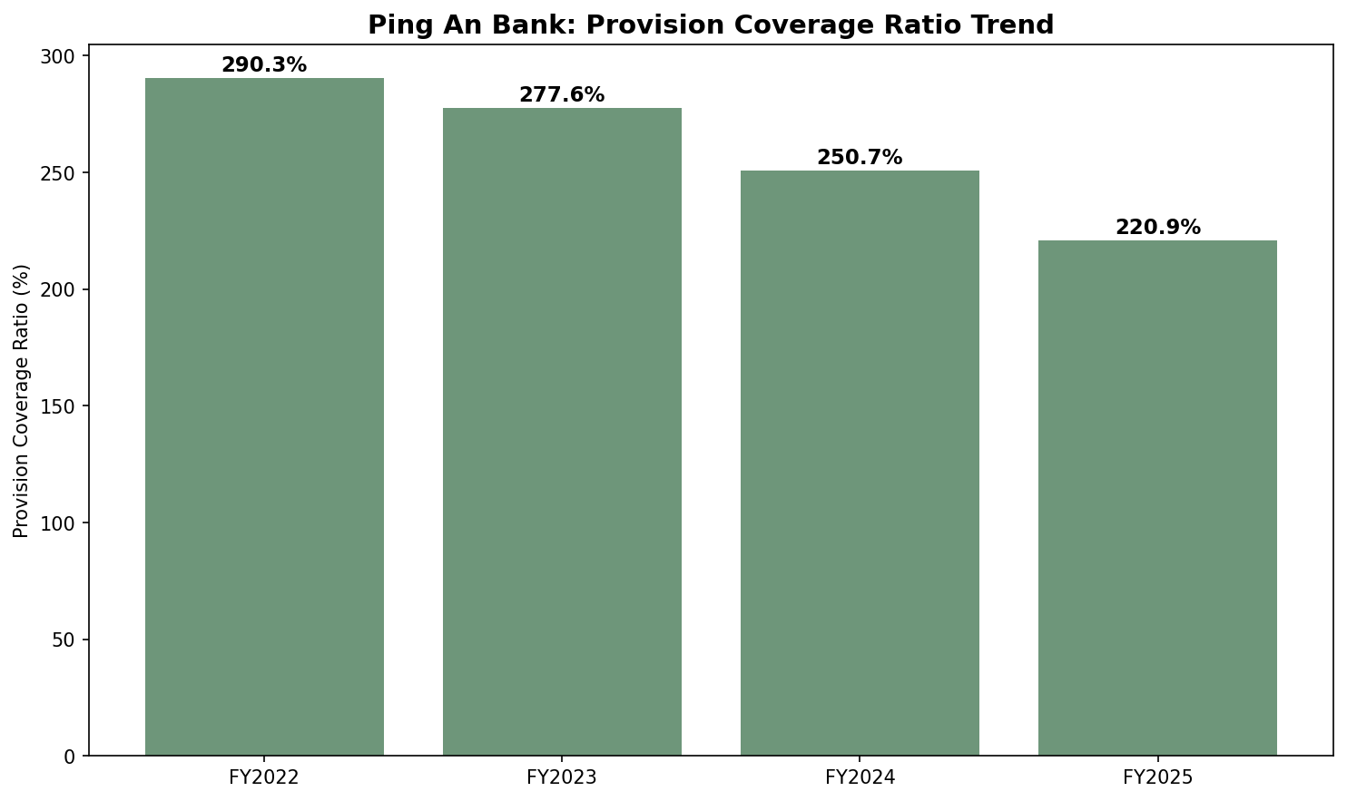

Segment Analysis

Retail: Shrinking but Higher Quality
Retail loans declined 2.3% YoY to RMB 1.73tn as the bank deliberately scaled back high-risk unsecured lending. The share of secured loans (mortgage and auto-backed) rose to 62.9%, improving overall portfolio risk.
- AUM: Retail AUM grew 1.1% YoY to RMB 4.24tn. Private banking clients increased 9.1% to 105,600 households, a positive signal for fee income potential.
- Deposits: Personal deposits grew with demand CASA up 12.9%, driving the retail deposit cost down 36bps to 1.82%.

Corporate: Steady Growth in Target Sectors
Corporate loans grew 3.5% YoY to RMB 1.68tn, with focused deployment into manufacturing, technology, and green finance.
- Green finance: Green loan balance reached RMB 247.1bn (+4.0% YoY), aligned with national policy priorities.
- Manufacturing: Medium- and long-term manufacturing loans rose 6.0%, reflecting the bank's strategic pivot toward real economy lending.

Guidance and Forward Outlook

Management Guidance
- No explicit quantitative FY2026 guidance was provided, but management signaled continued focus on "quality over quantity" and structural optimization.
- NIM pressure expected to persist but moderate as deposit repricing catches up with loan repricing.
- Asset quality: Management expects retail NPLs to continue improving as the high-risk book runs off.

Analyst Estimates Revisions
Following the FY2025 results, we expect modest downward revisions to FY2026 earnings estimates. Current street estimates likely embed a revenue recovery to ~RMB 132-135bn and net profit of RMB 41-43bn for FY2026.
- Key variables: (1) Pace of NIM stabilization; (2) Credit cost normalization; (3) Wealth management fee recovery tied to capital markets sentiment.

Investment Thesis Update

What Has Changed
- Negative: Revenue decline persists with no clear inflection point. Q4 weakness suggests the bottom may not yet be in.
- Negative: Provision release is not sustainable indefinitely; credit costs may normalize upward in FY2026.
- Positive: Retail risk detox is progressing; secured lending mix improvement should support long-term asset quality.
- Positive: Liability cost management is effective, with deposit costs falling meaningfully.

Key Risks
- Macro: Further LPR cuts or property sector stress could deepen NIM compression and credit losses.
- Structural: Revenue growth engine unclear; wealth management recovery is contingent on market conditions.
- Execution: Balancing "quality" growth with shareholder returns may prove difficult if top line remains weak.

Key Catalysts
- NIM stabilization or sequential improvement in quarterly revenue growth.
- Capital markets recovery driving AUM and fee income rebound.
- Potential dividend policy enhancement given low payout ratio relative to peers.

Valuation and Price Target
Ping An Bank trades at 0.48x P/B and 5.0x P/E (TTM), near historic lows. The valuation appears to price in a prolonged earnings decline, offering downside protection but limited near-term upside catalysts.

Valuation Metrics
Metric | Current | Sector Avg
P/B (MRQ) | 0.48x | ~0.55x
P/E (TTM) | 5.0x | ~5.5x
Dividend Yield | ~6.0% | ~5.5%
ROE | ~9.2% | ~10.0%
NIM | 1.78% | ~1.85%

Price Target Derivation
Our price target of RMB 12.50 is based on 0.55x FY2026E P/B, implying a slight discount to sector average to reflect below-peer ROE and growth prospects. Upside to our target is 15%, while downside risk is limited by the ~6% dividend yield and 0.48x P/B floor.
- Bull case (RMB 15.00): NIM bottoms in H1 2026; wealth management fees rebound strongly; P/B re-rates to 0.65x.
- Base case (RMB 12.50): Gradual stabilization; modest profit decline continues; P/B at 0.55x.
- Bear case (RMB 9.50): NIM falls below 1.60%; credit costs spike; P/B compresses to 0.40x.

Quarterly Progression
The quarterly trajectory in FY2025 shows a decelerating top line with Q4 the weakest quarter. Profit was front-loaded, with Q4 net profit dropping to RMB 4.3bn, the lowest in recent years.

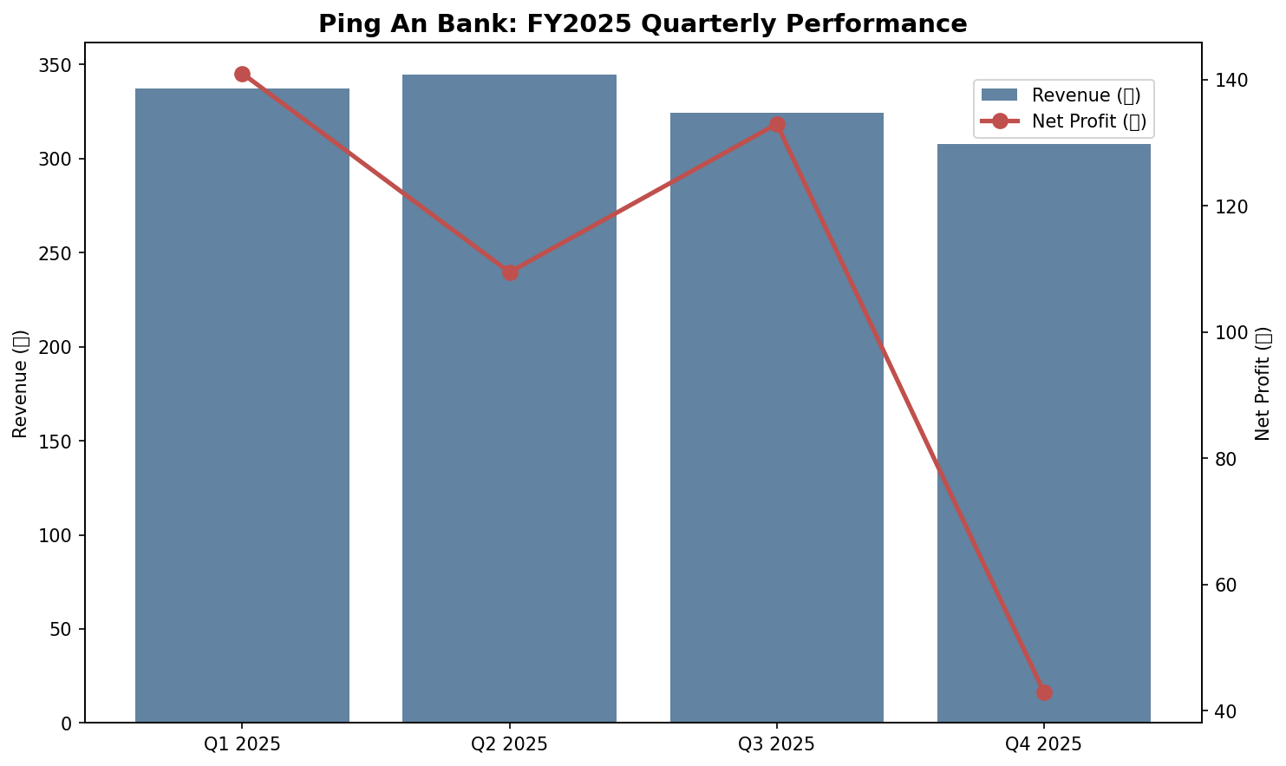
- Q1: Revenue RMB 33.7bn (-13.1% YoY), Net Profit RMB 14.1bn (-5.6% YoY)
- Q2: Revenue RMB 34.5bn (-10.2% YoY), Net Profit RMB 10.9bn (-7.8% YoY)
- Q3: Revenue RMB 32.5bn (-10.6% YoY), Net Profit RMB 13.3bn (+3.0% YoY)
- Q4: Revenue RMB 30.8bn (-12.4% YoY), Net Profit RMB 4.3bn (-10.1% YoY)

Sources
- Ping An Bank FY2025 Annual Report (March 20, 2026)
- Ping An Bank FY2025 Earnings Release (March 20, 2026)
- Wind/Hexin iFind Financial Database (As of April 22, 2026)
- Analyst Consensus Estimates (23 institutions) (As of March 2026)
- Sina Finance Research Report: "平安银行(000001)2024年报点评" (March 16, 2025)
- Sohu News: "平安银行2025年报深读" (March 23, 2026)
- Xueqiu: "营收两连降，但这次不一样了？" (April 13, 2026)

Disclaimer
This report is for informational purposes only and does not constitute investment advice. Past performance is not indicative of future results. Investors should conduct their own due diligence before making investment decisions.

