**V2 Development Notes – OnBoard eTraining**

**Website can be accessed from this link:** [**http://ec2-3-137-114-223.us-east-2.compute.amazonaws.com/**](http://ec2-3-137-114-223.us-east-2.compute.amazonaws.com/) **Or GitHub Repository:** [**https://github.com/NBryantNJ/CSIS483_eLearning**](https://github.com/NBryantNJ/CSIS483_eLearning)

**\*Some functions aren’t working yet.**

**Development Progress based off the WBS:**

Plans 2.0 Development and testing are complete.

The structure of the application now includes a basic UI with advanced functionality on each page.

**Development Progress Page by Page:**

* **Home Page**

Basic UI is complete, some functionality. Assigned courses are now visible, but the user needs to be able to click on them and go to the course content page.

* **Reports Page**

**Completed**. The user can now see if they’ve completed any tests and if they have, the reports of their grades will be available.

* **Admin Page**

Advanced functionality but more input error checking is needed. The page now has 3 main functions, create a course, assign a course and read reports. All 3 are functional but more error checking on the front and back end is needed. Users can now also request admin privileges.

* **Support Page**

**Completed**. Has error checking on the frontend and backend code. Emails get sent out by the bot with information. (Further improvements may come if needed)

* **User signup page**

**Completed**. However, more functionality will likely be added on if there’s extra time.

* **Website header bar with page links and login icon:**

All page links work, all pages are complete or at least 90% complete.

The Login function works and so does google captcha. There is also now a logout function if you click on your name when logged in

* **Citations**

Free logos and pictures were given approval to be used either by owners or description left by owners. *Citations for pictures and logos still has to be made on separate page.

**How to use the program**

**Step 1:** Go to <http://ec2-3-137-114-223.us-east-2.compute.amazonaws.com/>

**Step 2:** Click Login in the top right

**Step 3:** If you don’t have an account yet, click new user.

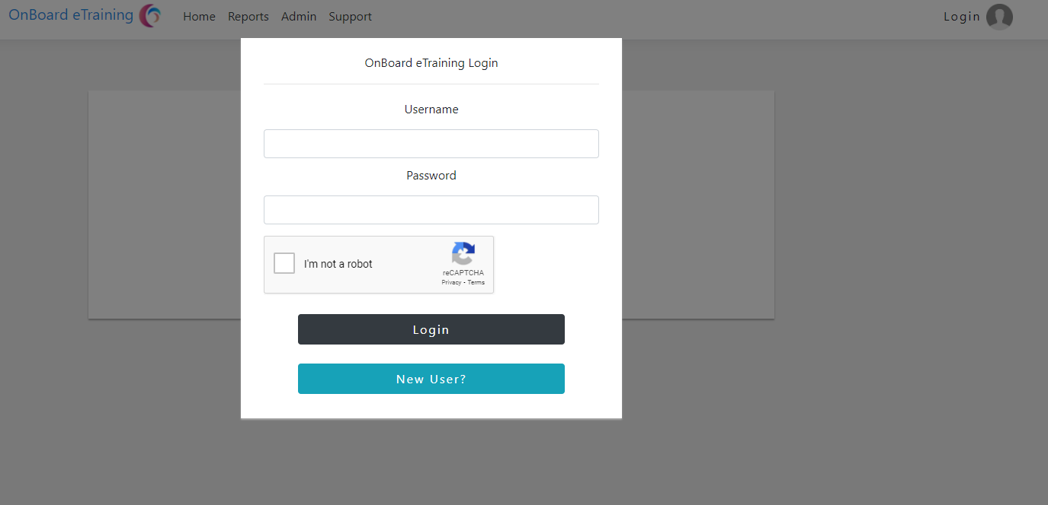

**Step 4:** Once clicking new user you will be brought to this page, create an account, then click sign up

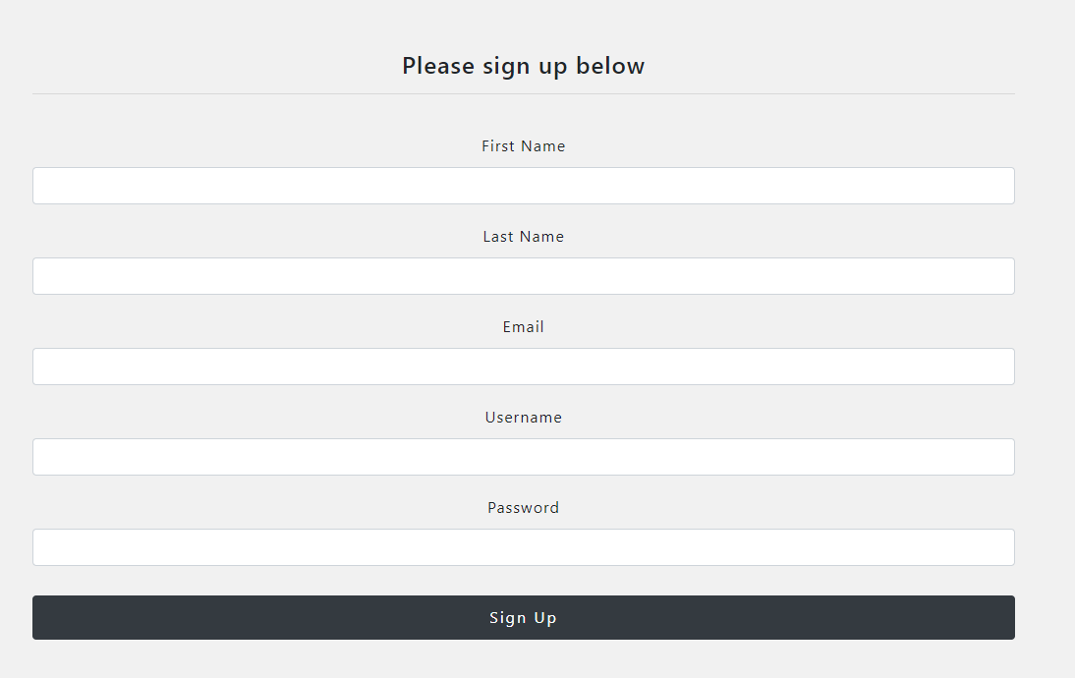

**Step 5:** Once your logged in, the home page will say you have no assigned courses.

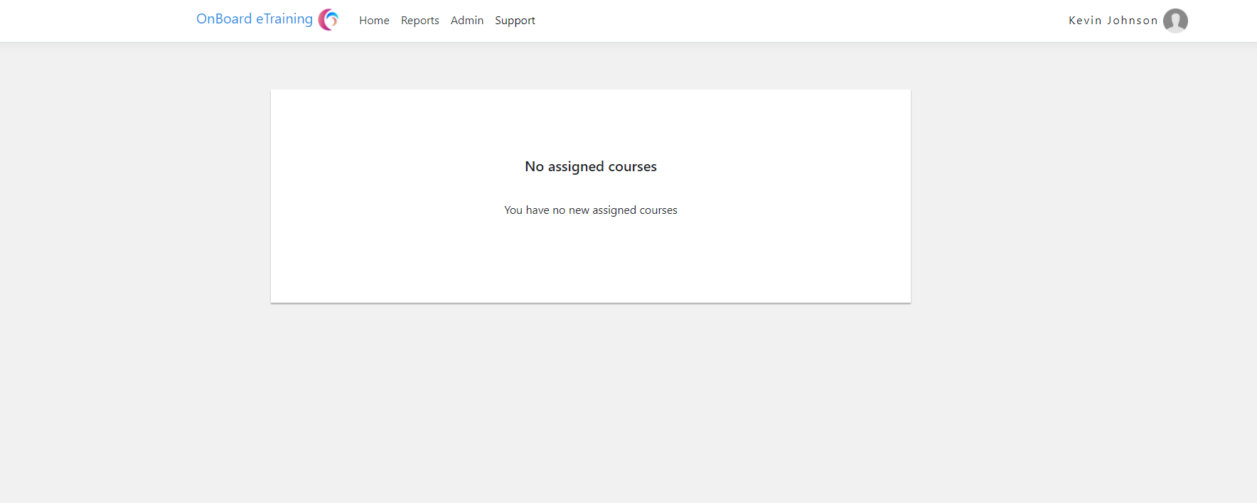

**Step 6:** You’ll have to wait for your admin to assign you courses. Once they have you’ll see tabs with each course on the home page.

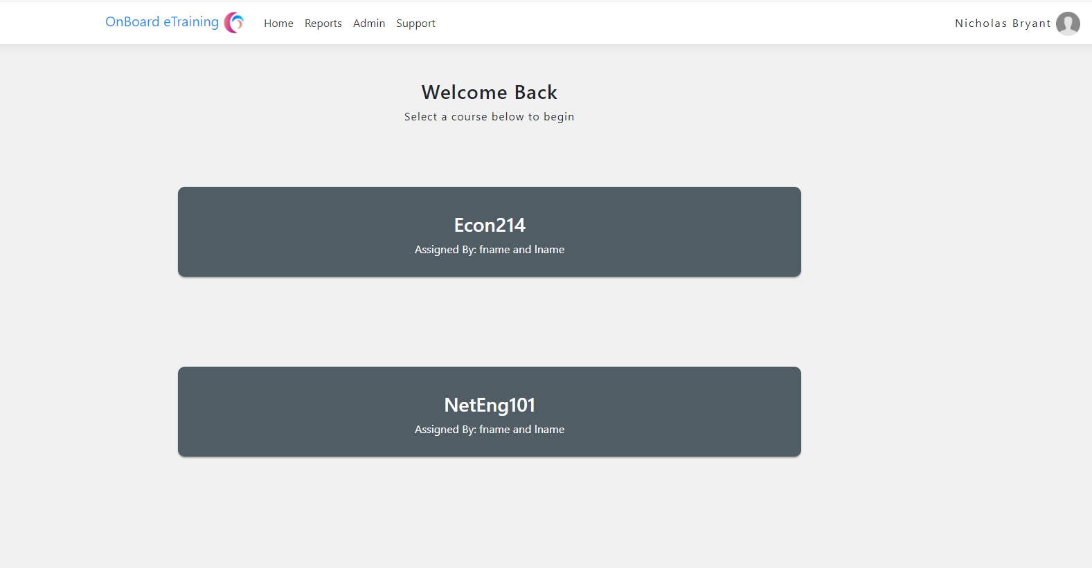

**Step 7:** Once you click one of those course tabs on the homepage, you’ll be brought to the course along with its content. *This won’t be functional until phase 3*

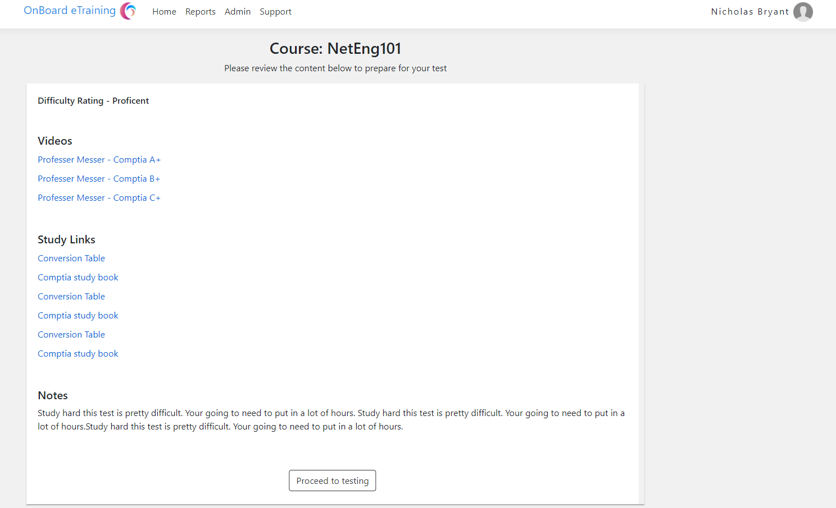

**Step 8:** Once you click proceed to testing you’ll land on this page. It’s not completed yet but it will look similar to what it does now. You’ll be presented with the testing questions, and graded once you filled all of them out and submitted it. *This is not functional until phase 3*

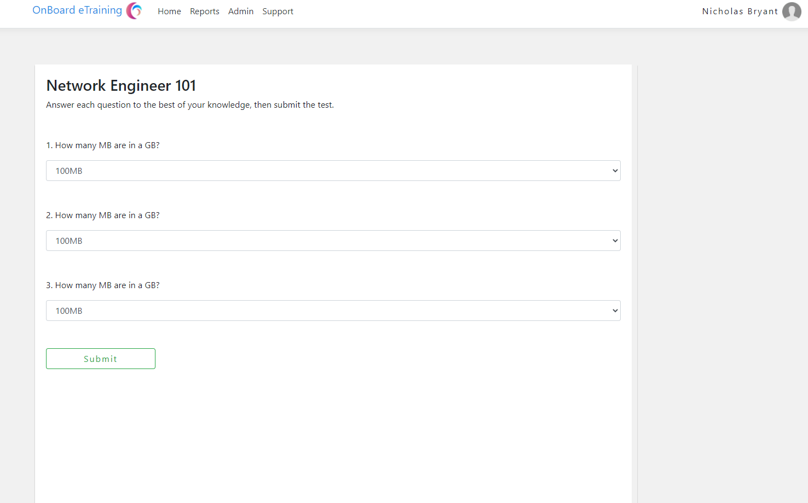

**Step 9:** Once you complete a course, you can go to the reports page and see your results. Your admin will also be able to see this.

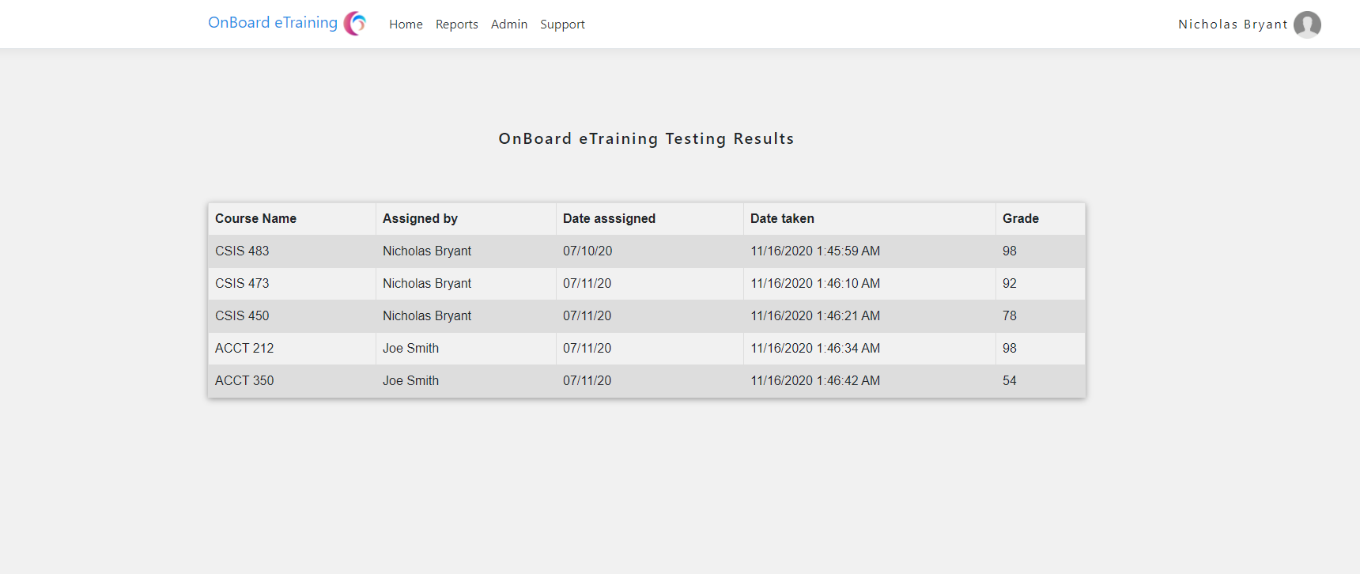

**Step 10:** If you want to log out when your done, click on your name in the top right and the following dialog will pop up.

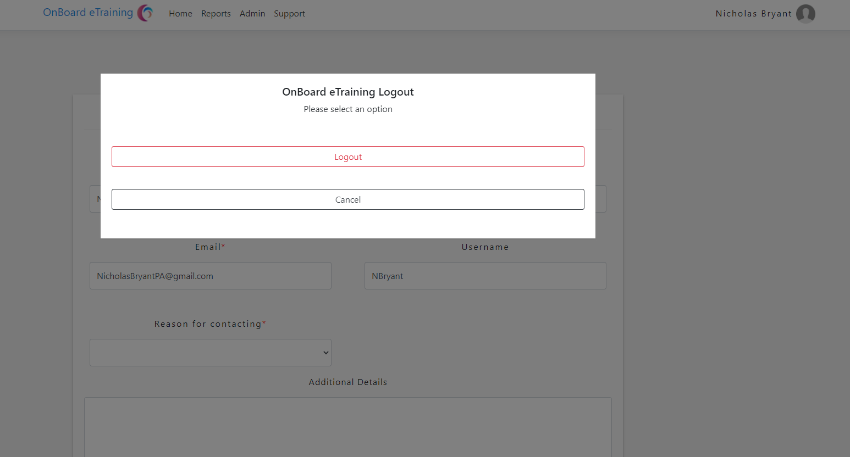

**Admin Page functions**

**Step 1:** You need to have admin privileges. If you don’t you can request them. If you have access, you’ll see the following screen on the admin page.

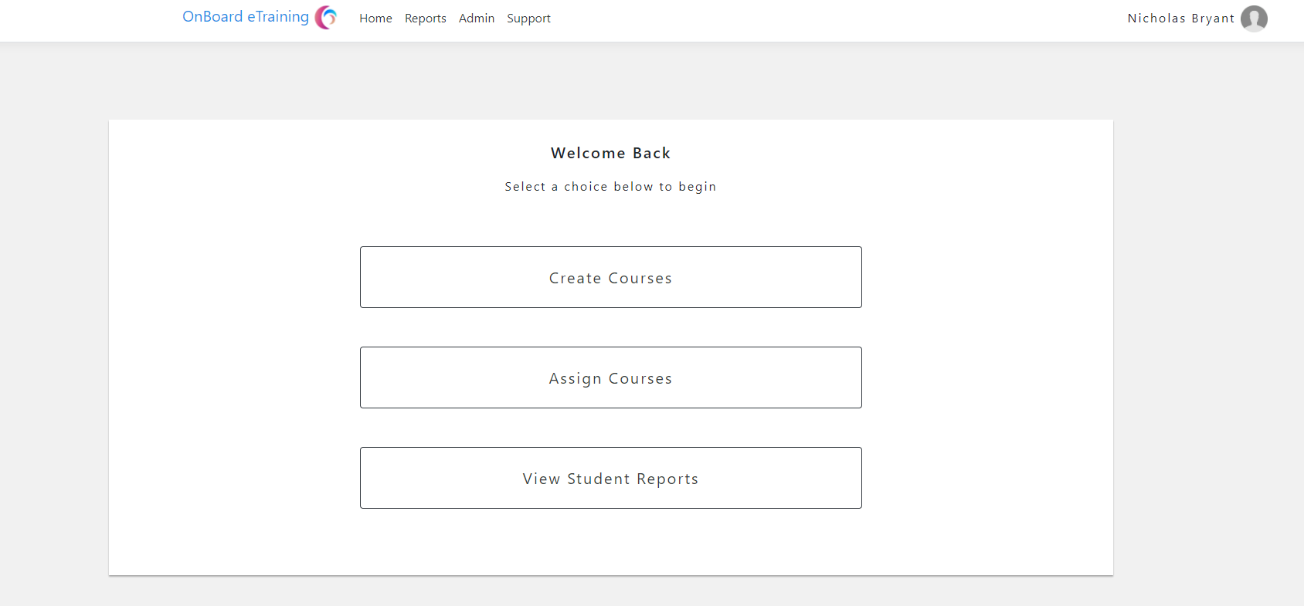

**Step 2:** Under create course you will be able to set up course content like web links students can use to study. First set up your web links you can add as many as you want.

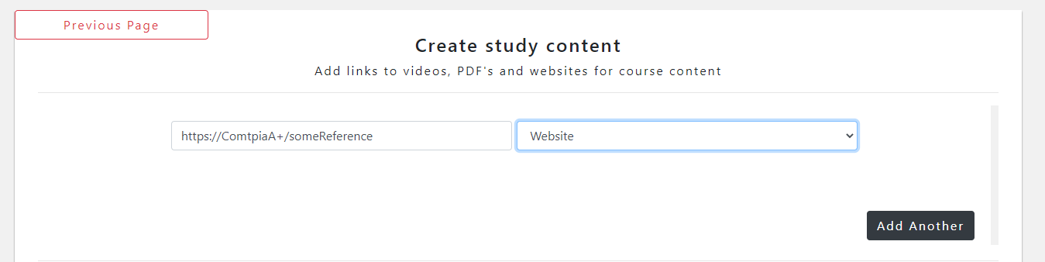

**Step 3:** You can then create your test. Each question will have a question with 4 multiple choice options. Fill out the first input table with your question, then fill out the rest with answer options, only select correct for your correct answer, the rest need to be set to incorrect. After that you can add as many questions as you want.

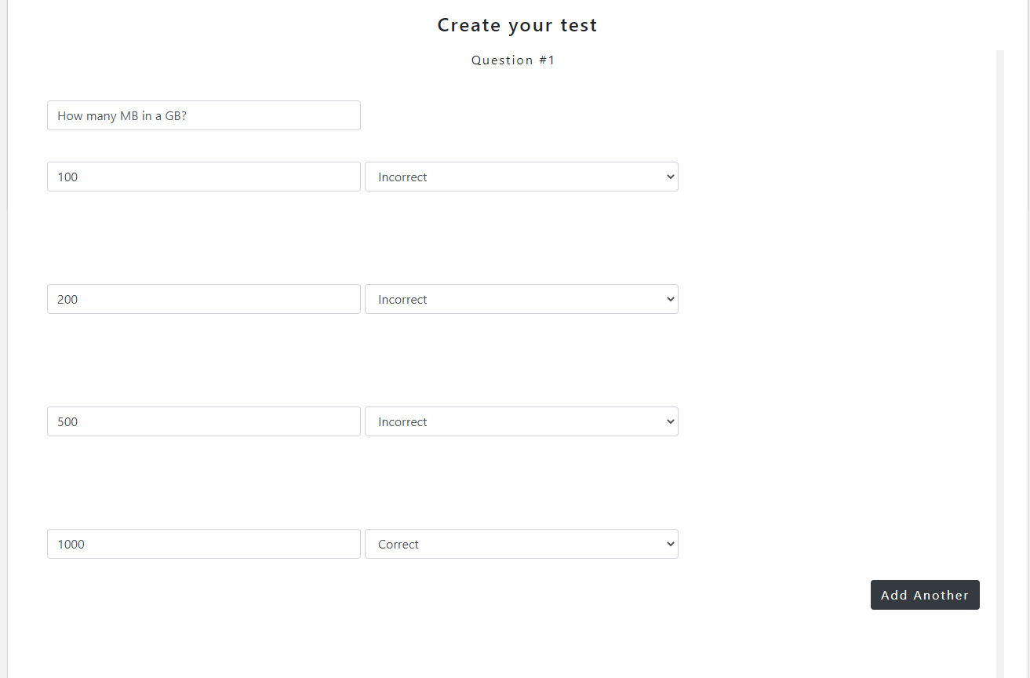

**Step 4:** Choose a difficulty rating you think best suits your test. Just click on of the buttons and the value will be assigned.

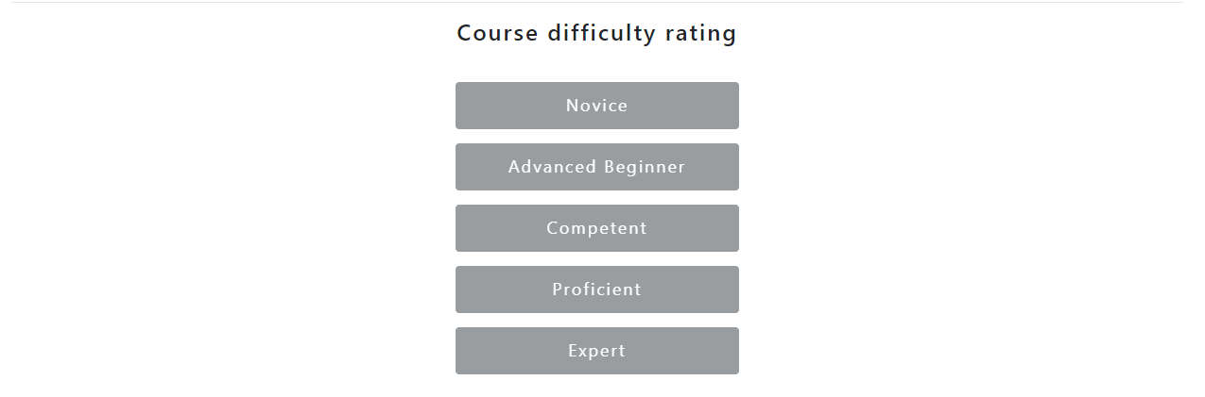

**Step 5:** Assign your course name and then click submit. *Another text area box will be added here later for notes you can leave the user about the test*

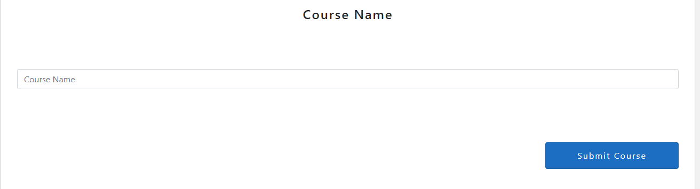

**Step 6:** Click previous page and then click assign courses. After you create your course your course will be an option in the course assign box. Click the usernames then click which courses you would like to assign them. Once done, click submit and the courses will be assigned.

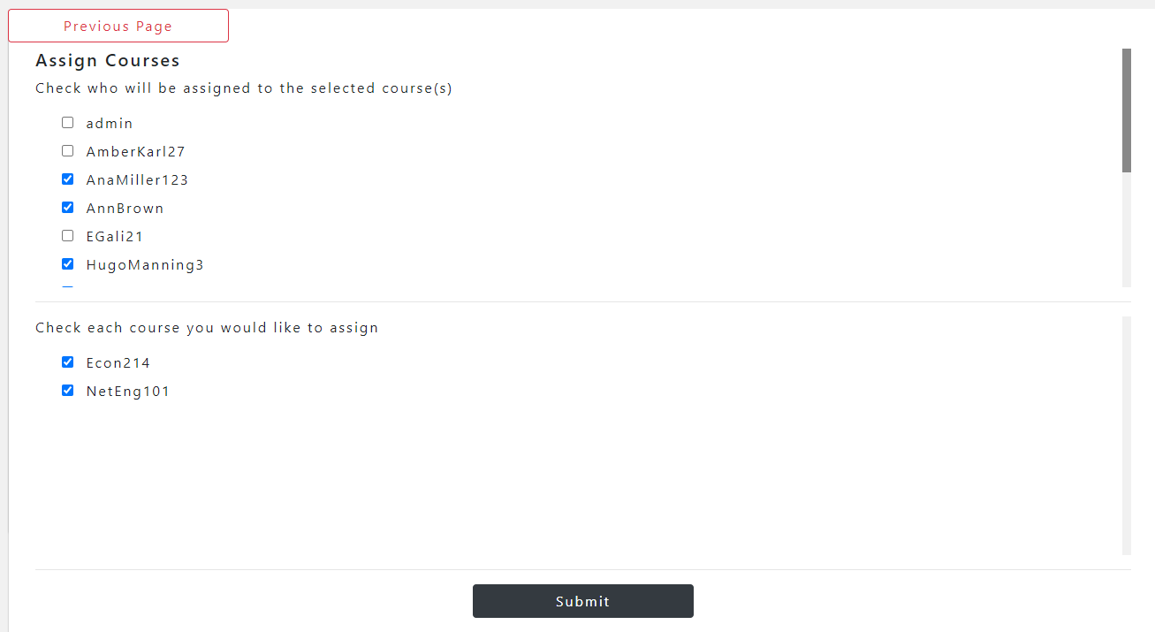

**Step 7:** Click previous page, then click View Student Reports. On this page you can input any username and see all their past grades.

