System DesignSpecificationforVersion 1.0 approvedPrepared by **Sonia Tasmin - 1811608042  
Md.Tawfiq-Uz-Zaman - 1812832042  
N M Rifat Rahman -1812817042  
  
Group – 5**

1. **Introduction:**

This document will tell the client how the software will be designed, providing specific information about the regular classes and functionality. This product (software) will be a Reading Management System which will allow a teacher to create classrooms and manage the reading tasks by uploading tasks and checking the progress of the students’ reading. This system will be fully featured so the user gets all the necessary information in the system. It will feature separate user interfaces for the teacher and the students so that they can navigate through the software easily. The web side of the system will use MySQL database for storing all relevant information and the android side of the software will use an API to connect with the MySQL database. This will ensure that the same software can be used in a browser as well as in the form of an Android application.

1. **Document Conventions:**Standard formats are used across the web and the android applications.
2. **Description of Design Components  
   3.1 Server Side:** The back-end development will be done by MySQL and  
   Django. The database will hold the user information, upload  
   files, store the images taken when viewing a document.

**3.2 Client Side:** The client side (front-end development) will be done with the  
help of HTML, CSS, python and JavaScript, to make the website more user  
friendly, responsive, simple interface.

**3.3 Mobile:** The android app will be fully featured. It will be made using java  
programming language.

* 1. **API:** This program will use some API (Application Programming Interface).  
     so that the Android application can communicate with the MySQL database and fetch data from a common source.

1. **UML Class Diagram**

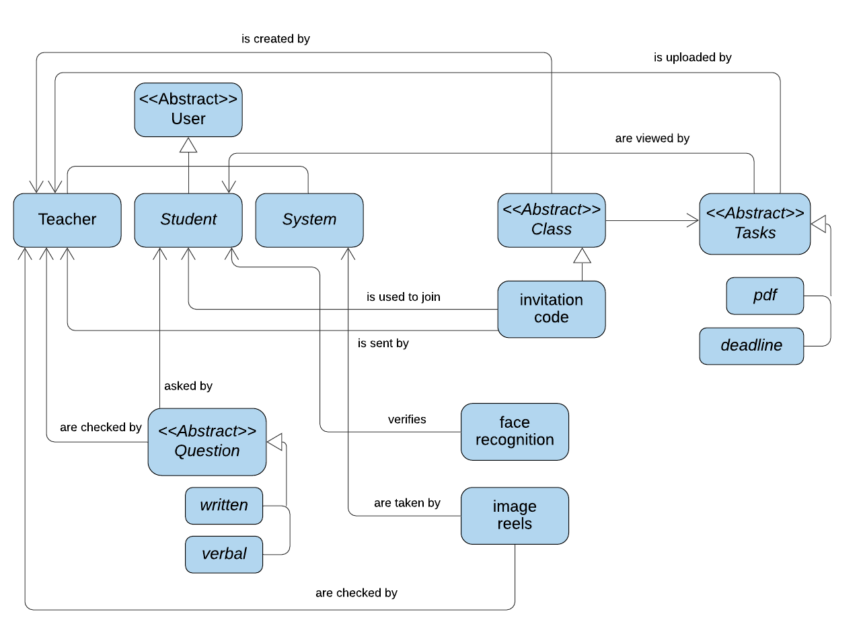

1. **Sequence Diagram**
2. **Database Design**

**6.1 ER Diagram:**

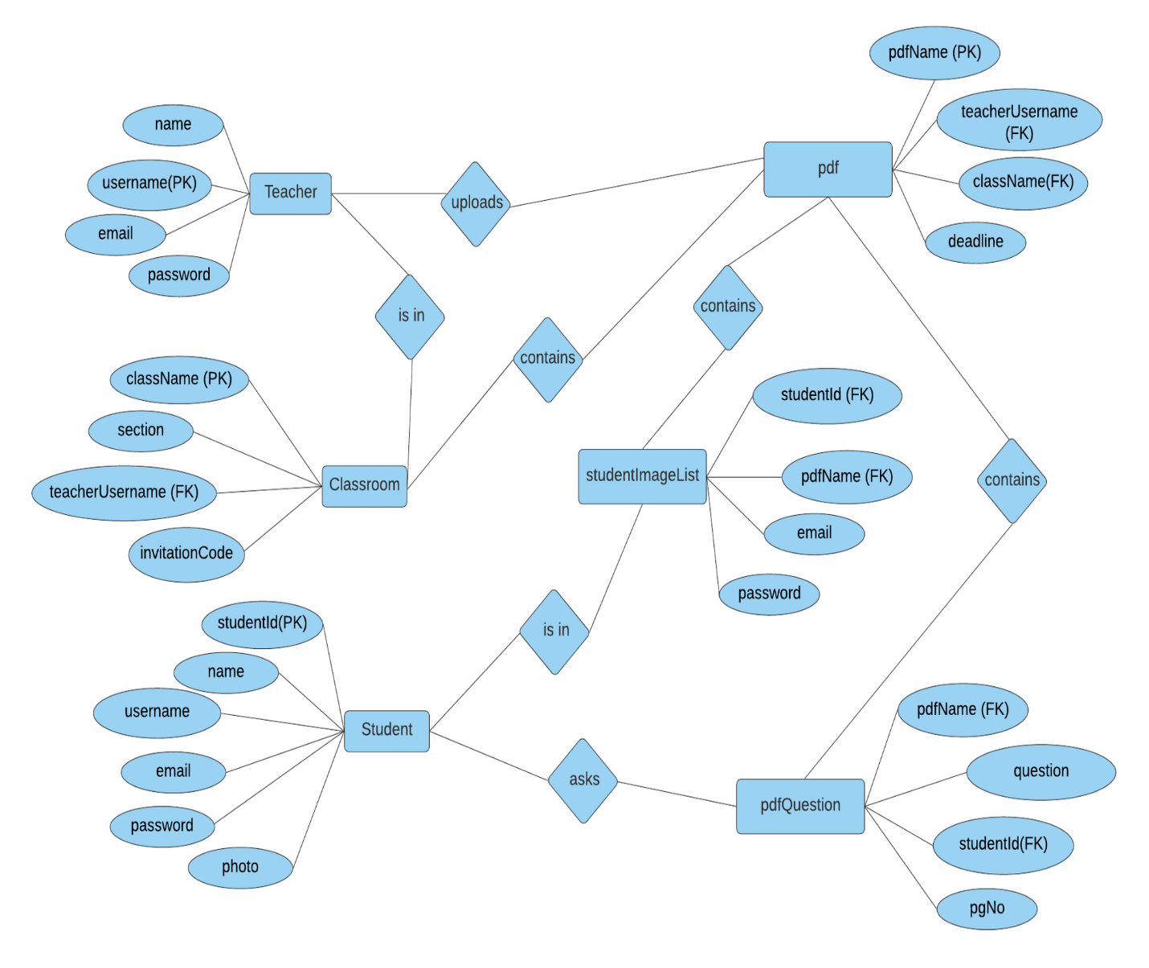

**6.2 ER Description**

**6.2.1 Table Name: Teacher**

Purpose: To store the basic information of the Teacher. This stores the general information of the teacher as well as the login credentials.

Attribute 1  
Name: name  
Type: Varchar  
Purpose: To identify the name of the teacher

Attribute 2

Name: username  
Type: Varchar  
Purpose: To identify the unique username assigned to the user

Attribute 3  
Name: email  
Type: Varchar  
Purpose: To identify the teacher’s email address

Attribute 4  
Name: password  
Type: String  
Purpose: To Identify user password

**6.2.2 Table Name: Classroom**

Purpose: To store all the necessary information pertaining to classrooms.

Attribute 1  
Name: className  
Type: Varchar  
Purpose: To identify the name of class which is unique

Attribute 2

Name: section  
Type: Int  
Purpose: To identify the section number of the classroom

Attribute 3  
Name: teahcerUsername  
Type: Varchar  
Purpose: To identify the teacher’s username who is assigned to the particular class

Attribute 4  
Name: invitationCode  
Type: String  
Purpose: To Identify the unique invitation code

**6.2.3 Table Name: Student**

Purpose: To store all the necessary information pertaining to student.

Attribute 1  
Name: studentId  
Type: Int  
Purpose: To identify the student Id.

Attribute 2

Name: name  
Type: Varchar  
Purpose: To identify the name of the student.

Attribute 3  
Name: username  
Type: Varchar  
Purpose: To identify the student’s username

Attribute 4  
Name: email

Type: String  
Purpose: To Identify the email of the student.

Attribute 5  
Name: password

Type: String  
Purpose: To Identify the password of the student’s account.

Attribute 6  
Name: photo

Type: LongBlob  
Purpose: To Identify the image of the student

**6.2.4 Table Name: pdf**

Purpose: To store all the necessary information pertaining to pdf

Attribute 1  
Name: pdfName  
Type: Varchar  
Purpose: To identify the name of the pdf

Attribute 2

Name: teacherUsername  
Type: Varchar  
Purpose: To identify the teacher assigned to the classroom

Attribute 3  
Name: className  
Type: Varchar  
Purpose: To identify the classroom name the pdf has been uploaded to

Attribute 4  
Name: deadline   
Type: DateTime  
Purpose: To Identify the deadline of the assigned task

**6.2.5 Table Name: studentImageList**

Purpose: To store all the necessary information pertaining to pdf

Attribute 1  
Name: studentImage

Type: LongBlob  
Purpose: To Identify the image of the student taken while reading the document

Attribute 2

Name: studentId  
Type: Int  
Purpose: To identify the student Id.

Attribute 3  
Name: pdfName   
Type: Varchar  
Purpose: To Identify the name of the pdf that the student is reading.

Attribute 4  
Name: timestamp  
Type: DateTime  
Purpose: To Identify the time the picture of the student was taken

**6.2.6 Table Name: pdfQuestion**

Purpose: To store all the questions asked by students when reading a pdf

Attribute 1  
Name: pdfName  
Type: Varchar  
Purpose: To identify the name of the pdf

Attribute 2

Name: question   
Type: Varchar  
Purpose: To identify the question asked by the student

Attribute 3  
Name: studentId  
Type: Int  
Purpose: To identify the student Id.

Attribute 4  
Name: pgNo   
Type: Int  
Purpose: To Identify the current page of the document.

**7. Implementation Plan**Firstly, we have designed our software using the diagram. Then according to the diagram, we have made the UI. After UI is done, we have made our application and website from the class diagram. After the application and website's front end, we have created our database from the ER diagram in the MySQL. We have connected our MySQL database with the android app and joined the same database with our website using the framework Django. After that, we will start testing our application and website and check if they are connected with the same database and working accordingly. Finally, we will check our features if they are working the way they are designed to work.