Item-based 相似度計算(計算兩個物品之間的相似度)：以計算(己,A,5)為例

|  |  |  |  |
| --- | --- | --- | --- |
|  | 物品A | 物品B | 物品C |
| 消費者甲 | 1 | 2 | 5 |
| 消費者乙 | 2 | 1 | Na |
| 消費者丙 | Na | Na | 2 |
| 消費者丁 | Na | 4 | 2 |
| 消費者戊 | 2 | Na | 3 |
| 消費者己 | Na | 5 | 1 |

**步驟一：計算相似度**

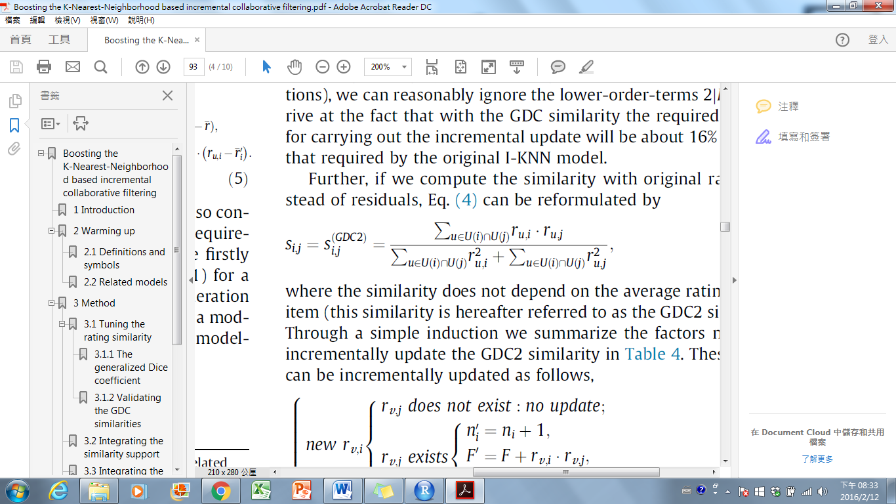計算式：

=F/G

說明：

F：所有同一個消費者同時對物品X與物品Y評分的分數相乘

G：所有同一個消費者同時對物品X評分的分數平方+所有同一個消費者同時對物品Y評分的分數平方

F矩陣：

|  |  |  |  |
| --- | --- | --- | --- |
|  | 物品A | 物品B | 物品C |
| 物品A | X | 4 | 3 |
| 物品B | 4 | X | 23 |
| 物品C | 11 | 23 | X |

G矩陣：

|  |  |  |  |
| --- | --- | --- | --- |
|  | 物品A | 物品B | 物品C |
| 物品A | X | 10 | 39 |
| 物品B | 10 | X | 75 |
| 物品C | 39 | 75 | X |

範例：物品B跟C的相似度

相似度=23/75=0.30667

A矩陣：

相似度矩陣：

|  |  |  |  |
| --- | --- | --- | --- |
|  | 物品A | 物品B | 物品C |
| 物品A | 1 | 0.4 | 0.282 |
| 物品B | 0.4 | 1 | 0.30667 |
| 物品C | 0.282 | 0.30667 | 1 |

**步驟二：計算SS以及LB**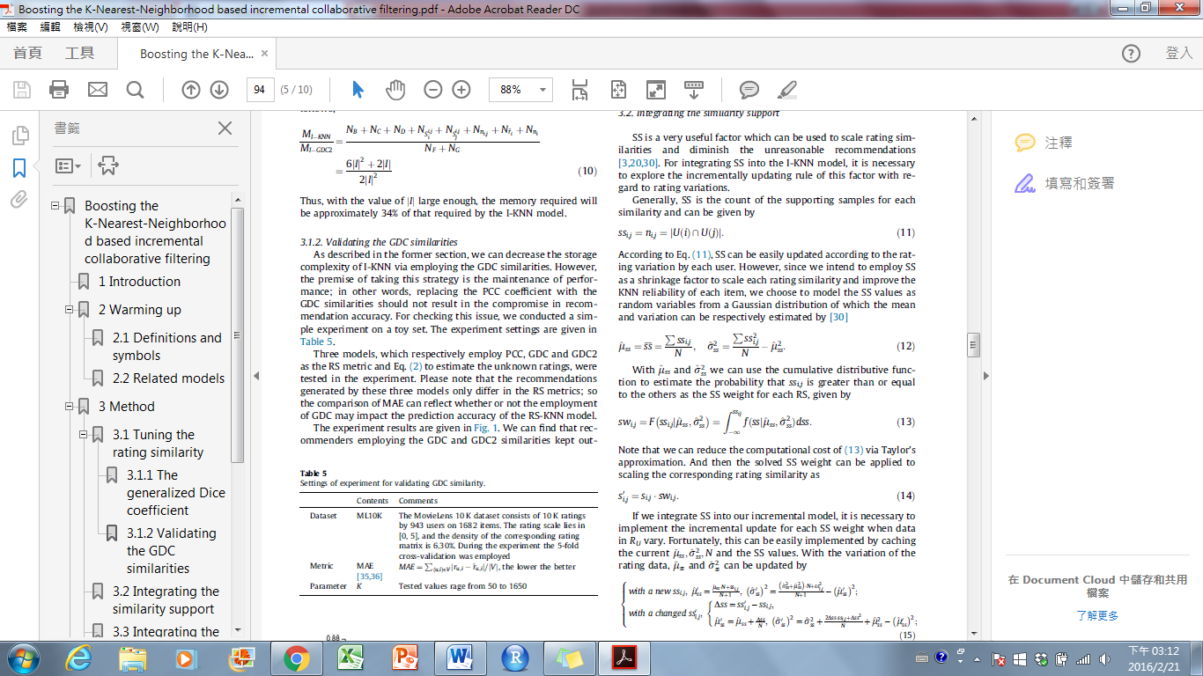

**SSij矩陣：**

|  |  |  |  |
| --- | --- | --- | --- |
|  | 物品A | 物品B | 物品C |
| 物品A |  | **2** | **2** |
| 物品B | **2** |  | **3** |
| 物品C | **2** | **3** |  |

**Uss=7/3=2.33333**

**變異數=17/3-5.443=0.223667**

**SWij矩陣：  
pnorm( 2, mean = 2.33333, sd = sqrt(0.223667) )**

|  |  |  |  |
| --- | --- | --- | --- |
|  | 物品A | 物品B | 物品C |
| 物品A |  | 0.2404635 | 0.2404635 |
| 物品B | 0.2404635 |  | 0.9206778 |
| 物品C | 0.2404635 | 0.9206778 |  |

**新Sij矩陣：  
Sij’=Sij*SWij**

|  |  |  |  |
| --- | --- | --- | --- |
|  | 物品A | 物品B | 物品C |
| 物品A |  | 0.4*0.2404635 | 0.282*0.2404635 |
| 物品B | 0.4*0.2404635 |  | 0.3066*0.9206778 |
| 物品C | 0.282*0.2404635 | 0.3066*0.9206778 |  |

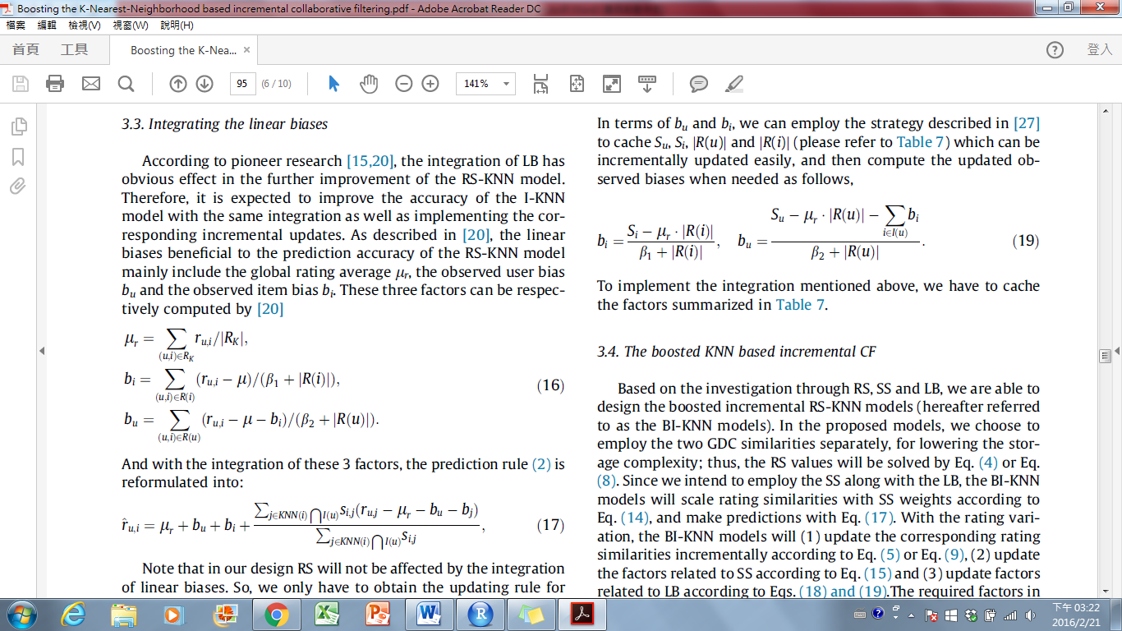

**Ur = 30/12=2.5(全部評分/已知評分個數)**

**Bi陣列[(全部評分 – Ur)加總/B1(已知參數)+物品i評分個數]：**

|  |  |  |
| --- | --- | --- |
| 物品A | 物品B | 物品C |
| **((1-2.5)+(2-2.5)+(2-2.5))/25+3=0.0892857142857143** | **2/25+4=0.0689655172413793** | **0.5/25+5=0.016667** |

**Bu陣列[(全部評分 – Ur – 物品i的偏差)加總/B2(已知參數)+消費者u評分個數]**

|  |  |  |  |  |  |
| --- | --- | --- | --- | --- | --- |
| **甲** | **乙** | **丙** | **丁** | **戊** | **己** |
|  |  |  |  |  | **0.91433** |

**預測評分：**

**KNN為選取鄰近值得個數預設500(但也應該要是可以調整的)**

**R(己,A)=2.5+0.91433+0.0893+(5-2.5-0.91433-0.06897)=** **5.02033**

**Mae=**

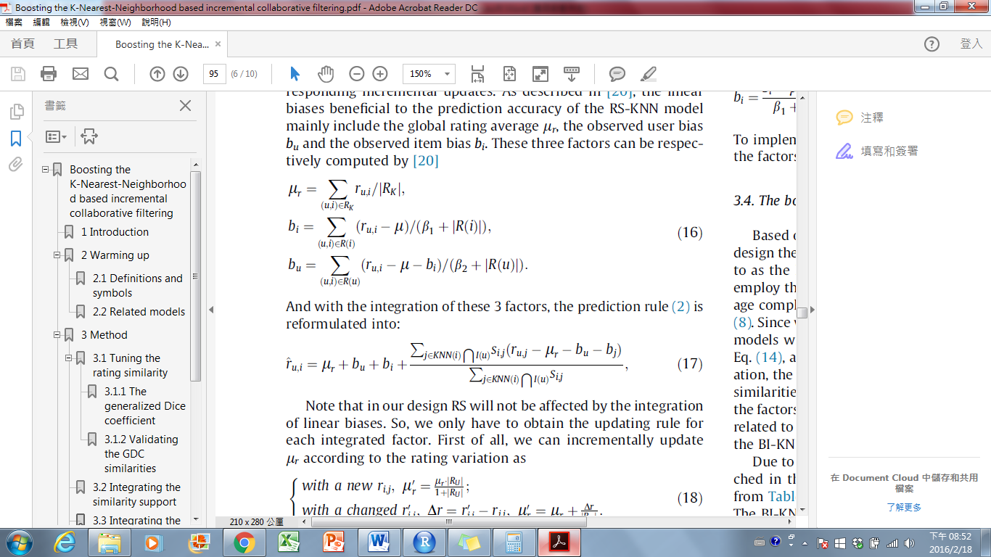

**步驟三Incremental update：**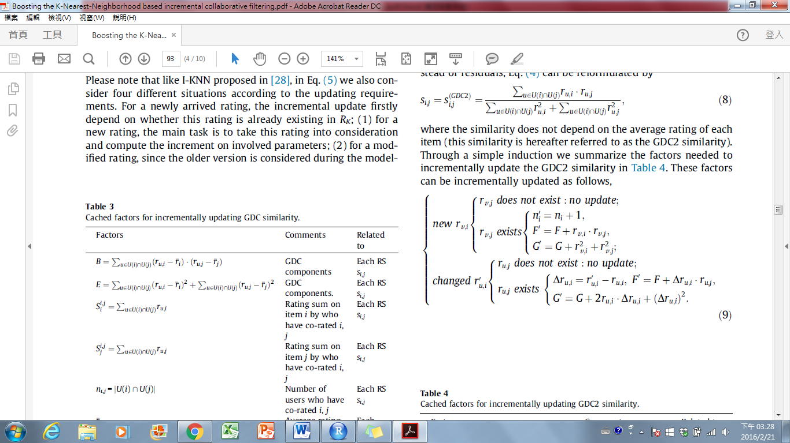

|  |  |  |  |
| --- | --- | --- | --- |
|  | 物品A | 物品B | 物品C |
| 消費者甲 | 1 | 2 | 5 |
| 消費者乙 | 2 | 1 | Na |
| 消費者丙 | Na | Na | 2 |
| 消費者丁 | Na | 4 | 2 |
| 消費者戊 | 2 | Na | 3 |
| 消費者己 | **5** | 5 | 1 |

F矩陣：

|  |  |  |  |
| --- | --- | --- | --- |
|  | 物品A | 物品B | 物品C |
| 物品A | X | **29** | **16** |
| 物品B | **29** | X | 23 |
| 物品C | **16** | 23 | X |

G矩陣：

|  |  |  |  |
| --- | --- | --- | --- |
|  | 物品A | 物品B | 物品C |
| 物品A | X | **60** | **65** |
| 物品B | **60** | X | 75 |
| 物品C | **65** | 75 | X |

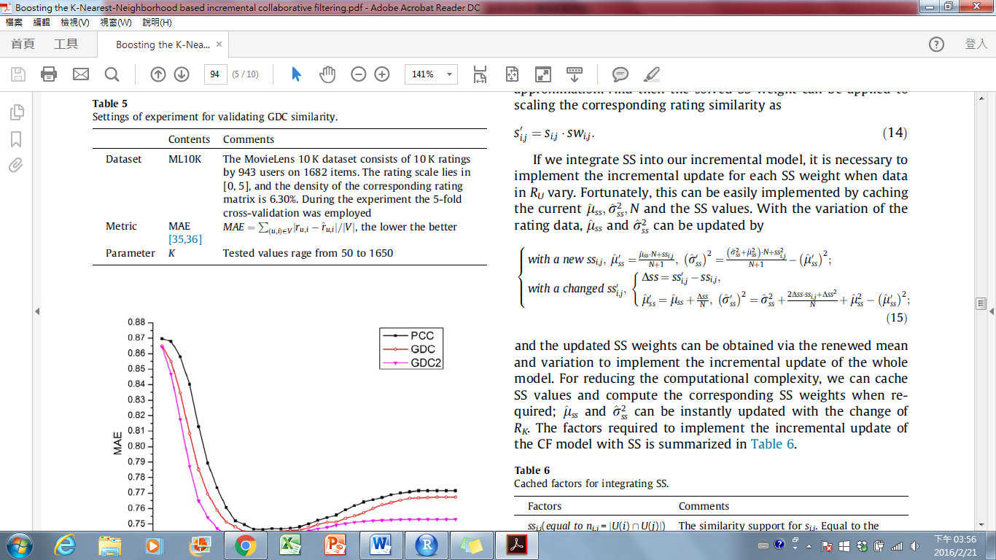

**通常不會發生新的情況(上面的式子)，除非是在現實環境有新的物品或使用者加入**

**SSij矩陣：**

|  |  |  |  |
| --- | --- | --- | --- |
|  | 物品A | 物品B | 物品C |
| 物品A |  | **3** | **3** |
| 物品B | **3** |  | **3** |
| 物品C | **3** | **3** |  |

**()**

|  |  |  |  |
| --- | --- | --- | --- |
|  | 物品A | 物品B | 物品C |
| 物品A |  | **1** | **1** |
| 物品B | **1** |  | **0** |
| 物品C | **1** | **0** |  |

**Uss=7/3+(2/3)=3**

**變異數=0(這裡感覺直接重算比式子好算…)**

**SWij矩陣：  
pnorm( 3, mean = 3, sd = sqrt(0) )**

|  |  |  |  |
| --- | --- | --- | --- |
|  | 物品A | 物品B | 物品C |
| 物品A |  | 1 | 1 |
| 物品B | 1 |  | 1 |
| 物品C | 1 | 1 |  |

**新Sij矩陣：  
Sij’=Sij*SWij**

|  |  |  |  |
| --- | --- | --- | --- |
|  | 物品A | 物品B | 物品C |
| 物品A |  | 29/60*1=0.4833 | 16/65*1=0.2461 |
| 物品B | 29/60*1=0.4833 |  | 0.3066*1=0.3066 |
| 物品C | 16/65*1=0.2461 | 0.3066*1=0.3066 |  |

