Processing scripts consist of three files:

1. The PDAL pipeline in JSON format, **Pipeline_PointStatistics.json**.
2. The batch processing script written for Windows in Windows shell that runs PDAL iteratively on files in a folder, **PDAL_BatchProcess_Stats.bat**.
3. The Python script that compiles the statistics into a single text file, **Point_Stats_Writer.py**.

(More information on PDAL pipelines can be found on the PDAL website: [pdal.io/pipeline.html](https://pdal.io/pipeline.html).)

Use following steps to execute the batch file correctly:

1. Copy the Python and the JSON scripts to a scripts folder – where you keep your scripts – or the same folder as the LAS files.
2. Copy the batch file to the folder with the LAS files.
3. Some of the entries in the batch file need to be checked and modified for the individual user (highlighted).
   1. Line 6 points to the folder with the Python and JSON script files. Put the correct folder location here.
   2. Line 13 points to the Anaconda installation folder.
   3. Line 14 activates the environment where PDAL is installed. Here it’s named “lidar.” Make sure it matches the name of your environment.

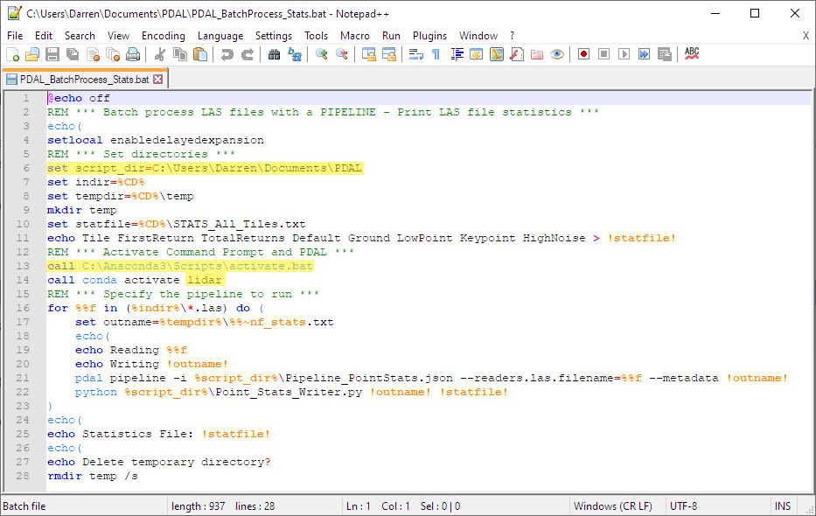

1. Run the script with Command Prompt in the location where the LAS files and script are located. Open Command Prompt by typing “cmd” in the address bar of the folder explorer.

The script will create a new temporary folder in the point cloud folder that has the individual metadata text files for each file. The compiled statistics file for all the point clouds is in the same folder as the point cloud files – where the batch file is located and run.