NCAR/UNIDATA

CfRadial Data File Format

Proposed
CF-compliant netCDF Format
for Moments Data for RADAR and LIDAR
in Radial Coordinates

Version 1.2
Mike Dixon, Wen-Chau Lee
Bob Rilling , Chris Burghart, Joe Van Andel
EOL, NCAR

2011-06-07

1 Introduction 5
1.1 On-line location 5
1.2 Summary of updates 5
1.3 Purpose 5
1.4 Extensions to the CF convention 5
1.5 Strict use of variable and attribute names 6
1.6 _FillValue value attribute 6
1.7 Required vs. optional variables 6
2 Data Content Overview 7
2.1 The nature of radar and lidar moments data 7
2.2 Geo-reference variables 7
2.3 Coordinate variables and storage of moments data 8
2.3.1 Regular 2-D storage – constant number of gates 8
2.3.2 Staggered 2-D storage – variable number of gates 9
2.3.3 Principal dimensions and variables for the case of a constant number of gates 9
2.3.1 Additional dimensions and variables for the case of a variable number of gates 10
2.4 Sweep indexes – a "pseudo" third dimension 10
2.5 Constant start range and gate spacing per volume 11
2.6 No grid mapping variable 11
2.7 Calibration information 11
2.8 Compression 12
3 Convention hierarchy 13
4 CF/Radial base convention 14
4.1 Global attributes 14
4.2 Dimensions 15
4.3 Global variables 15
4.4 Coordinate variables 16
4.4.1 Attributes for time coordinate variable 16
4.4.2 Attributes for range coordinate variable 17
4.5 Ray dimension variables 17
4.6 Location variables 18
4.7 Sweep variables 18
4.8 Sensor pointing variables 19
4.8.1 Attributes for azimuth(time) variable 20
4.8.2 Attributes for elevation(time) variable 20
4.9 Moving platform geo-reference variables 20
4.10 Moments field data variables 21
5 Sub-conventions 23
5.1 The instrument_parameters sub-convention 23
5.2 The radar_parameters sub-convention 24
5.3 The lidar_parameters sub-convention 24
5.4 The radar_calibration sub-convention 25
5.4.1 Dimensions 25
5.4.2 Variables 25
5.5 The lidar_calibration sub-convention 27
5.6 The platform_velocity sub-convention 28
5.7 The geometry_correction sub-convention 28
6 Standard names 30
6.1 Proposed standard names for metadata variables 30
6.2 Standard names for moments variables 37
7 Computing the data location from geo-reference variables 38
7.1 Special case – ground-based, stationary and leveled sensors 38
7.1.1 LIDARs 39
7.1.2 RADARs 39
7.2 Moving platforms 40
7.3 Coordinate transformations for the general case 40
7.3.1 Coordinate systems 41
7.3.2 The earth-relative coordinate system 41
7.3.3 The platform-relative coordinate system 41
7.3.4 The sensor coordinate system 44
7.4 Coordinate transformation sequence 45
7.4.1 Transformation from X_{i} to X_{a} 45
7.4.1.1 Type Z sensors 45
7.4.1.2 Type Y sensors 45
7.4.1.3 Type X sensors 46
7.4.2 Rotating from X_{a} to X 46
7.5 Summary of transforming from X_{i} to X 47
7.5.1 For type Z radars: 47
7.5.2 For type Y radars: 47
7.5.3 For type X radars: 48
7.5.4 Computing earth-relative azimuth and elevation 48
7.6 Summary of symbol definitions 48
8 Change log 49
8.1 Version 1.2, released 2011-06-07 49
8.2 Version 1.1, released 2011-02-01 49
9 References 50

Introduction

On-line location
This document, and other related information, is on-line at:
http://www.ral.ucar.edu/projects/titan/docs/radial_formats

Summary of updates
Version 1.1 was the first operational release for CfRadial.
All changes made subsequent to this version will be backward-compatible.
A major change was made for version 1.1. Support for a variable number of gates per ray was added.
This release, version 1.2, makes some minor additions.
See section 8 for details.

Purpose
The purpose of this document is to specify a CF-compliant netCDF format for radar and lidar moments data in radial (i.e. polar) coordinates.
The intention is that the format should, as far as possible, comply with the CF conventions for gridded data. However, the current CF 1.5 convention does not support radial radar/lidar data. Therefore, extensions to the conventions will be required.
The current CF conventions are documented at:
http://cf-pcmdi.llnl.gov/documents/cf-conventions/1.5

Extensions to the CF convention
This convention introduces the following extensions to CF:
- The following axis attribute types:
- axis = "radial_azimuth_coordinate";
- axis = "radial_elevation_coordinate";
- axis = "radial_range_coordinate";
- Additional standard units. The following need to be added:
- dB (ratio of two values, in log units. For example, ZDR).
- dBm (power in milliwatts, in log units)
- dBZ (radar reflectivity in log units)
- Additional standard names.
CfRadial files will be CF compliant, with the above extensions.

Strict use of variable and attribute names
However, because of the inherent complexity of radial radar and lidar data, the CfRadial format requires extra strictness, as compared to CF in general, in order to keep it manageable. There are so many metadata variables in CfRadial that it is essential to require strict adherence to the dimension names and metadata variable names exactly as specified in this document, in addition to their standard names. It is not practical to expect an application to search for standard names for metadata variables, since this makes the code unnecessarily complex.
Since this is a completely new format, there is no requirement to support legacy data sets which are less strictly defined.
Note that this strictness requirement only applies to metadata variables. The moments data fields will be handled as usual in CF, where the standard name is the definitive guide to the contents of the field. Suggested standard names for radar variables not yet supported by CF are listed in section 6.
One exception to this is the dimensions used to specify the length of string variables. String length dimensions may be added as needed. This document refers to the string length dimension as ‘string_length’, but any suitable dimension may be used in its place. See section 4.2.

_FillValue value attribute
CfRadial will use the _FillValue attribute to indicate missing values.
Note: the CF documentation mentions that the missing_value attribute is deprecated, and that _FillValue should be used instead. However, the CF document also states that missing_value is supported for backward compatibility purposes.
Therefore, it is recommended that CfRadial software applications check for missing_value as well.

Required vs. optional variables
Required variables are shown shaded in this document.
All other variables are optional.
If an optional variable is not provided, the reader applications should set the variable to a missing value as appropriate.

Data Content Overview

The nature of radar and lidar moments data
As a radar or lidar scans (or points) the data fields (or moments) are produced over an entity specified by a time interval or angular interval.
We refer to this entity as a ray, beam or dwell. In this document we will use the term ray.
For a given ray, the field data are computed for a sequence of ranges increasing radially away from the instrument. These are referred to as range gates.
In most cases, the spacing between the range gates is constant along the ray, although this is not necessarily the case. For example, some NOAA radars have gate spacings of 75m, 150m and 300m. Therefore, we need to be able to handle the cases for which the range gate spacing is variable. (This was not supported in version 1.0).

Geo-reference variables
A subset of the metadata variables in CfRadial are used to locate a radar or lidar measurement in space.
These are:
- range
- elevation
- azimuth
- latitude
- longitude
- altitude
See sections 4.4, 4.6 and 4.8 for details on these variables.
For moving platforms, extra variables are required for geo-referencing.
These are:
- heading
- roll
- pitch
- rotation
- tilt
See section 4.9 for details on these variables.
The mathematical procedures for computing data location relative to earth coordinates are described in detail in section 7.

Coordinate variables and storage of moments data
The moments data to be handled by this format is represented in 2 principal dimensions:
- time: rays have monotonically increasing time
- range: bins have monotonically increasing range

Regular 2-D storage – constant number of gates
If the rays at all times have the same number of gates, the data is stored in regular arrays, as shown below.
In this case the time dimension may be either fixed or unlimited.
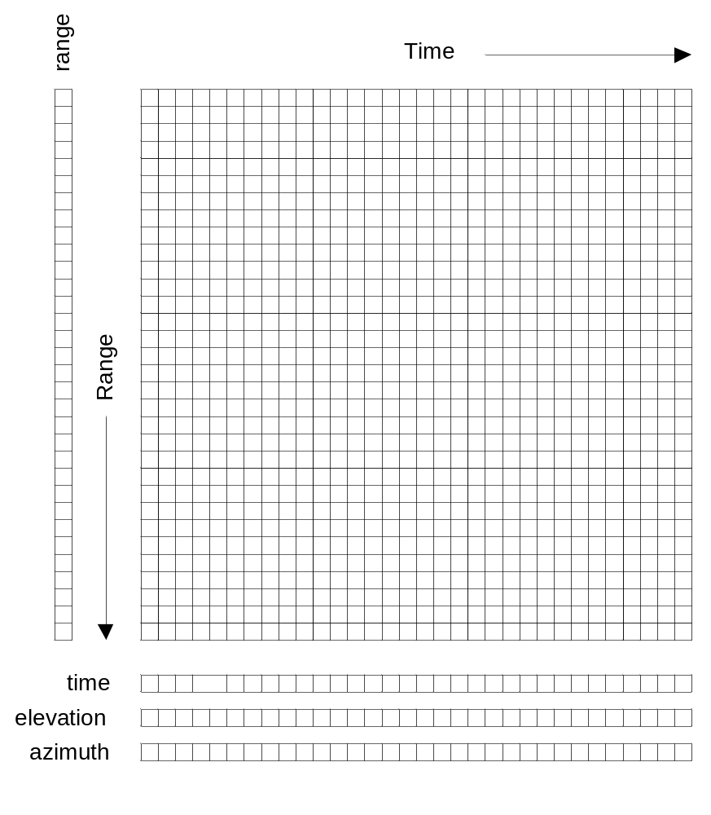
Figure 2.1 Data organization in time and range,
for a constant number of gates

Staggered 2-D storage – variable number of gates
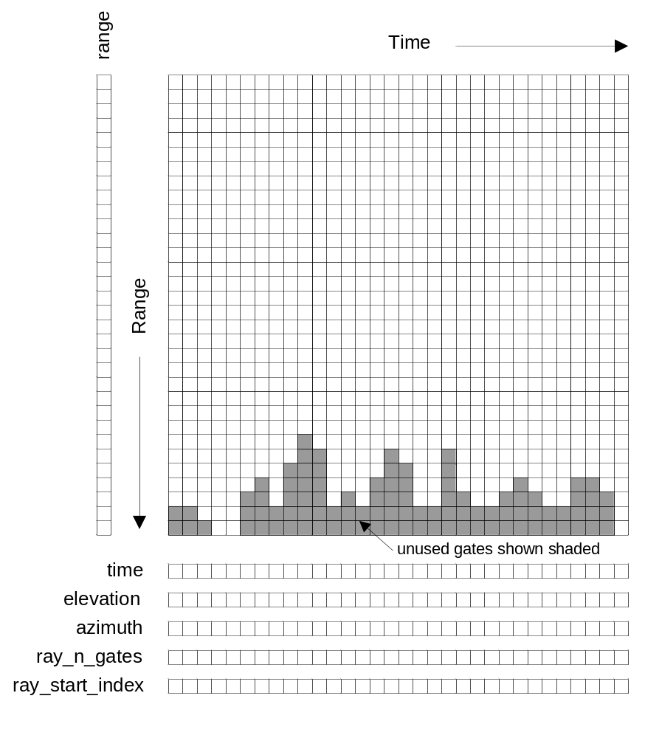
Figure 2.2 Data organization in time and range,
for a variable number of gates

Principal dimensions and variables for the case of a constant number of gates
Refer to figure 2.1.
The principal dimensions are time and range.
The primary coordinate is time and the secondary coordinate is range.
The time coordinate indicates the number of rays in the file. In the case of a constant number of gates, this may be either fixed or unlimited.
The range coordinate indicates the maximum number of gates for any ray in the file.
The time(time) coordinate variable stores the time of each ray, in seconds, from a reference time, which is normally the start of the volume (time_coverage_start) but may be a specified reference time (time_reference).
The range(range) coordinate variable stores the range to the center of each gate. All rays in the volume must have the same range geometry, but not necessarily the same number of gates..
The elevation(time) coordinate variable stores the elevation angle for each ray.
The azimuth(time) coordinate variable stores the azimuth angle for each ray.
The data fields are stored as 2-D arrays, with dimensions (time, range).

Additional dimensions and variables for the case of a variable number of gates
Refer to figure 2.2.
For a variable number of gates per ray, and additional dimension, n_points, is introduced. The time coordinate in this case must be fixed.
The ray_n_gates(time) variable stores the number of gates in a ray.
The ray_start_index(time) variable stores the start index of the moments data for a ray, relative to the start of the moments array.
The n_points dimension indicates the total number of gates stored in all of the rays. It is equal to the sum of ray_n_gates over all rays.
The data fields are stored as 1-D arrays with dimension (n_points). The data from consecutive rays is concatenated to form a single array. The ray_n_gates and ray_start_index values are used to locate the data for a given time in this 1-D array.

Sweep indexes – a "pseudo" third dimension
A set of one or more related sweeps, typically a complete 3-D radar or lidar scan, is referred to as a volume.
A volume scan is comprised of one or more sweeps.
Scanning may be carried out in a number of different ways. For example:
- horizontal scanning at fixed elevation (PPI mode)
- vertical scanning at constant azimuth (RHI mode)
- antenna not moving, i.e. constant elevation and azimuth (staring or pointing)
- aircraft radars which rotate around the longitudinal axis of the aircraft (e.g. ELDORA)
For each of these modes a sweep is defined as follows:
- PPI mode: a sequence of rays at fixed elevation angle
- RHI mode: a sequence of rays at fixed azimuth angle
- pointing mode: a sequence of rays over some time period, at fixed azimuth and elevation
The volume may therefore be logically divided into sweeps. In CfRadial, we do not separate the sweeps in the stored field data arrays. Rather, we store arrays of start and stop indexes, which identify the rays that belong to each sweep. Some recorded rays may be in the transition region between defined sweeps, i.e. they may not belong to any sweep. For these rays we set the ‘antenna_transition’ flag to 1.

Constant start range and gate spacing per volume
The CF/radial convention supports a varying number of gates per ray.
However, the range to each gate cannot vary within a volume. The range(range) coordinate variable stores the range to the center of each gate, and these values are applicable to all rays.
If the raw data range geometry changes over time within a volume, the data to be represented must be re-sampled using a common time-invariant range geometry for the volume.

No grid mapping variable
The data in this format is saved in the native coordinate system for RADARs and LIDARs, i.e. radial (or polar) coordinates, with the instrument at the origin.
A grid mapping type is not required, because the geo-reference variables contain all of the information required to locate the data in space.
For a stationary instrument, the following are stored as scalar variables (see section 4.6):
- latitude
- longitude
- altitude
Position and pointing references for moving platforms must take the following motions into account (see section 4.9):
- platform translation
- platform rotation

Calibration information
Radars must be calibrated to ensure that the moments data are accurate. Calibration for some types of lidar may also be appropriate.
A radar may have multiple sets of calibration parameters. Generally a separate calibration is performed for each transmit pulse width. Separate calibrations may be performed for other reasons as well. CfRadial supports storing multiple sets of calibration parameters, using the radar_calibration and lidar_calibration conventions.
The calibration applicable to a specific ray is indicated by the calibration_index variable.

Compression
The netCDF 4 library supports files in the following formats:
- classic
- 64bit offset
- netcdf4
- netcdf4 classic
The netcdf4 format is built on HDF5, which supports compression. Where data are missing or unusable, the data values will be set to a constant well-known _FillValue code. This procedure, combined with the use of the netcdf4 format, provides efficient compression.
It is therefore recommended that the netcdf4 option be used whenever possible, to keep data sets as small as possible.
However, for importing data into 3rd party applications such as MatLab ©, it is wise (at this stage) to store data in the NetCDF-3 classic format, which is uncompressed, since support for the compressed format is not yet widespread.

Convention hierarchy
The CF/Radial convention comprises a base convention, along with a series of optional sub-conventions for specific purposes.
At the time of writing, the following conventions are supported:

Convention name | Type | Description
CF/Radial | Base | Radial data extension to the  CF convention.  Contains all necessary information for interpreting and displaying the data fields in a geo-referenced manner
instrument_parameters | Optional | Parameters common to both radar and lidar instruments
radar_parameters | Optional | Parameters specific to radars
lidar_parameters | Optional | Parameters specific to lidars
radar_calibration | Optional | Calibration values for radars
lidar_calibration | Optional | Calibration values for lidars
platform_velocity | Optional | Velocity of the platform, in multiple dimensions
geometry_correction | Optional | Corrections to the geometry  of the data set
Note: items shown shaded are required, those not shaded are optional.
If a netCDF file conforms to a base convention and one or more sub-conventions, these are concatenated in the Conventions attribute as a space-delimited string.
The following are some examples:
- “CF/Radial instrument_parameters”
- “CF/Radial instrument_parameters radar_parameters radar_calibration”
- “CF/Radial lidar_parameters platform_velocity”

CF/Radial base convention
The base CF/Radial convention covers the minimum set of elements which are required to describe a radar/lidar data set sufficiently for basic display and plotting. CF/Radial is a specialization of CF.
NOTE on units: in the following tables, for conciseness, we do not spell out the units strings exactly as they are in the netCDF file. The following abbreviations apply:

Units string in netCDF file | Abbreviation in tables
“degrees per second” | degrees/s
“meters per second” | m/s

Global attributes

Attribute name | Type | Convention | Description
Conventions | string | CF | Conventions string will specify Cf/Radial, plus selected sub-conventions as applicable
version | string | CF/Radial | CF/Radial version number
title | string | CF | Short description of file contents
institution | string | CF | Where the original data were produced
references | string | CF | References that describe the data or the methods used to produce it
source | string | CF | Method of production of the original data
history | string | CF | List of modifications to the original data
comment | string | CF | Miscellaneous information
instrument_name | string | CF/Radial | Name of radar or lidar
site_name | string | CF/Radial | Name of site where data were gathered
scan_name | string | CF/Radial | Name of scan strategy used, if applicable
scan_id | int | CF/Radial | Scan strategy id, if applicable.  Assumed 0 if missing.
platform_is_mobile | string | CF/Radial | “true” or “false”  Assumed “false” if missing.
n_gates_vary | string | CF/Radial | “true” or “false”  Assumed “false” if missing.
Note: items shown shaded are required, those not shaded are optional.

Dimensions

Dimension name | Description
time | The number of rays.  This dimension is optionally UNLIMITED
range | The number of range bins
n_points * | Total number of gates in file.  Required for variable number of gates.
sweep | The number of sweeps
frequency | Number of frequencies used
string_length ** | Length of char type variables.
Note 1: items shown shaded are required, those not shaded are optional.
* Note2: n_points is required if the number of gates varies by ray. It must not be included if the number of gates is fixed.
** Note3: any number of ‘string_length’ dimensions may be created and used. For example, you may declare the dimensions ‘string_length”, ‘string_length_short’ and ‘string_length_long’, and use them appropriately for strings of various lengths. These are only used to indicate the length of the strings actually stored, and have no effect on other parts of the format.

Global variables

Variable name | Dimension | Type | Comments
volume_number | none | int | Volume numbers are sequential, relative to some arbitrary start time, and may wrap.
platform_type | (string_length) | char | Options are:  “fixed”, “vehicle”, “ship”, “aircraft”,  “aircraft_fore”,“aircraft_aft”,  “aircraft_tail”,“aircraft_belly”,  “aircraft_roof”,“aircraft_nose”,  “satellite_orbit”,  “satellite_geostat”  Assumed “fixed” if missing.
instrument_type | (string_length) | char | Options are: “radar”, “lidar”  Assumed “radar” if missing.
primary_axis | (string_length) | char | Options are:  “axis_z”, “axis_y”, “axis_x”  See section 7 for details.  Assumed “axis_z” if missing.
time_coverage_start | (string_length) | char | UTC time of first ray in file.  Resolution is integer seconds.  The time(time) variable is computed  relative to this time.  Format is:  yyyy-mm-ddThh:mm:ssZ
time_coverage_end | (string_length) | char | UTC time of last ray in file.  Resolution is integer seconds.  Format is:  yyyy-mm-ddThh:mm:ssZ
time_reference | (string_length) | char | UTC time reference.  Resolution is integer seconds.  If defined, the time(time) variable is computed relative to this time instead of relative to time_coverage_start.  Format is:  yyyy-mm-ddThh:mm:ssZ
Note: items shown shaded are required, those not shaded are optional.

Coordinate variables

Variable name | Dimension | Type | Units | Comments
time | (time) | double | seconds | Coordinate variable for time.  Time at center of each ray, in fractional seconds since start_time.
range | (range) | float | meters | Coordinate variable for range.  Range to center of each bin.
Note: all items are required.

Attributes for time coordinate variable
Attribute name | Type | Value
standard_name | string | “time”
long_name | string | “time in seconds since volume start”
units | string | “seconds since yyyy-mm-ddThh:mm:ssZ”,  where the actual reference time values are used.  This unit string is very important and must be correct. It should either match time_reference( if it exists) or time_coverage_start.
Note: All items are required.

Attributes for range coordinate variable
Attribute name | Type | Value
standard_name | string | “projection_range_coordinate”
long_name | string | “range_to_measurement_volume”
units | string | “meters”
spacing_is_constant | string | “true” or “false”
meters_to_center_of_first_gate | float | Start range in meters
meters_between_gates | float | Gate spacing in meters.  Only applicable if  spacing_is_constant is “true”
axis | string | “radial_range_coordinate”
Note: items shown shaded are required, those not shaded are optional.

Ray dimension variables

Variable name | Dimension | Type | Comments
ray_n_gates | (time) | int | Number of gates in a ray.
ray_start_index | (time) | int | Index of start of moments data for a ray, relative to the start of the moments array
Note: required if n_gates_vary global attribute is true. Do not specify if n_gates_vary is false.

Location variables
Note: for stationary platforms, these are scalars, and for moving platforms they are vectors in the time dimension.

Variable name | Dimension | Type | Units | Comments
latitude | none or (time) | double | degrees_north | Latitude of instrument.  For a stationary platform, this is a scalar. For a moving platform, this is a vector.
longitude | none or (time) | double | degrees_east | Longitude of instrument.  For a stationary platform, this is a scalar. For a moving platform, this is a vector.
altitude | none or (time) | double | meters | Altitude of instrument, above mean sea level.  For a stationary platform, this is a scalar. For a moving platform, this is a vector.
altitude_agl | none or (time) | double | meters | Altitude of instrument above ground level.  For a stationary platform, this is a scalar. For a moving platform, this is a vector.  Omit if not known.
Note: items shown shaded are required, those not shaded are optional.

Sweep variables

Variable name | Dimension | Type | Units | Comments
sweep_number | (sweep) | int |  | The number of the sweep, in the volume scan.  0-based.
sweep_mode | (sweep, string_length) | char |  | Options are:  “sector”,“coplane”,rhi”,  “vertical_pointing”,“idle”,  “azimuth_surveillance”,  “elevation_surveillance”,  “sunscan”,“pointing”,  “manual_ppi”,“manual_rhi”
fixed_angle | (sweep) | float | degrees | Target angle for the sweep.  elevation in most modes  azimuth in RHI mode
sweep_start_ray_index | (sweep) | int |  | Index of first ray in sweep, relative to start of volume.  0-based.
sweep_end_ray_index | (sweep) | int |  | Index of last ray in sweep, relative to start of volume.  0-based.
target_scan_rate | (sweep) | float | degrees/s | Intended scan rate for this sweep. The actual scan rate is stored according to section 4.8.  This variable is optional.  Omit if not available.
Note: items shown shaded are required, those not shaded are optional.
NOTE2: this section must always exist, even if a volume contains only 1 sweep. The reason for the inclusion is that the sweep_mode and sweep_fixed_angle are necessary for fully understanding the sweep strategy.

Sensor pointing variables
Variable name | Dimension | Type | Units | Comments
azimuth | (time) | float | degrees | Azimuth of antenna, relative to true north.
elevation | (time) | float | degrees | Elevation of antenna, relative to the horizontal plane.
scan_rate | (time) | float | degrees/s | Actual antenna scan rate.  Set to negative if counter-clockwise in azimuth or decreasing in elevation.  Positive otherwise.
antenna_transition | (time) | byte |  | 1 if antenna is in transition,  i.e. between sweeps, 0 if not.  If variable is omitted, the transition will be assumed to be 0 everywhere.  Assumed 0 if missing.
Note: items shown shaded are required, those not shaded are optional.

Attributes for azimuth(time) variable
Attribute name | Type | Value
standard_name | string | “beam_azimuth_angle”
long_name | string | “azimuth_angle_from_true_north”
units | string | “degrees”
axis | string | “radial_azimuth_coordinate”
Note: All items are required.

Attributes for elevation(time) variable
Attribute name | Type | Value
standard_name | string | “beam_elevation_angle”
long_name | string | “elevation_angle_from_horizontal_plane”
units | string | “degrees”
axis | string | “radial_elevation_coordinate”
Note: All items are required.

Moving platform geo-reference variables
For moving platforms, the following additional variables will be included to allow geo-referencing of the platform in earth coordinates. Only include this section for moving platforms, omit completely for fixed platforms.
See section 7 for further details.

Variable name | Dimension | Type | Units | Comments
heading | (time) | float | degrees | Heading of the platform relative to true N, looking down from above.
roll | (time) | float | degrees | Roll about longitudinal axis of platform. Positive is left side up, looking forward.
pitch | (time) | float | degrees | Pitch about the lateral axis of the platform. Positive is up at the front.
drift | (time) | float | degrees | Difference between heading and track over the ground. Positive drift implies track is clockwise from heading, looking from above. NOTE: not applicable to land-based moving platforms.
rotation | (time) | float | degrees | Angle between the radar beam and the vertical axis of the platform. Zero is along the vertical axis, positive is clockwise looking forward from behind the platform.
tilt | (time) | float | degrees | Angle between radar beam (when it is in a plane containing the longitudinal axis of the platform) and a line perpendicular to the longitudinal axis. Zero is perpendicular to the longitudinal axis, positive is towards the front of the platform.
Note: if this block is included, all items are required.

Moments field data variables
Each moments field variable has the dimension n_points. The moments variables are stored as staggered arrays, using the auxiliary variables ray_start_index(time) and ray_n_gates(time) to locate the data for a ray.
The field data will be stored using one of the following:

netCDF type | Byte width | Description
ncbyte | 1 | scaled signed integer
short | 2 | scaled signed integer
int | 4 | scaled signed integer
float | 4 | floating point
double | 8 | floating point

The netCDF variable name is interpreted as the short name for the field.
Field data variables have the following attributes:

Attribute name | Type | Convention | Description
long_name | string | CF | Long name describing the field.  Any string is appropriate.
standard_name | string | CF | CF standard name for field.  See section 6.2.
units | string | CF | Units for field
_FillValue | same type as field data | CF | Used if data are missing at this range bin
scale_factor | float | CF | Float value =  (integer value) * scale_factor  + add_offset  Only applies to integer types.
add_offset | float | CF
coordinates | string | CF | See note below
Note: scale_factor and add_offset are required for ncbyte, short and int fields. They are not applicable to float and double fields.
NOTE2: the “coordinates’ attribute lists the variables needed to compute the location of a data point in space.
For stationary platforms, the coordinates attribute should be set to:
“elevation azimuth range”
For moving platforms, the coordinates attribute should be set to:
“elevation azimuth range heading roll pitch rotation tilt”

Sub-conventions
The base CF/Radial convention, as described above, covers the minimum set of netCDF elements which are required to locate radar/lidar data in time and space.
The following sub-conventions augment the base convention with additional information for various purposes.

The instrument_parameters sub-convention
This convention stores parameters relevant to both radars and lidars.
Variables in this convention will have the string attribute meta_group, set to the value “instrument_parameters”.

Variable name | Dimension | Type | Units | Comments
frequency | (frequency) | float | s-1 | List of operating frequencies, in Hertz.  In most cases, only a single frequency is used.
follow_mode | (sweep,  string_length) | char |  | options are: “none”, “sun”, “vehicle”, “aircraft”, “target”, “manual”  Assumed “none” if missing.
pulse_width | (time) | float | seconds
prt_mode | (sweep, string_length) | char |  | Pulsing mode  Options are: “fixed”, “staggered”, “dual” Assumed “fixed” if missing.
prt | (time) | float | seconds | Pulse repetition time.  For staggered prt, also see prt_ratio.
prt_ratio | (time) | float |  | Ratio of prt/prt2.  For dual/staggered prt mode.
polarization_mode | (sweep, string_length) | char |  | Options are: “horizontal”, “vertical”, “hv_alt”, “hv_sim”, “circular” Assumed “horizontal” if missing.
nyquist_velocity | (time) | float | m/s | Unambiguous velocity
unambiguous_range | (time) | float | meters | Unambiguous range
n_samples | (time) | int |  | Number of samples used to compute moments
sampling_ratio | (time) | float |  | Number of samples for this field divided by n_samples.  Assumed 1.0 if missing.
Note: all items are optional.
The number of samples used to compute the moments may vary from field to field. In the table above, n_samples refers to the maximum number of samples used for any field. The sampling_ratio is computed as the actual number of samples used for any field, divided by n_samples.

The radar_parameters sub-convention
This convention handles parameters specific to radar platforms. Variables in this convention will have the string attribute meta_group, set to the value “radar_parameters”.

Variable name | Dimension | Type | Units | Comments
radar_antenna_gain_h | none | float | dB | Nominal antenna gain,  H polarization
radar_antenna_gain_v | none | float | dB | Nominal antenna gain,  V polarization
radar_beam_width_h | none | float | degrees | Antenna beam width  H polarization
radar_beam_width_v | none | float | degrees | Antenna beam width  V polarization
radar_receiver_bandwidth | none | float | s-1 | Bandwidth of radar receiver
radar_measured_transmit_power_h | (time) | float | dBm | Measured transmit power  H polarization
radar_measured_transmit_power_v | (time) | float | dBm | Measured transmit power  V polarization
Note: all items are optional.

The lidar_parameters sub-convention
This convention handles parameters specific to lidar platforms. Variables in this convention will have the string attribute meta_group, set to the value “lidar_parameters”.

Variable name | Dimension | Type | Units | Comments
lidar_beam_divergence | none | float | milliradians | Transmit side
lidar_field_of_view | none | float | milliradians | Receive side
lidar_aperture_diameter | none | float | cm
lidar_aperture_efficiency | none | float | percent
lidar_peak_power | none | float | watts
lidar_pulse_energy | none | float | joules
Note: all items are optional.

The radar_calibration sub-convention
Variables in this convention will have the string attribute meta_group, set to the convention name “radar_calibration”.

Dimensions
Dimension name | Description
r_calib | The number of calibrations available
Note: required if any radar_calibration variables are included..

Variables
The meaning of the designations used in the calibration variables are as follows for dual-polarization radars:
- 'h': horizontal channel
- 'v': vertical channel
- 'hc': horizontal co-polar (h transmit, h receive)
- 'hx' – horizontal cross-polar (v transmit, h receive)
- 'vc': vertical co-polar (v transmit, v receive)
- 'vx' – vertical cross-polar (h transmit, v receive)
For single polarization radars, the 'h' quantities should be used.

Variable name | Dimension | Type | Units | Comments
r_calib_index | (time) | byte |  | Index for the calibration that applies to each ray.  Assumed 0 if missing.
r_calib_time | (r_calib,  string_length) | char | UTC | e.g. 2008-09-25  T23:00:00Z
r_calib_pulse_width | (r_calib) | float | seconds | Pulse width for this  calibration
r_calib_ant_gain_h | (r_calib) | float | dB | Derived antenna gain  H channel
r_calib_ant_gain_v | (r_calib) | float | dB | ditto, V channel
r_calib_xmit_power_h | (r_calib) | float | dBm | Transmit power  H channel
r_calib_xmit_power_v | (r_calib) | float | dBm | ditto, V channel
r_calib_two_way_waveguide_loss_h | (r_calib) | float | dB | 2-way waveguide loss  measurement plane to feed horn  H channel
r_calib_two_way_waveguide_loss_v | (r_calib) | float | dB | ditto, V channel
r_calib_two_way_radome_loss_h | (r_calib) | float | dB | 2-way radome loss  H channel
r_calib_two_way_radome_loss_v | (r_calib) | float | dB | ditto, V channel
r_calib_receiver_mismatch_loss | (r_calib) | float | dB | Receiver filter bandwidth mismatch loss
r_calib_radar_constant_h | (r_calib) | float | m/mW  dB units | Radar constant  H channel
r_calib_radar_constant_v | (r_calib) | float | m/mW  dB units | ditto, V channel
r_calib_noise_hc | (r_calib) | float | dBm | Measured noise level  H co-pol channel
r_calib_noise_vc | (r_calib) | float | dBm | ditto, V co-pol channel
r_calib_noise_hx | (r_calib) | float | dBm | ditto, H cross-pol
r_calib_noise_vx | (r_calib) | float | dBm | ditto, V cross-pol
r_calib_receiver_gain_hc | (r_calib) | float | dB | Measured receiver gain  H co-pol channel
r_calib_receiver_gain_vc | (r_calib) | float | dB | ditto, V co-pol channel
r_calib_receiver_gain_hx | (r_calib) | float | dB | ditto, H cross-pol
r_calib_receiver_gain_vx | (r_calib) | float | dB | ditto, V cross-pol
r_calib_base_1km_hc | (r_calib) | float | dBZ | reflectivity at 1km for SNR=0dB  H co-pol channel
r_calib_base_1km_vc | (r_calib) | float | dBZ | ditto, V co-pol channel
r_calib_base_1km_hx | (r_calib) | float | dBZ | ditto, H cross-pol
r_calib_base_1km_vx | (r_calib) | float | dBZ | ditto, V cross-pol
r_calib_sun_power_hc | (r_calib) | float | dBm | Calibrate sun power  H co-pol channel
r_calib_sun_power_vc | (r_calib) | float | dBm | ditto, V co-pol channel
r_calib_sun_power_hx | (r_calib) | float | dBm | ditto, H cross-pol
r_calib_sun_power_vx | (r_calib) | float | dBm | ditto, V cross-pol
r_calib_noise_source_power_h | (r_calib) | float | dBm | Noise source power  H channel
r_calib_noise_source_power_v | (r_calib) | float | dBm | ditto, V channel
r_calib_power_measure_loss_h | (r_calib) | float | dB | Power measurement loss in coax and connectors  H channel
r_calib_power_measure_loss_v | (r_calib) | float | dB | ditto, V channel
r_calib_coupler_forward_loss_h | (r_calib) | float | dB | Coupler loss into waveguide  H channel
r_calib_coupler_forward_loss_v | (r_calib) | float | dB | ditto, V channel
r_calib_zdr_correction | (r_calib) | float | dB | corrected =  measured + correction
r_calib_ldr_correction_h | (r_calib) | float | dB | corrected =  measured + correction
r_calib_ldr_correction_v | (r_calib) | float | dB | corrected =  measured + correction
r_calib_system_phidp | (r_calib) | float | degrees | System PhiDp, as seen in drizzle close to radar
r_calib_test_power_h | (r_calib) | float | dBm | Calibration test power  H channel
r_calib_test_power_v | (r_calib) | float | dBm | ditto, V channel
r_calib_receiver_slope_hc | (r_calib) | float |  | Computed receiver slope, ideally 1.0  H co-pol channel
r_calib_receiver_slope_vc | (r_calib) | float |  | ditto, V co-pol channel
r_calib_receiver_slope_hx | (r_calib) | float |  | ditto, H cross-pol
r_calib_receiver_slope_vx | (r_calib) | float |  | ditto, V cross-pol
Note: all items are optional.

The lidar_calibration sub-convention
Variables in this convention will have the string attribute meta_group, set to the value “lidar_calibration”.
At the time of writing, this convention has not been defined.

The platform_velocity sub-convention
For moving platforms, include the following variables to indicate the velocity of the platform at each time. Omit entirely for fixed platforms.
Variables in this convention will have the string attribute meta_group, set to the value “platform_velocity”.

Variable name | Dimension | Type | Units | Comments
eastward_velocity | (time) | float | m/s | EW velocity of the platform.  Positive is eastwards.
northward_velocity | (time) | float | m/s | NS velocity of the platform.  Positive is northwards.
vertical_velocity | (time) | float | m/s | Vertical velocity of the platform. Positive is up.
eastward_wind | (time) | float | m/s | EW wind at the platform location. Positive is eastwards.
northward_wind | (time) | float | m/s | NS wind at the platform location. Positive is northwards.
vertical_wind | (time) | float | m/s | Vertical wind at the platform location. Positive is up.
heading_rate | (time) | float | degrees/s | Rate of change of heading
roll_rate | (time) | float | degrees/2 | Rate of change of roll of the platform
pitch_rate | (time) | float | degrees/s | Rate of change of pitch of the platform.
Note: if this block is included, all items are required.

The geometry_correction sub-convention
The following additional variables are used to quantify errors in the georeference data for the platform. These are constant for a data set.
Variables in this convention will have the string attribute meta_group, set to the value “geometry_correction”.
If any item is omitted, the value is assumed to be 0.

Variable name | Dimension | Type | Units | Comments
azimuth_correction | none | float | degrees | Correction to azimuth values
elevation_correction | none | float | degrees | Correction to elevation values
range_correction | none | float | degrees | Correction to range values
longitude_correction | none | float | degrees | Correction to longitude values
latitude_correction | none | float | degrees | Correction to latitude values
pressure_altitude_correction | none | float | meters | Correction to pressure altitude values
radar_altitude_correction | none | float | meters | Correction to radar altitude values
eastward_ground_speed_correction | none | float | m/s | Correction to EW ground speed values
northward_ground_speed_correction | none | float | m/s | Correction to NS ground speed values
vertical_velocity_correction | none | float | m/s | Correction to vertical velocity values
heading_correction | none | float | degrees | Correction to heading values
roll_correction | none | float | degrees | Correction to roll values
pitch_correction | none | float | degrees | Correction to pitch values
drift_correction | none | float | degrees | Correction to drift values
rotation_correction | none | float | degrees | Correction to rotation values
tilt_correction | none | float | degrees | Correction to tilt values
Note: none of these items is required. If missing, 0 will be assumed.

Standard names
To the extent possible, CfRadial uses standard names already defined by CF.
Section 6.1 lists the proposed standard names for metadata variables, and section 6.2 lists the proposed standard names for moments data.

Proposed standard names for metadata variables
Use of the standard names for metadata variables is optional, since the variable names themselves are reasonably self-explanatory. However, use of the standard names does enhance clarity and makes the file more self-documenting.
Variable name  Standard name | Units | Already  supported  in CF?
altitude_agl  altitude_above_ground_level | meters | no
altitude_correction  altitude_correction | meters | no
altitude  altitude | meters | yes
antenna_transition  antenna_is_in_transition_between_sweeps | unitless | no
azimuth_correction  azimuth_angle_correction | degrees | no
azimuth  beam_azimuth_angle | degrees | no
drift_correction  platform_drift_angle_correction | degrees | no
drift  platform_drift_angle | degrees | no
eastward_velocity_correction  platform_eastward_velocity_correction | m/s | no
eastward_velocity  platform_eastward_velocity | m/s | no
eastward_wind  eastward_wind_speed | m/s | yes
elevation_correction  beam_elevation_angle_correction | degrees | no
elevation  beam_elevation_angle | degrees | no
time_coverage_end  data_volume_end_time_utc | seconds | no
fixed_angle  target_fixed_angle | degrees | no
follow_mode  follow_mode_for_scan_strategy | unitless | no
frequency  radiation_frequency | s-1 | no
heading_change_rate  platform_heading_angle_rate_of_change | degrees | no
heading_correction  platform_heading_angle_correction | degrees | no
heading  platform_heading_angle | degrees | no
instrument_name  name_of_instrument | unitless | no
instrument_type  type_of_instrument | unitless | no
latitude_correction  latitude_correction | degrees | no
latitude  latitude | degrees_east | no
lidar_aperture_diameter  lidar_aperture_diameter | meters | no
lidar_aperture_efficiency  lidar_aperture_efficiency | unitless | no
lidar_beam_divergence  lidar_beam_divergence | radians | no
lidar_constant  lidar_calibration_constant | unitless | no
lidar_field_of_view  lidar_field_of_view | radians | no
lidar_peak_power  lidar_peak_power | watts | no
lidar_pulse_energy  lidar_pulse_energy | joules | no
longitude_correction  longitude_correction | degrees | no
longitude  longitude | degrees_east | no
northward_velocity_correction  platform_northward_velocity_correction | m/s | no
northward_velocity  platform_northward_velocity | m/s | no
northward_wind  northward_wind | m/s | yes
nyquist_velocity  unambiguous_doppler_velocity | m/s | no
n_samples  number_of_samples_used_to_compute_moments | unitless | no
pitch_change_rate  platform_pitch_angle_rate_of_change | degrees | no
pitch_correction  platform_pitch_angle_correction | degrees | no
pitch  platform_pitch_angle | degrees | yes
platform_is_mobile  platform_is_mobile | unitless | no
platform_type  platform_type | unitless | no
polarization_mode  transmit_receive_polarization_mode | unitless | no
prt_mode  transmit_pulse_mode | unitless | no
pressure_altitude_correction  pressure_altitude_correction | meters | no
primary_axis  primary_axis_of_rotation | unitless | no
prt  pulse_repetition_time | seconds | no
prt_ratio  multiple_pulse_repetition_frequency_ratio |  | no
pulse_width  transmitter_pulse_width | seconds | no
radar_antenna_gain_h  nominal_radar_antenna_gain_h_channel | dB | no
radar_antenna_gain_v  nominal_radar_antenna_gain_v_channel | dB | no
radar_beam_width_h  half_power_radar_beam_width_h_channel | degrees | no
radar_beam_width_v  half_power_radar_beam_width_v_channel | degrees | no
radar_receiver_bandwidth  radar_receiver_bandwidth | s-1 | no
radar_transmit_power_h  radar_transmit_power_h_channel | dBm | no
radar_transmit_power_v  radar_transmit_power_v_channel | dBm | no
range_correction  range_to_center_of_measurement_volume_correction | meters | no
range  projection_range_coordinate | meters | no
roll_correction  platform_roll_angle_correction | degrees | no
roll  platform_roll_angle | degrees | yes
rotation_correction  beam_rotation_angle_relative_to_platform_correction | degrees | no
rotation  beam_rotation_angle_relative_to_platform | degrees | no
r_calib_antenna_gain_h  calibrated_radar_antenna_gain_h_channel | dB | no
r_calib_antenna_gain_v  calibrated_radar_antenna_gain_v_channel | dB | no
r_calib_base_dbz_1km_hc  radar_reflectivity_at_1km_at_zero_snr_h_co_polar_channel | dBZ | no
r_calib_base_dbz_1km_hx  radar_reflectivity_at_1km_at_zero_snr_h_cross_polar_channel | dBZ | no
r_calib_base_dbz_1km_vc  radar_reflectivity_at_1km_at_zero_snr_v_co_polar_channel | dBZ | no
r_calib_base_dbz_1km_vx  radar_reflectivity_at_1km_at_zero_snr_v_cross_polar_channel | dBZ | no
r_calib_coupler_forward_loss_h  radar_calibration_coupler_forward_loss_h_channel | dB | no
r_calib_coupler_forward_loss_v  radar_calibration_coupler_forward_loss_v_channel | dB | no
r_calib_index  calibration_data_array_index_per_ray | unitless | no
r_calib_ldr_correction_h  calibrated_radar_ldr_correction_h_channel | dB | no
r_calib_ldr_correction_v  calibrated_radar_ldr_correction_v_channel | dB | no
r_calib_noise_hc  calibrated_radar_receiver_noise_h_co_polar_channel | dBm | no
r_calib_noise_hx  calibrated_radar_receiver_noise_h_cross_polar_channel | dBm | no
r_calib_noise_vc  calibrated_radar_receiver_noise_v_co_polar_channel | dBm | no
r_calib_noise_vx  calibrated_radar_receiver_noise_v_cross_polar_channel | dBm | no
r_calib_noise_source_power_h  radar_calibration_noise_source_power_h_channel | dBm | no
r_calib_noise_source_power_v  radar_calibration_noise_source_power_v_channel | dBm | no
r_calib_power_measure_loss_h  radar_calibration_power_measurement_loss_h_channel | dB | no
r_calib_power_measure_loss_v  radar_calibration_power_measurement_loss_v_channel | dB | no
r_calib_pulse_width  radar_calibration_pulse_width | seconds | no
r_calib_radar_constant_h  calibrated_radar_constant_h_channel | (m/mW)dB | no
r_calib_radar_constant_v  calibrated_radar_constant_v_channel | (m/mW)dB | no
r_calib_receiver_gain_hc  calibrated_radar_receiver_gain_h_co_polar_channel | dB | no
r_calib_receiver_gain_hx  calibrated_radar_receiver_gain_h_cross_polar_channel | dB | no
r_calib_receiver_gain_vc  calibrated_radar_receiver_gain_v_co_polar_channel | dB | no
r_calib_receiver_gain_vx  calibrated_radar_receiver_gain_v_cross_polar_channel | dB | no
r_calib_receiver_mismatch_loss  radar_calibration_receiver_mismatch_loss | dB | no
r_calib_receiver_slope_hc  calibrated_radar_receiver_slope_h_co_polar_channel | unitless | no
r_calib_receiver_slope_hx  calibrated_radar_receiver_slope_h_cross_polar_channel | unitless | no
r_calib_receiver_slope_vc  calibrated_radar_receiver_slope_v_co_polar_channel | unitless | no
r_calib_receiver_slope_vx  calibrated_radar_receiver_slope_v_cross_polar_channel | unitless | no
r_calib_sun_power_hc  calibrated_radar_sun_power_h_co_polar_channel | dBm | no
r_calib_sun_power_hx  calibrated_radar_sun_power_h_cross_polar_channel | dBm | no
r_calib_sun_power_vc  calibrated_radar_sun_power_v_co_polar_channel | dBm | no
r_calib_sun_power_vx  calibrated_radar_sun_power_v_cross_polar_channel | dBm | no
r_calib_system_phidp  calibrated_radar_system_phidp | degrees | no
r_calib_test_power_h  radar_calibration_test_power_h_channel | dBm | no
r_calib_test_power_v  radar_calibration_test_power_v_channel | dBm | no
r_calib_time  radar_calibration_time_utc | unitless | no
r_calib_two_way_radome_loss_h  radar_calibration_two_way_radome_loss_h_channel | dB | no
r_calib_two_way_radome_loss_v  radar_calibration_two_way_radome_loss_v_channel | dB | no
r_calib_two_way_waveguide_loss_h  radar_calibration_two_way_waveguide_loss_h_channel | dB | no
r_calib_two_way_waveguide_loss_v  radar_calibration_two_way_waveguide_loss_v_channel | dB | no
r_calib_xmit_power_h  calibrated_radar_xmit_power_h_channel | dBm | no
r_calib_xmit_power_v  calibrated_radar_xmit_power_v_channel | dBm | no
r_calib_zdr_correction  calibrated_radar_zdr_correction | dB | no
scan_name  name_of_antenna_scan_strategy | unitless | no
scan_rate  antenna_angle_scan_rate | unitless | no
site_name  name_of_instrument_site | unitless | no
spacing_is_constant  spacing_between_range_gates_is_constant | unitless | no
sweep_end_ray_index  index_of_last_ray_in_sweep | unitless | no
sweep_mode  scan_mode_for_sweep | unitless | no
sweep_number  sweep_index_number_0_based | unitless | no
sweep_start_ray_index  index_of_first_ray_in_sweep | unitless | no
sweep_unambiguous_range  unambiguous_range_for_sweep | meters | no
threshold_field_name  name_of_data_field_for_thresholding | unitless | no
threshold_value  value_applied_to_threshold_field | unitless | no
tilt_correction  beam_tilt_angle_relative_to_platform_correction | degrees | no
tilt  beam_tilt_angle_relative_to_platform | degrees | no
time  time | seconds | no
time_coverage_start  data_volume_start_time_utc | unitless | no
unambiguous_range  unambiguous_range | meters | no
vertical_velocity_correction  platform_vertical_velocity_correction | m/s | no
vertical_velocity  platform_vertical_velocity | m/s | no
vertical_wind  upward_air_velocity | m/s | yes
volume_number  data_volume_index_number | unitless | no

Standard names for moments variables
Below is an incomplete list of standard names suggested for this convention. (Please suggest additions as needed.)
Standard name | Short  name | Units | Already  in CF?
equivalent_reflectivity_factor | DBZ | dBZ | yes
linear_equivalent_reflectivity_factor | Z | Z | no
radial_velocity_of_scatterers_away_from_instrument | VEL | m/s | yes
doppler_spectrum_width | WIDTH | m/s | no
log_differential_reflectivity_hv | ZDR | dB | no
log_linear_depolarization_ratio_hv | LDR | dB | no
log_linear_depolarization_ratio_h | LDRH | dB | no
log_linear_depolarization_ratio_v | LDRV | dB | no
differential_phase_hv | PHIDP | degrees | no
specific_differential_phase_hv | KDP | degrees/km | no
cross_correlation_ratio_hv | RHOHV |  | no
log_power | DBM | dBm | no
log_power_co_polar_h | DBMHC | dBm | no
log_power_cross_polar_h | DBMHX | dBm | no
log_power_co_polar_v | DBMVC | dBm | no
log_power_cross_polar_v | DBMVX | dBm | no
linear_power | PWR | mW | no
linear_power_co_polar_h | PWRHC | mW | no
linear_power_cross_polar_h | PWRHX | mW | no
linear_power_co_polar_v | PWRVC | mW | no
linear_power_cross_polar_v | PWRVX | mW | no
signal_to_noise_ratio | SNR | dB | no
signal_to_noise_ratio_co_polar_h | SNRHC | dB | no
signal_to_noise_ratio_cross_polar_h | SNRHX | dB | no
signal_to_noise_ratio_co_polar_v | SNRVC | dB | no
signal_to_noise_ratio_cross_copolar_v | SNRVX | dB | no
normalized_coherent_power | NCP |  | no

Computing the data location from geo-reference variables
Weather radars and lidars rotate primarily about a principal axis (e.g., “zenith” for plan-position-indicator mode in ground-based radar), slew about a secondary axis, orthogonal to the primary axis (e.g., range-height-indicator in ground-based radar), or slew on a plane by changing both primary and secondary axis (e.g., COPLANE in ground-based radar). In the ground-based radar convention, a point in space relative to a radar is represented in a local spherical coordinate systems X_{i} by three parameters, range (r), azimuth (λ), and elevation (φ). A ground-based radar is assumed “leveled” with positive (negative) elevation, φ, above (below) a reference plane (a leveled plane orthogonal to the principal axis and containing the radar). The azimuth angle, λ, is the angle on the reference plane increases clockwise from the True North (TN) following the Meteorological coordinate convention (e.g., TN is 0° and East is 90°). Further processing and manipulating radar data (e.g., interpolation, synthesis, etc) typically are performed in a Cartesian coordinate systems X (a right-handed XYZ, geo-reference, coordinate systems) where Y is TN and X is East (Fig. 7.1). Hence, a coordinate transformation between X_{i} (radar sampling space) and X (geo-reference space) is required.
Based on the principal axes, remote sensors can be classified into three types, X, Y, or Z type. The purpose of this chapter is two-fold: (1) to define a consistent terminology for the CfRadial format, and (2) to derive coordinate transformation matrices for each type of remote sensor. Many sensors (e.g. fixed ground radars) are of the Z-type, have a fixed location, are leveled and are aligned relative to True North (TN). Dealing with such sensors is much simpler than for those on moving platforms. Therefore, they will be dealt with first, and the more complicated treatment of all three types of remote sensor mounted on moving platforms will be covered in the later sections.
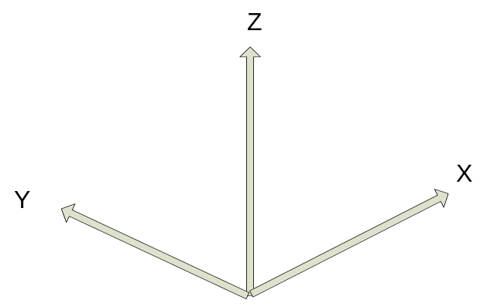
Figure 7.1: Right-handed XYZ coordinate system.

Special case – ground-based, stationary and leveled sensors
Ground-based sensors (radars and lidars) rotate primarily about the vertical (Z) axis (Z-Type), and the reference plane is a horizontal XY plane passing through the sensor. The Y-axis is aligned with TN, and the X-axis points East.
Azimuth angles (λ) are positive clockwise looking from above (+Z), with 0 being TN.
Elevation angles (φ) are measured relative to the horizontal reference plane, positive above the plane and negative below it.
A ground-based, leveled vertical pointing sensor can be classified as a Z-Type with φ=90°.

LIDARs
For LIDARs, the assumption is generally made that propagation of the beam is along a straight line, emanating at the sensor. The coordinate transformation between X_{i} (r, λ, φ) and X (x, y, z) is as follows:
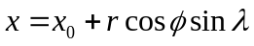
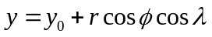
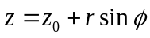
where
x is positive east
y is positive north
(x₀, y₀, z₀) are the coordinates of the sensor relative to the Cartesian grid origin and the azimuth angle (λ) is the angle clockwise from TN.
The sensor location is specified in longitude, latitude and altitude in the CfRadial format. Locations in the earth’s geo-reference coordinate system are computed using the sensor location and the (x,y,z) from above, using normal spherical geometry.

RADARs
The propagation of radar microwave energy in a beam through the lower atmosphere is affected by the change of refractive index of the atmosphere with height. Under average conditions this causes the beam to be deflected downwards, in what is termed ‘Standard Refraction’. For most purposes this is adequately modeled by assuming that the beam is in fact straight, relative to an earth which has a radius of 4/3 times the actual earth radius. (Rinehart 2004.)
For a stationary and leveled, ground-based radar, the equations are similar to those for the LIDAR case, except that we have one extra term, the height correction, which reflects the beam curvature relative to the earth.
The height h above the earth’s surface for a given range is:
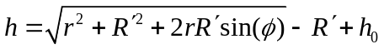
where 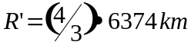 is the pseudo radius of earth. See Rinehart 2004, Chapter 3, for more details.
The (x,y) location for a given range is:
where x is positive east, y is positive north, and remembering that azimuth is the angle clockwise from true north.

Moving platforms
For moving platforms, the metadata for each beam will include:
- longitude of instrument
- latitude of instrument
- altitude of instrument
- rotation and tilt of the beam (see section 7)
- roll, pitch and heading of the platform
- platform motion (U_{G}, V_{G}, W_{G})
- air motion (U_{air}, V_{air}, W_{air})
For ground-based moving platforms (e.g., Doppler on Wheels), the earth-relative location of the observed point is:
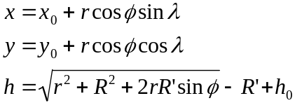
Note that for airborne radar platforms, correcting for refractive index does not apply. Therefore, for airborne radars, use the straight line equations for LIDARs.
Refer to the sections below for the computation of elevation (φ) and azimuth (λ) relative to earth coordinates.
Then apply the following equations, as before, to compute the location of the observed point.
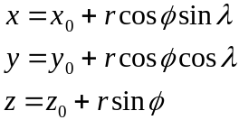

Coordinate transformations for the general case
This section details the processing for the general case.
Sensors which do not fall under section 7.1 above must be handled as a general case.

Coordinate systems
In addition to the previously-defined X_{i} and X coordinate systems, the following intermediate right-handed coordinate systems need to be defined to account for a moving, non-leveled platform:
- X_{a}: platform-relative coordinates, +Y points to heading, +X points to the right side (90° clockwise from +Y on the reference plane XY), +Z is orthogonal to the reference plane.
- X_{h} : leveled, platform heading-relative coordinates, +Y points heading, +X points 90° clockwise from heading, and Z points up (local zenith).
The goal here is to derive transformations from X_{i} to X via X_{a} and X_{h}.

The earth-relative coordinate system
The earth-relative coordinate system, X, is defined as follows, X is East, Y is North, and Z is zenith. Azimuth angle, λ, is defined as positive clockwise from TN (i.e., meteorological angle) while elevation angle, φ, is defined positive/negative above/below the horizontal plane at the altitude (h₀) of the remote sensor.

The platform-relative coordinate system
The general form of the mathematic representation describes a remote sensing device mounted on a moving platform (e.g., an aircraft, see Figure 7.2). This figure depicts the theoretical reference frame for a moving platform. (We use the aircraft analogy here, but the discussion also applies to water-borne platforms and land-based moving platforms.)
The platform-relative coordinate system of the platform, X_{a}, is defined by the right side, (X_{a}), the heading, (Y_{a}), and the zenith, (Z_{a}).
The origin of X_{a} is defined as the location of the INS on a moving platform.
The platform-relative coordinate system is defined by 3 rotations in the following order: heading (H), pitch (P) and roll (R) angles from X. These angles are generally measured by an inertial navigation system (INS).
The platform moves relative to X, based on its heading H, and the drift D, caused by wind or current. (D is 0 for land-based platforms). The track T is the line of the platform movement over the earth surface.
NOTE: -see Lee et al. (1994) for further background on this topic, and on the corrections to Doppler velocity for moving platforms. Usually, the platform INS and the sensor may not be collocated. The Doppler velocity needs to be compensated by the relative motion between these two.

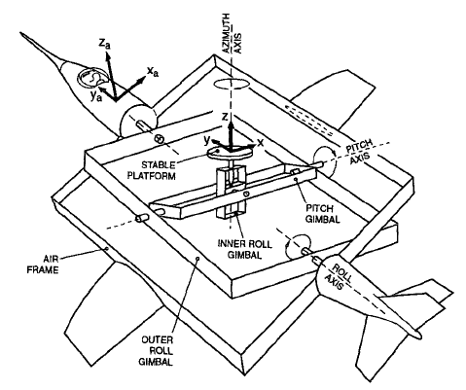
Figure 7.2 Moving platform axis definitions and reference frame (reproduced from Lee et al., 1994,originally from Axford, 1968) ©American Meteorological Society. Reprinted with permission.

Figures 7.3 a through c show the definitions of heading, drift, track, pitch and roll.
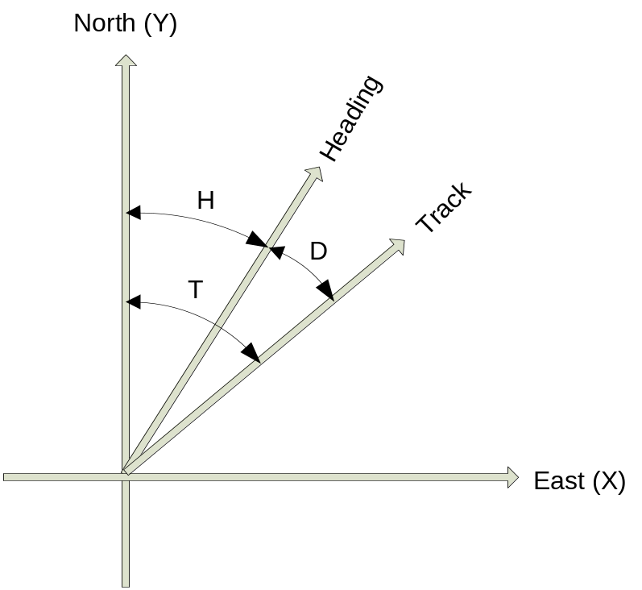
Figure 7.3(a): Definition of heading, drift and track.

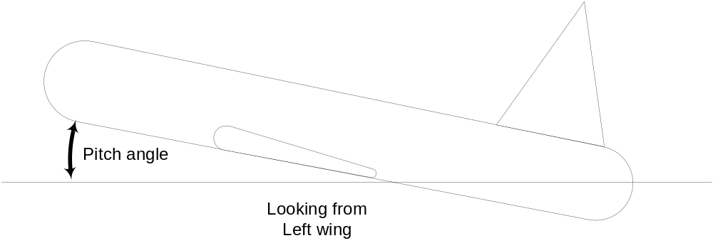
Figure 7.3(b): Definition of pitch

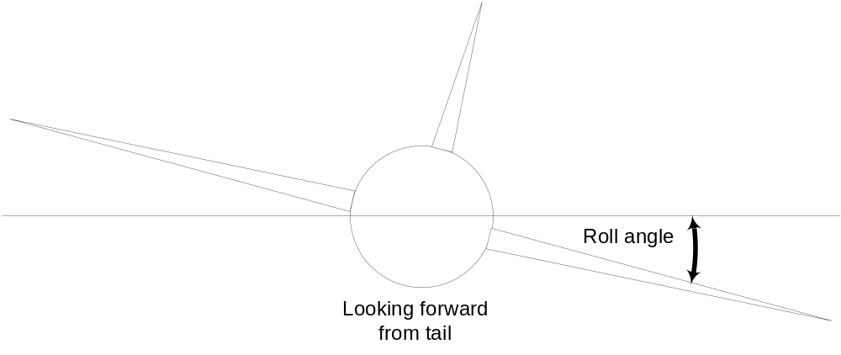
Figure 7.3(c): Definition of roll

The sensor coordinate system
In the sensor coordinate system, X_{i}, each data location is characterized by a range, r, a rotation angle, θ, and a tilt angle, τ. Following the ground-based radar convention, the rotation angle, θ, is the angle projected on the reference plane, positive clockwise from the third axis (counting from the principal axis in X_{a}) looking towards the sensor from the positive principal axis. The tilt angle, τ, is the angle of the beam relative to the reference plane. A beam has a positive/negative τ depending on whether it is on the positive/negative side of the reference plane, using the principal axis to determine the sign. Each gate location (r, θ, τ) in X_{i} can be represented in (r, λ, φ) in X.

Table 7.1: Characteristics of 3 types of sensors.
Sensor Type | Type X | Type Y | Type Z
Principal Axis | X_{a} | Y_{a} | Z_{a}
Reference Plane | Y_{a}Z_{a} | Z_{a}X_{a} | X_{a}Y_{a}
0° Rotation Angle | +Z_{a} | +X_{a} | +Y_{a}
90° Rotation Angle | +Y_{a} | +Z_{a} | +X_{a}
Examples | EDOP, Wyoming Cloud Radar, Wind Profiler, downward scanning radar on Global Hawk | Tail Doppler radars on NOAA P3 and NSF/NCAR ELDORA | Ground-based radar/lidar, aircraft nose radar, NOAA P3 lower-fuselage radar,  C-band scatterometer

Coordinate transformation sequence
The following transformations are carried out to transform the geometry from the instrument-based (X_{i}) to the earth-based coordinate system (X):
- translate from X_{i} to X_{a}
- rotate from X_{a} to X

Transformation from X_{i} to X_{a}
The details of this step depend on the sensor type: Z, Y or X (Table 7.1)

Type Z sensors
The characteristics are:
- the primary axis is Z_{a}
- the reference plane is (X_{a}, Y_{a})
- the rotation angle θ is 0 in the (Y_{a}, Z_{a}) plane, i.e. along the +Y axis. Rotation increases clockwise from +Y, when looking from above (i.e. from +Z)
- the tilt angle τ is 0 in the (X_{a}, Y_{a}) plane, positive above it (for +Z_{a}) and negative below it.
The transformation to Χ_{a} coordinates is:
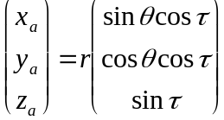

Type Y sensors
The characteristics are:
- the primary axis is Y_{a}
- the reference plane is (Z_{a}, X_{a})
- the rotation angle θ is 0 in the (Z_{a}, X_{a}) plane, i.e. along the +X_{a} axis. Rotation increases clockwise from +X, when looking from +Y.
- the tilt angle τ is 0 in the (Z_{a}, X_{a}) plane, positive for +Y_{a}.
Note that the definition of θ is different from the convention defined in Lee et al. (1994). Let θ’ is the rotation angle defined in Lee et al. (1994), θ=mod(450°- θ’).
The transformation to Χ_{a} coordinates is:
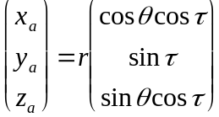

Type X sensors
The characteristics are:
- the primary axis is X_{a}
- the reference plane is (Y_{a}, Z_{a})
- the rotation angle θ is 0 in the (Y_{a}, Z_{a}) plane, i.e. along the +Z_{a} axis. Rotation increases clockwise from +Z_{a}, when looking from +X_{a}.
- the tilt angle τ is 0 in the (Y_{a}, Z_{a}) plane, positive for +X_{a}.
The transformation to Χ_{a} coordinates is:
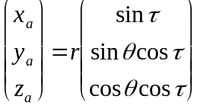

Rotating from X_{a} to X
Rotating X_{a} to X requires the following 3 steps (in the reverse order of the rotation):
- remove the roll R, by rotating the x axis around the y axis by –R.
- remove the pitch P, by rotating the y axis around the x axis by –P.
- remove the heading H, by rotating the y axis around the z axis by +H
The transformation matrix for removing the roll component is:
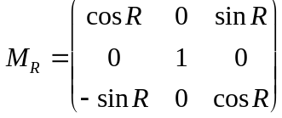
The transformation matrix for removing the pitch component is:
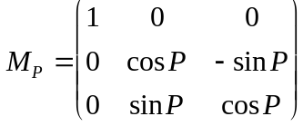
The transformation matrix for removing the heading component is:
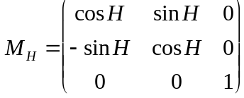

We apply these transformations consecutively:
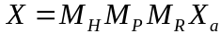
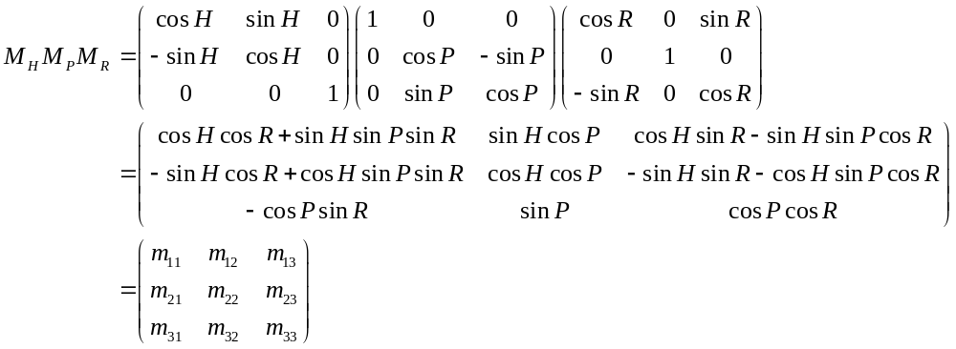

Summary of transforming from X_{i} to X
We combine the above 2 main steps for transform all the way from the instrument coordinates to earth coordinates:

For type Z radars:
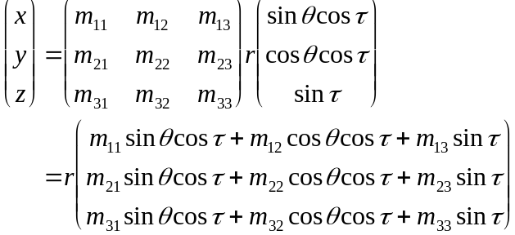

For type Y radars:
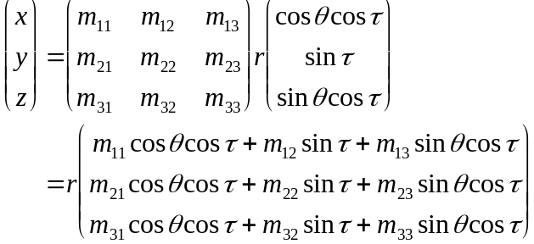

For type X radars:
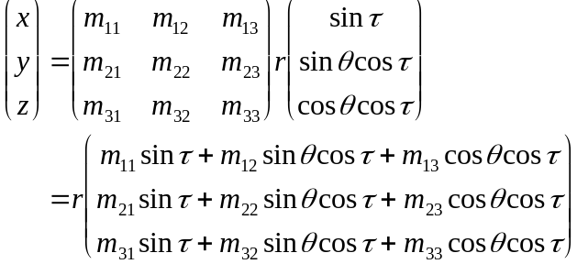

Computing earth-relative azimuth and elevation
We can then compute the earth-relative azimuth and elevation as follows:
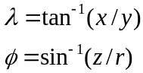

Summary of symbol definitions
Χ_{i}: instrument-relative coordinate system, (r, θ, τ) or (r, λ, φ)
Χ_{a}: platform-relative coordinate system (x_{a}, y_{a}, z_{a}) – see figure 7.2
Χ_{h}: coordinate system relative to level platform (no roll or pitch) with heading H.
Χ: earth-relative coordinate system (x, y, z), x is positive east, y is positive north, z is positive up.
H: heading of platform (see figure 7.3)
T: track of platform (see figure 7.3)
D: drift angle (see figure 7.3)
P: pitch angle (see figure 7.3)
R: roll angle (see figure 7.3)
λ: azimuth angle
φ: elevation angle
θ: rotation angle
τ: tilt angle
r: range
h: height
h_{0:} height of the instrument
R’: pseudo radius of earth = 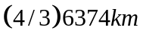

Change log

Version 1.2, released 2011-06-07
- Formalized the concept of required vs. optional dimensions and variables. In this document, required variables are shown shaded, and footnotes were added to each table,
- Added scan_id global attribute.
- Added time_reference variable. If this exists, the time(time) variable is computed relative to this time rather than relative to time_coverage_start.
- Added radar_receiver_bandwidth variable.
- Fixed various errors.

Version 1.1, released 2011-02-01
- Version 1.1 is the first operational release for CfRadial.
- All changes made subsequent to this version must be backward-compatible.
- A major change was made for version 1.1 – changing the storage of moments variables from regular (time, range) arrays to staggered arrays. This change supports a variable number of gates per ray, which makes the storage of operational data more efficient. For example, the NEXRAD data format supports changing the number of gates for different sweeps.

References
Axford, D. N., 1968: On the accuracy of wind measurements using an inertial platform in an aircraft, and an example of a measurement of the vertical structure of the atmosphere. J. Appl. Meteor., 7, 645-666.
Lee, W., P. Dodge, F. D. Marks Jr. and P. Hildebrand, 1994: Mapping of Airborne Doppler Radar Data. Journal of Oceanic and Atmospheric Technology, 11, 572 – 578.
Rinehart, R. E., 2004: Radar for Meteorologists, Fourth Edition. Rinehart Publications. ISBN 0-9658002-1-0

The rotation angle, θ’, defined in previous airborne tail Doppler radar convention (Lee et al. 1994) was positive clockwise looking from the tail toward the nose of an aircraft (i.e., looking from the -Y_{a}-axis) that has been the convention for airborne tail Doppler radars. θ’=0° points to +Z. However, this convention is different from that used in the ground-based radars. The r and τ were defined the same way in the current convention.

