NCAR/UNIDATA

CfRadial Data File Format

CF-compliant netCDF Format
for Moments Data for RADAR and LIDAR
in Radial Coordinates

Version 1.4
Mike Dixon
Wen-Chau Lee

EOL, NCAR*

2016-08-01

* NCAR is sponsored by the US National Science Foundation.

1 Introduction 5
1.1 On-line location 5
1.2 Summary of updates 5
1.2.1 Version 1.4 5
1.2.2 Version 1.3, released 2013-06-01 5
1.2.3 Version 1.2, released 2011-06-07 6
1.2.4 Version 1.1, released 2011-02-01 6
1.3 Purpose 6
1.4 Extensions to the CF convention 7
1.5 Strict use of variable and attribute names for non-field variables 7
1.6 _FillValue and missing_value attributes for data fields 8
1.7 Required vs. optional variables 8
1.8 String length variables 8
2 Data Content Overview 9
2.1 The nature of radar and lidar moments data 9
2.2 Geo-reference variables 9
2.3 Coordinate variables and storage of moments data 10
2.3.1 Regular 2-D storage – constant number of gates 10
2.3.2 Staggered 2-D storage – variable number of gates 11
2.3.3 Principal dimensions and variables for the case of a constant number of gates 11
2.3.1 Additional dimensions and variables for the case of a variable number of gates 12
2.4 Sweep indexes – a "pseudo" third dimension 12
2.5 Constant start range and gate spacing per sweep 13
2.6 No grid mapping variable 13
2.7 Calibration information 14
2.8 Compression 14
3 Convention hierarchy 15
4 CF/Radial base convention 16
4.1 Global attributes 16
4.2 Dimensions 17
4.3 Global variables 18
4.4 Coordinate variables 19
4.4.1 Attributes for time coordinate variable 19
4.4.2 Attributes for range coordinate variable 20
4.5 Ray dimension variables 20
4.6 Location variables 21
4.7 Sweep variables 22
4.8 Sensor pointing variables 23
4.8.1 Attributes for azimuth(time) variable 23
4.8.2 Attributes for elevation(time) variable 24
4.9 Moving platform geo-reference variables 24
4.10 Moments field data variables 25
4.10.1 Use of scale_factor and add_offset 27
4.10.2 Use of coordinates attribute 28
4.10.3 Use of flag values - optional 28
4.10.4 Flag mask fields - optional 28
4.10.5 Quality control fields - optional 28
4.10.6 Legend XML 29
4.11 Spectra field variables 29
4.11.1 Spectrum index variables 30
4.11.2 Spectrum fields 30
4.11.3 Spectrum field attributes 30
5 Sub-conventions 32
5.1 The instrument_parameters sub-convention 32
5.2 The radar_parameters sub-convention 34
5.3 The lidar_parameters sub-convention 34
5.4 The radar_calibration sub-convention 34
5.4.1 Dimensions 35
5.4.2 Variables 35
5.5 The lidar_calibration sub-convention 38
5.6 The platform_velocity sub-convention 38
5.7 The geometry_correction sub-convention 39
6 Standard names 41
6.1 Standard names for moments variables 41
6.2 Standard names for spectra variables 42
6.3 Long names for metadata variables 43
7 Computing the data location from geo-reference variables 50
7.1 Special case – ground-based, stationary and leveled sensors 51
7.1.1 LIDARs 51
7.1.2 RADARs 51
7.2 Moving platforms 52
7.3 Coordinate transformations for the general case 53
7.3.1 Coordinate systems 53
7.3.2 The earth-relative coordinate system 53
7.3.3 The platform-relative coordinate system 53
7.3.4 The sensor coordinate system 56
7.4 Coordinate transformation sequence 57
7.4.1 Transformation from X_{i} to X_{a} 57
7.4.1.1 Type Z sensors 57
7.4.1.2 Type Y sensors 57
7.4.1.4 Type X sensors 58
7.4.2 Rotating from X_{a} to X 58
7.5 Summary of transforming from X_{i} to X 60
7.5.1 For type Z radars: 60
7.5.2 For type Y radars: 60
7.5.3 For type Y-prime radars: 60
7.5.4 For type X radars: 61
7.5.5 Computing earth-relative azimuth and elevation 61
7.6 Summary of symbol definitions 61
8 References 62
9 Example ncdump of CfRadial file 63

Introduction

On-line location
This document, older versions, and other related information, is available on-line at:
https://github.com/NCAR/CfRadial/tree/master/docs

Summary of updates
Date | Version | Remarks
2011/02/01 | 1.1 | First operational version.
2011/06/07 | 1.2 | Minor changes / additions.
2013/07/01 | 1.3 | Major changes / additions
2016/08/01 | 1.4 | Major additions – data quality, spectra.
All changes made subsequent to version 1.1 are backward-compatible.
The changes/additions between this version, 1.4, and the previous version, 1.3, are highlighted in yellow in this document.

Version 1.4
- Clarifies the preferential use of _FillValue. Section 1.6.
- Relax requirement for gate geometry to be constant for entire volume. Changed to support gate geometry changes between sweeps. Sections 2.5, 4.4.
- Added support for multiple prts. Sections 4.2, 5.1.
- Added support for spectra. Sections 4.2, 4.11.
- ‘T’ optional in time strings. Section 4.3.
- Added ‘qc_procedures’ as optional sweep variable to document quality control procedures per sweep. Section 4.7.
- Added optional use of flag_values, flag_masks and flag_meanings for fields. Section 4.10.
- Added optional use of is_quality, qualified_variables and ancillary_variables for quality control fields. Section 4.10.
- Added optional rx_range_resolution – raw receiver range resolution. Section 5.1.

Version 1.3, released 2013-06-01
- Added Y-prime radar type, for ELDORA and NOAA tail-type radars.
- Added field_names global attribute, listing the fields in the file.
- Added rays_are_indexed and ray_angle_res sweep variables.
- Added is_discrete, field_folds, field_limit_lower and field_limit_upper field attributes.
- Version 1.3 changes are high-lighted in yellow.
- Moved section 6.2 to section 6.1. Added standard names to list.
- Moved section 6.1 to section 6.2 – and changed this section to specify suggested long names, rather than standard names.

Version 1.2, released 2011-06-07
- Formalized the concept of required vs. optional dimensions and variables. In this document, required variables are shown shaded, and footnotes were added to each table.
- Added scan_id global attribute.
- Added time_reference variable. If this exists, the time(time) variable is computed relative to this time rather than relative to time_coverage_start.
- Added radar_receiver_bandwidth variable.
- Fixed various errors.

Version 1.1, released 2011-02-01
- Version 1.1 is the first operational release for CfRadial.
- All changes made subsequent to this version must be backward-compatible.
- A major change was made for version 1.1 – changing the storage of moments variables from regular (time, range) arrays to staggered arrays. This change supports a variable number of gates per ray, which makes the storage of operational data more efficient. For example, the NEXRAD data format supports changing the number of gates for different sweeps.

See section 8 for details.

Purpose
The purpose of this document is to specify a CF-compliant netCDF format for radar and lidar moments data in radial (i.e. polar) coordinates.
The intention is that the format should, as far as possible, comply with the CF conventions for gridded data. However, the current CF 1.6 convention does not support radial radar/lidar data. Therefore, extensions to the conventions will be required.
The current CF conventions are documented at:
http://cfconventions.org/
http://cfconventions.org/cf-conventions/v1.6.0/cf-conventions.html

Extensions to the CF convention
This convention introduces the following extensions to CF:
- The following axis attribute types:
- axis = "radial_azimuth_coordinate";
- axis = "radial_elevation_coordinate";
- axis = "radial_range_coordinate";
- Additional standard units. For CfRadial to follow CF properly, the following need to be added to udunits:
- dB (ratio of two values, in log units. For example, ZDR).
- dBm (power in milliwatts, in log units)
- dBZ (radar reflectivity in log units)
- Additional standard names.
CfRadial files will be CF compliant, with the above extensions.

Strict use of variable and attribute names for non-field variables
In CfRadial a ‘field’ variable stores such quantities as radar moments, derived quantities, qc measures etc. These are either measured by the radar, or derived from a field that is measured. These ‘field’ variables require a standard_name as specified in the CF conventions. For example the field variable ‘radar reflectivity’ would have the standard name ‘equivalent_reflectivity_factor’. These variables store the fundamental scientific data associated with the instrument.
By contrast, metadata variables store the dimensional information such as time, range, azimuth and elevation, and other metadata such as calibration and radar characteristcs.
Because of the inherent complexity of radial radar and lidar data, the CfRadial format requires extra strictness, as compared to CF in general, in order to keep it manageable. There are so many metadata variables in CfRadial that it is essential to require strict adherence to the dimension names and variable names for the metadata variables, exactly as specified in this document. It is not practical to expect a software application to search for standard names for metadata variables, since this makes the code unnecessarily complex and difficult to maintain.
Since this is a completely new format, there is no requirement to support legacy data sets which are less strictly defined.
To summarize, this strictness requirement only applies to non-field metadata variables. The moments data fields (i.e. the field variables) will be handled as usual in CF, where the standard name is the definitive guide to the contents of the field. Suggested standard names for radar variables not yet supported by CF are listed in section 6.

_FillValue and missing_value attributes for data fields
CF 1.6 states that the use of missing_value is deprecated, and that only _FillValue should be used.
For CfRadial, either _FillValue or missing_value may be used to indicate missing values. _FillValue is preferred.
Only one or the other should be specified, not both.
Applications reading CfRadial data should check for both of these attributes.

Required vs. optional variables
Required variables are shown shaded in this document.
All other variables are optional.
If an optional variable is not provided, the reader applications should set the variable to a missing value as appropriate.

String length variables
An extra note is required with respect to the dimensions used to specify the length of string variables. String length dimensions may be added as needed. This document refers to the string length dimension as ‘string_length’, but any suitable dimension may be used in its place. See
section 4.2.

Data Content Overview

The nature of radar and lidar moments data
As a radar or lidar scans (or points) the data fields (or moments) are produced over an entity specified by a time interval or angular interval.
We refer to this entity as a ray, beam or dwell. In this document we will use the term ray.
For a given ray, the field data are computed for a sequence of ranges increasing radially away from the instrument. These are referred to as range gates.
In most cases, the spacing between the range gates is constant along the ray, although this is not necessarily the case. For example, some NOAA radars have gate spacings of 75m, 150m and 300m. Therefore, we need to be able to handle the cases for which the range gate spacing is variable. (This was not supported in version 1.0).

Geo-reference variables
A subset of the metadata variables in CfRadial are used to locate a radar or lidar measurement in space.
These are:
- range
- elevation
- azimuth
- latitude
- longitude
- altitude
See sections 4.4, 4.6 and 4.8 for details on these variables.
For moving platforms, extra variables are required for geo-referencing.
These are:
- heading
- roll
- pitch
- rotation
- tilt
See section 4.9 for details on these variables.
The mathematical procedures for computing data location relative to earth coordinates are described in detail in section 7.

Coordinate variables and storage of moments data
The moments data to be handled by this format is represented in 2 principal dimensions:
- time: rays have monotonically increasing time
- range: bins have monotonically increasing range

Regular 2-D storage – constant number of gates
If the rays at all times have the same number of gates, the data is stored in regular arrays, as shown below.
In this case the time dimension may be either fixed or unlimited.
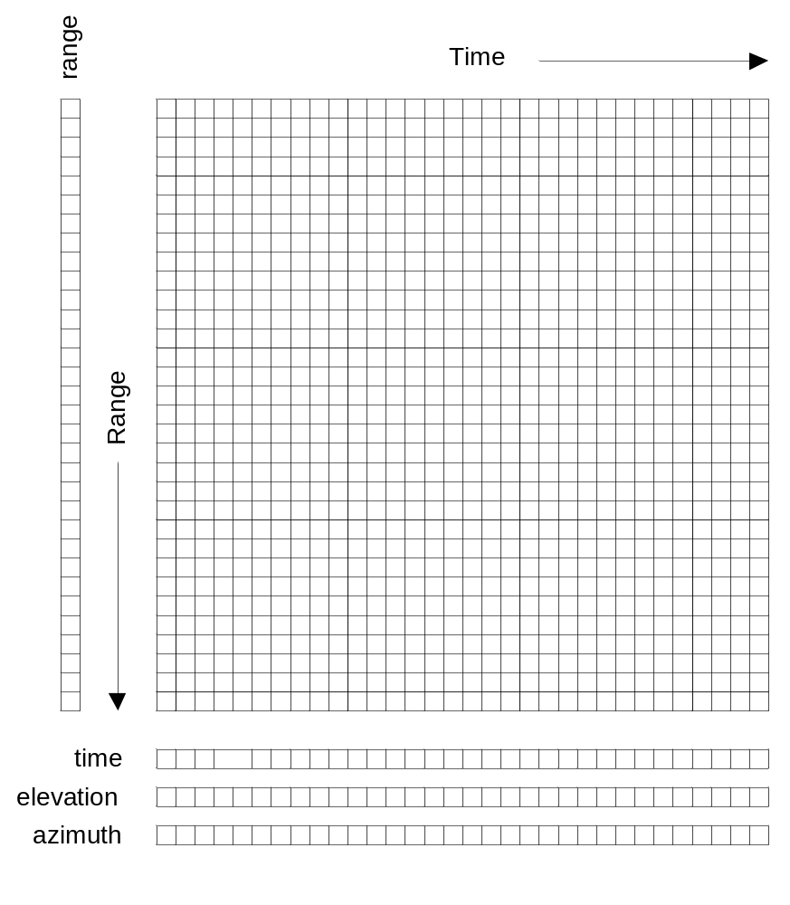
Figure 2.1 Data organization in time and range,
for a constant number of gates

Staggered 2-D storage – variable number of gates
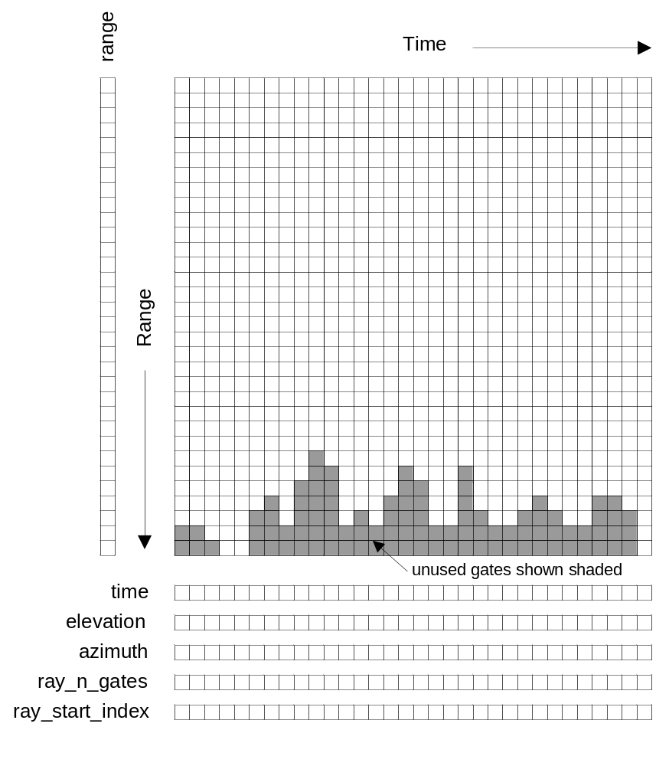
Figure 2.2 Data organization in time and range,
for a variable number of gates

Principal dimensions and variables for the case of a constant number of gates
Refer to figure 2.1.
The principal dimensions are time and range.
The primary coordinate is time and the secondary coordinate is range.
The time coordinate indicates the number of rays in the file. In the case of a constant number of gates, this may be either fixed or unlimited.
The range coordinate indicates the maximum number of gates for any ray in the file.
The time(time) coordinate variable stores the time of each ray, in seconds, from a reference time, which is normally the start of the volume (time_coverage_start) but may be a specified reference time (time_reference).
The range(range) coordinate variable stores the range to the center of each gate. All rays in the volume must have the same range geometry, but not necessarily the same number of gates..
The elevation(time) coordinate variable stores the elevation angle for each ray.
The azimuth(time) coordinate variable stores the azimuth angle for each ray.
The data fields are stored as 2-D arrays, with dimensions (time, range).

Additional dimensions and variables for the case of a variable number of gates
Refer to figure 2.2.
For a variable number of gates per ray, and additional dimension, n_points, is introduced. The time coordinate in this case must be fixed.
The ray_n_gates(time) variable stores the number of gates in a ray.
The ray_start_index(time) variable stores the start index of the moments data for a ray, relative to the start of the moments array.
The n_points dimension indicates the total number of gates stored in all of the rays. It is equal to the sum of ray_n_gates over all rays.
The data fields are stored as 1-D arrays with dimension (n_points). The data from consecutive rays is concatenated to form a single array. The ray_n_gates and ray_start_index values are used to locate the data for a given time in this 1-D array.

Sweep indexes – a "pseudo" third dimension
A set of one or more related sweeps, typically a complete 3-D radar or lidar scan, is referred to as a volume.
A volume scan is comprised of one or more sweeps.
Scanning may be carried out in a number of different ways. For example:
- horizontal scanning at fixed elevation (PPI mode)
- vertical scanning at constant azimuth (RHI mode)
- antenna not moving, i.e. constant elevation and azimuth (staring or pointing)
- aircraft radars which rotate around the longitudinal axis of the aircraft (e.g. ELDORA)
For each of these modes a sweep is defined as follows:
- PPI mode: a sequence of rays at fixed elevation angle, but changing azimuth angles
- RHI mode: a sequence of rays at fixed azimuth angle, but changing elevation angles
- pointing mode: a sequence of rays over some time period, at fixed azimuth and elevation
- ELDORA-type aircraft radars: a sweep starts at a rotation of 0 (antenna pointing vertically upwards) and ends 360 degrees later.
The volume may therefore be logically divided into sweeps. In CfRadial, we do not separate the sweeps in the stored field data arrays. Rather, we store arrays of start and stop indexes, which identify the rays that belong to each sweep. Some recorded rays may be in the transition region between defined sweeps, i.e. they may not belong to any sweep. For these rays we set the ‘antenna_transition’ flag to 1.

Constant start range and gate spacing per sweep
CF/Radial allows the number of gates stored per ray to vary.
However, the range geometry cannot vary within a sweep. This means that the range to the first gate, and the spacing between gates, must be constant for a sweep. For many datasets, the range geometry will be constant for the entire volume.
If the gate geometry is constant for the entire volume, then the range(range) coordinate variable is 1-Dimensional, and stores the range to the center of each gate, and these values are applicable to all rays.
If the gate geometry is not constant for the entire volume, then the range(sweep, range) coordinate variable is 2-Dimensional and stores the range to the center of each gate. These values apply to all rays within the specified sweep.
If the raw data range geometry changes over time (i.e. from ray to ray) within a sweep, the data to be represented in that sweep must be re-sampled using a common time-invariant range geometry for the sweep.

No grid mapping variable
The data in this format is saved in the native coordinate system for RADARs and LIDARs, i.e. radial (or polar) coordinates, with the instrument at the origin.
A grid mapping type is not required, because the geo-reference variables contain all of the information required to locate the data in space.
For a stationary instrument, the following are stored as scalar variables (see section 4.6):
- latitude
- longitude
- altitude
Position and pointing references for moving platforms must take the following motions into account (see section 4.9):
- platform translation
- platform rotation

Calibration information
Radars must be calibrated to ensure that the moments data are accurate. Calibration for some types of lidar may also be appropriate.
A radar may have multiple sets of calibration parameters. Generally a separate calibration is performed for each transmit pulse width. Separate calibrations may be performed for other reasons as well. CfRadial supports storing multiple sets of calibration parameters, using the radar_calibration and lidar_calibration conventions.
The calibration applicable to a specific ray is indicated by the calibration_index variable.

Compression
The netCDF 4 library supports files in the following formats:
- classic
- 64bit offset
- netcdf4
- netcdf4 classic
The netcdf4 format is built on HDF5, which supports compression. Where data are missing or unusable, the data values will be set to a constant well-known _FillValue (or missing_value) code. This procedure, combined with the use of the netcdf4 format, provides efficient compression.
It is therefore recommended that the netcdf4 option be used whenever possible, to keep data sets as small as possible.
However, for importing data into 3rd party applications such as MatLab ©, it is wise (at this stage) to store data in the NetCDF-3 classic format, which is uncompressed, since support for the compressed format is not yet widespread.

Convention hierarchy
The CF/Radial convention comprises a base convention, along with a series of optional sub-conventions for specific purposes.
At the time of writing, the following conventions are supported:

Convention name | Type | Description
CF/Radial | Base | Radial data extension to the  CF convention.  Contains all necessary information for interpreting and displaying the data fields in a geo-referenced manner
instrument_parameters | Optional | Parameters common to both radar and lidar instruments
radar_parameters | Optional | Parameters specific to radars
lidar_parameters | Optional | Parameters specific to lidars
radar_calibration | Optional | Calibration values for radars
lidar_calibration | Optional | Calibration values for lidars
platform_velocity | Optional | Velocity of the platform, in multiple dimensions
geometry_correction | Optional | Corrections to the geometry  of the data set
Note: items shown shaded are required, those not shaded are optional.
If a netCDF file conforms to a base convention and one or more sub-conventions, these are concatenated in the Conventions attribute as a space-delimited string.
The following are some examples:
- “CF/Radial instrument_parameters”
- “CF/Radial instrument_parameters radar_parameters radar_calibration”
- “CF/Radial lidar_parameters platform_velocity”

CF/Radial base convention
The base CF/Radial convention covers the minimum set of elements which are required to describe a radar/lidar data set sufficiently for basic display and plotting. CF/Radial is a specialization of CF.
NOTE on units: in the following tables, for conciseness, we do not spell out the units strings exactly as they are in the netCDF file. The following abbreviations apply:

Units string in netCDF file | Abbreviation in tables
“degrees per second” | degrees/s
“meters per second” | m/s

Global attributes

Attribute name | Type | Convention | Description
Conventions | string | CF | Conventions string will specify Cf/Radial, plus selected sub-conventions as applicable
version | string | CF/Radial | CF/Radial version number
title | string | CF | Short description of file contents
institution | string | CF | Where the original data were produced
references | string | CF | References that describe the data or the methods used to produce it
source | string | CF | Method of production of the original data
history | string | CF | List of modifications to the original data
comment | string | CF | Miscellaneous information
instrument_name | string | CF/Radial | Name of radar or lidar
site_name | string | CF/Radial | Name of site where data were gathered
scan_name | string | CF/Radial | Name of scan strategy used, if applicable
scan_id | int | CF/Radial | Scan strategy id, if applicable.  Assumed 0 if missing.
platform_is_mobile | string | CF/Radial | “true” or “false”  Assumed “false” if missing.
n_gates_vary | string | CF/Radial | “true” or “false”  Assumed “false” if missing.
ray_times_increase | string | CF/Radial | “true” or “false”  Assumed “true” if missing.  This is set to false if the rays are not stored in time order.
field_names | string | CF/Radial | Comma-delimited list of field names included in this file.
Note: items shown shaded are required, those not shaded are optional.

Dimensions

Dimension name | Description
time | The number of rays.  This dimension is optionally UNLIMITED
range | The number of range bins
n_points * | Total number of gates in file.  Required for variable number of gates.
sweep | The number of sweeps
frequency | Number of frequencies used
string_length ** | Length of char type variables.
n_prts | Number of prts used in pulsing scheme.  Optional for fixed, staggered or dual  Required for more complicated schemes.
n_spectra | Number of spectra in data set.  This dimension name is not fixed.  Any suitable name can be used.  There will be multiple dimensions if different spectral data sets have different shapes.
spectrum_n_samples | Number of samples per spectrum.  This dimension name is not fixed.  Any suitable name can be used.  There will be multiple dimensions if different spectral data sets have different shapes.
Note 1: items shown shaded are required, those not shaded are optional.
* Note2: n_points is required if the number of gates varies by ray. It must not be included if the number of gates is fixed.
** Note3: any number of ‘string_length’ dimensions may be created and used. For example, you may declare the dimensions ‘string_length”, ‘string_length_short’ and ‘string_length_long’, and use them appropriately for strings of various lengths. These are only used to indicate the length of the strings actually stored, and have no effect on other parts of the format.

Global variables

Variable name | Dimension | Type | Comments
volume_number | none | int | Volume numbers are sequential, relative to some arbitrary start time, and may wrap.
platform_type | (string_length) | char | Options are:  “fixed”, “vehicle”, “ship”, “aircraft”,  “aircraft_fore”,“aircraft_aft”,  “aircraft_tail”,“aircraft_belly”,  “aircraft_roof”,“aircraft_nose”,  “satellite_orbit”,  “satellite_geostat”  Assumed “fixed” if missing.
instrument_type | (string_length) | char | Options are: “radar”, “lidar”  Assumed “radar” if missing.
primary_axis | (string_length) | char | Options are:  “axis_z”, “axis_y”, “axis_x”, “axis_z_prime”, “axis_y_prime”, “axis_x_prime”.  See section 7 for details.  Assumed “axis_z” if missing.
time_coverage_start | (string_length) | char | UTC time of first ray in file.  Resolution is integer seconds.  The time(time) variable is computed  relative to this time.  Format follows ISO 8601:  yyyy-mm-ddThh:mm:ssZ  NOTE: the T is optional, any single character may be used in this location.
time_coverage_end | (string_length) | char | UTC time of last ray in file.  Resolution is integer seconds.  Format is:  yyyy-mm-ddThh:mm:ssZ  NOTE: the T is optional, any single character may be used in this location.
time_reference | (string_length) | char | UTC time reference.  Resolution is integer seconds.  If defined, the time(time) variable is computed relative to this time instead of relative to time_coverage_start.  Format is:  yyyy-mm-ddThh:mm:ssZ  NOTE: the T is optional, any single character may be used in this location.
Note: items shown shaded are required, those not shaded are optional.

Coordinate variables

Variable name | Dimension | Type | Units | Comments
time | (time) | double | seconds | Coordinate variable for time.  Time at center of each ray, in fractional seconds since time_coverage_start,  or since time_reference if it exists.
range | (range) or  (sweep, range) | float | meters | Coordinate variable for range.  Range to center of each bin.  If the range geometry is constant for the entire volume, use the 1-D array method.  If the range geometry varies from sweep to sweep, use the 2-D array method.  Client applications will determine which is in use by examining the dimensionality of the range variable.
Note: all items are required.

Attributes for time coordinate variable
Attribute name | Type | Value
standard_name | string | “time”
long_name | string | “time_in_seconds_since_volume_start”
units | string | “seconds since yyyy-mm-ddThh:mm:ssZ”,  where the actual reference time values are used.  This unit string is very important and must be correct. It should either match time_reference( if it exists) or time_coverage_start.  NOTE: the T is optional, any single character may be used in this location.
calendar | string | Defaults to “gregorian” if missing.  Options are:  “gregorian” or “standard”,  “proleptic_gregorian”,  “noleap” or “365_day”,  “all_leap” or “366_day”,  “360_day”,  “julian”  See CF conventions for details.
Note: items shown shaded are required, those not shaded are optional.

Attributes for range coordinate variable
Attribute name | Type | Value
standard_name | string | “projection_range_coordinate”
long_name | string | “range_to_measurement_volume”
units | string | “meters”
spacing_is_constant | string | “true” or “false”
meters_to_center_of_first_gate | float  or  float(sweep) | Start range in meters.  If the range variable has dimensions (sweep, range), the float(sweep) form is used.
meters_between_gates | float  or  float(sweep) | Gate spacing in meters.  Required if  spacing_is_constant is “true”.  Not applicable otherwise.  If the range variable has dimensions (sweep, range), the float(sweep) form is used.
axis | string | “radial_range_coordinate”
Note: items shown shaded are required, those not shaded are optional.

Ray dimension variables

Variable name | Dimension | Type | Comments
ray_n_gates | (time) | int | Number of gates in a ray.
ray_start_index | (time) | int | Index of start of moments data for a ray, relative to the start of the moments array
Note: required if n_gates_vary global attribute is true. Do not specify if n_gates_vary is false.

Location variables
Note: for stationary platforms, these are scalars, and for moving platforms they are vectors in the time dimension.

Variable name | Dimension | Type | Units | Comments
latitude | none or (time) | double | degrees_north | Latitude of instrument.  For a stationary platform, this is a scalar. For a moving platform, this is a vector.
longitude | none or (time) | double | degrees_east | Longitude of instrument.  For a stationary platform, this is a scalar. For a moving platform, this is a vector.
altitude | none or (time) | double | meters | Altitude of instrument, above mean sea level.  For a scanning radar, this is the center of rotation of the antenna.  For a stationary platform, this is a scalar. For a moving platform, this is a vector.
altitude_agl | none or (time) | double | meters | Altitude of instrument above ground level.  For a stationary platform, this is a scalar. For a moving platform, this is a vector.  Omit if not known.
Note: items shown shaded are required, those not shaded are optional.

Sweep variables

Variable name | Dimension | Type | Units | Comments
sweep_number | (sweep) | int |  | The number of the sweep, in the volume scan.  0-based.
sweep_mode | (sweep, string_length) | char |  | Options are:  “sector”,“coplane”,rhi”,  “vertical_pointing”,“idle”,  “azimuth_surveillance”,  “elevation_surveillance”,  “sunscan”,“pointing”,  “manual_ppi”,“manual_rhi”
fixed_angle | (sweep) | float | degrees | Target angle for the sweep.  elevation in most modes  azimuth in RHI mode
sweep_start_ray_index | (sweep) | int |  | Index of first ray in sweep, relative to start of volume.  0-based.
sweep_end_ray_index | (sweep) | int |  | Index of last ray in sweep, relative to start of volume.  0-based.
target_scan_rate | (sweep) | float | degrees/s | Intended scan rate for this sweep. The actual scan rate is stored according to section 4.8.  This variable is optional.  Omit if not available.
rays_are_indexed | (sweep) | string |  | “true” or “false”  Indicates whether or not the ray angles (elevation in RHI mode, azimuth in other modes) are indexed to a regular grid.
ray_angle_res | (sweep) | float | degrees | If rays_are_indexed is “true”, this is the resolution of the angular grid – i.e. the delta angle between successive rays.
qc_procedures | (sweep,  string_length) | char |  | Documents QC procedures per sweep.
Note: items shown shaded are required, those not shaded are optional.
NOTE2: this section must always exist, even if a volume contains only 1 sweep. The reason for the inclusion is that the sweep_mode and sweep_fixed_angle are necessary for fully understanding the sweep strategy.

Sensor pointing variables
Variable name | Dimension | Type | Units | Comments
azimuth | (time) | float | degrees | Azimuth of antenna, relative to true north.  The azimuth should refer to the center of the dwell.
elevation | (time) | float | degrees | Elevation of antenna, relative to the horizontal plane.  The elevation should refer to the center of the dwell.
scan_rate | (time) | float | degrees/s | Actual antenna scan rate.  Set to negative if counter-clockwise in azimuth or decreasing in elevation.  Positive otherwise.
antenna_transition | (time) | byte |  | 1 if antenna is in transition,  i.e. between sweeps, 0 if not.  If variable is omitted, the transition will be assumed to be 0 everywhere.  Assumed 0 if missing.
georefs_applied | (time) | byte |  | 1 if georeference information for moving platforms has been applied to correct the azimuth and elevation.  0 otherwise.  See section 4.9.  Assumed 0 if missing.
Note: items shown shaded are required, those not shaded are optional.

Attributes for azimuth(time) variable
Attribute name | Type | Value
standard_name | string | “ray_azimuth_angle”
long_name | string | “azimuth_angle_from_true_north”
units | string | “degrees”
axis | string | “radial_azimuth_coordinate”
Note: All items are required.

Attributes for elevation(time) variable
Attribute name | Type | Value
standard_name | string | “ray_elevation_angle”
long_name | string | “elevation_angle_from_horizontal_plane”
units | string | “degrees”
axis | string | “radial_elevation_coordinate”
Note: All items are required.

Moving platform geo-reference variables
For moving platforms, the following additional variables will be included to allow geo-referencing of the platform in earth coordinates. Only include this section for moving platforms, omit completely for fixed platforms.
See sections 5.6 and 7 for further details.

Variable name | Dimension | Type | Units | Comments
heading | (time) | float | degrees | Heading of the platform relative to true N, looking down from above.
roll | (time) | float | degrees | Roll about longitudinal axis of platform. Positive is left side up, looking forward.
pitch | (time) | float | degrees | Pitch about the lateral axis of the platform. Positive is up at the front.
drift | (time) | float | degrees | Difference between heading and track over the ground. Positive drift implies track is clockwise from heading, looking from above. NOTE: not applicable to land-based moving platforms.
rotation | (time) | float | degrees | Angle between the radar beam and the vertical axis of the platform. Zero is along the vertical axis, positive is clockwise looking forward from behind the platform.
tilt | (time) | float | degrees | Angle between radar beam (when it is in a plane containing the longitudinal axis of the platform) and a line perpendicular to the longitudinal axis. Zero is perpendicular to the longitudinal axis, positive is towards the front of the platform.
Note: if this block is included, all items are required.

Moments field data variables
If the number of gates per ray is fixed, the moments field variables will be 2-dimensional arrays, with the dimensions time and range.
If the number of gates per ray varies, the moments field variables will be 1-dimensional with the dimension n_points. The variables are stored as staggered arrays, using the auxiliary variables ray_start_index(time) and ray_n_gates(time) to locate the data for a ray.
The field data will be stored using one of the following:

netCDF type | Byte width | Description
ncbyte | 1 | scaled signed integer
short | 2 | scaled signed integer
int | 4 | scaled signed integer
float | 4 | floating point
double | 8 | floating point

The netCDF variable name is interpreted as the short name for the field.
Field data variables have the following attributes:

Attribute name | Type | Convention | Description
long_name | string | CF | Long name describing the field.  Any string is appropriate.  Although this is an optional attribute, its use is strongly encouraged.
standard_name | string | CF | CF standard name for field.  See section 6.2.
units | string | CF | Units for field
_FillValue  (or missing_value) | same type as field data | CF | Indicates data are missing at this range bin.  Use of _FillValue is preferred.  Only use one or the other.
scale_factor | float | CF | Float value =  (integer value) * scale_factor  + add_offset  Only applies to integer types.
add_offset | float | CF
coordinates | string | CF | See note below
sampling_ratio | float | CF/Radial | Number of samples for this field divided by n_samples  (see section 5.1).  Assumed 1.0 if missing.
is_discrete | string | CF/Radial | “true” or “false”  If “true”, this indicates that the field takes on discrete values, rather than floating point values. For example, if a field is used to indicate the hydrometeor type, this would be a discrete field.
field_folds | string | CF/Radial | “true” or “false”  Used to indicate that a field is limited between a min and max value, and that it folds between the two extremes. This typically applies to such fields as radial velocity and PHIDP.
fold_limit_lower | float | CF/Radial | If field_folds is “true”, this indicates the lower limit at which the field folds.
fold_limit_upper | float | CF/Radial | If field_folds is “true”, this indicates the upper limit at which the field folds.
is_quality_field | string | CF/Radial | “true” or ”false”  “true” indicates this is a quality control field.  If the attribute is not present, defaults to “false”.
flag_values | array of same type as field data | CF | Array of flag values. These values have special meaning, as documented in flag_meanings.
flag_meanings | string | CF | Meaning of flag_values or flag_masks.  Space-separated list in string.
flag_masks | array of same type as field data | CF | Valid bit-wise masks used in a flag field that is comprised of bit-wise combinations of mask values.  See flag_meanings.
qualified_variables | string | CF/Radial | Applicable if is_quality_field is “true”.  Space-separated list of variables that this variable qualifies.  Every field variable in this list should list this variable in its ancillary_variable attribute.
ancillary_variables | string | CF | Space-separated list of variables to which this variable is related. In particular, this is intended to list the variables that contain quality information about this field. In that case, the quality field will list this field in its qualified_variable attribute.
thresholding_xml | string | CF/Radial | Thresholding details.  Supplied if thresholding has been applied to the field.  This should be in self-descriptive XML. (See below for example)
legend_xml | string | CF/Radial | Legend details.  Applies to discrete fields.  Maps field values to the properties they represent.  This should be in self-descriptive XML. (See below for example)

Use of scale_factor and add_offset
scale_factor and add_offset are required for ncbyte, short and int fields. They are not applicable to float and double fields.

Use of coordinates attribute
The “coordinates’ attribute lists the variables needed to compute the location of a data point in space.
For stationary platforms, the coordinates attribute should be set to:
“elevation azimuth range”
For moving platforms, the coordinates attribute should be set to:
“elevation azimuth range heading roll pitch rotation tilt”

Use of flag values - optional
For all data sets, the _FillValue attribute has special meaning – see 1.6 above.
A field variable may make use of more than one reserved value, to indicate a variety of conditions. For example, with radar data, you may wish to indicate that the beam is blocked for a given gate, and that no echo will ever be detected at that gate. That provides more information than just using _FillValue.
The flag_values and flag_meanings attributes can be used in this case.
The flag_values attribute is a list of values (other than _FillValue) that have special meanings. It should have the same type as the variable.
The flag_meanings string attribute is a space-delimited list of strings that indicate the meanings of each of the flag_values. If multi-word meanings are needed, use underscores to connect the words. For example you might use flag meanings of ‘no_coverage’ and ‘low_snr’ to distinguish between regions where the radar cannot see as opposed to regions where the signal is well below the noise.

Flag mask fields - optional
An integer-type field variable may contain values that describe a number of independent Boolean conditions. The field is constructed using the bit-wise OR method to combine the conditions.
In this case, the flag_mask and flag_meanings attributes are used to indicate the valid values in the field, and the meanings.
The flag_masks attribute is a list of integer values (other than _FillValue) that are bit-wise combinations valid for the field variable. It should have the same type as the variable.
The flag_meanings string attribute is a space-delimited list of strings that indicate the meanings of each of the flag_masks. If multi-word meanings are needed, use underscores to connect the words.

Quality control fields - optional
Some field variables exist to provide quality information about another field variable. For example, one field may indicate the uncertainty associated with another field.
In this case, the field should have the is_quality string attribute, with the value set to “true”. If this attribute is missing, it is assumed to be “false”.
In addition, the field should have the qualified_variables string attribute. This is a space-separated list of field names that this field qualifies.
Each qualified field, in turn, should have the ancillary_variables string attribute. This is a space-separated list of fields that qualify it.

Legend XML
The legend_xml should contain self-explanatory information about the categories for a discrete field, as in the following example for particle type:

<legend label="particle_id">
<category>
<value>1</value>
<label>cloud</label>
<category>
<category>
<value>2</value>
<label>drizzle</label>
<category>
.......
.......
<category>
<value>17</value>
<label>ground_clutter</label>
<category>
</legend>

The thresholding_xml should contain self-explanatory information about any thresholding that has been applied to the data field, as in the following example:

<thresholding field="DBZ">
<field_used>
<name>NCP</name>
<min_val>0.15</min_val>
</field_used>
<field_used>
<name>SNR</name>
<min_val>-3.0</min_val>
</field_used>
<note>NCP only checked if DBZ > 40</note>
</thresholding>

Spectra field variables
Support for spectra has been added to CfRadial version 1.4.
Because spectra are potentially voluminous, they are stored in a sparse array, such that a spectrum need only be stored for gate locations of interest, rather than at all locations. This is achieved through the use of an integer index variable, which exists for every gate location. If the index is set to -1, no spectrum is stored for that gate. If the index is 0 or positive, it indicates the location of the spectrum in the contiguous array.

Spectrum index variables
The index variable for a spectrum is an integer variable, stored as a regular field data variable as specified in section 4.10 above. There is a spectrum index value for every gate in the CfRadial volume.
The _FillValue attribute for the index should be set to -1.
If the index is set to missing for a gate, this indicates that there is no spectrum stored for that gate.
If the index is not missing for a gate, it will be set to a value between 0 and (n_spectra – 1), which indicates the location for the spectrum in the spectrum field data variable array.
A single index variable can apply to a number of spectra fields.

Spectrum fields
A spectrum variable will have the dimensions:
(n_spectra, spectrum_n_samples).
These dimension names are not fixed. Any suitable names can be used. There will be multiple dimensions if different spectral data sets have different shapes.
As with moments field variables, a spectrum variable will be stored using one of the following:

netCDF type | Byte width | Description
ncbyte | 1 | scaled signed integer
short | 2 | scaled signed integer
int | 4 | scaled signed integer
float | 4 | floating point
double | 8 | floating point

Spectrum field attributes
Spectrum fields have the following attributes:

Attribute name | Type | Convention | Description
is_spectrum | string | CF/Radial | Set to “true” to indicate that this is a spectrum variable.
long_name | string | CF | Long name describing the field.  Any string is appropriate.  Although this is an optional attribute, its use is strongly encouraged.
standard_name | string | CF | CF standard name for field, or from section 6.
units | string | CF | Units for field
_FillValue or missing_value | same type as field data | CF | Indicates data are missing for a given sample. _FillValue is preferred.
scale_factor | float | CF | See section 4.10.  Float value =  (integer value) * scale_factor  + add_offset.  Only applied to integer types.
add_offset | float | CF
coordinates | string | CF | See section 4.10.
index_var_name | string | CF/Radial | Name of index variable for this field.  NOTE: a single index variable may be used for multiple spectrum fields.
fft_length | int | CF/Radial | Length used to compute this spectrum
block_avg_length | int | CF/Radial | Number of block spectra averaged for each output spectrum.

Sub-conventions
The base CF/Radial convention, as described above, covers the minimum set of netCDF elements which are required to locate radar/lidar data in time and space.
The following sub-conventions augment the base convention with additional information for various purposes.

The instrument_parameters sub-convention
This convention stores parameters relevant to both radars and lidars.
Variables in this convention will have the string attribute meta_group, set to the value “instrument_parameters”.

Variable name | Dimension | Type | Units | Comments
frequency | (frequency) | float | s-1 | List of operating frequencies, in Hertz.  In most cases, only a single frequency is used.
follow_mode | (sweep,  string_length) | char |  | options are: “none”, “sun”, “vehicle”, “aircraft”, “target”, “manual”  Assumed “none” if missing.
pulse_width | (time) | float | seconds
rx_range_resolution | (time) | float | meters | Resolution of the raw receiver samples.  If missing, assumed to be meters_between_gates (4.4.2).  Raw data may be resampled before data storage.
prt_mode | (sweep, string_length) | char |  | Pulsing mode  Options are: “fixed”, “staggered”, “dual”, “hybrid”.  Assumed “fixed” if missing.  May also be more complicated pulsing schemes, such as HHVV, HHVVH etc.
prt | (time) | float | seconds | Pulse repetition time.  For staggered prt, also see prt_ratio.
prt_ratio | (time) | float |  | Ratio of prt/prt2.  For dual/staggered prt mode.
prt_sequence | (time, n_prts) | float | seconds | Sequence of prts used.  Optional for fixed, staggered and dual, which can make use of ‘prt’ and ‘prt_ratio’.  Required for more complicated pulsing schemes.
polarization_mode | (sweep, string_length) | char |  | Options are: “horizontal”, “vertical”, “hv_alt”, “hv_sim”, “circular” Assumed “horizontal” if missing.
polarization_sequence | (sweep, n_prts) | char |  | This only applies if prt_mode is set to “hybrid”. As an example, the form of it would be [‘H’,’H’,’V’,’V’,’H’] for HHVVH pulsing.
nyquist_velocity | (time) | float | m/s | Unambiguous velocity.  This is the effective nyquist velocity after unfolding.  See also the field-specific attributes fold_limit_lower and fold_limit_upper, 4.10.
unambiguous_range | (time) | float | meters | Unambiguous range
n_samples | (time) | int |  | Number of samples used to compute moments
radar_measured_sky_noise | (time) | float | dBm | Noise measured at the receiver when connected to the antenna with no noise source connected.
radar_measured_cold_noise | (time) | float | dBm | Noise measured at the receiver when connected to the noise source, but it is not enabled.
radar_measured_hot_noise | (time) | float | dBm | Noise measured at the receiver when it is connected to the noise source and the noise source is on.
Note: all items are optional.
The number of samples used to compute the moments may vary from field to field. In the table above, n_samples refers to the maximum number of samples used for any field. The field attribute ‘sampling_ratio’ (see 4.10) is computed as the actual number of samples used for a given field, divided by n_samples. It would generally be 1.0.

The radar_parameters sub-convention
This convention handles parameters specific to radar platforms. Variables in this convention will have the string attribute meta_group, set to the value “radar_parameters”.

Variable name | Dimension | Type | Units | Comments
radar_antenna_gain_h | none | float | dB | Nominal antenna gain,  H polarization
radar_antenna_gain_v | none | float | dB | Nominal antenna gain,  V polarization
radar_beam_width_h | none | float | degrees | Antenna beam width  H polarization
radar_beam_width_v | none | float | degrees | Antenna beam width  V polarization
radar_receiver_bandwidth | none | float | s-1 | Bandwidth of radar receiver
radar_measured_transmit_power_h | (time) | float | dBm | Measured transmit power  H polarization
radar_measured_transmit_power_v | (time) | float | dBm | Measured transmit power  V polarization
Note: all items are optional.

The lidar_parameters sub-convention
This convention handles parameters specific to lidar platforms. Variables in this convention will have the string attribute meta_group, set to the value “lidar_parameters”.

Variable name | Dimension | Type | Units | Comments
lidar_beam_divergence | none | float | milliradians | Transmit side
lidar_field_of_view | none | float | milliradians | Receive side
lidar_aperture_diameter | none | float | cm
lidar_aperture_efficiency | none | float | percent
lidar_peak_power | none | float | watts
lidar_pulse_energy | none | float | joules
Note: all items are optional.

The radar_calibration sub-convention
Variables in this convention will have the string attribute meta_group, set to the convention name “radar_calibration”.

Dimensions
Dimension name | Description
r_calib | The number of calibrations available
Note: required if any radar_calibration variables are included..

Variables
The meaning of the designations used in the calibration variables are as follows for dual-polarization radars:
- 'h': horizontal channel
- 'v': vertical channel
- 'hc': horizontal co-polar (h transmit, h receive)
- 'hx' – horizontal cross-polar (v transmit, h receive)
- 'vc': vertical co-polar (v transmit, v receive)
- 'vx' – vertical cross-polar (h transmit, v receive)
For single polarization radars, the 'h' quantities should be used.

Variable name | Dimension | Type | Units | Comments
r_calib_index | (time) | byte |  | Index for the calibration that applies to each ray.  Assumed 0 if missing.
r_calib_time | (r_calib,  string_length) | char | UTC | e.g. 2008-09-25  T23:00:00Z
r_calib_pulse_width | (r_calib) | float | seconds | Pulse width for this  calibration
r_calib_antenna_gain_h | (r_calib) | float | dB | Derived antenna gain  H channel
r_calib_antenna_gain_v | (r_calib) | float | dB | Derived antenna gain  V channel
r_calib_xmit_power_h | (r_calib) | float | dBm | Transmit power  H channel
r_calib_xmit_power_v | (r_calib) | float | dBm | Transmit power  V channel
r_calib_two_way_waveguide_loss_h | (r_calib) | float | dB | 2-way waveguide loss  measurement plane to feed horn, H channel
r_calib_two_way_waveguide_loss_v | (r_calib) | float | dB | 2-way waveguide loss  measurement plane to feed horn, V channel
r_calib_two_way_radome_loss_h | (r_calib) | float | dB | 2-way radome loss  H channel
r_calib_two_way_radome_loss_v | (r_calib) | float | dB | 2-way radome loss  V channel
r_calib_receiver_mismatch_loss | (r_calib) | float | dB | Receiver filter bandwidth mismatch loss
r_calib_receiver_mismatch_loss_h | (r_calib) | float | dB | Receiver filter bandwidth mismatch loss  H channel
r_calib_receiver_mismatch_loss_v | (r_calib) | float | dB | Receiver filter bandwidth mismatch loss|V channel
r_calib_radar_constant_h | (r_calib) | float | m/mW  dB units | Radar constant  H channel
r_calib_radar_constant_v | (r_calib) | float | m/mW  dB units | Radar constant  V channel
r_calib_probert_jones_correction | (r_calib) | float | dB | Probert Jones antenna correction factor.
r_calib_dielectric_factor_used | (r_calib) | float |  | This is |K²|in the radar equation.
r_calib_noise_hc | (r_calib) | float | dBm | Measured noise level  H co-pol channel
r_calib_noise_vc | (r_calib) | float | dBm | Measured noise level  V co-pol channel
r_calib_noise_hx | (r_calib) | float | dBm | Measured noise level  H cross-pol channel
r_calib_noise_vx | (r_calib) | float | dBm | Measured noise level  V cross-pol channel
r_calib_receiver_gain_hc | (r_calib) | float | dB | Measured receiver gain  H co-pol channel
r_calib_receiver_gain_vc | (r_calib) | float | dB | Measured receiver gain  V co-pol channel
r_calib_receiver_gain_hx | (r_calib) | float | dB | Measured receiver gain  H cross-pol channel
r_calib_receiver_gain_vx | (r_calib) | float | dB | Measured receiver gain  V cross-pol channel
r_calib_base_1km_hc | (r_calib) | float | dBZ | reflectivity at 1km for SNR=0dB  noise-corrected  H co-pol channel
r_calib_base_1km_vc | (r_calib) | float | dBZ | reflectivity at 1km for SNR=0dB  noise-corrected  V co-pol channel
r_calib_base_1km_hx | (r_calib) | float | dBZ | reflectivity at 1km for SNR=0dB  noise-corrected  H cross-pol channel
r_calib_base_1km_vx | (r_calib) | float | dBZ | reflectivity at 1km for SNR=0dB  noise-corrected  V cross-pol channel
r_calib_sun_power_hc | (r_calib) | float | dBm | Calibrated sun power  H co-pol channel
r_calib_sun_power_vc | (r_calib) | float | dBm | Calibrated sun power  V co-pol channel
r_calib_sun_power_hx | (r_calib) | float | dBm | Calibrated sun power  H cross-pol channel
r_calib_sun_power_vx | (r_calib) | float | dBm | Calibrated sun power  V cross-pol channel
r_calib_noise_source_power_h | (r_calib) | float | dBm | Noise source power  H channel
r_calib_noise_source_power_v | (r_calib) | float | dBm | Noise source power  V channel
r_calib_power_measure_loss_h | (r_calib) | float | dB | Power measurement loss in coax and connectors  H channel
r_calib_power_measure_loss_v | (r_calib) | float | dB | Power measurement loss in coax and connectors  V channel
r_calib_coupler_forward_loss_h | (r_calib) | float | dB | Coupler loss into waveguide  H channel
r_calib_coupler_forward_loss_v | (r_calib) | float | dB | Coupler loss into waveguide  V channel
r_calib_zdr_correction | (r_calib) | float | dB | corrected =  measured + correction
r_calib_ldr_correction_h | (r_calib) | float | dB | corrected =  measured + correction
r_calib_ldr_correction_v | (r_calib) | float | dB | corrected =  measured + correction
r_calib_system_phidp | (r_calib) | float | degrees | System PhiDp, as seen in drizzle close to radar
r_calib_test_power_h | (r_calib) | float | dBm | Calibration test power  H channel
r_calib_test_power_v | (r_calib) | float | dBm | Calibration test power  V channel
r_calib_receiver_slope_hc | (r_calib) | float |  | Computed receiver slope, ideally 1.0  H co-pol channel
r_calib_receiver_slope_vc | (r_calib) | float |  | Computed receiver slope, ideally 1.0  V co-pol channel
r_calib_receiver_slope_hx | (r_calib) | float |  | Computed receiver slope, ideally 1.0  H cross-pol channel
r_calib_receiver_slope_vx | (r_calib) | float |  | Computed receiver slope, ideally 1.0  V cross-pol channel
Note: all items are optional.

The lidar_calibration sub-convention
Variables in this convention will have the string attribute meta_group, set to the value “lidar_calibration”.
At the time of writing, this convention has not been defined.

The platform_velocity sub-convention
For moving platforms, include the following variables to indicate the velocity of the platform at each time. Omit entirely for fixed platforms.
Variables in this convention will have the string attribute meta_group, set to the value “platform_velocity”.

Variable name | Dimension | Type | Units | Comments
eastward_velocity | (time) | float | m/s | EW velocity of the platform.  Positive is eastwards.
northward_velocity | (time) | float | m/s | NS velocity of the platform.  Positive is northwards.
vertical_velocity | (time) | float | m/s | Vertical velocity of the platform. Positive is up.
eastward_wind | (time) | float | m/s | EW wind at the platform location. Positive is eastwards.
northward_wind | (time) | float | m/s | NS wind at the platform location. Positive is northwards.
vertical_wind | (time) | float | m/s | Vertical wind at the platform location. Positive is up.
heading_rate | (time) | float | degrees/s | Rate of change of heading
roll_rate | (time) | float | degrees/s | Rate of change of roll of the platform
pitch_rate | (time) | float | degrees/s | Rate of change of pitch of the platform.
Note: no items are required.

The geometry_correction sub-convention
The following additional variables are used to quantify errors in the georeference data for the platform. These are constant for a data set.
Variables in this convention will have the string attribute meta_group, set to the value “geometry_correction”.
If any item is omitted, the value is assumed to be 0.

Variable name | Dimension | Type | Units | Comments
azimuth_correction | none | float | degrees | Correction to azimuth values
elevation_correction | none | float | degrees | Correction to elevation values
range_correction | none | float | meters | Correction to range values
longitude_correction | none | float | degrees | Correction to longitude values
latitude_correction | none | float | degrees | Correction to latitude values
pressure_altitude_correction | none | float | meters | Correction to pressure altitude values
radar_altitude_correction | none | float | meters | Correction to radar altitude values
eastward_ground_speed_correction | none | float | m/s | Correction to EW ground speed values
northward_ground_speed_correction | none | float | m/s | Correction to NS ground speed values
vertical_velocity_correction | none | float | m/s | Correction to vertical velocity values
heading_correction | none | float | degrees | Correction to heading values
roll_correction | none | float | degrees | Correction to roll values
pitch_correction | none | float | degrees | Correction to pitch values
drift_correction | none | float | degrees | Correction to drift values
rotation_correction | none | float | degrees | Correction to rotation values
tilt_correction | none | float | degrees | Correction to tilt values
Note: none of these items is required. If missing, 0 will be assumed.

Standard names
To the extent possible, CfRadial uses standard names already defined by CF.

Standard names for moments variables
This section lists the proposed standard names for moments data and other fields derived from the raw radar data.

Standard name | Short  name | Units | Already  in CF?
equivalent_reflectivity_factor | DBZ | dBZ | yes
linear_equivalent_reflectivity_factor | Z | Z | no
radial_velocity_of_scatterers_  away_from_instrument | VEL | m/s | yes
doppler_spectrum_width | WIDTH | m/s | no
log_differential_reflectivity_hv | ZDR | dB | no
log_linear_depolarization_ratio_hv | LDR | dB | no
log_linear_depolarization_ratio_h | LDRH | dB | no
log_linear_depolarization_ratio_v | LDRV | dB | no
differential_phase_hv | PHIDP | degrees | no
specific_differential_phase_hv | KDP | degrees/km | no
cross_polar_differential_phase | PHIHX | degrees | no
cross_correlation_ratio_hv | RHOHV |  | no
co_to_cross_polar_correlation_ratio_h | RHOHX |  | no
co_to_cross_polar_correlation_ratio_v | RHOXV |  | no
log_power | DBM | dBm | no
log_power_co_polar_h | DBMHC | dBm | no
log_power_cross_polar_h | DBMHX | dBm | no
log_power_co_polar_v | DBMVC | dBm | no
log_power_cross_polar_v | DBMVX | dBm | no
linear_power | PWR | mW | no
linear_power_co_polar_h | PWRHC | mW | no
linear_power_cross_polar_h | PWRHX | mW | no
linear_power_co_polar_v | PWRVC | mW | no
linear_power_cross_polar_v | PWRVX | mW | no
signal_to_noise_ratio | SNR | dB | no
signal_to_noise_ratio_co_polar_h | SNRHC | dB | no
signal_to_noise_ratio_cross_polar_h | SNRHX | dB | no
signal_to_noise_ratio_co_polar_v | SNRVC | dB | no
signal_to_noise_ratio_cross_polar_v | SNRVX | dB | no
normalized_coherent_power  (Note: this is also known as signal-quality-index) | NCP  (SQI) |  | no
corrected_equivalent_reflectivity_factor | DBZc | dBZ | no
corrected_radial_velocity_of_scatterers_  away_from_instrument | VELc | m/s | no
corrected_log_differential_reflectivity_hv | ZDRc | dB | no
radar_estimated_rain_rate | RRR | mm/hr | no
rain_rate | RR | kg/m2/s | yes
radar_echo_classification  (should be used for PID, HCA, HID etc) | REC | legend | no

Standard names for spectra variables
This section lists the proposed standard names for spectra field variables. After assuming reciprocity there are 6 unique elements of the covariance matrix and the following names reflect those combinations. In the short name, the notation due to Bringi and Chandrasekar where SVH refers to the backscattering element where horizontal polarization is transmitted, but vertical polarization is received. The * denotes complex conjugate.
The covariance matrix elements are given as

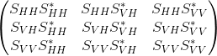

Elements below the diagonal are conjugate symmetric to elements above the diagonal.

Standard name | Suggested short  name | Units | Already  in CF?
spectrum_of_copolar_horizontal_to_copolar_horizontal | SPEC_HH_HH* |  | no
spectrum_of_copolar_horizontal_to_crosspolar_vertical | SPEC_HH_VH* |  | no
spectrum_of_copolar_horizontal_to_copolar_vertical | SPEC_HH_VV* |  | no
spectrum_of_crosspolar_vertical_to_crosspolar_vertical | SPEC_VH_VH* |  | no
spectrum_of_crosspolar_vertical_to_copolar_vertical | SPEC_VH_VV* |  | no
spectrum_of_copolar_vertical_to_copolar_vertical | SPEC_VV_VV* |  | no

Long names for metadata variables
Use of long names for metadata variables is optional, since the variable names themselves are reasonably self-explanatory. However, use of the long names does enhance clarity and makes the file more self-documenting.
The following long names are suggested for metadata variables.

Variable name  Long name | Units
altitude_agl  altitude_above_ground_level | meters
altitude_correction  altitude_correction | meters
altitude  altitude | meters
antenna_transition  antenna_is_in_transition_between_sweeps | unitless
azimuth_correction  azimuth_angle_correction | degrees
azimuth  ray_azimuth_angle | degrees
drift_correction  platform_drift_angle_correction | degrees
drift  platform_drift_angle | degrees
eastward_velocity_correction  platform_eastward_velocity_correction | m/s
eastward_velocity  platform_eastward_velocity | m/s
eastward_wind  eastward_wind | m/s
elevation_correction  ray_elevation_angle_correction | degrees
elevation  ray_elevation_angle | degrees
time_coverage_end  data_volume_end_time_utc | seconds
fixed_angle  target_fixed_angle | degrees
follow_mode  follow_mode_for_scan_strategy | unitless
frequency  radiation_frequency | s-1
heading_change_rate  platform_heading_angle_rate_of_change | degrees
heading_correction  platform_heading_angle_correction | degrees
heading  platform_heading_angle | degrees
instrument_name  name_of_instrument | unitless
instrument_type  type_of_instrument | unitless
latitude_correction  latitude_correction | degrees
latitude  latitude | degrees_east
lidar_aperture_diameter  lidar_aperture_diameter | meters
lidar_aperture_efficiency  lidar_aperture_efficiency | unitless
lidar_beam_divergence  lidar_beam_divergence | radians
lidar_constant  lidar_calibration_constant | unitless
lidar_field_of_view  lidar_field_of_view | radians
lidar_peak_power  lidar_peak_power | watts
lidar_pulse_energy  lidar_pulse_energy | joules
longitude_correction  longitude_correction | degrees
longitude  longitude | degrees_east
northward_velocity_correction  platform_northward_velocity_correction | m/s
northward_velocity  platform_northward_velocity | m/s
northward_wind  northward_wind | m/s
nyquist_velocity  unambiguous_doppler_velocity | m/s
n_samples  number_of_samples_used_to_compute_moments | unitless
pitch_change_rate  platform_pitch_angle_rate_of_change | degrees
pitch_correction  platform_pitch_angle_correction | degrees
pitch  platform_pitch_angle | degrees
platform_is_mobile  platform_is_mobile | unitless
platform_type  platform_type | unitless
polarization_mode  transmit_receive_polarization_mode | unitless
prt_mode  transmit_pulse_mode | unitless
pressure_altitude_correction  pressure_altitude_correction | meters
primary_axis  primary_axis_of_rotation | unitless
prt  pulse_repetition_time | seconds
prt_ratio
multiple_pulse_repetition_frequency_ratio
pulse_width  transmitter_pulse_width | seconds
radar_antenna_gain_h  nominal_radar_antenna_gain_h_channel | dB
radar_antenna_gain_v  nominal_radar_antenna_gain_v_channel | dB
radar_beam_width_h  half_power_radar_beam_width_h_channel | degrees
radar_beam_width_v  half_power_radar_beam_width_v_channel | degrees
radar_receiver_bandwidth  radar_receiver_bandwidth | s-1
radar_measured_transmit_power_h  radar_measured_transmit_power_h_channel | dBm
radar_measured_transmit_power_v  radar_measured_transmit_power_v_channel | dBm
range_correction  range_to_center_of_measurement_volume_correction | meters
range  projection_range_coordinate | meters
roll_correction  platform_roll_angle_correction | degrees
roll  platform_roll_angle | degrees
rotation_correction  ray_rotation_angle_relative_to_platform_correction | degrees
rotation  ray_rotation_angle_relative_to_platform | degrees
r_calib_antenna_gain_h  calibrated_radar_antenna_gain_h_channel | dB
r_calib_antenna_gain_v  calibrated_radar_antenna_gain_v_channel | dB
r_calib_base_dbz_1km_hc  radar_reflectivity_at_1km_at_zero_snr_h_co_polar_channel | dBZ
r_calib_base_dbz_1km_hx  radar_reflectivity_at_1km_at_zero_snr_h_cross_polar_channel | dBZ
r_calib_base_dbz_1km_vc  radar_reflectivity_at_1km_at_zero_snr_v_co_polar_channel | dBZ
r_calib_base_dbz_1km_vx  radar_reflectivity_at_1km_at_zero_snr_v_cross_polar_channel | dBZ
r_calib_coupler_forward_loss_h  radar_calibration_coupler_forward_loss_h_channel | dB
r_calib_coupler_forward_loss_v  radar_calibration_coupler_forward_loss_v_channel | dB
r_calib_index  calibration_data_array_index_per_ray | unitless
r_calib_ldr_correction_h  calibrated_radar_ldr_correction_h_channel | dB
r_calib_ldr_correction_v  calibrated_radar_ldr_correction_v_channel | dB
r_calib_noise_hc  calibrated_radar_receiver_noise_h_co_polar_channel | dBm
r_calib_noise_hx  calibrated_radar_receiver_noise_h_cross_polar_channel | dBm
r_calib_noise_vc  calibrated_radar_receiver_noise_v_co_polar_channel | dBm
r_calib_noise_vx  calibrated_radar_receiver_noise_v_cross_polar_channel | dBm
r_calib_noise_source_power_h  radar_calibration_noise_source_power_h_channel | dBm
r_calib_noise_source_power_v  radar_calibration_noise_source_power_v_channel | dBm
r_calib_power_measure_loss_h  radar_calibration_power_measurement_loss_h_channel | dB
r_calib_power_measure_loss_v  radar_calibration_power_measurement_loss_v_channel | dB
r_calib_pulse_width  radar_calibration_pulse_width | seconds
r_calib_radar_constant_h  calibrated_radar_constant_h_channel | (m/mW)dB
r_calib_radar_constant_v  calibrated_radar_constant_v_channel | (m/mW)dB
r_calib_receiver_gain_hc  calibrated_radar_receiver_gain_h_co_polar_channel | dB
r_calib_receiver_gain_hx  calibrated_radar_receiver_gain_h_cross_polar_channel | dB
r_calib_receiver_gain_vc  calibrated_radar_receiver_gain_v_co_polar_channel | dB
r_calib_receiver_gain_vx  calibrated_radar_receiver_gain_v_cross_polar_channel | dB
r_calib_receiver_mismatch_loss  radar_calibration_receiver_mismatch_loss | dB
r_calib_receiver_slope_hc  calibrated_radar_receiver_slope_h_co_polar_channel | unitless
r_calib_receiver_slope_hx  calibrated_radar_receiver_slope_h_cross_polar_channel | unitless
r_calib_receiver_slope_vc  calibrated_radar_receiver_slope_v_co_polar_channel | unitless
r_calib_receiver_slope_vx  calibrated_radar_receiver_slope_v_cross_polar_channel | unitless
r_calib_sun_power_hc  calibrated_radar_sun_power_h_co_polar_channel | dBm
r_calib_sun_power_hx  calibrated_radar_sun_power_h_cross_polar_channel | dBm
r_calib_sun_power_vc  calibrated_radar_sun_power_v_co_polar_channel | dBm
r_calib_sun_power_vx  calibrated_radar_sun_power_v_cross_polar_channel | dBm
r_calib_system_phidp  calibrated_radar_system_phidp | degrees
r_calib_test_power_h  radar_calibration_test_power_h_channel | dBm
r_calib_test_power_v  radar_calibration_test_power_v_channel | dBm
r_calib_time  radar_calibration_time_utc | unitless
r_calib_two_way_radome_loss_h  radar_calibration_two_way_radome_loss_h_channel | dB
r_calib_two_way_radome_loss_v  radar_calibration_two_way_radome_loss_v_channel | dB
r_calib_two_way_waveguide_loss_h  radar_calibration_two_way_waveguide_loss_h_channel | dB
r_calib_two_way_waveguide_loss_v  radar_calibration_two_way_waveguide_loss_v_channel | dB
r_calib_xmit_power_h  calibrated_radar_xmit_power_h_channel | dBm
r_calib_xmit_power_v  calibrated_radar_xmit_power_v_channel | dBm
r_calib_zdr_correction  calibrated_radar_zdr_correction | dB
scan_name  name_of_antenna_scan_strategy | unitless
scan_rate  antenna_angle_scan_rate | unitless
site_name  name_of_instrument_site | unitless
spacing_is_constant  spacing_between_range_gates_is_constant | unitless
sweep_end_ray_index  index_of_last_ray_in_sweep | unitless
sweep_mode  scan_mode_for_sweep | unitless
sweep_number  sweep_index_number_0_based | unitless
sweep_start_ray_index  index_of_first_ray_in_sweep | unitless
sweep_unambiguous_range  unambiguous_range_for_sweep | meters
tilt_correction  ray_tilt_angle_relative_to_platform_correction | degrees
tilt  ray_tilt_angle_relative_to_platform | degrees
time  time | seconds
time_coverage_start  data_volume_start_time_utc | unitless
unambiguous_range  unambiguous_range | meters
vertical_velocity_correction  platform_vertical_velocity_correction | m/s
vertical_velocity  platform_vertical_velocity | m/s
vertical_wind  upward_air_velocity | m/s
volume_number  data_volume_index_number | unitless

Computing the data location from geo-reference variables
Weather radars and lidars rotate primarily about a principal axis (e.g., “zenith” for plan-position-indicator mode in ground-based radar), slew about a secondary axis, orthogonal to the primary axis (e.g., range-height-indicator in ground-based radar), or slew on a plane by changing both primary and secondary axis (e.g., COPLANE in ground-based radar).
In the ground-based radar convention, a point in space relative to a radar is represented in a local spherical coordinate systems X_{i} by three parameters, range (r), azimuth (λ), and elevation (φ). A ground-based radar is assumed “leveled” with positive (negative) elevation, φ, above (below) a reference plane (a leveled plane orthogonal to the principal axis and containing the radar). The azimuth angle, λ, is the angle on the reference plane increases clockwise from the True North (TN) following the Meteorological coordinate convention (e.g., TN is 0° and East is 90°).
Processing and manipulating radar data (e.g., interpolation, synthesis, etc.) typically are performed in a right-handed 3-D XYZ Cartesian geo-referenced coordinate system X (see Fig. 7.1) where Y is TN and X is East. Hence, a coordinate transformation between X_{i} (radar sampling space) and X (geo-reference space) is required. Based on the principal axes, most remote sensors can be classified into three right-hand types, X, Y, or Z type.
The purpose of this chapter is two-fold: (1) to define a consistent terminology for the CfRadial format, and (2) to derive coordinate transformation matrices for each type of remote sensor. Many sensors (e.g. fixed ground radars) are of the Z-type, have a fixed location, are leveled and are aligned relative to True North (TN). Dealing with such sensors is much simpler than for those on moving platforms. Therefore, they will be dealt with first, and the more complicated treatment of all three types of remote sensor mounted on moving platforms will be covered in the later sections.
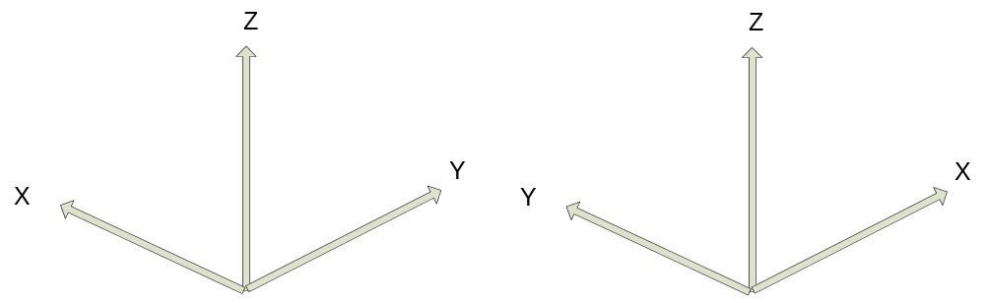
Figure 7.1: Left-handed XYZ coordinate system vs. Right-handed XYZ coordinate system.

In addition to the standard X, Y and Z right-hand types, specialized types such as the ELDORA and NOAA aircraft tail radars will be handled separately. The tail radars will be referred to as type Y-prime.

Special case – ground-based, stationary and leveled sensors
Ground-based sensors (radars and lidars) rotate primarily about the vertical (Z) axis (Z-Type), and the reference plane is a horizontal XY plane passing through the sensor. The Y-axis is aligned with TN, and the X-axis points East.
Azimuth angles (λ) are positive clockwise looking from above (+Z), with 0 being TN.
Elevation angles (φ) are measured relative to the horizontal reference plane, positive above the plane and negative below it.
A ground-based, leveled vertical pointing sensor can be classified as a Z-Type with φ=90°.

LIDARs
For LIDARs, the assumption is generally made that propagation of the beam is along a straight line, emanating at the sensor. The coordinate transformation between X_{i} (r, λ, φ) and X (x, y, z) is as follows:
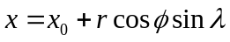
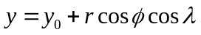
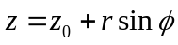
where
x is positive east
y is positive north
(x₀, y₀, z₀) are the coordinates of the sensor relative to the Cartesian grid origin and the azimuth angle (λ) is the angle clockwise from TN.
The sensor location is specified in longitude, latitude and altitude in the CfRadial format. Locations in the earth’s geo-reference coordinate system are computed using the sensor location and the (x,y,z) from above, using normal spherical geometry.

RADARs
The propagation of radar microwave energy in a beam through the lower atmosphere is affected by the change of refractive index of the atmosphere with height. Under average conditions this causes the beam to be deflected downwards, in what is termed ‘Standard Refraction’. For most purposes this is adequately modeled by assuming that the beam is in fact straight, relative to an earth which has a radius of 4/3 times the actual earth radius. (Rinehart 2004.)
For a stationary and leveled, ground-based radar, the equations are similar to those for the LIDAR case, except that we have one extra term, the height correction, which reflects the beam curvature relative to the earth.
The height h above the earth’s surface for a given range is:
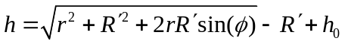
where 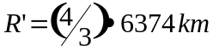 is the pseudo radius of earth. See Rinehart 2004, Chapter 3, for more details.
The (x,y) location for a given range is:
where x is positive east, y is positive north, and remembering that azimuth is the angle clockwise from true north.

Moving platforms
For moving platforms, the metadata for each beam will include:
- longitude of instrument
- latitude of instrument
- altitude of instrument
- rotation and tilt of the beam (see above)
- roll, pitch and heading of the platform
- platform motion (U_{G}, V_{G}, W_{G})
- air motion (U_{air}, V_{air}, W_{air})
For ground-based moving platforms (e.g., Doppler on Wheels), the earth-relative location of the observed point is:
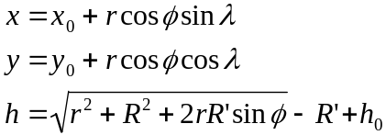
Note that for airborne radar platforms, correcting for refractive index does not apply. Therefore, for airborne radars, use the straight line equations for LIDARs.
Refer to the sections below for the computation of elevation (φ) and azimuth (λ) relative to earth coordinates.
Then apply the following equations, as before, to compute the location of the observed point.
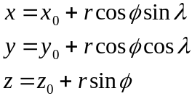

Coordinate transformations for the general case
This section details the processing for the general case.
Sensors which do not fall under section 7.1 above must be handled as a general case.

Coordinate systems
In addition to the previously-defined X_{i} and X coordinate systems, the following intermediate right-handed coordinate systems need to be defined to account for a moving, non-leveled platform:
- X_{a}: platform-relative coordinates, +Y points to heading, +X points to the right side (90° clockwise from +Y on the reference plane XY), +Z is orthogonal to the reference plane.
- X_{h} : leveled, platform heading-relative coordinates, +Y points heading, +X points 90° clockwise from heading, and Z points up (local zenith).
The goal here is to derive transformations from X_{i} to X via X_{a} and X_{h}.

The earth-relative coordinate system
The earth-relative coordinate system, X, is defined as follows, X is East, Y is North, and Z is zenith. Azimuth angle, λ, is defined as positive clockwise from TN (i.e., meteorological angle) while elevation angle, φ, is defined positive/negative above/below the horizontal plane at the altitude (h₀) of the remote sensor.

The platform-relative coordinate system
The general form of the mathematic representation describes a remote sensing device mounted on a moving platform (e.g., an aircraft, see Figure 7.2). This figure depicts the theoretical reference frame for a moving platform. (We use the aircraft analogy here, but the discussion also applies to water-borne platforms and land-based moving platforms.)
The platform-relative coordinate system of the platform, X_{a}, is defined by the right side, (X_{a}), the heading, (Y_{a}), and the zenith, (Z_{a}).
The origin of X_{a} is defined as the location of the INS on a moving platform.
The platform-relative coordinate system is defined by 3 rotations in the following order: heading (H), pitch (P) and roll (R) angles from X. These angles are generally measured by an inertial navigation system (INS).
The platform moves relative to X, based on its heading H, and the drift D, caused by wind or current. (D is 0 for land-based platforms). The track T is the line of the platform movement over the earth surface.
NOTE: -see Lee et al. (1994) for further background on this topic, and on the corrections to Doppler velocity for moving platforms. Usually, the platform INS and the sensor may not be collocated. The Doppler velocity needs to be compensated by the relative motion between these two.

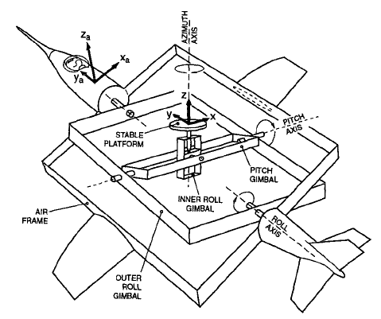
Figure 7.2 Moving platform axis definitions and reference frame (reproduced from Lee et al., 1994,originally from Axford, 1968) ©American Meteorological Society. Reprinted with permission.

Figures 7.3 a through c show the definitions of heading, drift, track, pitch and roll.
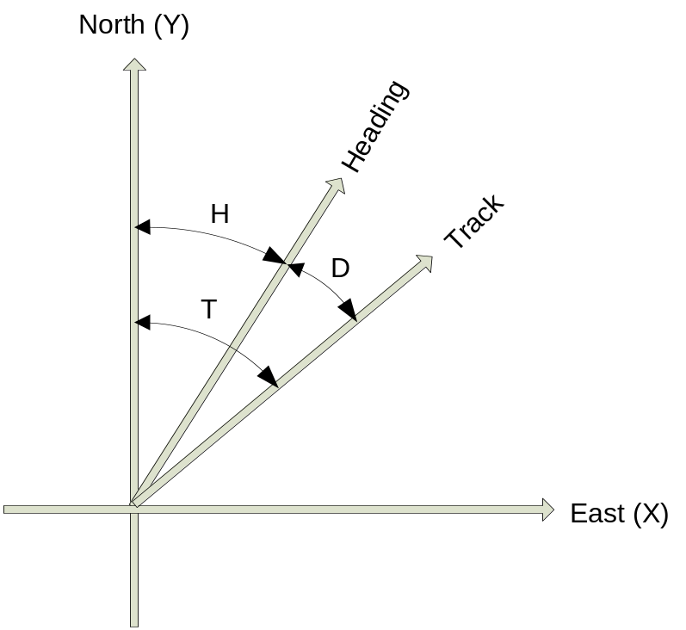
Figure 7.3(a): Definition of heading, drift and track.

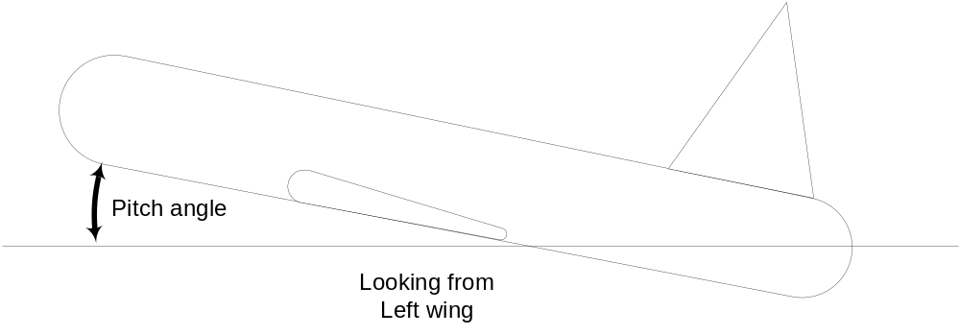
Figure 7.3(b): Definition of pitch

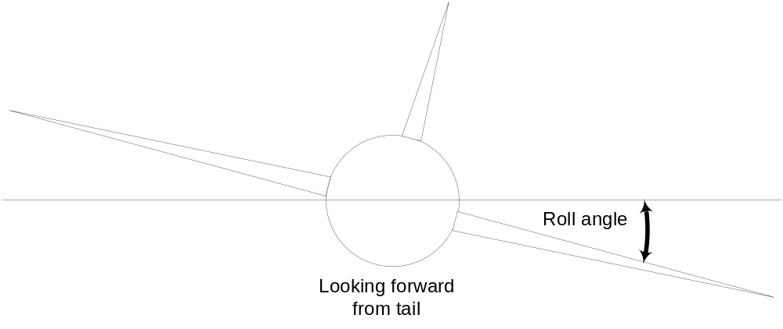
Figure 7.3(c): Definition of roll

The sensor coordinate system
In the sensor coordinate system, X_{i}, each data location is characterized by a range, r, a rotation angle, θ, and a tilt angle, τ. Following the ground-based radar convention, the rotation angle, θ, is the angle projected on the reference plane, positive clockwise from the third axis (counting from the principal axis in X_{a}) looking towards the sensor from the positive principal axis. The tilt angle, τ, is the angle of the beam relative to the reference plane. A beam has a positive/negative τ depending on whether it is on the positive/negative side of the reference plane, using the principal axis to determine the sign. Each gate location (r, θ, τ) in X_{i} can be represented in (r, λ, φ) in X.

Table 7.1: Characteristics of 4 types of sensors.
Sensor Type | Type X | Type Y | Type Y-prime | Type Z
Principal Axis | X_{a} | Y_{a} | Ya | Z_{a}
Reference Plane | Y_{a}Z_{a} | Z_{a}X_{a} | ZaXa | X_{a}Y_{a}
0° Rotation Angle | +Z_{a} | +X_{a} | +Za | +Y_{a}
90° Rotation Angle | +Y_{a} | +Z_{a} | +Xa | +X_{a}
Examples | EDOP, Wyoming Cloud Radar, Wind Profiler, downward scanning radar on Global Hawk |  | Tail Doppler radars on NOAA P3 and NSF/NCAR ELDORA | Ground-based radar/lidar, aircraft nose radar, NOAA P3 lower-fuselage radar,  C-band scatterometer

Coordinate transformation sequence
The following transformations are carried out to transform the geometry from the instrument-based (X_{i}) to the earth-based coordinate system (X):
- translate from X_{i} to X_{a}
- rotate from X_{a} to X

Transformation from X_{i} to X_{a}
The details of this step depend on the sensor type: Z, Y or X (Table 7.1)

Type Z sensors
The characteristics are:
- the primary axis is Z_{a}
- the reference plane is (X_{a}, Y_{a})
- the rotation angle θ is 0 in the (Y_{a}, Z_{a}) plane, i.e. along the +Y axis. Rotation increases clockwise from +Y, when looking from above (i.e. from +Z)
- the tilt angle τ is 0 in the (X_{a}, Y_{a}) plane, positive above it (for +Z_{a}) and negative below it.
The transformation to Χ_{a} coordinates is:
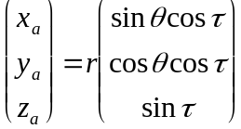

Type Y sensors
The characteristics are:
- the primary axis is Y_{a}
- the reference plane is (Z_{a}, X_{a})
- the rotation angle θ is 0 in the (Z_{a}, X_{a}) plane, i.e. along the +X_{a} axis. Rotation increases clockwise from +X, when looking from +Y.
- the tilt angle τ is 0 in the (Z_{a}, X_{a}) plane, positive for +Y_{a}.
Note that the definition of θ is different from the convention defined in Lee et al. (1994). Let θ’ be the rotation angle defined in Lee et al. (1994), θ=mod(450°- θ’).
The transformation to Χ_{a} coordinates is:
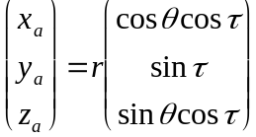
      - Type Y-prime sensors
The characteristics are:
the primary axis is Y_{a}
the reference plane is (Z_{a}, X_{a})
the rotation angle θ is 0 in the (Ya, Za) plane, i.e. along the +Z_{a} axis. Rotation increases clockwise from +Z, when looking from -Y.
the tilt angle τ is 0 in the (Z_{a}, X_{a}) plane, positive for +Y_{a}.
Note that the definition of θ is the convention defined in Lee et al. (1994
The transformation to Χ_{a} coordinates is:
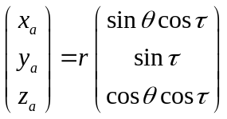

Type X sensors
The characteristics are:
- the primary axis is X_{a}
- the reference plane is (Y_{a}, Z_{a})
- the rotation angle θ is 0 in the (Y_{a}, Z_{a}) plane, i.e. along the +Z_{a} axis. Rotation increases clockwise from +Z_{a}, when looking from +X_{a}.
- the tilt angle τ is 0 in the (Y_{a}, Z_{a}) plane, positive for +X_{a}.
The transformation to Χ_{a} coordinates is:
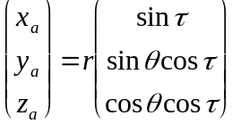

Rotating from X_{a} to X
Rotating X_{a} to X requires the following 3 steps (in the reverse order of the rotation):
- remove the roll R, by rotating the x axis around the y axis by –R.
- remove the pitch P, by rotating the y axis around the x axis by –P.
- remove the heading H, by rotating the y axis around the z axis by +H
The transformation matrix for removing the roll component is:
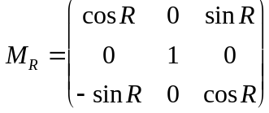
The transformation matrix for removing the pitch component is:
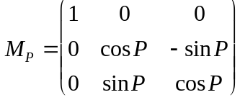
The transformation matrix for removing the heading component is:
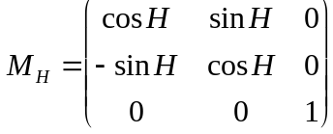

We apply these transformations consecutively:
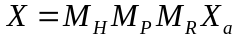
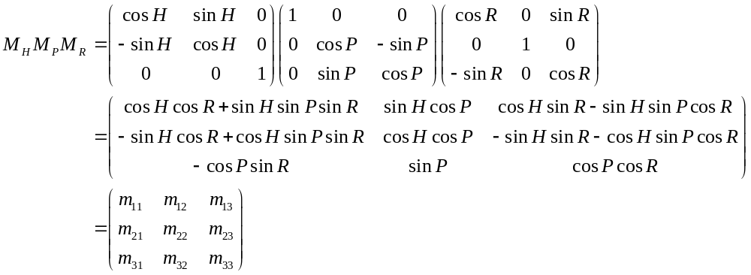

Summary of transforming from X_{i} to X
We combine the above 2 main steps for transform all the way from the instrument coordinates to earth coordinates:

For type Z radars:
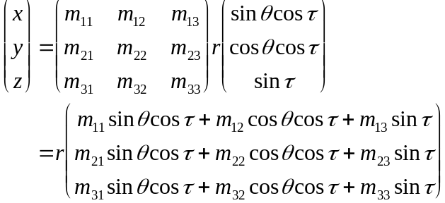

For type Y radars:
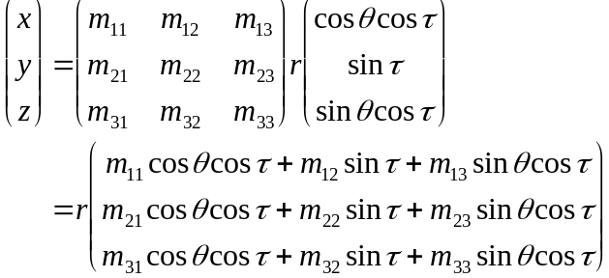

For type Y-prime radars:
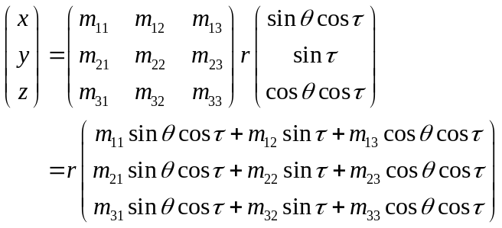

For type X radars:
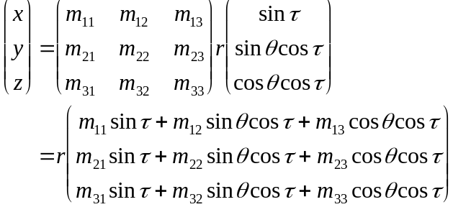

Computing earth-relative azimuth and elevation
We can then compute the earth-relative azimuth and elevation as follows:
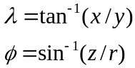

Summary of symbol definitions
Χ_{i}: instrument-relative coordinate system, (r, θ, τ) or (r, λ, φ)
Χ_{a}: platform-relative coordinate system (x_{a}, y_{a}, z_{a}) – see figure 7.2
Χ_{h}: coordinate system relative to level platform (no roll or pitch) with heading H.
Χ: earth-relative coordinate system (x, y, z), x is positive east, y is positive north, z is positive up.
H: heading of platform (see figure 7.3)
T: track of platform (see figure 7.3)
D: drift angle (see figure 7.3)
P: pitch angle (see figure 7.3)
R: roll angle (see figure 7.3)
λ: azimuth angle
φ: elevation angle
θ: rotation angle
τ: tilt angle
r: range
h: height
h_{0:} height of the instrument
R’: pseudo radius of earth = 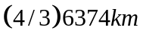

References
Axford, D. N., 1968: On the accuracy of wind measurements using an inertial platform in an aircraft, and an example of a measurement of the vertical structure of the atmosphere. J. Appl. Meteor., 7, 645-666.
Lee, W., P. Dodge, F. D. Marks Jr. and P. Hildebrand, 1994: Mapping of Airborne Doppler Radar Data. Journal of Oceanic and Atmospheric Technology, 11, 572 – 578.
Rinehart, R. E., 2004: Radar for Meteorologists, Fourth Edition. Rinehart Publications. ISBN 0-9658002-1-0

Example ncdump of CfRadial file
The following is an example ncdump from a valid CfRadial file, for the KDDC NEXRAD radar, at 12:04:15 on 2015/06/26:

netcdf cfrad.20150626_120415.982_to_20150626_120831.578_KDDC_Surveillance_SUR {
dimensions:
time = 4200 ;
range = 1832 ;
n_points = 6087840 ;
sweep = 9 ;
string_length_8 = 8 ;
string_length_32 = 32 ;
status_xml_length = 1 ;
r_calib = 1 ;
frequency = 1 ;
variables:
int volume_number ;
volume_number:long_name = "data_volume_index_number" ;
volume_number:units = "" ;
volume_number:_FillValue = -9999 ;
char platform_type(string_length_32) ;
platform_type:long_name = "platform_type" ;
platform_type:options = "fixed, vehicle, ship, aircraft_fore, aircraft_aft, aircraft_tail, aircraft_belly, aircraft_roof, aircraft_nose, satellite_orbit, satellite_geostat" ;
char primary_axis(string_length_32) ;
primary_axis:long_name = "primary_axis_of_rotation" ;
primary_axis:options = "axis_z, axis_y, axis_x, axis_z_prime, axis_y_prime, axis_x_prime" ;
char status_xml(status_xml_length) ;
status_xml:long_name = "status_of_instrument" ;
char instrument_type(string_length_32) ;
instrument_type:long_name = "type_of_instrument" ;
instrument_type:options = "radar, lidar" ;
instrument_type:meta_group = "instrument_parameters" ;
float radar_antenna_gain_h ;
radar_antenna_gain_h:long_name = "nominal_radar_antenna_gain_h_channel" ;
radar_antenna_gain_h:units = "db" ;
radar_antenna_gain_h:_FillValue = -9999.f ;
radar_antenna_gain_h:meta_group = "radar_parameters" ;
float radar_antenna_gain_v ;
radar_antenna_gain_v:long_name = "nominal_radar_antenna_gain_v_channel" ;
radar_antenna_gain_v:units = "db" ;
radar_antenna_gain_v:_FillValue = -9999.f ;
radar_antenna_gain_v:meta_group = "radar_parameters" ;
float radar_beam_width_h ;
radar_beam_width_h:long_name = "half_power_radar_beam_width_h_channel" ;
radar_beam_width_h:units = "degrees" ;
radar_beam_width_h:_FillValue = -9999.f ;
radar_beam_width_h:meta_group = "radar_parameters" ;
float radar_beam_width_v ;
radar_beam_width_v:long_name = "half_power_radar_beam_width_v_channel" ;
radar_beam_width_v:units = "degrees" ;
radar_beam_width_v:_FillValue = -9999.f ;
radar_beam_width_v:meta_group = "radar_parameters" ;
float radar_rx_bandwidth ;
radar_rx_bandwidth:long_name = "radar_receiver_bandwidth" ;
radar_rx_bandwidth:units = "s-1" ;
radar_rx_bandwidth:_FillValue = -9999.f ;
radar_rx_bandwidth:meta_group = "radar_parameters" ;
char time_coverage_start(string_length_32) ;
time_coverage_start:long_name = "data_volume_start_time_utc" ;
time_coverage_start:comment = "ray times are relative to start time in secs" ;
char time_coverage_end(string_length_32) ;
time_coverage_end:long_name = "data_volume_end_time_utc" ;
float frequency(frequency) ;
frequency:long_name = "transmission_frequency" ;
frequency:units = "s-1" ;
frequency:_FillValue = -9999.f ;
frequency:meta_group = "instrument_parameters" ;
int grid_mapping ;
grid_mapping:grid_mapping_name = "radar_lidar_radial_scan" ;
grid_mapping:longitude_of_projection_origin = -99.9688873291016 ;
grid_mapping:latitude_of_projection_origin = 37.7608337402344 ;
grid_mapping:altitude_of_projection_origin = 813. ;
grid_mapping:false_northing = 0. ;
grid_mapping:false_easting = 0. ;
double latitude ;
latitude:long_name = "latitude" ;
latitude:units = "degrees_north" ;
latitude:_FillValue = -9999. ;
double longitude ;
longitude:long_name = "longitude" ;
longitude:units = "degrees_east" ;
longitude:_FillValue = -9999. ;
double altitude ;
altitude:long_name = "altitude" ;
altitude:units = "meters" ;
altitude:_FillValue = -9999. ;
altitude:positive = "up" ;
double altitude_agl ;
altitude_agl:long_name = "altitude_above_ground_level" ;
altitude_agl:units = "meters" ;
altitude_agl:_FillValue = -9999. ;
altitude_agl:positive = "up" ;
int sweep_number(sweep) ;
sweep_number:long_name = "sweep_index_number_0_based" ;
sweep_number:units = "" ;
sweep_number:_FillValue = -9999 ;
char sweep_mode(sweep, string_length_32) ;
sweep_mode:long_name = "scan_mode_for_sweep" ;
sweep_mode:options = "sector, coplane, rhi, vertical_pointing, idle, azimuth_surveillance, elevation_surveillance, sunscan, pointing, calibration, manual_ppi, manual_rhi, sunscan_rhi" ;
char polarization_mode(sweep, string_length_32) ;
polarization_mode:long_name = "polarization_mode_for_sweep" ;
polarization_mode:options = "horizontal, vertical, hv_alt, hv_sim, circular" ;
polarization_mode:meta_group = "radar_parameters" ;
char prt_mode(sweep, string_length_32) ;
prt_mode:long_name = "transmit_pulse_mode" ;
prt_mode:options = "fixed, staggered, dual" ;
prt_mode:meta_group = "radar_parameters" ;
char follow_mode(sweep, string_length_32) ;
follow_mode:long_name = "follow_mode_for_scan_strategy" ;
follow_mode:options = "none, sun, vehicle, aircraft, target, manual" ;
follow_mode:meta_group = "instrument_parameters" ;
float fixed_angle(sweep) ;
fixed_angle:long_name = "ray_target_fixed_angle" ;
fixed_angle:units = "degrees" ;
fixed_angle:_FillValue = -9999.f ;
float target_scan_rate(sweep) ;
target_scan_rate:long_name = "target_scan_rate_for_sweep" ;
target_scan_rate:units = "degrees per second" ;
target_scan_rate:_FillValue = -9999.f ;
int sweep_start_ray_index(sweep) ;
sweep_start_ray_index:long_name = "index_of_first_ray_in_sweep" ;
sweep_start_ray_index:units = "" ;
sweep_start_ray_index:_FillValue = -9999 ;
int sweep_end_ray_index(sweep) ;
sweep_end_ray_index:long_name = "index_of_last_ray_in_sweep" ;
sweep_end_ray_index:units = "" ;
sweep_end_ray_index:_FillValue = -9999 ;
char rays_are_indexed(sweep, string_length_8) ;
rays_are_indexed:long_name = "flag_for_indexed_rays" ;
float ray_angle_res(sweep) ;
ray_angle_res:long_name = "angular_resolution_between_rays" ;
ray_angle_res:units = "degrees" ;
ray_angle_res:_FillValue = -9999.f ;
char r_calib_time(r_calib, string_length_32) ;
r_calib_time:long_name = "radar_calibration_time_utc" ;
r_calib_time:meta_group = "radar_calibration" ;
float r_calib_pulse_width(r_calib) ;
r_calib_pulse_width:long_name = "radar_calibration_pulse_width" ;
r_calib_pulse_width:units = "seconds" ;
r_calib_pulse_width:meta_group = "radar_calibration" ;
r_calib_pulse_width:_FillValue = -9999.f ;
float r_calib_xmit_power_h(r_calib) ;
r_calib_xmit_power_h:long_name = "calibrated_radar_xmit_power_h_channel" ;
r_calib_xmit_power_h:units = "dBm" ;
r_calib_xmit_power_h:meta_group = "radar_calibration" ;
r_calib_xmit_power_h:_FillValue = -9999.f ;
float r_calib_xmit_power_v(r_calib) ;
r_calib_xmit_power_v:long_name = "calibrated_radar_xmit_power_v_channel" ;
r_calib_xmit_power_v:units = "dBm" ;
r_calib_xmit_power_v:meta_group = "radar_calibration" ;
r_calib_xmit_power_v:_FillValue = -9999.f ;
float r_calib_two_way_waveguide_loss_h(r_calib) ;
r_calib_two_way_waveguide_loss_h:long_name = "radar_calibration_two_way_waveguide_loss_h_channel" ;
r_calib_two_way_waveguide_loss_h:units = "db" ;
r_calib_two_way_waveguide_loss_h:meta_group = "radar_calibration" ;
r_calib_two_way_waveguide_loss_h:_FillValue = -9999.f ;
float r_calib_two_way_waveguide_loss_v(r_calib) ;
r_calib_two_way_waveguide_loss_v:long_name = "radar_calibration_two_way_waveguide_loss_v_channel" ;
r_calib_two_way_waveguide_loss_v:units = "db" ;
r_calib_two_way_waveguide_loss_v:meta_group = "radar_calibration" ;
r_calib_two_way_waveguide_loss_v:_FillValue = -9999.f ;
float r_calib_two_way_radome_loss_h(r_calib) ;
r_calib_two_way_radome_loss_h:long_name = "radar_calibration_two_way_radome_loss_h_channel" ;
r_calib_two_way_radome_loss_h:units = "db" ;
r_calib_two_way_radome_loss_h:meta_group = "radar_calibration" ;
r_calib_two_way_radome_loss_h:_FillValue = -9999.f ;
float r_calib_two_way_radome_loss_v(r_calib) ;
r_calib_two_way_radome_loss_v:long_name = "radar_calibration_two_way_radome_loss_v_channel" ;
r_calib_two_way_radome_loss_v:units = "db" ;
r_calib_two_way_radome_loss_v:meta_group = "radar_calibration" ;
r_calib_two_way_radome_loss_v:_FillValue = -9999.f ;
float r_calib_receiver_mismatch_loss(r_calib) ;
r_calib_receiver_mismatch_loss:long_name = "radar_calibration_receiver_mismatch_loss" ;
r_calib_receiver_mismatch_loss:units = "db" ;
r_calib_receiver_mismatch_loss:meta_group = "radar_calibration" ;
r_calib_receiver_mismatch_loss:_FillValue = -9999.f ;
float r_calib_radar_constant_h(r_calib) ;
r_calib_radar_constant_h:long_name = "calibrated_radar_constant_h_channel" ;
r_calib_radar_constant_h:units = "db" ;
r_calib_radar_constant_h:meta_group = "radar_calibration" ;
r_calib_radar_constant_h:_FillValue = -9999.f ;
float r_calib_radar_constant_v(r_calib) ;
r_calib_radar_constant_v:long_name = "calibrated_radar_constant_v_channel" ;
r_calib_radar_constant_v:units = "db" ;
r_calib_radar_constant_v:meta_group = "radar_calibration" ;
r_calib_radar_constant_v:_FillValue = -9999.f ;
float r_calib_antenna_gain_h(r_calib) ;
r_calib_antenna_gain_h:long_name = "calibrated_radar_antenna_gain_h_channel" ;
r_calib_antenna_gain_h:units = "db" ;
r_calib_antenna_gain_h:meta_group = "radar_calibration" ;
r_calib_antenna_gain_h:_FillValue = -9999.f ;
float r_calib_antenna_gain_v(r_calib) ;
r_calib_antenna_gain_v:long_name = "calibrated_radar_antenna_gain_v_channel" ;
r_calib_antenna_gain_v:units = "db" ;
r_calib_antenna_gain_v:meta_group = "radar_calibration" ;
r_calib_antenna_gain_v:_FillValue = -9999.f ;
float r_calib_noise_hc(r_calib) ;
r_calib_noise_hc:long_name = "calibrated_radar_receiver_noise_h_co_polar_channel" ;
r_calib_noise_hc:units = "dBm" ;
r_calib_noise_hc:meta_group = "radar_calibration" ;
r_calib_noise_hc:_FillValue = -9999.f ;
float r_calib_noise_vc(r_calib) ;
r_calib_noise_vc:long_name = "calibrated_radar_receiver_noise_v_co_polar_channel" ;
r_calib_noise_vc:units = "dBm" ;
r_calib_noise_vc:meta_group = "radar_calibration" ;
r_calib_noise_vc:_FillValue = -9999.f ;
float r_calib_noise_hx(r_calib) ;
r_calib_noise_hx:long_name = "calibrated_radar_receiver_noise_h_cross_polar_channel" ;
r_calib_noise_hx:units = "dBm" ;
r_calib_noise_hx:meta_group = "radar_calibration" ;
r_calib_noise_hx:_FillValue = -9999.f ;
float r_calib_noise_vx(r_calib) ;
r_calib_noise_vx:long_name = "calibrated_radar_receiver_noise_v_cross_polar_channel" ;
r_calib_noise_vx:units = "dBm" ;
r_calib_noise_vx:meta_group = "radar_calibration" ;
r_calib_noise_vx:_FillValue = -9999.f ;
float r_calib_receiver_gain_hc(r_calib) ;
r_calib_receiver_gain_hc:long_name = "calibrated_radar_receiver_gain_h_co_polar_channel" ;
r_calib_receiver_gain_hc:units = "db" ;
r_calib_receiver_gain_hc:meta_group = "radar_calibration" ;
r_calib_receiver_gain_hc:_FillValue = -9999.f ;
float r_calib_receiver_gain_vc(r_calib) ;
r_calib_receiver_gain_vc:long_name = "calibrated_radar_receiver_gain_v_co_polar_channel" ;
r_calib_receiver_gain_vc:units = "db" ;
r_calib_receiver_gain_vc:meta_group = "radar_calibration" ;
r_calib_receiver_gain_vc:_FillValue = -9999.f ;
float r_calib_receiver_gain_hx(r_calib) ;
r_calib_receiver_gain_hx:long_name = "calibrated_radar_receiver_gain_h_cross_polar_channel" ;
r_calib_receiver_gain_hx:units = "db" ;
r_calib_receiver_gain_hx:meta_group = "radar_calibration" ;
r_calib_receiver_gain_hx:_FillValue = -9999.f ;
float r_calib_receiver_gain_vx(r_calib) ;
r_calib_receiver_gain_vx:long_name = "calibrated_radar_receiver_gain_v_cross_polar_channel" ;
r_calib_receiver_gain_vx:units = "db" ;
r_calib_receiver_gain_vx:meta_group = "radar_calibration" ;
r_calib_receiver_gain_vx:_FillValue = -9999.f ;
float r_calib_base_dbz_1km_hc(r_calib) ;
r_calib_base_dbz_1km_hc:long_name = "radar_reflectivity_at_1km_at_zero_snr_h_co_polar_channel" ;
r_calib_base_dbz_1km_hc:units = "dBZ" ;
r_calib_base_dbz_1km_hc:meta_group = "radar_calibration" ;
r_calib_base_dbz_1km_hc:_FillValue = -9999.f ;
float r_calib_base_dbz_1km_vc(r_calib) ;
r_calib_base_dbz_1km_vc:long_name = "radar_reflectivity_at_1km_at_zero_snr_v_co_polar_channel" ;
r_calib_base_dbz_1km_vc:units = "dBZ" ;
r_calib_base_dbz_1km_vc:meta_group = "radar_calibration" ;
r_calib_base_dbz_1km_vc:_FillValue = -9999.f ;
float r_calib_base_dbz_1km_hx(r_calib) ;
r_calib_base_dbz_1km_hx:long_name = "radar_reflectivity_at_1km_at_zero_snr_h_cross_polar_channel" ;
r_calib_base_dbz_1km_hx:units = "dBZ" ;
r_calib_base_dbz_1km_hx:meta_group = "radar_calibration" ;
r_calib_base_dbz_1km_hx:_FillValue = -9999.f ;
float r_calib_base_dbz_1km_vx(r_calib) ;
r_calib_base_dbz_1km_vx:long_name = "radar_reflectivity_at_1km_at_zero_snr_v_cross_polar_channel" ;
r_calib_base_dbz_1km_vx:units = "dBZ" ;
r_calib_base_dbz_1km_vx:meta_group = "radar_calibration" ;
r_calib_base_dbz_1km_vx:_FillValue = -9999.f ;
float r_calib_sun_power_hc(r_calib) ;
r_calib_sun_power_hc:long_name = "calibrated_radar_sun_power_h_co_polar_channel" ;
r_calib_sun_power_hc:units = "dBm" ;
r_calib_sun_power_hc:meta_group = "radar_calibration" ;
r_calib_sun_power_hc:_FillValue = -9999.f ;
float r_calib_sun_power_vc(r_calib) ;
r_calib_sun_power_vc:long_name = "calibrated_radar_sun_power_v_co_polar_channel" ;
r_calib_sun_power_vc:units = "dBm" ;
r_calib_sun_power_vc:meta_group = "radar_calibration" ;
r_calib_sun_power_vc:_FillValue = -9999.f ;
float r_calib_sun_power_hx(r_calib) ;
r_calib_sun_power_hx:long_name = "calibrated_radar_sun_power_h_cross_polar_channel" ;
r_calib_sun_power_hx:units = "dBm" ;
r_calib_sun_power_hx:meta_group = "radar_calibration" ;
r_calib_sun_power_hx:_FillValue = -9999.f ;
float r_calib_sun_power_vx(r_calib) ;
r_calib_sun_power_vx:long_name = "calibrated_radar_sun_power_v_cross_polar_channel" ;
r_calib_sun_power_vx:units = "dBm" ;
r_calib_sun_power_vx:meta_group = "radar_calibration" ;
r_calib_sun_power_vx:_FillValue = -9999.f ;
float r_calib_noise_source_power_h(r_calib) ;
r_calib_noise_source_power_h:long_name = "radar_calibration_noise_source_power_h_channel" ;
r_calib_noise_source_power_h:units = "dBm" ;
r_calib_noise_source_power_h:meta_group = "radar_calibration" ;
r_calib_noise_source_power_h:_FillValue = -9999.f ;
float r_calib_noise_source_power_v(r_calib) ;
r_calib_noise_source_power_v:long_name = "radar_calibration_noise_source_power_v_channel" ;
r_calib_noise_source_power_v:units = "dBm" ;
r_calib_noise_source_power_v:meta_group = "radar_calibration" ;
r_calib_noise_source_power_v:_FillValue = -9999.f ;
float r_calib_power_measure_loss_h(r_calib) ;
r_calib_power_measure_loss_h:long_name = "radar_calibration_power_measurement_loss_h_channel" ;
r_calib_power_measure_loss_h:units = "db" ;
r_calib_power_measure_loss_h:meta_group = "radar_calibration" ;
r_calib_power_measure_loss_h:_FillValue = -9999.f ;
float r_calib_power_measure_loss_v(r_calib) ;
r_calib_power_measure_loss_v:long_name = "radar_calibration_power_measurement_loss_v_channel" ;
r_calib_power_measure_loss_v:units = "db" ;
r_calib_power_measure_loss_v:meta_group = "radar_calibration" ;
r_calib_power_measure_loss_v:_FillValue = -9999.f ;
float r_calib_coupler_forward_loss_h(r_calib) ;
r_calib_coupler_forward_loss_h:long_name = "radar_calibration_coupler_forward_loss_h_channel" ;
r_calib_coupler_forward_loss_h:units = "db" ;
r_calib_coupler_forward_loss_h:meta_group = "radar_calibration" ;
r_calib_coupler_forward_loss_h:_FillValue = -9999.f ;
float r_calib_coupler_forward_loss_v(r_calib) ;
r_calib_coupler_forward_loss_v:long_name = "radar_calibration_coupler_forward_loss_v_channel" ;
r_calib_coupler_forward_loss_v:units = "db" ;
r_calib_coupler_forward_loss_v:meta_group = "radar_calibration" ;
r_calib_coupler_forward_loss_v:_FillValue = -9999.f ;
float r_calib_dbz_correction(r_calib) ;
r_calib_dbz_correction:long_name = "calibrated_radar_dbz_correction" ;
r_calib_dbz_correction:units = "db" ;
r_calib_dbz_correction:meta_group = "radar_calibration" ;
r_calib_dbz_correction:_FillValue = -9999.f ;
float r_calib_zdr_correction(r_calib) ;
r_calib_zdr_correction:long_name = "calibrated_radar_zdr_correction" ;
r_calib_zdr_correction:units = "db" ;
r_calib_zdr_correction:meta_group = "radar_calibration" ;
r_calib_zdr_correction:_FillValue = -9999.f ;
float r_calib_ldr_correction_h(r_calib) ;
r_calib_ldr_correction_h:long_name = "calibrated_radar_ldr_correction_h_channel" ;
r_calib_ldr_correction_h:units = "db" ;
r_calib_ldr_correction_h:meta_group = "radar_calibration" ;
r_calib_ldr_correction_h:_FillValue = -9999.f ;
float r_calib_ldr_correction_v(r_calib) ;
r_calib_ldr_correction_v:long_name = "calibrated_radar_ldr_correction_v_channel" ;
r_calib_ldr_correction_v:units = "db" ;
r_calib_ldr_correction_v:meta_group = "radar_calibration" ;
r_calib_ldr_correction_v:_FillValue = -9999.f ;
float r_calib_system_phidp(r_calib) ;
r_calib_system_phidp:long_name = "calibrated_radar_system_phidp" ;
r_calib_system_phidp:units = "degrees" ;
r_calib_system_phidp:meta_group = "radar_calibration" ;
r_calib_system_phidp:_FillValue = -9999.f ;
float r_calib_test_power_h(r_calib) ;
r_calib_test_power_h:long_name = "radar_calibration_test_power_h_channel" ;
r_calib_test_power_h:units = "dBm" ;
r_calib_test_power_h:meta_group = "radar_calibration" ;
r_calib_test_power_h:_FillValue = -9999.f ;
float r_calib_test_power_v(r_calib) ;
r_calib_test_power_v:long_name = "radar_calibration_test_power_v_channel" ;
r_calib_test_power_v:units = "dBm" ;
r_calib_test_power_v:meta_group = "radar_calibration" ;
r_calib_test_power_v:_FillValue = -9999.f ;
float r_calib_receiver_slope_hc(r_calib) ;
r_calib_receiver_slope_hc:long_name = "calibrated_radar_receiver_slope_h_co_polar_channel" ;
r_calib_receiver_slope_hc:units = "" ;
r_calib_receiver_slope_hc:meta_group = "radar_calibration" ;
r_calib_receiver_slope_hc:_FillValue = -9999.f ;
float r_calib_receiver_slope_vc(r_calib) ;
r_calib_receiver_slope_vc:long_name = "calibrated_radar_receiver_slope_v_co_polar_channel" ;
r_calib_receiver_slope_vc:units = "" ;
r_calib_receiver_slope_vc:meta_group = "radar_calibration" ;
r_calib_receiver_slope_vc:_FillValue = -9999.f ;
float r_calib_receiver_slope_hx(r_calib) ;
r_calib_receiver_slope_hx:long_name = "calibrated_radar_receiver_slope_h_cross_polar_channel" ;
r_calib_receiver_slope_hx:units = "" ;
r_calib_receiver_slope_hx:meta_group = "radar_calibration" ;
r_calib_receiver_slope_hx:_FillValue = -9999.f ;
float r_calib_receiver_slope_vx(r_calib) ;
r_calib_receiver_slope_vx:long_name = "calibrated_radar_receiver_slope_v_cross_polar_channel" ;
r_calib_receiver_slope_vx:units = "" ;
r_calib_receiver_slope_vx:meta_group = "radar_calibration" ;
r_calib_receiver_slope_vx:_FillValue = -9999.f ;
double time(time) ;
time:standard_name = "time" ;
time:long_name = "time in seconds since volume start" ;
time:calendar = "gregorian" ;
time:units = "seconds since 2015-06-26T12:04:15Z" ;
time:comment = "times are relative to the volume start_time" ;
float range(range) ;
range:long_name = "Range from instrument to center of gate" ;
range:units = "meters" ;
range:spacing_is_constant = "true" ;
range:meters_to_center_of_first_gate = 2125. ;
range:meters_between_gates = 250. ;
int ray_n_gates(time) ;
ray_n_gates:long_name = "number_of_gates" ;
ray_n_gates:units = "" ;
ray_n_gates:_FillValue = -9999 ;
int ray_start_index(time) ;
ray_start_index:long_name = "array_index_to_start_of_ray" ;
ray_start_index:units = "" ;
ray_start_index:_FillValue = -9999 ;
float ray_start_range(time) ;
ray_start_range:long_name = "start_range_for_ray" ;
ray_start_range:units = "meters" ;
ray_start_range:_FillValue = -9999.f ;
float ray_gate_spacing(time) ;
ray_gate_spacing:long_name = "gate_spacing_for_ray" ;
ray_gate_spacing:units = "meters" ;
ray_gate_spacing:_FillValue = -9999.f ;
float azimuth(time) ;
azimuth:long_name = "ray_azimuth_angle" ;
azimuth:units = "degrees" ;
azimuth:_FillValue = -9999.f ;
float elevation(time) ;
elevation:long_name = "ray_elevation_angle" ;
elevation:units = "degrees" ;
elevation:_FillValue = -9999.f ;
elevation:positive = "up" ;
float pulse_width(time) ;
pulse_width:long_name = "transmitter_pulse_width" ;
pulse_width:units = "seconds" ;
pulse_width:_FillValue = -9999.f ;
pulse_width:meta_group = "instrument_parameters" ;
float prt(time) ;
prt:long_name = "pulse_repetition_time" ;
prt:units = "seconds" ;
prt:_FillValue = -9999.f ;
prt:meta_group = "instrument_parameters" ;
float prt_ratio(time) ;
prt_ratio:long_name = "pulse_repetition_frequency_ratio" ;
prt_ratio:units = "seconds" ;
prt_ratio:_FillValue = -9999.f ;
prt_ratio:meta_group = "instrument_parameters" ;
float nyquist_velocity(time) ;
nyquist_velocity:long_name = "unambiguous_doppler_velocity" ;
nyquist_velocity:units = "meters per second" ;
nyquist_velocity:_FillValue = -9999.f ;
nyquist_velocity:meta_group = "instrument_parameters" ;
float unambiguous_range(time) ;
unambiguous_range:long_name = "unambiguous_range" ;
unambiguous_range:units = "meters" ;
unambiguous_range:_FillValue = -9999.f ;
unambiguous_range:meta_group = "instrument_parameters" ;
byte antenna_transition(time) ;
antenna_transition:long_name = "antenna_is_in_transition_between_sweeps" ;
antenna_transition:units = "" ;
antenna_transition:_FillValue = -128b ;
antenna_transition:comment = "1 if antenna is in transition, 0 otherwise" ;
int n_samples(time) ;
n_samples:long_name = "number_of_samples_used_to_compute_moments" ;
n_samples:units = "" ;
n_samples:_FillValue = -9999 ;
n_samples:meta_group = "instrument_parameters" ;
int r_calib_index(time) ;
r_calib_index:long_name = "calibration_data_array_index_per_ray" ;
r_calib_index:units = "" ;
r_calib_index:_FillValue = -9999 ;
r_calib_index:meta_group = "radar_calibration" ;
r_calib_index:comment = "This is the index for the calibration which applies to this ray" ;
float measured_transmit_power_h(time) ;
measured_transmit_power_h:long_name = "measured_radar_transmit_power_h_channel" ;
measured_transmit_power_h:units = "dBm" ;
measured_transmit_power_h:_FillValue = -9999.f ;
measured_transmit_power_h:meta_group = "radar_parameters" ;
float measured_transmit_power_v(time) ;
measured_transmit_power_v:long_name = "measured_radar_transmit_power_v_channel" ;
measured_transmit_power_v:units = "dBm" ;
measured_transmit_power_v:_FillValue = -9999.f ;
measured_transmit_power_v:meta_group = "radar_parameters" ;
float scan_rate(time) ;
scan_rate:long_name = "antenna_angle_scan_rate" ;
scan_rate:units = "degrees per second" ;
scan_rate:_FillValue = -9999.f ;
scan_rate:meta_group = "instrument_parameters" ;
short DBZ(n_points) ;
DBZ:long_name = "radar_reflectivity" ;
DBZ:standard_name = "equivalent_reflectivity_factor" ;
DBZ:units = "dBZ" ;
DBZ:sampling_ratio = 1.f ;
DBZ:_FillValue = -32768s ;
DBZ:scale_factor = 0.001411481f ;
DBZ:add_offset = 17.25f ;
DBZ:grid_mapping = "grid_mapping" ;
DBZ:coordinates = "time range" ;
short VEL(n_points) ;
VEL:long_name = "radial_velocity" ;
VEL:standard_name = "radial_velocity_of_scatterers_away_from_instrument" ;
VEL:units = "m/s" ;
VEL:sampling_ratio = 1.f ;
VEL:_FillValue = -32768s ;
VEL:scale_factor = 0.0009842219f ;
VEL:add_offset = -0.25f ;
VEL:grid_mapping = "grid_mapping" ;
VEL:coordinates = "time range" ;
short WIDTH(n_points) ;
WIDTH:long_name = "spectrum_width" ;
WIDTH:standard_name = "doppler_spectrum_width" ;
WIDTH:units = "m/s" ;
WIDTH:sampling_ratio = 1.f ;
WIDTH:_FillValue = -32768s ;
WIDTH:scale_factor = 0.0002899258f ;
WIDTH:add_offset = 9.5f ;
WIDTH:grid_mapping = "grid_mapping" ;
WIDTH:coordinates = "time range" ;
short ZDR(n_points) ;
ZDR:long_name = "differential_reflectivity" ;
ZDR:standard_name = "log_differential_reflectivity_hv" ;
ZDR:units = "dB" ;
ZDR:sampling_ratio = 1.f ;
ZDR:_FillValue = -32768s ;
ZDR:scale_factor = 0.000241287f ;
ZDR:add_offset = 0.03125f ;
ZDR:grid_mapping = "grid_mapping" ;
ZDR:coordinates = "time range" ;
short PHIDP(n_points) ;
PHIDP:long_name = "differential_phase" ;
PHIDP:standard_name = "differential_phase_hv" ;
PHIDP:units = "deg" ;
PHIDP:sampling_ratio = 1.f ;
PHIDP:_FillValue = -32768s ;
PHIDP:scale_factor = 0.3525968f ;
PHIDP:add_offset = 11553.19f ;
PHIDP:grid_mapping = "grid_mapping" ;
PHIDP:coordinates = "time range" ;
short RHOHV(n_points) ;
RHOHV:long_name = "cross_correlation" ;
RHOHV:standard_name = "cross_correlation_ratio_hv" ;
RHOHV:units = "" ;
RHOHV:sampling_ratio = 1.f ;
RHOHV:_FillValue = -32768s ;
RHOHV:scale_factor = 1.286864e-05f ;
RHOHV:add_offset = 0.63f ;
RHOHV:grid_mapping = "grid_mapping" ;
RHOHV:coordinates = "time range" ;

// global attributes:
:Conventions = "CF-1.6" ;
:Sub_conventions = "CF-Radial instrument_parameters radar_parameters radar_calibration" ;
:version = "CF-Radial-1.3" ;
:title = "" ;
:institution = "" ;
:references = "" ;
:source = "ARCHIVE 2 data" ;
:history = "" ;
:comment = "" ;
:author = "" ;
:original_format = "NEXRAD" ;
:driver = "RadxConvert(NCAR)" ;
:created = "2016/05/22 22:50:15.274" ;
:start_datetime = "2015-06-26T12:04:15Z" ;
:time_coverage_start = "2015-06-26T12:04:15Z" ;
:end_datetime = "2015-06-26T12:08:31Z" ;
:time_coverage_end = "2015-06-26T12:08:31Z" ;
:instrument_name = "KDDC" ;
:site_name = "" ;
:scan_name = "Surveillance" ;
:scan_id = 212 ;
:platform_is_mobile = "false" ;
:n_gates_vary = "true" ;
:ray_times_increase = "true" ;
}

The rotation angle, θ’, defined in previous airborne tail Doppler radar convention (Lee et al. 1994) was positive clockwise looking from the tail toward the nose of an aircraft (i.e., looking from the -Y_{a}-axis) that has been the convention for airborne tail Doppler radars. θ’=0° points to +Z. However, this convention is different from that used in the ground-based radars. The r and τ were defined the same way in the current convention.

