NCAR/UNIDATA

CfRadial2 Data File Format

CF2-compliant NetCDF Format
for Moments Data for RADAR and LIDAR
in Radial Coordinates

Version 2.0 DRAFT
Mike Dixon¹
Wen-Chau Lee¹
Daniel Michelson²
Mark Curtiss³

1: Earth Observing Laboratory, National Center for Atmospheric Research*, Boulder, CO, USA
2: Environment Canada
3: Bureau of Meteorology, Australia

2017-03-08

* NCAR is sponsored by the US National Science Foundation.

1 Introduction 5
1.1 Purpose 5
1.2 Terminology – CfRadial1 and CfRadial2 5
1.3 History 5
1.4 CF2 and CfRadial2 6
1.5 On-line URLs 6
2 Radar/Lidar Data Information Model 7
2.1 Logical organization of data in a volume, using sweeps and rays 7
2.2 Logical organization of data in a volume, using sweeps with 2-D data 9
2.3 Field data byte representation 11
2.4 Scanning modes 11
2.5 Geo-reference variables 12
3 Structure of CfRadial2 using NetCDF4 with groups 13
3.1 Group-based data structure 13
3.2 Principal dimensions and variables 16
3.3 Extensions to the CF convention 17
3.4 Strict use of variable and attribute names for non-field variables 17
3.5 _FillValue and missing_value attributes for data fields 18
3.6 Required vs. optional variables 18
3.7 No grid mapping variable 18
4 Root group 19
4.1 Global attributes 19
4.2 Global Dimensions 20
4.3 Global variables 20
5 Sweep groups 23
5.1 Sweep-specific Dimensions 23
5.2 Sweep coordinate variables 23
5.2.1 Attributes for time coordinate variable 23
5.2.2 Attributes for range coordinate variable 24
5.3 Sweep variables 24
5.3.1 Attributes for azimuth(time) variable 27
5.3.2 Attributes for elevation(time) variable 27
5.4 The georeference sub-group 28
5.5 The monitoring sub-group 29
5.6 Field data variables 30
5.6.1 Use of scale_factor and add_offset 33
5.6.2 Use of coordinates attribute 33
5.6.3 Use of flag values - optional 33
5.6.4 Flag mask fields - optional 33
5.6.5 Quality control fields - optional 34
5.6.6 Thresholding XML 34
5.6.7 Legend XML 34
6 Spectrum groups 35
6.1 Spectrum-specific information on sweep 35
6.2 spectrum_index variable 35
6.3 Spectrum group dimensions 35
6.4 Spectrum field variables 36
6.5 Spectrum field attributes 36
7 Root group metadata groups 38
7.1 The radar_parameters sub-group 38
7.2 The lidar_parameters sub-group 38
7.3 The radacalibration sub-group 39
7.3.1 Dimensions 39
7.3.2 Variables 39
7.4 The lidacalibration sub-group 42
7.5 The georeferenced_correction sub-group 42
8 Standard names 44
8.1 Standard names for moments variables 44
8.2 Standard names for spectra variables 45
9 Computing the data location from geo-reference variables 47
9.1 Special case – ground-based, stationary and leveled sensors 48
9.1.1 LIDARs 48
9.1.2 RADARs 48
9.2 Moving platforms 49
9.3 Coordinate transformations for the general case 50
9.3.1 Coordinate systems 50
9.3.2 The earth-relative coordinate system 50
9.3.3 The platform-relative coordinate system 50
9.3.4 The sensor coordinate system 53
9.4 Coordinate transformation sequence 54
9.4.1 Transformation from X_{i} to X_{a} 54
9.4.1.1 Type Z sensors 54
9.4.1.2 Type Y sensors 54
9.4.1.4 Type X sensors 55
9.4.2 Rotating from X_{a} to X 55
9.5 Summary of transforming from X_{i} to X 57
9.5.1 For type Z radars: 57
9.5.2 For type Y radars: 57
9.5.3 For type Y-prime radars: 57
9.5.4 For type X radars: 58
9.5.5 Computing earth-relative azimuth and elevation 58
9.6 Summary of symbol definitions 58
10 References 59

Introduction

Purpose
The purpose of this document is to specify CfRadial2, a CF2-compliant NetCDF format for radar and lidar moments data in radial (i.e. polar) coordinates.

Terminology – CfRadial1 and CfRadial2
We will refer to CfRadial 2.0, and future 2.x versions, collectively as CfRadial2.
The previous versions, 1.1 though 1.4, will be referred to collectively as CfRadial1.

History
CfRadial was introduced in 2011 as a format designed to store data from scanning weather radars and lidars in an accurate and lossless manner.
Since digital weather radars made their debut in the 1970s, a wide variety of data formats has emerged for pulsed instruments (radar and lidar) in polar coordinates. Researchers and manufacturers have tended to develop formats unique to their instruments, and since 1990 NCAR has supported over 20 different data formats for radar and lidar data. Researchers, students and operational users spend unnecessary time handling the complexity of these formats.
CfRadial grew out of the need to simplify the use of data from weather radars and lidars and thereby to improve efficiency. CfRadial adopts the well-known NetCDF framework, along with the Climate and Forecasting (CF) conventions. It is designed to accurately store the metadata and data produced by the instruments, in their native polar coordinates, without any loss of information. Mobile platforms are supported. Data field identification is facilitated by the 'standard_name' convention in CF, so that fields derived from algorithms (such as hydrometeor type) can be represented just as easily as the original fields (such as radar reflectivity).

Date | Version | Remarks
2011/02/01 | 1.1 | First operational version. NetCDF classic data model.
2011/06/07 | 1.2 | Minor changes / additions. NetCDF classic data model.
2013/07/01 | 1.3 | Major changes / additions. NetCDF classic data model.
2016/08/01 | 1.4 | Major additions – data quality, spectra. NetCDF classic data model.
2016/08/01 | 2.0 | Major revision – not backward compatible with CfRadial1  Uses NetCDF 4 and groups.  Combines CfRadial 1.4 and ODIM-H5 version 2.2.
Table 1.1: History of CfRadial versions
CfRadial1 has been adopted by NCAR, as well as NCAS (the UK National Center for Atmospheric Science) and the US DOE Atmospheric Radiation Measurement (ARM) program. CfRadial development was boosted in 2015 through a two-year NSF EarthCube grant to improve CF in general. Following the CF user community workshop in Boulder Colorado in May 2016, version 1.4 was agreed upon, adding explicit support for quality fields and spectra.

CF2 and CfRadial2
In 2015 the US National Science Foundation (NSF) funded the project “EarthCube IA: Advancing NetCDF-CF for the Geoscience Community". This project aims to update the CF conventions to make better use of NetCDF4 capabilities, such as groups, to organize data in CF-compliant files. CF2.0 standards will be developed to guide this process. The development of CfRadial2 is part of this work. A workshop was held in Boulder Colorado, in May 2016, to assess and collaborate on progress to Cf2.0.
Shortly after that, in July 2016, a WMO-sponsored meeting was held at NCAR in Boulder, during which the WMO Task Team on Weather Radar Data Exchange (TT-WRDE) considered the adoption of a single WMO-recommended format for radar and lidar data in polar coordinates. The two modern formats discussed as options were CfRadial and the European radar community ODIM-H5 (HDF5) format, in addition to the older and more rigid table-driven BUFR and GRIB2 formats. TT-WRDE recommended that CfRadial 1.4 be merged with the sweep-oriented structure of ODIM-H5, making use of groups to produce a single WMO format that will encompass the best ideas of both formats. That has led to the emergence of CfRadial2. This format should meet the objectives of both the NSF EarthCube CF 2.0 initiative and the WMO TT-WRDE.

On-line URLs
This document, older versions, full history and other related information, are available on-line at:
https://github.com/NCAR/CfRadial/tree/master/docs
These include detailed documentation of versions 1.1 through 1.4, as well as the current CfRadial2 development.
The current NetCDF CF conventions are documented at:
http://cfconventions.org/
http://cfconventions.org/cf-conventions/v1.6.0/cf-conventions.html

Radar/Lidar Data Information Model

Logical organization of data in a volume, using sweeps and rays
Radars and lidars are pulsing instruments that either scan in polar coordinates, or stare in a fixed direction.
A volume scan (or simply a volume) is defined as a scanning sequence that repeats over time.
volume
metadata

sweep_0

sweep_1

sweep_2

sweep_end
metadata

ray_0

ray_1

ray_2

ray_end
metadata

field_0

field_1

field_2

field_end
metadata
data[range]
metadata
data[range]
metadata
data[range]
metadata
data[range]
Figure 2.1: logical data structure for a volume scan,
using sweep and ray abstractions and 1-D data field arrays

Figure 2.1 shows an idealized data model for a radar or lidar volume, representing the data fields as 1-D arrays on a ray object.
A volume consists of a series of 1 or more sweeps (defined below).
As a radar or lidar scans (or points), the data fields (commonly known as ‘moments’) are computed over limits specified by a time interval or angular interval.
We refer to this entity as a ray, beam or dwell. In this document we will use the term ray.
A sweep is a collection of rays, for which certain properties remain constant. Examples are:
- PPI 360-degree surveillance (target elevation angle constant)
- PPI sector (target elevation angle constant)
- RHI (target azimuth angle constant)
- time period for vertically pointing instrument (azimuth and elevation both constant)
The following always remain constant for all rays in a sweep:
- number of gates
- range geometry (range to each gate)
- sweep mode (surveillance, sector, rhi, etc.)
- target angle(s)
The following would usually remain constant for the rays in a sweep:
- nominal scan rate
- pulse width
- pulsing scheme
- Nyquist velocity
- data quality control procedures
For a given ray, the field (or moments) data are computed for a sequence of ranges increasing radially away from the instrument. These are referred to as range gates.
A ray contains a number of fields, with a value for each field at each gate. In the ray abstraction, fields are represented as 1-D arrays, with length range.

Logical organization of data in a volume, using sweeps with 2-D data
volume
metadata

sweep_0

sweep_1

sweep_2

sweep_end
metadata

field_0

field_1

field_2

field_end
metadata
data[time][range]
metadata
data[time][range]
metadata
data[time][range]
metadata
data[time][range]
Figure 2.2: logical data structure for a volume scan,
using the sweep abstraction with 2-D data fields

In contrast to Figure 2.1, Figure 2.2 shows a modified data model, in which the sweeps contain the field (moments) data directly, stored as 2-D arrays of [time][range]. This requires that the number of gates be constant for all rays in a sweep.
This is the data model that has been adopted for CfRadial. Figure 2.3 below has more detail.
This representation has the advantage that the 2-D arrays per sweep simplify the data storage mechanism, and allow for more efficient data compression than do 1-D arrays per ray.
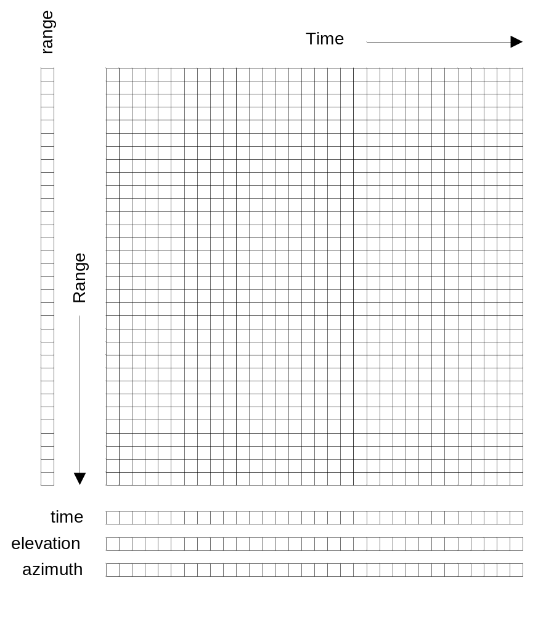
Figure 2.3 Data field for a sweep, represented in time and range,
with a constant number of range gates

Field data byte representation
The field data will be stored using one of the following:

NetCDF type | Byte width | Description
signed char | 1 | scaled signed integer
signed short | 2 | scaled signed integer
signed int | 4 | scaled signed integer
float | 4 | floating point
double | 8 | floating point
Table 2.1: field data representation
For the integer types, the stored data values are interpreted as:
data_value = (integer_value * scale_factor) + add_offset.
The scale_factor and add_offset are provided as metadata attributes on the field.

Scanning modes
Scanning may be carried out in a number of different ways. For example:
- horizontal scanning at fixed elevation (PPI mode), sector or 360 degree surveillance
- vertical scanning at a constant azimuth (RHI mode)
- antenna stationary, i.e. constant elevation and azimuth (staring or pointing)
- aircraft radars which rotate around the longitudinal axis of the aircraft (e.g. ELDORA, NOAA Tail Radar)
- sun scanning in either PPI or RHI mode.
For each of these modes a sweep is defined as follows:
- PPI mode: a sequence of rays at a fixed elevation angle, but changing azimuth angles
- RHI mode: a sequence of rays at a fixed azimuth angle but changing elevation angles
- pointing mode: a sequence of rays over some time period, at fixed azimuth and elevation
- aircraft tail-type radars: a sweep starts at a rotation angle of 0 (antenna pointing vertically upwards) and ends 360 degrees later.
As the antenna transitions between sweeps, some rays may be recorded during the transition. For many radars, especially operational types, these rays are filtered out at the source. For some research radars, however, the rays are retained, and an antenna_transition flag is set for these rays to allow them to be optionally filtered out at a later processing stage.

Geo-reference variables
Metadata variables in CfRadial are used to locate a radar or lidar measurement in space.
These are:
- range
- elevation
- azimuth
- latitude
- longitude
- altitude
See sections 4.3 and 5.4 for details on these variables.
For moving platforms, extra variables are required for geo-referencing. These are:
- heading
- roll
- pitch
- rotation
- tilt
See section 5.4 for details on these variables.
The mathematical procedures for computing data location relative to earth coordinates are described in detail in section 9.

Structure of CfRadial2 using NetCDF4 with groups

Group-based data structure
In order to be readily accessible to scientists in the user community using legacy applications, CfRadial1 uses the flat classic model of NetCDF3. A drawback of this approach is that the implementation quickly becomes complicated, since much of the metadata is placed at the top level in the data structure. Namespace clashes can easily occur.
By contrast, the European ODIM-H5 format makes extensive use of HDF5 groups to provide logical separation between data at different levels in the structure. In fact ODIM tends to rather over-use this approach, leading to complexity of a different type.
In designing CfRadial2, we chose to merge CfRadial1 and ODIM-H5, adopting the best features of each to produce a clear implementation that is as simple as reasonable, but no simpler. CfRadial2 makes use of the group capability available in NetCDF4.
CfRadial2 adopts the sweep-based model of Figure 2.2. The overall structure is shown in Figure 3.1 below.
The top-level (default) root group holds the global dimensions, attributes and variables. Nested below this group is a sub-group for each sweep. The name of the sweep sub-groups is provided in a string array named ‘sweep_group_names’, also at the top level. This allows the user to locate the sweep groups directly.
CfRadial2 supports moving platforms (aircraft, ships and vehicles), which requires storing the georeference data accurately at each ray time. Furthermore, storage of spectra on a gate-by-gate basis, for example for vertically-pointing precipitation radars, is supported. Figure 3.2 shows these details. Both of these are specializations, and are not required for most fixed operational radars.
A number of optional groups are available in the root group, to support radar and lidar parameters, calibrations, and corrections to the georeferenced data. These are shown in figure 3.3.
group:
sweep_name2
sweep attributes
dimensions: time, range
metadata variables:
time(time)
range(range)
elevation(time)
azimuth(time)
etc.
field variables: e.g.
dbz(time, range)
vel(time, range)
------
fieldn(time, range)
field attributes
field attributes
field attributes
group:
root
dimension: sweep (can be unlimited)
global attributes
global variables
sweep_group_names[sweep]
sweep_fixed_angles[sweep]
group:
sweep_name1
sweep attributes
dimensions: time, range
metadata variables:
time(time)
range(range)
elevation(time)
azimuth(time)
etc.
field variables: e.g.
dbz(time, range)
vel(time, range)
------
fieldn(time, range)
field attributes
field attributes
field attributes
group:
sweep_namen
sweep attributes
dimensions: time, range
metadata variables:
time(time)
range(range)
elevation(time)
azimuth(time)
etc.
field variables: e.g.
dbz(time, range)
vel(time, range)
------
fieldn(time, range)
field attributes
field attributes
field attributes

Figure 3.1: Group structure showing top-level dimensions,
attributes, variables and sweep groups
dimensions: index, sample

spectrum_index(time, range)

spectrum field variables: e.g.
spectrum_hco(index, sample)
spectrum_vco(index, sample)
latitude(time)
longitude(time)
altitude(time)
heading(time)
roll(time)
pitch(time)
etc.
attributes
attributes
attributes
group:
spectra
group:
georeference
group:
monitoring
transmit_power(time)
noise_power(time)
etc.
field variables: e.g.
dbz(time, range)
vel(time, range)
------
fieldn(time, range)
field attributes
field attributes
field attributes
group:
sweep_name
sweep attributes
dimensions: time, range, spectrum_group
metadata variables:
spectrum_group_names(spectrum_group)
time(time)
range(range)
elevation(time)
azimuth(time)
etc.
group:
georeference

Figure 3.2: Sweep group structure in more detail, showing
support for georeference metadata for moving platforms,
spectra, and monitoring data.
group:
root
sweep_name1 group

sweep_name2 group

sweep_nnnn group

radar_parameters group

lidar_parameters group

radacalibration group

lidacalibration group

georeference_correction group

dimension: sweep
global attributes
global variables

Figure 3.3: Optional metadata groups (highlighted in gray) in the root group

Principal dimensions and variables
The principal dimensions for data in a sweep are time and range. In CF terminology these are referred to as coordinate variables, which must have the same name for both the dimension and the variable.
The primary coordinate is time and the secondary coordinate is range.
The length of the time coordinate indicates the number of rays in the sweep.
The length of the range coordinate indicates the number of gates for the rays in the sweep.
The time(time) coordinate variable stores the double precision time of each ray, in seconds, from a reference time, which is normally the start of the volume (time_coverage_start). The units attribute for time indicates the time from which it is referenced.
The range(range) coordinate variable stores the range to the center of each gate. All rays in the sweep must have the same range geometry.
The elevation(time) coordinate variable stores the elevation angle for each ray.
The azimuth(time) coordinate variable stores the azimuth angle for each ray.
The data fields are stored as 2-D arrays, with dimensions (time, range).

Extensions to the CF convention
This convention requires the following extensions to CF:
- The following axis attribute types:
- axis = "radial_azimuth_coordinate";
- axis = "radial_elevation_coordinate";
- axis = "radial_range_coordinate";
- For CfRadial to follow CF properly, support for the following must be added to the udunits package:
- dB (ratio of two values, in log units. For example, ZDR).
- dBm (power in milliwatts, in log units)
- dBZ (radar reflectivity in log units)
- Additional standard names – see section 8.
Given the above extensions, CfRadial2 files will be CF2 compliant.
NOTE on units: in the following tables, for conciseness, we do not spell out the units strings exactly as they are in the NetCDF file. Instead, the following abbreviations are used:
Units string in NetCDF file | Abbreviation in tables
“degrees per second” | degrees/s
“meters per second” | m/s

Strict use of variable and attribute names for non-field variables
In CfRadial a field variable stores such quantities as radar moments, derived quantities, data quality indicators etc. These are either measured by the radar, or derived from a field that is measured. These field variables require a standard_name attribute as specified in the CF conventions. For example the field variable ‘radar reflectivity’ would have the standard name ‘equivalent_reflectivity_factor’. These variables store the fundamental scientific data associated with the instrument.
By contrast, metadata variables store the dimensional information such as time, range, azimuth and elevation, and other metadata such as calibration and radar characteristics.
Because of the inherent complexity of radial radar and lidar data, the CfRadial format requires extra strictness, as compared to CF in general, in order to keep it manageable. There are so many metadata variables in CfRadial that it is essential to require strict adherence to the dimension names and variable names for the metadata variables, exactly as specified in this document. It is not practical to require a software application to search for standard names for metadata variables, since this makes the code unnecessarily complex and difficult to maintain.
To summarize, this strictness requirement only applies to non-field metadata variables. The moments data fields (i.e. the field variables) will be handled as usual in CF, where the standard name is the definitive guide to the contents of the field. The standard names for radar variables are listed in section 8.

_FillValue and missing_value attributes for data fields
CF 1.6 states that the use of missing_value is deprecated, and that only _FillValue should be used.
For CfRadial2, _FillValue is preferred. However, missing_value may be used.
Only one or the other should be specified, not both.
Applications reading CfRadial data should check for both of these attributes.
NetCDF 4 is built on HDF5, which supports compression. Where data are missing or unusable, the data values will be set to a constant well-known _FillValue (or missing_value) code. This facilitates efficient compression.

Required vs. optional variables
Required variables are shown shaded in this document.
All other variables are optional.
If an optional variable is not provided, reader applications should set the variable to a missing value as appropriate.

No grid mapping variable
The data in this format is saved in the native coordinate system for radars and lidars, i.e. radial (or polar) coordinates, with the instrument at the origin.
A grid mapping type is not required, because the geo-reference variables contain all of the information required to locate the data in space.
For a stationary instrument, the following are stored as scalar variables (see section 4.3):
- latitude
- longitude
- altitude
Position and pointing references for moving platforms must take the following motions into account (see section 5.4):
- platform location
- platform translation and orientation

Root group
The following sections present the details of the information in the top-level (root) group of the data set.
NOTE that in the tables below, shading indicates required items. The non-shaded items are optional.

Global attributes

Attribute name | Type | Convention | Description
Conventions | string | CF | Conventions string will specify “Cf/Radial”.
version | string | CF/Radial | CF/Radial version number  (“2.0”)
title | string | CF | Short description of file contents
institution | string | CF | Where the original data were produced
references | string | CF | References that describe the data or the methods used to produce it
source | string | CF | Method of production of the original data
history | string | CF | List of modifications to the original data
comment | string | CF | Miscellaneous information
instrument_name | string | CF/Radial | Name of radar or lidar
site_name | string | CF/Radial | Name of site where data were gathered
scan_name | string | CF/Radial | Name of scan strategy used, if applicable
scan_id | int | CF/Radial | Scan strategy id, if applicable.  Assumed 0 if missing.
platform_is_mobile | string | CF/Radial | “true” or “false”  Assumed “false” if missing.
ray_times_increase | string | CF/Radial | “true” or “false”  Assumed “true” if missing.  This is set to true if ray times increase monotonically throughout all of the sweeps in the volume.
field_names | string[] | CF/Radial | Array of strings of field names present in this file.
time_coverage_start | string | CF/Radial | Copy of time_coverage_start global variable in 4.3.
time_coverage_end | string | CF/Radial | Copy of time_coverage_end global variable in 4.3.

Global Dimensions

Dimension name | Description
sweep | The number of sweeps in the dataset
frequency | Number of frequencies used

Global variables

Variable name | Dimension | Type | Units | Comments
volume_number |  | int |  | Volume numbers are sequential, relative to some arbitrary start time, and may wrap.
platform_type |  | string |  | Options are:  “fixed”, “vehicle”, “ship”, “aircraft”,  “aircraft_fore”,“aircraft_aft”,  “aircraft_tail”,“aircraft_belly”,  “aircraft_roof”,“aircraft_nose”,  “satellite_orbit”,  “satellite_geostat”  Assumed “fixed” if missing.
instrument_type |  | string |  | Options are: “radar”, “lidar”  Assumed “radar” if missing.
primary_axis |  | string |  | Options are:  “axis_z”, “axis_y”, “axis_x”, “axis_z_prime”, “axis_y_prime”, “axis_x_prime”.  See section 9 for details.  Assumed “axis_z” if missing.
time_coverage_start |  | string |  | UTC time of first ray in file.  Resolution is integer seconds.  The time(time) variable is generally computed  relative to this time.  Format follows ISO 8601:  yyyy-mm-ddThh:mm:ssZ  NOTE: the T is optional, any single character may be used in this location.
time_coverage_end |  | string |  | UTC time of last ray in file.  Resolution is integer seconds.  Format is:  yyyy-mm-ddThh:mm:ssZ  NOTE: the T is optional, any single character may be used in this location.
latitude |  | double | degrees_north | Latitude of instrument.  For a mobile platform, this is a latitude at the start of the volume.
longitude |  | double | degrees_east | Longitude of instrument.  For a mobile platform, this is the longitude at the start of the volume.
altitude |  | double | meters | Altitude of instrument, above mean sea level.  For a scanning radar, this is the center of rotation of the antenna.  For a mobile platform, this is the altitude at the start of the volume.
altitude_agl |  | double | meters | Altitude of instrument above ground level.  Omit if not known.
sweep_group_names | (sweep) | string |  | Array of names for sweep groups.  Allows the user to locate the sweep groups directly.
sweep_fixed_angles | (sweep) | float | degrees | Array of fixed angles for sweeps. This summarizes the fixed angles for all of the sweeps, so that a user does not need to read individual sweep groups to determine the fixed angles. The value should be copied from the fixed_angle attribute in the sweep groups.
frequency | (frequency) | float | s-1 | List of operating frequencies, in Hertz.  In most cases, only a single frequency is used.
status_xml |  | string |  | General-purpose XML string for storing any information that is not included in other parts of the data structure.

Sweep groups
This section provides details of the information in each sweep group.
The name of the sweep groups is found in the sweep_group_names array variable in the root group.
NOTE that in the tables below, shading indicates required items. The non-shaded items are optional.

Sweep-specific Dimensions

Dimension name | Description
time | The number of rays.
range | The number of range bins
prt | Number of prts used in pulsing scheme.  Optional for fixed, staggered or dual  Required for more complicated schemes.
spectrum_groups | Number of spectrum groups in this sweep

Sweep coordinate variables

Variable name | Dimension | Type | Units | Comments
time | (time) | double | seconds | Coordinate variable for time.  Time at center of each ray, in fractional seconds since time_coverage_start,  or since time_reference if it exists.
range | (range) | float | meters | Coordinate variable for range.  Range to center of each bin.

Attributes for time coordinate variable
Attribute name | Type | Value
standard_name | string | “time”
units | string | “seconds since yyyy-mm-ddThh:mm:ssZ”,  where the actual reference time values are used.  This unit string is absolutely required.  NOTE: the T is optional, any single character may be used in this location.
calendar | string | Defaults to “gregorian” if missing.  Options are:  “gregorian” or “standard”,  “proleptic_gregorian”,  “noleap” or “365_day”,  “all_leap” or “366_day”,  “360_day”,  “julian”  See CF conventions for details.

Attributes for range coordinate variable
Attribute name | Type | Value
standard_name | string | “projection_range_coordinate”
long_name | string | “range_to_measurement_volume”
units | string | “meters”
spacing_is_constant | string | “true” or “false”
meters_to_center_of_first_gate | float | Start range in meters.
meters_between_gates | float | Gate spacing in meters.  Required if  spacing_is_constant is “true”.  Not applicable otherwise.
axis | string | “radial_range_coordinate”

Sweep variables

Variable name | Dimension | Type | Units | Comments
sweep_number |  | int |  | The number of the sweep, in the volume scan.  0-based.
sweep_mode |  | string |  | Options are:  “sector”,“coplane”,rhi”,  “vertical_pointing”,“idle”,  “azimuth_surveillance”,  “elevation_surveillance”,  “sunscan”,“pointing”,  “manual_ppi”,“manual_rhi”
follow_mode |  | string |  | options are: “none”, “sun”, “vehicle”, “aircraft”, “target”, “manual”  Assumed “none” if missing.
prt_mode |  | string |  | Pulsing mode  Options are: “fixed”, “staggered”, “dual”, “hybrid”.  Assumed “fixed” if missing.  May also be more complicated pulsing schemes, such as HHVV, HHVVH etc.
polarization_mode |  | string |  | Options are: “horizontal”, “vertical”, “hv_alt”, “hv_sim”, “circular” Assumed “horizontal” if missing.
polarization_sequence | (prt) | string |  | This only applies if prt_mode is set to “hybrid”. As an example, the form of it would be [‘H’,’H’,’V’,’V’,’H’] for HHVVH pulsing.
fixed_angle |  | float | degrees | Target angle for the sweep.  elevation in most modes  azimuth in RHI mode
rays_are_indexed |  | string |  | “true” or “false”  Indicates whether or not the ray angles (elevation in RHI mode, azimuth in other modes) are indexed to a regular grid.
ray_angle_res |  | float | degrees | If rays_are_indexed is “true”, this is the resolution of the angular grid – i.e. the delta angle between successive rays.
qc_procedures |  | string |  | Documents QC procedures per sweep.
target_scan_rate |  | float | degrees/s | Intended scan rate for this sweep. The actual scan rate is stored according to section 4.8.  This variable is optional.  Omit if not available.
scan_rate | (time) | float | degrees/s | Actual antenna scan rate.  Set to negative if counter-clockwise in azimuth or decreasing in elevation.  Positive otherwise.
azimuth | (time) | float | degrees | Azimuth of antenna, relative to true north.  The azimuth should refer to the center of the dwell.
elevation | (time) | float | degrees | Elevation of antenna, relative to the horizontal plane.  The elevation should refer to the center of the dwell.
antenna_transition | (time) | byte |  | 1 if antenna is in transition,  i.e. between sweeps, 0 if not.  If variable is omitted, the transition will be assumed to be 0 everywhere.  Assumed 0 if missing.
pulse_width | (time) | float | seconds
calib_index | (time) | int |  | Index for the radar calibration that applies to this pulse width. See section 7.3.
rx_range_resolution | (time) | float | meters | Resolution of the raw receiver samples.  If missing, assumed to be meters_between_gates (5.2.2).  Raw data may be resampled before data storage.
prt | (time) | float | seconds | Pulse repetition time.  For staggered prt, also see prt_ratio.
prt_ratio | (time) | float |  | Ratio of prt/prt2.  For dual/staggered prt mode.
prt_sequence | (time, prt) | float | seconds | Sequence of prts used.  Optional for fixed, staggered and dual, which can make use of ‘prt’ and ‘prt_ratio’.  Required for more complicated pulsing schemes.
nyquist_velocity | (time) | float | m/s | Unambiguous velocity.  This is the effective nyquist velocity after unfolding.  See also the field-specific attributes fold_limit_lower and fold_limit_upper, 5.6.
unambiguous_range | (time) | float | meters | Unambiguous range
n_samples | (time) | int |  | Number of samples used to compute moments
spectrum_group_names | (spectrum_group) | string |  | Array of names of spectrum groups.
The number of samples used to compute the moments may vary from field to field. In the table above, n_samples refers to the maximum number of samples used for any field. The field attribute ‘sampling_ratio’ (see 5.6) is the actual number of samples used for a given field, divided by n_samples. It will generally be 1.0, the default.

Attributes for azimuth(time) variable
Attribute name | Type | Value
standard_name | string | “ray_azimuth_angle”
long_name | string | “azimuth_angle_from_true_north”
units | string | “degrees”
axis | string | “radial_azimuth_coordinate”

Attributes for elevation(time) variable
Attribute name | Type | Value
standard_name | string | “ray_elevation_angle”
long_name | string | “elevation_angle_from_horizontal_plane”
units | string | “degrees”
axis | string | “radial_elevation_coordinate”

The georeference sub-group
For mobile platforms, this sub-group will be included in each sweep group, to store the metadata for platform position, pointing and velocity.
This group will always be named ‘georeference’.

Variable name | Dimension | Type | Units | Comments
latitude | (time) | double | degrees_north | Latitude of instrument.
longitude | (time) | double | degrees_east | Longitude of instrument.
altitude | (time) | double | meters | Altitude of instrument, above mean sea level.  For a scanning radar, this is the center of rotation of the antenna.
heading | (time) | float | degrees | Heading of the platform relative to true N, looking down from above.
roll | (time) | float | degrees | Roll about longitudinal axis of platform. Positive is left side up, looking forward.
pitch | (time) | float | degrees | Pitch about the lateral axis of the platform. Positive is up at the front.
drift | (time) | float | degrees | Difference between heading and track over the ground. Positive drift implies track is clockwise from heading, looking from above. NOTE: not applicable to land-based mobile platforms.
rotation | (time) | float | degrees | Angle between the radar beam and the vertical axis of the platform. Zero is along the vertical axis, positive is clockwise looking forward from behind the platform.
tilt | (time) | float | degrees | Angle between radar beam (when it is in a plane containing the longitudinal axis of the platform) and a line perpendicular to the longitudinal axis. Zero is perpendicular to the longitudinal axis, positive is towards the front of the platform.
eastward_velocity | (time) | float | m/s | EW velocity of the platform.  Positive is eastwards.
northward_velocity | (time) | float | m/s | NS velocity of the platform.  Positive is northwards.
vertical_velocity | (time) | float | m/s | Vertical velocity of the platform. Positive is up.
eastward_wind | (time) | float | m/s | EW wind at the platform location. Positive is eastwards.
northward_wind | (time) | float | m/s | NS wind at the platform location. Positive is northwards.
vertical_wind | (time) | float | m/s | Vertical wind at the platform location. Positive is up.
heading_rate | (time) | float | degrees/s | Rate of change of heading
roll_rate | (time) | float | degrees/s | Rate of change of roll of the platform
pitch_rate | (time) | float | degrees/s | Rate of change of pitch of the platform.
georefs_applied | (time) | byte |  | 1 if georeference information for mobile platforms has been applied to correct the azimuth and elevation.  0 otherwise.  Assumed 0 if missing.

The monitoring sub-group
If monitoring data is available, this monitoring sub-group will be included in each relevant sweep group, to store the monitoring variables.
The group will always be named ‘monitoring’.

Variable name | Dimension | Type | Units | Comments
radar_measured_transmit_power_h | (time) | float | dBm | Measured transmit power  H polarization
radar_measured_transmit_power_v | (time) | float | dBm | Measured transmit power  V polarization
radar_measured_sky_noise | (time) | float | dBm | Noise measured at the receiver when connected to the antenna with no noise source connected.
radar_measured_cold_noise | (time) | float | dBm | Noise measured at the receiver when connected to the noise source, but it is not enabled.
radar_measured_hot_noise | (time) | float | dBm | Noise measured at the receiver when it is connected to the noise source and the noise source is on.

Field data variables
The field variables will be 2-dimensional arrays, with the dimensions time and range.
The field data will be stored using one of the following:

NetCDF type | Byte width | Description
ncbyte | 1 | scaled signed integer
short | 2 | scaled signed integer
int | 4 | scaled signed integer
float | 4 | floating point
double | 8 | floating point

The NetCDF variable name is interpreted as the short name for the field.
Field data variables have the following attributes:

Attribute name | Type | Convention | Description
standard_name | string | CF | CF standard name for field.  See section 8.
long_name | string | CF | Long name describing the field.  Any string is appropriate.  Although this is an optional attribute, its use is strongly encouraged.
units | string | CF | Units for field
_FillValue  (or missing_value) | same type as field data | CF | Indicates data are missing at this range bin.  Use of _FillValue is preferred.  Only use one or the other.
scale_factor | float | CF | Float value =  (integer value) * scale_factor  + add_offset  Only applies to integer types.  Section 5.6.1.
add_offset | float | CF | Float value =  (integer value) * scale_factor  + add_offset  Only applies to integer types.  Section 5.6.1.
coordinates | string | CF | Section 5.6.2.
sampling_ratio | float | CF/Radial | Number of samples for this field divided by n_samples  (see section 5.3).  Assumed 1.0 if missing.
is_discrete | string | CF/Radial | “true” or “false”  If “true”, this indicates that the field takes on discrete values, rather than floating point values. For example, if a field is used to indicate the hydrometeor type, this would be a discrete field.
field_folds | string | CF/Radial | “true” or “false”  Used to indicate that a field is limited between a min and max value, and that it folds between the two extremes. This typically applies to such fields as radial velocity and PHIDP.
fold_limit_lower | float | CF/Radial | If field_folds is “true”, this indicates the lower limit at which the field folds.
fold_limit_upper | float | CF/Radial | If field_folds is “true”, this indicates the upper limit at which the field folds.
is_quality_field | string | CF/Radial | “true” or ”false”  “true” indicates this is a quality control field.  If the attribute is not present, defaults to “false”.
flag_values | array of same type as field data | CF | Array of flag values. These values have special meaning, as documented in flag_meanings.
flag_meanings | string[] | CF | Meaning of flag_values or flag_masks.
flag_masks | array of same type as field data | CF | Valid bit-wise masks used in a flag field that is comprised of bit-wise combinations of mask values.  See flag_meanings.
qualified_variables | string[] | CF/Radial | Applicable if is_quality_field is “true”.  Array list of variables that this variable qualifies.  Every field variable in this list should list this variable in its ancillary_variable attribute.
ancillary_variables | string[] | CF | Array list of variables to which this variable is related. In particular, this is intended to list the variables that contain quality information about this field. In that case, the quality field will list this field in its qualified_variable attribute.
thresholding_xml | string | CF/Radial | Thresholding details.  Supplied if thresholding has been applied to the field.  This should be in self-descriptive XML. (See 5.6.6.)
legend_xml | string | CF/Radial | Legend details.  Applies to discrete fields.  Maps field values to the properties they represent.  This should be in self-descriptive XML. (See 5.6.7.)

Use of scale_factor and add_offset
scale_factor and add_offset are required for ncbyte, short and int fields. They are not applicable to float and double fields.
float_value = (integer_value * scale_factor) + add_offset

Use of coordinates attribute
The “coordinates’ attribute lists the variables needed to compute the location of a data point in space.
For stationary platforms, the coordinates attribute should be set to:
“elevation azimuth range”
For mobile platforms, the coordinates attribute should be set to:
“elevation azimuth range heading roll pitch rotation tilt”

Use of flag values - optional
For all data sets, the _FillValue attribute has special meaning – see 3.5.
A field variable may make use of more than one reserved value, to indicate a variety of conditions. For example, with radar data, you may wish to indicate that the beam is blocked for a given gate, and that no echo will ever be detected at that gate. That provides more information than just using _FillValue.
The flag_values and flag_meanings attributes can be used in this case.
The flag_values attribute is a list of values (other than _FillValue) that have special meanings. It should have the same type as the variable.
The flag_meanings string attribute is an array of strings that indicate the meanings of each of the flag_values. If multi-word meanings are needed, use underscores to connect the words. For example you might use flag meanings of ‘no_coverage’ and ‘low_snr’ to distinguish between regions where the radar cannot see as opposed to regions where the signal is well below the noise.

Flag mask fields - optional
An integer-type field variable may contain values that describe a number of independent Boolean conditions. The field is constructed using the bit-wise OR method to combine the conditions.
In this case, the flag_mask and flag_meanings attributes are used to indicate the valid values in the field, and the meanings.
The flag_masks attribute is a list of integer values (other than _FillValue) that are bit-wise combinations valid for the field variable. It should have the same type as the variable.
The flag_meanings string attribute is an array of strings that indicate the meanings of each of the flag_masks. If multi-word meanings are needed, use underscores to connect the words.

Quality control fields - optional
Some field variables exist to provide quality information about another field variable. For example, one field may indicate the uncertainty associated with another field.
In this case, the field should have the is_quality string attribute, with the value set to “true”. If this attribute is missing, it is assumed to be “false”.
In addition, the field should have the qualified_variables string attribute. This is an array of field names that this field qualifies.
Each qualified field, in turn, should have the ancillary_variables string attribute. This is an array of fields that qualify it.

Thresholding XML
The thresholding_xml should contain self-explanatory information about any thresholding that has been applied to the data field, as in the following example:

<thresholding field="DBZ">
<field_used>
<name>NCP</name>
<min_val>0.15</min_val>
</field_used>
<field_used>
<name>SNR</name>
<min_val>-3.0</min_val>
</field_used>
<note>NCP only checked if DBZ > 40</note>
</thresholding>

Legend XML
The legend_xml should contain self-explanatory information about the categories for a discrete field, as in the following example for particle type:

<legend label="particle_id">
<category>
<value>1</value>
<label>cloud</label>
<category>
<category>
<value>2</value>
<label>drizzle</label>
<category>
.......
.......
<category>
<value>17</value>
<label>ground_clutter</label>
<category>
</legend>

Spectrum groups
Because spectra are potentially voluminous, they are stored in a sparse array, such that a spectrum need only be stored for gate locations of interest, rather than at all locations. (For example, we may not store spectra for gates with low SNR.) This is achieved through the use of an integer ‘spectrum index’ variable, which exists for every gate location. If the index is set to -1, no spectrum is stored for that gate. If the index is 0 or positive, it indicates the location of the spectrum in the spectrum data array.

Spectrum-specific information on sweep
If spectra are stored in a sweep, the sweep will define the following:
dimension spectrum_group – the number of spectrum groups in the sweep;
variable spectrum_group_names(spectrum_group) – the names of the spectrum groups.
This array will allow the user to locate the spectrum groups in the sweep.

spectrum_index variable
Each spectrum group will contain a single spectrum_index variable.
spectrum_index is an integer variable, stored as a regular field data variable as specified in section 5.6 above. There is a spectrum index value for every gate in the sweep. The dimensions are:
spectrum_index(time, range)
just as for all field variables.
The _FillValue attribute is set to -1.
If the index is missing for a gate, this indicates that there is no spectrum stored for that gate.
If the index is not missing for a gate, it will be set to a value between 0 and (index – 1). This value indicates the location for the spectrum in the spectrum field data variable array.

Spectrum group dimensions

Dimension name | Description
index | Number of spectra stored in each spectrum variable in this group. This dimensions the number of indices used to locate the spectra, i.e. for the gates where the index is not -1.
sample | Number of samples in the spectra.

Spectrum field variables
A spectrum variable will have the dimensions: (index, sample).
As with moments field variables, a spectrum variable will be stored using one of the following:

NetCDF type | Byte width | Description
ncbyte | 1 | scaled signed integer
short | 2 | scaled signed integer
int | 4 | scaled signed integer
float | 4 | floating point
double | 8 | floating point

Spectrum field attributes
Spectrum fields have the following attributes:

Attribute name | Type | Convention | Description
long_name | string | CF | Long name describing the field.  Any string is appropriate.  Although this is an optional attribute, its use is strongly encouraged.
standard_name | string | CF | CF standard name for field, or from section 8.
units | string | CF | Units for field
_FillValue or missing_value | same type as field data | CF | Indicates data are missing for a given sample. _FillValue is preferred.
scale_factor | float | CF | See section 5.6.  Float value =  (integer value) * scale_factor  + add_offset.  Only applied to integer types.
add_offset | float | CF | See section 5.6.  Float value =  (integer value) * scale_factor  + add_offset.  Only applied to integer types.
coordinates | string | CF | See section 5.6.2.
fft_length | int | CF/Radial | Length used to compute this spectrum
block_avg_length | int | CF/Radial | Number of block spectra averaged for each output spectrum.

Root group metadata groups
The base CF/Radial convention, as described above, covers the minimum set of NetCDF elements which are required to locate radar/lidar data in time and space.
Additional groups may be included to provide metadata on other aspects of the system.
These groups reside in the root group, and are optional.

The radar_parameters sub-group
This group holds radar parameters specific to a radar instrument:

Variable name | Dimension | Type | Units | Comments
radar_antenna_gain_h | none | float | dB | Nominal antenna gain,  H polarization
radar_antenna_gain_v | none | float | dB | Nominal antenna gain,  V polarization
radar_beam_width_h | none | float | degrees | Antenna beam width  H polarization
radar_beam_width_v | none | float | degrees | Antenna beam width  V polarization
radar_receiver_bandwidth | none | float | s-1 | Bandwidth of radar receiver

The lidar_parameters sub-group
This group holds radar parameters specific to a lidar instrument:

Variable name | Dimension | Type | Units | Comments
lidar_beam_divergence | none | float | milliradians | Transmit side
lidar_field_of_view | none | float | milliradians | Receive side
lidar_aperture_diameter | none | float | cm
lidar_aperture_efficiency | none | float | percent
lidar_peak_power | none | float | watts
lidar_pulse_energy | none | float | joules

The radacalibration sub-group
For a radar, a different calibration is required for each pulse width. Therefore the calibration variables are arrays.

Dimensions
Dimension name | Description
calib | The number of radar calibrations available

Variables
The meaning of the designations used in the calibration variables are as follows for dual-polarization radars:
- 'h': horizontal channel
- 'v': vertical channel
- 'hc': horizontal co-polar (h transmit, h receive)
- 'hx' – horizontal cross-polar (v transmit, h receive)
- 'vc': vertical co-polar (v transmit, v receive)
- 'vx' – vertical cross-polar (h transmit, v receive)
For single polarization radars, the 'h' quantities should be used.

Variable name | Dimension | Type | Units | Comments
calib_index | (time) | byte |  | Calibration index for each ray.  Assumed 0 if missing.
time | (calib) | string | UTC | e.g. 2008-09-25  T23:00:00Z
pulse_width | (calib) | float | seconds | Pulse width for this  calibration
antenna_gain_h | (calib) | float | dB | Derived antenna gain  H channel
antenna_gain_v | (calib) | float | dB | Derived antenna gain  V channel
xmit_power_h | (calib) | float | dBm | Transmit power  H channel
xmit_power_v | (calib) | float | dBm | Transmit power  V channel
two_way_waveguide_loss_h | (calib) | float | dB | 2-way waveguide loss  measurement plane to feed horn, H channel
two_way_waveguide_loss_v | (calib) | float | dB | 2-way waveguide loss  measurement plane to feed horn, V channel
two_way_radome_loss_h | (calib) | float | dB | 2-way radome loss  H channel
two_way_radome_loss_v | (calib) | float | dB | 2-way radome loss  V channel
receiver_mismatch_loss | (calib) | float | dB | Receiver filter bandwidth mismatch loss
receiver_mismatch_loss_h | (calib) | float | dB | Receiver filter bandwidth mismatch loss  H channel
receiver_mismatch_loss_v | (calib) | float | dB | Receiver filter bandwidth mismatch loss V channel
radar_constant_h | (calib) | float | m/mW  dB units | Radar constant  H channel
radar_constant_v | (calib) | float | m/mW  dB units | Radar constant  V channel
probert_jones_correction | (calib) | float | dB | Probert Jones antenna correction factor.
dielectric_factor_used | (calib) | float |  | This is |K²| in the radar equation
noise_hc | (calib) | float | dBm | Measured noise level  H co-pol channel
noise_vc | (calib) | float | dBm | Measured noise level  V co-pol channel
noise_hx | (calib) | float | dBm | Measured noise level  H cross-pol channel
noise_vx | (calib) | float | dBm | Measured noise level  V cross-pol channel
receiver_gain_hc | (calib) | float | dB | Measured receiver gain  H co-pol channel
receiver_gain_vc | (calib) | float | dB | Measured receiver gain  V co-pol channel
receiver_gain_hx | (calib) | float | dB | Measured receiver gain  H cross-pol channel
receiver_gain_vx | (calib) | float | dB | Measured receiver gain  V cross-pol channel
base_1km_hc | (calib) | float | dBZ | reflectivity at 1km for SNR=0dB  noise-corrected  H co-pol channel
base_1km_vc | (calib) | float | dBZ | reflectivity at 1km for SNR=0dB  noise-corrected  V co-pol channel
base_1km_hx | (calib) | float | dBZ | reflectivity at 1km for SNR=0dB  noise-corrected  H cross-pol channel
base_1km_vx | (calib) | float | dBZ | reflectivity at 1km for SNR=0dB  noise-corrected  V cross-pol channel
sun_power_hc | (calib) | float | dBm | Calibrated sun power  H co-pol channel
sun_power_vc | (calib) | float | dBm | Calibrated sun power  V co-pol channel
sun_power_hx | (calib) | float | dBm | Calibrated sun power  H cross-pol channel
sun_power_vx | (calib) | float | dBm | Calibrated sun power  V cross-pol channel
noise_source_power_h | (calib) | float | dBm | Noise source power  H channel
noise_source_power_v | (calib) | float | dBm | Noise source power  V channel
power_measure_loss_h | (calib) | float | dB | Power measurement loss in coax and connectors  H channel
power_measure_loss_v | (calib) | float | dB | Power measurement loss in coax and connectors  V channel
coupler_forward_loss_h | (calib) | float | dB | Coupler loss into waveguide  H channel
coupler_forward_loss_v | (calib) | float | dB | Coupler loss into waveguide  V channel
zdr_correction | (calib) | float | dB | corrected =  measured + correction
ldr_correction_h | (calib) | float | dB | corrected =  measured + correction
ldr_correction_v | (calib) | float | dB | corrected =  measured + correction
system_phidp | (calib) | float | degrees | System PhiDp, as seen in drizzle close to radar
test_power_h | (calib) | float | dBm | Calibration test power  H channel
test_power_v | (calib) | float | dBm | Calibration test power  V channel
receiver_slope_hc | (calib) | float |  | Computed receiver slope, ideally 1.0  H co-pol channel
receiver_slope_vc | (calib) | float |  | Computed receiver slope, ideally 1.0  V co-pol channel
receiver_slope_hx | (calib) | float |  | Computed receiver slope, ideally 1.0  H cross-pol channel
receiver_slope_vx | (calib) | float |  | Computed receiver slope, ideally 1.0  V cross-pol channel

The lidacalibration sub-group
At the time of writing, the contents of this group have not been defined.

The georeferenced_correction sub-group
The following additional variables are used to quantify errors in the georeference data for moving platforms (see 5.4). These are constant for a volume.
If any item is omitted, the value is assumed to be 0.

Variable name | Dimension | Type | Units | Comments
azimuth_correction | none | float | degrees | Correction to azimuth values
elevation_correction | none | float | degrees | Correction to elevation values
range_correction | none | float | meters | Correction to range values
longitude_correction | none | float | degrees | Correction to longitude values
latitude_correction | none | float | degrees | Correction to latitude values
pressure_altitude_correction | none | float | meters | Correction to pressure altitude values
radar_altitude_correction | none | float | meters | Correction to radar altitude values
eastward_ground_speed_correction | none | float | m/s | Correction to EW ground speed values
northward_ground_speed_correction | none | float | m/s | Correction to NS ground speed values
vertical_velocity_correction | none | float | m/s | Correction to vertical velocity values
heading_correction | none | float | degrees | Correction to heading values
roll_correction | none | float | degrees | Correction to roll values
pitch_correction | none | float | degrees | Correction to pitch values
drift_correction | none | float | degrees | Correction to drift values
rotation_correction | none | float | degrees | Correction to rotation values
tilt_correction | none | float | degrees | Correction to tilt values

Standard names
To the extent possible, CfRadial uses standard names already defined by CF.
The standard_name entries not already accepted by CF have been requested for inclusion.

Standard names for moments variables
This section lists the proposed standard names for moments data and other fields derived from the raw radar data.

Standard name | Short  name | Units | Already  in CF?
equivalent_reflectivity_factor | DBZ | dBZ | yes
linear_equivalent_reflectivity_factor | Z | Z | no
radial_velocity_of_scatterers_  away_from_instrument | VEL | m/s | yes
doppler_spectrum_width | WIDTH | m/s | no
log_differential_reflectivity_hv | ZDR | dB | no
log_linear_depolarization_ratio_hv | LDR | dB | no
log_linear_depolarization_ratio_h | LDRH | dB | no
log_linear_depolarization_ratio_v | LDRV | dB | no
differential_phase_hv | PHIDP | degrees | no
specific_differential_phase_hv | KDP | degrees/km | no
cross_polar_differential_phase | PHIHX | degrees | no
cross_correlation_ratio_hv | RHOHV |  | no
co_to_cross_polar_correlation_ratio_h | RHOHX |  | no
co_to_cross_polar_correlation_ratio_v | RHOXV |  | no
log_power | DBM | dBm | no
log_power_co_polar_h | DBMHC | dBm | no
log_power_cross_polar_h | DBMHX | dBm | no
log_power_co_polar_v | DBMVC | dBm | no
log_power_cross_polar_v | DBMVX | dBm | no
linear_power | PWR | mW | no
linear_power_co_polar_h | PWRHC | mW | no
linear_power_cross_polar_h | PWRHX | mW | no
linear_power_co_polar_v | PWRVC | mW | no
linear_power_cross_polar_v | PWRVX | mW | no
signal_to_noise_ratio | SNR | dB | no
signal_to_noise_ratio_co_polar_h | SNRHC | dB | no
signal_to_noise_ratio_cross_polar_h | SNRHX | dB | no
signal_to_noise_ratio_co_polar_v | SNRVC | dB | no
signal_to_noise_ratio_cross_polar_v | SNRVX | dB | no
normalized_coherent_power  (Alias: signal-quality-index) | NCP  (alias SQI) |  | no
corrected_equivalent_reflectivity_factor | DBZc | dBZ | no
corrected_radial_velocity_of_scatterers_  away_from_instrument | VELc | m/s | no
corrected_log_differential_reflectivity_hv | ZDRc | dB | no
radar_estimated_rain_rate | RRR | mm/hr | no
rain_rate | RR | kg/m2/s | yes
radar_echo_classification  (should be used for PID, HCA, HID etc) | REC | legend | no

Standard names for spectra variables
This section lists the proposed standard names for spectra field variables. After assuming reciprocity there are 6 unique elements of the covariance matrix and the following names reflect those combinations. In the short name, the notation due to Bringi and Chandrasekar where SVH refers to the backscattering element where horizontal polarization is transmitted, but vertical polarization is received. The * denotes complex conjugate.
The covariance matrix elements are given as

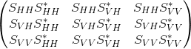

Elements below the diagonal are conjugate symmetric to elements above the diagonal.

Standard name | Suggested short  name | Units | Already  in CF?
spectrum_of_copolar_horizontal_to_copolar_horizontal | SPEC_HH_HH* |  | no
spectrum_of_copolar_horizontal_to_crosspolar_vertical | SPEC_HH_VH* |  | no
spectrum_of_copolar_horizontal_to_copolar_vertical | SPEC_HH_VV* |  | no
spectrum_of_crosspolar_vertical_to_crosspolar_vertical | SPEC_VH_VH* |  | no
spectrum_of_crosspolar_vertical_to_copolar_vertical | SPEC_VH_VV* |  | no
spectrum_of_copolar_vertical_to_copolar_vertical | SPEC_VV_VV* |  | no

Computing the data location from geo-reference variables
Weather radars and lidars rotate primarily about a principal axis (e.g., “zenith” for plan-position-indicator mode in ground-based radar), slew about a secondary axis, orthogonal to the primary axis (e.g., range-height-indicator in ground-based radar), or slew on a plane by changing both primary and secondary axis (e.g., COPLANE in ground-based radar).
In the ground-based radar convention, a point in space relative to a radar is represented in a local spherical coordinate systems X_{i} by three parameters, range (r), azimuth (λ), and elevation (φ). A ground-based radar is assumed “leveled” with positive (negative) elevation, φ, above (below) a reference plane (a leveled plane orthogonal to the principal axis and containing the radar). The azimuth angle, λ, is the angle on the reference plane increases clockwise from the True North (TN) following the Meteorological coordinate convention (e.g., TN is 0° and East is 90°).
Processing and manipulating radar data (e.g., interpolation, synthesis, etc.) typically are performed in a right-handed 3-D XYZ Cartesian geo-referenced coordinate system X (see Fig. 7.1) where Y is TN and X is East. Hence, a coordinate transformation between X_{i} (radar sampling space) and X (geo-reference space) is required. Based on the principal axes, most remote sensors can be classified into three right-hand types, X, Y, or Z type.
The purpose of this chapter is two-fold: (1) to define a consistent terminology for the CfRadial format, and (2) to derive coordinate transformation matrices for each type of remote sensor. Many sensors (e.g. fixed ground radars) are of the Z-type, have a fixed location, are leveled and are aligned relative to True North (TN). Dealing with such sensors is much simpler than for those on moving platforms. Therefore, they will be dealt with first, and the more complicated treatment of all three types of remote sensor mounted on moving platforms will be covered in the later sections.
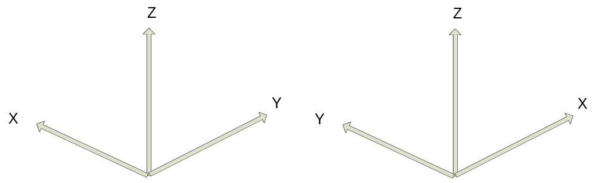
Figure 9.1: Left-handed XYZ coordinate system vs. Right-handed XYZ coordinate system.

In addition to the standard X, Y and Z right-hand types, specialized types such as the ELDORA and NOAA aircraft tail radars will be handled separately. The tail radars will be referred to as type Y-prime.

Special case – ground-based, stationary and leveled sensors
Ground-based sensors (radars and lidars) rotate primarily about the vertical (Z) axis (Z-Type), and the reference plane is a horizontal XY plane passing through the sensor. The Y-axis is aligned with TN, and the X-axis points East.
Azimuth angles (λ) are positive clockwise looking from above (+Z), with 0 being TN.
Elevation angles (φ) are measured relative to the horizontal reference plane, positive above the plane and negative below it.
A ground-based, leveled vertical pointing sensor can be classified as a Z-Type with φ=90°.

LIDARs
For LIDARs, the assumption is generally made that propagation of the beam is along a straight line, emanating at the sensor. The coordinate transformation between X_{i} (r, λ, φ) and X (x, y, z) is as follows:
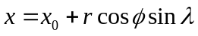
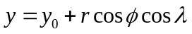
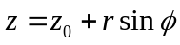
where
x is positive east
y is positive north
(x₀, y₀, z₀) are the coordinates of the sensor relative to the Cartesian grid origin and the azimuth angle (λ) is the angle clockwise from TN.
The sensor location is specified in longitude, latitude and altitude in the CfRadial format. Locations in the earth’s geo-reference coordinate system are computed using the sensor location and the (x,y,z) from above, using normal spherical geometry.

RADARs
The propagation of radar microwave energy in a beam through the lower atmosphere is affected by the change of refractive index of the atmosphere with height. Under average conditions this causes the beam to be deflected downwards, in what is termed ‘Standard Refraction’. For most purposes this is adequately modeled by assuming that the beam is in fact straight, relative to an earth which has a radius of 4/3 times the actual earth radius. (Rinehart 2004.)
For a stationary and leveled, ground-based radar, the equations are similar to those for the LIDAR case, except that we have one extra term, the height correction, which reflects the beam curvature relative to the earth.
The height h above the earth’s surface for a given range is:
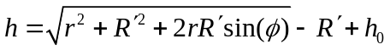
where 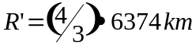 is the pseudo radius of earth. See Rinehart 2004, Chapter 3, for more details.
The (x,y) location for a given range is:
where x is positive east, y is positive north, and remembering that azimuth is the angle clockwise from true north.

Moving platforms
For moving platforms, the metadata for each beam will include:
- longitude of instrument
- latitude of instrument
- altitude of instrument
- rotation and tilt of the beam (see above)
- roll, pitch and heading of the platform
- platform motion (U_{G}, V_{G}, W_{G})
- air motion (U_{air}, V_{air}, W_{air})
For ground-based moving platforms (e.g., Doppler on Wheels), the earth-relative location of the observed point is:
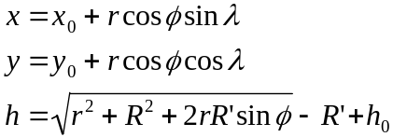
Note that for airborne radar platforms, correcting for refractive index does not apply. Therefore, for airborne radars, use the straight line equations for LIDARs.
Refer to the sections below for the computation of elevation (φ) and azimuth (λ) relative to earth coordinates.
Then apply the following equations, as before, to compute the location of the observed point.
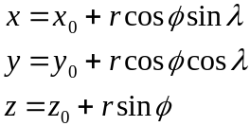

Coordinate transformations for the general case
This section details the processing for the general case.
Sensors which do not fall under section 7.1 above must be handled as a general case.

Coordinate systems
In addition to the previously-defined X_{i} and X coordinate systems, the following intermediate right-handed coordinate systems need to be defined to account for a moving, non-leveled platform:
- X_{a}: platform-relative coordinates, +Y points to heading, +X points to the right side (90° clockwise from +Y on the reference plane XY), +Z is orthogonal to the reference plane.
- X_{h} : leveled, platform heading-relative coordinates, +Y points heading, +X points 90° clockwise from heading, and Z points up (local zenith).
The goal here is to derive transformations from X_{i} to X via X_{a} and X_{h}.

The earth-relative coordinate system
The earth-relative coordinate system, X, is defined as follows, X is East, Y is North, and Z is zenith. Azimuth angle, λ, is defined as positive clockwise from TN (i.e., meteorological angle) while elevation angle, φ, is defined positive/negative above/below the horizontal plane at the altitude (h₀) of the remote sensor.

The platform-relative coordinate system
The general form of the mathematic representation describes a remote sensing device mounted on a moving platform (e.g., an aircraft, see Figure 7.2). This figure depicts the theoretical reference frame for a moving platform. (We use the aircraft analogy here, but the discussion also applies to water-borne platforms and land-based moving platforms.)
The platform-relative coordinate system of the platform, X_{a}, is defined by the right side, (X_{a}), the heading, (Y_{a}), and the zenith, (Z_{a}).
The origin of X_{a} is defined as the location of the INS on a moving platform.
The platform-relative coordinate system is defined by 3 rotations in the following order: heading (H), pitch (P) and roll (R) angles from X. These angles are generally measured by an inertial navigation system (INS).
The platform moves relative to X, based on its heading H, and the drift D, caused by wind or current. (D is 0 for land-based platforms). The track T is the line of the platform movement over the earth surface.
NOTE: -see Lee et al. (1994) for further background on this topic, and on the corrections to Doppler velocity for moving platforms. Usually, the platform INS and the sensor may not be collocated. The Doppler velocity needs to be compensated by the relative motion between these two.

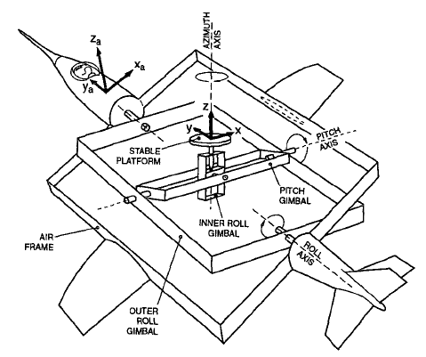
Figure 9.2 Moving platform axis definitions and reference frame (reproduced from Lee et al., 1994,originally from Axford, 1968) ©American Meteorological Society. Reprinted with permission.

Figures 7.3 a through c show the definitions of heading, drift, track, pitch and roll.
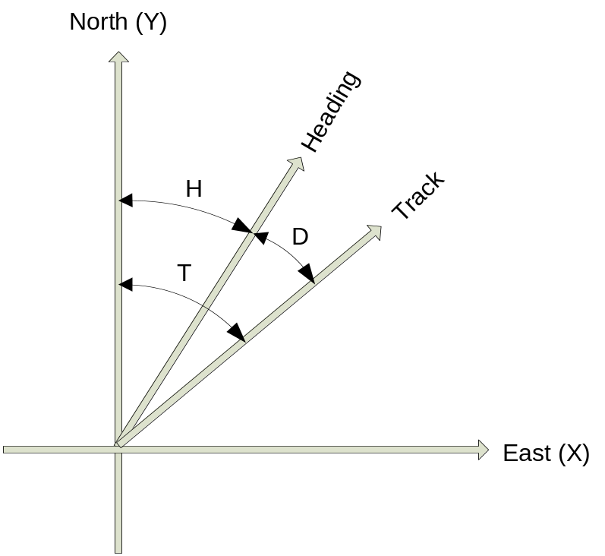
Figure 9.3(a): Definition of heading, drift and track.

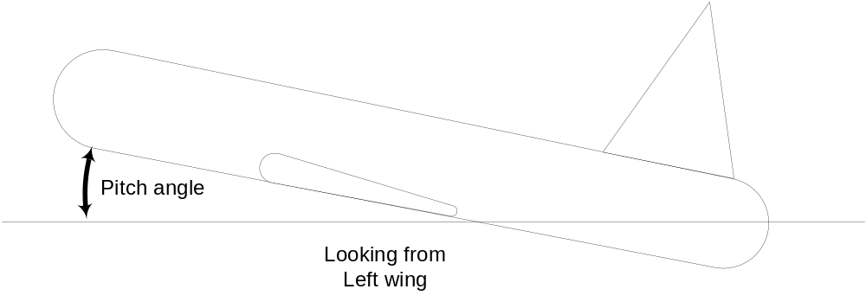
Figure 9.3(b): Definition of pitch

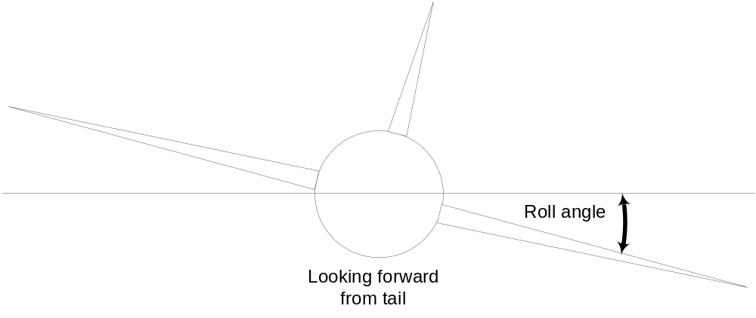
Figure 9.3(c): Definition of roll

The sensor coordinate system
In the sensor coordinate system, X_{i}, each data location is characterized by a range, r, a rotation angle, θ, and a tilt angle, τ. Following the ground-based radar convention, the rotation angle, θ, is the angle projected on the reference plane, positive clockwise from the third axis (counting from the principal axis in X_{a}) looking towards the sensor from the positive principal axis. The tilt angle, τ, is the angle of the beam relative to the reference plane. A beam has a positive/negative τ depending on whether it is on the positive/negative side of the reference plane, using the principal axis to determine the sign. Each gate location (r, θ, τ) in X_{i} can be represented in (r, λ, φ) in X.

Table 9.1: Characteristics of 4 types of sensors.
Sensor Type | Type X | Type Y | Type Y-prime | Type Z
Principal Axis | X_{a} | Y_{a} | Ya | Z_{a}
Reference Plane | Y_{a}Z_{a} | Z_{a}X_{a} | ZaXa | X_{a}Y_{a}
0° Rotation Angle | +Z_{a} | +X_{a} | +Za | +Y_{a}
90° Rotation Angle | +Y_{a} | +Z_{a} | +Xa | +X_{a}
Examples | EDOP, Wyoming Cloud Radar, Wind Profiler, downward scanning radar on Global Hawk |  | Tail Doppler radars on NOAA P3 and NSF/NCAR ELDORA | Ground-based radar/lidar, aircraft nose radar, NOAA P3 lower-fuselage radar,  C-band scatterometer

Coordinate transformation sequence
The following transformations are carried out to transform the geometry from the instrument-based (X_{i}) to the earth-based coordinate system (X):
- translate from X_{i} to X_{a}
- rotate from X_{a} to X

Transformation from X_{i} to X_{a}
The details of this step depend on the sensor type: Z, Y or X (Table 7.1)

Type Z sensors
The characteristics are:
- the primary axis is Z_{a}
- the reference plane is (X_{a}, Y_{a})
- the rotation angle θ is 0 in the (Y_{a}, Z_{a}) plane, i.e. along the +Y axis. Rotation increases clockwise from +Y, when looking from above (i.e. from +Z)
- the tilt angle τ is 0 in the (X_{a}, Y_{a}) plane, positive above it (for +Z_{a}) and negative below it.
The transformation to Χ_{a} coordinates is:
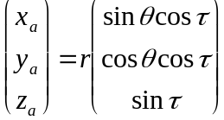

Type Y sensors
The characteristics are:
- the primary axis is Y_{a}
- the reference plane is (Z_{a}, X_{a})
- the rotation angle θ is 0 in the (Z_{a}, X_{a}) plane, i.e. along the +X_{a} axis. Rotation increases clockwise from +X, when looking from +Y.
- the tilt angle τ is 0 in the (Z_{a}, X_{a}) plane, positive for +Y_{a}.
Note that the definition of θ is different from the convention defined in Lee et al. (1994). Let θ’ be the rotation angle defined in Lee et al. (1994), θ=mod(450°- θ’).
The transformation to Χ_{a} coordinates is:
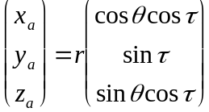
      - Type Y-prime sensors
The characteristics are:
the primary axis is Y_{a}
the reference plane is (Z_{a}, X_{a})
the rotation angle θ is 0 in the (Ya, Za) plane, i.e. along the +Z_{a} axis. Rotation increases clockwise from +Z, when looking from -Y.
the tilt angle τ is 0 in the (Z_{a}, X_{a}) plane, positive for +Y_{a}.
Note that the definition of θ is the convention defined in Lee et al. (1994
The transformation to Χ_{a} coordinates is:
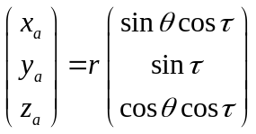

Type X sensors
The characteristics are:
- the primary axis is X_{a}
- the reference plane is (Y_{a}, Z_{a})
- the rotation angle θ is 0 in the (Y_{a}, Z_{a}) plane, i.e. along the +Z_{a} axis. Rotation increases clockwise from +Z_{a}, when looking from +X_{a}.
- the tilt angle τ is 0 in the (Y_{a}, Z_{a}) plane, positive for +X_{a}.
The transformation to Χ_{a} coordinates is:
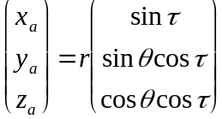

Rotating from X_{a} to X
Rotating X_{a} to X requires the following 3 steps (in the reverse order of the rotation):
- remove the roll R, by rotating the x axis around the y axis by –R.
- remove the pitch P, by rotating the y axis around the x axis by –P.
- remove the heading H, by rotating the y axis around the z axis by +H
The transformation matrix for removing the roll component is:
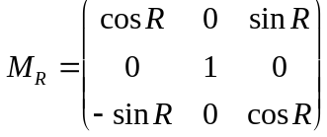
The transformation matrix for removing the pitch component is:
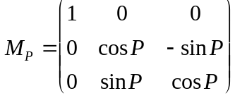
The transformation matrix for removing the heading component is:
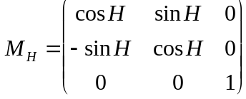

We apply these transformations consecutively:
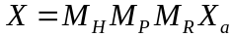
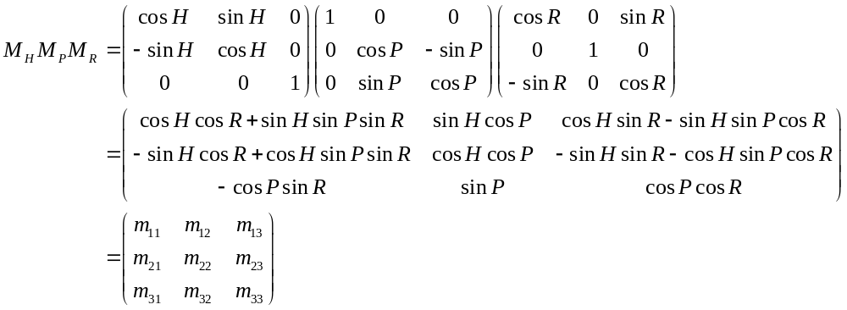

Summary of transforming from X_{i} to X
We combine the above 2 main steps for transform all the way from the instrument coordinates to earth coordinates:

For type Z radars:
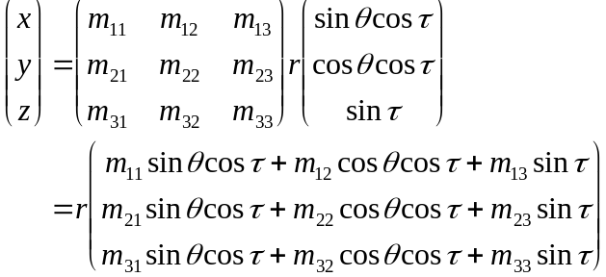

For type Y radars:
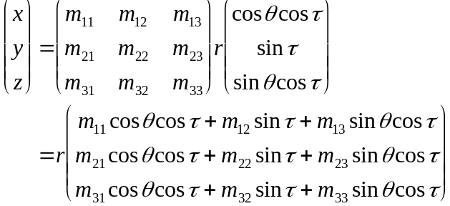

For type Y-prime radars:
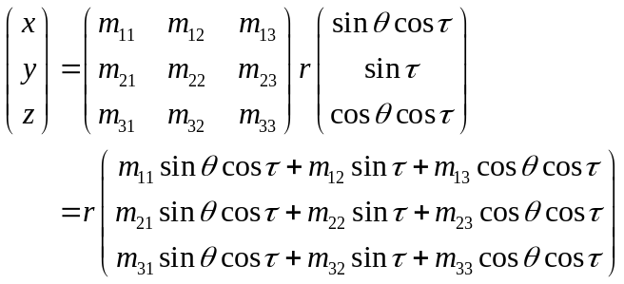

For type X radars:
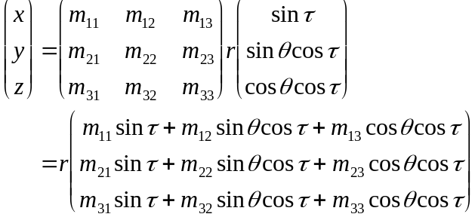

Computing earth-relative azimuth and elevation
We can then compute the earth-relative azimuth and elevation as follows:
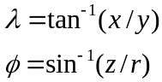

Summary of symbol definitions
Χ_{i}: instrument-relative coordinate system, (r, θ, τ) or (r, λ, φ)
Χ_{a}: platform-relative coordinate system (x_{a}, y_{a}, z_{a}) – see figure 7.2
Χ_{h}: coordinate system relative to level platform (no roll or pitch) with heading H.
Χ: earth-relative coordinate system (x, y, z), x is positive east, y is positive north, z is positive up.
H: heading of platform (see figure 7.3)
T: track of platform (see figure 7.3)
D: drift angle (see figure 7.3)
P: pitch angle (see figure 7.3)
R: roll angle (see figure 7.3)
λ: azimuth angle
φ: elevation angle
θ: rotation angle
τ: tilt angle
r: range
h: height
h_{0:} height of the instrument
R’: pseudo radius of earth = 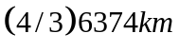

References
Axford, D. N., 1968: On the accuracy of wind measurements using an inertial platform in an aircraft, and an example of a measurement of the vertical structure of the atmosphere. J. Appl. Meteor., 7, 645-666.
Lee, W., P. Dodge, F. D. Marks Jr. and P. Hildebrand, 1994: Mapping of Airborne Doppler Radar Data. Journal of Oceanic and Atmospheric Technology, 11, 572 – 578.
Rinehart, R. E., 2004: Radar for Meteorologists, Fourth Edition. Rinehart Publications. ISBN 0-9658002-1-0

The rotation angle, θ’, defined in previous airborne tail Doppler radar convention (Lee et al. 1994) was positive clockwise looking from the tail toward the nose of an aircraft (i.e., looking from the -Y_{a}-axis) that has been the convention for airborne tail Doppler radars. θ’=0° points to +Z. However, this convention is different from that used in the ground-based radars. The r and τ were defined the same way in the current convention.

