**NCAR/EOL**

**CfRadial Overview**

**CF-compliant NetCDF Format**

**for Moments Data for RADAR and LIDAR**

**in Radial Coordinates**

Mike Dixon  
Wen-Chau Lee

EOL, NCAR*

2017-02-01

* NCAR is sponsored by the US National Science Foundation.

1 Introduction 4

1.1 Purpose 4

1.2 History 4

1.3 CF2 and CfRadial2 5

1.4 On-line URLs 5

2 The Nature of RADAR/LIDAR data – polar coordinates 6

2.1 PPI scanning mode 7

2.2 Range Height Indicator (RHI) scanning mode 8

2.3 Vertical pointing scanning mode 9

3 CfRadial 1 – based on the classic NetCDF 3 design 10

4 CfRadial 2 – NetCDF 4 with groups 12

4.1 Overview 12

4.2 Group-based data structure 13

5 Standard names 16

5.1 Standard names for moments variables 16

5.2 Standard names for spectra variables 18

6 Computing the data location from geo-reference variables 18

6.1 Special case – ground-based, stationary and leveled sensors 19

6.1.1 LIDARs 20

6.1.2 RADARs 20

6.2 Moving platforms 21

6.3 Coordinate transformations for the general case 21

6.3.1 Coordinate systems 21

6.3.2 The earth-relative coordinate system 22

6.3.3 The platform-relative coordinate system 22

6.3.4 The sensor coordinate system 25

6.4 Coordinate transformation sequence 26

6.4.1 Transformation from Xi to Xa 26

6.4.1.1 Type Z sensors 26

6.4.1.2 Type Y sensors 26

6.4.1.4 Type X sensors 27

6.4.2 Rotating from Xa to X 27

6.5 Summary of transforming from Xi to X 29

6.5.1 For type Z radars: 29

6.5.2 For type Y radars: 29

6.5.3 For type Y-prime radars: 29

6.5.4 For type X radars: 30

6.5.5 Computing earth-relative azimuth and elevation 30

6.6 Summary of symbol definitions 30

7 References 31

CfRadial Overview

# Introduction

## Purpose

CfRadial is a CF-compliant NetCDF convention for RADAR and LIDAR data in polar coordinates.

The conventions for CF (Climate and Forecast) metadata are designed to promote the processing and sharing of files created with the NetCDF API.

The current CF conventions are documented at:

<http://cfconventions.org>  
 <http://cfconventions.org/cf-conventions/v1.6.0/cf-conventions.html>

## History

CfRadial was introduced in 2011 as a format designed to store data from scanning weather radars and lidars in an accurate and lossless manner.

Since digital weather radars made their debut in the 1970s, a wide variety of data formats has emerged for pulsed instruments (radar and lidar) in polar coordinates. Researchers and manufacturers have tended to develop formats unique to their instruments, and since 1990 NCAR has supported over 20 different data formats for radar and lidar data. Researchers, students and operational users spend unnecessary time handling the complexity of these formats.

CfRadial grew out of the need to simplify the use of data from weather radars and lidars and thereby to improve efficiency. CfRadial adopts the well-known NetCDF framework, along with the Climate and Forecasting (CF) conventions. It is designed to accurately store the metadata and data produced by the instruments, in their native polar coordinates, without any loss of information. Mobile platforms are supported. Data field identification is facilitated by the 'standard_name' convention in CF, so that fields derived from algorithms (such as hydrometeor type) can be represented just as easily as the original fields (such as radar reflectivity).

|  |  |  |
| --- | --- | --- |
| **Date** | **Version** | **Remarks** |
| 2011/02/01 | 1.1 | First operational version. NetCDF classic data model. |
| 2011/06/07 | 1.2 | Minor changes / additions. NetCDF classic data model. |
| 2013/07/01 | 1.3 | Major changes / additions. NetCDF classic data model. |
| 2016/08/01 | 1.4 | Major additions – data quality, spectra. NetCDF classic data model. |
| 2016/08/01 | 2.0 | Major revision – not backward compatible with CfRadial1  Uses NetCDF 4 and groups.  Combines CfRadial 1.4 and ODIM-H5 version 2.2. |

Table 1: History of CfRadial versions

CfRadial1 has been adopted by NCAR, as well as NCAS (the UK National Center for Atmospheric Science) and the US DOE Atmospheric Radiation Measurement (ARM) program. CfRadial development was boosted in 2015 through a two-year NSF EarthCube grant to improve CF in general. Following the CF user community workshop in Boulder Colorado in May 2016, version 1.4 was agreed upon, adding explicit support for quality fields and spectra.

## CF2 and CfRadial2

In 2015 the US National Science Foundation (NSF) funded the project “EarthCube IA: Advancing NetCDF-CF for the Geoscience Community". This project aims to update the CF conventions to make better use of NetCDF4 capabilities, such as groups, to organize data in CF-compliant files. CF2.0 standards will be developed to guide this process. The development of CfRadial2 is part of this work. A workshop was held in Boulder Colorado, in May 2016, to assess and collaborate on progress to Cf2.0.

Shortly after that, in July 2016, a WMO-sponsored meeting was held at NCAR in Boulder, during which the WMO Task Team on Weather Radar Data Exchange (TT-WRDE) considered the adoption of a single WMO-recommended format for radar and lidar data in polar coordinates. The two modern formats discussed as options were CfRadial and the European radar community ODIM-H5 (HDF5) format, in addition to the older and more rigid table-driven BUFR and GRIB2 formats. TT-WRDE recommended that CfRadial 1.4 be merged with the sweep-oriented structure of ODIM-H5, making use of groups to produce a single WMO format that will encompass the best ideas of both formats. That has led to the emergence of CfRadial2. This format should meet the objectives of both the NSF EarthCube CF 2.0 initiative and the WMO TT-WRDE.

## On-line URLs

This document, older versions, full history and other related information, are available on-line at:

<https://github.com/NCAR/CfRadial/tree/master/docs>

These include detailed documentation of versions 1.1 through 1.4, as well as the current CfRadial2 development.

The current NetCDF CF conventions are documented at:

<http://cfconventions.org/>

<http://cfconventions.org/cf-conventions/v1.6.0/cf-conventions.html>

# The Nature of RADAR/LIDAR data – polar coordinates

Scanning instruments – such as RADARS and LIDARS – operate natively in polar coordinates.

The intention with CfRadial is to save the data in the native coordinate system without any loss of information.

RADARs and LIDARs are pulsed instruments, which sample the atmosphere at a series of **range gates**, generally at constant spacing, in the direction at which the antenna or telescope is pointing.

The gates are grouped into **rays**, or beams.

**Rays** are grouped into **sweeps**, which are logical divisions in the scanning strategy. For example, as a radar scans in PPI mode, a sweep comprises all of the rays at a given elevation angle.

In CfRadial, a **Volume** comprises all of the rays in the file.

## PPI scanning mode

In PPI scanning mode, the antenna moves predominantly in azimuth.

Sweeps contain rays at a constant elevation angle.



Figure 1: scanning in PPI (or surveillance) mode

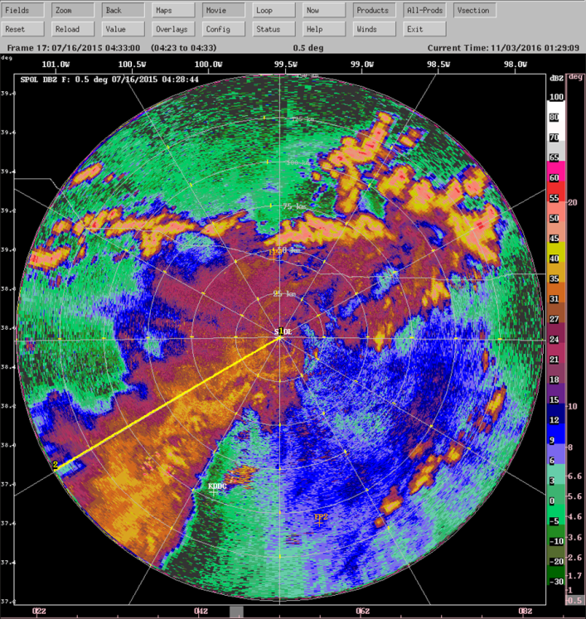

Figure 2: PPI radar reflectivity example

## Range Height Indicator (RHI) scanning mode

In RHI scanning mode, the antenna moves predominantly in elevation.

Sweeps contain rays at a constant azimuth angle.

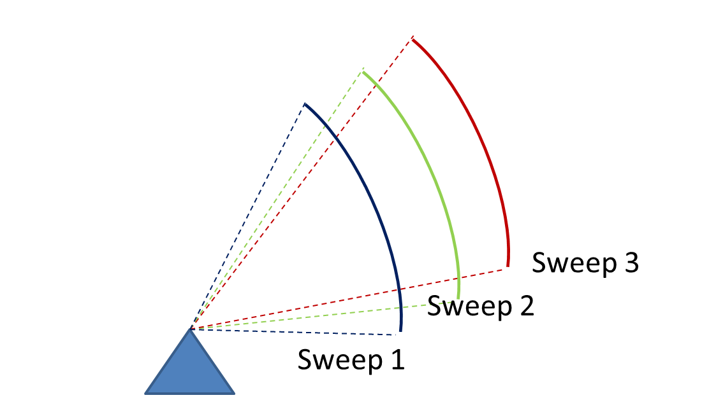

Figure 3: scanning in RHI mode

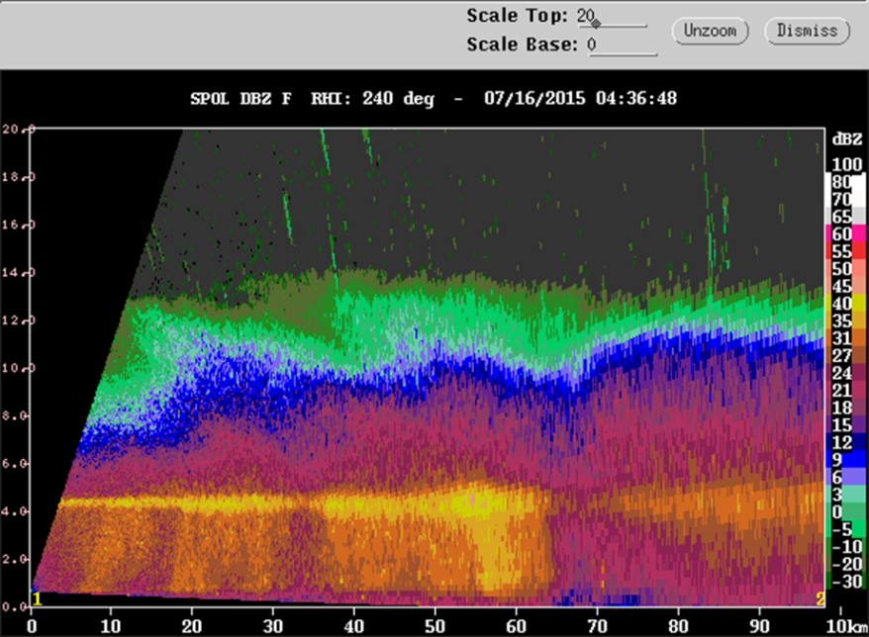

Figure 4: RHI radar reflectivity example

## Vertical pointing scanning mode

In vertically-pointing mode, the ntenna is stationary.

Sweeps contain rays within a given time interval.

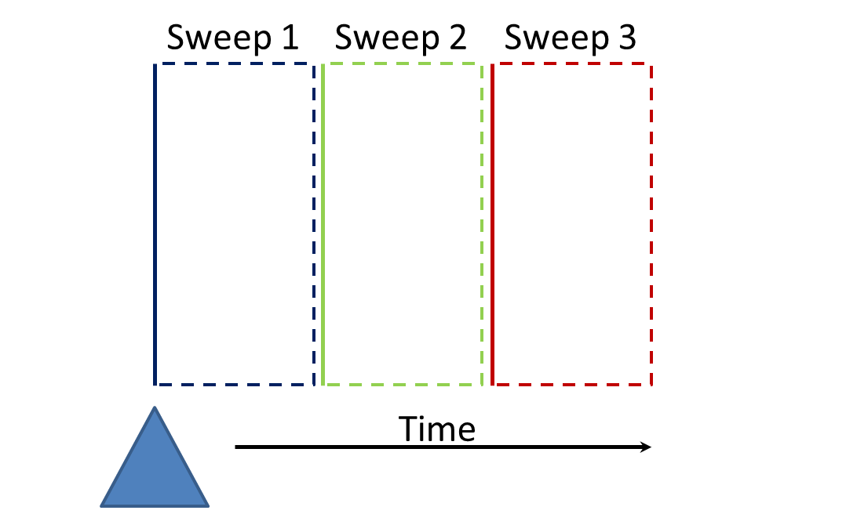

Figure 5: Vertically pointing scanning mode

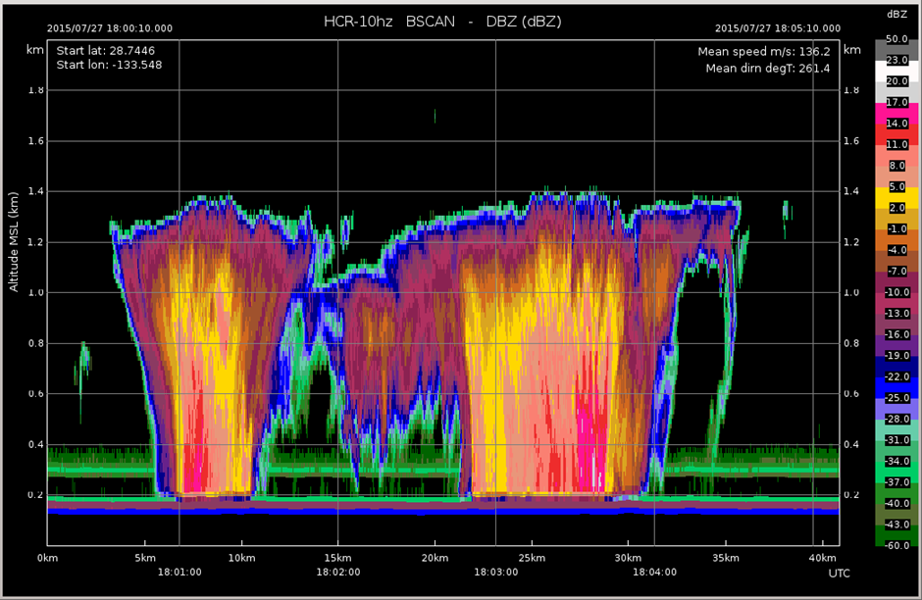

Figure 6: Vertically pointing radar reflectivity example

# CfRadial 1 – based on the classic NetCDF 3 design

CfRadial versions 1.1 to 1.4 are based on the classic NetCDF 3 model, in which the data structure is inherently **flat**.

All of the metadata variables, and the actual data set arrays, are stored at the same (top) **level**.

This is analogous to storing all of your computer files in a single folder – e.g. your home directory.

Some radar/lidar data contains rays with a constant number of gates. In CfRadial 1, this type of data can be stored in 2-D rectangular arrays where the primary dimension is time and the secondary dimension is range. See figure 7 below.



Figure 7: storing the field data in 2-D arrays

As an alternative, to store the data more efficiently, some data sets have a variable number of gates per ray. This allows us to discard gates beyond the range at which useful data exists for that ray. In this case the field data is stored in a so-called 1-D ‘ragged’ array, in which the primary dimension is npoints – the length of the array. The location of the data for a specific ray is found via the ray_start_index and ray_n_gates metadata arrays. See figure 8 below.



Figure 8: field data with variable number of gates per rays  
stored as ragged arrays.

In both of these cases, the metadata variables such as time, elevation angle and azimuth angle are stored as 1-D arrays.

As mentioned earlier, all of these arrays are stored at the top level in the NetCDF file – NetCDF3 has only a single level.

# CfRadial 2 – NetCDF 4 with groups

## Overview

NetCDF4, which is based on HDF5, introduced the concept of **groups**.

This allows us to create a **data tree structure**, in which data for different logical components are stored at different conceptual locations, or levels, within the file.

This is analogous to storing data files on your computed in a tree of folders or directories. This leads to a better organization of the data in a logical structure.

As shown in section 3 above, it makes sense to separate a radar volume into logical components called **sweeps**.

A sweep is defined as a series of rays for which certain characteristics are constant. In a PPI sweep, the elevation angle is held constant. In an RHI sweep, the azimuth angle is constant.

In CfRadial 2, the number of gates is in a sweep is always constant. This allows us to store the data set in a simple rectangular 2-D array, with dimensions time and range.

The object model is implemented as a simple hierarchy of types. The type at each level of the hierarchy is strictly a collection of the type(s) at the next lower level. An example of this arrangement is illustrated in 9.

Figure 9: Object Model Hierarchy (PPI sweep based example shown)

Figure 10, below, shows how data sets are logically grouped into sweeps and volumes.

Figure 10: Logical grouping into sweeps and volumes

## Group-based data structure

In order to be readily accessible to scientists in the user community using legacy applications, CfRadial1 uses the flat classic model of NetCDF3. A drawback of this approach is that the implementation quickly becomes complicated, since much of the metadata is placed at the top level in the data structure. Namespace clashes can easily occur.

By contrast, the European ODIM-H5 format makes extensive use of HDF5 groups to provide logical separation between data at different levels in the structure. In fact ODIM tends to rather over-use this approach, leading to complexity of a different type.

In designing CfRadial2, we chose to merge CfRadial1 and ODIM-H5, adopting the best features of each to produce a clear implementation that is as simple as reasonable, but no simpler. CfRadial2 makes use of the group capability available in NetCDF4.

CfRadial2 adopts the sweep-based model of Figure 2.2. The overall structure is shown in Figure 11 below.

The top-level (default) root group holds the global dimensions, attributes and variables. Nested below this group is a sub-group for each sweep. The name of the sweep sub-groups is provided in a string array named ‘sweep_group_names’, also at the top level. This allows the user to locate the sweep groups directly.

CfRadial2 supports moving platforms (aircraft, ships and vehicles), which requires storing the georeference data accurately at each ray time. Furthermore, storage of spectra on a gate-by-gate basis, for example for vertically-pointing precipitation radars, is supported. Figure 12 shows these details. Both of these are specializations, and are not required for most fixed operational radars.

A number of optional groups are available in the root group, to support radar and lidar parameters, calibrations, and corrections to the georeferenced data. These are shown in figure 13.



group:  
*sweep_name2*

sweep attributes  
dimensions: *time, range*

metadata variables:

*time*(time)  
 *range*(range)  
 *elevation*(time)  
 *azimuth*(time)  
 etc.

field variables: e.g.

*dbz*(time, range)

*vel*(time, range)

------

*fieldn*(time, range)



field attributes



field attributes



field attributes

group:  
*root*

dimension: *sweep* (can be unlimited)global attributes  
global variables  
sweep_group_names[sweep]  
sweep_fixed_angles[sweep]



group:  
*sweep_name1*

sweep attributes  
dimensions: *time, range*

metadata variables:

*time*(time)  
 *range*(range)  
 *elevation*(time)  
 *azimuth*(time)  
 etc.

field variables: e.g.

*dbz*(time, range)

*vel*(time, range)

------

*fieldn*(time, range)



field attributes



field attributes



field attributes



group:  
*sweep_namen*

sweep attributes  
dimensions: *time, range*

metadata variables:

*time*(time)  
 *range*(range)  
 *elevation*(time)  
 *azimuth*(time)  
 etc.

field variables: e.g.

*dbz*(time, range)

*vel*(time, range)

------

*fieldn*(time, range)



field attributes



field attributes



field attributes

Figure 11: Group structure showing top-level dimensions,  
attributes, variables and sweep groups



sweep attributes  
  
dimensions: *time, range, spectrum_group*

metadata variables:

spectrum_group_names(spectrum_group)

*time*(time)  
 *range*(range)  
 *elevation*(time)  
 *azimuth*(time)  
 etc.

group*:  
georeference*

group:  
*sweep_name*



dimensions: *index, sample*

*spectrum_index(*time, range*)*

spectrum field variables: e.g.

*spectrum_hco*(index, sample)

*spectrum_vco*(index, sample)



*latitude*(time)  
*longitude*(time)  
*altitude*(time)  
*heading*(time)  
*roll*(time)  
*pitch*(time)  
*etc.*

attributes

attributes

attributes

group*:  
spectra*

group*:  
georeference*

group*:  
monitoring*



*transmit_power*(time)  
*noise_power*(time)  
*etc.*

field variables: e.g.

*dbz*(time, range)

*vel*(time, range)

------

*fieldn*(time, range)

field attributes

field attributes

field attributes

Figure 12: Sweep group structure in more detail, showing  
support for georeference metadata for moving platforms,  
spectra, and monitoring data.

group:  
*root*

*sweep_name1* group *sweep_name2* group

*sweep_nnnn* group *radar_parameters* group *lidar_parameters* group *radacalibration* group *lidacalibration* group *georeference_correction* group

dimension: *sweep*global attributes  
global variables

Figure 13: Optional metadata groups (highlighted in gray) in the root group

# Standard names

To the extent possible, CfRadial uses standard names already defined by CF.

The standard_name entries not already accepted by CF have been requested for inclusion.

## Standard names for moments variables

This section lists the proposed standard names for moments data and other fields derived from the raw radar data.

| Standard name | Short name | Units | Already in CF? |
| --- | --- | --- | --- |
| equivalent_reflectivity_factor | DBZ | dBZ | yes |
| linear_equivalent_reflectivity_factor | Z | Z | no |
| radial_velocity_of_scatterers_ away_from_instrument | VEL | m/s | yes |
| doppler_spectrum_width | WIDTH | m/s | no |
| log_differential_reflectivity_hv | ZDR | dB | no |
| log_linear_depolarization_ratio_hv | LDR | dB | no |
| log_linear_depolarization_ratio_h | LDRH | dB | no |
| log_linear_depolarization_ratio_v | LDRV | dB | no |
| differential_phase_hv | PHIDP | degrees | no |
| specific_differential_phase_hv | KDP | degrees/km | no |
| cross_polar_differential_phase | PHIHX | degrees | no |
| cross_correlation_ratio_hv | RHOHV |  | no |
| co_to_cross_polar_correlation_ratio_h | RHOHX |  | no |
| co_to_cross_polar_correlation_ratio_v | RHOXV |  | no |
| log_power | DBM | dBm | no |
| log_power_co_polar_h | DBMHC | dBm | no |
| log_power_cross_polar_h | DBMHX | dBm | no |
| log_power_co_polar_v | DBMVC | dBm | no |
| log_power_cross_polar_v | DBMVX | dBm | no |
| linear_power | PWR | mW | no |
| linear_power_co_polar_h | PWRHC | mW | no |
| linear_power_cross_polar_h | PWRHX | mW | no |
| linear_power_co_polar_v | PWRVC | mW | no |
| linear_power_cross_polar_v | PWRVX | mW | no |
| signal_to_noise_ratio | SNR | dB | no |
| signal_to_noise_ratio_co_polar_h | SNRHC | dB | no |
| signal_to_noise_ratio_cross_polar_h | SNRHX | dB | no |
| signal_to_noise_ratio_co_polar_v | SNRVC | dB | no |
| signal_to_noise_ratio_cross_polar_v | SNRVX | dB | no |
| normalized_coherent_power (Alias: signal-quality-index) | NCP (alias SQI) |  | no |
| corrected_equivalent_reflectivity_factor | DBZc | dBZ | no |
| corrected_radial_velocity_of_scatterers_ away_from_instrument | VELc | m/s | no |
| corrected_log_differential_reflectivity_hv | ZDRc | dB | no |
| radar_estimated_rain_rate | RRR | mm/hr | no |
| rain_rate | RR | kg/m2/s | yes |
| radar_echo_classification (should be used for PID, HCA, HID etc) | REC | legend | no |

## Standard names for spectra variables

This section lists the proposed standard names for spectra field variables. After assuming reciprocity there are 6 unique elements of the covariance matrix and the following names reflect those combinations. In the short name, the notation due to Bringi and Chandrasekar where SVH refers to the backscattering element where horizontal polarization is transmitted, but vertical polarization is received. The * denotes complex conjugate.

The covariance matrix elements are given as

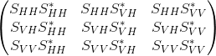

Elements below the diagonal are conjugate symmetric to elements above the diagonal.

| Standard name | Suggested short name | Units | Already in CF? |
| --- | --- | --- | --- |
| spectrum_of_copolar_horizontal_to_copolar_horizontal | SPEC_HH_HH* |  | no |
| spectrum_of_copolar_horizontal_to_crosspolar_vertical | SPEC_HH_VH* |  | no |
| spectrum_of_copolar_horizontal_to_copolar_vertical | SPEC_HH_VV* |  | no |
| spectrum_of_crosspolar_vertical_to_crosspolar_vertical | SPEC_VH_VH* |  | no |
| spectrum_of_crosspolar_vertical_to_copolar_vertical | SPEC_VH_VV* |  | no |
| spectrum_of_copolar_vertical_to_copolar_vertical | SPEC_VV_VV* |  | no |

# Computing the data location from geo-reference variables

Weather radars and lidars rotate primarily about a *principal axis* (e.g., “zenith” for plan-position-indicator mode in ground-based radar), slew about a secondary axis, orthogonal to the primary axis (e.g., range-height-indicator in ground-based radar), or slew on a plane by changing both primary and secondary axis (e.g., COPLANE in ground-based radar).

In the ground-based radar convention, a point in space relative to a radar is represented in a local spherical coordinate systems **X**i by three parameters, range (*r*), azimuth (*λ*), and elevation (*φ*). A ground-based radar is assumed “leveled” with positive (negative) elevation, *φ*, above (below) a *reference plane* (a leveled plane orthogonal to the principal axis and containing the radar). The azimuth angle, *λ*, is the angle on the reference plane increases clockwise from the True North (TN) following the Meteorological coordinate convention (e.g., TN is 0° and East is 90°).

Processing and manipulating radar data (e.g., interpolation, synthesis, etc.) typically are performed in a right-handed 3-D XYZ Cartesian geo-referenced coordinate system **X** (see Fig. 7.1) where Y is TN and X is East. Hence, a coordinate transformation between **X**i (radar sampling space) and **X** (geo-reference space) is required. Based on the principal axes, most remote sensors can be classified into three right-hand types, X, Y, or Z type.

The purpose of this chapter is two-fold: (1) to define a consistent terminology for the CfRadial format, and (2) to derive coordinate transformation matrices for each type of remote sensor. Many sensors (e.g. fixed ground radars) are of the Z-type, have a fixed location, are leveled and are aligned relative to True North (TN). Dealing with such sensors is much simpler than for those on moving platforms. Therefore, they will be dealt with first, and the more complicated treatment of all three types of remote sensor mounted on moving platforms will be covered in the later sections.



Figure 9.1: Left-handed XYZ coordinate system vs. Right-handed XYZ coordinate system.

In addition to the standard X, Y and Z right-hand types, specialized types such as the ELDORA and NOAA aircraft tail radars will be handled separately. The tail radars will be referred to as type Y-prime.

## Special case – ground-based, stationary and leveled sensors

Ground-based sensors (radars and lidars) rotate primarily about the vertical (Z) axis (Z-Type), and the reference plane is a horizontal XY plane passing through the sensor. The Y-axis is aligned with TN, and the X-axis points East.

Azimuth angles (*λ*) are positive clockwise looking from above (+Z), with 0 being TN.

Elevation angles (*φ*) are measured relative to the horizontal reference plane, positive above the plane and negative below it.

A ground-based, leveled vertical pointing sensor can be classified as a Z-Type with φ=90°.

### LIDARs

For LIDARs, the assumption is generally made that propagation of the beam is along a straight line, emanating at the sensor. The coordinate transformation between **X**i(*r*, *λ*, *φ*) and **X** (*x*, *y*, *z*) is as follows:







where

*x* is positive east

*y* is positive north

(*x*0, *y*0, *z*0) are the coordinates of the sensor relative to the Cartesian grid origin and the azimuth angle (*λ*) is the angle clockwise from TN.

The sensor location is specified in longitude, latitude and altitude in the CfRadial format. Locations in the earth’s geo-reference coordinate system are computed using the sensor location and the (*x*,*y*,*z*) from above, using normal spherical geometry.

### RADARs

The propagation of radar microwave energy in a beam through the lower atmosphere is affected by the change of refractive index of the atmosphere with height. Under average conditions this causes the beam to be deflected downwards, in what is termed ‘Standard Refraction’. For most purposes this is adequately modeled by assuming that the beam is in fact straight, relative to an earth which has a radius of 4/3 times the actual earth radius. (Rinehart 2004.)

For a stationary and leveled, ground-based radar, the equations are similar to those for the LIDAR case, except that we have one extra term, the height correction, which reflects the beam curvature relative to the earth.

The height *h* above the earth’s surface for a given range is:



where  is the pseudo radius of earth. See Rinehart 2004, Chapter 3, for more details.

The (*x*,*y*) location for a given range is:





where *x* is positive east, *y* is positive north, and remembering that azimuth is the angle clockwise from true north.

## Moving platforms

For moving platforms, the metadata for each beam will include:

* longitude of instrument
* latitude of instrument
* altitude of instrument
* rotation and tilt of the beam (see above)
* roll, pitch and heading of the platform
* platform motion (UG, VG, WG)
* air motion (Uair, Vair, Wair)

For ground-based moving platforms (e.g., Doppler on Wheels), the earth-relative location of the observed point is:



Note that for airborne radar platforms, correcting for refractive index does not apply. Therefore, for airborne radars, use the straight line equations for LIDARs.

Refer to the sections below for the computation of elevation (*φ*) and azimuth (*λ*) relative to earth coordinates.

Then apply the following equations, as before, to compute the location of the observed point.



## Coordinate transformations for the general case

This section details the processing for the general case.

Sensors which do not fall under section 7.1 above must be handled as a general case.

### Coordinate systems

In addition to the previously-defined **Xi** and **X** coordinate systems, the following intermediate right-handed coordinate systems need to be defined to account for a moving, non-leveled platform:

* **X**a: platform-relative coordinates, +Y points to heading, +X points to the right side (90° clockwise from +Y on the reference plane XY), +Z is orthogonal to the reference plane.
* **X**h: leveled, platform heading-relative coordinates, +Y points heading, +X points 90° clockwise from heading, and Z points up (local zenith).

The goal here is to derive transformations from **Xi** to **X** via **X**a and **X**h.

### The earth-relative coordinate system

The earth-relative coordinate system, **X**, is defined as follows, X is East, Y is North, and Z is zenith. Azimuth angle, *λ*, is defined as positive *clockwise* from TN (i.e., meteorological angle) while elevation angle, *φ*, is defined positive/negative above/below the horizontal plane at the altitude (*h*0) of the remote sensor.

### The platform-relative coordinate system

The general form of the mathematic representation describes a remote sensing device mounted on a moving platform (e.g., an aircraft, see Figure 7.2). This figure depicts the theoretical reference frame for a moving platform. (We use the aircraft analogy here, but the discussion also applies to water-borne platforms and land-based moving platforms.)

The platform-relative coordinate system of the platform, **X**a, is defined by the right side, (Xa), the heading, (Ya), and the zenith, (Za).

The origin of **X**a is defined as the location of the INS on a moving platform.

The platform-relative coordinate system is defined by 3 rotations in the following order: heading (*H*), pitch (*P*) and roll (*R*) angles from **X**. These angles are generally measured by an inertial navigation system (INS).

The platform moves relative to **X**, based on its heading *H*, and the drift *D*, caused by wind or current. (*D* is 0 for land-based platforms). The track *T* is the line of the platform movement over the earth surface.

NOTE: -see Lee et al. (1994) for further background on this topic, and on the corrections to Doppler velocity for moving platforms. Usually, the platform INS and the sensor may not be collocated. The Doppler velocity needs to be compensated by the relative motion between these two.

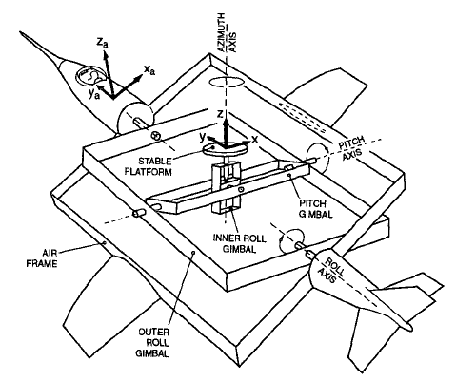

Figure 9.2 Moving platform axis definitions and reference frame (reproduced from Lee et al., 1994,originally from Axford, 1968) ©American Meteorological Society. Reprinted with permission.

Figures 7.3 a through c show the definitions of heading, drift, track, pitch and roll.



Figure 9.3(a): Definition of heading, drift and track.



Figure 9.3(b): Definition of pitch



Figure 9.3(c): Definition of roll

### The sensor coordinate system

In the sensor coordinate system, **X**i, each data location is characterized by a range, *r*, a rotation angle, *θ*, and a tilt angle, *τ*. Following the ground-based radar convention, the rotation angle, *θ*, is the angle projected on the reference plane, positive *clockwise* from the third axis (counting from the principal axis in **X**a) looking *towards the sensor* from the positive principal axis. The tilt angle, *τ*, is the angle of the beam relative to the reference plane. A beam has a positive/negative *τ* depending on whether it is on the positive/negative side of the reference plane, using the principal axis to determine the sign. Each gate location (*r*, *θ*, *τ*) in **X**i can be represented in (*r*, *λ*, *φ*) in **X**.

Table 9.1: Characteristics of 4 types of sensors.

|  |  |  |  |  |
| --- | --- | --- | --- | --- |
| Sensor Type | Type X | Type Y | Type Y-prime | Type Z |
| Principal Axis | Xa | Ya | Ya | Za |
| Reference Plane | YaZa | ZaXa | ZaXa | XaYa |
| 0° Rotation Angle | +Za | +Xa | +Za | +Ya |
| 90° Rotation Angle | +Ya | +Za | +Xa | +Xa |
| Examples | EDOP, Wyoming Cloud Radar, Wind Profiler, downward scanning radar on Global Hawk |  | Tail Doppler radars on NOAA P3 and NSF/NCAR ELDORA | Ground-based radar/lidar, aircraft nose radar, NOAA P3 lower-fuselage radar, C-band scatterometer |

## Coordinate transformation sequence

The following transformations are carried out to transform the geometry from the instrument-based (**X**i) to the earth-based coordinate system (**X**):

* translate from **X**i to **X**a
* rotate from **X**a to **X**

### Transformation from Xi to Xa

The details of this step depend on the sensor type: Z, Y or X (Table 7.1)

#### Type Z sensors

The characteristics are:

* the primary axis is Za
* the reference plane is (Xa, Ya)
* the rotation angle *θ* is 0 in the (Ya, Za) plane, i.e. along the +Y axis. Rotation increases clockwise from +Y, when looking from above (i.e. from +Z)
* the tilt angle *τ* is 0 in the (Xa, Ya) plane, positive above it (for +Za) and negative below it.

The transformation to Χa coordinates is:



#### Type Y sensors

The characteristics are:

* the primary axis is Ya
* the reference plane is (Za, Xa)
* the rotation angle *θ* is 0 in the (Za, Xa) plane, i.e. along the +Xa axis. Rotation increases clockwise from +X, when looking from +Y.
* the tilt angle *τ* is 0 in the (Za, Xa) plane, positive for +Ya.

***Note that the definition of*** ***θ is different from the convention defined in Lee et al. (1994)[1]. Let θ’ be the rotation angle defined in Lee et al. (1994), θ=mod(450°- θ’).***

The transformation to **Χ**a coordinates is:



* + - 1. **Type Y-prime sensors**

The characteristics are:

the primary axis is Ya

the reference plane is (Za, Xa)

the rotation angle *θ* is 0 in the (Ya, Za) plane, i.e. along the +Za axis. Rotation increases clockwise from +Z, when looking from -Y.

the tilt angle *τ* is 0 in the (Za, Xa) plane, positive for +Ya.

***Note that the definition of*** ***θ is the convention defined in Lee et al. (1994***

The transformation to **Χ**a coordinates is:



#### Type X sensors

The characteristics are:

* the primary axis is Xa
* the reference plane is (Ya, Za)
* the rotation angle *θ* is 0 in the (Ya, Za) plane, i.e. along the +Za axis. Rotation increases clockwise from +Za, when looking from +Xa.
* the tilt angle *τ* is 0 in the (Ya, Za) plane, positive for +Xa.

The transformation to Χa coordinates is:



### Rotating from Xa to X

Rotating **X**a to **X** requires the following 3 steps (in the reverse order of the rotation):

* remove the roll *R*, by rotating the x axis around the y axis by –*R*.
* remove the pitch *P*, by rotating the y axis around the x axis by –*P*.
* remove the heading *H*, by rotating the y axis around the z axis by +*H*

The transformation matrix for removing the roll component is:



The transformation matrix for removing the pitch component is:



The transformation matrix for removing the heading component is:



We apply these transformations consecutively:





## Summary of transforming from Xi to X

We combine the above 2 main steps for transform all the way from the instrument coordinates to earth coordinates:

### For type Z radars:



### For type Y radars:



### For type Y-prime radars:



### For type X radars:



### Computing earth-relative azimuth and elevation

We can then compute the earth-relative azimuth and elevation as follows:



## Summary of symbol definitions

**Χ**i: instrument-relative coordinate system, (*r*, *θ*, *τ*) or (*r*, *λ*, *φ*)

**Χ**a: platform-relative coordinate system (*x*a, *y*a, *z*a) – see figure 7.2

**Χ**h: coordinate system relative to level platform (no roll or pitch) with heading *H*.

**Χ**: earth-relative coordinate system (*x*, *y*, *z*), *x* is positive east, *y* is positive north, *z* is positive up.

*H*: heading of platform (see figure 7.3)

*T*: track of platform (see figure 7.3)

*D*: drift angle (see figure 7.3)

*P*: pitch angle (see figure 7.3)

*R*: roll angle (see figure 7.3)

*λ*: azimuth angle

*φ*: elevation angle

*θ*: rotation angle

*τ*: tilt angle

*r*: range

*h*: height

*h*0: height of the instrument

*R*’: pseudo radius of earth = 

# References

Axford, D. N., 1968: On the accuracy of wind measurements using an inertial platform in an aircraft, and an example of a measurement of the vertical structure of the atmosphere. *J. Appl. Meteor.*, 7, 645-666.

Lee, W., P. Dodge, F. D. Marks Jr. and P. Hildebrand, 1994: Mapping of Airborne Doppler Radar Data. *Journal of Oceanic and Atmospheric Technology*, 11, 572 – 578.

Rinehart, R. E., 2004: Radar for Meteorologists, Fourth Edition. *Rinehart Publications.* ISBN 0-9658002-1-0

1. The rotation angle, *θ*’, defined inprevious airborne tail Doppler radar convention (Lee et al. 1994) was positive clockwise looking from the tail toward the nose of an aircraft (i.e., looking from the -Ya-axis) that has been the convention for airborne tail Doppler radars. *θ*’=0° points to +Z. However, this convention is different from that used in the ground-based radars. The *r* and *τ* were defined the same way in the current convention.