HawkEye BSCAN Display

for

HCR Operations

Mike Dixon

Earth Observing Laboratory

National Center for Atmospheric Research

Boulder, Colorado

2017/11/26

# Introduction

The HawkEye Qt-based application is the principle BSCAN-type display for HCR during operations.

The display operates principally in real-time mode, in which the data is progressively painted to the screen as time progresses.

There is also an archive mode which allows the user to look back at previously stored data.

# Main window

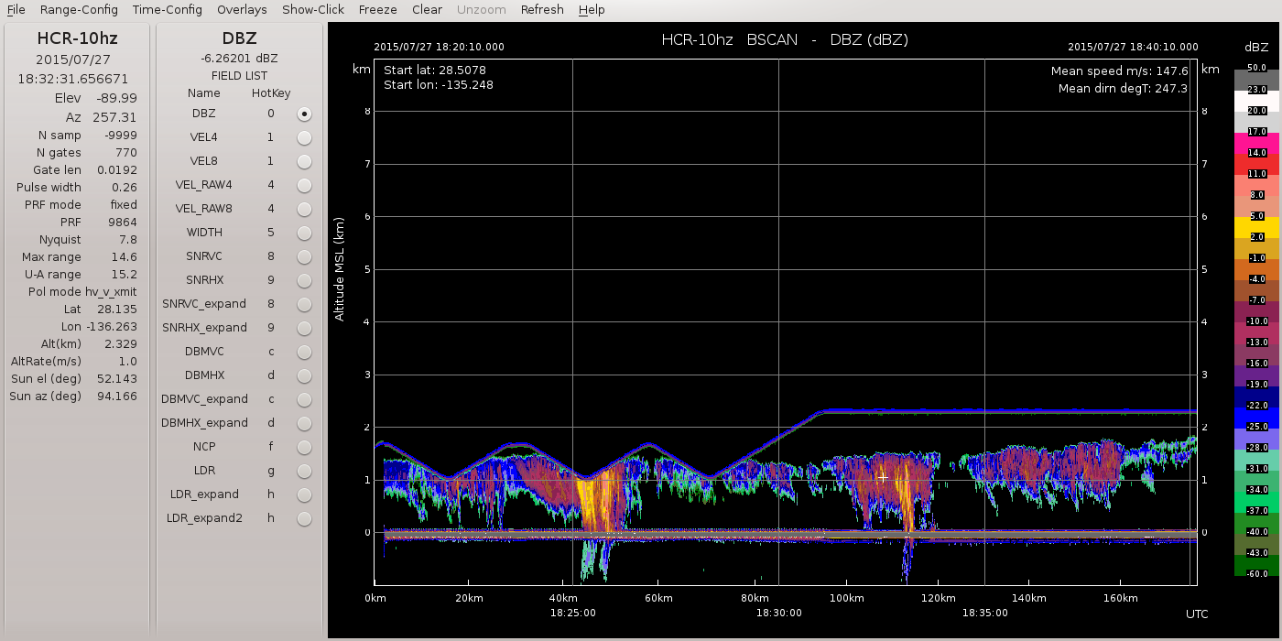

1. HawkEye main window

Figure 1 shows the main HawkEye window. It comprises the following:

* A menu bar at the top of the frame.
* A time and location panel at the left.
* The field menu between the time/location panel and the main plot window.
* The main plot window to the right.

# Main menu bar



1. Main menu in top bar

Table 1 below describes the functions in the main menu bar:

| **Label** | **Description** |
| --- | --- |
| File | 1. Save Image: save the current image to the location listed in the parameter file. 2. Exit: terminate the application. |
| Range-Config | Launch the range configuration panel (see section 6). |
| Time-Config | Launch the time configuration panel (see section 7). |
| Overlays | Allows you to select/deselect each overlay, as follows:   * Range grid: regular grid in the range dimension. * Time grid: regular grid in the time dimension. * Instrument ht line: the line showing the height of the instrument at each time. * Starting lat/lon legend: the legend at the top left of the plot window, showing the starting location in latitude/longitude. * Mean speed/track legend: the legend at the top right of the plot window, showing the mean aircraft speed and direction for the time of the plot. * Distance scale: if selected a secondary distance scale will appear below the plot along with the time. |
| Show Click | Launch the panel which shows the data at the click point (see section 8). |
| Freeze/Unfreeze | Freeze or Unfreeze the display. After you click Freeze, the menu label will change to Unfreeze. |
| Clear | Clear the main plot window. |
| Unzoom | Return to the full unzoomed state. |
| Refresh | Re-request the data, and replot. |
| Help | Provide help. |

Table1: Main menu bar entries

# The time and location panel, and Field List menu

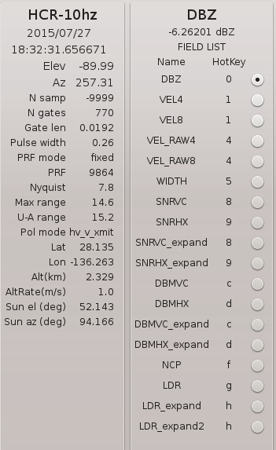

1. Information panel and FIELD LIST Menu

## Time and location panel

The left-most panel displays the time, location and pointing details, as well information on the aircraft motion and sun location.

This is a passive panel – there are no input options.

## Field selection panel

The FIELD LIST menu allows you to select the field to be displayed.

The Raw fields show unfiltered data.

The Filt fields show the same fields, but with some filtering applied to reduce the presence of noise.

After you have picked a field, you can navigate around the field menu using the arrow keys.

You can also use the HotKey list to select a field using the indicated key stroke.

If you click on a data pixel in the main window, the data value at the click point will appear just below the field name and above the FIELD LIST label.

# Main plot window

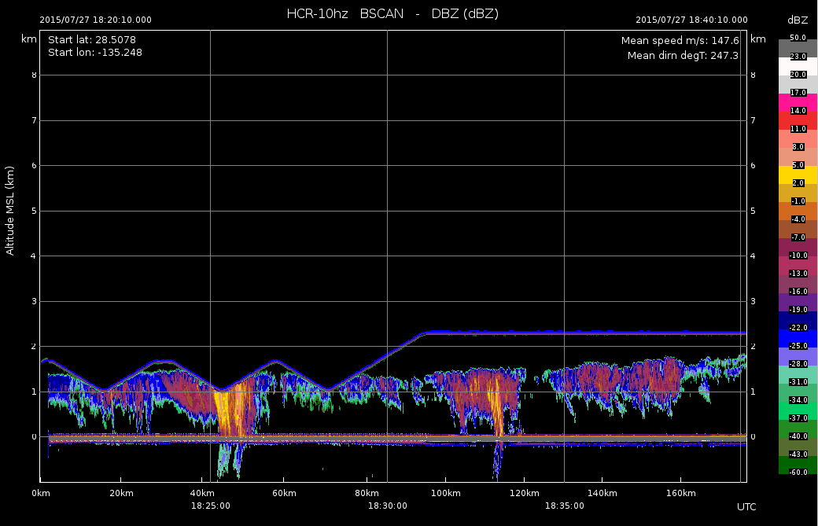

1. Main plot window

The main plot window shows the current data field.

The horizontal axis shows time (and optionally distance). The vertical axis shows height MSL, or range from the instrument.

The color scale appears at the right.

The location, speed and direction information appears in legends at the top left and top right.

In real-time mode the plotted data scrolls across the window and shifts back along the time axis when the plot is full.

The following actions apply to the plot window:

* zooming: you zoom by dragging a rectangle with the left mouse button. You can repeat the zoom action on a zoomed window.
* Unzoom: use the button in the main menu at the top.
* viewing data values: click on any data point. The value will appear above the Field List menu, in the field menu panel. Also, if you select the Show-Click option in the menu panel, the values of all of the fields will appear in the Click Point Data panel (see section 8 below).
* moving in time: in archive mode, click in the data area and then use the left and right arrow keys to navigate back and forward in time.

# Range configuration panel

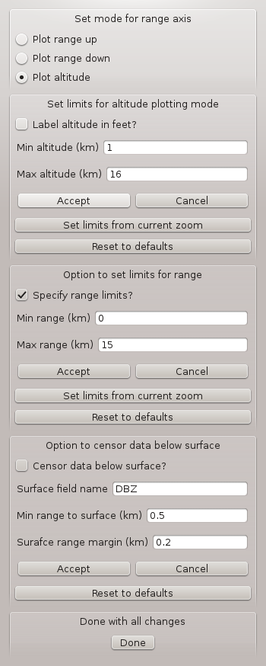

1. Range configuration panel

The Range configuration panel will pop up if you click the Range-Config menu button in the top bar.

## Range modes

* Plot range up: plot range away from the instrument, with range increasing upwards
* Plot range down: plot range away from instrument, with range increasing downwards
* Plot altitude: plot altitude of data, with altitude increasing upwards

## Set limits for altitude plotting mode

* set Min altitude and Max altitude to be displayed, then hit Accept.
* to set the min and max from the currently displayed window, hit Set limits from current zoom.
* you can also Reset to the defaults – the original settings.
* you can check Label altitude in feet to use feet instead of km for the labels.

## Set limits for range plotting mode

* set Min range and Max range to be displayed, then hit Accept.
* to set the min and max from the currently displayed window, hit Set limits from current zoom.
* you can also Reset to the defaults – the original settings.

## Censor the data below the surface

* you can censor the data below the surface, in altitude mode.
* to activate check Censor data below surface.
* the range to the surface is determined by examining the data in a specified field. This should normally be set to DBZ.
* Min range to surface and Surface range margin are parameters used to detect the surface. The default values are usually OK.

# Time configuration panel

The time configuration panel pops up when you hit the Time-Config button in the top menu.

## Realtime mode

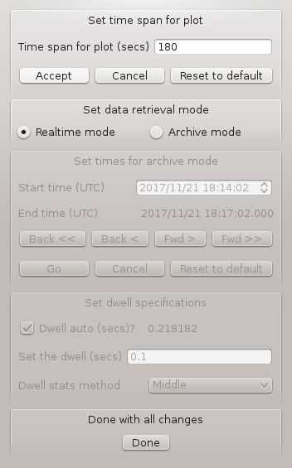

1. Time configuration menu in realtime mode

In Realtime mode, the data scrolls across the main window as time passes.

You can select the width of the plot, in seconds, using Time span for plot.

## Archive mode

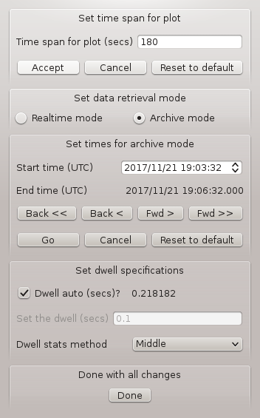

1. Time configuration menu in archive mode

To change to archive mode, select Archive mode in the Set data retrieval mode section of the panel.

Then set the desired start time, in UTC, and then hit Go.

To change the Start time, hover over any of the digits and use the mouse wheel to increase or decrease the value. You can also select the text for each item (year, month etc.) by dragging or double-clicking, and then type in the desired value.

The End time will follow the Start time, lagged by the Time span for plot.

Remember to click Go to activate the new time.

The Back< and Fwd> buttons move the time back and forward by a single plot width. You can click these any number of times to navigate to the desired time. Then hit Go.

The Back<< and Fwd>> buttons move back and forward by 5 times the Time span for plot.

Once in Archive mode, if you click in the main window, you can then use the left and right arrow keys to move back or forward by one plot width in time.

The Set dwell specifications menu allows you to specify the dwell width – i.e. the time period associated with each ray. The Dwell auto function computes this from the width of the plot in seconds, and the number of pixels across the plot. You can override this manually by unclicking the Dwell auto check box.

The Dwell stats method allows you to choose the method for combining multiple dwells into a single dwell as appropriate. The options are Mean, Median, Maximum, Minimum and Middle. The quickest response will be Middle, which simply selects the center dwell in the target dwell time period.

# Show click option

If you select Show-Click in the top menu bar, the CLICK POINT DATA panel will appear.

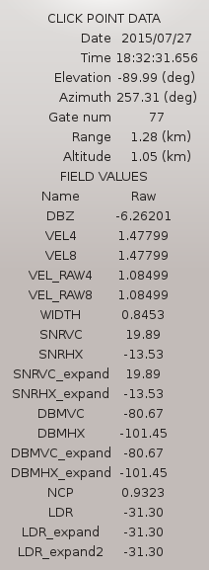

1. Click Point Data Panel

When you click on a data point in the main plot window, this panel displays the values for all of the fields for that location.