AXI4-Stream DDR4 SDRAM to DAC Waveform Generator IP Type 2

Pentek’s Navigator AXI4-Stream DDR4 SDRAM to DAC Waveform Generator Core Type-2 acts as a bridge between the Xilinx DDR4 SDRAM memory and a Digital to Analog Converter in the user design. This core converts the DDR4 SDRAM data received from read requests into AXI4-Streams to be used by the DAC in the user design. This core operates using a linked-list methodology with up to 128 link descriptors to define trigger length, trigger delay, and DDR4 address range.

This core complies with the ARM AMBA AXI4 Specification. This user manual defines the hardware interface, software interface, and parameterization options for the AXI4-Stream DDR4 SDRAM to DAC Waveform Generator Core Type-2.

This version (px_axis_ddr2wave_2) of the core has a 64-bit data output which is comprised of two 32-bit data samples - the first sample will be on the upper 32 bits, the second sample will be on the lower 32 bits.

Features
- Linked-list descriptors allow programming of trigger behavior and DDR4 address range to retrieve the DAC waveform
- Operates in trigger or gate mode
- 128 link descriptors, can be modified during operation
- Interrupts notify of start and end of acquisition and also start and end of link descriptor execution
- Compatible with Pentek’s DDR4 AXI4-Stream request and response bus definitions
- Status of present link descriptor number is accessible over the AXI4-Lite Control/Status Register Bus.

- Overview

  - Functional Description

The AXI4-Stream DDR4 SDRAM to DAC Waveform Generator Core Type-2 provides a transaction interface between the DDR4 SDRAM Memory and a DAC in the user design.
This core generates DDR4 read requests and accepts the DDR4 read responses which are converted into AXI4-Streams to be used by the DAC. The output AXI4-Streams generated by the core include sample data with time-aligned copy of timing events (gate, sync, and PPS), and data information.

A unique requester ID identifying the DDR4 request data streams can be defined by the user through the generic parameter id (see Section 2.5). This allows multiple requestors to access the same DDR4 memory. This core uses linked list methodology with up to 128 link descriptors to define the trigger length, trigger delay, and DDR4 memory address range. This core stores link descriptors in an internal RAM. This Link List Descriptor RAM can be accessed and set up by an AXI Master in the user design through an AXI4-Lite Interface.

The DAC Waveform Generator Core Type-2 receives timing event data streams from the user design which are used to generate the data acquisition gate signal to control the data flow. The gate signal is generated based on the mode select bits defined in the Mode Control Register of the core (see Section 4.1). The DAC Waveform Generator Core Type-2 can operate in three modes, where each mode defines the source of the data acquisition gate signal.

• Gate mode: The data acquisition gate signal is generated from the input gate signal from the timing event data streams. Users can define a gate signal by enabling the local gate mode in the Mode Control Register, and then defining the local gate bit (see Table 4-2).

• Trigger mode: The gate input signal is used as a trigger to generate a data acquisition gate signal which has a trigger delay and trigger length defined by the control registers in the Register Space (see Chapter 4).

• Trigger Hold mode: The gate input signal is used as a trigger to generate a data acquisition gate signal which remains active until the Trigger Control State Machine is reset.
The DAC Waveform Generator Core Type-2 has a Trigger Control State Machine which is used to generate the packetized data output for the acquisition gate period. The Mode Control Register is used to control the Trigger Control State Machine (see Table 4-2). This core also supports auto increment of the DDR4 memory address, after being set once, for contiguous read requests.

Figure 1-1 is a top-level block diagram of the AXI4-Stream DDR4 SDRAM to DAC
Waveform Generator Core Type-2. The modules within the block diagram are explained in other sections of this manual.

Figure 1-1: Pentek AXI4-Stream DDR4 SDRAM to DAC Waveform Generator Core Type-2

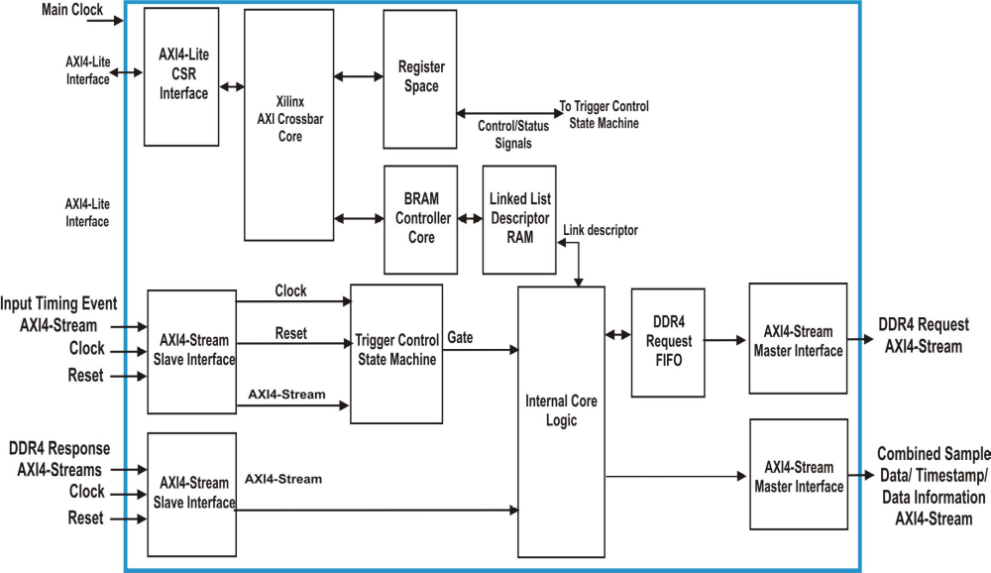

  AXI4-Lite Interface: This module implements a 32-bit AXI4-Lite Slave Interface to receive the memory read/write requests and also access the register space. For more details about the AXI4-Lite Interface, refer to Section 3.1 AXI4-Lite Core Interfaces.

❑ AXI4-Stream Interfaces: The AXI4-Stream DDR4 SDRAM to DAC Waveform
Generator Core has AXI4-Stream Interfaces to transfer requests and receive responses to/from the DDR4 SDRAM Memory Controller IP Core. This core also has AXI4-Stream Interfaces to receive timing event data streams and also to transfer the generated output AXI data streams. For more details about the AXI4-Stream Interfaces, refer to Section 3.2 AXI4-Stream Core Interfaces.

❑ Register Space: This module contains control and status registers including Interrupt Enable, Interrupt Flag, and Interrupt Status registers. Registers are accessed through the AXI4-Lite Interface.

❑ AXI4-Lite BRAM Controller Core: This is the Pentek AXI4-Lite BRAM Controller Core which is connected to the AXI4-Lite Interface to communicate with the Linked-List RAM within the DAC Waveform Generator Core Type-2.

❑ Linked List Descriptor RAM: This is a Xilinx Dual Port Block RAM generated to store up to 128 link descriptors.

❑ DDR4 Request FIFO: This is a clock crossing AXI4-Stream FIFO used to convert the DDR4 request AXI4-Streams from the AXI4-Stream clock domain to the DDR4 clock domain.

❑ Trigger Control State Machine: This state machine is used generate packed output data streams based on the acquisition gate, and the values defined in the Mode
Control Register. This state machine has three states:

• Reset - The Reset state resets the state machine based on the input reset signal (s_axis_aresetn) from the input AXI4-Stream Slave Interface.

• Wait for Trigger Arm - When the state machine is in the Wait for Arm state, it waits for the trigger arm signal, from the Mode Control Register, to go High.

• Armed - Once in the Armed State, the core waits for the data acquisition gate signal to go High when a valid input is available on the input AXI4-Stream
Slave Interface. When the acquisition gate signal goes High, output packed data streams are generated based on the data mode selected.

  - Applications

This core can be incorporated into any Kintex Ultrascale FPGA to generate AXI4-Stream waveform data from the DDR4 SDRAM data, to be transferred to a DAC in the user design.

  - System Requirements

For a list of system requirements, see the Vivado Design Suite Release Notes.

  - Licensing and Ordering Information

This core is included with all Pentek Navigator FPGA Design Kits for Pentek Jade series board products. Contact Pentek for Licensing and Ordering Information (www.pentek.com).

  - Contacting Technical Support

Technical Support for Pentek’s Navigator FPGA Design Kits is available via e-mail (fpgasupport@pentek.com) or by phone (201-818-5900 ext. 238, 9 am to 5 pm EST).

  - Documentation
      - Vivado Design Suite User Guide: Designing with IP
      - Vivado Design Suite User Guide: Programming and Debugging
      - ARM AMBA AXI4 Protocol Version 2.0 Specification

- General Product Specifications

  - Standards

The AXI4-Stream DDR4 SDRAM to DAC Waveform Generator Core Type-2 has bus interfaces that comply with the AMBA AXI4-Lite Protocol Specification and the AMBA AXI4-Stream Protocol Specification.

  - Performance

The performance of the AXI4-Stream DDR4 SDRAM to DAC Waveform Generator Core Type-2 is limited only by the FPGA logic speed. The values presented in this section should be used as an estimation guideline. Actual performance can vary.

    - Maximum Frequencies

This core is designed to meet a target frequency of 250 MHz on a Kintex Ultrascale -2 speed grade FPGA. 250 MHz is typically the PCI Express (PCIe) AXI Bus clock frequency.

  - Resource Utilization

The resource utilization of the AXI4-Stream DDR4 SDRAM to DAC Waveform Generator Core Type-2 is shown in Table 2-1. Resources have been estimated for the Kintex Ultra-scale XCKU060 -2 speed grade device. These values were generated using the Vivado Design Suite.

Table 2-1: Resource Usage and Availability
Resources | # Used
LUTs | 1,327
Memory LUTs | 89
Flip-Flops | 4,317
Block Ram | 26.5
DSP | 2
NOTE: Actual utilization may vary based on the user design in which the AXI4-Stream DDR4 SDRAM to DAC Waveform Generator Core Type-2 is incorporated.

  - Limitations and Unsupported Features

This section is not applicable to this IP core.

  - Generic Parameters

The generic parameter of the AXI4-Stream DDR4 SDRAM to DAC Waveform Generator Core Type-2 is described in Table 2-2. This parameter can be set as required by the user application while customizing the core.

Table 2-2: Generic Parameters
Port/Signal Name | Type | Description
id | Integer | Requester ID: The user can define a unique ID to identify the data streams through this generic parameter. It can range from 0 - 255. This requester ID is used by the Pentek DDR4 memory interface to identify the source of the memory access requests. It must be unique in a system for all cores that have access to the DDR4 memory. It is the only way that the requested data can be routed back to the correct requester.

- Port Descriptions

This chapter provides details about the port descriptions for the following interface type:

• AXI4-Lite Core Interfaces

• AXI4-Stream Core Interfaces

• I/O Signals

  - AXI4-Lite Core Interfaces

The AXI4-Stream DDR4 SDRAM to DAC Waveform Generator Core Type-2 has the following AXI4-Lite interface which is used to receive memory read/ write requests from the user design.

    - AXI4-Lite Core Interface

The AXI4-Stream DDR4 SDRAM to DAC Waveform Generator Core Type-2 has the following AXI4-Lite interface which is used to receive memory read/ write requests from the user design…

Table 3-1 defines the ports in the AXI4-Lite Slave Interface. The AXI4-Lite
Interface is connected to a Xilinx AXI Crossbar Core within the core which creates two master interfaces from the single slave interface. One of these master interfaces is used to access the Register Space while the other is used to access the Linked List Descriptor RAM. See the AMBA AXI4-Lite Specification for more details on the AXI4-Lite interface.

- AXI4-Lite Slave Interface Port Descriptions0000.doc
Port | Direction | Width | Description
s_axi_aclk | Input | 1 | Clock
s_axi_aresetn | Input | 1 | Reset: Active low. This will reset the state machine within the core.
s_axi_csr_awaddr | Input | 12 | Write Address: Address used for write operations. It must be valid when s_axi_csr_awvalid is asserted and must be held until s_axi_csr_awready is asserted by the DAC Waveform Generator Core Type-2.
s_axi_csr_awprot | Input | 3 | Protection: The DAC Waveform Generator Core Type-2 ignores these bits.
s_axi_csr_awvalid | Input | 1 | Write Address Valid: This input must be asserted to indicate that a valid write address is available on s_axi_csr_awaddr. The DAC Waveform Generator Core Type-2 asserts s_axi_csr_awready when it is ready to accept the address. The s_axi_csr_awvalid must remain asserted until the rising clock edge after the assertion of s_axi_csr_awready.
s_axi_csr_awready | Output | 1 | Write Address Ready: This output is asserted by the DAC Waveform Generator Core Type-2 when it is ready to accept the write address.The address is latched when s_axi_csr_awvalid and s_axi_csr_awready are high on the same cycle.
s_axi_csr_wdata | Input | 32 | Write Data: This data will be written to the address specified by s_axi_csr_awaddr when s_axi_csr_wvalid and s_axi_csr _wready are both asserted. The value must be valid when s_axi_csr_wvalid is asserted and held until s_axi_csr_wready is also asserted.
s_axi_csr_wstrb | Input | 4 | Write Strobes: This signal, when asserted, indicates the number of bytes of valid data on the s_axi_csr_wdata signal. Each of these bits, when asserted, indicate that the corresponding byte of s_axi_csr_wdata contains valid data. Bit 0 corresponds to the least significant byte, and bit 3 to the most significant.
s_axi_csr_wvalid | Input | 1 | Write Valid: This signal must be asserted to indicate that the write data is valid for a write operation. The value on s_axi_csr _wdata is written into the register at address s_axi_csr_awaddr when s_axi_csr_wready and s_axi_csr_wvalid are high on the same cycle.
s_axi_csr_wready | Output | 1 | Write Ready: This signal is asserted by the DAC Waveform  Generator Core when it is ready to accept data. The value on s_axi_csr_wdata is written into the register at address s_axi_csr_awaddr when s_axi_csr_wready and s_axi_csr_wvalid are high on the same cycle, assuming that the address has already or simultaneously been submitted.
s_axi_csr_bresp | Output | 2 | Write Response: The DAC Waveform Generator Core Type-2  indicates success or failure of a write transaction through this signal, which is valid when s_axi_csr_bvalid is asserted;  00 = Success of normal access  01 = Success of exclusive access  10 = Slave Error  11 = Decode Error  Note: For more details about this signal refer to the AMBA AXI Specification.
s_axi_csr_bready | Input | 1 | Write Response Ready: This signal must be asserted by the user logic when it is ready to accept the Write Response.
s_axi_csr_bvalid | Output | 1 | Write Response Valid: This signal is asserted by the DAC Waveform Generator Core Type-2 when the write operation is complete and the Write Response is valid. It is held until s_axi_csr_bready is asserted by the user logic.
s_axi_csr_araddr | Input | 12 | Read Address: Address used for read operations. It must be valid when s_axi_csr_arvalid is asserted and must be held until s_axi_csr_arready is asserted by the DAC Waveform Generator Core Type-2.
s_axi_csr_arprot | Input | 3 | Protection: These bits are ignored by the DAC Waveform Generator Core Type-2.
s_axi_csr_arvalid | Input | 1 | Read Address Valid: This input must be asserted to indicate that a valid read address is available on the s_axi_csr_araddr. The DAC Waveform Generator Core Type-2 asserts s_axi_csr_arready when it is ready to accept the Read Address. This input must remain asserted until the rising clock edge after the assertion of s_axi_csr_arready.
s_axi_csr_arready | Output | 1 | Read Address Ready: This output is asserted by the DAC Waveform Generator Core Type-2 when it is ready to accept the read address. The address is latched when s_axi_csr_arvalid and s_axi_csr_arready are high on the same cycle.
s_axi_csr_rdata | Output | 32 | Read Data: This value is the data read from the address specified by the s_axi_csr_araddr when s_axi_csr_arvalid and s_axi_csr_arready are High on the same cycle.
s_axi_csr_rresp | Output | 2 | Read Response: The DAC Waveform Generator Core Type-2 indicates success or failure of a read transaction through this signal, which is valid when s_axi_csr_rvalid is asserted;  00 = Success of normal access  01 = Success of exclusive access  10 = Slave Error  11 = Decode Error  Note: For more details about this signal refer to the AMBA AXI Specification.
s_axi_csr_rvalid | Output | 1 | Read Data Valid: This signal is asserted by the DAC Waveform Generator Core Type-2 when the read is complete and the read data is available on the s_axi_csr_rdata. It is held until s_axi_csr_rready is asserted by the user logic.
s_axi_csr_rready | Input | 1 | Read Data Ready: This signal is asserted by the user logic when it is ready to accept the Read Data.
irq | Output | 1 | Interrupt: This is an active high, edge-type interrupt output.

  - 3.2 AXI4-Stream Core Interfaces

The AXI4-Stream DDR4 SDRAM to DAC Waveform Generator Core Type-2 has the following AXI4-Stream Interfaces, used to receive and transfer data streams:

- DDR4 Request (RQST) Interface: This core has a DDR4 Memory Request AXI4-Stream Interface at the output of the core to transfer the generated memory read requests.

- DDR4 Response (RSP) Interface: This core has a DDR4 Memory Response AXI4-Stream Interface at the input of the core to receive response data streams from the DDR4 Memory Controller core.

- Timing Events (PTCTL) Interface: This is an AXI4-Stream Slave Interface through which timing event data streams are received by the core from the user design.

- Combined Sample Data/ Timestamp/ Information Stream (PDTI) Interface: This is an AXI4-Stream Master Interface of the core used to transfer AXI4-Streams in the PDTI format.

    - 3.2.1 DDR4 Request (RQST) Interface

The AXI4-Stream DDR4 SDRAM to DAC Waveform Generator Core Type-2 implements an DDR4 Request Interface across the output to transfer DDR4 SDRAM memory read request data streams. This is an AXI4-Stream Master Interface. Table 3-2 defines the ports in the AXI4-Stream Master Request Interface. See the AMBA AXI4-Stream Protocol Specification for more details on the operation of the AXI4-Stream Interface.

Table 3-2: DDR4 Request Interface Port Descriptions0000.doc
Port | Direction | Width | Description
m_axis_ddr_aclk | Input | 1 | DDR4 SDRAM Clock
m_axis_ddr_rqst_tdata | Output | 512 | Request Data Bus: This is the DDR4 Memory Request data. For read requests it is not used.
m_axis_ddr_rqst_tvalid | Output | 1 | Request Data Valid: Asserted when data is valid on m_axis_ddr_rqst_tdata. The user application can pace the data transfer using the m_axis_ddr_rqst_tready signal.
m_axis_ddr_rqst_tuser | Output | 256 | Request User Data: This is the sideband user information data which contains the DDR4 memory request packet header. Table 3-5 includes the bit definitions of the bits tuser[256:0].
m_axis_ddr_rqst_tlast | Output | 1 | Request Data Last: Since all request frames are single cycle in length, this tlast signal is asserted on every valid data cycle. It is provided mainly to allow arbitration in AXI Stream switches to use it to arbitrate on tlast.
m_axis_ddr_rqst_tid | Output | 8 | Request Data Stream Identifier: This is the unique data stream identifier specified by the user using the generic parameter id.
m_axis_ddr_rqst_tready | Input | 1 | Request Data Ready: Activation of this signal by the user logic indicates that the user logic is ready to accept data. Data is transferred across the interface when both m_axis_ddr_rqst _tvalid and m_axis_ddr_rqst_tready are asserted in the same cycle. If the user application deasserts the ready signal when m_axis_ddr_rqst_tvalid is asserted, the core maintains the data on the bus and keeps the valid signal asserted until the user application has asserted the ready signal.

Table 3-3 shows the bit definitions of the DDR4 Request User Data (m_axis_ddr_rqst_tuser).

Table 3-3: DDR4 Request User Data Bit Definitions0000.doc
Bit Index | Name | Width | Description
255:128 | DATA | 128 | RAM Data: These bits carry the upper 128 bits of RAM data to be written to the address location in the DDR4 SDRAM. Note: The DDR4 memory bus is 640 bit wide. These 128 bits are the upper bit [639:512].
127:120 | RES | 8 | Reserved
119:40 | MSK | 80 | Byte Mask: These bits indicate the byte masks of the data which indicate the data on the data bus to be masked. During write requests, bytes with mask bits set to ‘1’ will not be written.
39:36 | RES | 4 | Reserved
35 | OP | 1 | Type of Request: This bit indicates the type of Memory request. 0 = Write; 1 = Read
34:32 | ADDRE | 3 | Future Address Expansion: These bits indicate the address expansion of the DDR4 SDRAM memory location.
31:0 | ADDR | 32 | DDR4 Memory Address: This is the address location in the DDR4 SDRAM where the read/ write operation is to be performed. The address must be aligned to request size boundaries of 64 bytes.

    - 3.2.2 DDR4 Response (RSP) Interface

The AXI4-Stream DDR4 SDRAM to DAC Waveform Generator Core Type-2 implements a DDR4 Response Interface across the input to receive response data streams. This is an AXI4-Stream Slave Interface. Table 3-4 defines the ports in the AXI4-Stream Slave DDR4 Response Interface. See the AMBA AXI4-Stream Protocol Specification for more details on the operation of the AXI4-Stream Interface.

Table 3-4: DDR4 Response Interface Port Descriptions0000.doc
Port | Direction | Width | Description
s_axis_ddr_rsp_tdata | Input | 512 | Response Data Bus: This is the Response data received from the DDR memory in response to a DDR4 memory read request.
s_axis_ddr_rsp_tvalid | Input | 1 | Response Data Valid: Asserted when data is valid on s_axis_rsp_tdata. This bus cannot be throttled and there is no tready output from the core. The core must be ready to accept data if it requested it.
s_axis_ddr_rsp_tuser | Input | 256 | Request User Data: This is the sideband user information data which contains the DDR4 response packet header. Table 3-5 defines the bit definitions of the bits tuser[255:0].
s_axis_ddr_rsp_tlast | Input | 1 | Request Data Last: Since all request frames are single cycle in length, this tlast signal is asserted on every valid data cycle. It is provided mainly to allow arbitration in AXI Stream switches to use it to arbitrate on tlast.
s_axis_ddr_rsp_tid | Input | 8 | Response Data Stream Identifier: This is the unique data stream identifier specified by the user in the request which indicates the request corresponding to the response.

Table 3-5 shows the bit definitions of the DDR4 Response User Data (m_axis_ddr_rsp_tuser).

Table 3-5: DDR4 Response User Data Bit Definitions0000.doc
Bit Index | Name | Width | Description
255:128 | DATA | 128 | RAM Data: These bits carry the upper 128 bits of RAM data being received from the address location in the DDR4 SDRAM. Bits: [639:512]
127:120 | RES | 8 | Reserved
119:40 | MSK | 80 | Byte Masks: These bits indicate the byte masks of the data on the data bus to be masked. This information is echoed back from the request.
39:35 | RES | 4 | Reserved
34:32 | ADDRE | 3 | Future Address Expansion: These bits indicate the address expansion of the DDR4 SDRAM memory location.
31:0 | ADDR | 32 | DDR4 Memory Address: This is the address location in the DDR4 SDRAM where the read/ write operation is to be performed. The address must be aligned to request size boundaries of 64 bytes.

    - 3.2.3 Timing Events (PTCTL) Interface

Table 3-6 defines the ports in the Timing Events Interface. This interface is an
AXI4-Stream Slave Interface that is used to receive timing events data streams from the user design. See the AMBA AXI4-Stream Specification for more details on the operation of the AXI4-Stream Interface.

Table 3-6: Timing Events Interface Port Descriptions0000.doc
Port | Direction | Width | Description
s_axis_pctl_tdata | Input | 8 | Timing Event Input Data: This is the timing event data which indicates the gate, sync and PPS signal positions.  tdata[0] - Gate  tdata[1] – Sync  tdata[2] - PPS
s_axis_pctl_tvalid | Input | 1 | Data Valid: Asserted when data is valid on s_axis_pctl_tdata.

    - 3.2.4 Combined Sample Data/ Timestamp/ Information Streams (PDTI) Interface

The Pentek Jade series board products have AXI4-Streams that follow a combined Sample Data/ Timestamp/ Information Stream (PDTI) format. This type of data stream combines sample data with its time-aligned timing events (Gate, Sync, and PPS) and data information. There is an AXI4-Stream Master Interface across the output to transfer AXI4-Streams in the PDTI format. Table 3-7 defines the ports in the AXI4-Stream Slave Combined Sample Data/ Timestamp/ Information Stream Interface. See the AMBA AXI4-Stream Specification for more details on the operation of the AXI4-Stream Interface.

Table 3-7: Combined Sample Data/Timestamp/Information Streams Interface Port Descriptions0000.doc
Port | Direction | Width | Description
s_axis_aclk | Input | 1 | AXI4-Stream Clock
s_axis_aresetn | Input | 1 | Reset: Active Low.
m_axis_pdti_tdata | Output | 64 | Output DAC Waveform Data: This core generates output data having only single-sample-per-cycle data streams with either two 16-bit real data values, or 16-bit I/Q packed data.
m_axis_pdti_tvalid | Output | 1 | Input Data Valid: Asserted when data is valid on  s_axis_pdti_tdata.
m_axis_pdti_tuser | Output | 128 | Sideband Information: This is the user-defined sideband information received alongside the data stream.  tuser [63:0] - Timestamp[63:0]  tuser [71:64] - Gate Positions  tuser [79:72] - Sync Positions  tuser [87:80] - PPS Positions  tuser [91:88] - Samples per clock cycle  tuser[92] - I/Q data of the sample => 0 = I ; 1 = Q  tuser [94:93] - Data Format => 0 = 8-bit; 1 = 16-bit;  2 = 24-bit; 3 = 32-bit  tuser [95] - Data Type => 0 = Real; 1 = I/Q  tuser [103:96] - channel [7:0]  tuser [127:104] - Reserved  Note: The bits [103:96] define the channel number in the user design from where the data is being received.

  - I/O Signals

The I/O port/signal descriptions of the top level module of the AXI4-Stream DDR4
SDRAM to DAC Waveform Generator Core Type-2 are discussed in Table 3-8.

Table 3-7: Combined Sample Data/Timestamp/Information Streams Interface Port Descriptions0000.doc
Port/Signal Name | Type | Direction | Description
realtime_lost | std_logic | Output | Real Time Lost: This output signal is asserted (set to ‘1’) when the gate signal is active and the output DDR4 request FIFO is empty. When this occurs the DAC Waveform Generator Core Type-2 will have discontinuous output data, and will result in losing real time.

- Register Space

This chapter provides the memory map and register descriptions for the Register Space of the AXI4-Stream DDR4 SDRAM to DAC Waveform Generator Core Type-2. The memory map is provided in Table 4-1.

- Register Space Memory Map
Register Name | Base Address (Base Address +) | Access | Description
Mode Control | 0x00 | R/W | Controls the mode select, data mode select, and trigger state machine arm signals
Trigger Clear | 0x04 | R/W | Controls the clear and disarm signals of the Trigger Control State Machine
Linked List Start | 0x08 | R/W | Controls the loading of the linked list descriptor start index
Linked List Start Index | 0x0C | R/W | Holds the index of the linked list descriptor to start execution
FIFO Flush | 0x10 | R/W | Controls the reset of the output FIFO and the DDR4 request FIFO
Output Rate Divider | 0x14 | R/W | Control the output data rate
Output Gate Delay | 0x18 | R/W | Control the output gate delay
Reserved | 0x1C | N/A | Reserved
Status Register | 0x20 | R | Indicates the status of the Trigger Control State Machine, and the mode of operation of the core
Current Link Index | 0x24 | R | Indicates the index of the current link descriptor being executed and the next link descriptor
Reserved | 0x28 | N/A | Reserved
Reserved | 0x2C | N/A | Reserved
Reserved | 0x30 | N/A | Reserved
Interrupt Enable | 0x34 | R/W | Interrupt enable bits
Interrupt Status | 0x38 | R | Interrupt status bits
Interrupt Flags | 0x3C | R/Clr | Interrupt flag bits.

******** The register descriptions are identical to the ones for the ******** ******** px_axis_ddr2wave_1, so use the existing text, figures and ********
******** tables for this version. ********

- : Linked List Descriptor RAM Memory Maps

******** The Linked List Descriptor RAM Memory Maps are identical ********
******** to the ones for the px_axis_ddr2wave_1, so use the existing text ********
******** and tables for this version. ********

- Designing with the Core

This chapter includes guidelines and additional information to facilitate designing with
the AXI4-Stream DDR4 SDRAM to DAC Waveform Generator Core Type-2.

  - General Design Guidelines
The AXI4-Stream DDR4 SDRAM to DAC Waveform Generator Core Type-2 is used to generate read requests to the DDR4 SDRAM and also generate output DAC data streams from the DDR4 responses.

  - Clocking

Main Clock: s_axis_aclk
This clock is used to clock all the AXI4-Stream ports on the core.

CSR Clock: s_axi_csr_aclk
This clock is used to clock CSR Interface ports of the core.

DDR4 SDRAM Clock: m_axis_ddr_aclk
This is used to clock the DDR4 SDRAM Interface of the DAC Waveform Generator Core Type-2 and should be the same clock used by the DDR4 interface.

  - Resets

CSR Reset: s_axi_csr_aresetn
This is active low synchronous reset associated with the s_axi_csr_aclk.

Reset: s_axis_aresetn
This is active low synchronous reset associated with the s_axis_aclk.

  - Interrupts

This core has an edge type (rising edge-triggered) interrupt output, which is synchronous with the s_axi_csr_aclk. On the rising edge of any interrupt signal, a one clock cycle wide pulse is output from the core on the irq output. Each interrupt event is stored in two registers, accessible on the s_axi_csr bus. The Interrupt Status Register always reflects the current state of the interrupt condition, which may have changed since the generation of the interrupt. The Interrupt Flag Register latches the occurrence of each interrupt, in a bit that retains its state until explicitly cleared. The interrupt flags can be cleared by writing ‘1’ to the associated bit’s location. All interrupt sources that are enabled (via the Interrupt Enable Register) are “OR ed” onto the irq output.

NOTE: All interrupt sources are latched in the Interrupt Flag Register, even when an interrupt source is not enabled (via the Interrupt Enable Register).

NOTE: Because this core uses edge-triggered interrupts, an interrupt condition which remains active after servicing will not cause the generation of a new interrupt. A new interrupt will only be generated by another rising edge on an interrupt source.

  - Interface Operation

AXI4-Lite Interface: This is an AXI4-Lite Slave Interface and is associated with s_axi_csr_aclk. This interfaces to both the Register Space and Linked List Descriptor RAM within the core.

DDR4 Request (RQST) Interface: This is an AXI4-Stream Master Interface used to transfer DDR4 request data streams and is associated with m_axis_ddr_aclk. For more details about this interface, refer to Section 3.2.1.

DDR4 Response (RSP) Interface: This is an AXI4-Stream Slave Interface used to receive DDR4 response data streams for the requests transferred by the core and is associated with m_axis_ddr_aclk. For more details about this interface, refer to Section 3.2.2.

Timing Events (PTCTL) Interface: This is the interface through which timing events such as the gate signal are input. It is associated with s_axis_aclk. For more details about this interface, refer to Section 3.2.3.

Combined Sample Data/ Timestamp/ Information Streams (PDTI) Interface: This core implements an AXI4-Stream Slave interface across the input to receive AXI PDTI streams and is associated with s_axis_aclk. For more details about this interface, refer to Section 3.2.4.

  - Programming Sequence

This section briefly describes the programming sequence for the AXI4-Stream DDR4 SDRAM to DAC Waveform Generator Core TYPE-2.

1) Set the desired values to the control registers.
2) Load the linked list descriptor RAM.
3) Write/waveform into the DDR4 SDRAM.
4) Toggle the link start bit.
5) Apply gate or trigger to the start execution.

  - Timing Diagrams

The timing diagram for the AXI4-Stream DDR4 SDRAM to DAC Waveform Generator Core Type-2, shown in Figure 7-3, is obtained by running the simulation of the test bench of the core in Vivado VSim environment. For more details about the test bench, refer to Section 7.5.

- Design Flow Steps

  - Pentek IP Catalog

This chapter describes customization and generation of the Pentek AXI4-Stream DDR4 SDRAM to DAC Waveform Generator Core Type-2. It also includes simulation, synthesis, and implementation steps that are specific to this IP core. This core can be generated from the Vivado IP Catalog when the Pentek IP Repository has been installed. It will appear in the IP Catalog list as px_axis_ddr2wave_1_v2_0 as shown in Figure 7-1.

Figure 7-1: px_axis_ddr2wave_1_v2_0 in Pentek IP Catalog

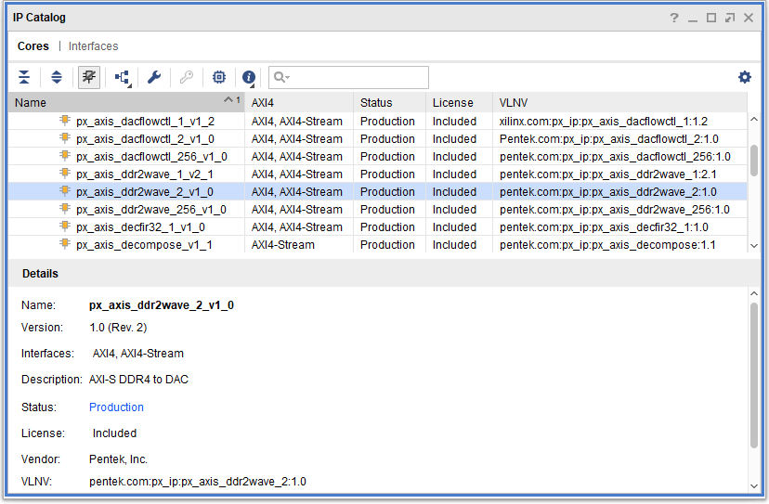

When you select the px_axis_ddr2wave_1_v2_0 core, a screen appears that shows the core’s symbol and the core’s parameters (see Figure 7-2). The core’s symbol is the box on the left side.

Figure 7-2: Pentek px_axis_ddr2wave_1_v2_0 Core IP Symbol

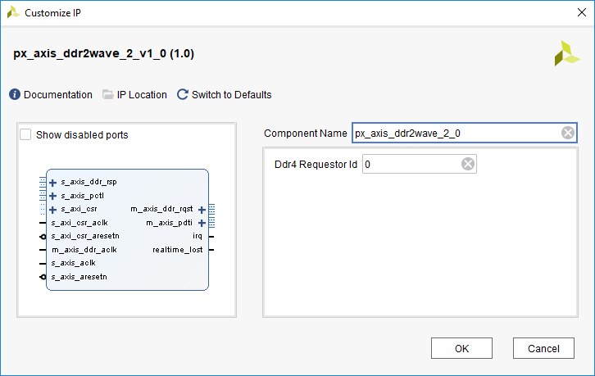

  - User Parameters

For a detailed explanation of the user parameters, refer to Section 2.5.

  - Generating Output

For more details about generating and using IP in the Vivado Design Suite, refer to the Vivado Design Suite User Guide - Designing with IP.

  - Constraining the Core

This section contains information about constraining the core in Vivado Design Suite environment.

Required Constraints

The XDC constraints are not provided with this core. The necessary constraints can be applied in the top level module of the user design.

Device, Package, and Speed Grade Selections

This IP works for the Kintex Ultrascale and Virtex-7 FPGAs.

Clock Frequencies
The clock frequency (s_axi_csr_aclk) for this IP core is 250 MHz.

Clock Management

This section is not applicable for this IP core.

Clock Placement

This section is not applicable for this IP core.

Banking and Placement

This section is not applicable for this IP core.

Transceiver Placement

This section is not applicable for this IP core.

I/O Standard and Placement

This section is not applicable for this IP core.

  - Simulation

The AXI4-Stream DDR4 SDRAM to DAC Waveform Generator Core has a test bench which generates the output waveforms using the Vivado VSim environment. The test bench is designed to run at 250 MHz CSR clock frequency, 200 MHz AXI4-Stream clock frequency and 333 MHz DDR4 SDRAM clock frequency.

The test bench sets the requester ID to 0. The control registers in the Register Space of the DAC Waveform Generator Core are written to based on the values defined in a test_parameters.txt file. The test parameters file also includes the link descriptors to be loaded into the DDR4 SDRAM, which are written to the core through the AXI4-Lite Interface. The programming sequence of the DMA is the same as described in Section 6.6.

The contents of the test_parameters.txt file along with descriptions of the parameters are provided in Table 7-1.

Table 7-1: Test Parameters File Contents and Parameter Descriptions
Parameter | Type | Value | Description
mode_sel | std_logic_vector | 0x1 | Mode Select: This parameter is used to define  the mode of operation of the core. It defines the  source of the data acquisition gate signal  generated by the core. (See Table 4-2)  0x0 = Gate mode  0x1 = Trigger mode  0x2 = Trigger Hold mode  0x3= Reserved
data_mode_sel | std_logic_vector | 0x1 | Data Mode Select: This parameter defines the  data type of the input data to the DAC Waveform  Generator Core.  0 = Single Sample Real Data  1 = Packed I/Q Data
stay_armed | Boolean | True | Stay Armed: When set to True, the Trigger Control State Machine is held in the armed state.
output_rate_div | std_logic_vector | 0x00000000 | Output Rate Divider: This parameter indicates the rate divider value of the output data.
gate_out_dly | std_logic_vector | 0x40 | Output Gate Delay: This is the output delay to be introduced to the gate signal and other control signals.
trig_space | std_logic_vector | 0x00000140 | Trigger Space: This parameter indicates the space between two triggers in number of clock cycles.
ll_start_addr | std_logic_vector | 0x00000000 | Linked List Start Address
interrupt_enable | std_logic_vector | 0x000001ff | Interrupt Enable: This parameter indicates the interrupt enables for the interrupt sources of the Interrupt Enable register.
link1_descr_word0 | std_logic_vector | 0x00000000 | Link Descriptor 1 Trigger Delay
link1_descr_word1 | std_logic_vector | 0x00000100 | Link Descriptor 1 Trigger Length
link1_descr_word2 | std_logic_vector | 0x80000000 | Link Descriptor 1 DDR4 Start Address
link1_descr_word3 | std_logic_vector | 0x80000000 | Link Descriptor 1 DDR4 End Address
link1_descr_word4 | std_logic_vector | 0x00040001 | Link Descriptor 1 Next Link Address
link2_descr_word0 | std_logic_vector | 0x00000000 | Link Descriptor 2 Trigger Delay
link2_descr_word1 | std_logic_vector | 0x00000020 | Link Descriptor 2 Trigger Length
link2_descr_word2 | std_logic_vector | 0x80000400 | Link Descriptor 2 DDR4 Start Address
link2_descr_word3 | std_logic_vector | 0x90000200 | Link Descriptor 2 DDR4 End Address
link2_descr_word4 | std_logic_vector | 0x00040000 | Link Descriptor 2 Next Link Address

The programming procedure is the same as described in Section 6.6. When run, the simulation produces the results shown in Figure 7-3.
Figure
Figure 7-3: Pentek 33240 FMC Control & Interface Core Test Bench Simulation Output

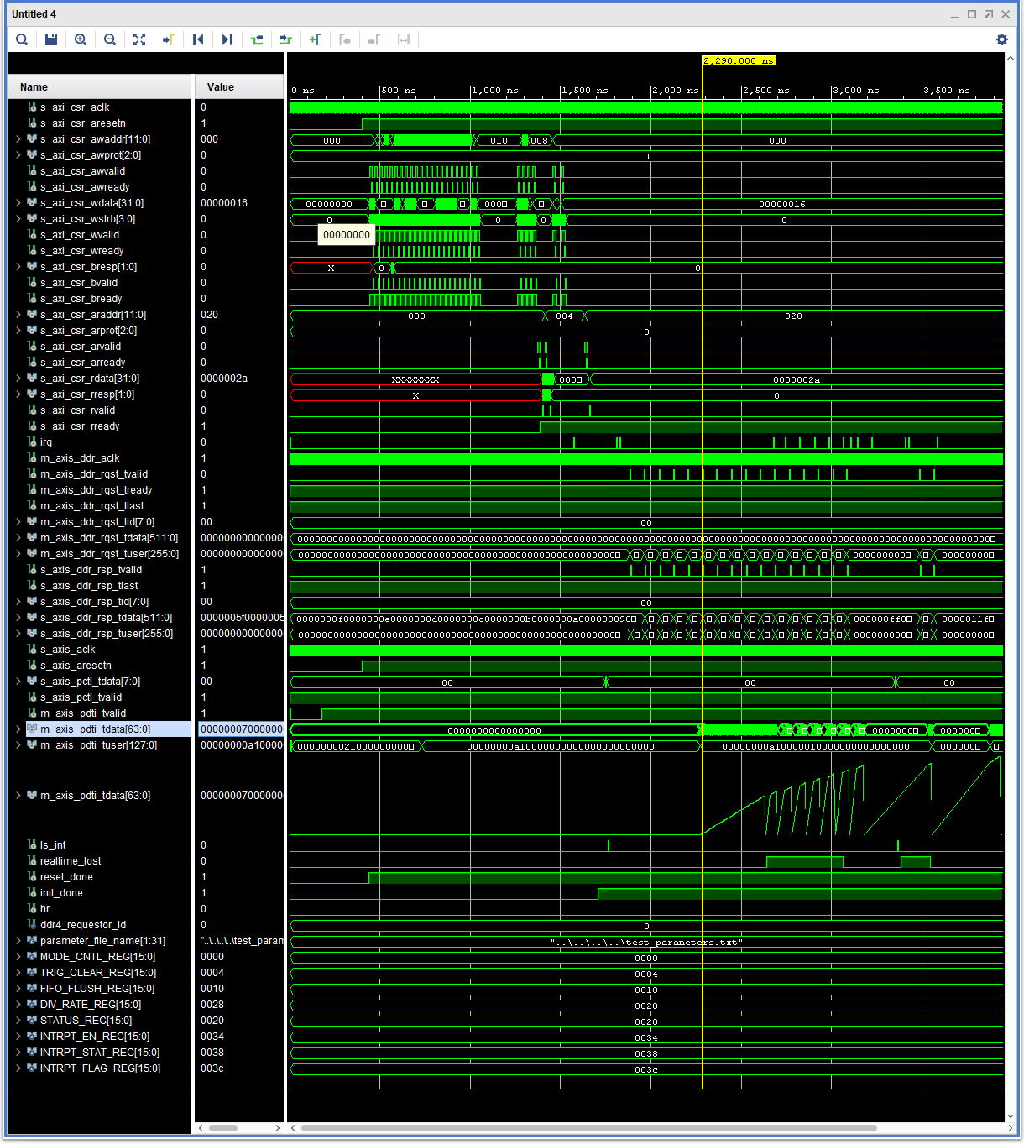

  - Synthesis and Implementation

For details about synthesis and implementation see the Vivado Design Suite User Guide - Designing with IP.

