Pentek 33240 FMC Interface Core

The Pentek 33240 FMC Interface Core provides user accessible host SPI and TWSI interfaces as well as LMK clock generator control for a Pentek model 33240 FMC module.

Features
- Provides communication via 4-wire SPI for ADC1, ADC2, DAC1 and DAC2
- Provides communication via 3-wire SPI for the LMK clock device
- Provides TWSI communication for the temperature sensor and the configurable clock oscillator
- Provides direct control for the LMK as well as access to the LMK’s status outputs
- Register access through an AXI4-Lite CSR interface

- : Overview

  - Functional Description

The Pentek 33240 FMC Interface Core provides the user interface for communication between a Pentek carrier and a Pentek Model 33240 FMC Module. The user interface is implemented using an AXI4-Lite CSR interface, through which the user can access all of the set-up and status registers in the ADCs, the DACs, the configurable clock oscillator, the temperature sensor and the LMK clock device on a Pentek 33240 FMC Module. For register map details see Chapter 4. For details on the AXI4-Lite CSR interface, refer to Section 3.1.

Figure 1-1 is a top-level block diagram of the Pentek 33240 FMC Interface Core. The modules within the block diagram are explained in the later sections of this manual.

Figure 1-1: Pentek 33240 FMC Interface Core Block Diagram

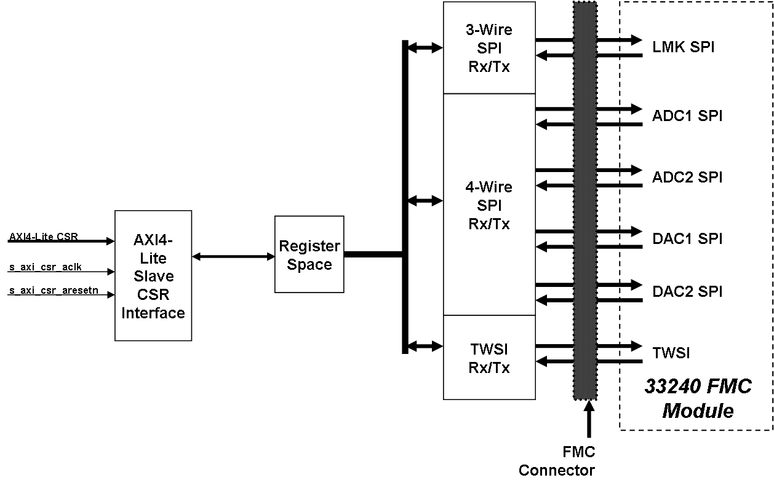

  AXI4-Lite Interface: This module implements a 32-bit AXI4-Lite Slave interface to access the Register Space. For additional details about the AXI4-Lite Interface, refer to Section 3.1 AXI4-Lite Core Interfaces.

  Register Space: This module contains the control registers for the core. The registers are accessed through the AXI4-Lite CSR interface. For register map details see Chapter 4.
  3-Wire SPI Rx/Tx: This module contains the logic for communicating with the LMK device via the 3-wire SPI interface.

  4-Wire SPI Rx/Tx: This module contains the logic for communicating with the ADCs and the DACs via the 4-wire SPI interface.

  TWSI Rx/Tx: This module contains the logic for communicating with the temperature sensor and the configurable clock oscillator on the FMC module via the TWSI interface.

  - Applications

The Pentek 33240 FMC Interface Core can be used for communicating with the devices on a Pentek 33240 FMC module, and can be incorporated into any Kintex Ultrascale FPGA.

  - System Requirements

For a list of system requirements, see the Vivado Design Suite Release Notes.

  - Licensing and Ordering Information

This core is included with all Pentek Navigator FPGA Design Kits for Pentek Jade series board products. Contact Pentek for Licensing and Ordering Information (www.pentek.com).

  - Contacting Technical Support

Technical Support for Pentek’s Navigator FPGA Design Kits is available via e-mail (fpgasupport@pentek.com) or by phone (201-818-5900 ext. 238, 9 am to 5 pm EST).

  - Documentation
- Vivado Design Suite User Guide: Designing with IP
- Vivado Design Suite User Guide: Programming and Debugging
- ARM AMBA AXI4 Protocol Version 2.0 Specification
- Texas Instruments ADS54J69 ADC Data Sheet
- Texas Instruments LMK04824 Product Guide and Data Sheet
- Texas Instruments DAC38J84 DAC Data Sheet

- : General Product Specifications

  - Standards

Pentek 33240 FMC Interface Core has an interface that complies with the ARM AMBA AXI4-Lite Protocol Specification.

  - Performance

The performance of the Pentek 33240 FMC Interface Core is limited by the data rates at which the FMC module’s devices can communicate.

  - Resource Utilization

The resource utilization of Pentek 33240 FMC Interface Core is shown in Table 2-1. Resources have been estimated for the Kintex Ultrascale XCKU060 -2e speed grade device. These values were generated using the Vivado Design Suite. Actual utilization will vary based on the user design in which the Pentek 33240 FMC Interface Core is incorporated.

Table 2-1: Resource Usage and Availability
Resources | # Used
LUTs | 674
Flip-Flops | 1,153

  - Limitations and Unsupported Features

This section is not applicable to this IP core.

  - Generic Parameters

This section is not applicable to this IP core.

- : Port Descriptions

This chapter provides details about the port descriptions for the following interface type:

• AXI4-Lite Core Interfaces
• I/O Signals

  - AXI4-Lite Core Interfaces

The Pentek 33240 FMC Interface Core uses the Control/Status Register (CSR) interface to access the control and status registers from the user design and, hence, to communicate with the various devices on the FMC module.

    - Control/Status Register (CSR) Interface
The CSR interface is an AXI4-Lite Slave Interface that can be used to access the control and status registers in the Pentek 33240 FMC Interface Core. Table 3-1 defines the ports in the CSR Interface. See Chapter 4 for a Register memory map and bit definitions. See the AMBA AXI4-Lite Specification for more details on operation of the AXI4-Lite interfaces.

- Control/Status Register (CSR) Interface Port Descriptions0000.doc
Port | Direction | Width | Description
s_axi_csr_aclk | Input | 1 | Clock
s_axi_csr_aresetn | Input | 1 | Reset: Active low. This value will reset all control registers to their initial states.
s_axi_csr_awaddr | Input | 7 | Write Address: Address used for write operations. It must be valid when s_axi_csr_awvalid is asserted and must be held until s_axi_csr_awready is asserted by the Pentek 33240 FMC Interface Core.
s_axi_csr_awprot | Input | 3 | Protection: The Pentek 33240 FMC Interface Core ignores these bits.
s_axi_csr_awvalid | Input | 1 | Write Address Valid: This input must be asserted to indicate that a valid write address is available on s_axi_csr_ awaddr. The Pentek 33240 FMC Interface Core asserts s_axi_csr_awready when it is ready to accept the address. The s_axi_csr_awvalid must remain asserted until the rising clock edge after the assertion of s_axi_csr_awready.
s_axi_csr_awready | Output | 1 | Write Address Ready: This output is asserted by the Pentek 33240 FMC Interface Core when it is ready to accept the write address. The address is latched when s_axi_csr_awvalid and s_axi_csr_awready are high on the same cycle.
s_axi_csr_wdata | Input | 32 | Write Data: This data will be written to the address specified by s_axi_csr_awaddr when s_axi_csr_wvalid and s_axi_csr_ wready are both asserted. The value must be valid when s_axi_csr_wvalid is asserted and held until s_axi_csr_wready is also asserted.
s_axi_csr_wstrb | Input | 4 | Write Strobes: This signal indicates the number of bytes of valid data on s_axi_csr_wdata signal. Each of these bits, when asserted, indicate that the corresponding byte of s_axi_csr_wdata contains valid data. Bit 0 corresponds to the least significant byte, and bit 3 to the most significant.
s_axi_csr_wvalid | Input | 1 | Write Valid: This signal must be asserted to indicate that the write data is valid for a write operation. The value on s_axi_csr_wdata is written into the register at address s_axi_csr_awaddr when s_axi_csr_wready and s_axi_csr_wvalid are high on the same cycle.
s_axi_csr_wready | Output | 1 | Write Ready: This signal is asserted by the Pentek 33240 FMC Interface Core when it is ready to accept data. The value on s_axi_csr_wdata is written into the register at address s_axi_csr_awaddr when s_axi_csr_wready and s_axi_csr_wvalid are high on the same cycle, assuming that the address has already or simultaneously been submitted.
s_axi_csr_bresp | Output | 2 | Write Response: The core indicates success or failure of a write transaction through this signal, which is valid when s_axi_csr_ bvalid is asserted;  00 = Success of normal access  01 = Success of exclusive access  10 = Slave Error  11 = Decode Error  Note: For more details about this signal refer to the AMBA AXI Specification.
s_axi_csr_bready | Input | 1 | Write Response Ready: This signal must be asserted by the user logic when it is ready to accept the Write Response.
s_axi_csr_bvalid | Output | 1 | Write Response Valid: This signal is asserted by the Pentek 33240 FMC Interface Core when the write operation is complete and the Write Response is valid. It is held until s_axi_csr_bready is asserted by the user logic.
s_axi_csr_araddr | Input | 7 | Read Address: Address used for read operations. It must be valid when s_axi_csr_arvalid is asserted and must be held until s_axi_csr_arready is asserted by the Pentek 33240 FMC Interface Core.
s_axi_csr_arprot | Input | 3 | Protection: These bits are ignored by the Pentek 33240 FMC Interface Core.
s_axi_csr_arvalid | Input | 1 | Read Address Valid: This input must be asserted to indicate that a valid read address is available on the s_axi_csr_araddr. The Pentek 33240 FMC Interface Core asserts s_axi_csr_arready when it is ready to accept the Read Address. This input must remain asserted until the rising clock edge after the assertion of s_axi_csr_arready.
s_axi_csr_arready | Output | 1 | Read Address Ready: This output is asserted by the Pentek 33240 FMC Interface Core when it is ready to accept the read address. The address is latched when s_axi_csr_arvalid and s_axi_csr_arready are high on the same cycle.
s_axi_csr_rdata | Output | 32 | Read Data: This value is the data read from the address specified by the s_axi_csr_araddr when s_axi_csr_arvalid and s_axi_csr_arready are High on the same cycle.
s_axi_csr_rresp | Output | 2 | Read Response: The Pentek 33240 FMC Interface Core indicates success or failure of a read transaction through this signal, which is valid when s_axi_csr_rvalid is asserted;  00 = Success of normal access  01 = Success of exclusive access  10 = Slave Error  11 = Decode Error  Note: For more details about this signal refer to the AMBA AXI Specification.
s_axi_csr_rvalid | Output | 1 | Read Data Valid: This signal is asserted by the Pentek 33240 FMC Interface Core when the read is complete and the read data is available on the s_axi_csr_rdata. It is held until s_axi_csr_rready is asserted by the user logic.
s_axi_csr_rready | Input | 1 | Read Data Ready: This signal is asserted by the user logic when it is ready to accept the Read Data.

  - I/O Signals

The I/O port/signal descriptions of the top level module of the Pentek 33240 FMC Interface Core are discussed in Table 3-2.

Table 3-2: I/O Signals
Port/Signal Name | Type | Direction | Description
PCIE_CLK | std_logic | Input | PCIE Clock: This is the system-level clock used for the SPI, TWSI and LMK interface logic.
LRST_N | std_logic | Input | System Level Reset: This is the active-low system-level reset used for all of the interfaces.
TWSI_SDA | std_logic | Bidirectional | TWSI Data: This is the TWSI serial data line.
TWSI_SCL | std_logic | Bidirectional | TWSI Clock: This is the TWSI serial clock.
TRNS_DONE_INT | std_logic | Output | TWSI TDI: This is the interrupt that indicates the TWSI transfer is done. This is a single-clock-wide pulse, synchronized to PCIE_CLK.
NO_ACK_INT | std_logic | Output | TWSI No Ackowledge Interrupt: This is the interrupt that indicates there was no acknowledgement received following an address request on the TWSI bus. This interrupt is also synchronized to PCIE_CLK, but may be multiple clocks in duration.
SDIO | std_logic | Bidirectional | SPI Data: This is the SPI Bidirectional Data line used for both 3-wire (as bidirectional) and 4-wire (output only) interfaces.
SDENB | std_logic_vector | Output | SPI Device Enables: These are the enables for the devices sharing the SPI bus.
SCLK | std_logic | Bidirectional | SPI Clock: This provides the clock for the SPI bus when the Pentek 33240 FMC Interface Core is the master. When the core is a slave it receives the clock from the device currently acting as the master.
SDO | std_logic_vector | Input | SPI Data Input: This is the input data bus for the devices using the SPI 4-wire configuration.
INT_REF_SEL | std_logic | Output | Reference Select: This is the select line for the LMK PLL1 reference on the 33240 FMC Module. ‘0’ = External Reference Connector (J6)  ‘1’ = SYNCB from the Sync Bus Connector (J16) For further details see the Texas Instruments LMK04824 Product Guide and Data Sheet.
JESD_RESET_GPO | std_logic | Output | LMK Reset: This is the reset (active HIGH) for the LMK device on the 33240 FMC Module.
PLL1_CLKIN_SEL0,1 | std_logic | Output | LMK Clock Select Pins: These are the clock select pins for the LMK device on the 33240 FMC Module. For further details see the Texas Instruments LMK04824 Product Guide and Data Sheet.
PLL1_REF_ENAB | std_logic | Output | <This output is currently not used on the 33240 FMC Module>
PLL2_REF_ENAB | std_logic | Output | Reference Enable: This is the enable for the reference oscillator on the 33240 FMC Module.
GATE_B_SEL | std_logic | Output | GATEB Select: This is the select for the GATEB input to the FPGA.  ‘0’ = GATEB pins on the Sync Bus Connector (J16)  ‘1’ = SYNCA pins on the Sync Bus Connector (J16)
SYSREF_SYNC | std_logic | Output | LMK SYSREF SYNC: This is the sync for the LMK device on the 33240 FMC Module. For further details see the Texas Instruments LMK04824 Product Guide and Data Sheet.
STATUS_LD1,2 | std_logic | Input | STATUS LED Inputs: These inputs provide a path for the LMK’s Status LED outputs on the FMC Module to the LEDs on the carrier.

- : Register Space
This chapter provides the memory map and register descriptions for the Pentek 33240 FMC Interface Core. The memory map is provided in Table 4−1.

- Register Space Memory Map
Register Name | Base Address (Base Address +) | Access | Description
SPI Interface Control Register | 0x00 | R/W | Controls SPI modes, data length, address and reset for both the 3-wire and 4-wire SPI interfaces.
SPI Interface Write Data | 0x04 | R/W | Data to be written to the currently-selected SPI bus.
SPI Interface Start | 0x08 | R/W | Initiates a SPI transaction.
TWSI Interface Control | 0x0C | R/W | Controls enable, read/write mode, address and initiate transfer for the TWSI interface.
TWSI Interface Write Data | 0x10 | R/W | Data to be written to the TWSI bus.
TWSI Interface Start | 0x14 | R/W | Initiates a TWSI transaction.
LMK Control | 0x18 | R/W | Controls feature set-up for the LMK clock device.
SPI Interface Status | 0x1C | R | SPI interface status bits.
SPI Interface Read Data | 0x20 | R | Data read from the currently selected SPI bus.
TWSI Interface Status | 0x24 | R | TWSI interface status bits.
TWSI Interface Read Data | 0x28 | R | Data read from the TWSI bus.
LMK Status | 0x2C | R | LMK device status bits.

  - SPI Interface Control Register
This register selects the target SPI device, sets the required modes for communication and provides the target address for the SPI interface. This register is illustrated in Figure 4-1 and described in Table 4-2.

Figure 4-1: SPI Interface Control Register

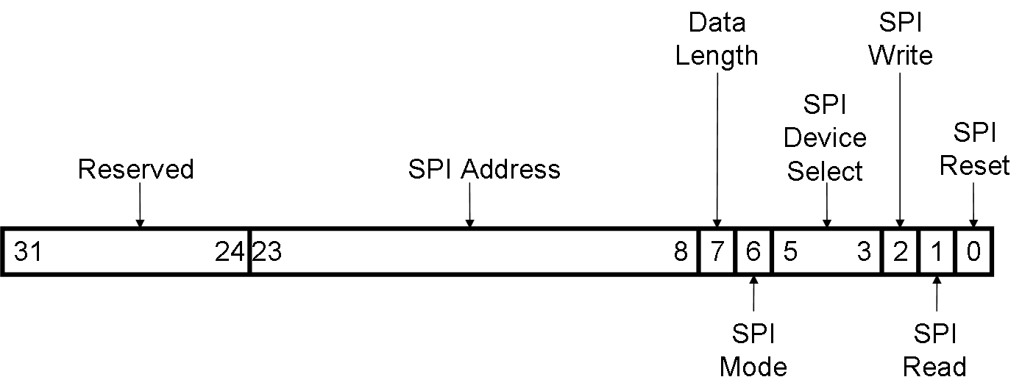

Table 4-2: SPI Interface Control Register (Base + 0x00)
Bits | Field Name | Default  Value | Access  Type | Description
31:24 | Reserved | - | - | Reserved
23:8 | SPI Address | 0x00 | R/W | SPI Address: Address for reading or writing to the target device.
7 | Data Length | 0 | R/W | Data Length: ‘0’ = 8-bit mode, ‘1’ = 16-bit mode.
6 | SPI Mode | 0 | R/W | SPI Mode: ‘0’ = 4-wire mode, ‘1’ = 3-wire mode.
5:3 | Device Select | 000 | R/W | Device Select: Selects the target device as follows:  000 = ADC0  001 = ADC1  010 = DAC0  011 = DAC1  100 = LMK
2 | SPI Write | 0 | R/W | SPI Write: When HIGH this bit puts the SPI interface controller in WRITE mode.
1 | SPI Read | 0 | R/W | SPI Read: When HIGH this bit puts the SPI interface controller in READ mode.
0 | SPI Reset | 0 | R/W | SPI Reset: When LOW, this bit resets the selected SPI interface. Note: the SPI interfaces are HELD IN RESET by default.

  - SPI Interface Write Data Register
The SPI Interface Write Data Register provides the data that will be written to the SPI interface as set-up by the SPI Interface Control Register (see Section 4-1). This register is illustrated in Figure 4−2 and described in Table 4−3.

Figure 4-2: SPI Interface Write Data Register

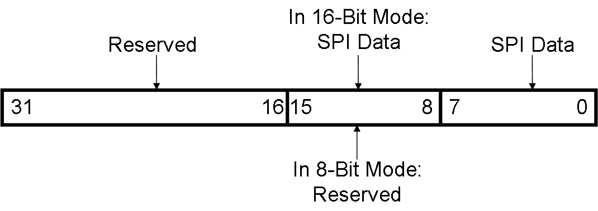

Table 4-3: SPI Interface Write Data Register (Base + 0x04)
Bits | Field Name | Default  Value | Access  Type | Description
31:16 | Reserved | - | - | Reserved
15:8 | SPI Data/Reserved | 0x00 | R/W | SPI Data/Reserved: When Data Length Mode is set to 16-bit mode, these bits contain the upper 8 bits of the data word to be written. When Data Length Mode is set to 8-bit mode, these bits are RESERVED.
7:0 | SPI Data | 0x00 | R/W | SPI Data: This register contains the lower 8-bits of the data word to be written.

  - SPI Interface Start Register
The SPI Interface Start Register initiates a SPI data transaction. This register is illustrated in Figure 4−3 and described in Table 4−4.

Figure 4-3: SPI Interface Start Register

31
0
1
Reserved
Start SPI Transaction

Table 4-4: SPI Interface Start Register (Base + 0x08)
Bits | Field Name | Default  Value | Access  Type | Description
31:1 | Reserved | - | - | Reserved
0 | SPI Start | 0 | R/W | SPI Start: When toggled, this bit will initiate a SPI data transaction.

  - TWSI Interface Control Register
The TWSI Interface Control Register is used to set-up and initiate data transfers on the TWSI interface This register is illustrated in Figure 4−4 and described in Table 4−5.

Figure 4-4: TWSI Interface Control Register

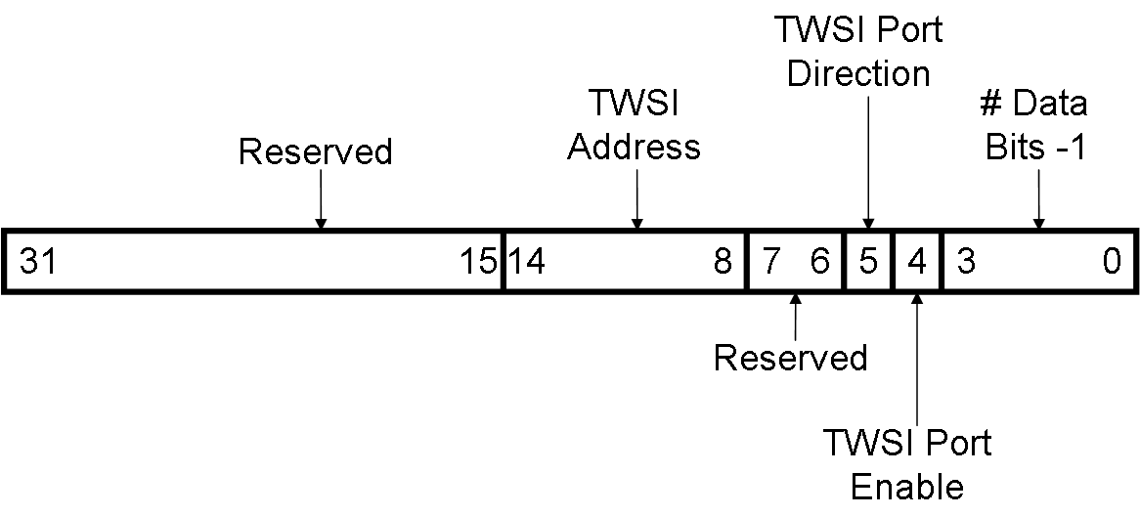

Table 4-5: TWSI Interface Control Register (Base + 0x0C)
Bits | Field Name | Default  Value | Access  Type | Description
31:15 | Reserved | - | - | Reserved
14:8 | TWSI Address | 0x00 | R/W | TWSI Address: Target address for the TWSI transaction.
7:6 | Reserved | - | - | Reserved
5 | Port Direction | 0 | R/W | Port Direction: Sets the port direction for the data transfer: ‘0’ = WRITE, ‘1’ = READ.
4 | Port Enable | 0 | R/W | Port Enable: This bit is used to enable/ disable the TWSI port. When disabled, the TWSI interface is held in reset. When enabled, the interface is activated. This bit must be set to ‘0’ to reset the TWSI Control State Machine.  0 = Disable  1 = Enable
3:0 | Number of Bytes | 0x0 | R/W | Number of Bytes: Indicates/Specifies the number of data bytes that are to be transferred.

  - TWSI Interface Write Data

The TWSI Interface Write Data Register contains the 8-bit data word to be written to the TWSI interface. This register is illustrated in Figure 4−5 and described in Table 4−6.

Figure 4-5: TWSI Interface Write Data Register

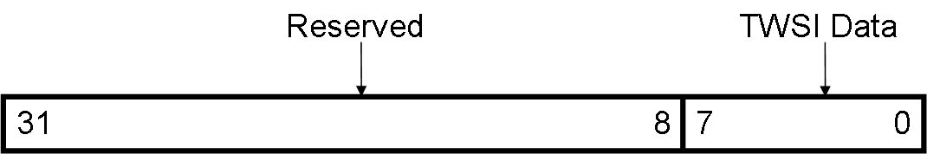

Table 4-6: TWSI Interface Write Data Register (Base + 0x10)
Bits | Field Name | Default  Value | Access  Type | Description
31:8 | Reserved | - | - | Reserved
7:0 | TWSI Write Data | 0x00 | R/W | TWSI Write Data: : A write to the TWSI interface’s Write Data FIFO is initiated when the TWSI Control Register’s Port Enable s set HIGH, the Port Direction bit is set LOW and a transfer is initiated by toggling the Transfer Start bit (see Section 4.4).

  - TWSI Interface Start Register
The TWSI Interface Start Register initiates a TWSI data transaction. This register is illustrated in Figure 4−6 and described in Table 4−7.

Figure 4-6: TWSI Interface Start Register

31
0
1
Reserved
Start TWSI Transaction

Table 4-7: TWSI Interface Start Register (Base + 0x14)
Bits | Field Name | Default  Value | Access  Type | Description
31:1 | Reserved | - | - | Reserved
0 | TWSI Start | 0 | R/W | TWSI Start: When toggled, this bit will initiate a TWSI data transaction.

  - LMK Control Register

The LMK Control Register is used to control the setup pins on the LMK device on the 33240 FMC Module. This register is illustrated in Figure 4−7 and described in Table 4−8.

Figure 4-7: LMK Control Register

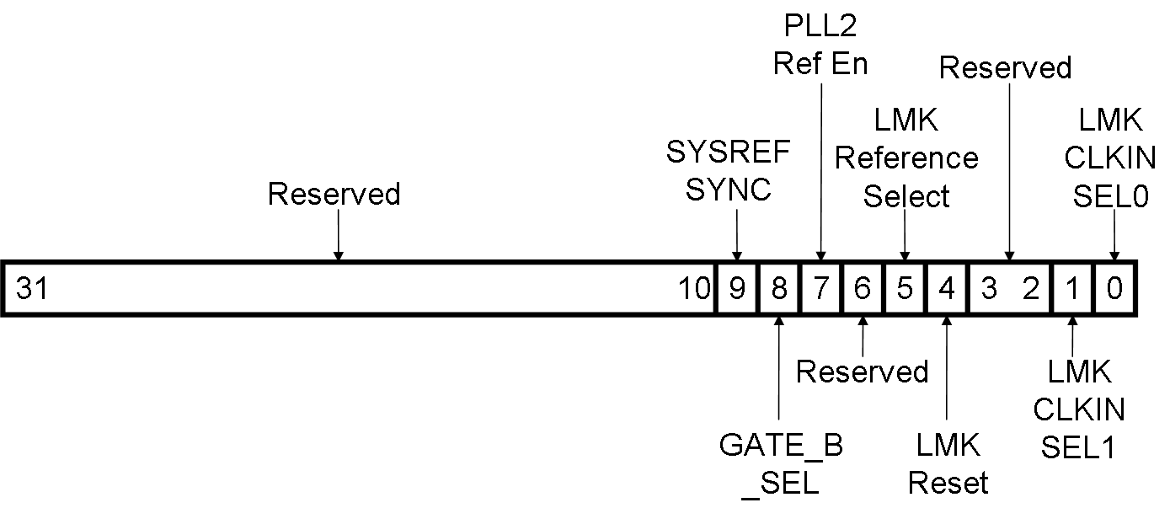

Table 4-8: LMK Control Register (Base + 0x18)
Bits | Field Name | Default  Value | Access  Type | Description
31:10 | Reserved | - | - | Reserved
9 | SYSREF_SYNC | 0 | R/W | SYSREF_SYNC: Controls the SYNC/SYSREF_REQ pin on the LMK device. See LMK04828 data sheet for details on setting this bit.
8 | GATE_B_SEL | 0 | R/W | GATE_B_SEL: Selects the source for GATE_B: when ‘0’, the 33240 Module’s “GATEB” front panel input is selected; when ‘1’ the 33204 Module’s “SYNCA” front panel input is selected.
7 | PLL2 Ref En | 0 | R/W | PLL2 Reference Enable: Output enable for the reference oscillator on the 33240 Module.
6 | Reserved | - | - | Reserved
5 | LMK Ref Sel |  |  | LMK Reference Select: Reference select for the LMK device: when ‘0’ the 33240 module’s “EXT REF/EXT CLK IN” front panel connector is selected as the source, when ‘1’ the module’s “SYNCB” front panel input is selected.
4 | LMK Reset | 0 | R/W | LMK Reset: Active HIGH reset for the LMK device.
3:2 | Reserved | - | - | Reserved
1:0 | CLKIN_SEL1, 0 | 0 | R/W | CLKIN_SEL1, 0: These bits select the input clock for the LMK device. NOTE: the functionality of these pins can change based on register settings within the LMK device. Refer to the LMK04828 data sheet for details.

  - SPI Interface Status Register
This register provides the status of the SPI interface selected by the SPI Interface Control Register (see Section 4-1). This register is illustrated in Figure 4−8 with the bits described in Table 4−9.

Figure 4-8: SPI Interface Status Register

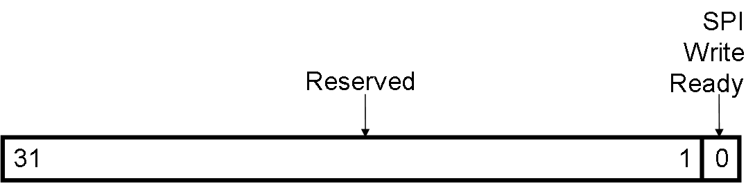

Table 4-9: SPI Interface Status Register (Base + 0x1C)
Bits | Field Name | Default  Value | Access  Type | Description
31:1 | Reserved | - | - | Reserved
0 | SPI Write Ready | 0 | R | SPI Write Ready: This bit indicates when it is safe to write to the target device.

  - SPI Interface Read Data Register
The SPI Interface Read Data Register will contain the data transferred from the target device during the last SPI Read. This register is illustrated in Figure 4−9 and described in Table 4−10.

Figure 4-9: SPI Interface Read Data Register

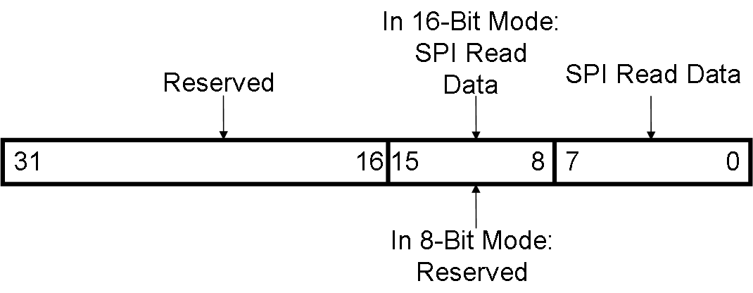

Table 4-10: SPI Interface Read Data Register (Base + 0x20)
Bits |  | Field Name |  | Default  Value |  | Access  Type |  | Description
31:16 | Reserved |  | - |  | - |  | Reserved
15:8 | SPI Data/Reserved |  | 0x00 |  | R/W |  | SPI Data/Reserved: When Data Length Mode is set to 16-bit mode, these bits contain the upper 8 bits of the data word received. When Data Length Mode is set to 8-bit mode, these bits are RESERVED.
7:0 | SPI Data |  | 0x00 |  | R/W |  | SPI Data: This register contains the lower 8-bits of the data word received.

  - TWSI Interface Status Register
The TWSI Interface Status Register provides the status of several functions of the TWSI interface controller. This register is illustrated in Figure 4−10 and described in Table 4−11.

Figure 4-10: TWSI Interface Status Register

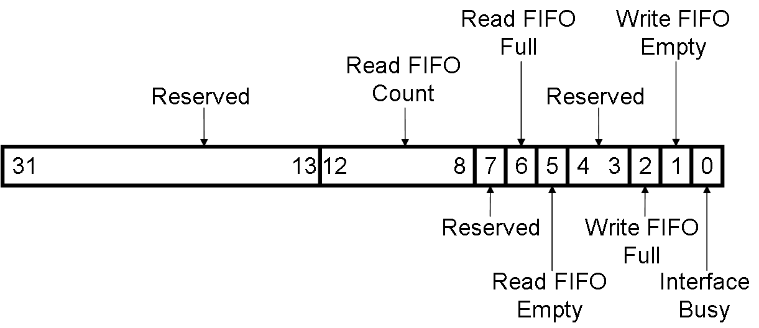

Table 4-11: TWSI Interface Status Register (Base + 0x24)
Bits | Field Name | Default  Value | Access  Type | Description
31:13 | Reserved | - | - | Reserved
12:8 | Read FIFO Count | 00000 | R | Read FIFO Count: These bits indicate the number of data bytes available to read from the read FIFO.
7 | Reserved | - | - | Reserved
6 | Read FIFO Full | 0 | R | Read FIFO Full: This bit indicates FIFO full status of the TWSI Interface read FIFO.  0 = FIFO not full  1 = FIFO full
5 | Read FIFO Empty | 0 | R | Read FIFO Empty: This bit indicates FIFO empty status of the TWSI Interface read FIFO.  0 = FIFO not empty  1 = FIFO empty
4:3 | Reserved | - | - | Reserved
2 | Write FIFO Full | 0 | R | Write FIFO Full: This bit indicates FIFO full status of the TWSI Interface write FIFO.  0 = FIFO not full  1 = FIFO full
1 | Write FIFO Empty | 0 | R | Write FIFO Empty: This bit indicates FIFO empty status of the TWSI Interface write FIFO.  0 = FIFO not empty  1 = FIFO empty
0 | TWSI Interface Busy | 0 | R | TWSI Interface Busy: This bit indicates if a transaction is in progress on the TWSI Interface.  0 = Not active  1 = Transaction in progress  Note: Ensure that this bit is ‘0’ before starting a new transaction or reading or writing the FIFOs.

  - TWSI Interface Read Data Register
This register contains the 8-bit data received by the TWSI interface. This register is illustrated in Figure 4−11 and described in Table 4−12.

Figure 4-11: TWSI Interface Read Data Register

Table 4-12: TWSI Interface Read Data Register (Base + 0x28)
Bits | Field Name | Default  Value | Access  Type | Description
31:8 | Reserved | - | - | Reserved
7:0 | TWSI Read Data | 0x00 | R | TWSI Read Data: A read of the TWSI interface’s Read FIFO is initiated when the TWSI Control Register’s Port Enable and Port Direction bits are set HIGH and a transfer is initiated by toggling the Transfer Start bit (see Section 4.3).

  - LMK Status Register
The LMK Status Register provides the current state of the two programmable status indicator bits from the LMK device on the 33240 FMC Module. This register is illustrated in Figure 4−12 and described in Table 4−13.

Figure 4-12: LMK Status Register

31
0
1
Reserved
LMK STATUS_LD1
2
LMK STATUS_LD2

Table 4-13: LMK Status Register (Base + 0x2C)
Bits | Field Name | Default  Value | Access  Type | Description
31:2 | Reserved | - | - | Reserved
1 | LMK STATUS_LD2 | 0 | R | LMK STATUS_LD2: This is a programmable status bit from the LMK device on the 33240 FMC Module. See the LMK04828 data sheet for details on setting-up this bit.
0 | LMK STATUS_LD1 | 0 | R | LMK STATUS_LD1: This is a programmable status bit from the LMK device on the 33240 FMC Module. See the LMK04828 data sheet for details on setting-up this bit.

- : Designing with the Core

This chapter includes guidelines and additional information to facilitate designing with the Pentek 33240 FMC Interface Core.

  - General Design Guidelines
The Pentek 33240 FMC Interface Core provides the required logic to communicate with the ADCs, DACs and clock devices on a Pentek 33240 FMC Module.

  - Clocking

AXI4-Lite Clock: s_axi_csr_aclk. This 250MHz clock is used to clock the AXI4-Lite Control/Status Register (s_axi_csr) interface of the core and its associated logic.

PCIe Clock: PCIE_CLK. This 250MHz clock provides clocking for the SPI and TWSI interfaces.

  - Resets

CSR Reset: s_axi_csr_aresetn. This is an active-low synchronous reset associated with the s_axi_csr_aclk. When asserted, all CSR state machines in the core are reset.

System-Level Reset: LRST_N. This is an active-low asynchronous system reset.

  - Interrupts

This core has two interrupt outputs for the TWSI Interface. The “Transfer Done” interrupt is a single-clock-wide pulsed output synchronous to the PCIE_CLK, and the “No Acknowledgement” interrupt can be a mulit-clock-wide pulse which is also synchronous to the PCIE_CLK.

  - Interface Operation

Control/Status Register Interface: This is the control register interface. It is associated with the s_axi_csr_aclk, and is a standard AXI4-Lite type interface. See Chapter 4 for the control register memory map and for more details on the registers that can be accessed through this interface. For more details about this interface refer to Section 3.1.

SPI Interfaces: The SPI interfaces provide communication links to the ADCs, DACs and LMK devices for parameter setup and monitoring. The SPI bus clock is derived from the PCIE_CLK.

TWSI Interface: The TWSI interface provides communication links to the temperature sensor and programmable oscillator. The TWSI bus clock is derived from the PCIE_CLK.

  - Programming Sequence

This section briefly describes the programming sequence for the Pentek 33240 FMC Interface Core.

- For SPI Bus Transactions:
  - Set the SPI Interface Control register as required for the data transfer.
  - If the transfer is a write, set the SPI Interface Write Data register with the desired write data.
  - Verify the SPI interface is available by reading the SPI Interface Status register.
  - Initiate a SPI transaction by writing a ‘1’ followed by writing a ‘0’ to the SPI Interface Start register.
  - If the transfer was a read, the resulting data will appear in bits 7:0 of the SPI Interface Read Data register.
- For TWSI Bus Transactions:
  - Set the TWSI Interface Control register as required for the data transfer.
  - If the transfer is a write, set the TWSI Interface Write Data register with the desired write data.
  - Verify the TWSI interface is available by reading the SPI Interface Status register. Also verify that the appropriate fifo (read or write) is not full.
  - Initiate a TWSI transaction by writing a ‘1’ followed by writing a ‘0’ to the TWSI Interface Start register.
  - If successful, a “TRNS_DONE_INT” interrupt will be generated when the transaction has completed.
  - If the transfer was a read, the resulting data will appear in bits 7:0 of the TWSI Interface Read Data register.
- For LMK control set the appropriate bits in the LMK Control register as desired.
- For LMK status, read the appropriate bits in the LMK Status register.

  - Timing Diagrams

The timing diagrams for the Pentek 33240 FMC Interface Core are shown in Figures 6−3, 6-4 and 6-5. These timing diagrams are obtained by running the simulations of the three test benches for the core in the Vivado VSim environment. For more details about the test benches, refer to Section 6.5.

- : Design Flow Steps

  - Pentek IP Catalog

This chapter describes the customization and generation of the Pentek 33240 FMC Interface Core. It also includes simulation, synthesis and implementation steps that are specific to this core. This IP core can be generated from the Vivado IP Catalog when the Pentek IP Repository has been installed. It will appear in the IP Catalog list as px_3324_FMC_intrfc_v1_0 as shown in Figure 6-1.

Figure 6-1: px_3324_FMC_intrfc_v1_0 in Pentek IP Catalog

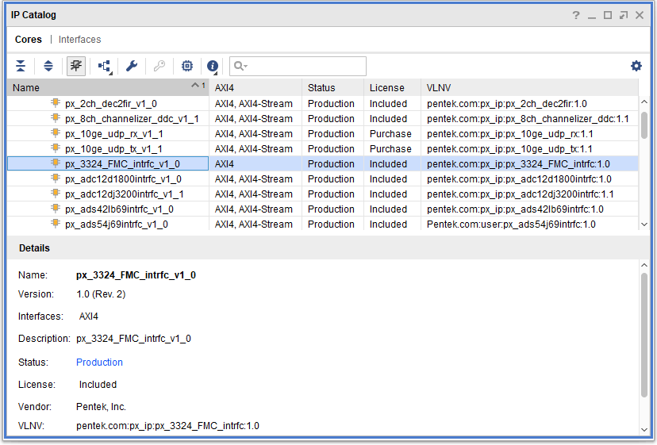

When you select the px_3324_FMC_intrfc_v1_0 core, a screen appears that shows the core’s symbol and parameters (see Figure 6-2). The core’s symbol is the box on the left side.

Figure 6-2: Pentek 33240 FMC Interface Core IP Symbol

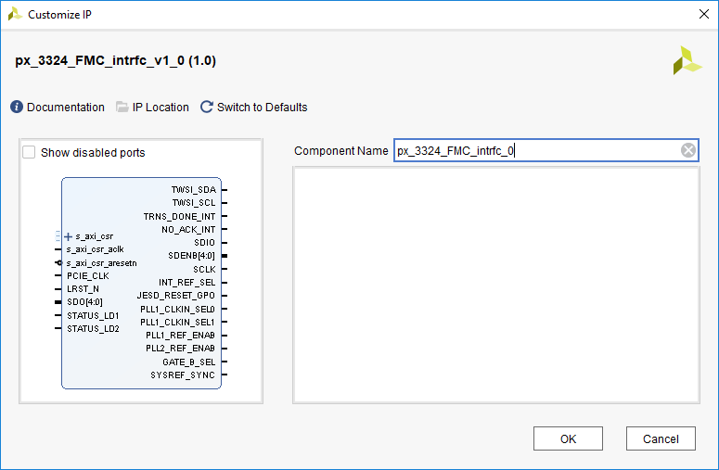

  - User Parameters
This section is not applicable for this IP core.

  - Generating Output
For more details about generating and using IP in the Vivado Design Suite, refer to the VivadoDesign Suite User Guide - Designing with IP.

  - Constraining the Core
This section contains information about constraining the core in Vivado Design Suite.

- Required Constraints
The XDC constraints are not provided with this core. The necessary constraints can be applied in the top level module of the user design.

- Device, Package, and Speed Grade Selections
This IP works for the Kintex Ultrascale FPGAs.

- Clock Frequencies
Both the CSR clock (s_axi_csr_aclk) and the PCIE clock (PCIE_CLK) have a maximum frequency of 250 MHz.

- Clock Management
This section is not applicable for this IP core.

- Clock Placement
This section is not applicable for this IP core.

- Banking and Placement
This section is not applicable for this IP core.

- Transceiver Placement
This section is not applicable for this IP core.

- I/O Standard and Placement
This section is not applicable for this IP core.

  - Simulation
The Pentek 33240 FMC Interface Core has three simulation sets which automatically verify the functionality of the three main functions of the core. Each simulation set is completely self-contained and self-checking. Pass/fail status will be provided in the console of the simulator at the conclusion of each of the simulations.

The simulation sets are executed one-at-a-time by selecting the desired simulation set in Vivado’s “Sources” window, then right-click and select “Make Active”. Simulation is then started by selecting SIMULATION => Run Simulation => Run Behavioral Simulation in Vivado’s “Flow Navigator” window.

- The first simulation set (SPI_intrfc_simulation) contains all of the necessary files to test the SPI interfaces. The testbench will setup and execute writes to all 5 of the SPI interfaces, verifying the data transfer at the SPI interface as they progress. The testbench will then initiate reads of the 5 SPI interfaces, and verifies the read data following each read.
The resulting waveforms for this simulation can be seen in Figure 6-3. If successful the following message will appear in the simulator’s console:
Failure: >>>>>>>>>>>>>>******* NOT A FAILURE: All SPI Tests Completed with No Errors. Time = 45276000 ps
If the simulation is not successful, the message in the simulator’s console will provide information on the part of the test that failed.
- The second simulation set (TWSI_intrfc_simulation) contains all of the necessary files to test the TWSI interface. The testbench will setup and execute a write to the TWSI interface, verifying the data transfer at the TWSI interface as it progresses. The testbench will then initiate a read of the TWSI interface, and verifies the read data following the read.
The resulting waveforms for this simulation can be seen in Figure 6-4. If successful the following message will appear in the simulator’s console:
Failure: >>>>>>>>>>>>>>******* NOT A FAILURE: All TWSI Tests Completed with No Errors. Time = 620656000 ps
If the simulation is not successful, the message in the simulator’s console will provide information on the part of the test that failed.
- The third simulation set (LMK_intrfc_simulation) contains all of the necessary files to test the LMK interface. The testbench will execute CSR writes to the LMK Control register which will drive each of the LMK control interface bits. The testbench will then verify the states of the corresponding outputs of the core.
Likewise, the testbench will then drive the two LMK status inputs to the core, and verify their functionality by executing reads of the LMK status register.
The resulting waveforms for this simulation can be seen in Figure 6-5. If successful the following message will appear in the simulator’s console:
Failure: >>>>>>>>>>>>>>******* NOT A FAILURE: All LMK Control Register Tests Completed with No Errors. Time = 12620000 ps
If the simulation is not successful, the message in the simulator’s console will provide information on the part of the test that failed.

Figure 6-3: Pentek 33240 FMC Interface Core SPI_intrfc_simulation Test Bench Simulation Output

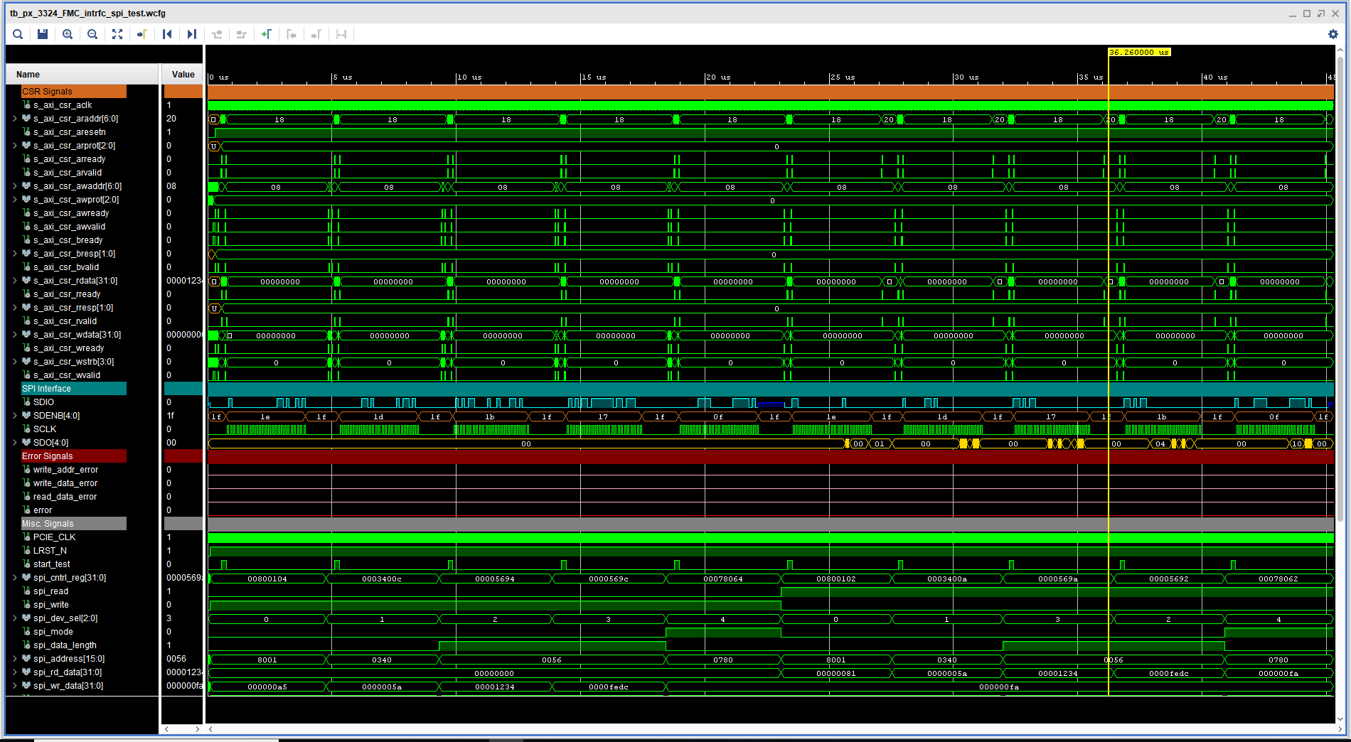

Figure 6-4: Pentek 33240 FMC Interface Core TWSI_intrfc_simulation Test Bench Simulation Output

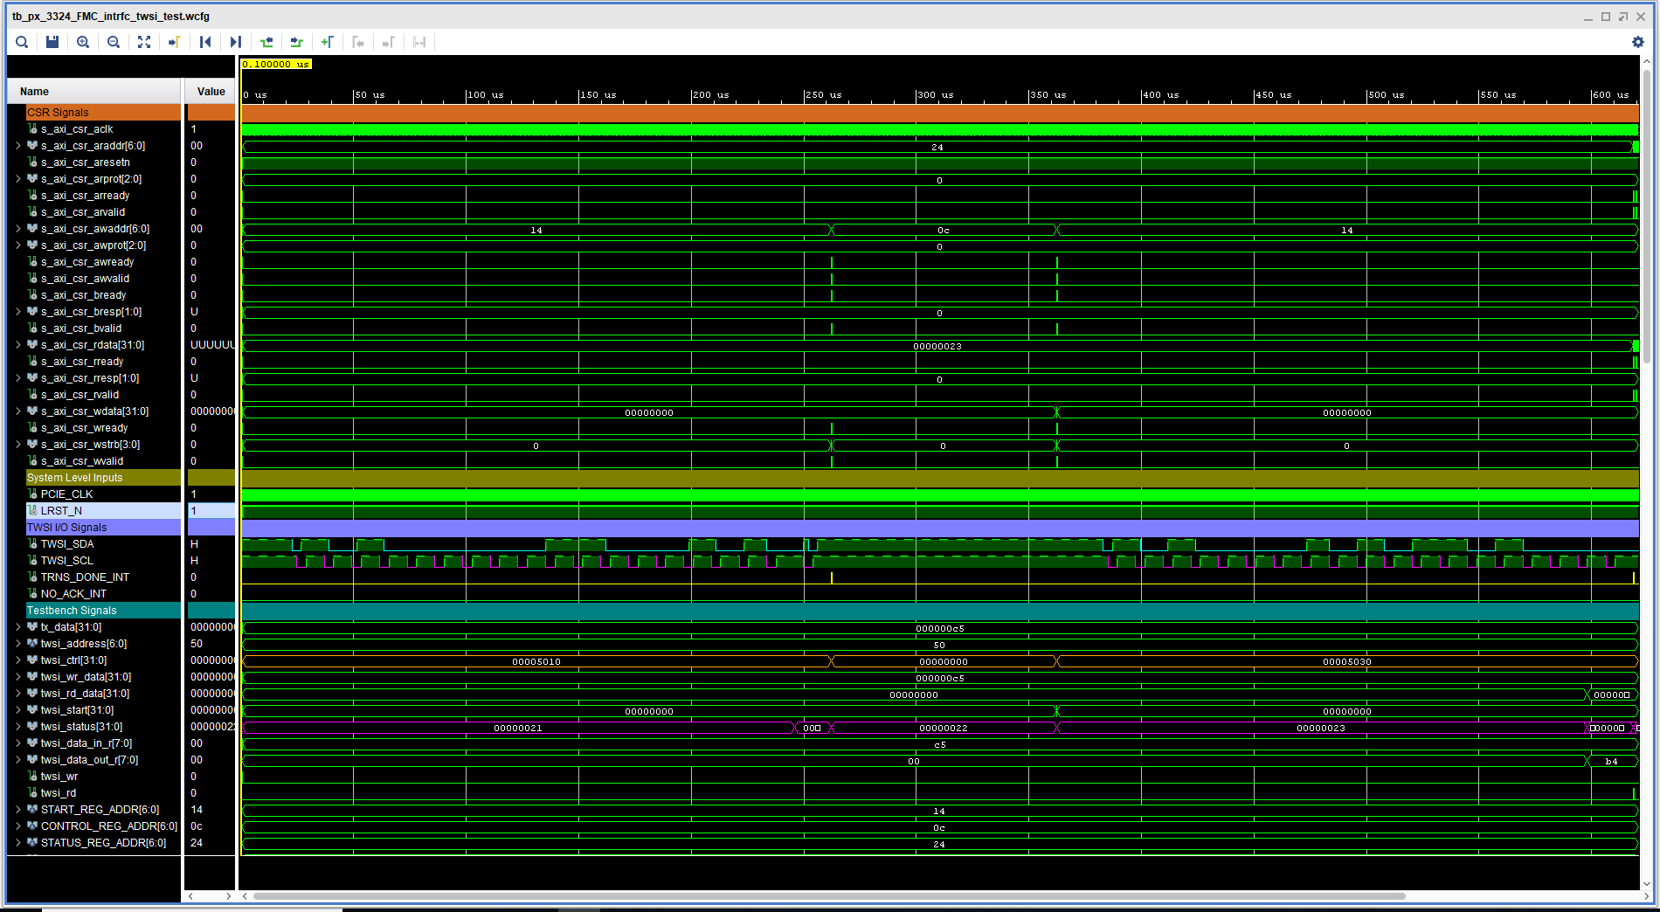

Figure 6-3: Pentek 33240 FMC Interface Core LMK_intrfc_simulation Test Bench Simulation Output

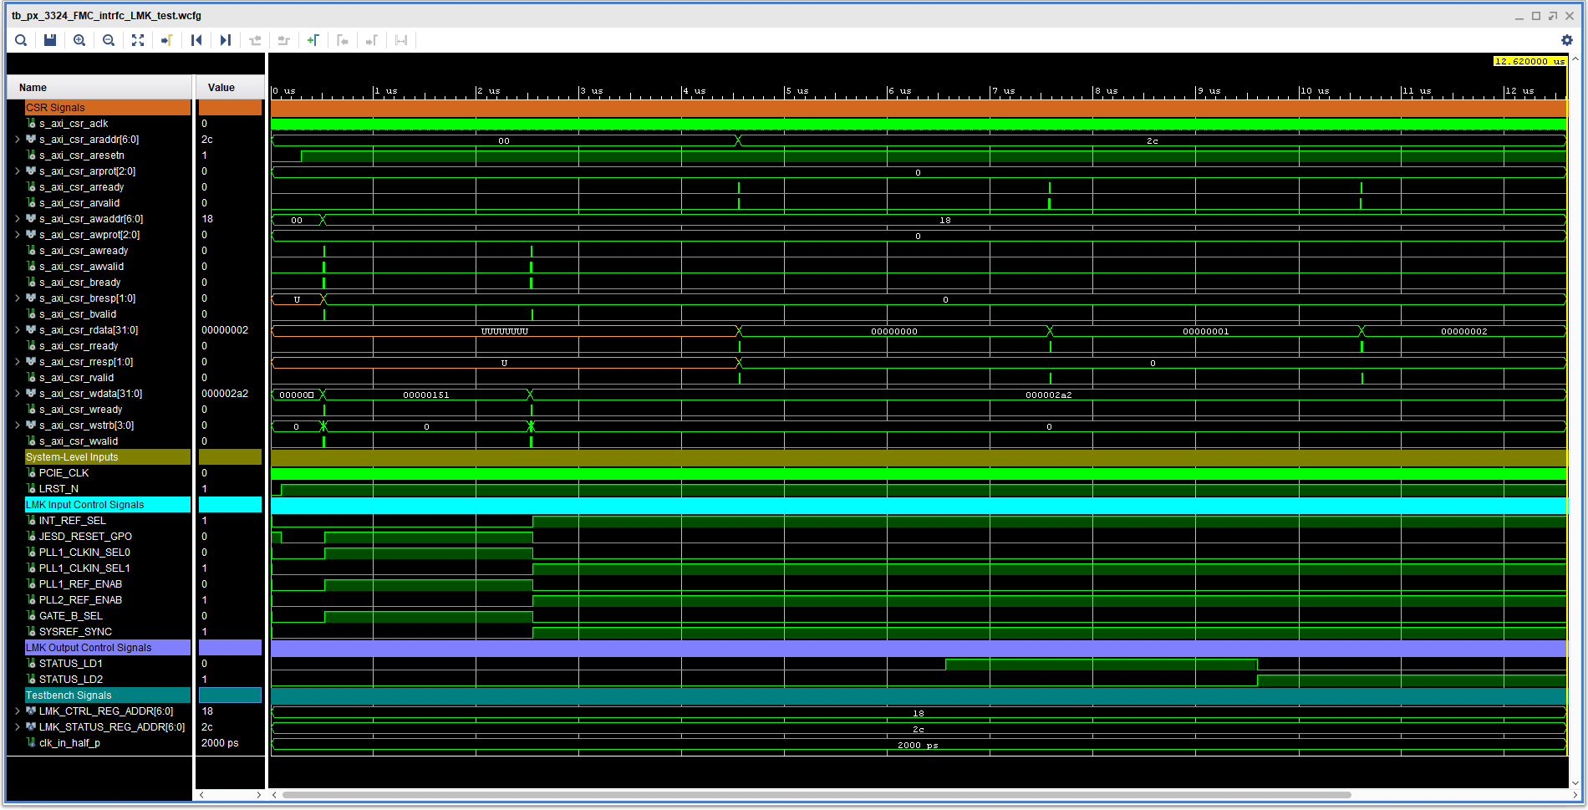

  - Synthesis and Implementation
For details about synthesis and implementation see the Vivado Design Suite User Guide - Designing with IP.

