AXI4-Stream DAC Data Flow Control IP
Type 2

DAC Data Flow Control Type-2 Core controls the flow of input data AXI4-Streams and timing event AXI4-Streams, and generates a packed Data/Timestamp/Information output AXI4-Stream, where the start and end of packet are controlled either by a gate signal or trigger signal. This core is a Data Flow Control Type-2 Core which accepts input data with only single sample-per-clock-cycle, and has a 64-bit data output. This core generates a data acquisition gate signal based on the selected source (gate/trigger) to control the data flow, and generates output data synchronized to the acquisition gate.

This core complies with the ARM AMBA AXI4 Specification and also provides a control/status register interface. This user manual defines the hardware interface, software interface, and parameterization options for the AXI4-Stream DAC Data Flow Control Type-2 Core.

Features
- Supports 16-bit I/Q packed, or 16-bit real input data streams
- Supports only single-sample-per-clock-cycle input data streams
- Register access through AXI4-Lite interface
- Start and end of packet can be controlled by gate or trigger which is user-defined
- User-programmable trigger length, trigger delay, and timestamp range
- Generates interrupts for start and end of acquisition gate
- Supports user-defined gate signal

- : Overview

  - Functional Description

The DAC Data Flow Control Type-2 Core (Pentek AXI4-Stream DAC Data Flow Control Type-2 Core) accepts input data AXI4-Streams from a DMA Core, and Timing Event data streams from a Pentek Sync Bus Interface Core in the user design. The core generates combined Data/Timestamp/Information AXI4-Streams, which include sample data with a time-aligned copy of the timing events (gate, sync, PPS), and data information (see Section 3.2). This core does not support timestamp information. This core has a Register Space which includes the control, status, and interrupt registers, which can be accessed using an AXI4-Lite Interface as shown in Figure 1-1.

The DAC Data Flow Control Type-2 Core generates a data acquisition gate signal to control the data flow based on the mode select bits defined in the Mode Control Register of the core (see Section 4.1). The DAC Data Flow Control Type-2 Core can operate in three modes, where each mode defines the source of the data acquisition gate signal.

• Gate mode: The data acquisition gate signal is generated from the input gate signal or a user-defined gate signal. Users can define a gate signal by enabling the local gate mode in the Mode Control Register, and then defining the local gate bit (see Table 4-2).

• Trigger mode: The gate input signal is used as a trigger to generate a data acquisition gate signal which has a trigger delay and trigger length defined by the control registers in the Register Space (see Chapter 4).

• Trigger Hold mode: The gate input signal is used as a trigger to generate a data acquisition gate signal which remains active until the Trigger Control State Machine is reset.
The DAC Data Flow Control Type-2 Core has a Trigger Control State Machine which is used to generate the packetized data output for the acquisition gate period. The Mode Control Register is used to control the Trigger Control State Machine (see Table 4-2). The DAC Data Flow Control Type-2 Core also provides edge detection of the active data acquisition gate period for use in creating gate event interrupts.

Figure 1-1 is a top-level block diagram of the Pentek AXI4-Stream DAC Data Flow Control Type-2 Core. The modules within the block diagram are explained in the later sections of this user manual.

Figure 1-1: Pentek AXI4 AXI4-Stream DAC Data Flow Control Type-2 Core
Block Diagram

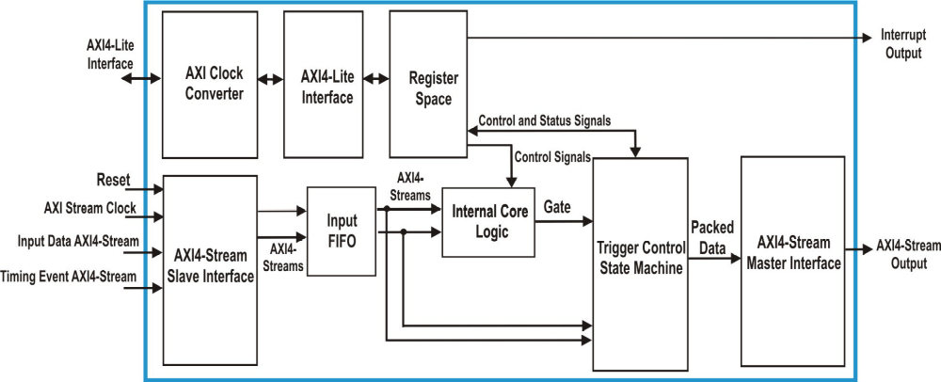

  AXI4-Lite Interface: This module implements a 32-bit AXI4-Lite Slave Interface to access the Register Space. For additional details about the AXI4-Lite Interface, refer to Section 3.1 AXI4-Lite Core Interfaces.

❑ Register Space: This module contains the control and status registers including Interrupt Enable, Interrupt Flag and Interrupt Status registers. Registers are accessed through the AXI4-Lite interface.

❑ AXI4-Stream Interfaces: The DAC Data Flow Control Type-2 Core has three AXI4-Stream Interfaces. At the input, two AXI4-Stream Slave Interfaces are used to receive input AXI4-Streams and at the output an AXI4-Stream Master Interface is used to transfer packed AXI4-Streams through the output ports. For more details about the AXI4-Stream Interfaces refer to Section 3.2 AXI4-Stream Core Interfaces.

❑ Input FIFO: This FIFO is used as a clock crossing FIFO for the input data AXI4-Stream to convert from the PCIe clock domain to the DAC clock domain. The incoming AXI4-Stream data from the DMA will be in the PCIe clock domain.

❑ Trigger Control State Machine: This state machine is used to generate packed output data streams based on the acquisition gate, and the values defined in the Mode Control Register. This state machine has three states:

• Reset - The Reset state resets the state machine based on the input reset signal (s_axis_aresetn) from the input AXI4-Stream Slave Interface.

• Wait for Trigger Arm - When the state machine is in the Wait for Arm state, it waits for the trigger arm signal, from the mode control register, to go High.

• Armed - Once in the Armed State, the core waits for the data acquisition gate signal to go High when a valid input is available on the input AXI4-Stream Slave Interface. When the acquisition gate signal goes High, output packed data streams are generated based on the data mode selected.

  - Applications

The AXI4-Stream DAC Data Flow Control Core Type 2 can be incorporated into any Kintex Ultrascale FPGA where data flow control and packetization of the input AXI4-Stream is required.

  - System Requirements

For a list of system requirements, see the Vivado Design Suite Release Notes.

  - Licensing and Ordering Information

This core is included with all Pentek Navigator FPGA Design Kits for Pentek Jade series board products. Contact Pentek for Licensing and Ordering Information (www.pentek.com).

  - Contacting Technical Support

Technical Support for Pentek’s Navigator FPGA Design Kits is available via e-mail (fpgasupport@pentek.com) or by phone (201-818-5900 ext. 238, 9 am to 5 pm EST).

  - Documentation
      - Vivado Design Suite User Guide: Designing with IP
      - Vivado Design Suite User Guide: Programming and Debugging
      - ARM AMBA AXI4 Protocol Version 2.0 Specification

- : General Product Specifications

  - Standards

The AXI4-Stream DAC Data Flow Control Type-2 Core has bus interfaces that comply with the ARM AMBA AXI4-Lite Protocol Specification and the AMBA AXI4-Stream Protocol Specification.

  - Performance

The performance of the DAC Data Flow Control Type-2 Core is limited only by the FPGA logic speed. The values presented in this section should be used as an estimation guideline. Actual performance can vary.

    - Maximum Frequencies

The DAC Data Flow Control Type-2 Core has two incoming clock signals, the AXI4-Stream clock and AXI4-Lite Interface CSR clock, and both of these clocks have a maximum frequency of 250 MHz on a Kintex Ultrascale -2 speed grade FPGA. Note that 250 MHz is typically the PCI Express (PCIe) AXI bus clock frequency.

  - Resource Utilization

The resource utilization of the DAC Data Flow Control Type-2 Core is shown in Table 2-1. Resources have been estimated for the Kintex Ultra-scale XCKU060 -2 speed grade device. These values were generated using the Vivado Design Suite.

Table 2-1: Resource Usage and Availability
Resources | # Used
LUTs | 831
Shift-Register LUTs | 5
Memory LUTs | 5
Flip-Flops | 2,460
Block Ram | 8.5
DSP | 2
NOTE: Actual utilization may vary based on the user design in which the DAC Data Flow Control Type-2 Core is incorporated.

  - Limitations and Unsupported Features

  This core supports only single-sample-per-clock-cycle data streams.

  The input data streams must be either 16-bit real or 16-bit I/Q packed values.

  This core does not provide timestamp information in the output data streams.

  - Generic Parameters

This section is not applicable to this IP core.

- : Port Descriptions

This chapter provides details about the port descriptions for the following interface type:

• AXI4-Lite Core Interfaces

• AXI4-Stream Core Interfaces

• I/O Signals

  - AXI4-Lite Core Interfaces

The AXI4-Stream DAC Data Flow Control Type-2 Core uses the Control/Status Register (CSR) interface to control, and receive status from, the user design.

    - Control/Status Register (CSR) Interface

The CSR interface is an AXI4-Lite Slave Interface that can be used to access the control and status registers in the DAC Data Flow Control Type-2 Core. Table 3-1 defines the ports in the CSR interface. See Chapter 4 for a Control/Status Register memory map and bit definitions. See the AMBA AXI4-Lite Specification for more details on operation of the AXI4-Lite interfaces.

- AXI4-Lite Slave Interface Port Descriptions0000.doc
Port | Direction | Width | Description
s_axi_aclk | Input | 1 | Clock
s_axi_aresetn | Input | 1 | Reset: Active low. This will reset all control registers to their initial states.
s_axi_csr_awaddr | Input | 12 | Write Address: Address used for write operations. It must be valid when s_axi_csr_awvalid is asserted and must be held until s_axi_csr_awready is asserted by the DAC Data Flow Control Type-2 Core.
s_axi_csr_awprot | Input | 3 | Protection: The DAC Data Flow Control Type-2 Core ignores these bits.
s_axi_csr_awvalid | Input | 1 | Write Address Valid: This input must be asserted to indicate that a valid write address is available on s_axi_csr_awaddr. The DAC Data Flow Control Type-2 Core asserts s_axi_csr_awready when it is ready to accept the address. The s_axi_csr_awvalid must remain asserted until the rising clock edge after the assertion of s_axi_csr_awready.
s_axi_csr_awready | Output | 1 | Write Address Ready: This output is asserted by the DAC Data Flow Control Type-2 Core when it is ready to accept the write address.The address is latched when s_axi_csr_awvalid and s_axi_csr_awready are high on the same cycle.
s_axi_csr_wdata | Input | 32 | Write Data: This data will be written to the address specified by s_axi_csr_awaddr when s_axi_csr_wvalid and s_axi_csr _wready are both asserted. The value must be valid when s_axi_csr_wvalid is asserted and held until s_axi_csr_wready is also asserted.
s_axi_csr_wstrb | Input | 4 | Write Strobes: This signal, when asserted, indicates the number of bytes of valid data on the s_axi_csr_wdata signal. Each of these bits, when asserted, indicate that the corresponding byte of s_axi_csr_wdata contains valid data. Bit 0 corresponds to the least significant byte, and bit 3 to the most significant.
s_axi_csr_wvalid | Input | 1 | Write Valid: This signal must be asserted to indicate that the write data is valid for a write operation. The value on s_axi_csr _wdata is written into the register at address s_axi_csr_awaddr when s_axi_csr_wready and s_axi_csr_wvalid are high on the same cycle.
s_axi_csr_wready | Output | 1 | Write Ready: This signal is asserted by the DAC Data Flow Control Type-2 Core when it is ready to accept data. The value on s_axi_csr_wdata is written into the register at address s_axi_csr_awaddr when s_axi_csr_wready and s_axi_csr_wvalid are high on the same cycle, assuming that the address has already or simultaneously been submitted.
s_axi_csr_bresp | Output | 2 | Write Response: The DAC Data Flow Control Type-2 Core  indicates success or failure of a write transaction through this signal, which is valid when s_axi_csr_bvalid is asserted;  00 = Success of normal access  01 = Success of exclusive access  10 = Slave Error  11 = Decode Error  Note: For more details about this signal refer to the AMBA AXI Specification.
s_axi_csr_bready | Input | 1 | Write Response Ready: This signal must be asserted by the user logic when it is ready to accept the Write Response.
s_axi_csr_bvalid | Output | 1 | Write Response Valid: This signal is asserted by the DAC Data Flow Control Type-2 Core when the write operation is complete and the Write Response is valid. It is held until s_axi_csr_bready is asserted by the user logic.
s_axi_csr_araddr | Input | 12 | Read Address: Address used for read operations. It must be valid when s_axi_csr_arvalid is asserted and must be held until s_axi_csr_arready is asserted by the DAC Data Flow Control Type-2 Core.
s_axi_csr_arprot | Input | 3 | Protection: These bits are ignored by the DAC Data Flow Control Type-2 Core.
s_axi_csr_arvalid | Input | 1 | Read Address Valid: This input must be asserted to indicate that a valid read address is available on the s_axi_csr_araddr. The DAC Data Flow Control Type-2 Core asserts s_axi_csr_arready when it is ready to accept the Read Address. This input must remain asserted until the rising clock edge after the assertion of s_axi_csr_arready.
s_axi_csr_arready | Output | 1 | Read Address Ready: This output is asserted by the DAC Data Flow Control Type-2 Core when it is ready to accept the read address. The address is latched when s_axi_csr_arvalid and s_axi_csr_arready are high on the same cycle.
s_axi_csr_rdata | Output | 32 | Read Data: This value is the data read from the address specified by the s_axi_csr_araddr when s_axi_csr_arvalid and s_axi_csr_arready are High on the same cycle.
s_axi_csr_rresp | Output | 2 | Read Response: The DAC Data Flow Control Type-2 Core indicates success or failure of a read transaction through this signal, which is valid when s_axi_csr_rvalid is asserted;  00 = Success of normal access  01 = Success of exclusive access  10 = Slave Error  11 = Decode Error  Note: For more details about this signal refer to the AMBA AXI Specification.
s_axi_csr_rvalid | Output | 1 | Read Data Valid: This signal is asserted by the DAC Data Flow Control Type-2 Core when the read is complete and the read data is available on the s_axi_csr_rdata. It is held until s_axi_csr_rready is asserted by the user logic.
s_axi_csr_rready | Input | 1 | Read Data Ready: This signal is asserted by the user logic when it is ready to accept the Read Data.
irq | Output | 1 | Interrupt: This is an active high, edge-type interrupt output.

  - AXI4-Stream Core Interfaces

The DAC Data Flow Control Core has the following AXI4-Stream Interfaces, used to receive and transfer data streams:

  - Data Stream (PD) Interface: This is an AXI4-Stream Slave Interface used to receive data AXI4-Streams from a DMA Core in the user design.

  - Timing Events (PTCTL) Interface: This is an AXI4-Stream Slave Interface through which timing event data streams are received from the user design.

  - Combined Data/ Timestamp/ Information Stream (PDTI) Interface: This is an AXI4-Stream Master Interface of the core used to transfer combined data/timestamp/data information AXI4-Streams in the PDTI format.

    - Data Stream (PD) Interface

The AXI4-Stream DAC Data Flow Control Type-2 Core implements a Data Stream Interface across the input to receive AXI data streams from a DMA core in the user design. This is an AXI4-Stream Slave Interface. Table 3-2 defines the ports in the Data Stream Interface of the DAC Data Flow Control Type-2 Core. See the AMBA AXI4-Stream Specification for more details on the operation of the AXI4-Stream Interface.

Table 3-2: Data Stream Interface Port Descriptions
Port | Direction | Width | Description
s_axis_aclk | Input | 1 | Clock
s_axis_aresetn | Input | 1 | Reset: Active Low.
s_axis_pd_tdata | Input | 256 | Input Data
s_axis_pd_tvalid | Input | 1 | Input Data Valid: Asserted when data is valid on s_axis_pd_tdata.
s_axis_pd_tkeep | Input | 32 | Data Keep: The tkeep signal indicates the valid data sample bytes on s_axis_pd_tdata. Each bit corresponds to a 8-bit word in s_axis_pd_tdata i.e., bit 0 corresponds to the least significant 8 bits and bit 1 to the most significant. When it is asserted, the data is considered valid. All tkeep bits must be ‘1’ contiguously until the tlast.
s_axis_pd_tlast | Input | 1 | Data Last: When asserted, this marks the last data in the current data frame.
s_axis_pd_tready | Output | 1 | Data Ready: The DAC Data Flow Control Type-2 Core asserts this signal when it is ready to receive data.

    - Timing Events (PTCTL) Interface

The AXI4-Stream DAC Data Flow Control Type-2 Core implements a Timing Events AXI4-Stream Slave Interface across the input to receive timing event data streams from the user design. Table 3-3 defined the ports in the Timing Events Interface of the DAC Data Flow Control Type-2 Core. See the AMBA AXI4-Stream Specification for more details on the operation of the AXI4-Stream Interface.

Table 3-3: Timing Events Interface Port Descriptions
Port | Direction | Width | Description
s_axis_aclk | Input | 1 | Clock
s_axis_aresetn | Input | 8 | Reset: Active Low.
s_axis_pctl_tdata | Input | 8 | Input Data: This is the timing event data and indicates the gate, sync and PPS positions:  tdata[0] - Gate positions  tdata[1] - Sync positions  tdata[2] - PPS positions
s_axis_pctl_tvalid | Input | 1 | Input Data Valid: Asserted when data is valid on s_axis_pctl_tdata.

    - Combined Sample Data/ Timestamp/ Information Streams (PDTI) Interface

The Pentek Jade series board products have AXI4-Streams that follow a combined Data/Timestamp/Information Stream (PDTI) format. This type of data stream combines sample data with its time-aligned timestamp and data information. There is an AXI4-Stream Master Interface across the output to transfer the generated output AXI4-Streams in the PDTI format. Table 3-4 defines the ports in the AXI4-Stream Master Combined Sample Data/ Timestamp/Information Stream Interface. See the AMBA AXI4-Stream Specification for more details on the operation of the AXI4-Stream Interface.

Table 3-4: Combined Sample Data/Timestamp/Information Streams Interface Port Descriptions
Port | Direction | Width | Description
s_axis_aclk | Input | 1 | AXI4-Stream Clock
s_axis_aresetn | Input | 1 | Reset: Active Low.
m_axis_pdti_tdata | Output | 64 | Output Data: This is the output data stream.  Packed Real Data: Real data is packed with four consecutive real samples stored in each 64-bit output data word:  First sample is placed in bits 47:32  Second sample is placed in bits 63:48  Third sample is placed in bits 31:16  Fourth sample is placed in bits 15_0  I/Q Packed Data or two-channel Real Data: I/Q packed data is packed with two consecutive samples of input data placed in each 64-bit word, or two dual-channel read data is packed in each 64-bit word:  m_axis_pdti_tdata (15:0) – I (second sample)  m_axis_pdti_tdata (31:16) – Q (second sample)  m_axis_pdti_tdata (47:32) – I (first sample)  m_axis_pdti_tdata (63:48) – Q (first sample)
m_axis_pdti_tvalid | Output | 1 | Output Data Valid: Asserted when data is valid on m_axis_pdti_tdata.
m_axis_pdti_tuser | Output | 128 | Sideband Information: This is the user-defined sideband information received alongside the data stream.  tuser [63:0] - Timestamp[63:0] - not supported  tuser [71:64] - Gate Positions  tuser [79:72] - Sync Positions  tuser [87:80] - PPS Positions  tuser [91:88] - Samples-per-clock-cycle  tuser[92] - I/Q data of the sample => 0 = I; 1 = Q  tuser [94:93] - Data Format => 0 = 8-bit; 1 = 16-bit;  2 = 24-bit; 3 = 32-bit  tuser [95] - Data Type => 0 = Real; 1 = I/Q  tuser [103:96] - channel [7:0]  tuser [127:104] - Reserved  Note: The bits [103:96] define the channel number in the user design from where the data is being received.

  - I/O Signals

The I/O port/signal descriptions of the top level module of the AXI4-Stream DAC
Data Flow Control Type-2 Core are discussed in Table 3-5.

Table 3-5: I/O Signals
Port/Signal Name | Type | Direction | Description
realtime_lost | std_logic | Output | Real Time Lost: This output signal is asserted (set to ‘1’) when the gate signal is active and the input FIFO of the core is empty. When this occurs the DAC Data Flow Control Type-2 Core will have discontinuous output data, and will result in losing real time.

- Register Space
This chapter provides the memory map and register descriptions for the Register Space of the AXI4-Stream DAC Data Flow Control Type-2 Core. The memory map is provided in Table 4-1.

- Register Space Memory Map
Register Name | Base Address (Base Address +) | Access | Description
Mode Control | 0x00 | R/W | Controls the mode select, data mode select, and state machine trigger arm signals
Trigger Clear | 0x04 | R/W | Controls the clear and disarm signals of the Trigger Control State Machine.
Trigger Delay Value | 0x08 | R/W | Controls the trigger delay value in Trigger mode.
Trigger Length Value | 0x0C | R/W | Controls the trigger length value in Trigger mode.
FIFO Flush | 0x10 | R/W | Controls the reset of the FIFO
Output Rate Divider | 0x14 | R/W | Control the output data rate
Reserved | 0x18 | N/A | Reserved
Reserved | 0x1C | N/A | Reserved
Status | 0x20 | R | Indicates status of the Trigger Control State Machine, the input FIFO, and the mode of operation of the core.
FIFO Count | 0x24 | R | Indicates the input FIFO dword count.
Interrupt Enable | 0x34 | R/W | Interrupt enable bits
Interrupt Status | 0x38 | R | Interrupt source status bits
Interrupt Flag | 0x3C | R/Clr | Interrupt flag bits

******** The register descriptions are identical to the ones for the ******** ******** px_axis_dacflowctl_1, so use the existing text, figures and ********
******** tables for this version. ********

- : Designing with the Core

This chapter includes guidelines and additional information to facilitate designing with the AXI4-Stream DAC Data Flow Control Type-2 Core.

  - General Design Guidelines
The AXI4-Stream DAC Data Flow Control Type-2 Core provides the required logic to control the input DAC data flow and generate packed output data streams. This IP core supports AXI4-Lite and AXI4-Stream user interfaces. The user can control the Trigger Control State Machine to generate the desired output by setting the required values of the control registers as described in Chapter 4.

  - Clocking

AXI4-Stream Clock: s_axis_aclk
This clock is used to clock all ports in the DAC Data Flow Control Type-2 Core.

CSR Clock: s_axi_csr_aclk
This clock is used to clock the input AXI4-Lite Interface of the core.

  - Resets

CSR Reset: s_axi_csr_aresetn
This is active low synchronous reset associated with the s_axi_csr_aclk. When asserted, the control/status registers and the interrupt registers are reset.

Main Reset: s_axis_aresetn
This is active low synchronous reset associated with the s_axis_aclk.

  - Interrupts

This core has an edge type (rising edge-triggered) interrupt output, which is synchronous with the s_axi_csr_aclk. On the rising edge of any interrupt signal, a one-clock-cycle-wide pulse is output from the core on the irq output. Each interrupt event is stored in two registers, accessible on the s_axi_csr bus.

The Interrupt Status Register always reflects the current state of the interrupt condition, which may have changed since the generation of the interrupt. The Interrupt Flag Register latches the occurrence of each interrupt, in a bit that retains its state until explicitly cleared. The interrupt flags can be cleared by writing ‘1’ to the associated bit’s location. All interrupt sources that are enabled (via the Interrupt Enable Register) are “OR ed” onto the irq output.

NOTE: All interrupt sources are latched in the Interrupt Flag Register, even when an interrupt source is not enabled (via the Interrupt Enable Register).

NOTE: Because this core uses edge-triggered interrupts, an interrupt condition which remains active after servicing will not cause the generation of a new interrupt. A new interrupt will only be generated by another rising edge on an interrupt source.

  - Interface Operation

CSR Interface: This is the Control/Status Register Interface and is associated with s_axi_csr_aclk. It is a standard AXI4-Lite Slave Interface. See Chapter 4 for the control register memory map, which provides more details on the registers that can be accessed through this interface.

Data Stream (PD) Interface: This core implements an AXI4-Stream Slave Interface across the input to receive AXI data streams and is associated with s_axis_aclk. For more details about this interface, refer to Section 3.2.1.

Timing Events (PTCTL) Interface: This is the interface through which timing events data is received across the input ports and is associated with s_axis_aclk. For more details about this interface, refer to Section 3.2.2.

Combined Sample Data/ Timestamp/ Information Streams (PDTI) Interface: This core implements an AXI4-Stream Master Interface across the output to transfer AXI PDTI streams and is associated with s_axis_aclk. For more details about this interface, refer to Section 3.2.3.

  - Programming Sequence

This section briefly describes the programming sequence of registers in the DAC Data Flow Control Type-2 Core.

1) Ensure that the Interrupt Flag Register is cleared.

2) Enable the Interrupt Enable Register bits based on the user design requirement.

3) Write the desired values to the control registers.

4) Observe the outputs across the outputs ports.

5) When done, check the Interrupt Flag Register and clear the interrupts.

  - Timing Diagrams

The timing diagram for the DAC Data Flow Control Type-2 Core is shown in Figure 6-3. This timing diagram is obtained by running the simulation of the test bench of the core in Vivado VSim environment. For more details about the test bench, refer to Section 6.5.

- : Design Flow Steps

  - Pentek IP Catalog

This chapter describes customization and generation of the Pentek AXI4-Stream DAC Data Flow Control Type-2 Core. It also includes simulation, synthesis, and implementation steps that are specific to this IP core. This core can be generated from the Vivado IP Catalog when the Pentek IP Repository has been installed. It will appear in the IP Catalog list as px_axis_dacflowctl_2_v1_0 as shown in Figure 6-1.

Figure 6-1: px_axis_dacflowctl_2_v1_0 in Pentek IP Catalog
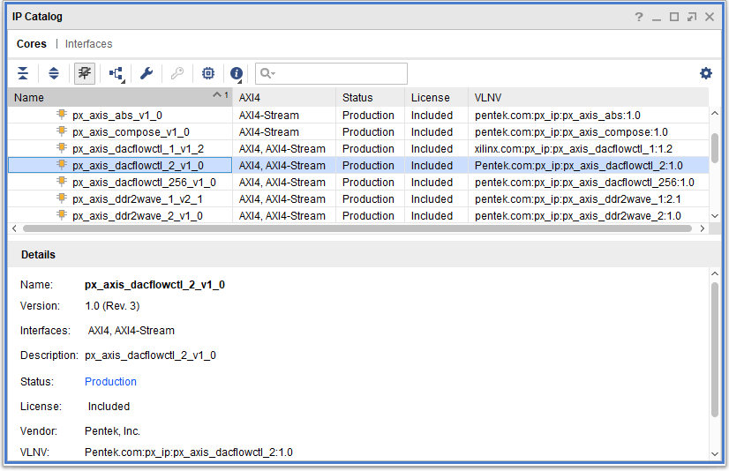

When you select the px_axis_dacflowctl_2_v1_0 core, a screen appears that shows the core’s symbol and the core’s parameters (see Figure 6-2). The core’s symbol is the box on the left side.

Figure 6-2: Pentek px_axis_dacflowctl_2_v1_0 Core IP Symbol

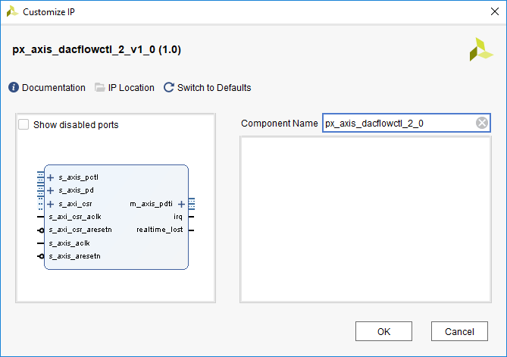

  - User Parameters

This section is not applicable to this IP core.

  - Generating Output

For more details about generating and using IP in the Vivado Design Suite, refer to the Vivado Design Suite User Guide - Designing with IP.

  - Constraining the Core

This section contains information about constraining the core in the Vivado Design Suite environment.

Required Constraints

The XDC constraints are not provided with this core. Clock constraints can be applied in the top-level module of the user design.

Device, Package, and Speed Grade Selections

This IP works for the Kintex Ultrascale FPGAs.

Clock Frequencies

The CSR clock (s_axi_csr_aclk) and AXI4-Stream clock (s_axis_aclk) can both take frequencies up to 250 MHz.

Clock Management

This section is not applicable for this IP core.

Clock Placement

This section is not applicable for this IP core.

Banking and Placement

This section is not applicable for this IP core.

Transceiver Placement

This section is not applicable for this IP core.

I/O Standard and Placement

This section is not applicable for this IP core.

  - Simulation

The Data Flow Control Core has a test bench which generates output waveforms using the Vivado VSim environment. The test bench is designed to run at 200 MHz AXI4-Stream clock frequency and 250 MHz CSR clock frequency.

The test bench provides control register values through a test_parameters.txt file. The parameter defined in the test_parameters.txt file is described in Table 6-1. The control registers within the core are written with the values from the text file and verified by reading from them.

Table 6-1: Test Parameters File Contents and Parameter Descriptions
Parameter | Type | Value | Description
mode_sel | std_logic_vector | 0x1 | Mode Select: This parameter is used to define the mode of operation of the core. It defines the source of the data acquisition gate signal generated by the core. (See Table 4-2)  0x0 = Gate mode  0x1 = Trigger mode  0x2 = Trigger Hold mode  0x3= Reserved
data_mode_sel | std_logic_vector | 0x0 | Data Mode Select: This parameter defines the  data type of the input data to the DAC Waveform  Generator Core.  0 = Single Sample Real Data  1 = Packed I/Q Data or two channel real data
stay_armed | Boolean | True | Stay Armed: When set to True, the Trigger Control State Machine is held in the armed state.
trigger_dly_value | std_logic_vector | 0x00000000 | Trigger Delay Value: This is the delay to be introduced to the data acquisition gate signal after a trigger event has occurred.
trigger_len_value | std_logic_vector | 0x00000100 | Trigger Length Value: This is the length of the data acquisition gate signal generated by the gate/trigger generator module.
output_rate_div | std_logic_vector | 0x00000000 | Output Rate Divider: This parameter defines the rate divider value of the output data.

The test bench has the core operating in the Trigger mode and data mode set to Single Sample Real data. Once the trigger control state machine is armed, the input data to the core is generated using an up counter starting from 0x0000. The acquisition gate trigger length is set to 256 AXI4-Stream clock cycles and has no trigger delay. When run, the simulation produces the results shown in Figure 6-3.

Figure 6-3: AXI4-Stream DAC Data Flow Control Type-2 Core
Test Bench Simulation Output
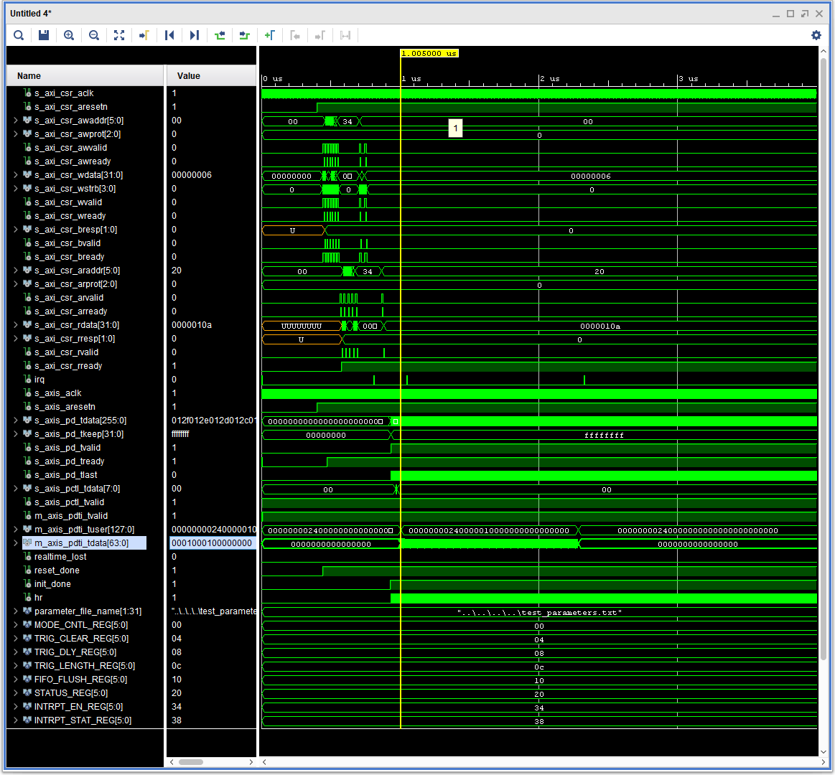

  - Synthesis and Implementation

For details about synthesis and implementation see the Vivado Design Suite User Guide - Designing with IP.

