**HCR Health Monitoring Card (HMC) Operation**

E. Loew

September 12, 2013

1. Theory of Operation

The HMC was developed by NCAR/EOL and built using the PCI mezzanine card (PMC) form factor. Its chief function is to control and monitor the EMS latching circulators, which protect the HCR LNAs during transmit. It accepts a 3 bit operational mode command from the Acromag PMC730 multi-function I/O card and returns EMS status to the card via the Distribution board. It also relays digital quadrature angle information from the rotation and tilt motor encoders to the Pentek 7142 digital transceiver card to allow for real-time position ingestion directly into the data stream.

A Xilinx Spartan-3A FPGA provides the intelligence for control and monitoring of the EMS circulators. A four state synchronous state machine running at 15.625 MHz provides control, while asynchronous processes monitor and report status. illustrates state machine behavior for the various operational modes. State S0 is the intitial state. During normal operation (no errors), the state machine will cycle through all four states each PRT.

*Table 1: HMC State Machine function for each Ops Mode*

|  |  |  |  |  |
| --- | --- | --- | --- | --- |
| Mode | S0 | S1 | S2 | S3 |
| **“000”**  (H-Tx; HV-Rx) | Set state of EMS switches, sets waveguide switch to correct position, disable noise source | Configure EMS switches for appropriate transmit mode | Enable Mod_Pulse to PSM, if EMS switches are in correct position | Configure EMS switches for appropriate receive mode |
| **“001”**  (V-Tx; HV-Rx) | Set state of EMS switches, sets waveguide switch to correct position, disable noise source | Configure EMS switches for appropriate transmit mode | Enable Mod_Pulse to PSM, if EMS switches are in correct position | Configure EMS switches for appropriate receive mode |
| **“010”**  (HHVV-Tx; HV-Rx) | Set state of EMS switches, sets waveguide switch to correct position, disable noise source | Configure EMS switches for appropriate transmit mode | Enable Mod_Pulse to PSM, if EMS switches are in correct position | Configure EMS switches for appropriate receive mode |
| **“011”**  (Corner reflector, reduced NF, Tx H) | Set state of EMS switches, sets waveguide switch to correct position, disable noise source | Configure EMS switches for appropriate transmit mode | Enable Mod_Pulse to PSM, if EMS switches are in correct position | Configure EMS switches for appropriate receive mode |
| **“100”**  (Noise source cal.) | Set state of EMS switches, sets waveguide switch to correct position, enable noise source | Configure EMS switches for appropriate transmit mode | Disable Mod_Pulse | Configure EMS switches for appropriate receive mode |
| **“101”**  (Corner reflector, reduced NF, Tx V) | Set state of EMS switches, sets waveguide switch to correct position, disable noise source | Configure EMS switches for appropriate transmit mode | Enable Mod_Pulse to PSM, if EMS switches are in correct position | Configure EMS switches for appropriate receive mode |
| **“110”**  (Test mode, PSM can be on or off) | Set state of EMS switches, sets waveguide switch to correct position, disable noise source | Configure EMS switches for appropriate transmit mode | Disable Mod_Pulse | Configure EMS switches for appropriate receive mode |
| **“111”**  (Unused) |  |  |  |  |

*Table 2: HMC State Machine valid condition for each state by Ops Mode*

|  |  |  |  |  |
| --- | --- | --- | --- | --- |
| Mode | S0 | S1 | S2 | S3 |
| **“000”**  (H-Tx; HV-Rx) | Entered upon reset, or EMS voltage levels not ok, or HV is off or 1 sec. delay is not complete or all range gates have been sampled (RX_GATE is ‘0’) | Entered when HV 1 sec. delay is complete, EMS voltage levels ok, T0 is ‘1’ and EMS_TRIG is ‘1’ | Entered when HV 1 sec. delay is complete, EMS voltage levels ok and EMS switch, tx status is ok | Entered when HV 1 sec. delay is complete, EMS voltage levels ok, and EMS switches have had sufficient time to switch (both Tx and Rx) |
| **“001”**  (V-Tx; HV-Rx) | Entered upon reset, or EMS voltage levels not ok, or HV is off or 1 sec. delay is not complete or all range gates have been sampled (RX_GATE is ‘0’) | Entered when HV 1 sec. delay is complete, EMS voltage levels ok, T0 is ‘1’ and EMS_TRIG is ‘1’ | Entered when HV 1 sec. delay is complete, EMS voltage levels ok and EMS switch, tx status is ok | Entered when HV 1 sec. delay is complete, EMS voltage levels ok, and EMS switches have had sufficient time to switch (both Tx and Rx) |
| **“010”**  (HHVV-Tx; HV-Rx) | Entered upon reset, or EMS voltage levels not ok, or HV is off or 1 sec. delay is not complete or all range gates have been sampled (RX_GATE is ‘0’) | Entered when HV 1 sec. delay is complete, EMS voltage levels ok, T0 is ‘1’ and EMS_TRIG is ‘1’ | Entered when HV 1 sec. delay is complete, EMS voltage levels ok and EMS switch, tx status is ok | Entered when HV 1 sec. delay is complete, EMS voltage levels ok, and EMS switches have had sufficient time to switch (both Tx and Rx) |
| **“011”**  (Corner reflector, reduced NF, Tx H) | Entered upon reset, or EMS voltage levels not ok, or HV is off or 1 sec. delay is not complete or all range gates have been sampled (RX_GATE is ‘0’) | Entered when HV 1 sec. delay is complete, EMS voltage levels ok, T0 is ‘1’ and EMS_TRIG is ‘1’ | Entered when HV 1 sec. delay is complete, EMS voltage levels ok and EMS switch, tx status is ok | Entered when HV 1 sec. delay is complete, EMS voltage levels ok, and EMS switches have had sufficient time to switch (both Tx and Rx) |
| **“100”**  (Noise source cal.) | Entered upon reset, or EMS voltage levels not ok, or HV is off or 1 sec. delay is not complete or all range gates have been sampled (RX_GATE is ‘0’) | Entered when EMS voltage levels ok, T0 is ‘1’ and EMS_TRIG is ‘1’ | Entered when EMS voltage levels ok and EMS switch, tx status is ok | Entered when EMS voltage levels ok, and EMS switches have had sufficient time to switch (both Tx and Rx) |
| **“101”**  (Corner reflector, reduced NF, Tx V) | Entered upon reset, or EMS voltage levels not ok, or HV is off or 1 sec. delay is not complete or all range gates have been sampled (RX_GATE is ‘0’) | Entered when HV 1 sec. delay is complete, EMS voltage levels ok, T0 is ‘1’ and EMS_TRIG is ‘1’ | Entered when HV 1 sec. delay is complete, EMS voltage levels ok and EMS switch, tx status is ok | Entered when HV 1 sec. delay is complete, EMS voltage levels ok, and EMS switches have had sufficient time to switch (both Tx and Rx) |
| **“110”**  (Test mode, PSM can be on or off) | Entered upon reset, or EMS voltage level not ok or all range gates have been sampled (RX_GATE is ‘0’) | Entered when EMS voltage levels ok, T0 is ‘1’ and EMS_TRIG is ‘1’ | Entered when EMS voltage levels ok and EMS switch, tx status is ok | Entered when EMS voltage levels ok, and EMS switches have had sufficient time to switch (Tx only) |
| **“111”**  (Unused) |  |  |  |  |

Table 2 shows the valid conditions which must be present at the inputs of each state of the state machine in order to advance to the next state. If the conditions are not met, the state machine returns to state 0 and waits for the next PRT. An error condition will also be logged.

1. Timing

EMS switch timing is shown in . It takes ~315 nanoseconds for the BITE status to be valid on a low to high transition of the EMS trigger command and ~294 nanoseconds for BITE status to be valid on a high to low transition of the command. As evidenced by the presence of the high going pulse of the detected RF signal (purple trace), the switches switch a minimum of 100 nanoseconds before the status BITE is valid. This provides a necessary operational safety factor.

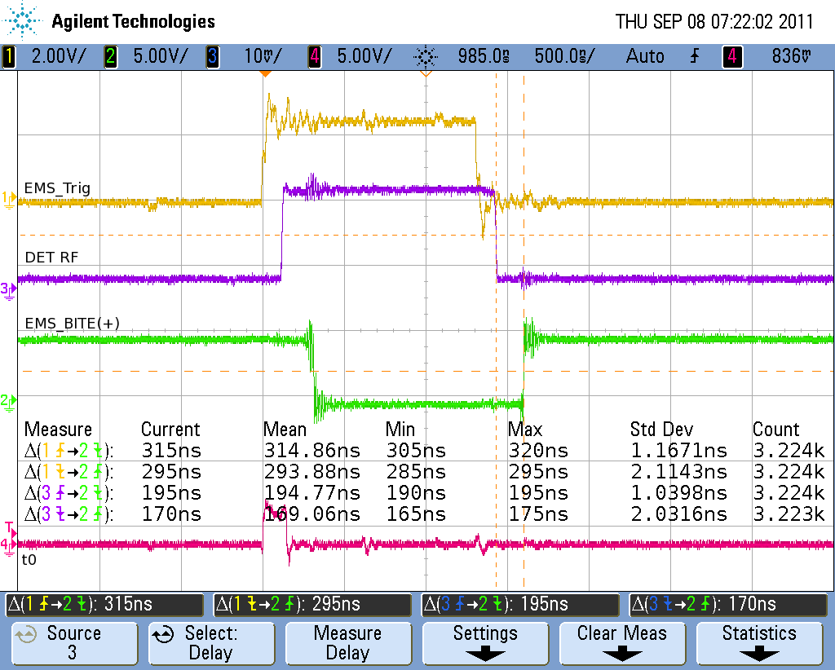

*Figure 1: EMS switch timing and EMS BITE timing*

Signal timing for a 256 nanosecond transmit pulse is shown in . Signal t0 initiates the timing and occurs each PRT. Signal tx_gate triggers the DAC on the Pentek to produce the transmit waveform. The transmit waveform is up-converted to W band and fed to the EIK. The detected RF signal is “envelope” of the transmitted pulse after it emerges from the EIK. Signal EMS_Trig indicates when the EMS switches are commanded into their transmit and receive positions. Similarly, shows the same timing signals for a 512 nanosecond pulse.

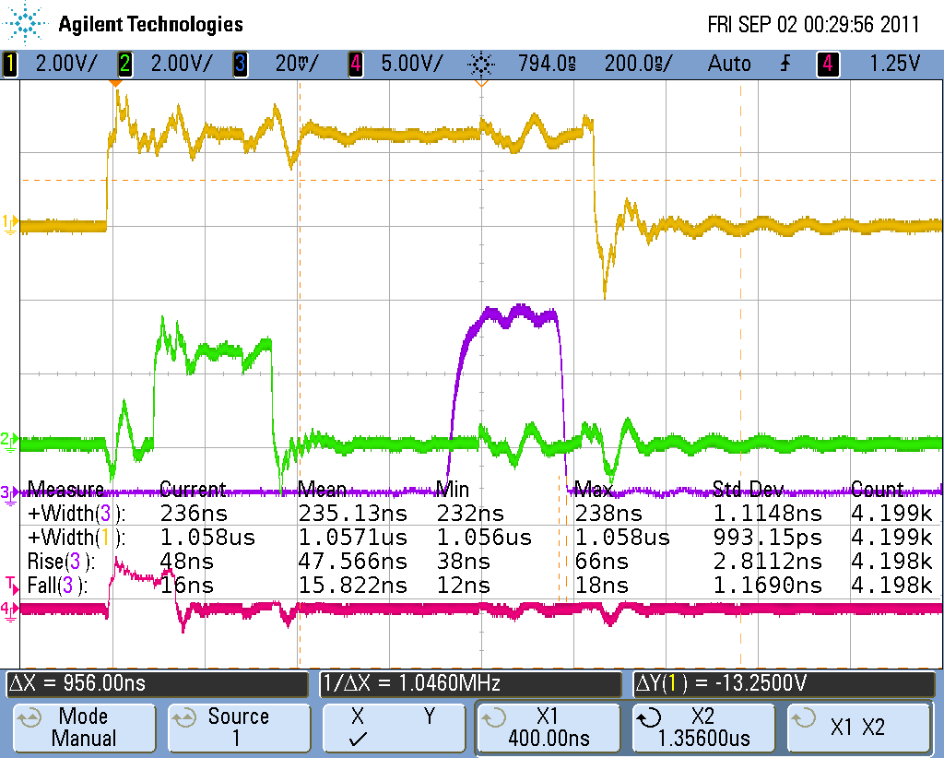

*Figure 2: Timing signals from HMC for a 256 nanosecond transmit pulse. The red trace is t0, the green trace is tx_gate, the purple trace is the detected RF and the yellow trace is EMS_trig.*

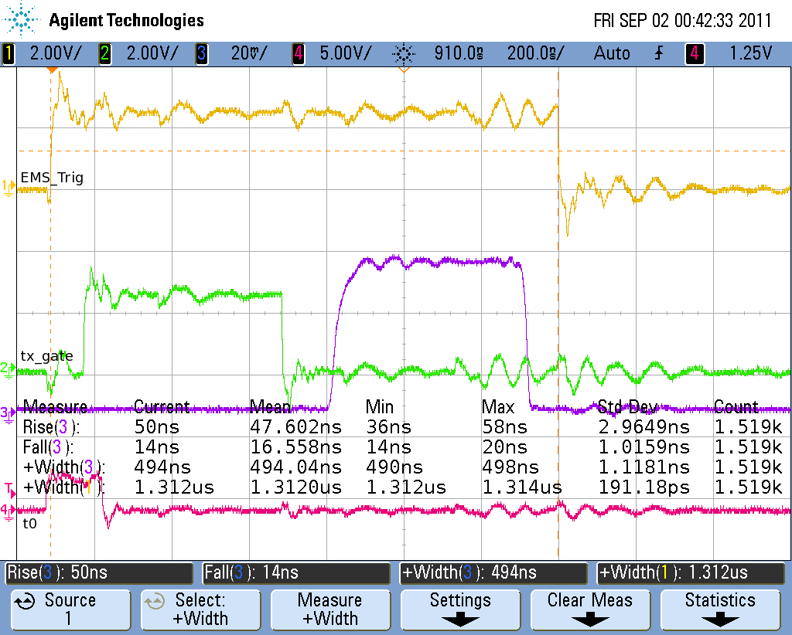

*Figure 3: Timing signals from HMC for a 512 nanosecond transmit pulse. The red trace is t0, the green trace is tx_gate, the purple trace is the detected RF and the yellow trace is EMS_trig.*