LFDI Software Repositories
Relationships and Current State — Narrative Overview
August 26, 2026
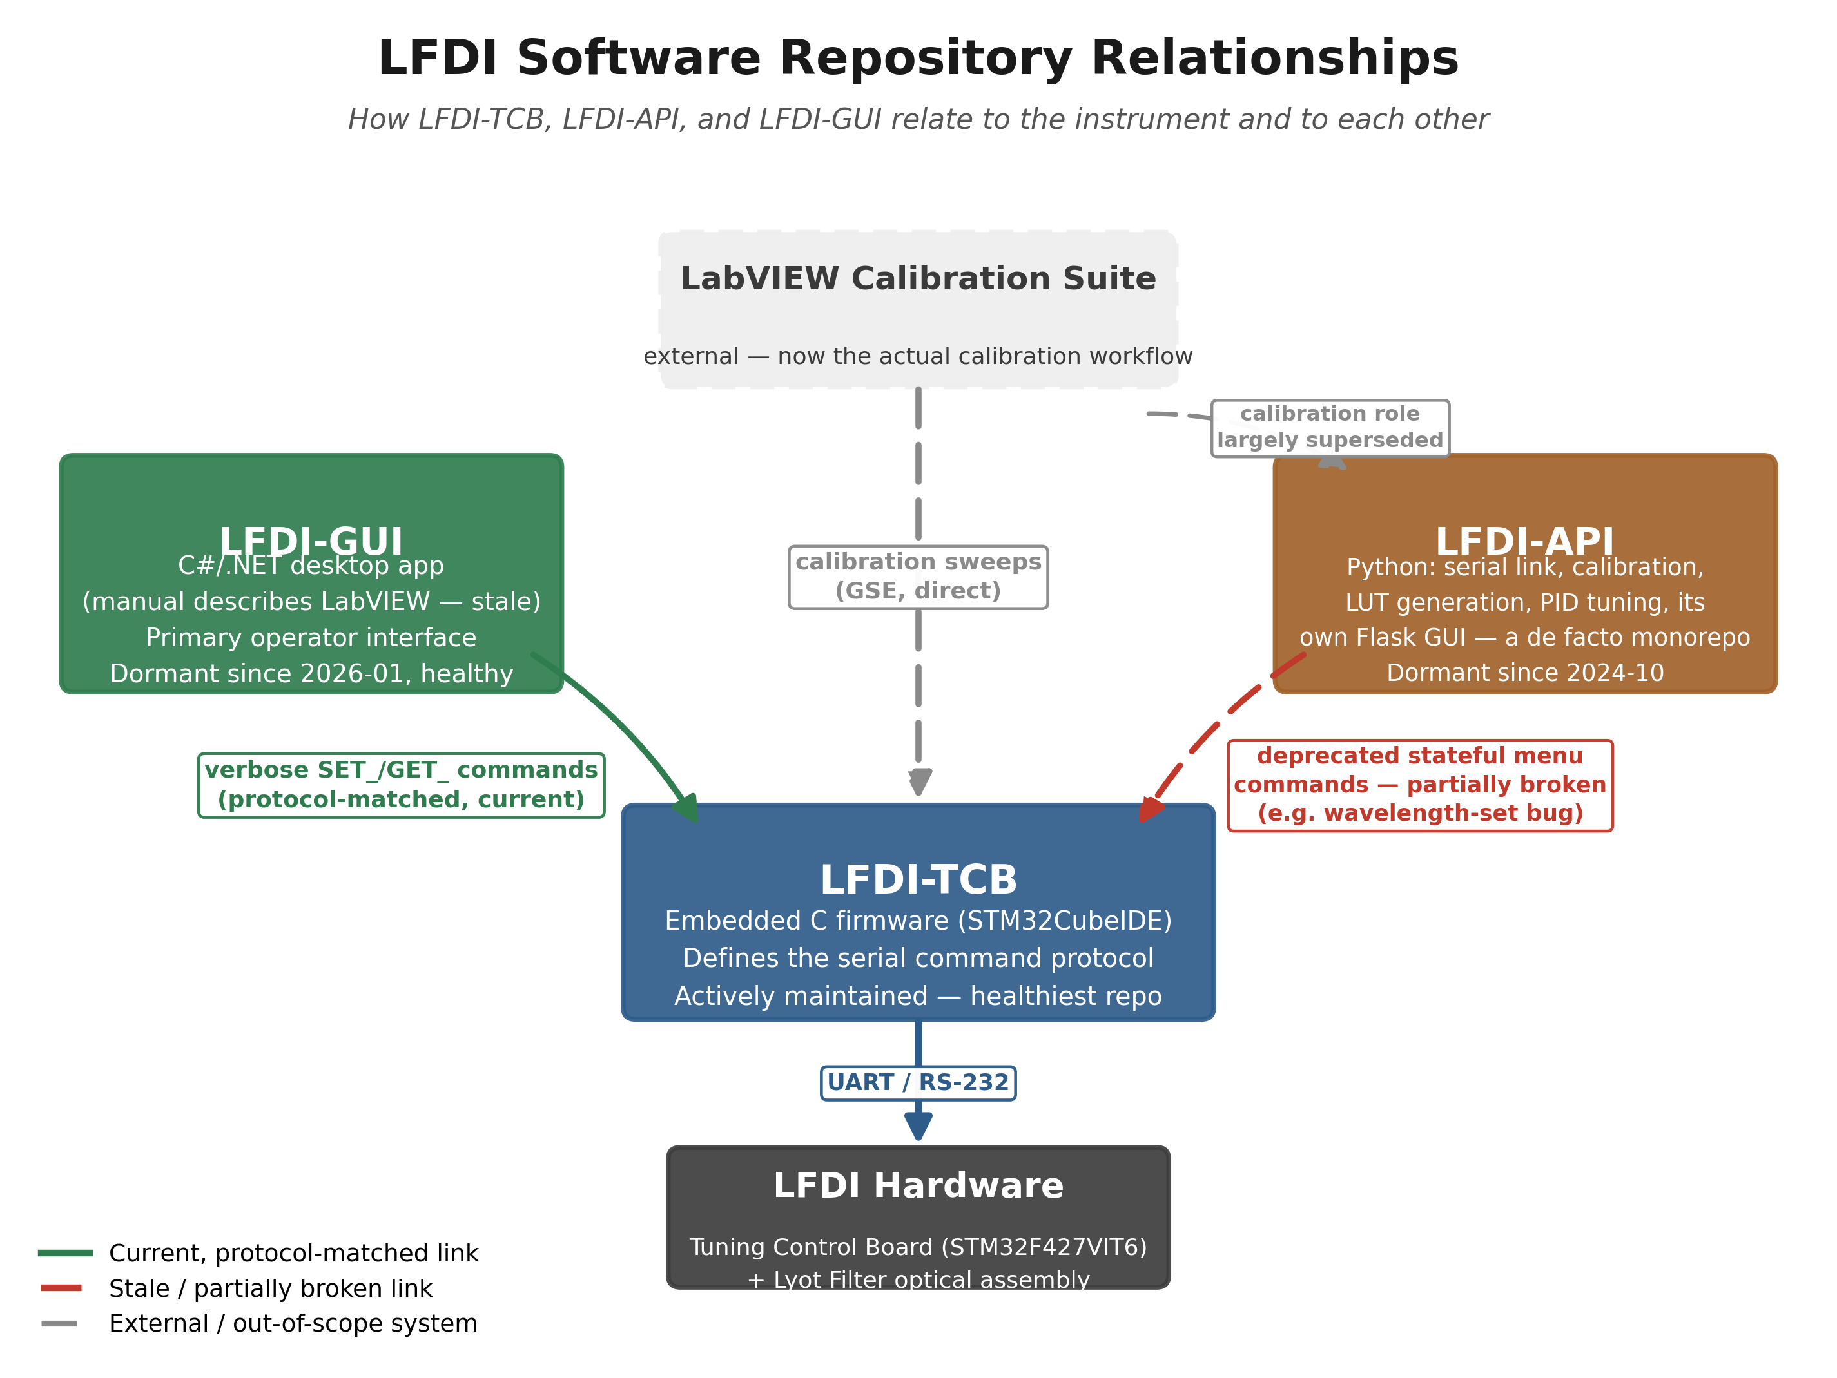
Figure 1. Command-protocol relationships between LFDI-GUI, LFDI-API, LFDI-TCB, the hardware, and the external LabVIEW calibration suite.

Overview
The Lyot Filter Demonstration Instrument (LFDI) is operated through three software repositories — LFDI-TCB, LFDI-GUI, and LFDI-API — plus an external LabVIEW calibration suite now maintained separately. The LFDI Operators Manual describes a cleaner four-part split (TCB firmware, a Python API, a distinct calibration repo, and a LabVIEW GUI) than what actually exists in the codebase today. A repository audit conducted August 25–26, 2026 found that the real boundaries have shifted: one repo absorbed far more scope than documented, one piece of documentation (the GUI's tech stack) is simply out of date, and a fourth documented repo (LFDI_Calibration) does not appear to exist as a separate codebase at all.

The Three Repositories

LFDI-TCB — the firmware, and the source of truth
LFDI-TCB is the embedded C firmware running on the Tuning Control Board's STM32F427VIT6 microcontroller. It matches the Operators Manual's description closely and is, by a clear margin, the most actively maintained of the three repositories, with real commits as recently as February 2026. It defines the serial command protocol that any client software must speak correctly to drive the instrument — heater PID control, LCVR tuning voltages, and housekeeping telemetry all flow through commands this firmware parses. Because it is the only repository that runs on the actual hardware, it is treated as the authoritative reference for “what the correct protocol is” when the other two repos disagree with each other.

LFDI-GUI — the real, current operator interface
LFDI-GUI is a C#/.NET desktop application. This corrects a stale claim in the Operators Manual, which describes the operator GUI as a LabVIEW-built executable — that description no longer matches what is actually deployed. LFDI-GUI's serial commands were confirmed, command-for-command, to match current LFDI-TCB firmware exactly. It has been dormant since January 2026 but is not abandoned: it builds cleanly with no errors and shows no sign of being replaced by anything else. Of the two client applications, this is the one actually exercising the instrument's current, correct protocol.

LFDI-API — a dormant, broader-than-documented toolkit
LFDI-API was originally scoped, per the manual, as a Python API for serial commanding of the TCB. In practice it grew into a much broader toolkit: alongside a serial link, it contains calibration data collection code, LUT generation, PID tuning utilities, general data processing and plotting, and its own separate Flask-based web GUI. It has been dormant since October 2024 — roughly 22 months at the time of the audit — making it the least actively maintained of the three repositories. Its serial command layer was found to rely on an older, deprecated command style that current firmware only partially tolerates; one concrete consequence is a wavelength-tuning command that is effectively restricted to a narrow ≈656–657 nm band along the path LFDI-API uses, versus the unrestricted range available through the correct, current command form that LFDI-GUI already uses.

Assessment: Is LFDI-API Fundamental to Instrument Operation?
No — the audit supports the view that LFDI-API is not fundamental to real-time operation of the Lyot filter system. LFDI-GUI and LFDI-TCB together already form a complete, protocol-current operational loop: LFDI-GUI issues the verbose, currently-supported command set, and LFDI-TCB's firmware executes it directly against the hardware. Nothing in that loop depends on LFDI-API.
LFDI-API's ongoing relevance has instead been concentrated in calibration data collection and processing — sweeping LCVR driving voltages, generating lookup tables, and producing the calibration curves referenced in the Operators Manual's tuning-compensation procedure. That role has now been superseded by a separate, purpose-built LabVIEW calibration suite maintained outside these three repositories, which the Operators Manual's own “LabVIEW Software GSE” section already documents as the calibration workflow (sweep VIs, LUT processing VIs, and the full statistical calibration VI). With calibration work moved there, LFDI-API's remaining unique contribution is smaller than its file footprint suggests.
Practical implication: LFDI-API can reasonably be treated as legacy — useful as a historical reference and possibly for its data-processing/plotting utilities, but not a dependency for operating the instrument day to day, and not currently safe to rely on for serial control given its stale, partially broken command layer. A deliberate decision (archive it, or keep it narrowly for non-serial utilities only) would remove the ambiguity the manual's outdated repo list currently creates.

Open Items
- Reconcile or retire LFDI-API's serial command layer (a reconciliation spec already exists: specs/SPEC_serial_protocol_reconciliation_2026-08-26.md in LFDI-API).
- Confirm no other consumer depends on LFDI-API's calibration/LUT code before considering it fully superseded by the LabVIEW suite.
- Update the Operators Manual to reflect LFDI-GUI's actual C#/.NET stack and the LabVIEW suite's separate repository status.
- Review three uncommitted, pre-existing working-tree edits in LFDI-API (Hardware_API/LFDI_API.py, LFDI_LUT_Data_Collection.py, Level2 Processing/Level2_Processing.py) before they are lost or conflict with future work.

