GIS Tutorial for

Atmospheric Sciences

***Jennifer Boehnert, National Center for Atmospheric Research***

***Paige Hoel, National Center for Atmospheric Research***

***J. Greg Dobson, University of North Carolina at Asheville***

© 2019 UCAR and UNC-Asheville.

***Adapted by:***

***Kevin Sampson, National Center for Atmospheric Research***

***License:***

This is an open access article under the terms of the Creative Commons Attribution-NonCommercial 3.0 Unported License, which permits all non-commercial use, distribution, and reproduction in any medium, provided the original work is properly cited.

***Changes Made:***

Adapted for region-specific geographic data.

**Section 1: Basic GIS Fundamentals**

Exercise 2

Exploring Spatial Data

Now that you have been introduced to the basic features and tools within ArcGIS Pro, let us take a closer look at the type of information you can visualize and analysis in ArcGIS Pro.

The main benefit of GIS is that it allows you to view, manage, store, edit, and analyze both spatial and non-spatial data. Spatial data are data that contain information about location. It can be stored in many different formats, such as shapefiles, Geodatabases, and raster datasets.

Sub-Sections in Exercise 2:

1. *Exploring data types in ArcGIS Pro*
2. *Working with vector data*
3. *Exploring raster datasets*
4. *Working with The Living Atlas*

Exploring data types in ArcGIS Pro

Spatial data represents features on the Earth, such as roads, lakes, and cities. Spatial data can also represent atmospheric phenomena such as temperature, humidity, and snowfall amounts. Working with spatial data in a GIS software package, such as ESRI ArcGIS Pro, can inform complex questions. For example, in Exercise 1, you mapped tornados recorded over the past 60 years. By using the Selection tool, you were able to see which States experienced the most tornadoes for certain years.

Spatial data are represented by two types of data models: vector and raster. Vector data represent discrete features such as points, lines, and polygons. Within a Geodatabase, GIS terminology refers to vector data as “feature classes.” A feature class is composed of a collection of features represented by the same geometry type; points, lines, or polygons, and containing similar attribute fields.

Raster data consists of cells organized in rows and columns. Raster or gridded data are commonly used for continuous fields such as elevation or temperature. Some common raster data examples are aerial photographs, satellite imagery, digital elevation models (DEM), and background images. Raster data are also commonly used for thematic data, such as land use, or for continuous data such as elevation, temperature, and radar.

In the next few steps you will explore feature classes and raster datasets.

1. Explore vector files in ArcGIS Pro

In this first step you will explore different types of vector datasets in ArcGIS Pro. Vector data represents real-world objects as discrete points, lines, or polygons (areas).

* Open **Exercise 2.aprx** that is located in<your working directory>\exercise2\maps_data**.**

In the center of the screen, you should see a map of the world. On the left, you will see the **Contents** pane, describing the layers (datasets) displayed in the map.

* In the upper left, click the **Basemap** button to activate basemap selection window.
* Choose Modern Antique Map.
* Explore other basemap options and select any basemap you would like.

There are 2 group layers called (Wildfires, and Regional Scale).

* In the **Contents** pane, open the **Wildfires** group layer by clicking the arrow.
* Turn on the **fireLocations_MODIS_2017 Locations** layers.
* Right click on **fireLocations_MODIS_2017 Locations** and **Zoom to Layer.**
* Turn off the **Wildfires** group layer.

A group layer is a grouping mechanism for layers displayed in your map.

* Close the **Wildfires** group layer.

You will now make a folder connection to our NCAR data server. We have many datasets on this server and it is a good place to start looking for data. You must be on the NCAR network (VPN if working remote).

* In the **Catalog** pane, navigate to **Folders,** right click and select **Add Folder Connection**.
* Connect to \\gisdata.ucar.edu\data and hit enter.
* Open the **data** folder.

You will see a number of folder. These are named based on data categories. Once you open the folders you will see many datasets.

* Open the folder **HydrologyAndWaterResources**.
* Open **HydroBasins** and **NorthAmerica**.
* Drag the layer **hybas_na_lev12_v1c** into the map.

The dataset with a green icon is called a shapefile. A shapefile is a vector type of data format that stores information about a single feature class. The geometry type of the shapefile can be seen in its icon – points , lines , and polygons .

**Shapefiles** are composed of a series of files that each performs a specific function to make the spatial layer work properly. In the previous exercise, you learned that Catalog View should always be used instead of Windows Explorer when managing data files. This is because the Catalog View is capable of displaying each shapefile as ONE single file whereas Explorer can only show all the individual files at once. If just one of these individual files is deleted, there is a chance of corrupting the shapefile.

A shapefile must have **at least three** of these files to be read correctly — **.shp, .dbf**, and .**shx**. While only three are necessary, many shapefiles, such as GlobalRivers.shp, are composed of more than three files. The additional files store information such as indexes, metadata, and projection information. The file types are as follows:

SHP - This file holds the feature geometry information.

DBF - This Dbase file holds the attributes associated with the features.

SBX, SBN, and SHX- These files are index files for faster searching and querying of the data.

PRJ - This is the file that holds the projection information about the shapefile.

XML - This is the metadata file.

* Turn off the HydroBasin layer.
* Click the button on the top Ribbon to zoom back to **Full Extent**.
* In the **Catalog** pane, type in **oceans** into the Search Project text box and click enter.

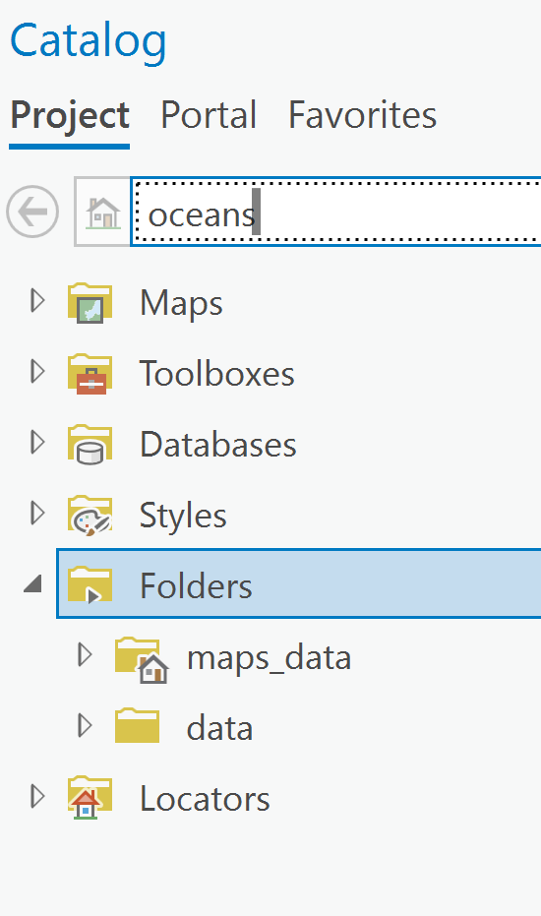

This search feature can help you locate data in the data folder if you are unsure where it may be located.

* Drag oceans into the map.

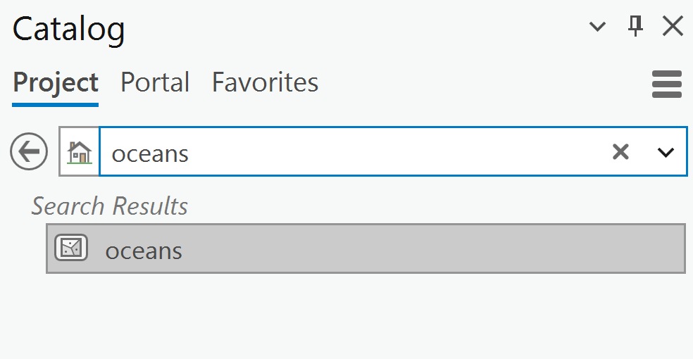

* Click the back arrow button to return to the folders.
* In the data folder, click on the **data** folder and then on Boundaries and add the cntry_ln_World2006 shapefile by dragging the layers into the map.
* Change the oceans symbology to be a nice light blue and make the **cntry_ln_World2006** symbology to be a **gray 40% 1 pt** line.

Your map should look similar to the one below.

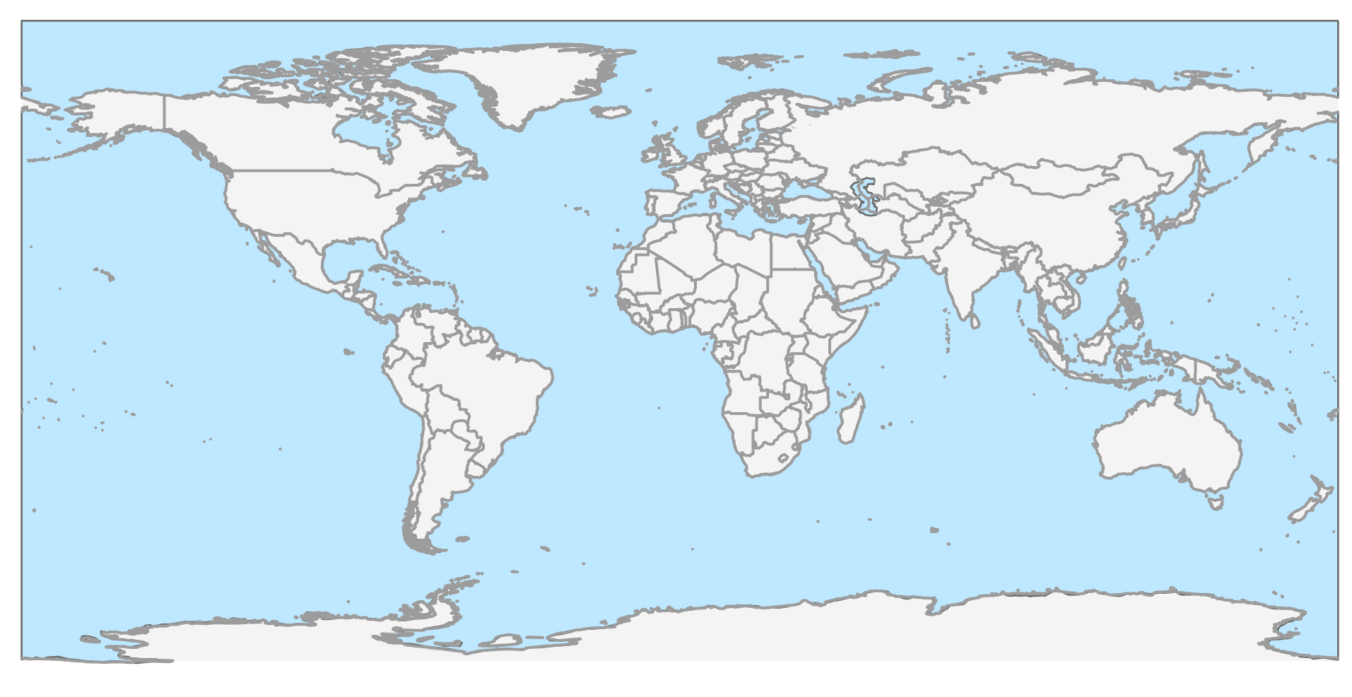

1. Explore feature classes in a file Geodatabase

A **Geodatabase** is an Esri proprietary data format for storing vector and raster data.

* Back in the Catalog pane, close the **data** folder.
* Open the **maps_data** folder and double click on Exercise 2.gdb.

A Geodatabase is composed of many files that hold attribute and spatial information, as well as indexes about the spatial data.

Inside this Geodatabase, there are several vector and raster datasets. These datasets are called “Geodatabase Feature Classes.” Feature classes are similar to shapefiles and can store points, lines, or polygons.

* Click on **allRivers** and add the data to the map and change the symbology to a blue color.

1. Explore raster data

Raster tables are structured differently than vector tables, raster datasets are composed of rows and columns of individual cells. Each of these cells is assigned a value.

* Click the Bookmarks button on the top Ribbon and select **US Drought**.
* Click **Add Data** button on the top Ribbon.
* Navigate to **Folders > data > CulturalSocietyAndDemography > LandScan2019**

This folder may take a few seconds to load.

* Add the dataset **daytime_subset.tif** to the map.
* Right click on daytime_subset.tif and select Symbology.
* In the Symbology pane click the three horizontal lines in the top right.
* Select Import from Layer File.
* Navigate to **Folders > data > CulturalSocietyAndDemography > LandScan2019** and select **daytime_subset.lyrx**
* Close the Symbology pane**.**

In this dataset is daytime population from LandScan. The data represent daytime population in the 30 meter grid cell.

* Right click on the layer **daytime_subset** layer and open the **Properties**.

Notice that the properties are different than those you saw in the shapefile and **Geodatabase** feature classes. Under the first tab, **General**, you can find information about the number of columns and rows, the cell size, and the projection information.

* Click on Source.
* Open the Raster Information to find the number of columns and rows as well as the cell size.
* Close the Properties dialog box.
* Move the layer in between Wildfires and Regional Scale.
* Turn off the population layer.
* Save your map.

You have just explored some of the most common vector and raster data formats used in GIS - shapefiles, Geodatabase feature classes, and raster datasets. In the next section you will display and analyze these datasets.

1. Explore layer properties

Once a dataset is added to ArcGIS Pro it is referred to as a layer. A layer is the visual representation of spatial data and contains information about the data source (e.g. shapefile or Geodatabase feature class), and how the data are displayed. You will now explore some of the layer properties in your map document.

* Double-click on the group layer Regional Scale in the Contents pane to open the **Group Layer Properties Window**.
* Click the General tab.

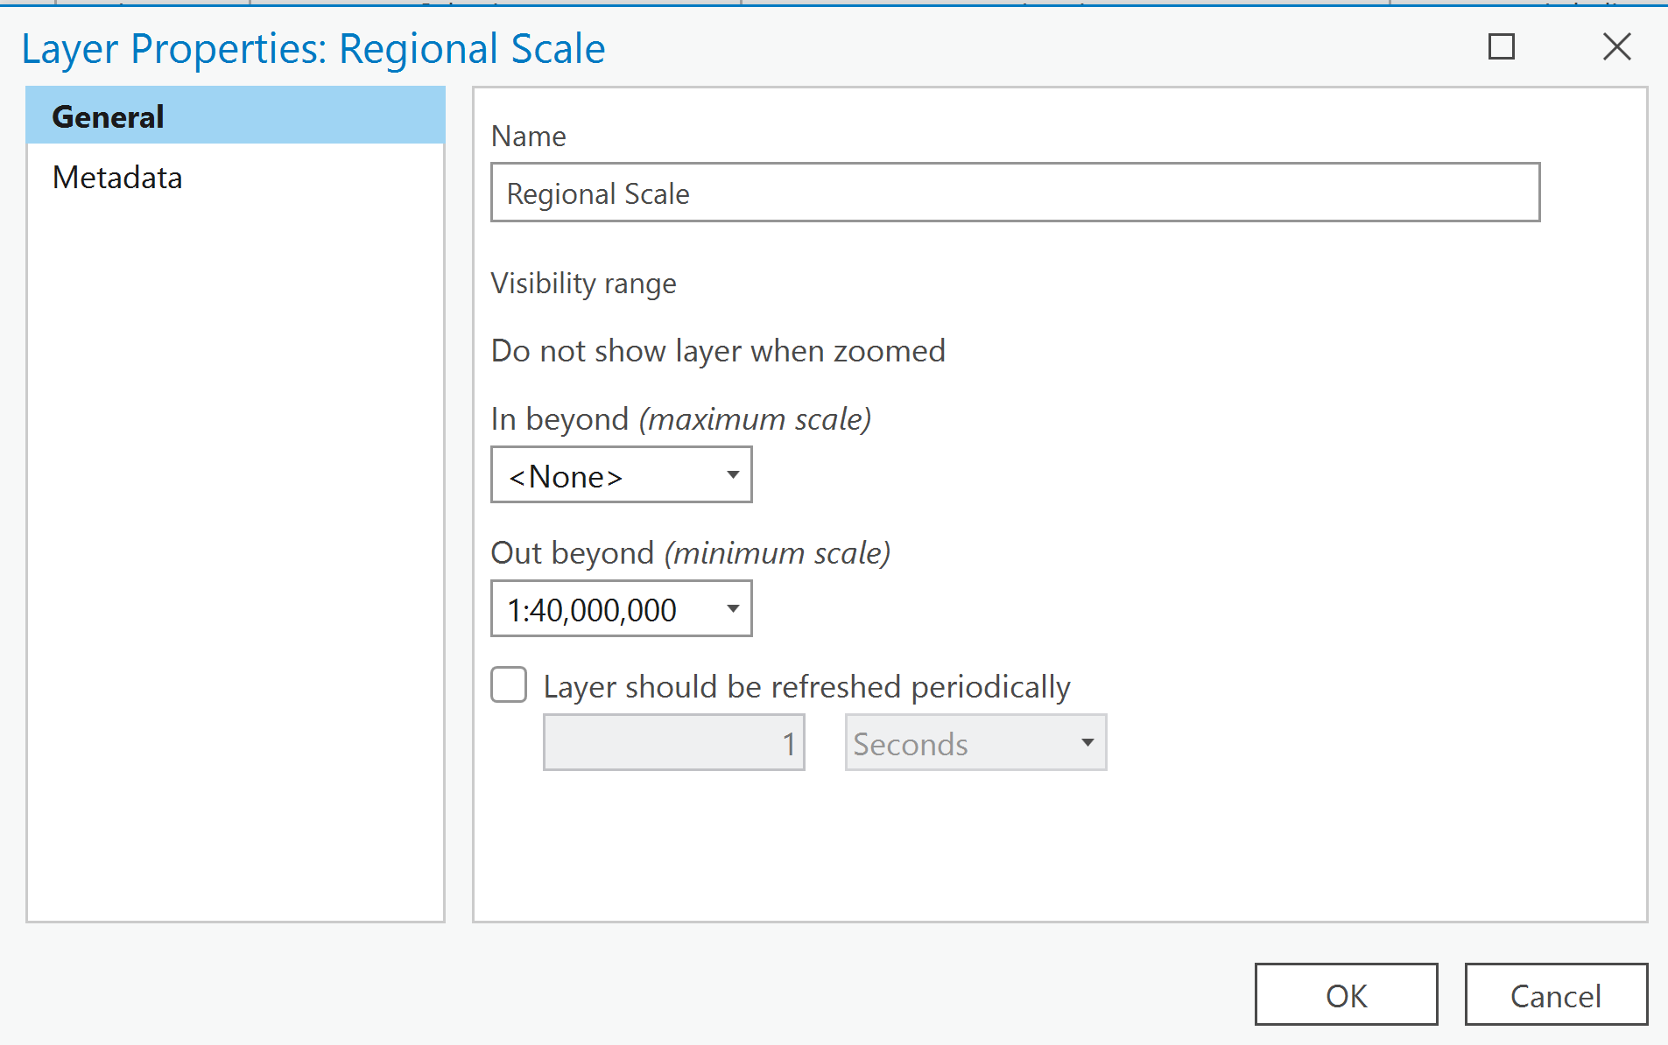

In the **Scale Range** box, a scale range is set for the data inside the group layer. A scale range is the scale at which data are visible. In this situation, the data in the **Regional Scale** group layer will turn on when zoomed in beyond 1:40,000,001. Because this property is set at the group-layer level, it is not necessary to set the same property at the feature-layer level; any data you add to this group layer will adopt this property.

**Map scale** is the relationship between the distances on a map compared to the distance on the ground. A map scale of 1:40,000,000 means that 1 unit on the map represents 40,000,000 units on the ground. It does not matter what the units are. They can be feet, meters, or miles; however, they must be same on the map as on the ground. In this example, you can think of 1:40,000,000 to be 1 cm on the map represents 400 km (40,000,000 cm) on the ground.

* Close the **Group Layer Property** window by clicking Cancel.
* Expand the group layer Regional Scale by clicking the arrow sign beside the name in the **Contents** pane.

Within this group, you’ll notice that the **Cities** layer is greyed out. This is because this layer has its own scale range set.

* Right click on **Cities** and open the Properties dialog box.
* Notice there are many tabs to the left.
* Click the **Source** tab.
* In the Source page click the **Spatial Reference** to see the projection of this data.
* Close the Properties dialog box.

Exploring raster datasets

1. Working with fire location data

In this step, you will look at the locations of wildfires in 2017 derived from MODIS satellite imagery. One of the costliest wildfires in California history was the Thomas Wildfire, which broke out in December 2017.This fire burned more 281,893 acres and claimed two lives. At the time, the Thomas Fire was the largest fire in California history.

* In the **Contents** pane, turn off the **landcover** layer.
* Expand the group layer Wildfires in the **Contents** pane.

This group layer contains fire locations’ datasets for 2017, a layer outlining Santa Barbara and Ventura County, and a gridded layers from satellite imagery (LandSat). First, you are going to explore the fire locations.

* Turn **Wildfire** back on.
* Right-click on the layer fireLocations_MODIS_2017 and select **Open Attribute Table**.

**TIP:** If you are interested to learn more about the fire locations MODIS data or downloading this yourself, visit the following website. <https://firms.modaps.eosdis.nasa.gov/>

The table contains information about each fire detected in 2017 via MODIS. In this quick analysis, you will investigate the number of fires in 2017 and where these fires occurred.

In the table below, write the number of fires detected in 2017 from the MODIS satellite.

HINT: the number of fires detected is the total number of features in each dataset.

|  |  |
| --- | --- |
| **Year** | **Number of Fires Detected** |
| 2017 |  |

* Close the **Attribute Table** window.
* In the **Map** tab click the **Locate** button, found in the **Inquiry** tab.
* In the search box, type in *Ventura County, CA*.
* Click the first result, to be zoomed to this location.
* Close the **Locate** pane.

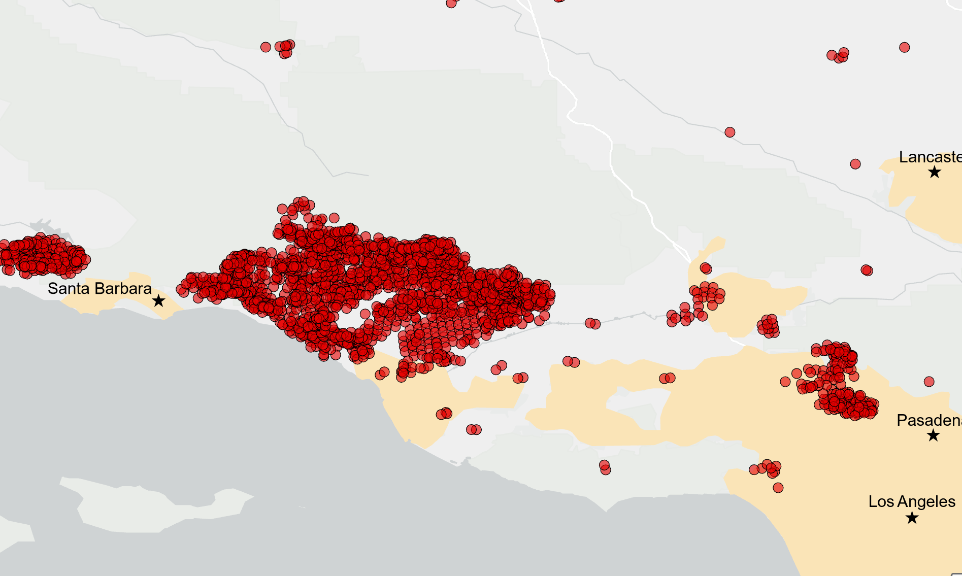

The red points are the fire locations detected in the MODIS imagery. The Thomas County wildfire burned mostly forested areas, shrub, and developed areas.

Many of these datasets can be found at EarthExplorer http://earthexplorer.usgs.gov/.

* Turn on the layer November 23rd, 2017 LandSat.

This is an image derived from a multispectral satellite dataset. That means that the data were captured at specific frequencies across the electromagnetic spectrum. This image of the area around the burn site is a helpful way to visualize what is happening on the ground.

* Turn off the fireLocations_MODIS_2017 layer.

The greens are forested regions, the pinks are crops, and the white/grey are urban areas. Notice that the region that experienced the Thomas fire is largely green.

* Turn off the November 23rd, 2017 LandSat layer and turn on the March 15th, 2018 LandSat layer.
* Turn the 2017 LandSat on and off to see the burn scares in this area.

This image was taken on March 15th, 2018, about two months after the fire burned. Notice the burn area from the Thomas fire is clearly visible.

*Do you see any other burn-scar areas visible in the satellite imagery that match a fire detection point from the MODIS file?*

1. Add data from the Living Atlas

* In the **Catalog** pane, click on the **Portal** tab.
* Select the last icon for the **Living Atlas**.
* Type in burn scars to the search box and click Enter.

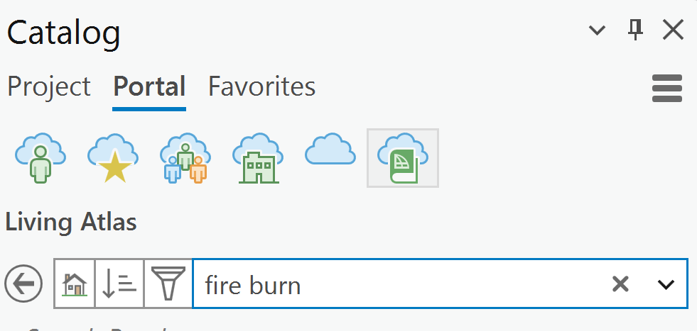

* Drag the dataset called **California Fire Perimeters 2017** into the map.
* Turn off the **Wildfires** group layer.
* Make sure the **Explore** tool is selected in the **Navigator** section on the ribbon.
* Make sure the **California Fire Perimeters 2017** is highlighted in the **Contents** pane.
* Click the Thomas Fire polygon.

Notice a dialog box will appear with information about the polygon that was clicked.

* Back in the Living Atlas search box type in **drought** and click Enter.
* Right click on the layer **US Drought Intensity 2000-present** and select add to current map.
* This is a group layer. Open the **US Drought Intensity** layer and turn on the first layer called **US_Drought**.

This is a layer that is time enabled. A time slider will appear at the top of your map.

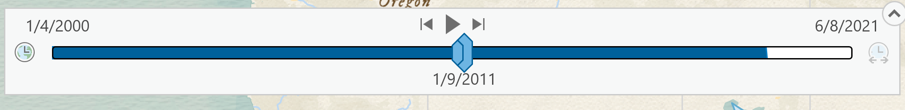

* **Enable** the time slider by clicking the button to the left of the slider.
* **Zoom out** so you can see California and Arizona**.**
* Slowly click the right arrow to move forward 1 time step.
* Keep clicking the right arrow using you get to March.

Sometimes these time enables layers can be slow depending on your internet speed. Notice that so far the area North of LA where the Thomas fire occurred was not in too much drought.

* Click the play button until 10/30/2001 and keep an eye on the area that the Thomas fire burnt in 2017.

Notice that this area was not in drought in the year 2000.

* Move the time location to be around 1/6/2016.
* Click the play button until 10/26/2016.

Notice that this area has been in extreme drought condition for quite a long time.

* Once you are finished exploring the data, click File > Save. Change the name on your new map to ThomasFire and save the project.

1. Exploring Elevation in the Living Atlas

In this step you will explore an elevation dataset that is available in the Living Atlas.

* In the Catalog pane, make sure Portal and the Living Atlas is selected.
* Enter the term **elevation** into the search box.
* Make sure you are zoomed into the bookmark **US Drought**.
* Turn off the **US Drought** layer.
* Right click on the layer **Terrain: Elevation Tinted Hillshade** and select **Add to Current Map**.
* Right click on the layer **Terrain: Elevation Tinted Hillshade** and select **Properties**.
* Select the **Processing Templates**.

This dataset has a number of different processing templates set up. A processing template allows you to generate new information on the fly.

* For the processing template select **Aspect Map** and click **OK**.
* Explore different processing templates available.
* When you are finished you can explore the Living Atlas on your own and then close ArcGIS Pro.