VAPOR User Interface Reference Manual

November, 2008

Version 1.4

Table of Contents

1 Introduction 4
1.1 Terminology and symbols. 4
2 VAPOR Main Menu capabilities 6
2.1 VAPOR main window layout 6
2.2 Main Menu bar 7
2.2.1 File Menu and the VAPOR session 7
2.2.2 Edit Menu 8
2.2.3 Data Menu 15
2.2.4 View Menu 18
2.2.4 Help Menu 18
3 Visualizers 20
3.1 Toolbars 20
3.1.1 Mouse Modes and the Mouse Mode Toolbar. 20
3.1.2 The VizTools toolbar 22
3.2 Visualizer features panel 23
4 Tabbed Parameter Panels 28
4.1 General settings of the tabbed panels 28
4.1.1 Scope 28
4.1.2 VAPOR Renderers and Renderer Control 29
4.1.3 Refinement 30
4.2 Viewpoint and Lights panel 31
4.3 Animation panel 33
4.4 Region panel 34
4.4.1 Settings in the region panel 35
4.4.2 Obtaining information about data and the current region 36
4.5 DVR panel 37
4.5.1 General DVR Settings 38
4.5.2 Transfer Function Editor 39
4.5.3 Additional DVR settings 41
4.6 Flow panel 42
4.6.1 Basic Flow Parameters 43
4.6.2 Advanced Flow Parameters 46
4.6.3 Flow Seeding Parameters 48
4.6.4 Shape Parameters 50
4.6.5 Color/Opacity map editing 50
4.7 Probe panel 53
4.7.1 Probe overview 54
4.7.2 General probe settings 55
4.7.3 Probe Position and Size 55
4.7.4 Flow Image Control 56
4.7.5 Probe Cross-Section view 57
4.7.6 Cursor (cross-hair) Selection and Usage 57
4.7.7 Appearance parameters 58
4.8 Isosurface Panel 59
4.8.1 General Isosurface settings 60
4.8.2 Isovalue selection 60
4.8.3 Isosurface appearance 61
4.9 Two-D Panel 61
4.9.1 General settings 62
4.9.2 Two-D position controls 63
4.9.3 Contour view 63
4.9.4 Point selection capabilities 63
4.9.5 Remaining capabilities 64

Introduction

This VAPOR User Interface Reference Manual provides a technical specification of the capabilities of the VAPOR User Interface, version 1.4. It is meant to be used in conjunction with other documentation, such as the VAPOR Quick Start Guide, the Visualization of WRF Data using VAPOR: A Georgia Weather Case Study, and the An Overview of VAPOR Data Collections. This manual specifies all the capabilities of the VAPOR user interface; however it does not describe how these capabilities are used. Read the VAPOR Quick Start Guide and the VAPOR Georgia Weather Case Study to understand the process of using the VAPOR User Interface in scientific analysis.

Terminology and symbols.
Underlining is used in this document to identify text that is a literal copy of the text in the user interface. Italics are used to identify terms that are being defined.

The user interface includes many editable text boxes. If the value can be edited the box is recessed, as in the following:
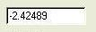
Usually you must press the <enter> key after changing the value in a text box for the change to take effect.

Text that is not editable is not recessed, as in:
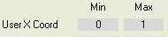

Combo boxes provide a means of selecting from a list of choices in a dropdown menu:
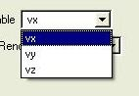

Buttons are used to trigger an action, and are also used to toggle an on/off state:
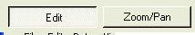

Often sliders are combined with text boxes, providing multiple means of controlling a single variable:

Check boxes are useful for controlling binary (on/off) state:
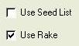

VAPOR Main Menu capabilities

VAPOR main window layout

When VAPOR is launched, the user interface appears as in Figure 2.1. Across the top of the window is the main menu bar, including the File, Edit, Data, View, Script, Animation, and Help menus. These menus enable the user to perform high level capabilities, such as reading files or controlling options in a VAPOR session. These menus are described in section 2.2.

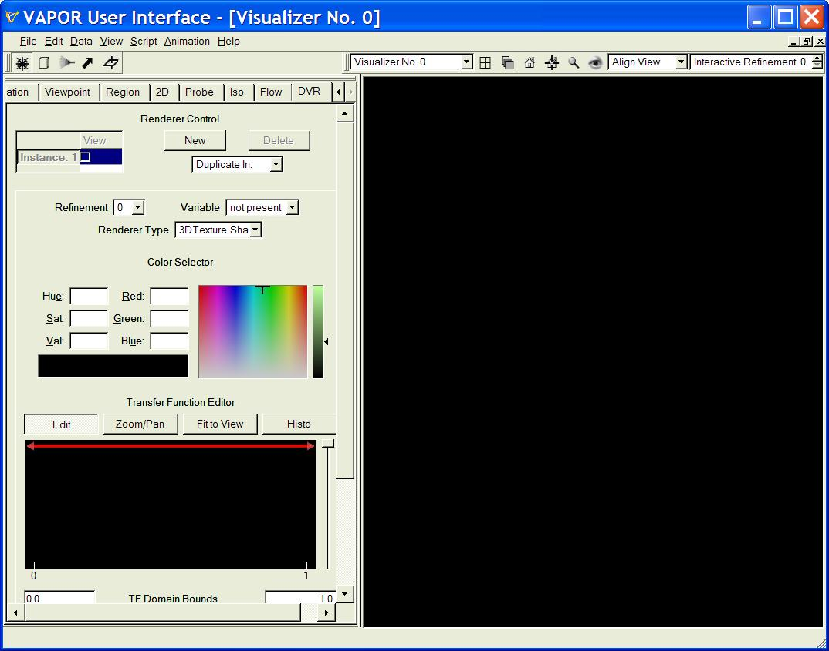
Figure 2.1: Vapor User Interface at start-up

Below the main menu bar are two toolbars, the Mouse Mode toolbar on the left, and the Visualizer toolbar on the right. These toolbars are described in Section 3.1.
The rest of the VAPOR main window is divided into two (left and right) halves. On the right side are visualizer(s), wherein VAPOR visualization is performed. The right side can be subdivided into many different visualizer windows, although initially (by default) it contains only one visualizer. The operation of the visualizers is described in Section 3.

On the left side of the main window are the tabbed parameter panels. These panels allow the users to specify all the various settings needed for controlling the visualizers. There are several different tabs at the top of the tabbed parameter panels, which can be used to select a set of parameters. These tabs (from left to right) are Animation, Viewpoint, Region, 2D, Probe, Iso, Flow, and DVR. The tabbed parameter panels are described in Section 4.

Main Menu bar

The main menu bar has seven dropdown menus, however, currently only five are implemented: (File, Edit, Data, View, and Help).

File Menu and the VAPOR session
The VAPOR File menu appears as follows:
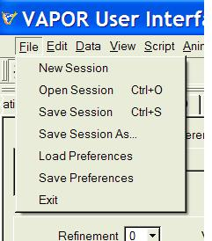
File Menu

The seven entries in the file menu relate to controlling the VAPOR session and specifying the user preferences, which persist between sessions. The session is the totality of settings established by the user during the VAPOR application. The session includes all of the current state of the VAPOR application, except for the following:

- User Preferences (discussed below)
- Window size and layout
- Visualizer contents (rendered images), discussed in section 3
- Mouse mode (discussed in section 3.1.1)
- Tabbed panel enabled/disabled state (discussed in section 4.1)
- History (queue) of commands executed (see 2.2.2)

The following are the seven choices in the File menu:

- New Session: This resets VAPOR to an initial default session, such as the session that results when you launch VAPOR.
- Open Session: This enables you to read a “Vapor Saved Session” (*.vss) file, and sets VAPOR to the settings in that session.
- Save Session: This saves the current session state in the current default session file. The session cannot be saved until a dataset has been loaded (see the Data menu, Section 3.2.3). Initially the session file is by default “VaporSaved.vss” in the current directory; however the default session file always refers to the most recent file name that was specified by either of the File menu options: Open Session or Save Session As.
- Save Session As: This requests the user to specify a file (name and path) and saves the current session state in the named file. The session cannot be saved until after a dataset has been loaded (see the Data menu, Section 2.2.3). On completion, the specified file becomes the default session file.
- Load Preferences: This reads user preferences from a ‘preference file’ (this file is by default named “.vapor_prefs”); however any user preferences file can be loaded here, if for example you would like to change between different user preference settings. By default, the user preferences are saved and loaded from the directory identified by the environment variable $(VAPOR_PREFS_DIR). If that variable is not defined, preferences are loaded from the directory $(HOME). If neither of the above are defined, the default preferences will be used. Setting the VAPOR_PREFS_DIR variable is useful if it is desired to use the preferences in a different environment from the standard environment; e.g. as a result of changing systems on which VAPOR is being used. A default preferences file is installed in the $(VAPOR_SHARE)/examples directory, but this preferences file may not be optimal for your use. Windows users: When you load or save preferences, if neither HOME nor VAPOR_PREFS_DIR are defined, then the $(VAPOR_SHARE)/examples directory is used as the default.
- Save Preferences: This saves the current preferences to a preferences file. When you change your preferences you may find it useful to save the new ones so that they will be loaded the next time Vapor is started.
- Exit: This ends the current session, exiting the VAPOR application.

Edit Menu
This menu has four entries: Undo .., Redo.., Edit Visualizer Features, and Edit User Preferences:
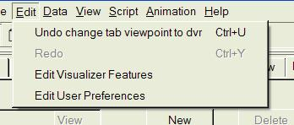
Edit Menu

- Undo… and Redo…: These control the session command queue. VAPOR maintains a history of the most recent 100 changes to the session state. Undo enables the user to move to the previous state. After clicking Undo one or more times, the user can return the session to following states by clicking Redo. The Undo option is disabled until an actual change has been made, and then a short descriptive phrase is provided after the word “Undo”, specifying the action that will be undone. The Redo option is only available after an Undo.
- Edit Visualizer Features: This launches a panel allowing the user to set various features of the visualizer windows. These will be discussed later (in section 3.2).
- Edit User Preferences. This launches the Set User Preferences Panel, shown below (in figure 2.1):

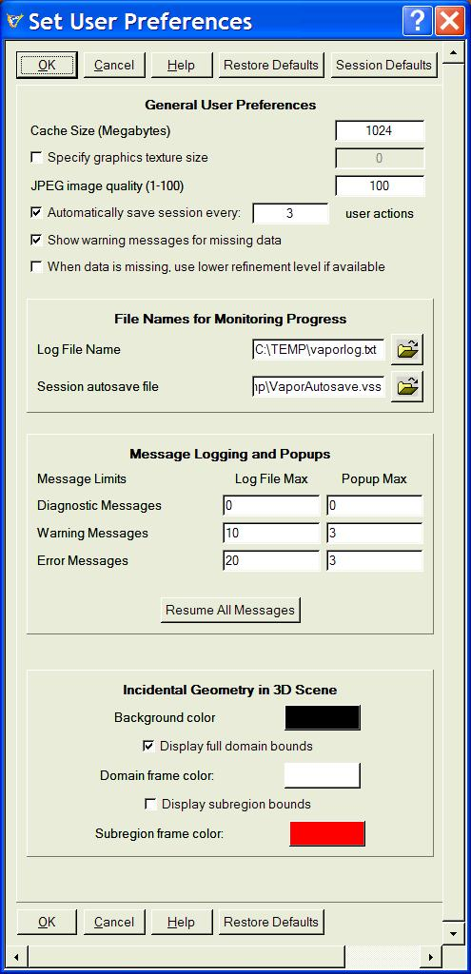
Figure 2.1: Basic User Preferences panel

At the top there are four buttons (four of which are repeated at the bottom):
- OK – to close and accept any changes made.
- Cancel – to close and ignore any changes made.
- Help - Changes to context-sensitive help mode. Click anywhere in the panel to get more information about a function of this panel.
- Restore Defaults – resets the user preferences to the initial defaults provided by VAPOR.
- Session Defaults – This expands the user preferences panel to a large panel, on which you can set the default values that VAPOR uses for some variables whenever a new session is started. The expanded panel, shown in figure 2.2, is described after that figure.

The top section, entitled General User Preferences, includes the following:
- Cache Size (Megabytes) : This specifies the amount of memory that will be used to store the most recent volume data that is being used by VAPOR, at the next Load Data operation. This should be set to a value near the amount of physical memory available for your use in your system.
- Graphics Texture Size: This consists of a checkbox and a text box. If the checkbox in unchecked, VAPOR will use a default value, which is usually adequate. However, on some platforms the rendering performance may be slow (due to the texture size being too small), or there may be rendering errors resulting from the value being too large. The value that is specified in the text box is the side of the largest cube of volume data that will be stored in the graphics memory.
- JPEG image quality (1-100): is a value between 1 and 100 specifying the level of quality in visualizer images saved (see the View menu, Section 2.2.4, below). Default value is 100.
- Automatically save session every…: This allows you to specify an interval (number of user actions) between automatic session saves. This is useful if you need to recover your VAPOR state after a crash or if you need to terminate the application abnormally. VAPOR can then be restarted with the most recent saved session file.
- Show warning messages for missing data: When this checkbox is un-checked, there will be no warning message when data is unavailable for a particular rendering. This is useful if you have a lot of missing data and would like to avoid annoying warning messages.
- When data is missing use lower refinement level if available: This is useful if you request a rendering for which the requested refinement level of a variable is not available, but for which a lower refinement lever is available. If this box is checked, the rendering will use the lower refinement level and will not display a warning message.

The second section, “File Names for Monitoring Progress”, allows you to specify the path and file name for:
- Log File: Specifies the name of a file that will contain any log messages (specified in the Message Logging and Popups below)
- Session Autosave File: The path to the file that is used for session auto-save files, when the “Automatically Save Session…” box is checked.

The third section, Message Logging and Popups, controls various console or log messages that are output during a VAPOR run; the messages that can result are of the following types:

- Diagnostic Messages are indications of actions performed. These are primarily for debugging. Hundreds or thousands of these are posted during a typical session.
- Warning Messages indicate unusual conditions that ordinarily do not interfere with completion of the current VAPOR operation.
- Error Messages indicate more serious problems that may interfere with completion of the current VAPOR operation.

The Log File Max values in the Message Logging specify how many times a given message will be output to the log file. If this value is 0, the message will not be output. If this value is N, a given message will appear at most N times in the log file. Note that if the text of the message is only slightly changed (e.g. a numerical value in the message is different), then the changed message is considered different for the purposes of this count.

The Popup Max values in the Message Logging specify how many times a given message will be presented to the user as a Pop-Up dialog. If this value is 0, the message will not be shown. If this value is N, a given message will appear at most N times as a Pop-Up message. Note that if the text of the message is only slightly changed, the message is considered different for the purposes of this count.

Changing any of the max values in this panel, or changing the log file name, resets all the counts to zero.

The button labeled “Resume All Messages” resets all the message counts to zero, so that subsequently any message with a positive message limit will displayed.

The section entitled “Incidental Geometry in 3D Scene” enables you to specify some values that apply to all visualizations:

- Background color button: Click on this button to specify the color that will appear behind the image in the visualizer.
- Display full domain bounds check-box: When checked, the extents of the full domain are framed with lines. Click on the Domain frame color button to select a color for this frame.
- Display subregion bounds check-box: When checked, the extents of the current region are framed with lines. Click on the Subregion frame color button to select a color for this frame.

When you click on the “Session Defaults” button, the preferences panel expands to a larger panel, that includes in addition the setting of several defaults for the various tab panels, as shown on the next page:
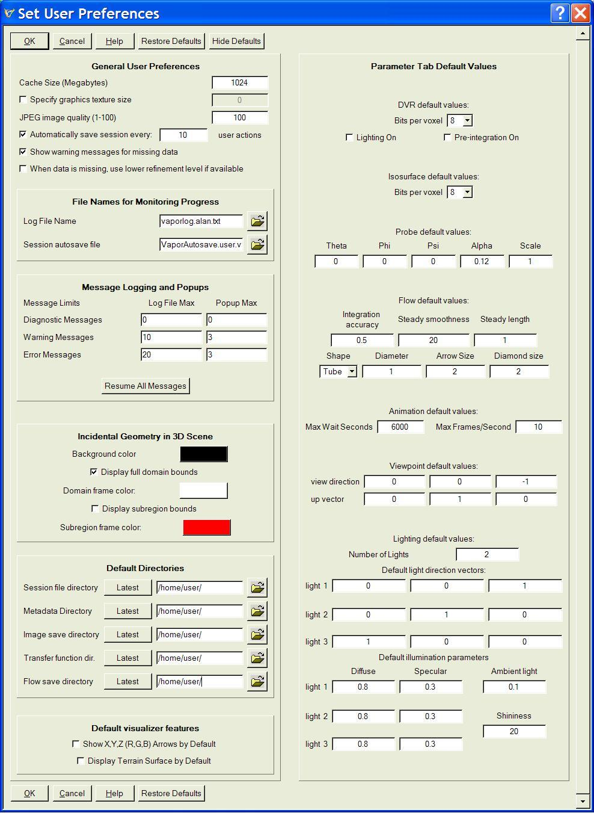
Figure 2.2: Expanded User Preferences panel

The additional capabilities in the Expanded User Preferences Panel enable you to set default parameter settings that you may find useful for your own personal style in operating VAPOR or creating visualizations. Note however that these settings are only the default settings that VAPOR uses when you first start the application. Loading a session file will change the current values so they may not be the same as the defaults set in this panel. These settings are as follows:

The Default Directories section enables you to specify the directories that are used by default in reading or writing certain files used by VAPOR. The directories can be “.”, specifying the directory from which VAPOR is launched. If you click on the Latest button, the directory is replaced by the directory most recently used for the corresponding file read or write. These include:
- Session file directory: When you first load a session file, this is the directory where VAPOR starts.
- Metadata directory: This is the directory where VAPOR initially looks for metadata. Note, however, that the metadata directory is specified in a session, so that this directory will be changed whenever a session file is read.
- Image save directory: This directory is used when you load or save a jpeg file
- Transfer function directory: Used when transfer functions are loaded or saved into the DVR, Probe, 2D, or Isosurface panel.
- Flow save directory: This is the default directory when you save flow lines or flow seed points, or load flow seed points in the Flow panel.

Default visualizer features section contains two checkboxes, both of which affect initial default settings in the Visualizer Features Panel:

- Show X,Y,Z (R,G,B) Arrows by default check-box: When this is checked, then, by default, coordinate axis directions are displayed as arrows in the visualizer. The current display of the arrows is controlled in the Visualizer Features Panel, discussed below. This checkbox only determines the default, not the current setting.
- Display Terrain Surface by default checkbox: This controls whether the terrain surface is displayed by default when a layered (e.g. WRF) dataset is loaded. More information about this option is discussed in the Section 3 discussion of the Visualizer Features Panel.

The right side of the expanded User Preferences Panel contains defaults for various parameters in the parameter tabs. These parameters are ones that are likely to be set according to your personal preferences based on the kind of data and platform you are using. These parameters are discussed in detail in subsection of section 3 pertaining to the appropriate tabbed panel. Here we just list the defaults that can be set:
- For the DVR panel,
  - Bits per voxel (8 or 16)
  - Lighting on (or off)
  - Pre-integration (on or off)
- For the Isosurface panel:
  - Bits per voxel (8 or 16)
- For the Probe/Contour panel:
  - Theta, phi and psi orientation angles
  - Alpha and scale controlling Flow images in the Probe
- For the Flow panel:
  - Integration accuracy
  - Steady flow smoothness
  - Steady flow length
  - Shape used to display flow lines
  - Flow shape diameter
  - Arrowhead diameter
  - Diamond diameter
- For the Animation panel:
  - Max wait seconds
  - Max frames per second
- For the Viewpoint panel:
  - View direction
  - Up vector
  - Number of lights
  - Light direction vectors (for 3 lights)
  - Diffuse and Specular coefficients for each light
  - Ambient lighting coefficient
  - Shininess exponent

Data Menu
The Data Menu has seven options:
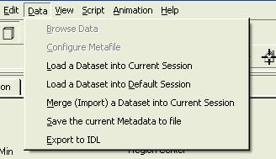
Data Menu

The first two entries in this menu, Browse Data and Configure Metafile, are not yet implemented. The remaining entries refer to various operations involved in specifying the data (Vapor Data Collection, or VDC) that VAPOR will be visualizing, and enabling the VAPOR user interface to communicate with an IDL analysis session.
The VAPOR Data Collection Overview provides more information about VAPOR metadata and about interaction with IDL. We provide some basic terminology here: A VDC contains one or more named variables. A variable can be regarded as a function of space and time. Each variable has one or more time-steps. For each time-step, there is a 3-dimensional volume of data values, such as a 3-dimensional array, specifying the value of the variable at a spatial coordinate and at the associated time-step. There may also be two-dimensional variables in a VDC, i.e. variables that are a function of two of the three spatial dimensions.
When VAPOR is used to visualize WRF data, the Grid Type attribute is set to be “layered”. When visualizing layered data, a reinterpolation is applied to the third (Z) dimension of the data, based on values of the ELEVATION variable. This is explained in the guide VAPOR/WRF Data and Image Preparation Guide.
A VAPOR session involves performing visualization and other operations on data in a VDC. Only one dataset is used in the current session. The dataset that is being examined is described by a VAPOR metadata file (an xml file, of type *.vdf). The metadata specifies information about the dataset, enabling applications to access the data. The actual data that is read is contained in numerous files specified in the metadata. The data is not read from disk until it is required for a specified user operation.

The following actions may be selected in the Data menu:

- Load a Dataset into Current Session. This launches a file-open dialog, enabling the user to specify a metadata file (i.e. file of type *.vdf) to be read. The current session settings are not changed (unless there is an inconsistency between the session settings and the metadata). After the user has restored a previously saved session, this option should be used to re-load the data prior to continuing the session. This option should not be used to load a dataset that is inconsistent with the current session settings (e.g. with different region settings) because the previous session settings may be inappropriate for examining such a dataset.

- Load a Dataset into Default Session. This launches a file-open dialog enabling the user to specify a metadata file to be loaded. The current session state is reset to default (as in the New Session option of the File menu), and then the data is loaded into that session. The session is set to appropriate values for visualizing the specified metadata. Because the previous session parameters are lost, any important session state should be saved prior to choosing this option.

- Merge (Import) a Dataset into Current Session. This launches a file-open dialog enabling the user to specify a metadata file to be loaded. If successful, this results in a merged metadata that includes the previous metadata in the session as well as the newly specified metadata. The operation will fail if the newly specified metadata does not have the same physical extents or grid dimensions as the previous metadata. The resulting VDC will include all of the variable names that appear in either metadata. If a variable name exists in both the former and the newly specified metadata, then the variable is replaced (i.e. the variable data in the former metadata will not be referenced in the merged metadata). Prior to performing the merge, the user is prompted to provide a time-step offset. The time steps in the new data will begin at the offset specified in the new, merged metadata.
The merge operation is intended to be used when new data is created that should be examined alongside the previous data. For example, the new data may result from performing operations in IDL. The result of these operations may be a newly derived dataset that can then be adjoined to (merged with) the previous data.
VDC metadata contains references to the locations of VDC field data (variables). In general, these references are file path names relative to the location of the metafile. When a merge operation is performed the newly created metadata will use absolute path names to reference the newly merged field variables.

With a few minor exceptions, the contents of the metafile to be merged with the current metadata will replace the current metadata in the session.

- Save the current Metadata to file. This option is useful after performing a merge operation. This is useful, for example, whenever the user needs to save the session containing the merged metadata. Note that a merge will result in new metadata in the VAPOR session; however, there may not exist a metadata file (*.vdf file) that describes the merged data. It can be difficult to restore the session if the merged metadata is not available in one file.
When the Save the current Metadata to file option is chosen, the user is presented with a file-open dialog, allowing the specification of a *.vdf file, in the same directory where the previously-read *.vdf file resides. The user is required to save the metadata in that same directory. The current metadata is written to the specified file.

- Export to IDL. This option saves a file (of type .xml) in a location that is known to the user’s current IDL session, specifying the current metadata location and the current region settings. This file is in the /tmp directory on Unix systems, and in C:\TEMP on Windows. The file contains sufficient information so that the IDL session can locate the specified data and perform operations on that data. The options Export to IDL and Merge (import) a dataset into current session are intended to be used in tandem, enabling the user to repeatedly do the following:
    - Identify regions of interest, using the VAPOR user interface
    - Perform IDL analysis on the region of interest in the dataset.
    - Visualize new variables resulting from the IDL analysis
If the dataset is a layered dataset (e.g. derived from WRF data) then the exported region must include the full vertical (Z) extents of the data; i.e. the region must be maximal in the Z dimension.

View Menu
The View menu has four options:
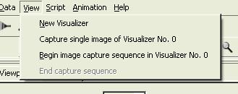
View Menu

- New Visualizer: This creates a new visualizer window, sharing the space in the right-hand side of the screen
- Capture single image in Visualizer…: This results in a file-open dialog, enabling the user to specify a jpeg file name. Then an image is written to the jpeg file, based on the contents of the specified visualizer. The specified visualizer is the currently active visualizer, and can be changed by clicking in a visualizer. Note: The user should make sure the file selection dialog is not positioned over the specified visualizer in order to get a clean image capture.
- Begin image capture sequence in Visualizer…: This action results in a file-open dialog, enabling the user to specify a jpeg file name. Then jpeg images are successively written using the specified file name, appended by a 4-digit integer. Additional JPEG Images are written each time the specified visualizer is redrawn. Note: The user should move the file selection dialog away from the specified visualizer to get a clean image capture. This image capture operation continues until End Capture Sequence is clicked.
- End capture sequence. This option is only available during an image capture sequence. It results in termination of the current image-capturing operation.

Help Menu
The Help menu appears as follows:
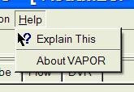

The two options are:
- ? Explain This : Provides access to context-sensitive technical help. Many of the capabilities of the VAPOR user interface are more fully described by this feature. To access this, first click on ? Explain This, and then click on the GUI element of interest. A one-paragraph explanation is provided.
- About Vapor provides top-level information about the version of VAPOR you are using.

Visualizers

The right side of the VAPOR main window is used for data visualization. Up to 16 separate windows can be created in this space. Each window can be maximized to fill the space, or minimized, leaving an icon in the space. By default the visualizers are named “Visualizer No. n” where n is the order of creation of the visualizer; however users can give the visualizers more meaningful names by using the Visualizer Features panel in Section 3.2.
All of the visualizers can simultaneously display images; however exactly one of the visualizers is the active visualizer. When parameter values are specified in the user interface, those values apply to the visualization in the active visualizer. The settings may apply also to other visualizers when using Global Scope (see section 4.1.1) Users can specify the active visualizer by clicking the mouse in that visualizer, or by selecting that visualizer in the VizTools toolbar (Section 3.1.2).

Toolbars
There are two toolbars on the VAPOR main menu, both initially located immediately below the main menu bar. The toolbars can be grabbed with the left mouse button and moved elsewhere on the screen. Both are used in conjunction with visualizers.

Mouse Modes and the Mouse Mode Toolbar.
The Mouse Mode toolbar contains five buttons, as shown below:

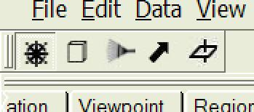
Mouse Mode Toolbar

The mouse mode toolbar determines the function of mouse clicks and drags in the visualizer windows.

The leftmost button, with a wheel icon, specifies the default mode, navigation mode. When in navigation mode, you can drag with the left, middle, or right mouse. Left mouse drags result in a rotation in the scene about the current rotation center (as specified in the viewpoints menu). If you release the left mouse button while the mouse is still moving, the scene will continue to spin. The spinning can be stopped by mouse-clicking in the scene. Middle mouse drags perform a (vertical and/or horizontal) translation of the scene in the plane orthogonal to the view direction. Right mouse drags (vertical only) result in a zoom-in or zoom-out toward or away from the rotation center.
The other four buttons, from left to right, using cube, rake, arrow, and pierced plane icons, enable Region Select mode, Rake mode, Data Probe/Contour plane mode, and 2D mode respectively. Clicking one of these mode buttons results in a red wire-frame outline of the volume or region associated with the mode, and also causes the appropriate tab which specifies the box dimensions (region, flow, probe, 2D) to show up at the front of the tabbed panels. Each of these wire-frames has 6 red cube-shaped handles, one on each face of the wire-frame, connected by a straight line to the center of the volume. A handle is highlighted with yellow when it is grabbed by clicking and holding the mouse button down over the handle. A typical region-select frame (with a grabbed handle) is pictured below:

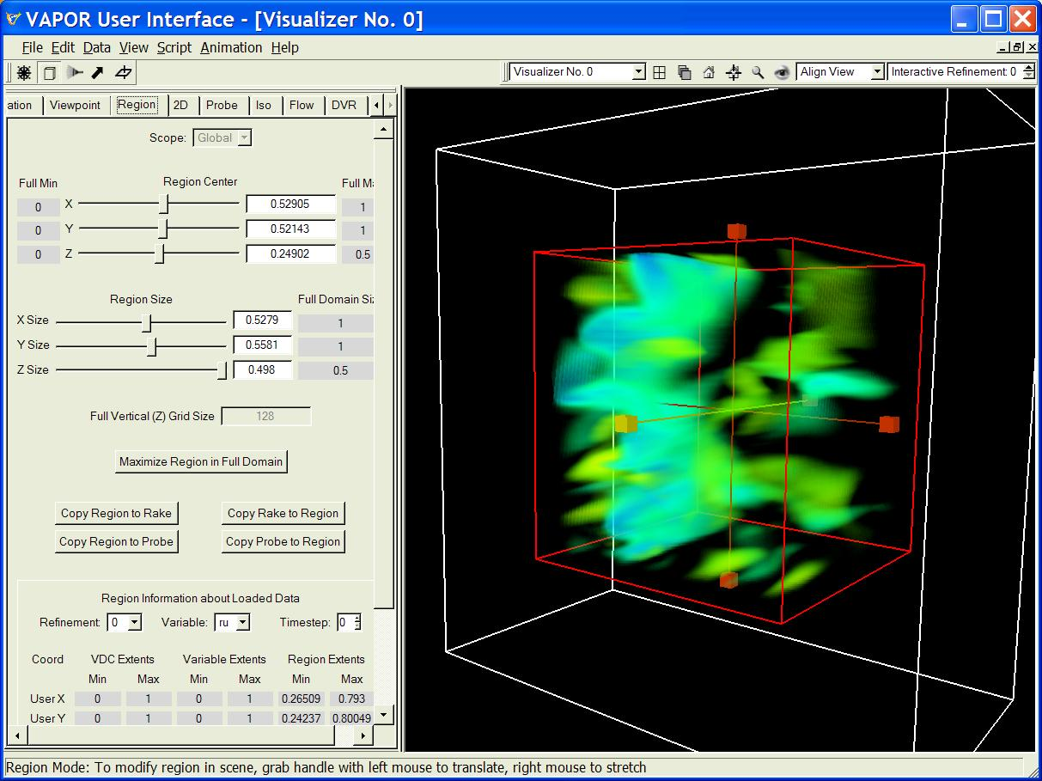
Figure 3.1 A typical region select frame

In Region mode, Rake mode, Probe mode or 2D mode, mouse clicks and drags can be used to manipulate the size and position of the associated box or plane. A mouse drag with the left mouse button depressed over a handle is used to slide the box in the direction of that handle. A drag with the right mouse button pressed slides the edge of the box closest to the handle. A drag elsewhere in the scene (not over any handle) performs navigation (as in the navigation mode described above).
While in Probe mode, if the probe is rotated to be non-axis-aligned (i.e. if there is a rotation angle that is not a multiple of 90 degrees) then the right mouse drag can no longer be used to adjust the probe volume size. In that situation, the sliders in the data probe tabbed panel can still be used to change the size.
2D mode is used for translation and stretching of the two-dimensional region. However, the right mouse cannot be used for vertical (Z) stretching of the 2D box. If the two-dimensional region is mapped to the terrain, then the left mouse cannot be use for vertical translation of the region. When mapped to the terrain, the vertical extents of the two-dimensional box are the minimum and maximum extents of the terrain in the full data volume.

The VizTools toolbar
The VizTools toolbar provides several capabilities that are useful in manipulating visualizers. This toolbar appears as follows:

The VizTools toolbar

From left to right, the elements of this toolbar include:
- The “Visualizer combo”: This provides a dropdown menu, enabling the user to select one of the existing visualizers by name, or to create a new visualizer. The current active visualizer is shown in the combo box. When an existing visualizer is selected, it becomes the active visualizer.
- The “Tile Window” button (icon is a 2x2 array of squares) is useful in arranging more than one visualizer. It automatically arranges the visualizers to cover the available area, so they can all be seen at once.
- The “Cascade Windows” button (icon shows three overlapping squares) arranges the visualizer in a cascade so that you can see the front one with others partially hidden behind it.
- The “Home” button (icon is a house) resets the viewpoint in the current active visualizer to the home viewpoint. This is a reference viewpoint that can be defined and reset by the user. The home viewpoint is initially the default viewpoint, looking at the center of the full data array, with the camera/eye positioned in the negative Z direction from that center. Users can change the home viewpoint by clicking on the set-home button (discussed next).
- The “set-home” button (icon is a house with cross-hairs) is used to establish a home viewpoint. When this is clicked, the current viewpoint in the active visualizer becomes the home viewpoint in that visualizer.
- The “Zoom to Region” button (icon is a magnifying glass) is used to get a close look at the current region. (Current region is discussed in section 4.4). Clicking this button changes the viewpoint to be centered at the center of the current region and at a distance so that the current region almost fills the visualizer. The viewer direction remains the same as before the button was pressed.
- The “View All” button (icon is an eye) positions the viewpoint to see the entire data volume. The view center becomes the center of that volume and the distance is adjusted to make the data volume almost fill the visualizer. The viewer direction remains the same as before the button was pressed.
- The “Align View” combo box provides a dropdown menu with positive or negative X, Y, or Z values, except that the first choice is “Nearest Axis”. This is used to provide an axis-aligned viewpoint, looking in the specified direction or the closest axis-aligned view to the current viewpoint. The view rotation center is not changed.
- The “Interactive Refinement” level selector has up- and down-arrows allowing the user to increase or decrease the interactive refinement level. While a volume visualization or isosurface rendering is being rotated or manipulated in the scene, the volume renderer and isosurface renderers revert to a lower refinement level to minimize the time to render. The interactive refinement level , when less than the current refinement level, is the level that is used during rotation or manipulation. If the interactive refinement level is greater than or equal to the current refinement level, then the level is not changed. By default this is zero, so that you revert to the lowest possible refinement level during scene rotation and manipulation. Increase the interactive refinement level to a large integer (larger than the highest refinement level in the data) if you do not want the renderers to revert to lower refinement levels.

Visualizer Feature Selection panel
Several properties of the visualizers can be set in the Visualizer Feature Selection panel, by selecting Edit Visualizer Features from the main window Edit menu, as shown on the next page:
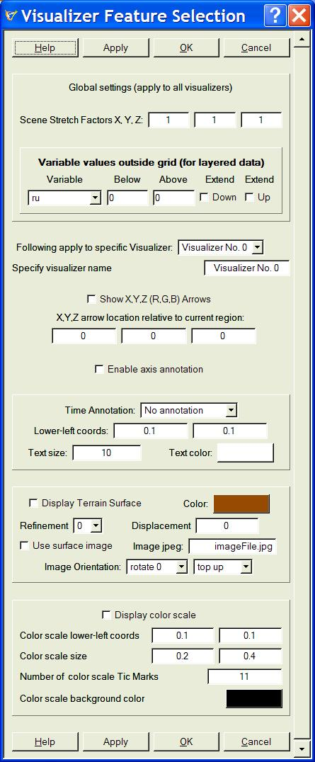
Fig 3.2: The Visualizer Features panel

More information about many of these parameters is available by clicking on the Help button at the top or bottom of the panel, and then clicking on the specific item. The visualizer features panel contains the following (listed from top to bottom):
Along the top of the panel are four buttons: The Help button results in context-sensitive help. The Apply button can be used to immediately apply the settings on the panel to the current visualizer. Click OK to accept the settings, or Cancel to reject.

Next to the top is a section containing several global parameters that apply to all visualizers:

- Scene Stretch Factors (X, Y, Z): These three factors allow a stretching of the visible scene size in the X, Y, and Z dimensions. They only affect the visual appearance of the data, and do not affect flow integration or other operations on the data.
- Variable values outside grid (for layered data): This list of values is only enabled when using layered (e.g. WRF) data. With layered data it is possible that a valid point in the 3D grid may be either above or below the valid data region. For example the bottom layer of the grid may follow the terrain surface, and there can be points below the terrain surface, so will be below the valid data region. By default all variable values below the grid are set to the same value as the variable value at the bottom layer in the grid (having the same X and Y coordinates) and, similarly, variables above the grid extend the top value of the variable from the grid. If you un-check the “Extend Up” checkbox or the “Extend Down” checkbox, then the variable will instead be extended as the constant value specified in the text box labeled “Below” or “Above”. When performing flow integration on a volume near the terrain surface, it is useful to extend the flow variables to be zero below the grid, so that wind velocity will be zero below the terrain.

Below the global values is a selector (combo box) that specifies the name of the visualizer to which the other settings will apply. This is followed by several miscellaneous settings that apply to that visualizer:
- Specify Visualizer name: Type a new name here to rename a visualizer.
- Show X,Y,Z (R,G,B) Arrows check-box: When this is checked, the coordinate axis directions are displayed as arrows in the visualizer. These are represented as three orthogonal arrows pointing in the positive X, Y, and Z directions. The X-axis is shown as a red arrow, Y is green, Z is blue.
- X,Y,Z arrow position relative to current region edit boxes: These three boxes specify where the coordinate direction arrows will be displayed, relative to the smallest (x,y,z) corner of the current region, in user coordinates.
- Enable Axis Annotation check-box: When checked, coordinate axes with annotation (tic marks and coordinate values) will be displayed. Parameters controlling the annotation properties (described below) are only shown when this is checked. Figure 3.4 illustrates the section of the visualizer features panel that is used for setting axis annotation properties:

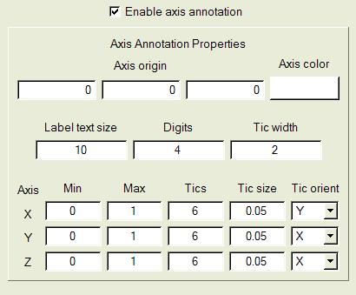
Figure 3.3: Axis Annotation Properties

Axis Annotation Properties: This section of the visualizer features panel is only displayed if the axis annotation is enabled with the Enable axis annotation checkbox. These parameters control the color and positioning of axes, the size and positioning of tic marks, and the formatting of the numerical label associated with each tic mark, as follows:
- Axis origin specifies the user coordinates for the axis origin. These can be any values in the user coordinate space.
- Axis color is a pushbutton that enables choice of axis color. The axis color is used for the axis lines, the tic marks, and the axis labels. Note that the background color for axis labels is the same as the visualizer background color.
- The formatting of the axis labels is controlled by the Label text size, and Digits text boxes. The text size is in points; Digits refers to the maximum number of digits used to represent the axis label.
- Tic width refers to the thickness of the tic marks, in pixels.
- The positioning of the tic marks along each axis is controlled by Min, Max, and Tics, indicating the minimum and maximum coordinate values where tics will be displayed, and the number of tics along that axis. Set Tics to be 0 if no tics are desired on a particular axis.
- Tic size indicates the length of the tic marks in user coordinates.
- Tic orient determines the orientation of the tic marks along each axis. The tic marks always point in one of the two directions orthogonal to the axis.

The next group of settings relates to the display of time steps in the scene:
- Time Annotation selector. This selector can be used to choose “No Annotation”, “Time Step number” or “Date/Time stamp”. When there is no time stamp in the data (i.e. when the UserTimeStampString is not set in the metadata) the third option is not available. When WRF data is converted using wrf2vdf, the UserTimeStampString is set to the correct time stamp associated with the current time step, based on the WRF input data.
- Lower-Left Coords specify the lower-left starting location for the time annotation text to appear in the visualizer, relative to the full image size. Coordinates (0,0) specify the lower-left corner of the image, and (1,1) specify the upper-right corner of the image.
- Text size specifies the font size (points) for the time annotation.
- Text color: identifies a push button for choosing the color of the text used in time annotation. Click on the push button to select a text color.

The next group of settings refers to the display of a terrain surface:
- Display Terrain Surface checkbox: When the box is checked, the lowest level of the data is displayed as a surface. The color and refinement level of the surface can also be selected.
- Refinement selector specifies the refinement level of the data that is used for calculating the surface image
- Displacement text box provides the ability to displace the terrain vertically (in user Z-coordinates). With layered data a displacement of 0 corresponds to the lowest layer of the data. With non-layered data, the displacement of 0 corresponds to the bottom of the Cartesian grid.
- Use Surface Image checkbox: When the box is checked, a file selection dialog is provided to select a jpeg (.jpg) file that will be displayed upon the terrain surface. The image is mapped onto the full data domain, so the image must be adjusted to agree with the horizontal data extents in the VDC.
- Image jpeg textbox displays the file path of the image file that is being mapped to the terrain.
- Image orientation selectors allow rotation (in increments of 90 degrees) or up/down reflection, to ensure the surface image is correctly applied to the surface.

The final group of settings enables using a color scale to show the current DVR color map in the scene:
- Display color scale checkbox: When checked, the current color mapping of the active DVR transfer function (see section 4.5.2) in the selected window is shown as a color scale in the visualizer. The color scale can be used to calibrate the numerical values associated with colors. (Note: Some users may find that the text in the color scale is clipped and hard to read. This problem can be corrected by running the “qtconfig” application, setting the font size to 10 or 12, and saving this setting from qtconfig) .

The color scale is customized as follows:
- Color scale lower-left coordinates: These specify the lower-left corner of the color scale relative to the visualizer window, where (0,0) is the lower left corner of the visualizer and (1,1) is the upper-right corner.
- Color scale size specifies the horizontal and vertical size of the color scale relative to the visualizer dimensions.
- Number of Tic Marks: Specifies how many uniformly spaced tic marks will be placed in the color scale.
- Color scale background color: Click on this button to pick a background color for the color scale.

At the bottom of the Visualizer Features panel, the Help, Apply, OK, and Cancel buttons are repeated.

Tabbed Parameter Panels
The left side of the VAPOR main window is used to specify the parameters that control the visualizations. The parameters are grouped into tabbed panels, each tab controlling a collection of related capabilities. Five of the tabbed panels are associated with rendering images: DVR, Flow, Iso, 2D, and Probe. These five control a specific rendering (drawing) functionality in the visualizers. The other three tabs (viewpoint, region, and animation) control sets of parameters that must be readily accessed during a visualization session.
Each tabbed parameter panel should be regarded as a collection of panels, one for each visualizer. When you click with the left mouse in a visualizer (i.e., make that visualizer active), the parameter values associated with that visualizer are displayed in the front tabbed parameter panel.
Most panels contain lots of edit boxes in which values are displayed. To change these values, type in the new value, and then press <enter> while the cursor is still over the edit box. If you do not press <enter>, and do not click on another widget in that panel, your changes may be lost. You can avoid unnecessary data access delays by typing in multiple changes, and then verifying that the values are correct, before pressing <enter>.

General settings of the tabbed panels

Scope
The Region, Animation, and Viewpoint parameter tabs have at the top a Scope selector. It can be set either to Local or Global. The scope selectors are only available when there is more than one visualizer, because they would have no effect when there is just one visualizer.
The scope provides a means of sharing parameter settings between different visualizers. If a particular tabbed panel is set to Local scope, then the settings in that panel apply only to the one (current active) visualizer. If the scope is set to Global, then the current active visualizer will use a unique shared set of parameters associated with Global scope. All visualizers that have scope set to Global on a tabbed panel will share that same parameter set. For example, to share region settings between two visualizers, select the Region tab and select Global scope for each of the two visualizers. By default, the region, animation, and viewpoint parameters have Global scope.

VAPOR Renderers and Renderer Control

The DVR, Flow, Iso, 2D, and Probe tabs control the rendering of images in the visualizers. Each of these tabs has a Renderer Control section near the top, appearing as follows:

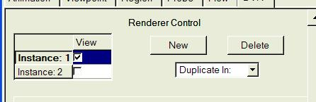
Renderer Control

Using the Renderer Control, you can control any number of renderers in the current visualizer. The different renderers are identified as “Instance: 1”, “Instance: 2”, etc. When you click in the check-box, the specified renderer is enabled; i.e. the renderer will start drawing in the current visualizer. One of the renderers is active, in the sense that the parameters displayed in the tab apply to that renderer. You can change the active renderer by clicking over the instance name. Additional renderers can be created by using the “New” button or the “Duplicate In” selector. The “Duplicate In” selector constructs a duplicate of the renderer in the current visualizer, or in any other visualizer (when multiple visualizers are available). Multiple Flow, Iso, 2D, and Probe renderers can be enabled at the same time in the same visualizer. However, only one DVR renderer can be enabled at one time, because of limitations in hardware support for volume rendering.

Users must always enable rendering before performing visualization, because rendering may result in time-consuming access to data if it is not properly initialized. After loading a new dataset, all the renderers will be disabled.

Refinement
The five rendering tabs, DVR, Flow, Iso, 2D, and Probe, also have a Refinement selector:
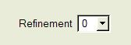
This specifies the resolution of the data that is used for rendering. By default the Refinement is set to 0, meaning that the lowest available resolution of the data will be accessed. Increases in the refinement by 1 will double the volume resolution in each dimension, thereby resulting in an 8-fold increase in the data size in a 3D volume, or a 4-fold increase in surface data.

Viewpoint and Lights panel
The Viewpoint panel controls the position and orientation of a virtual camera, as well as the position and attributes of up to three light sources. It is pictured below:
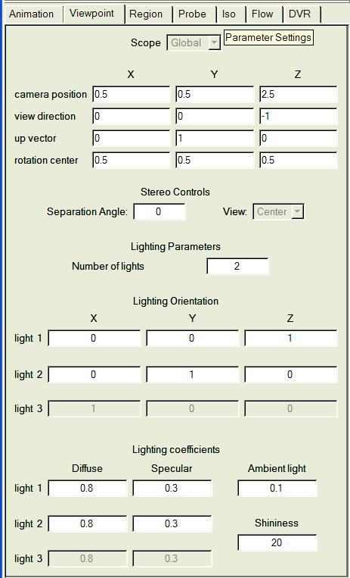
Figure 4.1: The Viewpoint and Lights Panel

The camera can also be positioned by mouse navigation (described in section 3.1.1). The viewpoint panel will display the result of any camera positioning in the appropriate edit boxes. The VAPOR camera subtends a horizontal field of view of 45 degrees. The following are the settings in the viewpoint panel:
- Camera position: Specifies the camera location in world coordinates
- View direction. Specifies a direction vector, pointing in the direction the camera is pointed. This vector should be nonzero.
- Up vector. Determines how the camera is rotated. The actual upward direction of the camera is the projection of this vector into the plane orthogonal to the view direction. This vector should be nonzero.
- Rotation center. This vector should ordinarily be set to the center of the data being examined. This vector does not affect the camera position but does affect the navigation. During navigation, rotations are about the rotation center position.
- Stereo controls are provided to facilitate creation of stereo pair images. When the Separation Angle is set to a nonzero value, the View selector allows choosing center, left, or right viewpoint. The left and right viewpoints are obtained by rotating the camera position to the left or right of the rotation center by ½ of the separation angle (degrees), using the up vector as the rotation axis direction.
- Lighting orientation. The direction of up to three different directional white light sources can be specified in this panel. Up to 3 lights are used for rendering flow lines and the elevation surface; however only the first of these lights (light 1) is used for volume rendering or isosurface rendering (when lighting is enabled in the dvr or iso panel). The value in the Number of Lights edit box determines how many directional lights are used, and a nonzero direction vector should be specified for each enabled light. These directions specify the light direction relative to the viewer direction, so the default (z-axis aligned) first light source is pointed in the same direction as the viewer.
- Lighting coefficients. Each light source has a diffuse and specular coefficient (between 0 and 1), determining the amount of diffuse and specular reflection is associated with each light. The ambient coefficient (again between 0 and 1) determines the amount of ambient (nondirectional) light in the scene. The shininess coefficient, between 1 and 128, affects the specular illumination, regulating the sharpness of the specular reflection.

Animation panel
VAPOR data collections are indexed by an integral time step, starting at a nonnegative integer. The current setting of the time step, as well as the timing of changes to that time step, are controlled in the animation panel, pictured below:

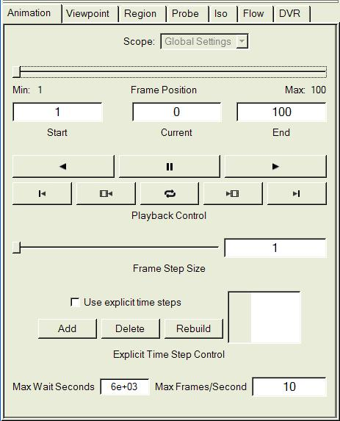
Figure 4.2: The Animation Panel

By default, the animation panel has global scope, so that one animation panel will control the time-stepping of all visualizers. The animation panel has the following settings:

- The current time step is specified by the frame position slider, as well as by the Current text box. Below the frame position slider are the Min and Max time steps, indicating the range of actual time steps that are specified in the metadata.
- The Start and End time steps default to the Min and Max, but can be specified to be a sub-interval of [Min,Max]. These determine the range of time steps that will be used during animation.
- There are two rows of buttons provided for animation control. The top row contains buttons for backward and forward play (icons are left and right-pointing triangles), as well as a pause button (icon is a pair of vertical lines) in the middle.
The buttons on the second row, from left to right, specify:
  - Jump to start (icon is vertical line with left-pointer)
  - Single frame step back (icon is film clip with left-pointer)
  - Continuous play on/off (icon is rotating arrows)
  - Single frame step forward (icon is film clip with right-pointer)
  - Jump to end. (icon is vertical line with right-pointer)

The single-step buttons are disabled when the forward or reverse play buttons are pressed.

- The Frame Step Size (slider and text box) enables users to skip multiple timesteps.
- The check box labeled “Use explicit time steps” is useful when the time steps to be animated are not evenly spaced. When this box is checked, the Add and Delete buttons become active, and the list of time steps (at the right) becomes editable. To specify a list of time steps, repeatedly click the “Add” button, and then type the time step number desired into the list. This list is automatically maintained in ascending order. The Rebuild button automatically constructs a list of all the time steps in the current metadata for which any variables are available at any resolution.
- The Max Wait Seconds text box specifies the maximum number of seconds that will be waited for rendering completion(as well as any data loading required for rendering) before starting a new rendering. If a rendering takes longer than this, it is likely that a renderer is not available (e.g. the window may not be visible on the screen) so that other renderers that are synchronized with it will go ahead.
- The Max Frames/Second text box sets a limit on how fast the animation is allowed to proceed. Rendering rate is always limited by the software and hardware, so users may not obtain the specified rendering rate. Often a slower animation rate is useful for better data understanding.

Region panel
The region panel is used to specify a region of interest within the full data extents. The region of interest is a 3D box, bounded by 6 axis-aligned planes within the full data extents. The Region panel is used to position those planes and also to see the current positions of the planes. The bounds of the region can be visualized and manipulated in region mode; see Figure 3.1 and the accompanying discussion in Section 3.1.1. The region panel also provides a means of determining the resolution and other properties of the data that is available in the current Vapor Data Collection. The Region panel is shown below:
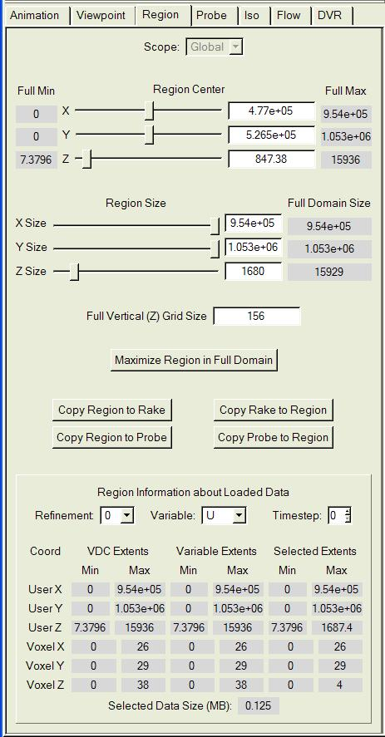
Figure 4.3: The Region Panel

Settings in the region panel
The region panel contains the following settings:
- The Region Center (sliders and text boxes) specify the center of the region in user coordinates. These values are further restricted by the requirement that the entire region must lie within the extents specified by Full Min and Full Max. It may be necessary to first reduce the Region Size to meet this requirement.
- The Region Size (sliders and text boxes) specify values between 0 and the full domain size. The Full Domain Size, indicated on the right, is obtained from the domain extents in the metadata.

Note that the region center and size can also be controlled interactively in the visualizer, by using Region mode (Section 3.1.1 above).

- When using layered (e.g. WRF) data the Full Vertical (Z) Grid Size textbox is available. This allows the user to specify the vertical grid height that is used for interpolating the data from its layered representation to a uniform grid. By default this parameter is set to four times the number of layers in the data. When examining regions between closely spaced layers, it is useful to increase this parameter, resulting in more accurate interpolation. However, there is little value in making the vertical grid spacing finer than ½ the distance between the closest layers being viewed. When using refinement levels of data below the highest level, the vertical grid used for interpolation is reduced accordingly. For example, if the highest refinement level of the data is 3, if it is being visualized at refinement level 2, and the Full Vertical Grid Size is 150, then the visualized data will be interpolated to a uniform grid of 75 vertical levels.

Several useful buttons follow the full vertical grid size text box:

- Maximize Region in Full Domain: This button resets the region to use the full extents of the data.
- The four Copy .. to buttons enable the region center and size in the current active visualizer to be copied to, or from, the rake bounds (in the current instance in the Flow panel) and the probe bounds (in the current instance in the Probe panel). Note however that this copying ignores any rotation associated with the probe.

Obtaining information about data and the current region
At the bottom of the Region panel is a section entitled Region Information about Loaded Data. This section enables the user to determine dimensions of the VDC, plus exactly what data is available in the current VDC. Three selectors (Refinement, Variable, Timestep) control the information that is displayed. Note that this section is purely informative: Setting the values of the three selectors will not have any effect on the data that is accessed by VAPOR.
The information about the data is displayed in a 6x6 array of values.
The first two columns provide user and voxel (grid) coordinate extents as specified in the metadata. The next two columns provide user and voxel coordinate extents for the actual data that is available on disk. The last two columns provide user and voxel extents for the current region (as specified at the top of this Region panel). Whenever the data is not available (i.e. does not exist in the VDC) the corresponding values in the Variable Extents are left blank.
Finally, the Selected Data Extents field shows the amount of data in megabytes that is associated with the specified refinement, variable, and timestep and for the current region. This value is useful in determining data cache size and estimating memory requirements.

DVR panel
The term “DVR” refers to Direct Volume Rendering. The DVR panel specifies the settings for volume rendering, as shown below:

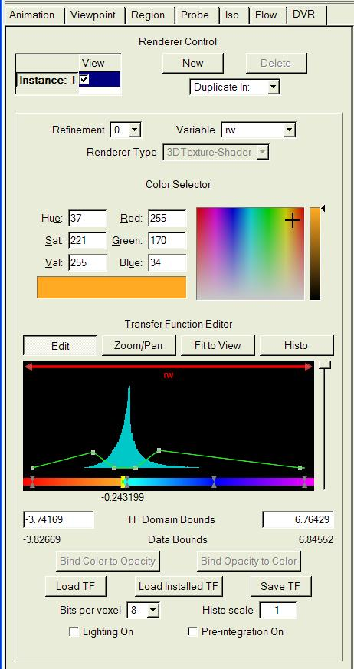
Figure 4.4: The DVR panel

General DVR Settings
From top to bottom, these are the settings in the DVR panel:

- Renderer control: This is described in Section 4.1.2. Note that only one DVR renderer can be enabled in a visualizer.
- Refinement: This is described in Section 4.1.3.
- The Variable combo specifies the variable (named in the metadata) that will be volume-rendered.
- Renderer Type combo is only active when the renderer is disabled. It includes a choice of renderers, based on what graphics hardware is currently available in the system.

Transfer Function Editor
A transfer function is a mapping from data values to color and transparency. This is very important for volume rendering because it specifies the appearance of the variable being rendered. The Transfer Function Editor is a tool for defining the transfer function. There is a transfer function editor in the DVR panel and another one in the Probe panel.

The VAPOR transfer function is, by default, defined by a set of color control points and a set of opacity control points. Using the transfer function editor, the user specifies the location (a floating point value) for each of the control points, plus a color value at each color control point and an opacity value at each opacity control point. The resulting transfer function is obtained by linearly interpolating the color (in HSV coordinates) and opacity between the control points.
Optionally, the user may specify one or more “opacity widgets” to control the opacity. Each opacity widget determines a function defined in an interval of the variable with values in the interval [0,1]. The opacity can be either a piecewise-linear mapping or a Gaussian curve. Multiple opacity widgets are either added or multiplied to determine the total opacity at each variable value. This functionality is described more fully below.

The elements of the transfer function editor are the following:
    - The Color Selector is located above the Transfer Function Editor. This is a tool for specifying a color, using RGB or HSV coordinates, or by picking it from a palette. The palette selection specifies the hue and saturation of the color, and the slider on the right specifies the value (intensity).
- Next is a row of four buttons:
- Edit and Zoom/Pan determine the function of the left mouse. In Edit mode the mouse is used to select and drag control points (discussed below). In Zoom/Pan mode the left-mouse drags result in translation or stretching of the transfer function position in the editor window. Zooming and panning do not change the transfer function; they only affect its appearance in the editing window.
- The Fit to View button resets the edit window so that the transfer function domain uses the full window (from left to right). It does not change the transfer function.
- The Histo button rebuilds and redraws the histogram that appears in the opacity graph (discussed below).
- Below the buttons is a dark red horizontal bar (the domain bar) with red triangles at each end. Click/drag the bar to the left or right to translate the domain interval on which the transfer function is defined. Click/drag either triangle to translate one or the other end-point of the transfer function domain interval. The name of the variable being mapped is printed in red below the domain bar.
- Below the domain bar is a rectangular region (opacity edit region) with a black background, on which both a histogram and the opacity curve are drawn, as in the following:
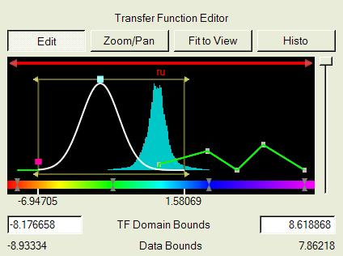
Opacity widgets in the opacity edit region

The opacity edit region displays the following:
    - Bounds of an opacity widget are shown, when that widget is selected. The opacity widget is shown as a dark gold rectangle with outward-pointing arrowheads at the top and bottom of both ends. Click and drag an arrowhead to change the bounds of that widget.
    - The curve associated with an opacity widget is shown in white when that widget is selected. The overall opacity curve associated with all combined opacity widgets is shown in green when no opacity widget is selected.
    - The individual control points of a piecewise-linear opacity widget are shown in grey, or, when a point is selected, in yellow.
    - A selected Gaussian opacity widget is controlled by a red control point (on the left edge of the widget) and a green control point (on the top of the widget). The red control point controls the horizontal scale (standard deviation) of the Gaussian, and the green control point, located at the mean, translates the Gaussian along the x-axis.
    - A histogram of data values in the transfer function domain is displayed in blue-green, behind the opacity curve. This is a histogram of the values of the specified variable in the current region at the specified refinement level. The histogram is normalized to use the top of the opacity edit region for the maximum value of the histogram.

- Right-mouse menus are available by clicking in the opacity edit region, to control the following:
    - Creation and deletion of opacity widgets
    - Creation and deletion of opacity and color control points
    - Boolean, linear, or logarithmic scaling of the histogram.
    - Addition or multiplication for combining of multiple opacity widgets
    - Enabling or disabling the contribution of any individual opacity widget to the overall opacity curve.
- Values of the transfer function and histogram are displayed (as a tool-tip) when the cursor hesitates for a few seconds in the opacity edit region.
- Below the opacity edit region is the color bar, a horizontal strip on which hourglass shapes (pairs of triangles) specify the location of color control points.
- Control point editing functionality: The control points and the values they are mapped to can be edited as follows:
    - New control points are created by clicking with the right mouse in the opacity edit region or color bar at the desired location.
    - A right-click near an existing control point provides the option of deleting or adjusting the position/value at that control point.
    - Control points are highlighted (in yellow) when selected. Control points can be selected by clicking with the left mouse button. Multiple points can be selected by selecting with the control key. An interval of control points can be selected using the shift key. The x-coordinate of selected points is shown below the transfer function editor. Note that selection only occurs in Edit mode.
    - Selected points can be dragged together by sliding the mouse, or deleted by pressing the delete key. Dragged control points are not allowed to slide past unselected control points.
- Immediately below the color bar are displayed the coordinates of the selected control points as well as the coordinates at the left and right endpoints of the editing interval. Each coordinate is associated with a tic mark at that coordinate.
- At the right side of the transfer function editor is the opacity scale slider. This slider provides an immediate means of scaling all the opacity values of the transfer function. It is useful when the transfer function needs to be quickly made more or less transparent. The scaling factor is 1 at the top and 0 at the bottom, varying quadratically over that interval. The scale factor is displayed in a tool-tip when the cursor hesitates over the slider.

Additional DVR settings
Below the transfer function editor are several additional text boxes and buttons.
- TF Domain Bounds identifies two text boxes (left and right) indicating left and right endpoints of the transfer function domain. These values can also be modified by sliding the domain bar or its endpoints (see above)
- Left and right limits in the current variable are indicated below the domain bounds by Actual Data Bounds.
- Two buttons (labeled Bind Color to Opacity and Bind Opacity to Color) are enabled whenever exactly one color control point and one opacity control point are simultaneously selected. Clicking the Bind Color to Opacity button moves the selected color control point to the same location as the opacity control point. Similarly the Bind Opacity to Color button moves the selected opacity control point to the same location as the color control point.
- Load TF and Save TF buttons provide the capability of loading and saving transfer functions, either from/to files, or from/to a set of transfer functions that are named and kept in the current session. Saving transfer functions in the current session provides a means of sharing transfer functions between different contexts, such as between different variables in a DVR, between the DVR’s associated with different visualizers, or between the DVR and other panels with transfer functions (such as the probe panel). Clicking on one of these buttons launches a dialog that enables the user to choose the file name or to choose the name of the transfer function in the session. The Load Installed TF button is similar the Load TF button, however it always loads from the directory where pre-installed transfer functions are provided.
- Bits per voxel allows selection of 8 or 16-bit data for volume rendering.
- Histo Scale is a text box that specifies a value that scales the height of the histogram in the transfer function editor.
- The Lighting On checkbox is currently only available when the Renderer Type is “3D Texture-Shader”. When lighting is enabled, the volume is shaded in accordance with properties of the first light source in the Viewpoint and Lights panel.
- The Pre-Integration On checkbox should be checked to obtain higher quality rendering (with consequent increased rendering time) by improved volume sampling.

Flow panel
The Flow panel specifies the parameters controlling the integration and display of flow lines associated with a 3-dimensional vector field. There are three different types of flow advection: Steady flow, Unsteady flow, and Field Line Advection, selected from the flow Type selector at the top of the Basic Flow Parameters. In order to not present irrelevant options to the user, the Flow panel appears quite different, depending on the flow Type selected. The Basic Flow Parameters for each of these Types are displayed below the Renderer Control, as shown below:

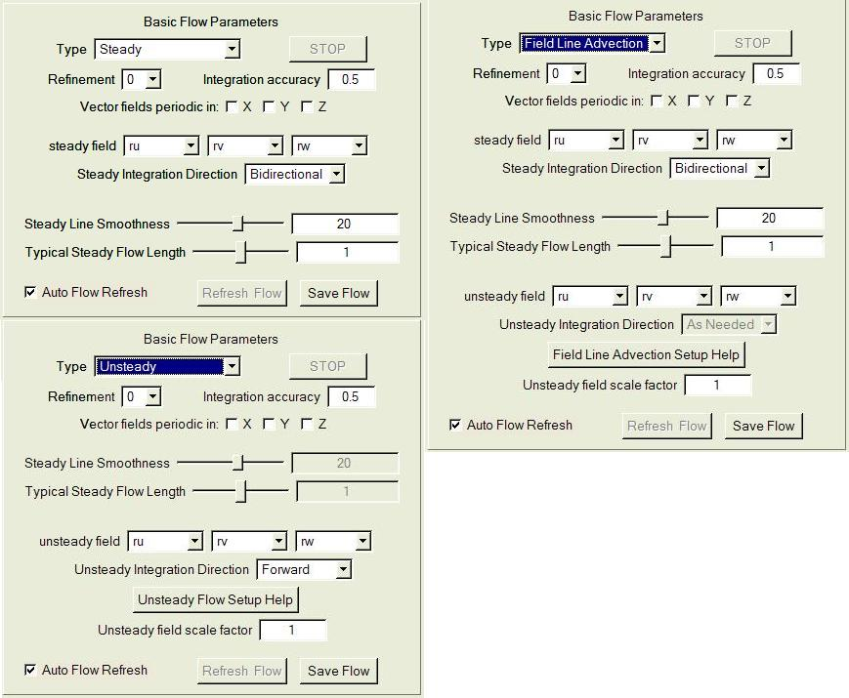
Figure 4.5: Basic Flow Parameters for Steady, Unsteady, and Field Line Advection flow types.

Basic Flow Parameters
The Basic Flow Parameters are as follows:
- The flow Type and Refinement selectors are at the top of the Basic Flow Parameters. The Refinement selector is described in Section 4.1.3. The Type selector supports the following choices:
    - When Steady flow is selected, the integration of flow lines is performed using the field values at a single time step (using the current time step from the animation panel). Steady flow results in a different set of flow lines for each time step, each flow line based on the current seeding parameters.
    - When Unsteady is selected, the flow integration is across multiple time steps, using vector field values at all time steps, and interpolating between the vector field values at adjacent time steps.
    - Field Line Advection combines steady and unsteady flow to enable animation of steady field lines subject to a time-varying velocity field. The result of Field Line Advection is a set of different steady flow lines at each time step, each field line determined from the corresponding field line at the previous time step.
- During the unsteady flow integration and during field line advection (but not during steady flow integration), the Stop button is active. Clicking this button will terminate the integration at the next time step. Auto flow refresh is also un-checked when the integration is stopped.
- The Integration accuracy specifies a number between 0 and 1 that adjusts the integration feedback loop. The flow integration is performed using order 4 Runge-Kutta integration. The vector field is sampled by performing tri-linear interpolation within the grid cells determined by the Refinement level within the data region associated with the visualizer. The step size (distance between successive sample points) is adapted (repeatedly doubled or halved) to ensure that the change in angle between successive samples is between 3 and 15 degrees. The Integration accuracy parameter affects both the maximum and the minimum step size relative to the grid spacing. When the accuracy parameter is 0, the minimum step size is 0.01, and the maximum step size is 4.0. When the accuracy parameter is 1, the minimum step size is 0.25 and the maximum is 10. Values between 0 and 1 use a linear interpolation of both the minimum and maximum step sizes between their limiting values.
- There are three (X, Y, Z) checkboxes labeled “Vector fields periodic in:” . When checked, all variables are assumed to be periodic in the indicated dimension with period equal to the full size of the data extents in that dimension. Flow lines that exit on one end of the domain resume at the opposite end.
- For Steady flow and Field Line Advection, three text boxes, labeled steady field (x-, y-, and z- variables) specify the variables that comprise the vector field that is integrated in the flow line calculation. For Unsteady flow and Field Line Advection, three similar text boxes are provided to specify the unsteady field.
- The panel includes integration direction selectors for both steady and unsteady flow, that have different choices for each flow type:
    - For Steady flow, and for Field Line Advection, the Steady Integration Direction is either backward, forward, or bidirectional, indicating the integration direction along each field line from the seed point.
    - For Unsteady flow the Unsteady Integration Direction is either backward or forward, indicating that all integration goes either backwards or forwards in time.
    - For Field Line Advection, the Unsteady Integration Direction is always “As Needed”, indicating that the integration is either backwards or forwards in time, going from the Seed Time Start (described below) to the current time, as specified in the Animation panel.

- In the Steady and Field Line Advection parameters, there are sliders and text boxes labeled Steady Line Smoothness and Typical Steady Flow Length. These are to provide easy control of the appearance of the steady field lines. The integration length and the sampling frequency is determined by these values. This is based on the average value of the steady field magnitude over the current region: If the field magnitude were constant, equal to its average, then the field lines would have length equal to the value of Typical Steady Flow Length times the diameter of the full data extents. The value of Steady Line Smoothness indicates the number of distinct line segments used to represent a field line of length equal to the domain diameter. In general, the field magnitudes will usually not be constant, so these values provide only a coarse estimate of line length and smoothness. More direct control over integration length and resampling can be obtained by turning off the automatic scaling of the steady field, an option in the Advanced Flow Parameters discussed below.
- The help buttons, “Unsteady Flow Setup Help” and “Field Line Advection Setup Help” provide detailed instructions for setting up either unsteady advection or field line advection, because that setup requires several technical issues to be considered.
- In the Basic Flow Parameters for both the Unsteady flow and Field Line Advection, there is an Unsteady Field Scale Factor. The unsteady field is multiplied by this factor during unsteady integration. It is often necessary to use this factor to correct for inconsistencies in the time step size and the domain size, to make the parameters in the flow integration match those of the simulation that produced the data. This factor should be set to the reciprocal of the number of time steps per second (assuming the vector data has seconds as time units). It should then be divided by a spatial correction factor if the domain size is not the size of the simulated domain in the units in which the vector fields are specified.
- The Auto Flow Refresh checkbox determines whether or not the flow will be recalculated whenever a parameter that affects it is changed. When this is un-checked, the Refresh Flow button becomes enabled whenever the flow needs to be recalculated, and then clicking the Refresh Flow results in immediate flow recalculation.
- The Save Flow button launches a file-chooser dialog, to specify the name of a text file that will contain the current flow. In the output file, one line is written for each point of each flow line. Each line of the output file contains four floating point values, corresponding to the 3 spatial coordinates and the time step associated with the point. For a steady flow, the time coordinate is the current time step. For an unsteady flow, the time coordinate is the time step or fraction thereof at the current temporal position along the length of the flow. For steady flow, the number of points that are output for each flow line is equal to the number of samples per flow line, as determined by Steady Line Smoothness and Typical Steady Flow Length described above. If the field line is not being automatically scaled (see the Advanced Flow Parameters, below), then the value of Steady samples per flow line is used for the number of points. For unsteady flow, the number of points output per flow line is the number of time steps (in the Animation panel) multiplied by the value of Unsteady samples per time step in the Shape Parameters (below).
Frequently, when a flow line is output, the number of valid points in the flow is less than the specified number of samples. In that situation, missing values are padded with flags so that all flow lines in the file have the same number of points. When a flow line exits the current region, the value 1.e+30 is written as the x, y, and z-coordinates of all the subsequent points in the flow. This flag can occur at either the start or the end of the flow line or both, depending on whether the flow line is bidirectional, forward, or backward.
A steady flow line can become stationary; i.e. the value of the vector field can become so small that further integration will not exit the current grid cell. In that case the stationary point and subsequent points are coded as -1.e+30. The value -1.e+30 can be written to either the start or the end of a flow, or both, depending on whether the stationary point results from integration in the negative or positive direction. Unsteady flows do not identify stationary points because it is always possible that a change in the field value will start a flow moving again.

Advanced Flow Parameters
Several infrequently used parameters can be set by clicking the button “Show Advanced Flow Parameters”. These parameters are different, depending on whether the flow Type is Steady, Unsteady, or Field Line Advection. One of the following three panels is displayed:

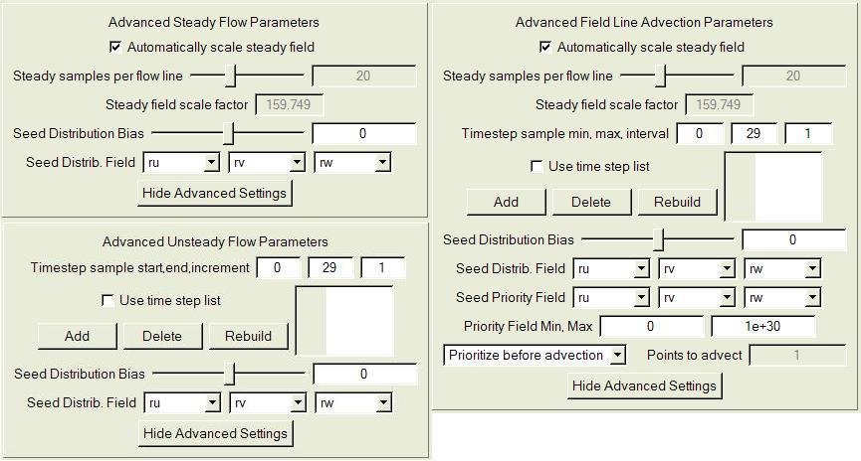

Figure 4.6: The three Advanced Flow Parameters panels for steady flow, unsteady flow, and field line advection.

The advanced flow parameters include the following:
- The checkbox labeled “Automatically scale steady field” is available for both steady flow and field line advection. When checked, the Steady Line Smoothness and Typical Steady Flow Length settings of the Basic Flow Parameters are used to control the integration length and resampling. When un-checked, the sampling and field length are controlled directly by the Steady Samples per Flow Line (slider and text box) and by the Steady field scale factor in the advanced flow parameters.
- Timestep sample start, end, increment identifies three text boxes that are available with both unsteady flow integration and field line advection. These text boxes specify a first and last time step that will be used in the flow integration, and an interval (increment) between successive time step samples. The sequence of time steps is always increasing, independent of whether the integration proceeds in the forward or backward direction. By default the values are the starting and ending time steps in the data, with an increment of 1, so that the unsteady flow integration will use the vector field data at all time steps. Unsteady flow integration calculates the field values at a time by linearly interpolating the field between the nearest sampled time steps.
- Also with both unsteady flow and field line advection, there is a check box “use time step list”, to handle situations where the time steps are not equally spaced. When this box is checked, the Timestep sample start, end, increment text boxes become disabled, the Add and Delete buttons become active, and the list of time steps (at the right) becomes editable. To specify a list of time steps to be sampled, repeatedly click the “Add” button, and then edit the time step integer that results. This list is always kept in ascending order. The Rebuild button can be used to automatically construct a list of timesteps consisting of all the time steps in the current metadata for which there is any variable data at any refinement level.
- The Save Flow button provides a means of saving the current flow lines to a file. Clicking on this button launches a file-open dialog, where the user specifies a text file (*.txt) where the flow will be written. The flow panel must be enabled in order to write this output file.
- The Seed Distribution Bias (slider and textbox) is used when the flow seed points use a Random Rake but a nonuniform distribution is desired. Whenever this value is nonzero, the random seed distribution is biased, based on the magnitude of the Seed Distrib. Field, specified in this panel. Larger values of b result in seeds with higher magnitude of the Seed Distrib. Field. If b is the value of the bias (between -15 and 15) then (m/M)^{b} is the probability that a random point having seed distribution field magnitude of m is chosen, where M is the maximum magnitude of points in the rake.
- The Seed Distrib. Field combo boxes enable the selection of the field that is used for biased seed distribution. By default this is the steady field.
- The Seed Priority Field is only used with Field Line Advection. This field is used to determine how to select seed points when a field line is being advected to another time step. By default (when Prioritize before advection is selected), the point along a steady field having the largest magnitude of the Seed Priority Field is selection for advection to the next time step.
- Priority Field Min, Max specifies two textboxes that are used only with Field Line Advection. These values influence the choice of seed points when Prioritize before advection is selected. The search for the point having the largest Seed Priority Field magnitude is terminated if a point is found that is not between the Priority Field Min and Max values. This search starts at the seed point and goes first forward, then backward, along the field line. The steady field line that is displayed is truncated at the point(s) where the specified Min is attained. If the Max is attained then the search ends, but the field line is not truncated. If it is desired to just advect the seed point and render the resulting field line, then set the Priority Field Max to 0.
- The selector at the bottom of the Advanced Field Line Advection Parameters allows the selection of either Prioritize before advection, or Prioritize after advection. When Prioritize after advection is selected, the text box “Points to Advect” is enabled. When Prioritize before advection is selected, the seeds at the next time step are determined by maximizing the Seed Priority Field along each field line, as described in the previous two bullets. If Prioritize after advection is selected, with Points to Advect equal to a positive integer N>1, then N (evenly spaced) points are selected along the field line for advection to the next time step. The seed point for the advected field line is chosen to be the advected point having the largest magnitude of the Seed Priority Field.

Flow Seeding Parameters

Below the Advanced Flow Parameters is located the section of the flow panel entitled Flow Seeding Parameters. These parameters are described in the order they appear from top to bottom in this section of the panel:

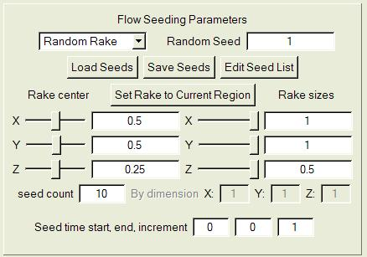
Figure 4.5: Flow seeding parameters

- The top line of the Flow Seeding Parameters contains a selector with the options “Random Rake”, “Nonrandom Rake” and “Seed List”. These options work as follows:
- When Random Rake is selected, the seed points are chosen randomly from within the bounds of the current Rake (as established by the values of Rake center and Rake sizes in this panel section). The number of seed points is the value of “seed count” below. This distribution is uniform unless the Seed Distrib. Bias in the Advanced Flow Parameters is nonzero. The Random Seed textbox determines the pseudorandom seed used for point generation.
- When Nonrandom Rake is selected, a 1-, 2-, or 3-dimensional grid of seed points is obtained by evenly subdividing the seed rake in each dimension, with the grid size in each dimension determined by the three integers specified next to the labels: By dimension X: …Y:… Z:….
- When Seed List is specified, the points that are contained in the current seed list (in the current flow instance) are used as seeds. A point from the seed list is only used if the time step in the seed list agrees with the time step being used for flow seeding. The seed list contents can be edited or read from a file, using buttons described in the next section.

- Next are three push buttons:
- The Load Seed List button results in a file-open dialog, whereby the user specifies a text (*.txt) file that contains a list of seeds. The format of the seed list file is the same as the format of the save flow file (described above): Each line has four floating point values, 3 spatial coordinates and one time step coordinate. If the time step is negative, the seed point is valid for all time steps. Otherwise, the seed point is only valid for the integer time step nearest the nonnegative time step coordinate.
- Click Save Seeds to specify a file to write the current seeds. If the seeds are using Random Rake or Nonrandom Rake, the seeds from the rake are generated and written to file (formatted as in Load Seeds above). If a Seed List is currently specified, then the seeds in the seed list are output.
- Click Edit Seed List to launch a table containing the current list of seeds. Buttons enable the user to Add Seed or Delete Seed, and the currently selected seed can be edited by typing in a new value and then pressing the <enter> key.
- The button labeled Set Rake to Current Region causes the rake to be immediately set to have the same extents as the current region in the current active visualizer.
- The Rake center and Rake sizes (sliders and text boxes) specify the X, Y, and Z extents of the rake. These are similar to the region extents that are specified in the region panel in Section 4.4.1 above. The rake is not required to lie within the current region; however, if the rake is outside the current region, the flow seeds that like outside the region will not be integrated. The rake extents can also be specified interactively in the scene in Rake Mode (see section 3.1.1).
- The seed count text box indicates the total number of seeds being used. It is only editable with a Random Rake.
- The three text boxes labeled Seed time start, end, and increment are only available with unsteady flow and with seed line advection.
- With unsteady flow, a seed point can be repeated; that is, the seed point can be injected into the flow at multiple times. These three values specify the first and last time steps for injection, and the interval between injections. Note that the increment is always positive, whether the flow is forward or backward. If a seed list is specified in an unsteady flow, a seed with a nonnegative time step will be only injected once at that time step. A seed with a negative time step will be repeatedly injected at all values specified by the values of Seed time start, end, and increment.
- When using field line advection, only the first value (Seed time start) is used. This is the time step when the field line advection begins. Field lines at other times are determined by advecting field lines (either forwards or backwards) from that time step.

Shape Parameters
Below the Flow Seeding Parameters is a section labeled Shape parameters. This section of the flow panel is shown in Figure 4.6, below. These settings are generally related to how the flow will be displayed and (with unsteady flow) how the display changes over time.

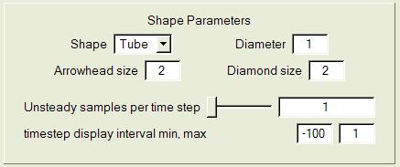
Figure 4.6: Shape Parameters

- Shape specifies whether the flow lines will be represented as Tubes, Arrows or Points. One geometric shape is associated with each geometric sample.
- Diameter specifies the diameter of the geometric shape (relative to the size of a voxel at full data resolution). If the diameter of a tube is 0, it is drawn with lines.
- Arrowhead size is only used when the Geometric Shape is set to Arrows. This specifies the diameter of an arrowhead as a multiple of the shape diameter.
- Unsteady samples per time step (slider and text box) is used only with unsteady flow. This quantity determines how many points are used to track flow lines between successive time steps. Minimum value is 1, resulting in a time sample at each time step.
- timestep display interval min/max (only available with unsteady flow) is followed by two text boxes. These (min and max) values define the portion of the flow that will be displayed at a given time. If the current time step (in the Animation panel) is T, the portion of the flow from (T+min) to (T+max) will be displayed. These values can be used to track particle motion along an unsteady flow line, by animating the time step and showing the changing segment of the field line as it moves along the full flow path resulting from integration.

Color/Opacity map editing
Below the Shape Parameters is a section labeled Color/Opacity mapping. This section of the flow panel is similar to the transfer function editors in the DVR and Probe panels. These mappings specify how color and opacity will be applied to the flow lines. Unlike the transfer function editor, there are two separate editors here, one for opacity and one for color. Also there is no histogram in the opacity editor. The Color/Opacity mapping section is shown below:

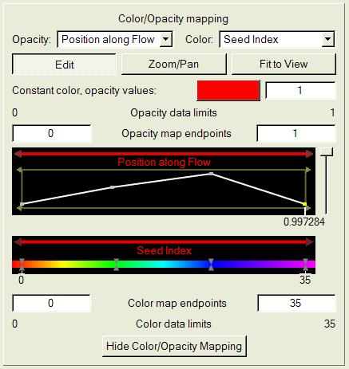

The parameters in this section include:
- At the top of the Color/Opacity mapping section are two combo boxes containing lists of entities that are mapped to color and opacity, identified with the labels Opacity: and Color: The available entities include:
- Constant: (i.e. there is just one opacity or color). This is the default.
- Position along flow: This entity is available for either steady flow or field line advection. The value is the relative position along a steady flow line, between 0 and 1. In bidirectional flow, the seed point is at 0.5.
- Timestep (available only with unsteady flow) is the time step along the flow line starting at 0.
- Field Magnitude: This setting uses as mapping entity the magnitude of the vector field defining the flow, at each point along the flow.
- Seed Index: The seed points are numbered with nonnegative integers. With a seed list the index is the position of the seed in the list. With nonrandom rake, the index increases first in x, then y, then z. With a random rake, the index is the order that the seed point was generated. When Seed Index is specified, each flow line has a constant color and opacity along its full length. The color and opacity of the flow line depend only upon the index of its seed point.
- Variable: Any of the variables in the current metadata can also be used as the mapped entity for color and opacity mapping. The value of the variable at each point along the flow is used for the mapping.
- Below the opacity and color combo boxes are three buttons that control the flow map editor. These are similar to the buttons above the transfer function editor (although there is no “Histo” button here):
  - Edit: When clicked, the left mouse performs editing functions such as selecting and moving control points
  - Zoom/Pan: When clicked, the left mouse button enables zooming (magnification) and panning (translation), in either the opacity map or in the color map, not changing the color/opacity mapping.
  - Fit to View: When clicked, the opacity and color editors are reset to use the full window width.
- Constant color/opacity values: This button and textbox control the color and the opacity that are used when the Opacity map combo box and/or the Color map combo box are set to Constant. Click the colored button to launch a color selector.
- The flow map editor permits separate control of color and opacity bounds. The opacity bounds are shown above the editing region:
  - The Opacity data limits (left and right labels) indicate the lower and upper bounds of the entity that is currently mapped to opacity.
  - The Opacity map endpoints (left and right text boxes) specify the lower and upper limits of the domain of the opacity mapping. Values to the left of the lower limit are mapped to the same value as the lower limit. Values to the right of the upper limit are mapped to the same value as the upper limit.
- The top part of the flow map editor controls the opacity map, by the positioning of opacity domain endpoints and the placement of opacity control points. The bottom part similarly controls the color map. These are edited in the same manner as the opacity is edited in the transfer function editor (above, section 4.5.2). However there are separate domain bars for opacity (above the opacity editing region) and color (immediately above the color bar), enabling separate control of the opacity and color mapping domains by dragging the left mouse over either of these bars.
- Below the opacity editor are displayed the coordinates of any selected opacity control points, with tic marks at the horizontal position, as well as the left and right bounds.
- Below the color bar are displayed the coordinates of any selected color control points, with tic marks at the horizontal position, as well as the left and right bounds.
- The color mapping bounds are shown below the color editing region:
  - The Color map endpoints (left and right text boxes) specify the lower and upper limits of the domain of the color mapping. Values to the left of the lower limit are mapped to the same color as the lower limit. Values to the right of the upper limit are mapped to the same color as the upper limit.
  - The Color data limits (left and right labels) indicate the lower and upper bounds of the entity that is currently mapped to color.

Probe panel
The probe panel controls the location of a 3-dimensional box-shaped volume that can be positioned and rotated anywhere in the data volume. The probe can be used to interrogate data values (visually and numerically) within its volume. The probe can also be used to interactively place seed points for flow calculations.
The center plane of the probe can be used as a contour plane, displaying a slice through a dataset, or it can be used to show an image of a flow field, that can be animated to provide a planar view of a moving field.
The entire probe is shown below, with the top on the left and the bottom on the right side of the image:

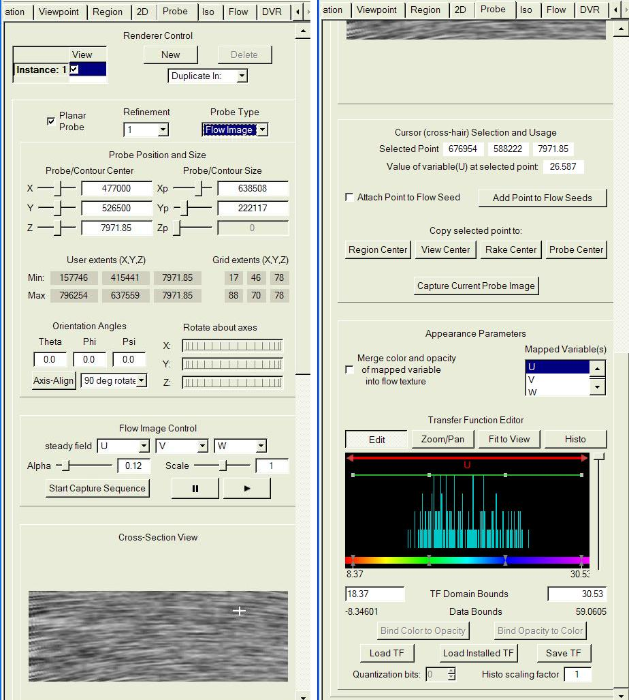
Figure 4.7: Probe Panel Top (left) and Bottom (right)

Probe overview

The probe can be regarded as a 2- or 3- dimensional box that is linearly mapped into the data volume. The x,y,z coordinates of the probe box are initially aligned with the x,y,z coordinates in the data volume, but a rotation of the box will change this alignment.
The center plane of the probe box (the rectangle inside the probe, defined by z = z_{center}, is displayed as a texture in the probe panel when the probe is enabled. This textured rectangle is also displayed in the associated visualizer, in the location defined by the probe mapping, when the probe is enabled. When the mouse mode is data probe mode (Section 3.1.1), the extents of the probe in the 3D scene are outlined by a red frame with handles. The image of the probe center plane in the Probe tab can also be used for positioning a cursor that is displayed as two-dimensional cross-hairs in the probe panel, and as three-dimensional cross-hairs in the visualizer (in data probe mode).
The probe can be used either as a “Data Probe” when used for displaying a contour plane of a variable in the data, or as a “Flow Image” when used to display the motion of a vector field. The entire contents of the probe box are used to calculate a histogram of data values of a selected 3D variable or of the norm of a set of variables. The histogram appears in a transfer function editor near the bottom of the probe panel.

General probe settings

The top of the probe panel is shown on the left side of figure 4.7, above. The elements in the probe panel are described from top to bottom:

- The Renderer Control section has the same functionality as described in section 4.1.2, as in DVR, Flow, Iso and 2D panels, enabling multiple probes to be defined in each visualizer.
- The Planar Probe checkbox, when checked, locks the z-size of the probe to zero. This is the default, enabling the probe to be used to position a plane slicing through the data volume.
- The Refinement combo box specifies the resolution of the data that is used by the probe.
- The Probe Type selector determines whether the probe is a Data Probe, which will display a contour plane of one (or more) selected variable(s), or a Flow Image, that displays a moving texture indicating the direction and speed of a flow field. These capabilities will be discussed more below.

Probe Position and Size

- The Probe Center and Probe Size sliders and text boxes control the positioning and size of the probe in X, Y, and Z dimensions. Note that, when in data probe mode (Section 3.1.1), the probe positioning and size can also be controlled by left- and right-mouse drags in the visualizer scene. The probe is permitted to overlap the full extents of the data domain.
- User Extents and Grid Extents displays show the min and max values of coordinates in the probe, in both user coordinates and in voxel coordinates. The voxel coordinates are based on the highest refinement level of the data. These values are based the smallest axis-aligned box containing the probe, so they depend on how the probe is rotated as well as its size and center.
- The Orientation Angles text boxes allow the user to rotate the probe relative to the coordinate axes in user space. The Theta text box specifies the horizontal angle between the positive X-axis in user space and the positive X-axis of the probe. The Phi text box specifies an angle of rotation between the positive Z-axis of the probe and the positive Z-axis in user space. The Psi text box specifies an angle of rotation about the axis determined by the values of theta and phi. The orientation of the probe in the 3D scene is determined by first applying the psi angle (in the X-Y plane), then applying the vertical (phi) rotation, rotating the probe in the X-Z plane, finally applying the horizontal (theta) rotation, rotating the probe in the X-Y plane.
- To facilitate interactive orientation of the probe, there are thumbwheels labeled “Rotate about axes”, one for each of the three coordinate axes. Rotating a thumbwheel causes the probe to rotate about its center in the plane orthogonal to the indicated axis.
- Under the Orientation Angles is the Axis-Align button. Clicking on this button causes the probe to rotate to the nearest axis-aligned orientation.
- Next to the Axis-Align button is the 90 deg rotate selector. This provides the option of rotating the probe 90 degrees about its center in any axis-aligned direction.

Flow Image Control
- This section of the probe panel is only displayed when the selected Probe Type is Flow Image. The display of the vector field uses a technique called “Image Based Flow Visualization” or IBFV. This is a technique introduced by Jarke Van Wijk, published in Proceedings, ACM Siggraph 2002. A random spot noise pattern is repeatedly advected by the vector field. The vector field is projected into the plane of the probe so as to always display the motion in the plane of the probe. Multiple such images are accumulated, resulting in the effect of smearing the pattern in the direction of the flow. This IBFV display is based on the flow field at the current time step; it does not show unsteady flow or how the flow moves in time.
- steady field selectors are used to choose the variables that specify the X-, Y-, and Z-coordinates of the vector field that will be displayed. The display of the vector field uses the technique called “Image Based Flow Visualization” or IBFV.
- The Alpha value (slider and text box) is a factor that specifies the fraction of each image that is added into the accumulated image. The default (0.12) works well to show motion that is fairly uniform.
- The Scale value is used to scale the values of the vector field. The field is initially scaled so that its average magnitude over the probe is 4.0 pixels per timestep when the Scale value is set to 1.0 (the default).
- The button labeled Start Capture Sequence can be used to save the IBFV images to jpeg files. When you click this button you are asked to specify the name of the first file of the sequence. Every subsequent image will be saved to file. When this button is clicked again, it terminates the saving of jpeg files.
- The pause (║) and play(►) buttons are used to control the advance of the IBFV images. By default the animation is paused.

Probe Cross-Section view
When the probe is enabled, the Cross-Section View displays a two-dimensional texture. The image displayed depends on the variable(s) selected and other parameters in the Appearance Parameters of the Probe, described in section 4.7.7.
In the Cross-Section View are also displayed white cross-hairs. The cross-hairs track the location of the most recent click or drag of the left mouse in the Cross-Section View.
If the probe is enabled, the probe cross-section image is also displayed in the visualizer at the position determined by the mapping. In probe mouse-mode, the currently active probe instance is outlined with a red frame. In addition, the cross-hair position in the scene is shown in the visualizer as 3-dimensional white cross-hairs, aligned with the coordinate axes.
With a data probe, the texture is the result of applying the mapping of the center (X-Y) plane (i.e. the plane defined by z = z_{center} in probe coordinates) from probe space into user space, as determined by the probe/contour center, size, and orientation. The points in the Cross-Section View are colored by applying a transfer function (described below) to the values of the Mapped Variable(s) in the probe center plane. The color (but not the opacity) of that transfer function is displayed in this texture.
If the probe type is Flow Image, the displayed image is the accumulated IBFV black-and-white spot noise (as described in the previous section). If in addition the checkbox (in the Appearance Parameters) labeled “Merge color and opacity of mapped variable into flow texture” is checked, then the resulting image will be a combination of IBFV with the color of the data probe. In that case, the color (hue and saturation) of each point in the image is determined by the transfer function applied to the Mapped Variable(s), while the darkness (value) at a point in the image is determined by the IBFV.

Cursor (cross-hair) Selection and Usage
This section of the probe, immediately below the Cross-Section View, is displayed on the right side of Figure 4.7, and provides several functions associated with the point selected with the cursor in the image.

- The Selected Point indicates the three coordinates in user space that the current cross-hairs are mapped to.
- The Value of Variable at Selected Point specifies the value of the single variable (if only one is selected in the Mapped Variable(s) combo) or the length of the vector of variables (if more than one is selected in the Mapped Variable(s) combo).
- When checked, Attach Selected Point to Flow Seed inserts a seed point as the last seed in the flow panel’s seed list, at the position of the selected point. As long as this remains checked, changes to the selected point position result in changes to the position of the last seed point in the list. Note that, in order for this check-box to have a visible effect, the active flow instance must be enabled, and the Use Seed List checkbox must be checked in that flow instance.
- When clicked, the button labeled Add Selected Point to Flow Seeds causes the current selected point to be added to the end of the list of flow seeds in the current flow instance. If Attach Selected Point to Flow Seed is checked, then the current point will appear twice in the list until the selected point is moved. This will have no visible effect unless the current instance in the flow panel is enabled and Use Seed List is checked in the current flow instance in that panel.
    - Four buttons, below the label Copy selected point to:, can be used to make the selected point become the center of the extents defined in the region panel (region center), viewpoint panel (center of rotation), flow panel (rake center) and the center of the current probe instance. These buttons are respectively labeled Region Center, View Center, Rake Center, and Probe Center.
    - The button labeled “Capture Current Probe Image” launches a file-selection dialog, enabling the user to choose a jpeg image file, to which the current probe/contour plane is written. The image will be of resolution at least as fine as the probe data at its current resolution.

Appearance parameters
- The check-box labeled “Merge color and opacity of mapped variable into flow texture” is only available if the probe type is Flow Image. If checked, the probe hue and saturation as well as its opacity (in the 3D view) are determined by mapping the Mapped Variable(s) of the probe using the Probe transfer function (below). The value (intensity) in the probe texture is obtained from the IBFV texture.
- The Mapped Variable(s) list-box enables the user to select any subset of the variables in the current metadata. Multiple variables are selected by holding down the <Ctrl>-key while clicking with the left mouse button. If only one variable is selected, then the probe displays and uses the values of that variable. If multiple variables are selected, then the probe displays and uses the length of the vector defined by the multiple variables; i.e, the square root of the sum of the squares of the selected variables.

The bottom of the probe panel contains a transfer function editor. The functionality of this transfer function editor is identical to the transfer function editor in the DVR panel described in section 4.5.2, with the following minor differences:
- The transfer function is applied either to a single variable or to the length of the vector determined by multiple selected variables.
- The histogram displays the values of the selected variable (or the values of the vector length, if multiple variables are selected) within the current extents of the probe. If multiple variables are selected, only the name of the first of those variables is displayed in the editor.
- When the probe is enabled, both the color and opacity of the probe texture are applied to a rectangular texture in the visualizer, along the center plane of the probe region, determined by the extents and orientation of the probe.
- Only the color (not the opacity) determined by the transfer function is applied to the texture in the Cross-Section View of the probe panel.
- There is no color selector associated with the transfer function editor in the probe. Colors can be identified and specified by clicking on color control points with the right mouse button.

Isosurface Panel

The isosurface panel appears as follows:
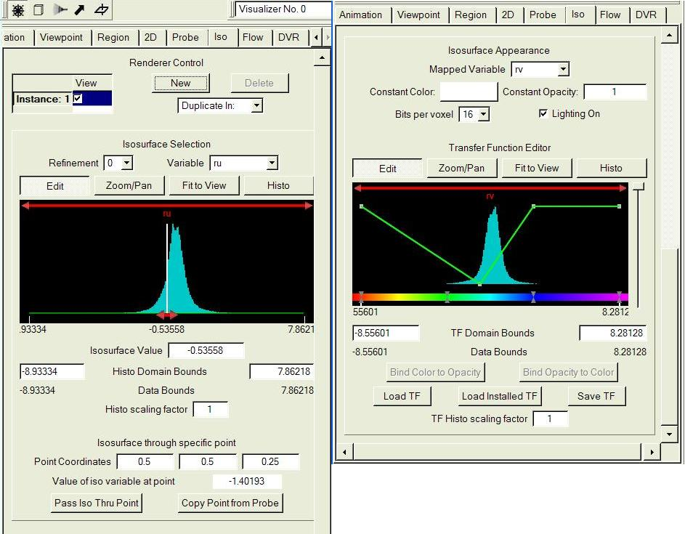
Figure 4.8: Isosurface Panel Top (left) and Bottom (right)

The isosurface panel controls the rendering of one or more isosurfaces in the visualizer. Each isosurface is associated with a variable V and an “isovalue” Ival, and the isosurface is the surface defined by V(x,y,z) = Ival. Any number of isosurfaces can be rendered in a renderer. One of the isosurfaces in the scene can be partially transparent. If more than one isosurface is specified as partially transparent the rendering may not properly show the relationship between the two surfaces.
The isosurface is calculated as it is rendered, using the graphics hardware. The isosurface rendering may not work correctly on older graphics cards. If the isosurface fails to render properly, you should check for graphics driver updates.

General Isosurface settings
Each isosurface in the visualizer is associated with a different instance, controlled by the instances in Renderer Control. Check the instance selector to enable rendering of the current instance. The isosurface that is rendered depends on the selected variable and its refinement level, as well as the other parameters below:

Isovalue selection
The top of the Isovalue Selection section contains a histogram window. The functionality in this histogram is similar to the histogram in the transfer function editor in the DVR panel described in section 4.5.2.
- There are Edit, Zoom/Pan, Fit to View and Histo buttons, that enable the user to move the histogram window horizontally and to refresh the histogram displayed.
- At the top of the histogram window is a red arrow that, in Edit mode, can be used to translate the histogram window horizontally. This does not affect the Isosurface value.
- The histogram window displays a histogram of the selected variable within the current Histo Display Bounds specified below. The right mouse button can be used to change the histogram scaling.
- At the bottom of the histogram window is a double-arrow that, while in Edit mode, is used to modify the isosurface value, by clicking and dragging with the left mouse button
- A text box, labeled Isosurface Value displays the current isovalue, and can be modified by typing in a new value.
- The left and right bounds of the variable being histogrammed are shown and can be edited in the two Histo Domain Bounds text boxes.
- The actual bounds of the current variable are shown as the Data Bounds.
- Below the Data Bounds is the Histo scaling factor, that stretches or shrinks the histogram vertically.
- For specifying the isosurface to pass through a specific point, there are three editable Point Coordinates. When the isosurface is enabled, and if the point coordinates are inside the current region, the Value of Variable at Point textbox will display the current value at the point. Click on the button labeled Pass Iso Thru Point, and the isovalue will change to the value of the variable at the specified point.
- The Copy Point from Probe button can be used to set the current Point Coordinates to the coordinates of the current probe (for this visualizer). The coordinate copy does not result in a change in the isovalue until the Pass Iso Thru Point button is clicked.

Isosurface appearance
The Isosurface Appearance parameters are at the bottom of the Iso tab, shown on the right side of Figure 4.8. The isosurface can be given a constant color and opacity, or a 3D variable can be used to map color and opacity to the surface.

- The Mapped Variable selector can be used to select Constant or can select any 3D variable in the VDC.
- Click on the Constant Color: button to launch a color selection dialog, choosing a constant color of the isosurface.
- The Constant Opacity: text box enables the opacity to be set to any value between 0 (transparent) and 1 (opaque). Note however that a semi-transparent isosurface will sometimes not render correctly with other semi-transparent geometry in the scene. For best results, use at most one non-opaque isosurface in the scene. When changing the transparency from opaque to non-opaque, or from non-opaque to opaque, it is best to disable and re-enable the isosurface.
- The Bits per voxel can be set to either 8 or 16. The value specifies the bits of accuracy of the data that is used for calculating the isosurface. The quality is significantly better with 16 bits; however the rendering time is longer, especially with very large volumes.
- By default the Lighting on checkbox is checked, indicating that the isosurface will be illuminated, as specified in the Viewpoint panel. Rendering quality is much better (but significantly slower) with lighting enabled.
- The Transfer Function Editor is used to determine a color mapping whenever the Mapped Variable is not Constant. This is similar to the Transfer Function Editor in the DVR panel, described in section 4.5.2, except that there is no color selector provided. To select a color, click with the right mouse over a color control point and select “Edit Control Point” to launch a color chooser for the specified control point.

Two-D Panel
The 2D panel provides the capability of visualizing two-dimensional variables in a three-dimensional scene. A two-dimensional variable can be displayed as a contour image, using a provided transfer function editor. Or it can be applied to a terrain image in the 3D scene. The 2D panel is similar to the probe panel; however it has no flow image capability and the plane cannot be rotated. The 2D panel is shown in figure 4.9 below:

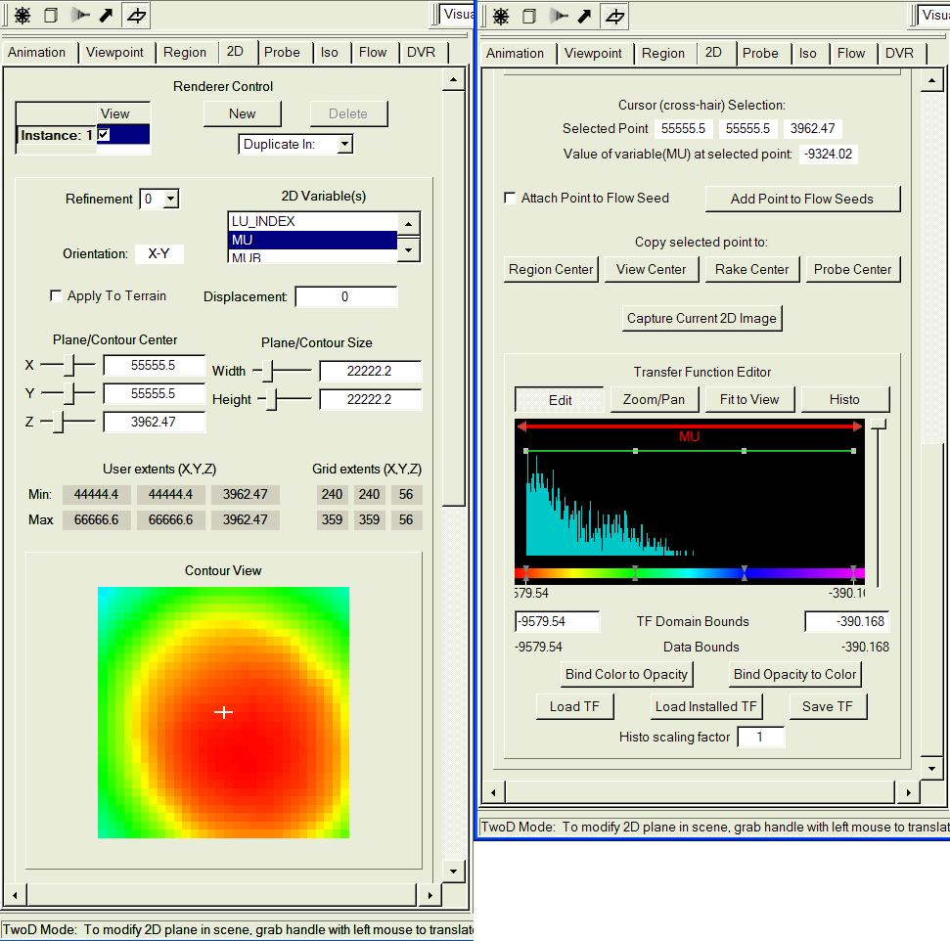
Figure 4.9: The 2D Panel Top (left) and Bottom (right)

We describe the functions of the 2D panel from top (left) to bottom (right).

General settings
- At the top of the 2D tab is a Renderer Control, enabling creation or duplication of any number of 2D renderer instances in a 3D scene.
- The Refinement selector is similar to the refinement selector for 3D variables; however 2D variables are only refined in two dimensions.
- The 2D Variable(s) selector can be used to select 1 or more two-dimensional variables in the VDC (if there are any 2D variables in the VDC). If multiple variables are selected, then the magnitude of the vector consisting of the variables is used for mapping color onto the 2D contour plane. Multiple variables must have the same orientation. Currently only X-Y (horizontally) oriented variables are supported.
- The Orientation textbox displays the orientation of the selected variable(s).
- When the Apply to Terrain checkbox is checked, the 2D image is visualized on (or vertically displaced from) the terrain elevation in the scene. If the VDC is layered (e.g. a WRF dataset) then the variable “HGT” is used to determine terrain elevation. If the “HGT” variable is not available, then the “ELEVATION” variable is used.
- The Displacement textbox specifies a vertical displacement of the terrain elevation in user (Z) coordinates. When Apply to Terrain is checked, the 2D image is displayed this distance above (or below) the terrain elevation.

Two-D position controls
- The Plane/Contour Center sliders and textboxes determine the 3D coordinates in the scene for the center of the 2D image to be displayed. If the Apply to Terrain checkbox is checked, then the Z coordinate is ignored.
- The Plane/Contour Size sliders and textboxes determine the extent of the 2D plane, using X and Y coordinate extents.
- The User extents (X,Y,Z) and Grid extents (X,Y,Z) text boxes display the minimum and maximum coordinates of the 2D plane in both user and grid coordinates. Grid coordinates are based on the full resolution grid of the VDC.

Contour view
This displays a two-dimensional image determined by applying a transfer function to the data values specified in the Two-D position controls described above. This same image is also displayed in the 3D scene at the position determined by the Two-D position controls, or applied to the terrain surface.

Point selection capabilities
The cursor in the Contour view is used to determine a selected point, in both the Contour view and in the 3D scene. A three-dimensional cursor is only displayed in the 3D scene when in 2D mode (see mouse mode section 3.1.1). The third coordinate of the point is the Z coordinate of the 2D center. The cursor supports the following operations:
- Selected Point textboxes display 3D coordinates of the point.
- Value of variable (…) at selected point specifies the value of the Mapped Variable(s).
- When checked, Attach Selected Point to Flow Seed inserts a seed point as the last seed in the flow panel’s seed list, at the position of the selected point. As long as this remains checked, changes to the selected point position result in changes to the position of the last seed point in the list. Note that, in order for this check-box to have a visible effect, the active flow instance must be enabled, and the Use Seed List checkbox must be checked in that flow instance.
- When clicked, the button labeled Add Selected Point to Flow Seeds causes the current selected point to be added to the end of the list of flow seeds in the current flow instance. If Attach Selected Point to Flow Seed is checked, then the current point will appear twice in the list until the selected point is moved. This will have no visible effect unless the current instance in the flow panel is enabled and Use Seed List is checked in the current instance in that panel.
- Four buttons, below the label Copy selected point to:, can be used to make the selected point the center of the extents defined in the region panel (region center), viewpoint panel (center of rotation), flow panel (rake center) and the center of the current probe instance. These buttons are respectively labeled Region Center, View Center, Rake Center, and Probe Center.

Remaining 2D capabilities
- The button labeled “Capture Current 2D Image” launches a file-selection dialog, enabling the user to choose a jpeg image file, to which the current 2D contour plane is written. The image will be of resolution at least as fine as the 2D data at its current resolution.
- At the bottom of the 2D tab is a Transfer Function Editor that is used to map the 2D variable to color and opacity values. This editor is identical to the corresponding transfer function editor in the Probe panel.

