Getting Started with
VAPOR and WRF

Version 2.1
January 2012

Overview

VAPOR is the Visualization and Analysis Platform for Ocean, Atmosphere, and Solar Researchers. VAPOR was developed at NCAR to provide interactive visualization and analysis of numerically simulated fluid dynamics. VAPOR supports visualization of WRF-ARW simulation output. This document is a brief overview of the capabilities of VAPOR with WRF. For a more complete understanding, see the following:
VAPOR/WRF Data and Image Preparation Guide : Instructions for converting WRF data to VAPOR format, obtaining georeferenced images to use in the VAPOR scene, and performing analysis on WRF data.

Georgia Weather Case Study : A quick-start tutorial showing how to use VAPOR to explore a WRF data set.

Using NCL with VAPOR to visualize WRF-ARW data: A tutorial showing how to use NCL to make plots of NCL data that can be embedded in a VAPOR 3D scene.

VAPOR User’s Guide for WRF Typhoon Research : A guide to using VAPOR to visualize typhoon Jangmi, including instructions for preparing satellite images and NCL plots to visualize in VAPOR.

Using Python with VAPOR: A guide to defining derived variables using VAPOR’s embedded Python interpreter.

Additional documentation on the VAPOR Web site : Includes general information about using VAPOR to explore turbulence data.

Basic capabilities of VAPOR with WRF-ARW output
- Direct Volume rendering (DVR):
Any 3D variable in the WRF data can be viewed as a density. Users control transparency and color to view temperature, water vapor, clouds, etc. in 3D.

- Flow:
  - Using Barbs tab: Position an array of wind barbs based on 2D or 3D wind field. Barbs may be a fixed distance from terrain, and may be aligned with horizontal data grid.
  - Using Flow tab: Draw 2D and 3D streamlines and flow arrows, showing the wind motion and direction, and how wind changes in time.
  - Path tracing (unsteady flow) enables visualization of trajectories that particles take over time. Users control when and where the particles are released.
  - Flow image animation: Vapor supports image-based flow visualization in the Probe tab. Provides a means of viewing a planar slice of the flow as random particles moving in time.

- Isosurfaces:
The isosurfaces of variables are displayed interactively. Users can control iso-values, color and transparency of the isosurfaces. 3D variables in the dataset can be color-mapped onto the isosurface.

- Contour planes and Probes
3D variables can be intersected with arbitrarily oriented planes. Contour planes can be interactively positioned. Users can interactively pinpoint the values of a variable and establish seed points for flow integration. Image-based flow (IBFV) can also be visualized in the probe plane.

- Animation:
Control the time-stepping of the data, for interactive replaying and for recording animated sequences. Animations can be captured to jpeg files.

- Image rendering:
Georeferenced tiff image files can be properly positioned in the VAPOR scene to fit the geo-referencing of the WRF model. NCL plots of WRF data can be inserted in the VAPOR scene. Images can be applied to the terrain surface. A sequence of tiff images can move to follow a moving WRF nested domain. Satellite images can be retrieved from the Web and installed in the Vapor scene.

- Two-dimensional data rendering: Two dimensional variables can be displayed in the 3-D scene, either as a horizontal plane, or mapped to the terrain. Color and transparency are specified using a transfer function editor.

- Derived variables: New variables can be defined as simple mathematical expressions applied to existing WRF variables. Python functions are provided to derive several weather-related variables, such as radar reflectivity, cloud-top height, relative humidity, temperature in degrees Kelvin, dewpoint temperature, vorticity, potential vorticity, sea-level pressure, and horizontal wind shear.

VAPOR requirements
VAPOR is supported on Linux, Mac, and Windows. VAPOR works best with a recent graphics card (say 1-2 years old). The advanced features of VAPOR perform best with nVidia, AMD, or ATI graphics accelerators.
VAPOR 2.2 is installed on NCAR visualization systems. Users with UCAR accounts can connect their (Windows, Mac, or Linux) desktops to the NCAR visualization systems using TurboVNC, and operate a remote VAPOR session. Instructions for using this are on the NCAR/HSS Web site at http://www2.cisl.ucar.edu/docs/mirage-storm/visualization Contact dasg@ucar.edu for assistance.

VAPOR support resources
The VAPOR website: http://www.vapor.ucar.edu provides software, documentation, example data, and links to other resources.
The VAPOR sourceforge website http://sourceforge.net/projects/vapor enables users to post bugs, request features, download software, etc.
Users of VAPOR on NCAR visualization systems should contact dasg@ucar.edu for support.
Questions, problems, bugs etc. should be reported to vapor@ucar.edu
VAPOR development priorities are established by the VAPOR steering committee, a group of turbulence researchers who are interested in improving the ability to analyze and visualize time-varying simulation results. Post a feature request to the VAPOR sourceforge website, or e-mail vapor@ucar.edu if you have requests or suggestions about improving VAPOR capabilities.

How to use VAPOR with WRF-ARW data

1. Install VAPOR
VAPOR installers for Windows, Macintosh and Linux are available on the VAPOR download page, http://www.vapor.ucar.edu/page/vapor-download#Binary. For most users, a binary installation is fine. Installation instructions may be found at http://www.vapor.ucar.edu/docs/vapor-installation/vapor-installation .
After VAPOR is installed, it is necessary to perform user environment setup on Unix or Mac, before executing any VAPOR software. These setup instructions are provided on the VAPOR install documentation page, http://www.vapor.ucar.edu/docs/vapor-installation/vapor-installation .

2. [optional]Conversion of WRF output data to VAPOR
If you have a very large WRF dataset, you will get better visualization performance if you convert your WRF data to a VAPOR Data Collection (VDC). This conversion is not necessary with small datasets, because VAPOR can import the wrfout files directly.
VAPOR datasets consist of (1) a metadata file (file type .vdf) that describes an entire VAPOR data collection, and (2) a directory of multi-resolution data files where the actual data is stored. The metadata file is created by the command wrfvdfcreate, and the multiresolution data files are written by the command wrf2vdf. The simplest way to create a VAPOR data collection is as follows
- First issue the command
wrfvdfcreate wrf_files metadata_file.vdf
where:
wrf_files is a list of one or more wrf output files that you want to use.
metadata_file.vdf is the name that you will use for your metadata file.

- Then issue the command
wrf2vdf metadata_file.vdf wrf_files
using the same arguments (in reversed order) as you used with wrfvdfcreate. Note that wrf2vdf does most of the work, and may take a few minutes to convert a large WRF dataset.

After issuing the above commands, all of the spatial variables in the specified WRF output files will be converted, for all the time steps in the files. If you desire more control over the conversion process, there are many additional options that you can provide to wrfvdfcreate and wrf2vdf. Type the command with the argument “-help” to get a short listing of the command usage. Data conversion options are described in section 1 of the VAPOR/WRF Data and Image Preparation Guide, and details of the command-line option are specified in the man pages of the various commands. Some of the options include:

- Overriding default volume dimensions and/or spatial extents.
- Converting only a subset of the WRF output timesteps
- Converting a specific collection of variables.

3. Visualize the WRF data
After initializing your environment (e.g. sourcing the vapor-setup.csh script), from the command line, issue the command “vaporgui”, or double-click the VAPOR desktop icon (on Windows or Mac). When running remotely in a VirtualGL window, issue the command “vglrun vaporgui” This will launch the VAPOR user interface. From the Data menu, choose “Load a dataset into default session”, and select the metadata file that you associated with your converted WRF data.

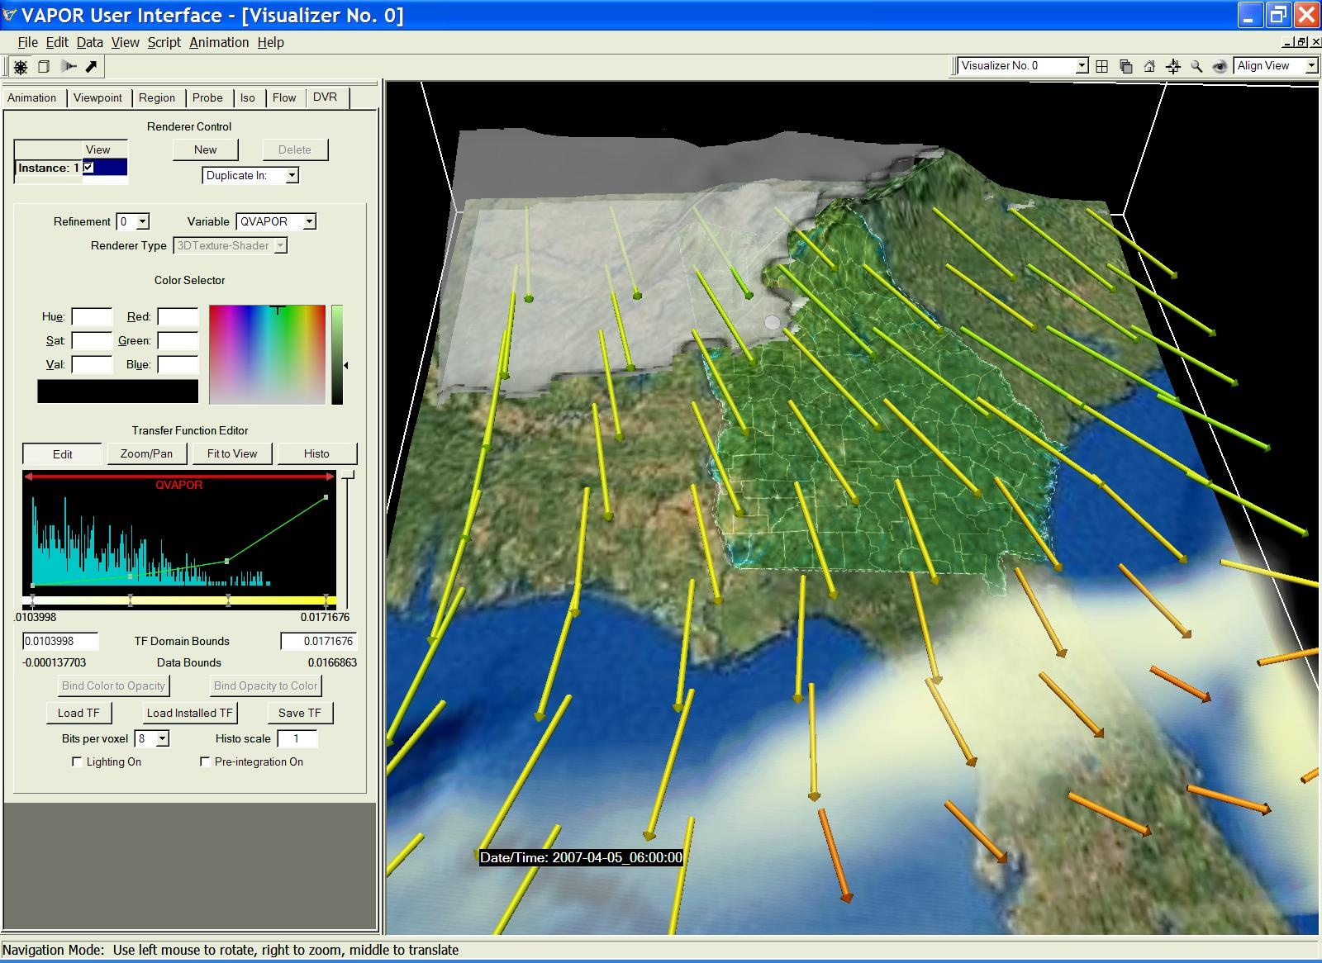

To visualize the data, select a renderer tab (DVR, Iso, Flow, Image, 2D, or Probe), and then, at the top of that tab, check the box labeled “Instance:1”, to enable a renderer. For example, the above image combines volume, flow and isosurface visualization with a terrain image.
There are many capabilities in VAPOR to support visualization of WRF data. Several resources are available to help users quickly get the information they need to obtain the most useful visualizations:

- The document “VAPOR/WRF Data and Image Preparation Guide” provides instructions on how to convert WRF data into VAPOR, how to obtain georeferenced TIFF images to use with the WRF data, and how to perform analysis of WRF data in conjunction with VAPOR visualization of the data. This document also provides a technical discussion of the VAPOR capabilities for handling WRF data sets.

- To learn how to use the VAPOR user interface, a step-by-step tutorial is provided, the “Georgia Weather Case Study”. This tutorial explains how to use most of the WRF-related visualization capabilities of VAPOR.

- To understand the meaning or function of an element in the VAPOR user interface:
  - Tool tips: Place the cursor over a widget for a couple of seconds and a one-sentence description is provided.
  - Context-sensitive help: From the Help menu, click on “?Explain This”, and then click with the left mouse button on a widget, to get a longer technical explanation of the functionality.

- Complete documentation of all capabilities of the VAPOR user interface is provided in the VAPOR GUI General Guide

- The VAPOR Quick Start Guide provides a step-by-step tutorial for using VAPOR on turbulence data. The Quick Start Guide is not specific to WRF.

