Characteristics of Cloud-Nucleating Aerosols and their Effects

on Cloud Microphysical and Radiative Properties in INDOEX

Project Description

1. Introduction

Of critical importance in predicting climate change is the indirect effect of aerosol particles on clouds; that is, how added particles act as cloud condensation nuclei (CCN) and subsequently may affect the radiation budget through changes in cloud albedo (Twomey, 1977) and lifetime (Albrecht, 1989). Our limited knowledge of this process severely handicaps our ability to understand radiative forcing of anthropogenic aerosols, since the uncertainty due to aerosol effects on clouds is exceedingly large (Charlson et al., 1992). This problem, although difficult, needs to be addressed with multiple approaches until a comprehensive understanding of the controlling factors emerges.

Measurements have demonstrated that aerosol particles can have a large influence on cloud radiative properties. For example, ship effluents often increase the albedo of overlying stratus clouds due to increases in droplet concentrations (Radke et al., 1989), and similar effects have been observed downwind of industrial areas (e.g., Fitzgerald and Spyers-Duran, 1973, Twohy et al., 1995). Leaitch et al. (1992) compiled data from a series of flights in the northeastern United States and Canada and developed some positive relationships between aerosol number and droplet number. Likewise, Hudson (1983) established relationships between CCN number and droplet number in stratus clouds. Some evidence for indirect effects of aerosols on cirrus clouds has even been presented (Sassen et al., 1995).
Applying these limited measurements and our understanding of the physical processes governing cloud lifecycles to general circulation models (GCMs) is extremely difficult. The non-linearity and multi-step nature of the indirect effect, as well as its regional variability, means that simple parameterizations desirable for global models are most likely inadequate. In addition, the emphasis to-date has been on understanding sulfate aerosol effects. The influence of many other aerosol types potentially important in cloud formation, for example, soil-dust, organics and sea-salt, are not yet included in most global models.

Thus, indirect aerosol effects are now recognized as important, but they are still poorly understood. For example, sea-salt was previously considered to be relatively unimportant in cloud formation, since its number concentration is often low relative to sulfate aerosol concentrations. However, this is not necessarily true in marine environments with moderate to high wind speeds, which trigger sea-salt production (Ayers and Ivey, 1988, O’Dowd et al., 1996). Recent modeling (O'Dowd et al., 1998, Ghan et al., 1998) suggests that in such cases, the presence of sea-salt may dramatically influence the ability of sulfate to affect the microphysical, and therefore the radiative, properties of clouds. The impact of more complex aerosol types, such as soil-dust and carbonaceous aerosols, are even less well understood.

2. Scientific Questions

The multinational Indian Ocean Experiment (INDOEX) seeks to assess the significance of anthropogenic sulfates and other aerosol types for global radiative forcing. During the winter monsoon season in the equatorial Indian Ocean, anthropogenic pollutants from the Northern Hemisphere flow into and interact with pristine Southern Hemispheric air. This situation permits the opportunity to study the initial source aerosol, its downwind transformations, and its ultimate impact on a pristine environment. INDOEX plans to study both the direct and indirect effect of aerosol particles on climate (for details see http://www-indoex.ucsd.edu/). This specific proposal focuses on the indirect effect, using physical and chemical measurements of aerosols below and within clouds. The specific scientific questions we aim to study are:

a) Which particle types are preferentially incorporated into clouds? In particular, what are the relative roles of sulfate, sea-salt, soil-dust, and elemental carbon?

b) How do measurements of cloud condensation nuclei in the ambient aerosol compare with those actually incorporated into clouds? Is this a simple relationship that can be used in global models? Are the physical and chemical properties of the in-cloud aerosols consistent with measured CCN spectra?

c) What is the impact of the cloud nucleating aerosols, in particular anthropogenic aerosols, on the microphysical and radiative properties of clouds?

3. Field Experiment

Stratocumulus clouds downwind of the Indian sub-continent will be sampled by the NCAR C-130 aircraft as a major element of INDOEX. The experiment will take place during the winter monsoon of February/March of 1999, when the low-level winds are north/northeasterly over the Indian sub-continent and out over the Arabian Sea (Fig. 1). Pollutant plumes flowing southwest from the coast of India are readily observable by satellite (Fig. 2), and some flights will focus on the direct radiative impact of this aerosol. However, 82 hours of research flight time will be devoted to cloud sampling in a concerted effort to detect and quantify the indirect aerosol effect.
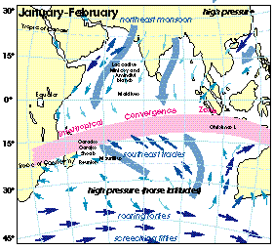
Figure 1. Prevailing surface winds in the INDOEX research area. Thickness of arrows is proportional to the force of the wind. From the Indian Ocean Atlas (1976).

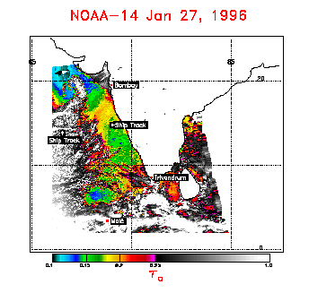
Figure 2. Aerosol optical depths at 0.63 μm retrieved for 27 January 1996 from the NOAA-14 AVHRR. Pixels with optical depths less than 0.25 are colored to emphasize the aerosol; those with optical depths greater than 0.25 are gray. Partly cloudy pixels cause the rapid rise in optical depths near clouds, regions of high optical depths and optical depths exhibiting high spatial variability. Also, high optical depths at the western edge are due to sunglint. Ship tracks are evident in both the stratocumulus deck and also in the cloud-free coastal zone. Image courtesy of J. Coakley, Jr.

The aerosol plume emanating from India will be a complex chemical soup, with sulfate, nitrate, and carbonaceous aerosol from industry on India's western coast mixed with soil-dust from arid portions of India, Saudi Arabia, and/or North Africa (Kristamurdi et al. 1997). Additionally, Satheesh et al. 1998 observed that the contribution of sea-salt to the total aerosol can be substantial and varies with surface windspeed. During this season, aerosol visible optical depth drops exponentially with distance from India, but visible optical depths as high as 0.10 were still observed 2000 km downstream (Satheesh et al. 1998¹⁵). Sub-micron aerosol number concentration drops by more than an order of magnitude in the same distance (Jayaraman et al., 1998). Intriguingly, Han et al. (1994) observed substantial differences in the low-cloud droplet size inferred from satellite in this region, with droplet size increasing downwind of the west coast of India, toward the Equator. However, no detailed study of droplet microphysics has yet been made in this location.

The C-130 will carry a broad range of radiation, aerosol and cloud physics sensors, utilizing both in-situ and remote techniques. Along with the standard radiometers and Particle Measurement Systems (PMS) optical probes for particle size distributions, NCAR will provide the Simple Aerosol Backscatter Lidar (SABL), the Multichannel Cloud Radiometer (MCR), the Airborne Imaging Microwave Radiometer (AIMR) and the Counterflow Virtual Impactor (CVI) (details of these instruments can be found at http://www.atd.ucar.edu/dir_off/facilities/non_laof.html). Scientific users will measure various aerosol physical, chemical, and cloud-nucleating properties.

During INDOEX, the CVI (Noone et al., 1988) will separate cloud droplets larger than about 8 μm diameter from the interstitial aerosol and impact them into dry nitrogen gas. This method assures that only cloud droplets are sampled, and because the sampling is highly sub-isokinetic, droplets are enhanced inside the CVI by a factor of about 20. The non-volatile residual particles and water vapor remaining after droplet evaporation at 50°C will be simultaneously sampled downstream of the inlet with several different instruments (Fig. 3).

Flow
Splitter
CN Counter

LAS-Air
Lyman-α Ηyg.
F
F
F

Vacuum Pump
Exhaust to Atm.
CVI Sample Flow
Nitrogen Cylinder
F
Filter
Return Flow
(to probe)
TEM Sampler
SEM Sampler
F
Vacuum Pump
Exhaust to Atm.
F
CCN Spect.
F
F
excess flow

Figure 3. Flow diagram of CVI components for INDOEX. "F" denotes a mass flowmeter or controller.
The total number of residual nuclei larger than 0.013 μm will be measured with a TSI 3760 condensation nucleus counter (CNC), from which droplet concentration is inferred. The water vapor will be measured by a Lyman-α hygrometer, so the liquid water content of the sampled droplets can be determined (Twohy et al., 1997). The size distribution of residual nuclei will be measured in-situ with a PMS 1001 LASAIR optical counter (diameter range 0.1 to >2.0 μm), while the chemical properties of the residual nuclei as a function of particle size will be determined by collecting particles onto filters and analyzing them by automated scanning electron microscopy (SEM) and energy dispersive X-ray spectrometry (Anderson et al., 1996) Single-stage impactor samples for transmission electron microscopy (TEM) will also be collected. Finally, the actual CCN spectrum (critical supersaturation) of the residual nuclei will be measured in-situ with a fast-response CCN spectrometer (Hudson, 1989). Although this is an extensive array of instruments to deploy simultaneously behind a CVI, all these techniques have been successfully used with CVIs in other experiments (e.g., Tucker, 1989; Twohy and Hudson, 1995; Heintzenberg et al., 1996; Ström et al., 1997). The CVI operated successfully during recent INDOEX test flights on the C-130 aircraft. Below is an example of the basic cloud microphysical data obtained (Fig. 4).
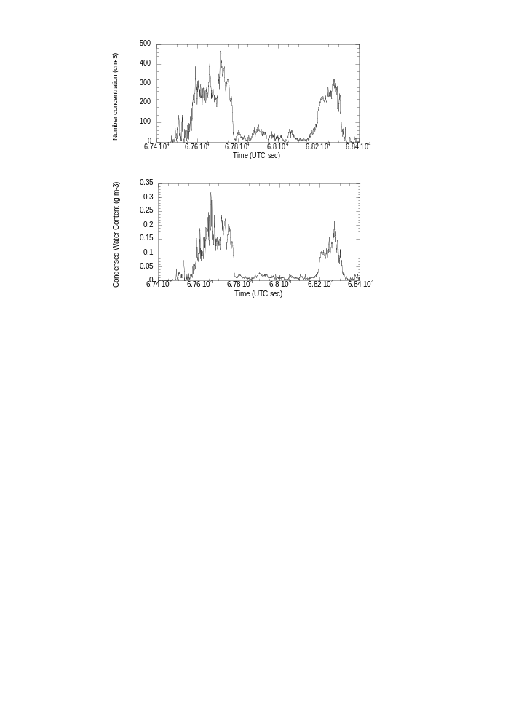
Figure 4. Cloud droplet number concentration and condensed water content measured by the CVI in an altocumulus cloud over central Colorado on 15 January 1999. After droplet evaporation, residual nuclei number concentration was measured with a TSI condensation nucleus counter, and water content with a Lyman-α hygrometer.

Ambient aerosol particles from below and above cloud will also be sampled by a variety of instruments behind NCAR's community aerosol inlet (CAI). Aerosol chemical properties will be measured by Dr. James Anderson (Arizona State University) and cloud nucleating properties (CCN) will be measured by Dr. James Hudson (Desert Research Institute). These techniques to measure ambient particles are the same as those being used directly behind the CVI. Ambient aerosol size distributions will be measured by Dr. Antony Clarke (Clarke, 1991), using a similar optical particle counter to that being used with the CVI. The size, composition, and cloud nucleating properties of the ambient aerosol therefore can be compared directly to corresponding properties of the residual nuclei actually present in clouds formed on that aerosol. Inlets to collect interstitial aerosol within cloud will also be installed. If the clouds in the study region are sufficiently homogeneous, interstitial aerosol samples will be collected.

4. Analysis of Residual Nuclei from Cloud Droplets

a. Particle size distributions

Particle size distributions of the CVI residual nuclei will be constructed in two ways. First and most straightforward, data from the LASAIR optical particle counter and TSI condensation nucleus counter will be analyzed to produce a nine-channel size distribution. This will utilize the eight LASAIR channels, and the total CN concentration minus the total LASAIR concentration for the smallest size channel (the LASAIR samples only the larger particles, while the CNC samples smaller particles as well). Another particle size distribution will be obtained through the automated SEM analyses of Anderson (1996²⁰), utilizing streaker samplers outfitted with 90 mm Nuclepore filters to collect sequential samples. This technique has a lower detection limit of 0.08 to 0.15 μm, depending on particle composition. While the LASAIR can obtain a sample in six seconds, the SEM technique will require at least a one-minute cloud sample for adequate statistics. In order to compare results from the two techniques, LASAIR data will be averaged over the SEM sample intervals. Since the CVI rejects ambient aerosol between clouds, residual nuclei size distributions can be obtained even if the clouds are small and patchy. After corrections for sampling conditions (see d, below), the two sets of nuclei size distributions will be compared with each other for consistency, and with ambient particle size distributions measured by Dr. Clarke.

b. Particle composition via SEM/TEM

The automated SEM analysis will provide size-dependent composition for several particle types, including sea salt, sulfates, and soil-dust*. Unlike bulk sampling methods, this technique produces information on individual particles, such as their size and composition and the degree to which they are internally mixed (i.e., different chemical species present within a single particle). This type of analysis is critical in determining what particle types actually participate in cloud formation, and it can be extremely revealing. For example, using the CVI, Twohy and Gandrud (1997) found that both mineral and metallic particles apparently can nucleate ice crystals in aircraft contrails, although these particle types were previously considered to be insignificant.

The SEM technique to be used in this work is automated, so that much more data can be produced than by methods requiring a human operator. Since the automated technique can run continuously, as many as 50 ambient and 50 residual nuclei samples can be analyzed in a relatively short time. We expect to have at least this many samples of interest from INDOEX, and plan to have them analyzed within a year of the project's conclusion.

More detailed chemical information can be obtained via TEM with energy dispersive spectrometry (Posfai et al., 1995). However, since the TEM analysis requires an operator, it is more expensive and time-consuming; thus, only a subset of samples will be analyzed via TEM. This sample subset will be selected after the project in order to derive more information about the clouds that clearly address the INDOEX objectives of anthropogenic aerosol forcing on cloud microphysics. The TEM analysis will supplement the faster SEM analysis by providing more information about both elemental carbon and nitrate within individual particles. Of particular interest is the degree of internal mixing of elemental carbon (EC) with sulfate, since sulfate coatings can make EC hydrophyllic and more likely to act as CCN. When coupled with electron diffraction techniques, the crystalline structure of various minerals and salts can also be identified via TEM.

Dr. Anderson is already funded for SEM analysis through NSF, so funds for the basic SEM analysis of CVI samples are not requested here. This proposal does, however, request nominal funds for 100 hours use of the TEM facilities at Arizona State University, to be conducted by Dr. Anderson's colleagues. Consolidation of the large quantities of data acquired by SEM, correction of the size distributions for sampling effects (see d, below) and comparisons of the data with ambient samples and with cloud microphysical properties are also covered through this proposal.

c. Aerosol critical supersaturations from CCN spectrometer

In a cloud formed during adiabatic expansion, the droplet size distribution will be systematically related to the critical supersaturation, S

_{c}

, of the cloud condensation nuclei (CCN). The S

_{c}

is determined by the size and composition of the particle and is related to the number of soluble ions within a particle; larger, more soluble particles will have lower S_{c}

values than smaller, less soluble particles.

Particles that have S_{c} values less than the supersaturation actually reached within a cloud form activated cloud droplets if given sufficient time for growth (Squires, 1952), while those with higher S

_{c}

's remain as smaller unactivated droplets, or haze droplets. This simple relationship can be complicated, however, in actual clouds in the atmosphere. While ideal, adiabatic regions do occur in the atmosphere (e.g., Jensen et al., 1985), they usually comprise a relatively small fraction of cloud volume (Mason, 1971). Useful information about cloud processes in non-ideal clouds, such as entrainment, coagulation, and chemical reactions, can be obtained from direct measurements of the CCN involved in droplet nucleation. The degree to which clouds can be described by simple adiabatic models, and which processes may act to change cloud microphysical properties, can be determined by these measurements.

The NCAR CVI and DRI CCN spectrometer were paired previously to measure marine cumulus clouds during the Hawaiian Rainband Project. In order to easily compare the ambient and residual nuclei samples, the median critical supersaturation (S–_{c}) was used to describe the general characteristics of the particle distributions measured with the CCN spectrometer. Results for all the cloud passes are summarized in Table 1, with each line summarizing measurements taken at different levels in the same cloud or cloud band.

Table 1. Average S–_{c} of CCN Spectra
Date  1990 | Time (UTC) | Altitude  (m) | Ambient  S–_{c} (%) | Droplet  Nuclei S–_{c} (%)
2 Aug | 1758-1820 | 900-1900 | 0.14 | 0.02
2 Aug | 1820-1912 | 300-2000 | 0.15 | 0.08
3 Aug | 1744-1823 | 1500-2300 | 0.39 | 0.33
5 Aug | 0223-0257 | 600-1400 | 0.34 | 0.27
5 Aug | 0241-0256 | 700-1100 | 0.32 | 0.24
5 Aug | 0300-0323 | 100-1500 | 0.26 | 0.15
5 Aug | 0412-0430 | 400-1300 | 0.25 | 0.22
8 Aug | 0928-1022 | 200-1600 | 0.05 | 0.03
8 Aug | 1039-1135 | 500-2700 | 0.14 | 0.05
10 Aug | 1800-1901 | 1100-2700 | 0.25 | 0.08
10 Aug | 1908-1930 | 800-1900 | 0.14 | 0.  02
10 Aug | 1930-1945 | 1100-2100 | 0.12 | 0.11
20 Aug | 1832-1854 | 500-1100 | 0.27 | 0.20
20 Aug | 1912-1937 | 1000-1600 | 0.32 | 0.19
20 Aug | 1950-1958 | 500-1400 | 0.30 | 0.16

The minimum size of droplets entering the CVI (cut size) was varied during this experiment, and droplets sampled tended to be the larger ones in the cloud (excluding precipitation-sized particles). In every case, the median critical supersaturation of the droplet nuclei was shifted to lower values than the ambient particles, reflecting the preferential nucleation of the larger drops on larger, more soluble particles. This is expected from theories of adiabatic cloud formation. However, when details of the actual critical supersaturation spectra were examined, deviations from adiabatic theory could be observed, especially in the upper regions of the clouds where entrainment and mixing with ambient air had occurred. Studies like this are important to demonstrate where particles actually enter clouds, and when simple theories of cloud formation are insufficient. Further details, including results for individual cloud cases, can be found in Twohy and Hudson (1995²³).

d. Sampling issues and corrections

Basic qualitative assessments of the nature of residual nuclei and general comparisons with nearby ambient particles can be made with the basic data set, without extensive corrections to the data collected by the various instruments. However, quantitative assessments that specifically match characteristics of residual nuclei with characteristics of corresponding ambient particles require that deviations in the original particle distributions due to sampling biases be quantified, and corrected when possible. These sampling issues are time-consuming and are often omitted from aircraft studies, but can be significant (e.g., Huebert et al., 1990). Through the analysis discussed below, we can be assured that differences observed between CVI and ambient samples are due to actual cloud processes, and not sampling conditions.

First, we consider the ambient aerosol samples collected using the Community Aerosol Inlet (CAI). When sampling from an aircraft, the speed of air moving through the inlet tip should in most cases be the same speed as the speed of the aircraft moving through the air. If these "isokinetic" conditions are not achieved, particle trajectories may deviate from streamlines and be present within the inlet in greater or lesser concentrations than in the ambient air. Fortunately, the CAI used to collect ambient aerosol on the C-130 is known to be approximately isokinetic (Schanot et al., 1999). However, turbulent sampling losses at such high velocities and over the long (10 m) length of the CAI are expected to limit transmission of particles larger than about 5 microns aerodynamic diameter to less than 50% (Muyshondt et al., 1996). Also, particle losses can occur in the lines between the sampling inlet and the detecting instrument due to impaction, sedimentation, and diffusion. While these processes can be minimized with proper sampling design, they cannot, in most cases, be eliminated entirely. These loss mechanisms are a function of particle size, and they can be calculated with reasonably accuracy based on existing theoretical and empirical studies (e.g., Reist, 1993). The effect of changes in relative humidity during the sampling process (Howell and Huebert, 1998), and of spreading of liquid particles on the SEM and TEM samples (e.g., Gras and Ayers, 1979) will also be considered. Based on these factors, size-dependent corrections algorithms will be developed for the sampling configurations used for the ambient CCN, SEM/TEM, and optical size distributions, in order to correct the data used in this work.

Impaction and collection efficiency of the CVI has been studied both empirically and theoretically, with reasonable agreement between the different methods (Noone et al., 1988¹⁸, Anderson et al., 1993, Lin and Heintzenberg, 1995, Laucks and Twohy, 1998). Fig. 5 shows the impaction efficiency (blue) and collection efficiency (red) of the NCAR CVI for droplets of different sizes, as predicted by the computational fluid dynamics code Star-CD (Laucks and Twohy, "L&T", 1998⁴⁰). The difference between impaction and collection efficiency is due to droplets which are predicted to impact on internal surfaces within the CVI, and not be transmitted through the inlet to the sensing instruments downstream. However, droplet evaporation was not included in the L&T study. Evaporation is expected to increase collection efficiency, since evaporating droplets will be smaller and will more readily follow flow streamlines inside the CVI. Thus, the true collection efficiency of the CVI is expected to lie between the impaction and collection efficiency shown in Fig. 5. In this study, we propose to add evaporation to the L&T calculations to improve and narrow the uncertainty in the L&T results.
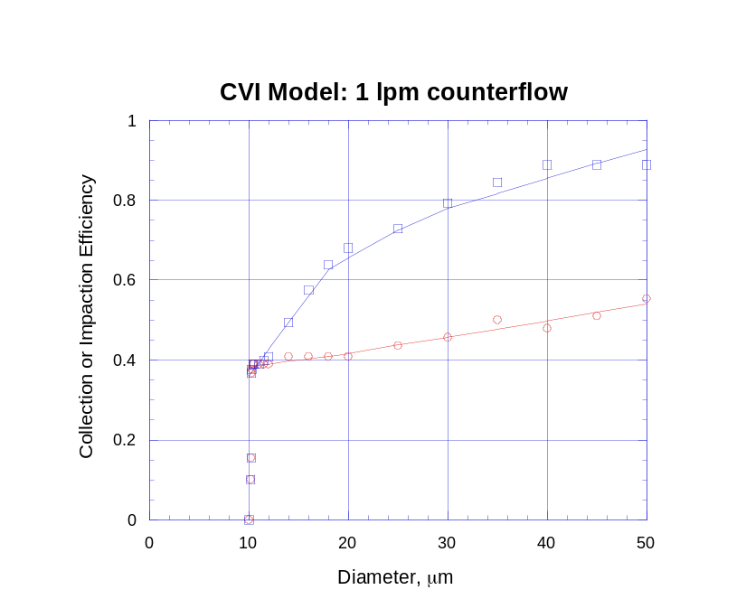
Figure 5. Calculated impaction efficiency (blue) and collection efficiency (red) for the CVI from Laucks and Twohy (1998). Counterflow rate is 1 liter min⁻¹, for a cut size of 10 μm. Calculations do not include droplet evaporation, which is expected to bring collection efficiency closer to impaction efficiency.

The other element not included in the L&T study was impaction of large droplets in the 90-degree bend downstream of the CVI tip. Droplets larger than about 50 μm are expected to be collected with low efficiency, since they don't evaporate sufficiently prior to transiting this bend. This decrease in collection efficiency for large droplets in the bend will be modeled and combined with the collection efficiency of the tip region to develop an overall collection efficiency for the CVI system. In the tip region (Fig. 5), collection efficiency will increase with increasing droplet size; in the bend, it will decrease with droplet size. As a result, the overall collection efficiency in the diameter range of greatest droplet number (10 to 50 μm) should be relatively constant as a function of drop size. Any remaining small deviations in collection efficiency as a function of droplet size will be used to develop error bars for the final size and critical supersaturation distributions generated from the CVI data.

5. Microphysical Measurements and Analysis

A series of microphysical measurements will be made in-situ on the C-130. These will include a full range of PMS optical probes to measure particle diameter from about 0.3 μm to 1 mm (http://raf.atd.ucar.edu/~darrel/), hot-wire probes, and the Gerber Scientific PVM-100 (Gerber, 1994). The Multichannel Cloud Radiometer (MCR) on the C-130 and AVHRR on the NOAA-14 satellite will probe the cloud structure and characteristics from above. We will work closely with instrument experts to assure we use the highest quality microphysical information. Dr. Darrel Baumgardner of NCAR/RAF will summarize important quantities, such as liquid water content, number concentration, and effective radius, of the clouds sampled in-situ during INDOEX. Professor Jim Coakley of Oregon State University plans to synthesize similar parameters (liquid water path and effective radius) from the remote sensing data produced by the MCR and NOAA AVHRR. Such quantities are critical in interpreting the ultimate effect of anthropogenic aerosol on cloud radiative properties, as proposed by Twomey (1977¹).

Fig. 6 shows an example of how the CVI data can be used together with the microphysical and optical parameters to observe the indirect aerosol effect. The plots near the bottom of the figure show changes in several quantities with distance from the San Francisco Bay region during offshore flow, as measured by the NCAR King Air (Twohy et al., 1995⁶). Near the shore, aerosol number concentration increases, droplet concentration increases, mean droplet diameter decreases, and 3.7 μm reflectance of the clouds increases. (Liquid water content, not shown, remained nearly constant). The top plots show CVI nuclei size distributions at both ends of the flight track. When overlain (top center plot), they show that substantially more accumulation-mode particles are present within clouds in the region of enhanced particle density.
Figure 6. The plot near the bottom of the figure shows changes in several quantities with distance from an aerosol source region (in this case, the San Francisco Bay region). From the bottom: aerosol number concentration as measured by the ASASP, droplet concentration from the FSSP-100, mean droplet diameter, and 3.7 μm reflectance from the NOAA AVHRR. The top plots show CVI residual size distributions at both ends of the flight track.

Section 3 described the strong dependence of aerosol loading on distance from the INDOEX source region. This is important, since weak aerosol gradients can make unequivocal detection of the indirect aerosol effect difficult (e.g., Anderson et al., 1994). Multi-level air trajectories, surface flows, satellite images, and precipitation fields will be provided in near real time for each day during INDOEX operations by Dr. T. Krishnamurti of Florida State University. These products are already available on the Internet, and will significantly aid in the determination of the origin and fate of anthropogenic aerosols sampled from the C-130.

6. Modeling Efforts

Models with more details of cloud chemistry and microphysics can provide valuable information for understanding indirect climate forcing—for example, which aerosol types can be important in cloud formation (O'Dowd et al., 1998¹²), how gas and particulate partitioning may change due to cloud processing (Hegg, 1985, Hoppel et al., 1986, Lelieveld and Heintzenberg, 1992), and even how cloud lifetime may be modified due to changes in the drop size distribution (Albrecht, 1989²). When substantiated by measurements, these models can be utilized to drive the development of new modules and to develop parameterizations useful for GCMs.

Two different modeling groups have expressed interest in utilizing the size-dependent chemical information obtained during INDOEX to test their models. At NCAR, a one-dimensional chemical model is being developed by Dr. Susan Durlak. The NCAR model is based on a detailed aerosol model developed and supplied by Wexler et al. (1994). Aerosol types in this model are divided into distinct size classes, which is necessary since chemical composition, solute concentration, and sulfate production are all expected to vary with cloud droplet size (Twohy et. al., 1989). This model also includes detailed chemical information, including organic species and the effects of internally mixed particles. Although this model does not currently handle external aerosol mixtures or cloud processes, these improvements are expected to be complete by mid-1999 (progress documented online at http://raf.atd.ucar.edu/~durlak/NAMhome.html). At the Geophysical Fluid Dynamics Laboratory (GFDL), Dr. Leo Donner is interested in using the INDOEX data as input to a high-resolution cloud-system model (Andronache et al., 1998). These simulations will predict changes in cloud droplet distributions and radiative properties produced by different aerosol concentrations.

Both groups would like to use the CVI data, along with the ambient aerosol data, to evaluate whether their models accurately predict cloud formation and processing of aerosol. Since this work should improve their cloud modeling capabilities and lead to better understanding of the factors controlling the indirect aerosol effect, we strongly endorse this use of the INDOEX data. Although these modeling studies are not supported explicitly through this proposal, we will provide detailed, corrected chemical size distributions as input for the work of these scientists.

7. Integration of Data with Scientific Questions

This section describes how the proposed measurements and analysis will aid specifically in answering the scientific questions posed in the Section 2.

a) Which particle types are preferentially incorporated into clouds? In particular, what are the relative roles of sulfate, sea-salt, soil-dust, elemental carbon, and mixed particles?

The single-particle chemical analyses will be used to determine the relative percentages of these particle types in each sample. The ambient and CVI samples will be compared and contrasted statistically, as well as on a case-by-case basis. Particle size distributions (from both the optical sensors and the electron microscope analysis) will supplement this, since cloud-nucleating ability is dependent on particle size as well as composition.

b) How do measurements of cloud condensation nuclei in the ambient aerosol compare with those actually incorporated into clouds? Is this a simple relationship that can be used in global models? Are the physical and chemical properties of the in-cloud aerosols consistent with the corresponding CCN spectra?

The critical supersaturation spectra of the ambient particles and residual nuclei will be compared statistically and on a case-by-case basis, as in a). Case studies will determine if the in-cloud aerosol follow the simple adiabatic relationship expected--i.e., that the particles with the lowest S_{c} preferentially nucleate into cloud droplets. Also, the size and chemical characteristics will be compared to the CCN characteristics of the residual nuclei to determine if these two measurement types are consistent*.

c) What is the impact of the cloud nucleating aerosols, in particular anthropogenic aerosols, on the microphysical and radiative properties of clouds?

Air trajectories and aerosol chemical measurements will enable us to determine the presence and loading of anthropogenic aerosols in the region. Thermodynamic, aerosol, microphysical, and cloud radiative properties will be compiled to develop a statistical data base. Variations in these parameters will be studied via multivariate techniques such as principal component analysis (PCA), in order to determine which variables are related and to help separate aerosol effects from dynamic effects on clouds.

8. Work Plan

In the first year, the flow modeling work on the CVI inlet will be completed, correction algorithms required for various sampling conditions will be developed, and an overall quality check of the CVI data will be performed. (During the same year, SEM/TEM analysis of ambient and residual nuclei will be performed at Arizona State University). In the second year, corrected CCN and size distributions, including chemical speciation, will be constructed. Comparison of the ambient and CVI samples and integration with cloud microphysical parameters will also occur in the second year. In the final year, statistical relationships between the various parameters will be developed, and it is expected that the results will be published as a graduate student thesis and in peer-reviewed journals.

This work will be performed by the PI in the first year, and by both the PI and a graduate student in the second and third years. Table 2 lists the various tasks required and the expected time required for completion in months (PI=Principal Investigator; GS=Graduate Student).

Table 2. TASK | Yr1  PI | Yr1  GS | Yr2  PI | Yr2  GS | Yr3  PI | Yr3  GS
Complete CVI inlet modeling | 2.0
Develop corrections for size distributions | 1.0
Quality check of CVI data | 1.0
Correct EM and optical size distributions |  |  | 0.5 | 1.0
Compile ambient vs. CVI comparisons-EM/size |  |  | 0.5 | 1.0
Correct CCN size distributions |  |  | 0.5 | 1.0
Compile ambient vs. CVI comparisons-CCN |  |  | 0.5 | 1.0
Microphysical comparisons |  |  | 1.0 | 2.0
Finalize and write up results |  |  |  |  | 2.0 | 6.0
TOTALS | 4.0 | 0.0 | 3.0 | 6.0 | 2.0 | 6.0

9. Personnel

The PI, Dr. Cynthia Twohy, will perform the first-year analysis described with the data she collects during INDOEX. (Her data collection in the INDOEX field experiment, but not subsequent analysis, is supported by NSF and NCAR's Research Aviation Facility). In the second year, a graduate student from Oregon State University's Atmospheric Sciences department will be supported to aid in the ongoing analysis; this will also provide valuable experience with a diverse data set for the student. Dr. Twohy will oversee all the analyses, continue the collaborations with involved scientists at other institutions, and assure publication of final results. Dr. Twohy has over ten years experience analyzing various chemical and microphysical data from aerosols and clouds (see attached biographical information). She also has extensive experience with airflow modeling (Twohy and Rogers, 1993; Laucks and Twohy; 1998⁴⁰; Twohy, 1998).

Several scientists plan to collaborate in this effort, and are key to its success. Professor Jim Hudson of Desert Research Institute will collect and provide the CCN data from INDOEX, while Professor Jim Anderson and colleagues at Arizona State University will collect and provide size-dependent composition using the electron microscope facilities at the university. Ambient size distributions from an optical particle counter will be obtained by lead aircraft scientist Dr. Tony Clarke (University of Hawaii), who is interested in the CVI comparisons as well. Microphysical and thermodynamic data from the aircraft will be provided by NCAR's Research Aviation Facility. Dr. Darrel Baumgardner (NCAR/RAF) and Professor Jim Coakley (Oregon State University) will calculate microphysical and optical cloud properties for the various cloud events, and we will coordinate our efforts with theirs. Dr. Susan Durlak, an Advanced Studies Program (ASP) Postdoctoral Fellow at NCAR, will develop and run the aerosol model being developed at NCAR, while Dr. Leo Donner (Princeton/GFDL) will use the CVI data for larger-scale modeling efforts. All these investigators have sufficient funding for their efforts, and have expressed interest in collaboration. Written correspondence from most of them are attached at the end of this proposal.

10. Facilities and Equipment

The deployment of the various instruments on the C-130 for INDOEX is funded by NSF, and will be complete by April 1999. The STAR-CD computational fluid dynamics code to be used for the CVI flow modeling is available on a SPARC 5 workstation at NCAR, and will be run remotely from Oregon State University. The SEM to be used at Arizona State University is a JEOL model 5800 with a five-axis, eucentric stage and full automation of the column, stage, and imaging systems. Energy-dispersive spectrometer (EDS) is used to acquire X-ray spectra. ASU also has several TEMs that can be used for chemical analysis (using both EDS and electron energy-loss spectroscopy), high-resolution structure imaging, and electron diffraction. These TEM facilities are available for a nominal charge as a result of our collaboration with Dr. Anderson. Computing facilities required for the remainder of the work (except as discussed in the Budget section) are already in place at NCAR and Oregon State University.

D. References Cited

The particles measured downstream of the CVI inlet after droplet evaporation will be called "residual nuclei" here, although in some cases, they may contain substances added to the actual cloud droplet nucleus after droplet formation, e.g., through chemical reactions, coalescence, or other in-cloud processes. The possible effect of these processes on CVI data and interpretation is discussed at length in Ogren and Charlson (1992⁵²). Because particles are typically recycled through clouds many times before their removal from the atmosphere, these particles sampled by the CVI would also be potential CCN on their next passage through a cloud.
* Recent studies have shown that carbonaceous species other than elemental carbon can be a significant component of the aerosol in many areas. These particles types are not readily detectable by microscopic/X ray methods, and so we will not attempt to include them explicitly in our analysis. However, sampling of carbonaceous aerosols will be performed by other groups on the C-130. We plan to utilize their results to assess possible effects the omission of these particle types may have on our analysis, and hope to include carbonaceous aerosols in future experiments.
* The conditions inside a CCN instrument do not simulate exactly what occurs in a natural cloud, so it is possible that particles acting as CCN in nature do not act as CCN inside an instrument, and vice-versa. These comparisons should help to evaluate the veracity of the CCN measurements.
Twomey, S., The influence of pollution on the shortwave albedo of clouds, J. Atmos. Sci., 34, 1149-1152, 1977.
Albrecht, B.A., Aerosols, cloud microphysics, and fractional cloudiness, Science, 245, 1227-1230, 1989.
Charlson, R.J., Schwartz, S.E., Hales, J.M., Cess, R.D., Coakley, J.A. Jr., Hansen, J.E. and D.J. Hoffman, Climate forcing by anthropogenic aerosols, Science, 255, 423-430, 1992.
? Radke, L.F., Coakley, J.A. Jr. and M.D. King, Direct and remote sensing observations of the effects of ships on clouds, Science, 246, 1146-1148, 1989.
Fitzgerald, J.W. and P.A. Spyers-Duran, Changes in cloud nucleus concentration and cloud droplet size distribution associated with pollution from St. Louis, J. Appl. Meteor., 12, 511-516, 1973.
Twohy, C.H, Durkee., P.A., Huebert, B.J. and R.J. Charlson, Effects of aerosol particles on the microphysics of coastal stratiform clouds, J. Climate, 8, 773-783, 1995.
Leaitch, W.R., Isaac., G.A., Strapp, J.W., Banic, C.M. and H.A. Wiebe, The relationship between cloud droplet number concentrations and anthropogenic pollution: Observations and climatic implications, J. Geophys. Res., 97, 2463-2472, 1992.
Hudson, J.G., Effects of CCN on stratus clouds, J. Atmos. Sci., 40, 480-486, 1983.
Sassen, K., Starr, D., Mace, G.C., Poellet, M.R., Melfi, S.H., Eberhard, W.L., Spinhirne, J.D., Eloranta, E.W., Hagen, D.E. and J. Hallett, The 5-6 December 1991 FIRE IFO jet stream cirrus case study: possible influences of volcanic aerosols, J. Atmos. Sci., 52, 97-125, 1995
Ayers, G.P. and J.P. Ivey, Precipitation composition at Cape Grim, 1997-1985, Tellus, 40B, 297-307, 1988.
O’Dowd, C.O., Smith, M.H., Consterdine, I.E. and J.A. Lowe, Marine aerosol, sea-salt, and the marine sulphur cycle: A short review, Atmos. Environ., 31, 73-80, 1996.
O’Dowd, C.O., Lowe, J.A. and M. H. Smith, Coupling sea-salt and sulphate interactions and its impact on cloud droplet concentration predictions, Geophys. Res. Lett, submitted, 1998.
Ghan, S.J., Guzman, G. and H. Abdul-Razzak, Competition between sea-salt and sulfate particles as cloud condensation nuclei, J. Atmos. Sci., 55, 3340-3347, 1998.
Kristamurdi, T.N., Jha, B., Prospero, J.M., Jayaraman, A. and V. Ramanathan, Aerosol and pollutant transport over the tropical Indian Ocean during the 1996 northeast monsoon and the impact on radiative forcing, Tellus, submitted, 1997.
Satheesh, S.K., Krishna Moorthy, K. and B.V. Krishna Murthy, Spatial gradients in aerosol characteristics over the Arabian Sea and Indian Ocean, J. Geophys. Res., 103, 26,183-26,192, 1998.
Jayaraman, A., Lubin, D., Ramachandran, S., Ramanathan, V., Woodbridge, E., Collins, W.D. and K.S. Zalpuri, Direct observations of aerosol radiative forcing over the tropical Indian Ocean during the January-February 1996 pre-INDOEX cruise, J. Geophys. Res., 103, 13827-13836, 1998.
Han, Q., Rossow, W.B. and A.A. Lacis, Near-global survey of effective droplet radii in liquid water clouds using ISCCP data, J. Climate, 7, 465-497, 1994.
Noone, K.J., Ogren, J.A., Heintzenberg, J., Charlson, R.J. and D.S. Covert, Design and calibration of a counterflow virtual impactor for sampling of atmospheric fog and cloud droplets, Aer. Sci. Technol., 8, 235-244, 1988.
Twohy, C.H., Schanot, A.J. and W.A. Cooper, Measurement of condensed water content in liquid and ice clouds using an airborne counterflow virtual impactor, J. Atmos. Oceanic Technol., 14, 197-202, 1997.
Anderson, J.R., Buseck, P.R. and R. Arimoto, Characterization of the Bermuda Aerosol by combined individual-particle and bulk-aerosol analysis, Atmos. Environ. 30, 319-338, 1996.
Hudson, J. G., An instantaneous CCN spectrometer, J. Atmos. Oceanic Technol. , 6 , 1055-1065, 1989.
Tucker, S. L., Analysis of marine stratus cloud condensation nuclei collected with a new counterflow virtual impactor, Master's Thesis, University of Washington, Seattle, Washington, 88 pp., 1989.
Twohy, C. H. and J. G. Hudson, Measurements of cloud condensation nucleus spectra within maritime cumulus cloud droplets: Implications for mixing processes, J. Appl. Meteor., 34, 815-833, 1995.
Heintzenberg, J., Okada, K. and J. Ström, On the composition of non-volatile material in upper tropospheric aerosols and cirrus crystals, Atmos. Res., 41, 81-88, 1996.
Ström, J., Strauss, B., Anderson, T., Schöder, F., Heintzenberg, J. and P. Wendling, In situ observations of the microphysical properties of young cirrus clouds, J. Atmos. Sci., 54, 2542-2553, 1997.
Clarke, A. D., A thermo-optical technique for in situ analysis of size-resolved aerosol physicochemistry. Atmos. Environ. 25A: 635-644, 1991.
Twohy, C. H. and B. W. Gandrud, Electron microscope analysis of residual particles from aircraft contrails. Geophys. Res. Lett ., 25, 1359-1362, 1998.
Posfai, M., Anderson, J.R., Buseck, P. R. and H. Sievering, compositional variations of sea-salt-mode aerosol particles from the North Atlantic, J. Geophys. Res., 100, 23,063-23,074, 1995.
Squires, P., The growth of cloud drops by condensation, Aust. J. Scient. Res., A5 , 59-86, 1952.
Jensen, J.B., Austin, P.H., Baker, M.B. and A.M. Blyth, Turbulent mixing, spectral evolution and dynamics in a warm cumulus cloud, J. Atmos. Sci., 42, 173-192, 1985.
Mason, B.J., The Physics of Clouds . Oxford University Press, 671 pp., 1971.
Huebert, B.J., Lee, G. and W.L. Warren, Airborne aerosol inlet passing efficiency measurements, J. Geophys. Res., 95, 16389-16381, 1990.
Schanot, A.J., Twohy, C. H., Huebert, B. J., Howell, S., LaFleur, B., Seebaugh, R. and D. Rogers, NCAR C-130 Community Aerosol Inlet: User's Guide, NCAR Technical Note, in preparation, 1999.
Muyshondt, A., Anand, N.K. and A. R. McFarland, Turbulent deposition of aerosol particles in large transport tubes, Aer. Sci. Technol., 24, 107-116, 1999.
Reist, P.C., Aerosol Science and Technology, 2nd Ed., McGraw-Hill, Inc., New York, 379 pp, 1993.
Howell, S. G. and B.J. Huebert, Determining marine aerosol scattering characteristics at ambient humidity from size-resolved chemical composition, J. Geophys. Res. 103, 3659-3686, 1998.
Gras, J.L. and G.P. Ayers, On sizing sulfuric acid aerosol particles, J. Appl. Meteor., 18, 634-638, 1979.
Anderson, T.L., Charlson, R.J. and D.S. Covert, Calibration of a counterflow virtual impactor at aerodynamic diameters from 1 to 15 μm, Aer. Sci. Technol., 19, 317-329, 1993.
Lin, H. and J. Heintzenberg, A theoretical study of the counterflow virtual impactor, J. Aer. Sci., 26, 903-914, 1995.
Laucks, M.L. and C. H. Twohy, Size-dependent sampling efficiency of an airborne counterflow virtual impactor, Aer. Sci. Technol ., 28 , 40-61, 1998.
Gerber, H., B.G. Arends and A.S. Ackerman, New microphysics sensor for aircraft use, Atmos. Res. 32, 235-252, 1994.
Anderson, T.L., Covert, D.S. and R.J. Charlson, Cloud droplet number studies with a counterflow virtual impactor, J. Geophys. Res., 99, 8249, 1994.
Hegg, D.A., The importance of liquid-phase oxidation of SO₂ in the troposphere, J. Geophys. Res., 90, 3773-3779, 1985.
Hoppel, W.A. Frick, G.M. and R.E. Larson, Effect of nonprecipitating clouds on the aerosol size distribution in the marine boundary layer, Geophys. Res. Lett., 13, 125-128, 1986.
Lelieveld, J. and J. Heintzenberg, Sulfate cooling effect on climate through in-cloud oxidation of anthropogenic SO₂, Science, 258, 117-120, 1992.
Wexler, A.S., Lurmann, F. W. and J. H. Seinfeld, Modelling Urban and Regional Aerosols - I. Model Development”, Atmos. Env., 28, 531-546, 1994.
Twohy, C.H., Austin, P.H. and R.J. Charlson, Chemical consequences of the initial diffusional growth of cloud droplets: A clean marine case, Tellus, 41B, 51-60, 1989.
Andronache, C., Donner, L.J., Ramaswamy, V., Seman, C.J. and R.S. Hemler, The effects of atmospheric sulfur on the radiative properties of convective clouds: a limited area modeling study, Geophys. Res. Lett., 25, 1423-1426, 1998.
Sharaf, M, Illman, D. and B. Kowalsi, Chemometrics, John Wiley and Sons, New York, 1986.
Twohy, C. H. and D. Rogers, Airflow and water drop trajectories at instrument sampling points around the Beechcraft King Air and Lockheed Electra. J. Atmos. Oceanic Technol., 10, 566-578, 1993.
Twohy, C.H., Model calculations and wind tunnel testing of an isokinetic shroud for high-speed sampling, Aer. Sci. and Technol. , 29, 261-280, 1998. ⁵² Ogren, J.A. and R.J. Charlson, Implications for models and measurements of chemical inhomogeneities among cloud droplets, Tellus, 44B, 208-225, 1992.

