4.12 INSTRUMENT DEVELOPMENT AND EDUCATION IN AIRBORNE SCIENCE

Jeffrey Stith* and David C. Rogers
National Center for Atmospheric Research, Boulder, Colorado

- INTRODUCTION

The inspiration for the Instrument Development and Education in Airborne Science (IDEAS) program came from the annual University Corporation for Atmospheric Research (UCAR) member’s meeting in the fall of 2000. The meeting identified the need for testing and development of airborne instruments and recognized the need for training of students in observational science. In particular, there have been insufficient opportunities for university faculty and students to participate in such efforts, due to the limited number of airborne field programs dedicated to instrument development and the limited space on the research aircraft.
Because the NCAR/NSF C130 research aircraft (Fig. 1) can carry up to nineteen people, there is often space available for students to participate as members of the scientific flight crew. The C130 carries a wide variety of instrumentation for measurement of turbulence, cloud properties, chemical trace species, and remote sensors. A description of the C130 and the instrumentation available is provided at the NCAR Atmospheric Technology Division’s Research Aviation Facility (RAF) website at http://raf.atd.ucar.edu/. In addition to the
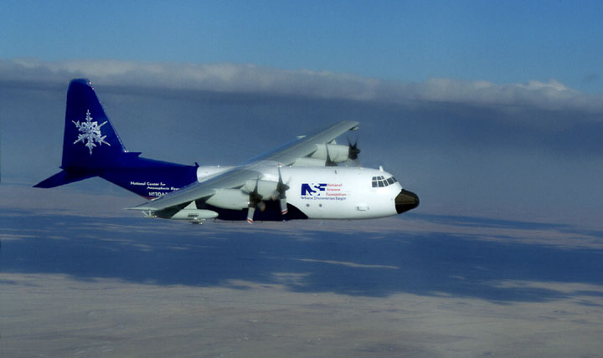

Figure 1. The NCAR/NSF C130 Research Aircraft.
NCAR-supplied instrumentation, rack and mounting space are available for a large payload of university-supplied instruments.
The objectives of IDEAS are to develop future instrumentation for NSF airborne field deployments, to provide opportunities for select students to learn about airborne measurements, and to provide data for students and instructors to use in research and teaching. Periods when the C130 was not involved in a major field deployment were selected and three test flights periods were scheduled. These occurred during April and October, 2002 (IDEAS I and II) and August-September, 2003 (IDEAS III). Flights were based out of the RAF facility in Broomfield, Colorado. We solicited participation by university instrument developers and also invited participation by students and instructor participation. We developed several activities to assist the educational portion of IDEAS as described below.

2. PARTICIPANTS

University scientists from several institutions tested instrumentation during IDEAS. Institutions represented included: Texas A and M, Michigan Tech., University of Nevada (DRI), Oregon State University, Colorado State University, The University of Colorado, The University of Denver, The University of Wyoming, and Scripps Institute of Oceanography. Several NCAR scientists also tested instrumentation and collaborated with the university scientists during IDEAS. During the project about a dozen scientists were on hand at the RAF facility, representing state of the art instrument development efforts in airborne atmospheric chemistry, meteorology, cloud physics, remote sensing and engineering.
Most students participated as a part of instrumentation or meteorology (classes). A few students applied for participation individually. Students also participated as a part of their graduate student research requirements for advanced degrees. A web site announcing and describing the program was used to invite participation (available at http://raf.atd.ucar.edu/Projects/IDEAS/).

3. EDUCATIONAL ACTIVITIES AND OUTCOMES FROM STUDENT PARTICIPANTS

A major goal of IDEAS was to introduce students to observational (airborne) science by first-hand interaction with scientists active in this field. A second goal was to provide them with tools that they could use to do their own research and class projects, using data collected during the flights. Although many of the instruments flown on IDEAS were in the development stage, a wide variety of meteorological, trace gas, aerosol, turbulence, and remote sensing data were routinely available in several types of cloud and synoptic regimes. Activities that were done to promote the educational goals included:
- Briefings on airborne research and rules for participation in airborne research (e.g. safety and operational constraints).
- Tours of the aircraft and research instrumentation.
- Meetings with the NCAR and University Scientists participating in IDEAS. As a result of this meeting, students selected a mentor from the participating scientists in a field of interest to the student.
- Discussions of specific class requirements and how the data on clouds, trace gases, etc. might be used for class or individual projects.
- Demonstrations of software for data processing and a discussion of how to obtain data and software.
- Students were invited to participate in science discussion meetings with the IDEAS scientists during the project. During these meetings, the results of the instrument tests were discussed by the participating scientists and students had the opportunity to present the results of their own work.
Students selected a mentor from among the IDEAS scientists and spent time learning about the instrumentation from their mentor. They then participated in one or more flights with their mentor and assisted in collecting data. Following the flight (s) RAF staff and their mentors assisted them in using the data for a class project. Students were able to follow the flight schedule and data products/analysis from the IDEAS web page. Some (graduate) students participated under the direct supervision of their faculty advisors. Several students performed detailed research projects with the IDEAS data. Some examples of these projects are shown below.

4. TOOLS FOR EFFECTIVE STUDENT AND INSTRUCTOR PARTICIPATION

Several new tools were used to facilitate the educational effort. Web pages were used to accept applications for participation and included links to sources of weather information, instrument descriptions, daily schedules, and areas to post results from the flights.
Two tools, in particular, were especially helpful to the educational effort, an online display of real time data and an online chat tool for communication between the airborne crew and ground personnel. This was accomplished through a satellite link to transmit data between the aircraft and the ground. Students were flying on the aircraft operating instrumentation while their instructor, located at their home institution, was observing the flight data and discussing the instrument performance with the students in real time. The use of these tools by instructors and students has the potential to greatly increase their participation in research campaigns.

5. RESULTS OF STUDENT RESEARCH

Many of the student projects were of high quality. Two examples illustrate different approaches used by student participants in IDEAS: (a) Using the data collected by the aircraft for a specific project, and (b) Participating directly in the development of new instrumentation. One student used the Rapid Update Cycle (RUC) model to compare with the aircraft measurements and observations for a class project, resulting in a detailed case study of model performance and cloud characteristics. He compared the modeled altitudes and locations of the clouds and the microphysical characteristics (e.g. liquid water content) with that observed from the C130. An example of his model results is given in Figure 2.
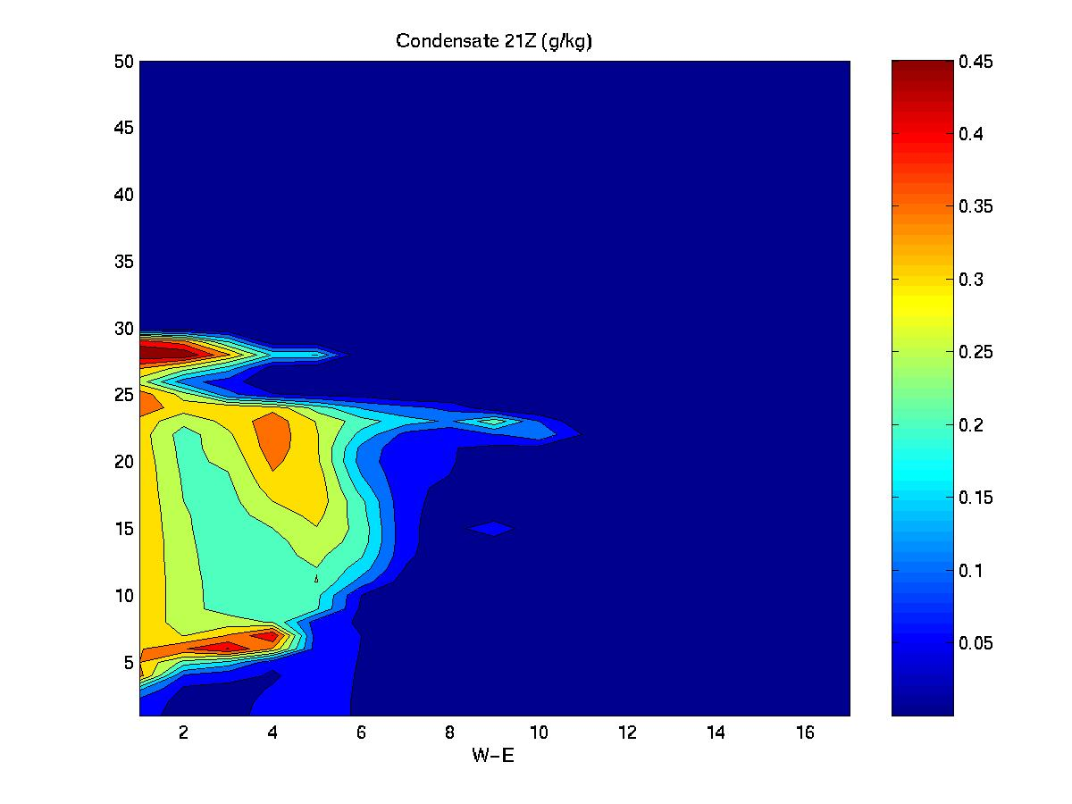

Figure 2. An example of student research. The data represent the location of condensate predicted by the RUC model near the time of a C130 flight through a cumulus clouds. The model correctly predicts the altitude and the microstructure (e.g. condensate mixing ratio) of the cloud that was sampled. Figure courtesy of Frank McDonough, a student IDEAS participant from Colorado State University.

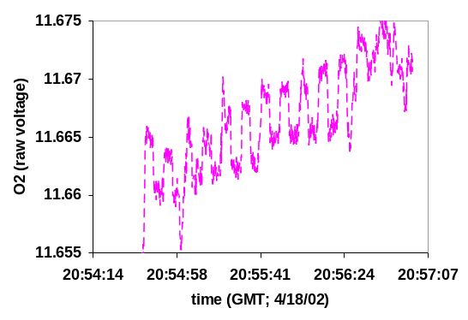
Figure 3. Data from a student project, studying the performance of a new airborne Oxygen instrument being developed by Britt Stephens, NCAR scientist. Figure courtesy of John Ortega, a student at the University of Colorado. The purpose of the project is to better understand the sources of noise in the instrument in various regions (e.g. near turbulent cloud regions). The figure shows the noise level of the instrument (for two different calibration levels) in smooth air above a cloud.

Another student looked at the performance of a new Oxygen measuring instrument being developed by one of the NCAR scientists, in collaboration with the scientist. An example of his work is given in Fig. 3.
A third group of students from Michigan Technological University, constructed and tested a Holographic cloud particle camera, as a part of their graduate research for an advanced degree. These students made extensive use of the online chat feature to communicate with their thesis advisor during the IDEAS flights.

6. THE FUTURE OF IDEAS

The need to continue flights for instrument development continues. Enough students and instructors participated in IDEAS I, II, and III, that most of the available seats on the aircraft were occupied on each flight. The response from participating students and instructors has been very positive, encouraging us to continue the educational portion of this project. We are now in the process of considering how future IDEAS projects should be structured. We have compiled a number of recommendations for future IDEAS projects:
- Encourage participation from a wider geographic region. The greatest numbers of students came from schools close to NCAR. Given class schedules and travel costs, this bias is difficult to overcome. However, the online tools for remote participation are likely to open up many more options for participation.
- Involve more of the research aviation community. Several university, state and federal research aircraft have expressed an interest in IDEAS. This may help with the first recommendation.
- Provide support for student research and education. NCAR/RAF already provides software support for analysis of airborne data and publishes technical bulletins on specific airborne instrumentation. We have made these resources available online. We are also developing improved online tools, such as the online chat and aircraft data display software. We are looking for collaborators to make more of these types of tools available for students and teachers.
We have established a web site with links to the IDEAS I, II, and III web pages at http://raf.atd.ucar.edu/Projects/IDEAS/. The site also has a link to express interest in collaborating on future IDEAS projects. If you have an interest in providing these types of educational adventures for students, we would like to hear from you.

Acknowledgements. NCAR and the IDEAS program are supported by the National Science Foundation. Thanks are due to the student participants for their enthusiasm and encouragement. Several RAF scientists played important roles in the success of IDEAS, especially Allen Schanot.

* Corresponding author address: Jeffrey Stith, NCAR, Box 3000, Boulder CO 80307

