Pacific Atmospheric Sulfur Experiment

Project Description

1.0 Introduction

Pacific Atmospheric Sulfur Experiment (PASE) is a comprehensive study of the chemistry of sulfur in the remote marine troposphere. A major part of PASE will be devoted to the chemistry and physics (primarily of sulfur) in a cloud free convective boundary layer (CBL). Our strategy is to first understand the chemistry and physics of gases and aerosols (including cloud condensation nuclei, CCN) in a cloud free environment before trying to understand systems containing cloud. Studies of systems containing cloud can be logically built on an understanding of cloud free systems. PASE also will focus on developing a better understanding of the buffer layer (BuL) and formation of new particles in the cloud outflow of marine cumulus.

PASE will provide information on aerosol chemistry and physics in the remote marine atmosphere essential for developing an understanding for the Aerosol Indirect Effect (AIE) in this region and will also explore key elements of the CLAW (Charlson, Lovelock, Andreae, Watson [1987]) hypothesis that describes how dimethyl sulfide oxidation can have important impacts on AIE. At the core of PASE is the chemistry of sulfur because much of the chemistry of AIE in the marine atmosphere involves the products of dimethyl sulfide (DMS) oxidation and their interactions with aerosols. The detailed information on sulfur chemistry of both aerosols and gases obtained in PASE will make a major contribution to understanding the link between sulfur chemistry and the evolution, growth, and properties of aerosols in the marine atmosphere. We expect that our measurements will allow us to test the viability of the atmospheric sulfur portions of the CLAW hypothesis even if they cannot fully resolve the issue.

State of the art instruments will be used to make accurate and high speed airborne determinations of sulfur dioxide (SO₂), dimethyl sulfide, dimethyl sulfoxide (DMSO, dimethyl sulfone (DMSO₂), methane sulfonic acid (MSA), sulfuric acid (H₂SO₄), hydroxyl radical (OH), peroxyl radical (HO₂), ammonia (NH₃), water vapor (H₂O), ozone (O₃), hydrogen peroxide (H₂O₂), methyl hydrogen peroxide (CH₃OOH), liquid water, temperature, pressure, wind velocity. DMS, SO₂, H₂O and O₃ will be determined at 25 samples per second allowing vertical fluxes of these species to be determined by eddy correlation. Chemical budgets for the sulfur species can be calculated from the concentrations and fluxes. These budgets will contain valuable information on chemistry in general but specifically on their chemical formation and destruction rates.

The entire suite of NCAR aerosol probes available for C-130 will be flown. In addition, researchers will measure size and volatility (0.15-10.0 um), size and volatility (0.01-0.3 um), size resolved mixing state, refractory and volatile number, ultrafine number concentration, absorption coefficient (Black Carbon), whitecap/bubble coverage, size integrated ambient total ions around a circle, leg average size resolved ions, coarse particle size distribution, fast submicron aerosol ion composition, CCN concentration and supersaturation spectrum. Aerosol non-sea salt sulfate (NSS), methane sulfonate (MS), sodium, ammonium, calcium, magnesium, nitrate, oxalate, chloride, bromide and organic carbon will be determined using filter and impactor methods, integrated over 30 minute constant-altitude legs.

The origin of small particles and their growth to larger particles and CCN are core issues in developing an understanding of AIE and in testing CLAW. Another intriguing hypothesis that can also be tested is that small particles, formed by wave breaking, grow by accreting H₂O and H₂SO₄ and that these particles with a sea salt core are also CCN. The formation of nanometer size sea salt pre-CCN will be studied including their potential growth to CCN. Loss of SO₂ and H₂SO₄ to aerosol surface area, including sea salt near the ocean surface, will be intensively studied. Using some assumptions, fluxes of CCN and aerosol at the ocean surfaces can be estimated.

2.0 Resources and Scheduling

In support of this project the NSF C-130 aircraft will be deployed to Kiribati (Christmas Island) for the period 2 August to 10 September 2007. Roughly 13 round robin research flights will be conducted from Cassidy International Airport. Several pre-dawn departures will be needed to achieve the scientific goals of the project. Because all of the missions initiate at and return to Cassidy Field without an intermediary stop, they are considered to be “local” flights and will not require either customs or immigrations services. No surface measurements will be conducted on the island, itself. While ramp parking, fueling and safety arrangements will be required, all ground support equipment (GPU, AC cart, aircraft spares, compressed gases, etc) will be temporarily shipped to the island via two U.S. military air transports. This shipment is expected to occur around July 27 2007, with a follow-up mission to remove the equipment on September 11 2007. A total research staff of around 40 scientists, air crews and students will be on the island for the entire duration of the flight operations. Housing and the facilities to support a temporary science center will be contracted with the Captain Cook Hotel. It is hoped that access to the retired SEC compound and its support equipment located at the hotel can be arranged. The aviation fuel required to support these operations (approximately 400,000 liters of Jet A) will be purchased from Kiribati Oil Company LTD either directly or through an international intermediary (World Fuel Services). Due to the large quantities of fuel, the local branch will need to make special arrangements for the delivery of a larger than normal fuel reserve in their annual delivery schedule.

On August 4th 2007 the C-130 will begin research flight operations. A rough summary of the research objectives for each mission appears in Table 2. Since all of these missions are considered “local”, no customs or immigration services will be required. The flight tracks for the program will be conducted about 250 km east of Christmas Island (Kiritimati). The entire deployment interval will be devoted to these operations so that the best available meteorological conditions can be chosen for study. As mentioned above the stable meteorological phases tend to be 3-4 days in length with the overall length of a stable-unstable period being approximately 7 days. In 5 weeks approximately 4 stable periods are expected which provides ample opportunity to complete this research. The plan presented below assumes that the flights will be flown at every opportunity that does not exceed crew rest requirements. There may other adjustments if critical measurement systems are not operational.
Table 2 Flights for Budget Studies
Flight | Time | Duration | Purpose
1 | Night* | 9 | Nighttime budgets
2 | Night* | 9 | Surface Fluxes
3 | Night* | 9 | Nighttime budgets
4 | Day | 9 | Daytime Budgets
5 | Day | 9 | Daytime Budgets
6 | Day | 9 | Daytime Budgets
7 | Day | 9 | Daytime Budgets
8 | Night* | 9 | Nighttime budgets
9 | Night* | 9 | Surface Fluxes
10 | Night* | 9 | Surface Fluxes
11 | Day | 9 | Cloud Outflow & BuL
12 | Day | 9 | Cloud Outflow & BuL
13 | Day | 9 | Cloud Outflow & BuL
*Nighttime flights will conform to NCAR RAF safety requirements.

Field activities
Allen Schanot is the overall coordinator of all C-130 support and will be the primary point of contact for any interactions with local government officials and service providers. Dr. Alan Bandy will serve as overall mission scientist of the field phase. He is responsible for all decisions concerning science in the mission. He will organize mission planning, select flight dates and mission, and will be make decisions on safety issues not covered by RAF. Ian Faloona will fly in the cockpit and will be the interface between the pilots and Alan Bandy on all flight issues. Faloona also will monitor the progress of the flight as well as some important instruments.
3.0 Research Summary

PASE flight operations will be conducted east of Christmas Island (Kiritimati, 2 N, 157 W). This region was chosen because its chemistry and meteorology are well characterized and it is an ideal outdoor laboratory to study the chemistry of DMS. The chemical and aerosol characteristics have been reported by Bandy et al. [1996], Huebert et al., [1996], Clarke et al. [1996], Davis et al. [1999], and Chen et al. [2000]. The meteorological characteristics were reported by [Lenschow et al., 1999]. These investigations contain considerable detail so only the most relevant characteristics will be discussed here.

Christmas Island is in the southeast trade wind regime, far from anthropogenic sources of sulfur. Soundings of the 25 sps vertical velocity, water vapor mixing ratio, air temperature and ozone are shown in Figure 1. The CBL is characterized by a region of high and uniform fluctuations in vertical velocity that imply effective and rapid vertical mixing. Typical of turbulent layers, the sounding of water vapor is almost constant up to the CBL top where it rapidly decreases. The BuL is less well mixed because turbulence is weaker and intermittent. The top of the BuL is characterized by a further large drop in turbulence, water vapor, DMS, etc. at the trade wind inversion. Above the BuL is the free troposphere.
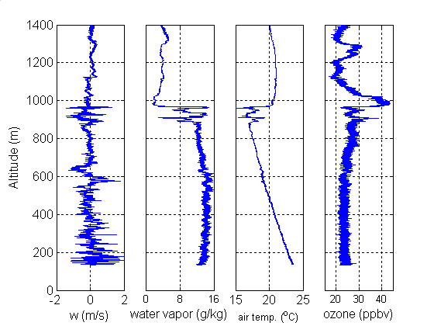

Figure 1 Soundings for vertical velocity, water vapor, air temperature and ozone in the Christmas Island trade wind system. The convective boundary layer (CBL) extends from the surface to about 630 m. The buffer layer (BuL) begins at 630 m and extends to about 970 m. The free troposphere is above 970 m.
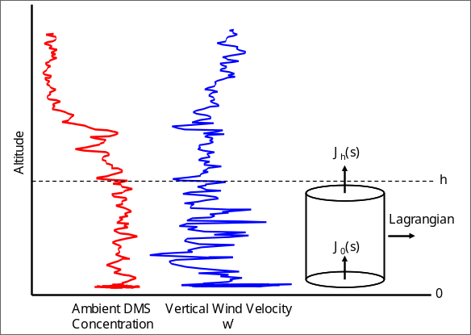
Figure 2 Soundings DMS and vertical velocity (1 Hz) for the trade wind regime east of St. Croix. The CBL depth is h and is about 800m.

An important property of the Christmas Island trade wind regime in August and September is that there are long periods during which few clouds exist especially in the CBL [Bandy et al., 1996]. The budget studies of PASE will be carried in one of these common, very stable, nearly cloud-free periods in August. However, aging, growth, and uptake onto aerosol will be enhanced in the small non-precipitating clouds that are often present in the BuL [Bandy et al., 1996]. Studies of cloud processing are an important component of PASE. Focus will be on both the nonprecipitating clouds that are often present in the BuL layer during the stable periods and the outflow of convective cumulus clouds that penetrate the trade wind inversion that often appear at the end of stable periods.
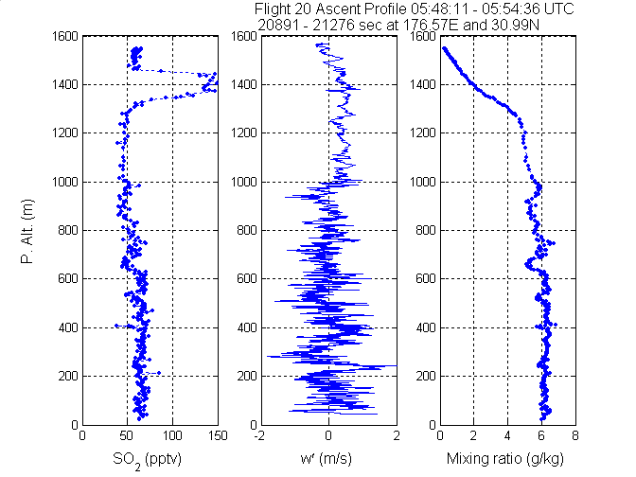
Figure 3 Vertical profiles for SO₂, vertical wind velocity and moisture mixing ratio for the Midway Island region. In this system the CBL extended to about 1 km with the buffer layer between 1 and 1.3 km. The SO₂ layer at about 1.4 km is in the free troposphere.

The characteristics of the CBL appear to be a general property of the marine trade wind regime. The soundings for DMS and vertical velocity in Figure 2 were obtained in the northeast trade wind regime in the Atlantic east of St. Croix, VI. Soundings for SO₂, vertical velocity and water vapor mixing ratio for Midway Island in the Pacific are shown in Figure 3. Each of these trade wind regimes has a turbulent, well mixed CBL and a less well mixed BuL.

Because fluxes and time derivatives of concentrations are the variables to be measured in this study, requirements of homogeneity are greatly reduced (Lenschow, private communication) compared to previous studies of the Christmas Island trade wind regime [Bandy et al., 1996; Chen et al., 2000; Davis et al., 1999]. However, homogeneity makes data analysis easier and to some extent more precise.

East of Christmas Island for a few hundred kilometers, the ocean appears to have a reasonably homogeneous flux of DMS. Evidence of this homogeneity was obtained in Mission 7 of PEM Tropics A that was flown over a region 100 km in length just east of Christmas Island. In this mission level legs were flown as circles 60 km in diameter (30 minutes in length) that were advected with the mean wind. The variability of the concentrations along the track was small and very repeatable [Lenschow et al., 1999] and fit on a smooth curve determined by the photochemistry of the system [Davis et al., 1999]. To draw this inference of homogeneity it is useful to recognize that the CBL mixes vertically within the CBL in less than 0.5 hours (I. Faloona, private communication). Horizontal mixing is slower, so any change in surface flux quickly appears as a change in DMS around the circle. Systematic changes of this type were not observed at Christmas Island [Lenschow et al., 1999]. Finally, Bandy et al. [1996] reported repeatable diel variations of DMS and SO₂ over 4 days that could not have been achieved unless the upstream DMS flux was reasonably uniform and constant.

3.1 Flight Plans
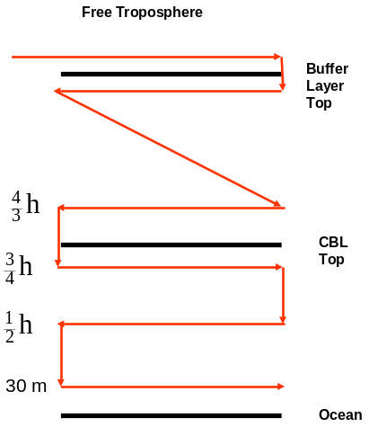
Figure 4 Flight profiles for CBL fluxes

CBL budgets for DMS, SO₂, O₃, H₂O and possibly DMSO and DMSO₂ will be determined using the flight plan shown in Figure 4. Each set of legs will begin and end with a sounding to identify the top (h) of the CBL by locating the large decrease in variance of vertical velocity at the top of the CBL. Thirty-minute circles will then be flown at 30 m, h/2 and 3/4h and 4h/3 levels. This will be repeated 3 times. For nighttime missions the 30 m level can be flown only in daylight or twilight (for safety reasons). It is noteworthy that the soundings will be performed at 800 ft min⁻¹ so the total expected duration for the sounding is about 3 min. The column concentrations of DMS, SO₂, DMSO, DMSO₂, and any other species with fast measurement rates will be obtained from these soundings. Since there will be 4 soundings per flight there will be 4 determinations of the column concentrations of these species, separated by about 2.5 hours. We will compute 3 time derivatives of the column concentrations of DMS, SO₂, DMSO, DMSO₂, and the other species with fast measurement rates. Finally short legs above the trade wind inversion will be flown at the beginning and end of the mission and possibly near the middle of the flight to characterize these regions. These will include soundings of the buffer layer.
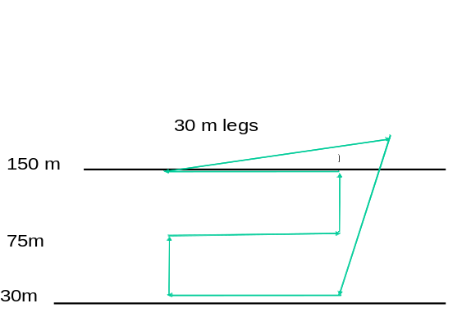
Figure 5 Flight profile for studying fluxes near the sea surface

Near-surface budgets of DMS and SO₂ and possibly of DMSO and DMSO₂ will be determined using the flight profiles shown in Figure 5. To minimize the impact of any variation in surface flux these studies will be flown over the same circle geographically to the extent possible, without entering the aircraft plume. These profiles will be flown 5 times per mission. Most of this flight will be flown under low light conditions to minimize photochemistry.

  - Other Activities

PASE will have a substantial instructional component both at the undergraduate, graduate, and postdoctoral level. A Drexel University undergraduate student and the post doc will each operate one of the instruments for determining SO₂, DMSO and DMSO₂ on the C-130 and will have the responsibility of processing and reporting the data to the PASE archive. Under the supervision of Byron Blomquist and Alan Bandy, the students and the post doc will interpret and publish papers based on their data. The graduate student will focus on the PASE data for a thesis dissertation. One female undergraduate student is currently working in the Bandy research group. In the past year a second undergraduate student from the Drexel Honors program participated in data analyses for the RICO program as an REU. This student also has expressed an interest in continuing this association with the Bandy research group. Additional Drexel students will be given the opportunity to participate in PASE data interpretation through our Chemistry research courses (Chemistry 493 and 497), which are required of all chemistry majors.

Several undergraduate students, graduate students and post docs from Georgia Tech, the University of Hawaii and the University of Rhode Island will be involved in both the field and interpretation phase of the program. These activities are described in the proposals of individual researchers. Each investigator has agreed to present a seminar to students during the field campaign at Christmas Island. Scientists will also be encouraged to request that students attend workshops and make presentations when appropriate.

A website will be developed to communicate the progress of the field mission including Google Earth with aircraft flight tracks and data. This application is in development at RAF for the HIAPER and we hope to apply this approach for PASE. We will publicize the site through cooperative links to The Academy of Natural Sciences and The Franklin Institute in Philadelphia as well as The Philadelphia Inquirer.

Investigators
Dr. Alan Bandy is the mission scientist and is responsible for the execution of the field program and organizing the interpretation and publication of the data. Dr. Byron Blomquist (U. Hawaii) will be responsible for the fast SO₂, DMS, DMSO and DMSO₂ measurements. OH, H₂SO₄, MSA and NH₃ will be determined by Dr. Lee Mauldin (NCAR). Dr. Jim Hudson (Desert Research Institute) will make CCN measurements. Dr. Anthony Clarke will perform aerosol size, thermal properties and composition measurements. Drs. Barry Huebert and Steve Howell (U. Hawaii) will make aerosol composition measurements. Drs. Brian Heikes, John Merrill (U. Rhode Island) and Dr. Daniel O'Sullivan (US Naval Academy) will provide H₂O₂ and CH₃OOH data and meteorological support. Drs. Ian Faloona (UC-Davis) and Donald Lenschow (NCAR) will direct mission planning and the aircraft mission as well as assisting in the eddy correlation analyses. Drs. Yuhang Wang and Douglas Davis (Georgia Tech) will provide photochemical modeling.

