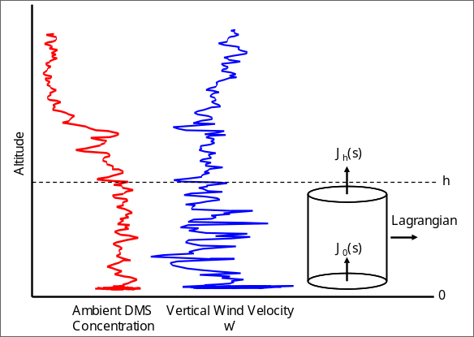
Figure 2 Soundings DMS and vertical velocity (1 Hz) for the trade wind regime east of St. Croix. The CBL depth is h and is about 800m.

