PACific Dust EXperiment (PACDEX)
First Release, November 29, 2005

PIs: J. Stith (NCAR) & V. Ramanathan (Scripps)
Co PIs: J. Anderson (ASU), T. Campos (NCAR), G. Carmichael (U. Iowa), W. Collins (NCAR), D. Covert (U. Wash), P. DeMott (CSU), A. Heymsfield (NCAR), B. Huebert (U Hawaii,), J. Jensen (NCAR), N. Mahowald (NCAR), P. Rasch (NCAR), G. Roberts (Scripps), D. Rogers (NCAR), C. Twohy (Ore. State & NCAR)

Project Summary: The long range transport of dust and anthropogenic aerosols (e.g, black carbon, organics and sulfates, and air pollution from Eurasia, across the Pacific Ocean, into North America is one of the most wide spread and major pollution events on the planet. This plume passes through the Pacific Ocean extra tropical cloud systems, which are important climate regulators through their large radiative cooling effect. The effect of this mixed dust-pollution plume on the Pacific cloud systems and the associated radiative forcing is an outstanding problem for understanding climate change and has not been explored. The primary reason is the lack of an airborne platform that can sample the evolution of this plume in situ all the way across the Pacific Ocean. The NSF/NCAR-HIAPER (High Performance Instrumented Airborne Platform for Environmental Research) platform fills this observational gap and opens new doors for observing this great natural/man made phenomenon.
This document describes plans for a pilot study using Lagrangian sampling of this Eurasian-Pacific-North American dust plume. We will observe the evolution of the aerosol physical and chemical characteristics from the lower to the upper troposphere, the vertical and horizontal gradients in the CCN and ice nuclei across the Pacific, and cloud size spectra and liquid and ice water content. This pilot experiment is designed to exploit and demonstrate the unique capabilities of the HIAPER platform. PACDEX has the potential to open new frontiers of science by observing human impacts on the mixed-phase and ice-phase cirrus cloud systems.
TABLE OF CONTENTS
PACific Dust EXperiment (PACDEX) 1
1 Science Goals 3
1.1 Long Range Transport, Radiative Forcing and Dimming 4
1.2 CCN Connections to Clouds and Climate 5
1.3 Dust-pollution Interaction with Pacific Cloud Systems 8
1.4 Dust as Ice Nuclei 9
1.5 Fate of Dust and Pollution Plume Once It Reaches the Continental USA. 11
1.6 Aerosol-Cloud indirect effects within the Mid to Upper Troposphere: A New Frontier 12
2 PACDEX Observing Systems 13
2.1 Airborne Platform 14
2.2 Ground Based Observations by Scripps Institute of Oceanography (SIO): 15
2.3 Satellite Observations: 17
3 Flight Mission Details 18
3.1 Objectives of HIAPER Missions 18
3.2 Flight Patterns 18
3.3 Airborne Instrumentation 21
3.3.a Facility aerosol instruments 21
3.3.b Optical and bulk aerosol instrumentation 22
3.3.c Cloud Condensation Nuclei Measurements 23
3.3.d Air sample inlets on HIAPER 23
3.3.e Facility cloud particle instruments 24
3.3.f The CSU Continuous Flow Diffusion Chamber (CFDC) 24
3.3.g Trace Gas Instruments 26
3.3.h Airborne Radiation measurements 26
4 Modeling in PACDEX 26
4.1 Modeling at NCAR 26
4.2 Modeling at the University of Iowa 28
5 Education in PACDEX 29
6 Participants 30
7 References 32

Science Goals
The impact of long range transport of dust and air pollution from their continental sources over the oceanic regions is one of the outstanding problems in regional and global climate change. Dust mixed with air pollution leads to a brownish haze, which absorbs and scatters sunlight and leads to a large reduction of sunlight at the surface (Ramanathan, et al., 2001) resulting in so-called “global dimming.” The degree of vertical mixing between dust and pollution layers as they are transported over the Pacific Ocean is, however, poorly known. Seasonal mean sunlight reductions can be as large as 10% to 15% over large, if not entire, ocean basins. The wide spread dust and pollution over the northern Pacific Ocean (see Fig. 1) makes it one of the largest pollution-affected oceanic regions of the world, at least during spring time. This transport is sufficiently fast that several studies have reported that transport across the Pacific from Asia to North America contributes significantly to atmospheric loading of black carbon (BC, Van Curen, et al 2005; Lariviere, et al 2003, 2004), mercury (Friedli, et al., 2004), carbon monoxide and ozone (de Gouw, et al., 2004; Jaffe, et al., 2005).

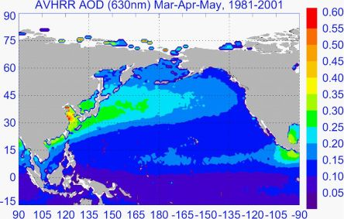
Figure 1a. Persistence of plume over the Pacific Basin area indicated by 20-year mean of aerosol optical depth (AOD) for spring from NOAA-AVHRR.

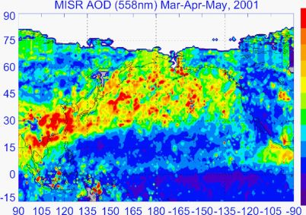
Figure 1b. Same as Fig 1a but for 2001 from MISR instrument on Terra satellite. (Ref: Li and Ramanathan, in preparation, 2005)

The long range transport of air pollution over the Pacific Ocean has been studied extensively: by examining surface data along the west coast of North America (e.g., Van Curen, et al., 2005; Jaffe et al 2005); by airborne campaigns such as the ITCT campaign (de Gouw, et al., 2004;Van Curen, et al., 2005; Heald, et al., 2005; Brock, et al., 2004) and the CIFEX campaign (Larivere, et al., 2003 and 2004 ); and by examining satellite data (e.g., Husar, et al., 2001). The direct radiative forcing of this dust/pollution has also been studied during the ACE-Asia project (Hubert et al., 2003, Conant, et al., 2003; Kim et al 2005 ). While the transport of dust reaches a peak during the spring time, it is important to note that the transport of Asian aerosols occurs through out the year (Van Curen, et al., 2005). The dust from Eurasia contributes as much as 0.5 µ g m⁻³ to the background aerosol loading (above the boundary layer) over the western U.S. (Jaffe, et al., 2005).  These earlier studies have set the stage for addressing the following fundamental issues dealing with the impact of the polluted dust on the radiative forcing and the cloud systems over the vast Pacific Ocean.

Long Range Transport, Radiative Forcing and Dimming
This project will focus on direct measurements of dust and pollution transport across the Pacific Ocean, following the plume from the western Pacific to the eastern Pacific and into North America. Such measurements are crucial to understanding how the dust and the pollution plume (including back carbon) are modified as they age. These measurements must include:
Basic physical and chemical characterization of the aerosols, particularly the composition of BC, dust, sulfates and organics; the albedo of the dust-pollution layer (measured from above the plume whose tops can be as high as 15 km), and transmission of solar radiation through the layer to determine the magnitude of the dimming across the Pacific Ocean. The only data we have to estimate approximately the thickness and top altitude of this plume across the Pacific Ocean are from SAGE (Stratospheric Aerosol and Gas Experiment), and indicate the plume extends as high as 10 to 15 km (Fig. 2).
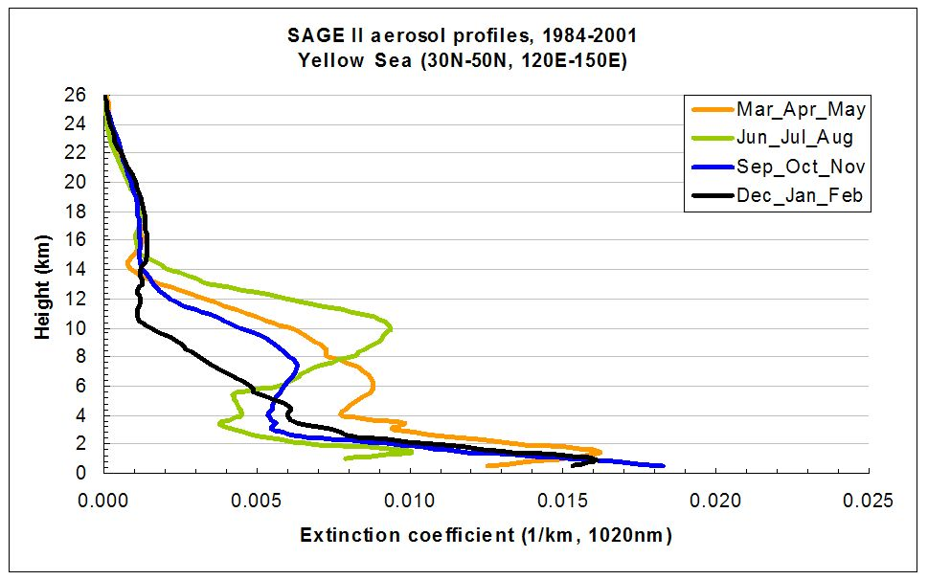
Figure 2. Vertical distribution of aerosol extinction over the western Pacific Ocean from SAGE data for all four seasons. The dust plume is extending up to about 15 km. (Ref: Li and Ramanathan, in preparation, 2005).
Thus far, we are not aware of any field experiment that has followed the plume in-situ all the way across the Pacific Ocean. The unique ability of HIAPER to follow this plume from the western to the eastern Pacific into the continental United States is a principal motivating factor for the proposed campaign.

CCN Connections to Clouds and Climate
The largest uncertainty in understanding the climate is relating the effects of aerosols on cloud formation and subsequent indirect radiative forcing and precipitation processes (Houghton et al., 2001). Cloud condensation nuclei (CCN) are linked to radiative forcing, precipitation, and cloud structure; yet, their role in climate feedback remains largely unknown. Models and field observations (e.g., Ramanathan, et al., 2001b; Kaufman et al., 1998; Raes, et al., 2000) have shown that an increase in anthropogenic aerosols can ultimately lead to higher concentrations of cloud drops, which can enhance the cloud albedo, thereby leading to a cooling effect (Twomey, 1977; Charlson, et al., 1992). This process can also yield clouds that are less efficient at releasing precipitation (Rosenfeld, 1999). The International Panel of Climate Change (IPCC) report (Houghton, et al., 2001) shows that this cooling effect may be large enough to offset 50% to 100% of the radiative heating due to the build up in greenhouse gases and acknowledges this indirect effect (i.e., the regulation of cloud albedo by anthropogenic aerosols) to be the largest source of uncertainty in understanding the human impact on the global climate.
Dust and anthropogenic emissions from Asia traverse the Pacific Ocean and intercept the North American continent within several days during the spring months when storm and frontal activity is most intense. Numerous field campaigns – i.e., ACE-Asia (Seinfeld, et al., 2004), APEX (Sano, et al., 2003) and INDOEX (Ramanathan, et al., 2001b) – have documented the direct impact of the long-range transport of dust and anthropogenic emissions on radiative fluxes to the surface. Since dust and biomass burning aerosols also provide surface area for the uptake of gas phase species (i.e., sulfates and nitrates), over time these aerosols become more hygroscopic and may play an important role in cloud formation during their transport. Cloud droplet concentrations, cloud depth and liquid water content determine the albedo of stratocumulus clouds (Twomey, 1977) which extend over large regions of the Pacific Ocean and strongly influence solar energy input into the earth-atmosphere system. Droplet concentrations in cumulus clouds are largely controlled by the physico-chemical properties of aerosol and updraft velocity at cloud base (Twomey and Warner, 1967; Seinfeld and Pandis, 1998). A significant fraction of the aerosol in the Pacific originates from anthropogenic activity; hence, it is important to characterize the aerosols capable of nucleating into cloud drops so that their sources can be identified.
CIFEX, the Cloud Indirect Forcing Experiment (http://borneo.ucsd.edu/cifex) occurred in April 2004 and focused on the measurement of aerosol and cloud properties to assess the impact of long-range transport on aerosol-cloud interactions. As a pilot study for the Atmospheric Brown Cloud (ABC) project, CIFEX allowed a comparison to the aerosol-CCN-cloud interactions in the polluted N. Indian Ocean (Ramanathan, et al., 2001b), which is influenced by long range transport from India and southwest Asia. The airborne experiment measured multiple aerosol layers of long-range transport and highlighted the influence of physico-chemical aerosol properties on CCN concentrations (Roberts, et al., 2005). The measurements indicated that new particle formation, characterized by high concentrations of particles < 20 nm diameter, frequently occurs in thin stratified layers between 1000 and 7000 m altitude over the Eastern Pacific Ocean. However, due to their small size, these ultra-fine aerosols neither effectively scatter light nor immediately serve as CCN. In contrast, aged, long-range transport aerosols effectively scatter light and serve as CCN, with activation ratios (f_{CCN/CN}) averaging 0.54 at 0.2% supersaturation. In spite of their low soluble content, aged aerosol particles from long-range transport effectively serve as CCN due to their large sizes. Unless these layers of particles from long-range transport are mixed into the boundary layer, the CIFEX results suggest that such aerosol layers may contribute more to the direct effect than to the indirect effect as regards liquid phase clouds.
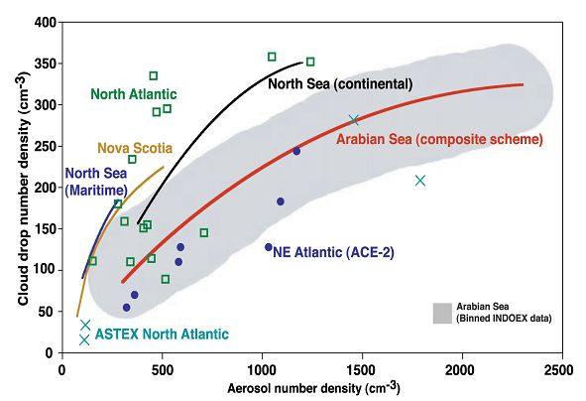
High quality CCN measurements are needed to provide a 3-D characterization of CCN by linking measurements at the surface (ABC stations) with airborne observations. This is particularly important for assessing the impacts of aerosols on radiative forcing, as we ultimately need to relate forcing to regional sources of aerosol emissions by developing an understanding of how the chemical and physical properties of aerosols change as they move away from the source regions and subsequently encounter (or grow into) cloud droplets. Figure 3 shows a positive relationship between cloud droplet and total aerosol concentrations obtained during several field experiments over oceanic regions in the northern hemisphere (Ramanathan, et al., 2001a). Considerable variation exists between the different measurements, in part, because there are many factors that influence cloud formation, including vertical velocity, water vapor and particle composition-size distribution, and entrainment. The relationship between cloud droplets and total aerosol concentration provides an incomplete explanation of the microphysical cloud processes. A more appropriate measurement is to use CCN and aerosol composition data to obtain closure on the number concentration of observed cloud droplets.
Figure 3. Relationships between cloud droplet number and total aerosol concentrations for various field campaigns
The fundamental step in understanding the growth of an aerosol particle into a cloud droplet is to know its cloud activation properties. In theory, if a particle’s size and chemical composition are precisely known, the supersaturation at which activation occurs may be calculated using Köhler theory (Seinfeld and Pandis, 1998). However, ambient aerosol populations can contain myriad chemical species, and the activation properties of most species have not been established. Furthermore, recent studies have demonstrated that simply categorizing aerosol species into soluble and insoluble fractions is sometimes insufficient to determine activation spectra (Cruz and Pandis, 1998; Hegg, et al., 2001; Raymond and Pandis, 2002), as slightly soluble species, surfactants, and soluble gases can affect activation either thermodynamically or kinetically (Charlson, et al., 2001; Nenes, et al., 2001; Nenes, et al., 2002). Therefore, it is desirable to measure directly the portion of the aerosol population that activates at a given water vapor supersaturation to establish the connection between theory and the actual atmosphere. In the laboratory, instruments using such measurement strategies can be tested using aerosols of a known size and composition. Thus, the activation behavior of an ambient aerosol can be measured and compared to predictions of CCN activity based on simultaneously measured aerosol size and composition information. A successful closure study serves to validate both the performance of the CCN instrument itself and the theoretical basis for the prediction of the activation properties of the aerosol.
Another approach to studying which particles form cloud droplets and ice crystals is to use a counterflow virtual impactor (CVI) to separate hydrometeors from the ambient aerosol and then evaporate them. The resulting residual particles are the original non-volatile CCN or Ice Nuclei (IN) plus other material incorporated through cloud processes such as chemical reactions or scavenging. The CVI technique has been used successfully to examine both black carbon and organics in cloud droplets (Twohy et al., 1989; Twohy et al., 2005), as well as dust and black carbon in ice clouds (Ström and Ohlsson, 1998; Twohy and Poellot, 2005). In PACDEX we will use a CVI to collect residual nuclei from clean and polluted clouds and will also collect ambient aerosol from inside and outside the plume. Using transmission and scanning electron microscopy (Anderson et al., 1996), we will examine particle composition, morphology, and mixing state to study particle evolution and cloud processing.
A newly developed aerosol impaction system (NCAR/RAF) will be used to sample giant aerosols (greater than 1 μm in maximum dimension). These will be sized and their hygroscopic ability will be examined using image recognition techniques.

Dust-pollution Interaction with Pacific Cloud Systems
The impact of the polluted-dust on the microphysics and radiative properties of cloud systems over the Pacific Ocean is virtually unknown, but may be a potentially important global issue. As is well known (Ramanathan, et al., 1989; Harrison, et al., 1990) clouds have a large net radiative cooling effect on the planet. Globally clouds exert a greenhouse effect (alternately referred to as longwave cloud forcing) of 30 W m⁻² which tends to warm the planet; this is more than offset by the reflection of solar radiation of --- 48 W m⁻², such that the clouds have a global cooling effect of about -18 W m⁻². Roughly 60% of this global cooling effect is from cloud systems over the extra-tropical oceans (Weaver and Ramanathan, 1997). Persistent bright clouds, found polewards of 35° over these oceans reflect more than 75 W m⁻² to space. The Pacific Ocean, because of its largest spatial extent, contributes a major fraction of this forcing. Cloud systems associated with extra-tropical cyclones and stratus that follows the passage of these cyclones are responsible for this cooling.
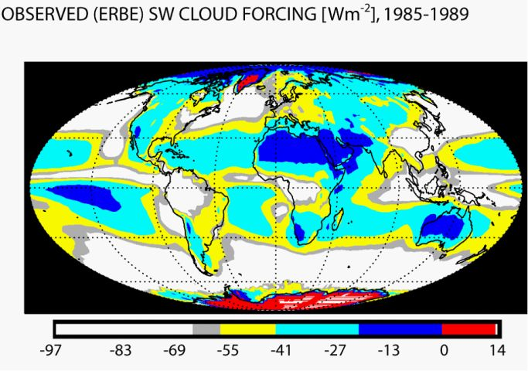
Figure 4. Global view of five year average shortwave cloud forcing from ERBE satellite. The extra tropical cloud systems reflect more than 65 W m⁻² (white regions). Ref: Ramanathan and Inamdar (2005).
A comparison of Figure 1, showing the spatial extent of the thick dust-aerosol plume, with the short wave cloud forcing over the northern Pacific in Figure 4, indicates a close association of the dust plume with the brightest cloud systems over the Pacific Ocean. This does not necessarily imply that aerosols are the major reason for the brightness of the clouds. However, it does suggest that the polluted dust-cloud interaction may be an important contributing factor deserving study. We need to understand the major source of cloud-active nuclei for these cloud systems and how the dust, pollution and dust-mixed-with-pollution modify the cloud microphysical properties and lead to the formation of precipitation in these cloud systems. It will also be important to correlate the location of water substance (vapor and condensed phases) with the plume locations, to understand better, and eventually model the effects of the plume.
The ACE-Asia project generally was not able to sample the highest regions of the dust, but the observed dust that was observed in the free troposphere contained less evidence of anthropogenic pollution than dust observed in the marine boundary layer (Hubert, private communication). The U of Hawaii Total Air sampler (TAS) is ideal for characterizing the level of pollution in the dust layers by examining the ratios of sulfate and nitrate to inorganic calcium (and other mineral species), for example.

Dust as Ice Nuclei
“Dust” aerosol consists of mineral particles of surface crustal origin, composed primarily of silicon, aluminum, potassium and calcium. Large scale events of dust production have been detected from satellites and have been tracked across large distances. Studies of dust deposition indicate potential distribution on global scales (Husar, et al., 2001; Prospero, 1996; 1999). Large scale sources include African Sahara and eastern Asia (Huebert, et al., 2003). Evidence of a relationship between dust and IN comes from several different types of studies, some of which involve direct examinations of IN particles, and others are based on inferential evidence.
One type of direct evidence comes from identifying the nucleating particles in snowfall. Kumai (1951) and Isono et al. (1959) made formvar casts of precipitating snow crystals. They found particles at the crystal centers and analyzed them using ion microprobe and electron microscope (EM) techniques. The chemical composition indicated clay materials, including illite, kaolinite, halloysite and other minerals, as well as particles containing sodium chloride. While this evidence is suggestive that the central particles were the ice nucleating particles, the approach has inherent uncertainties: (1) although the location at the crystal centers indicate the particles were the nuclei, they may have been collected by processes other than nucleation scavenging; (2) when several particles are near the center, there is an inherent bias towards the larger ones (Mossop 1963); (3) the analysis identifies elements, weighted by mass fraction – the nucleating structure may be a minor component; (4) structure and chemical bonding are not characterized; (5) the technique requires particles larger than ~0.02 µm; and (6) nucleation occurs on the surface at a particular site, the properties of which are not characterized.
Similar studies to capture ice particles from clouds aloft and determine the compositions of their residual nuclei have used counterflow virtual impactor (CVI) inlets. Heintzenberg et al. (1996) evaporated cirrus crystals collected with a CVI and impacted the residual particles onto transmission EM grids for single particle analysis. The dominant particles were identified as minerals, containing silicon and iron. Twohy and Poellot (2005) found that crustal material and industrial metals dominated residual nuclei from anvil cirrus sampled at temperatures warmer than about -37°C. Again, it is tempting to assert that these are the nucleating particles, but they could have been scavenged in ways other than ice nucleation.
Appreciable quantities of African dust are transported over large areas of the Atlantic Ocean to the Caribbean during much of the year (Prospero and Lamb, 2003). Recent airborne studies and ground-based polarization lidar measurements in Florida during the NASA CRYSTAL-FACE project (July 2002) provide direct evidence of a connection between dust and ice nuclei (Sassen, et al., 2003; DeMott, et al., 2003a). Measurements were made over Florida in air masses with sources in the Sahara Desert. The dust layer was detected by satellite and ground-based lidar. Trajectory analyses indicated it was of Saharan origin. The observations support the potential importance of mineral dust aerosols to enhance greatly the heterogeneous nucleation of ice at temperatures warmer than -37°C. Using aerosol trajectory forecasting and remote sensing, future studies could target airborne sampling of dust plumes to explore the impact on a wide range of cloud temperature regimes. Cziczo et al. (2004) sampled cirrus (in-situ and anvil) crystals with a CVI during the NASA CRYSTAL-FACE project and measured their compositions in real-time with single particle laser ablation mass spectrometry (PALMS). Mineral dust particles larger than about 0.2 µm were one of the major residual particle classes during the project as a whole and predominated during the presence of lower altitude Saharan dust layers.
Direct evidence for dust as a major contributor to atmospheric IN also comes from measurements of the aerosol particles that are processed as ice nuclei to form small ice crystals, hence leaving little opportunity for additional scavenging, and in some cases the subsequent collection of IN residuals for either EM analyses (Chen, et al., 1998) or single particle mass spectrometry analyses (Cziczo, et al., 2003). Chen et al. (1998) and Rogers et al. (2001a) processed aerosols in a continuous flow diffusion chamber in the vicinity of cirrus and Arctic stratus clouds respectively and found large signals of silicates and other crustal materials in residual ice nucleating particles. Real-time mass spectrometric measurements of IN by the technique of Cziczo et al. (2003) were made by DeMott et al. (2003b) at a high altitude continental U.S. site and they likewise identified mineral dust-like particles as the major contributors during sampling under “background” or remote aerosol conditions.
Inferential evidence of a connection between dust and ice nuclei comes from analysis of weather modification in Israel (Gabriel and Rosenfeld 1990) and from U.S. lidar studies of dust layer interactions with clouds (Sassen, 2002; Sassen, et al., 2003). The Israeli analyses suggested that cloud seeding increased precipitation on days with low natural IN concentration, but decreased precipitation when IN concentration was high. Ice nucleating aerosols were measured with membrane filters. Higher natural IN concentrations were associated with days having greater amounts of desert dust, as determined by meteorological trajectories, rain water chemistry and total suspended particulate analyses. An earlier study by Gagin (1965) reported that desert dust, especially loess, produces large quantities of ice nuclei. Additional inferential evidence from laboratory studies indicated the strong ice nucleating behavior associated with dust in air (Roberts and Hallett, 1968; Zuberi, et al., 2002) and many of the metal oxide components of desert dust (Hung, et al., 2003). The Sassen et al. (2002; 2003) studies reported the rapid glaciation of clouds forming in regions of enhanced dust layers.

Fate of Dust and Pollution Plume Once It Reaches the Continental USA.
Model simulations indicate significant transport into North America, as shown in Figure 5, a year when the event was further north than usual. There are several critical issues that need to be investigated. The first issue is the vertical profiles (from surface to about 15 km) of radiatively important aerosols such as dust, black carbon, organics and sulfates and their impact on surface dimming and atmospheric absorption over the western North American region. The next major issue is the amount of dust and BC that settles over the snow pack regions and the impact on snow albedo, which is a potential contributor to early snow melt. This issue can not be studied by aircraft, but, Scripps Institute of Oceanography (SIO) will be setting up two mountain sites in California (funded by state of California) to sample the snow and estimate the snow and dust content. Another major issue is to compare the concentrations of ice nuclei and CCN in the plume with the background concentrations (i.e., before the plume reaches U.S.). Again the HIAPER is ideally suited to make such vertical profiles of the plume.
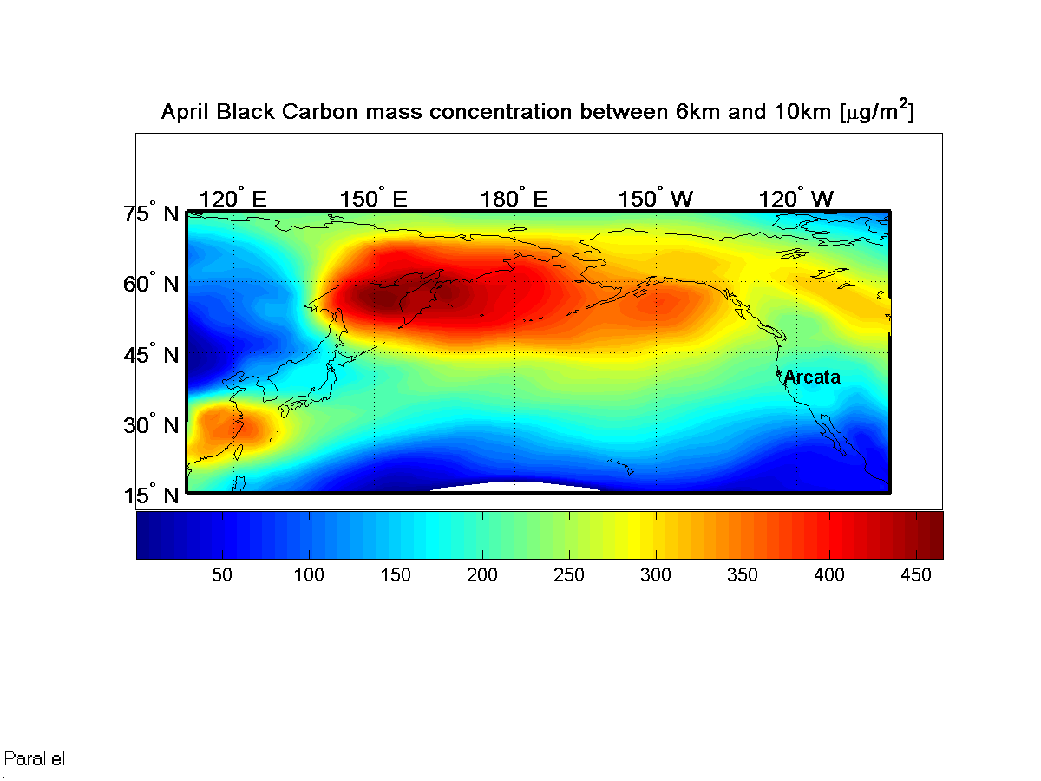
Figure 5a. Simulated BC concentrations (6km to 10 km) for April 2004 by Carmichael& Tang (2004).
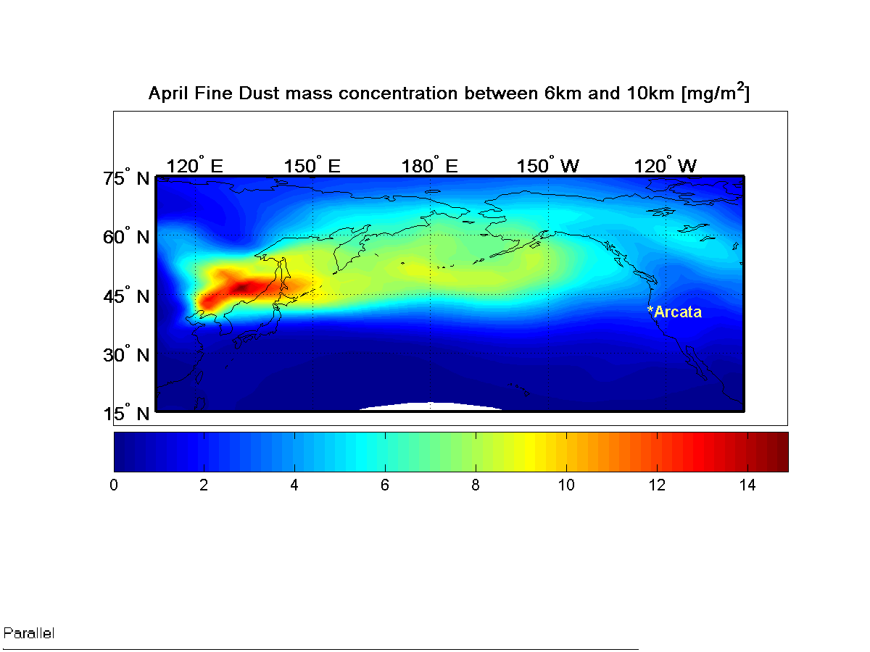
Figure 5b. Simulated fine dust concentrations (6km to 10 km) for April 2004. (Lariviere, Ramanathan, Robers, Charmical, Yang, Mauger, 2004 AGU meeting)

Aerosol-Cloud indirect effects within the Mid to Upper Troposphere: A New Frontier
Thanks to the pioneering study by Twomey (1977) about 30 years ago, the phenomenon of aerosol-liquid-cloud interactions in the lower troposphere is now one of the most actively studied issues, in part, due its potential importance to the global warming problem. We are now beginning to realize that aerosol-cloud interactions in the mid and upper troposphere are probably just as important, with potential impacts on indirect effects through heterogeneous nucleation of ice phase clouds (Jensen and Toon, 1997; Gorbunov, et al., 2001; DeMott, et al., 2003b; Sassen, et al., 2003). As discussed earlier, it is likely that dust particles have significant activity as heterogeneous ice nuclei in clouds.
There are at least three major reasons why this problem may be a fundamental issue in climate change. First, because of fast large-scale transport in the upper troposphere, once aerosols such as dust and black carbon enter the upper troposphere (above 8 km) they can be transported around the earth in a latitudinal belt in a week or two. As a result, dust and BC from Asia can impact upper troposphere clouds over North America and the Atlantic as well. For example, DeMott et al (2003a) use CRYSTAL-FACE data to suggest that fine dust from North Africa contributed significantly to ice nuclei populations over Florida (also see Sassen, et al., 2003). Using ground based lidar polarization data, Sassen indicates that Asian dust affected the formation and phase of ice clouds, leading to unusually warm cirrus ice clouds.
Second, mid and upper troposphere clouds exert a strong greenhouse effect, in addition to increasing the planetary albedo. Particularly, over the Pacific Ocean long wave cloud forcing (i.e, greenhouse effect) is between 35 to 50 W m⁻², while the shortwave cloud forcing is -60 to -95 W m⁻² (Figs. 4 and 6). Thus a preferential increase in greenhouse effect of a few W m⁻² (e.g, due to an increase in thin cirrus cloud optical depth or life time due to increased IN) can amplify the greenhouse forcing. On the other hand, if the presence of dust leads to warmer cirrus clouds, the greenhouse effect would be suppressed and the albedo effect would dominate and lead to a negative forcing.
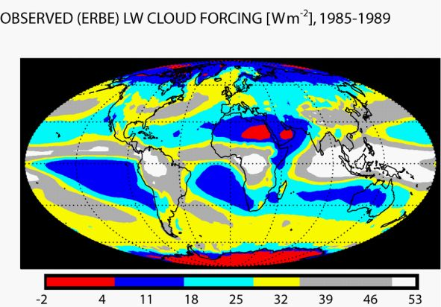
Figure 6. Five year average of longwave cloud forcing from ERBE satellite. The extra tropical cloud systems have a greenhouse effect exceeding 35 Wm⁻² (see the grey and yellow shaded regions). Ref: Ramanathan and Inamdar (2005).
Third, black carbon in cloud drops or ice crystals can enhance solar absorption (Chylek and Hallet, 1992 and Michailov, et al., 2005) and potentially lead to a dimming over the Pacific Ocean.
Fundamental measurements we need to make are the albedo, identification of the major type of absorbing aerosol in cloud droplets, and the absorption and single scattering albedo of polluted clouds. Such measurements, if they can be made with sufficient absolute accuracy, will lay the foundation for resolving the outstanding anomalous absorption issue. The northern Pacific Ocean is the ideal region to examine this question due to abundance of soot, dust and other aerosols in the most cloudy regions of the planet. The optical measurements will be especially important in the context of measurements of the size distribution of cloud hydrometeors and ice particle habit/types.

PACDEX Observing Systems
Observations from HIAPER will be integrated with ground based observations, satellite (NASA A-Train) observations and regional chemistry-transport models to estimate the effects of dust and air pollution on the radiative forcing and impact on clouds over the Pacific Ocean and North America.

Airborne Platform
The primary airborne platform will be the NSF/NCAR HIAPER aircraft. Its specifications are provided in Fig. 7.

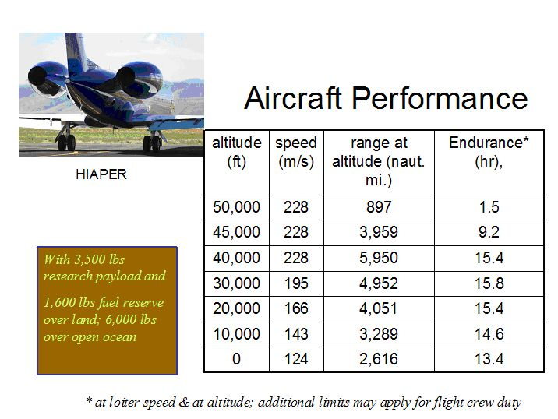

Figure 7. Performance of HIAPER aircraft at various altitudes.

The long range, high altitude capability of HIAPER is ideally suited to following a large plume across the Pacific Ocean. The flight plans that utilize this capability to satisfy the scientific objectives are described below. With one crew and typical loading, HIAPER has the capability to conduct several hours of plume sampling even with an extended ferry to the plume location (Fig. 8).
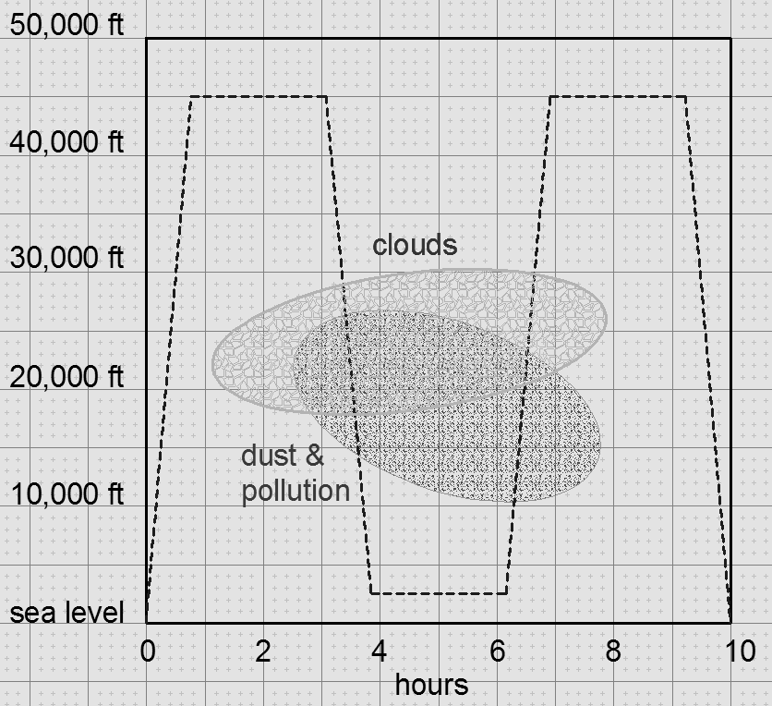

Figure 8. Example of HIAPER endurance for a plume sampling mission, assuming 6000 lb fuel reserve and lowest mission altitude 500 ft.
The endurance and range of HIAPER allow the evolution of the dust plume to be followed, given typical transit speeds for the dust across the Pacific Ocean (Fig. 9), which indicate about a 5 day transit. In addition to HIAPER, there is a possibility of another research aircraft from the University of Tokyo. Discussions are in progress with scientists from this university and from the Meteorological Institute of Japan, concerning their participation and measurement capabilities for PACDEX.

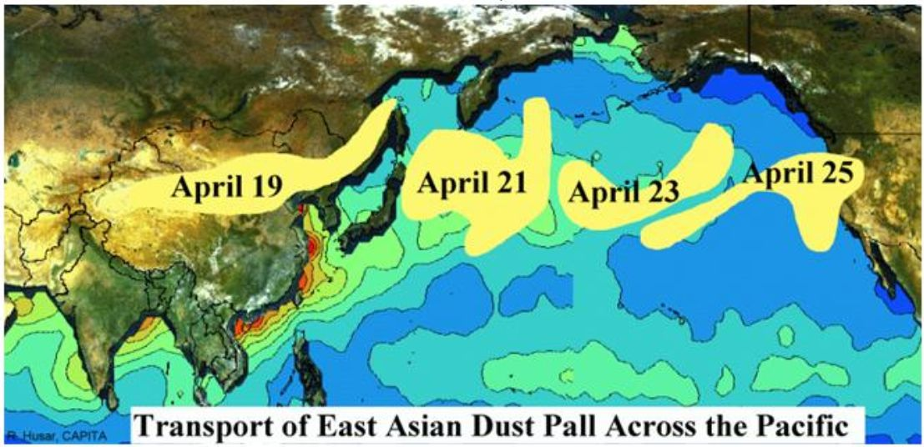

Figure 9. Example of dust plume event crossing the Pacific Ocean in six days during April 1998; from Husar et al. (2001)

Ground Based Observations by Scripps Institute of Oceanography (SIO):
Surface observations from a variety of sites will support this research. The locations of these sites are shown in Figure 10. The ABC (Atmospheric Brown Cloud) observatories are shown by white stars (5 sites) and are operated by the ABC project (Ramanthan, co-chief scientist) with NOAA funding in collaboration with regional scientists and agencies. On the western side, the Bashang site of inner Mongolia (in collaboration with U. of Peking) will be able to sample the dust and its radiative forcing before it is mixed with pollution over eastern Asia. This will be part of Aihua Zhu’s Ph. D thesis (SIO with PI: VR) work. The Gosan site (an ABC super site maintained by Seoul Natl Univ.) will sample the polluted dust as it exits Asia into the Pacific. The Okinawa ABC site in Japan (maintained by Univ Of Tokyo) will capture the southern flank of the dust. In the mid Pacific, the Midway site (maintained by Scripps) will sample the southern flank of the plume. The Trinidad Head (California; maintained by NOAA-Boulder) site will sample the dust and BC reaching the coastal surface. All of these ABC sites will have aerosol chemical sampling and radiative flux measurements. The Bashang (China), the Gosan (Korea) and Okinawa (Japan) site will also have Lidar to estimate the vertical extent of the plume. A description of the instrumentation for the ground based sites is provided in Table 1.

Table 1. Instruments of Inner Mongolia, Gosan, and Mountain station in California
Description | Instrument (Model) | Site
Micro-pulse lidar | MPL | Gosan,  Bashang (propose)
Sun photometer | Cimel (AERONET) | Gosan,  Bashang (propose)
Sky radiometer | POM-01 (Prede) | Gosan
Pyranometer  (global, diffuse flux) | CM21 (K&Z) | Gosan,  Bashang (propose)
Pyrheliometer  (direct flux) | CH1 (K&Z) | Gosan
Pyrgeometer  (LW flux) | CG4 (K&Z) | Gosan,  Bashang (propose)
Spectroradiometer  (UV, visible) | GUV-2511 (BSI) | Gosan
CPC (total particle concentration) | CPC (TSI 3022) | Gosan
Nephelometer  (3-wavelength) | TSI 3653 | Gosan
SMPS (particle size distribution, 10-500 nm) | TSI 3936 | Gosan
APS (particle size distribution, 0.5-10 μm) | TSI 3321 | Gosan,  Bashang (propose)
Aethalometer (aerosol light absorption) | AE-31 (Magee) | Gosan,  Bashang (propose)
CCN (Cloud Condensation Nuclei) counter | CCN counter (SIO) | Gosan
Snow sample collector | Wet sampler (EchoTech) | California Mountain site
Disdrometer  (precipitation monitor) | ThiesCLIMA Laser Precipitation Monitor | California Mountain site

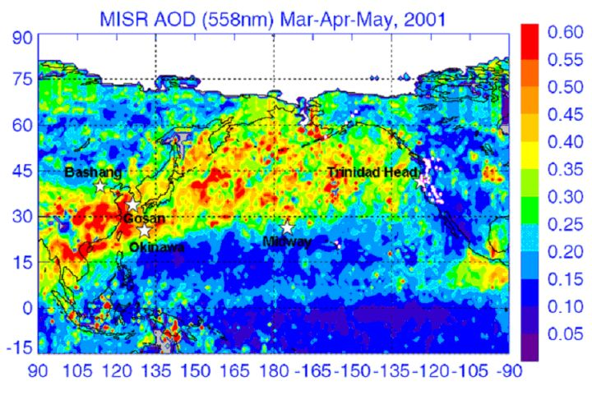
Figure 10. Map of Pacific Basin area showing surface observing system for PACDEX overlaid with contours of aerosol optical depth from MISR. White stars are ABC stations in Bashang (north western China), Gosan (S. Korea), Okinawa (Japan), Midway (mid Pacific) and Trinidad Head (California). White circles at Hawaii and along the west coast of US are IMPROVE sites.
The IMPROVE (Interagency Monitoring of PROtected Visual Environments) sites are at altitudes from sea level to about 2.5 km and measure BC, organics, sulfates, dust, among others. Data from these sites can be compared with data collected from the lower altitude HIAPER data.
In addition, support from the California Energy Commission is anticipated to fund two Improve sites (Mt. Sassen and Trinidad ) to sample BC in snowfall and surface snow, and will be part of Odelle Hadley’s Ph.D. thesis. The surface site data collection will be SIO’s (VR’s) responsibility. Two grad students and a post doc (supported by NOAA and NSF) will undertake this task.

Satellite Observations:
The A-Train satellite observing system will provide measurements of the vertical structure of aerosols, clouds, their optical properties and the top-of-atmosphere radiation budget. Our first objective will be to validate this data set with HIAPER in-situ observations. After this validation process, A-Train data will be used, using procedures developed during INDOEX (Ramanathan, et al., 2001) to obtain the ocean basin scale perspective of HIAPER observations.

Flight Mission Details

Objectives of HIAPER Missions
The HIAPER flights missions are designed to fulfill the following objectives:
- Characterize the clean (non dusty) environment in the area outside of a major Pacific dust event.
- Follow the evolution of a major dust and pollution plume in its journey across the ocean.
- Document the interaction of a dust and pollution plume with clouds.
- Provide a means of testing specific climate model processes in an exploratory framework
- Set the stage for more detailed model and observational studies in the future.

Flight Patterns
The flight patterns planned for PACDEX are described in Figures 11 and 12 and include the following features:
- A ferry across the Pacific just ahead of an event (or in the early stages), with several vertical aerosol and trace gas profiles to characterize the background atmosphere. The cruise altitudes will vary from 6 km to 14 km to sample horizontal gradients in aerosols, CCN, Ice Nuclei, and cloud water and ice content.
- A series of return flights originating in Asia to follow the plume in its trip across the Pacific Ocean. This will include two or three refueling stops en route (e.g, Hawaii, Midway, Alaska) to the west coast of U.S.
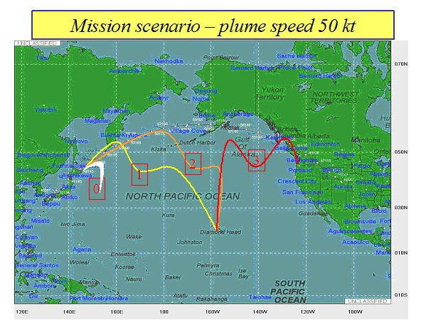
Figure 11. Map of Pacific Basin showing mission scenarios for possible plume flights. The great circle route for outbound ferry from Denver to Japan is indicated by the dotted northern track. Boxed numbers are missions flown subsequent days, following the plume.

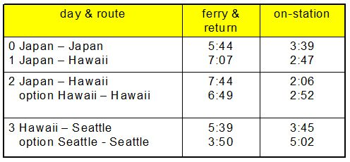
Figure 12. Table of four research flights in Figure 11, allowing for sampling time, refueling and drift of the plume across the Pacific Ocean. Option 0 refers to a possible sampling mission before the major portion of the event has reached the Pacific Ocean.
Period of the Mission: Climatologically, the best period for observing the dust events is during mid March to mid May. Any four week period during this period would be adequate, while the ideal time is centered on the month of April.
Logistics: Minimal pre-positioning of people and equipment—with most of the payload and support needs self-contained. The field project would probably base out of Boulder, Colorado, until a dust event appears likely. Aircraft launch would occur on 24 hour notice for a week “round robin” plume sampling event.
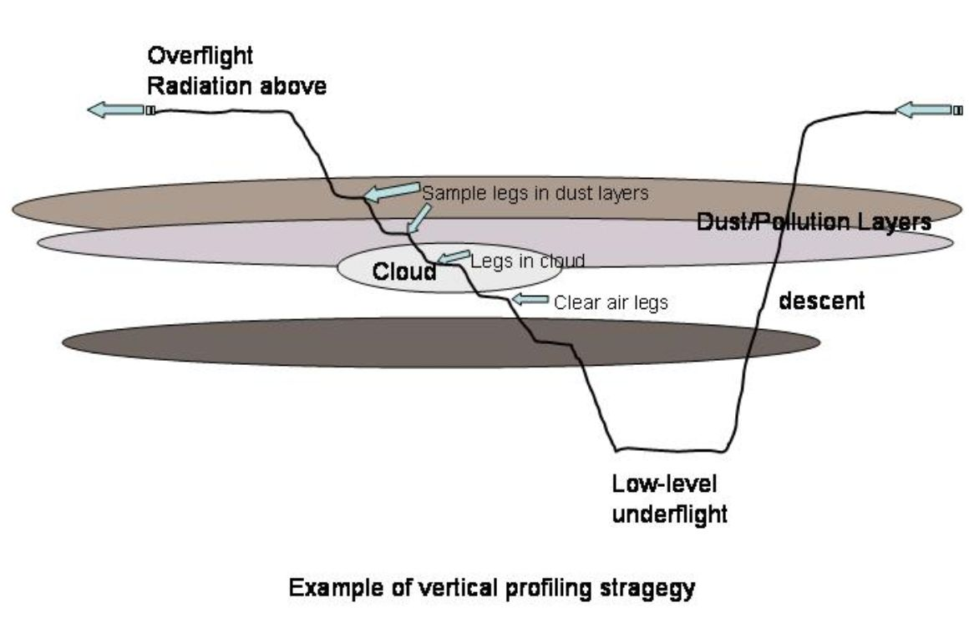
Figure 13. Example of descending/ascending flight pattern to sample dust and cloud layers. Individual horizontal leg may be directed toward areas of interest, such as clouds or to document horizontal variations in the plume. Real-time monitoring of data during the descent will be used to identify changes in layer characteristics to select horizontal leg altitudes. A similar ascending/descending pattern may also be used.
Vertical profiles of the plume will be made (Fig. 13), especially in areas where there are clouds. Regions where there are interactions between the clouds and the dust and pollution plumes will be targeted, as well as clouds just past the edges of the plumes to characterize clouds affected and unaffected by the aerosol plume.
Duration of event sampling: The outbound trip will take less than two days. The dust plume typically takes about 4 to 6 days (Fig. 9) to cross the Pacific Ocean. Thus sampling of the plume during the return trip should take about 6 days. A schematic of the proposed flight tracks is given in Figure 11. The entire round trip with instrument maintenance and crew rest days should last for about 10 to 12 days, with the airborne portion requiring about 5 days. Given a project lifetime of four weeks and about 85 flight hours, it is expected that two separate events can be studied.

Airborne Instrumentation
This airborne study requires several mission-critical measurements. Some of these will be available as user-requestable resources from NCAR/EOL, and others will be provided by project investigators. The key measurements include:
- Trace gases that identify clean and polluted air.
- Aerosol physical properties (total number concentration and size distribution), basic chemical composition (dust, black carbon, sulfates and organics (if possible), characterization of cloud active nuclei (CCN, giant nuclei, and ice nuclei), and aerosol light scattering and absorption.
- Cloud microphysical properties - basic measurements for droplet, ice, and precipitation size spectra, water and ice content, including a CVI for condensed water content and residual particle composition.
- A radiation package that provides adequate characterization of the radiative impact of the plume and clouds at least in the solar part of the spectrum. Measurements covering wavelengths from about 0.3 µm to 3 µm are required to cover the direct impact of the Asian plume. The focus of PACDEX airborne radiation measurements will be on the solar portion of the spectrum, which is well sampled by available HIAPER instrumentation. Additional instrumentation to measure the terrestrial component may also be pursued, but is not part of the current request.
- Real-time communication from HIAPER to the ground via satcomm for data and satellite imagery

Several of the key instruments are described below.

Facility aerosol instruments
Condensation nuclei (CN) will be measured with a new water-based instrument that has been acquired by EOL/Research Aviation Facility (RAF) as part of the HIAPER instrument infrastructure. This instrument is being modified by the manufacturer (Aerosol Dynamics, Inc.) to improve its response across the wide range of pressures flown by the HIAPER (~1000 to 100 mb). It detects particles larger than ~3 nm (Hering et al., 2005). Two instruments can be flown, with one operating at this size threshold and the second one at ~20 nm. Nucleation-mode particles can then be identified by differencing. These will be available by early 2006.
A new Ultra-High Sensitivity Aerosol Spectrometer (UHSAS, manufactured by ParticleMetrics, Inc.) is being acquired by RAF for use on HIAPER. This is an optical scattering, single-particle instrument that spans the size range 55 to 1000 nm. It is an under-wing pod-mounted instrument, and will be available for research by Fall 2006.
Measurements of aerosol light scattering will be made using two integrating nephelometers, Radiance Research model M903, currently available at RAF. The units are identical, and an in-line humidifier can be used in front of either one to assess the response of the aerosol to humidity (adjustable from ambient to 90%+).

Optical and bulk aerosol instrumentation
Optical absorption measurements are planned using Particle Soot Absorption Photometer (PSAP, Radiance Research, Inc.) operated by the University of Washington.
Bulk aerosol samples will be collected by The University of Hawaii total aerosol sampler (TAS). The TAS is designed to collect every particle that enters its tip, so all can be returned to the lab for chemical analysis. It was developed to be a reference sampler since all other aerosol sampling devices include some form of an inlet and conveyance tubing, whose efficiencies depart from unity over some size ranges. This is especially an issue for large particles, such as sea salt and dust. With TAS the uncertainty in estimating these passing efficiencies is not an issue.
TAS is mounted outside the airframe (to eliminate transfer tubing) and features replaceable diffuser-cone liners. Since every particle entering the TAS tip is deposited either on its filter or on the TAS liner cone, all sizes of particles are collected with unit efficiency. Both the filter and the interior of the liner cone are extracted in the lab and the extracts are then analyzed. Thus we can be confident of measuring an unbiased total aerosol concentration. Bulk chemical analysis, using standard techniques similar to those in ACE-Asia, will be performed at the University of Hawaii. The samples will also be sized and analyzed for composition at the Arizona State University using electron microscopy and microprobe analysis.
In addition to the TAS, the Arizona State University analyses will be conducted on samples from the CVI and the giant aerosol collector and from two small samplers which are used to collect particles for individual particle analysis, a Programmable Streaker sampler (PIXE International) set up as a filter sampler for SEM analysis and a 3-stage micro-impactor (California Microsystems) for impaction onto 3 mm grids for TEM analysis. The Streaker has a rotary stage and can acquire up to 40 separate samples (each 2 x 8 mm) on a 90 mm polycarbonate filter; the streaker stage advance is controlled by a signal from a laptop. For the micro-impactor, only one set of sample stages can be mounted at a time and sample change is accomplished by hand, requiring the presence of an operator.
Automated SEM analysis of filter samples from the streaker measures the size, shape, and elemental composition of particles 0.1 microns in diameter and larger on a population of approximately 1000 particles per sample analyzed. Because it takes 24 hours to analyze this many particles, a subset of the collected samples are selected for analysis. The Arizona State University also will perform manual high-resolution SEM imaging of the filter samples to investigate mixing states (e.g. aggregation of dust and black carbon) and aerosol aging.
Manual TEM analysis investigates the structure and physical properties of individual aerosol particles. Details of the mixing state of black carbon, sulfate, and high-molecular-weight organics are of particular interest, as well as the variety of forms of black carbon.

Cloud Condensation Nuclei Measurements
The measurements described here directly address how the physico-chemical evolution of the Asian plume affect the ability of aerosols to serve as CCN and the potential subsequent indirect effects of aerosols. On the HIAPER aircraft, fast response CCN measurements are with a multi-column Continuous-Flow Streamwise Thermal Gradient CCN Chamber (MCSTGCC), being developed at Scripps Institution of Oceanography. The continuous-flow thermal gradient diffusion chamber [Roberts and Nenes, 2005] was developed for autonomous operation in airborne studies employing a novel technique of generating a supersaturation along the streamwise axis of the instrument. Roberts and Nenes are transforming the single-column streamwise CCN instrument into a compact, automated multi-column device to retrieve CCN activation spectra over a range of supersaturations appropriate for aerosol/cloud interactions. CCN spectra are especially important for the proposed airborne measurements as supersaturations can change spatially and temporally in different parts of a cloud system. The multi-column CCN instrument will provide 1 Hz measurements at four supersaturations between 0.1% and 1% supersaturation. The measured CCN spectra during PACDEX will yield valuable insight on how the aging of the urban pollution and dust affects cloud microphysics and subsequent changes to cloud radiative properties.
Giant (>1 μm) and ultra-giant (>10 μm) CCN will be measured by a giant nuclei collection system that is based on a proven technique of impacting aerosol on microscope media directly exposed to the airstream. This technique, at typical HIAPER airspeed, collects particles larger than a few microns. Many of these larger particles require a large sample volume for proper statistics, which is provided by the giant nuclei sampling system. Two techniques will be used to analyze the aerosol. Some of the sampling will be done on electron microscope grids, which will be analyzed at the Arizona State University for size, composition and morphology, as will be done for the Hawaii TAS samples. The reset of the sampling will be done on optical microscope slides. Digitized optical analysis of the size distribution will be made under dry and humidified conditions. This allows the identification of giant and ultra-giant cloud condensation nuclei, which are critical to the production of rain by collision and coalescence. In addition, it allows the determination of the size segregated soluble mass of particles.

Air sample inlets on HIAPER
Inlets for bringing air to instruments inside the aircraft cabin have been developed to support HIAPER. These HIAPER Modular Inlets (HIMIL) can be configured for sampling trace gases and aerosol particles. As shown in Figure 14, HIMIL consists of a aerodynamic strut and the cylindrical tube it supports. Metal or Teflon piping can feed through the strut and terminate in the tube. Tip and tail ends of the tube can be modified as needed; for example, Figure 14 shows a flow-alignment shroud. Other options may include a diffuser tip, converging tail, or open tube with small piping inserted to draw samples from the centerline. Leading edges have temperature-controlled heating to prevent ice accumulation in supercooled water clouds. First flights with HIMIL are underway (November 2005). Flow modeling work is being done to characterize the performance. For more information, see http://www.atd.ucar.edu/~dcrogers/HIAPER/Inlets/HIMIL/

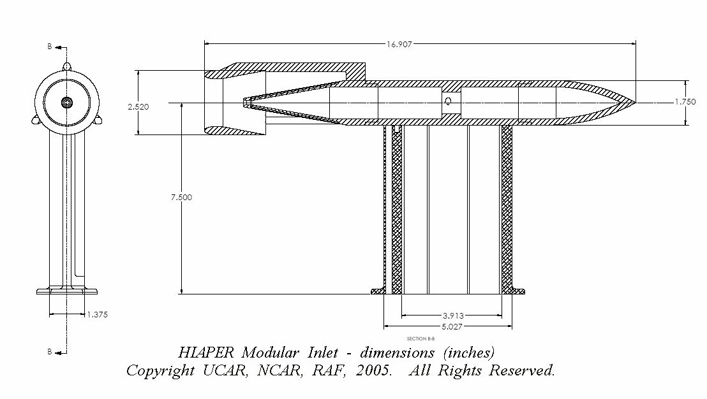
Figure 14. HIAPER Modular Inlet (HIMIL)
Compressional heating of the air is a significant issue for airborne sampling of particles. At typical HIAPER airspeeds, ~225 m s⁻¹, it amounts to ~25°C. Small particles that have volatile components (e.g., sulfuric acid) are likely to evaporate partially or completely. This is not a significant factor for mineral dust or soot, but it can be important for acids or organic species. RAF is collaborating with aerosol researchers and exploring options to compensate for this effect and to avoid or reduce the impact of this issue.

Facility cloud particle instruments
An assortment of facility instruments for measuring cloud particles will be available in time for PACDEX. For cloud droplets, RAF plans to purchase and install a CDP (Cloud Droplet Probe, made by Droplet Measurement Technologies). The CDP is an optical, single particle forward-scattering instrument, designed for airborne use and covering the size range 2-60 µm diameter at speeds up to 250 m s⁻¹.
The Small Ice Detector, version 2, (SID-2) is being acquired with NSF funding through the Major Research Equipment and Facilities Construction program. SID-2 is a single particle optical scattering instrument. It has multiple detectors to measure scattering asymmetry, from which small ice particles and small water drops can be discriminated (Hirst et al., 2001; Field et al., 2004). SID-2 is an under-wing pod-mounted instrument and should be available for research early in 2007.
Engineering staff at RAF are modifying a standard 2D-C (Two-dimensional Cloud) probe so that it will function at the faster speeds of HIAPER (up to 240 m s⁻¹) and so that it can image a larger range of particle sizes (up to 1600 µm). Standard versions of this probe with older electro-optics lose sensitivity above ~150 m s⁻¹. This is an under-wing pod-mounted probe and will be available for use on HIAPER in Fall 2006.

The CSU Continuous Flow Diffusion Chamber (CFDC)
The continuous-flow (ice-thermal) diffusion chamber (CFDC, Fig. 15), is a device for processing populations of aerosol particles in order to promote ice formation by those particles capable of acting as ice nuclei (Rogers 1988; Rogers et al. 2001a). Air flow is directed vertically between two concentric ice-coated cylinders held at different temperatures, creating a supersaturated zone in the annular region. The sample air, ~ 10% (1 liter min⁻¹) of the total flow, is sandwiched between two particle-free sheath flows. Particles in the sample flow are exposed to defined temperatures and ice (or water) supersaturations and those particles active as IN are grown to ice crystal sizes larger than a few microns. These nucleated ice crystals are detected and counted by an optical particle counter (OPC) at the outlet of the instrument. Any activated cloud droplets are not counted due to the removal of the warm wall ice source in the lower third of the chamber, which reduces relative humidity toward ice saturation and causes the evaporation of liquid particles. By altering the ice wall temperatures and allowing a few minutes for stabilization, ice nuclei measurements may be made over a range of temperatures and supersaturations. The technique is most sensitive to deposition and condensation freezing nucleation due to limited (~10 s) residence times. Measurements are also limited at present to aerosol particles smaller than 1 micron in order to prevent false positive identification of large aerosol particles as nucleated ice crystals. This is accomplished by operating an impactor upstream of the CFDC. Developments are underway to replace the OPC detection system with a system capable of discriminating particle phase through spatial scattering properties, but it is not certain that this task will be complete prior to PACDEX. If available, the new detection system is not expected to require any selective removal of larger aerosols.
The CFDC instrument technique has a history of use for studies of mixed phase and ice phase clouds on a variety of aircraft (e.g., DeMott et al. 1998; Rogers et al. 2001b; DeMott et al. 2003a). Presently, two aircraft-capable versions and one laboratory version of this instrument exist. Cooling of the walls of the aircraft versions is accomplished by active refrigeration using compressors. Air samples are typically obtained from an appropriate forward-facing aircraft inlet or alternately, cloud particle residuals can be sampled after a counterflow virtual impactor. A web site exists that describes the instruments in more detail (http://lamar.colostate.edu/~pdemott/cfdc/cfd.html) and shows examples of installations.

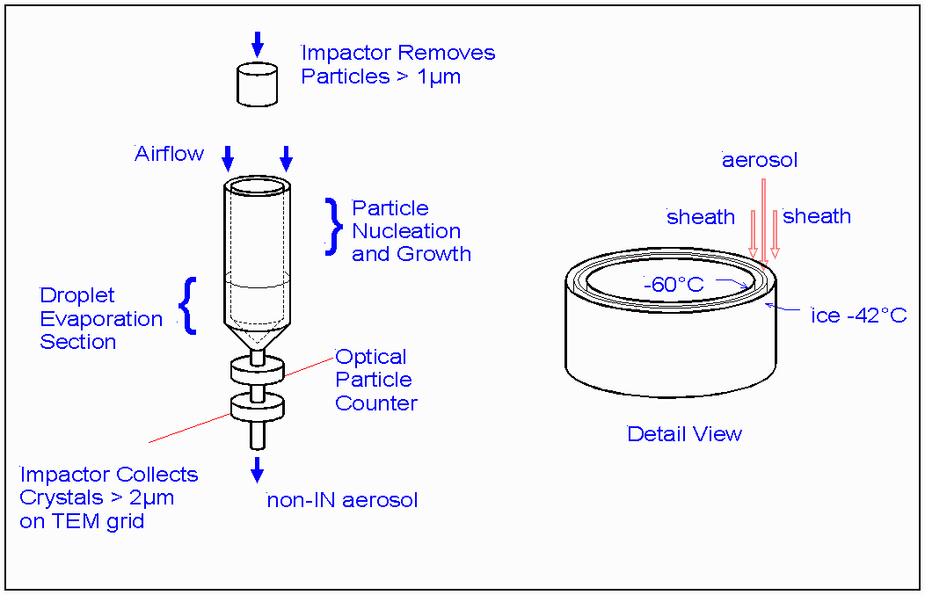

Figure 15. Schematic of the CFDC, configured in this case of studies in the cirrus regime.

Trace Gas Instruments

Although trace gas chemistry is not one of the major goals of PACDEX, we intend to measure trace gases to help identify anthropogenic pollution in the dust plumes from Asia. In situ measurements of CO and ozone mixing ratios will be measured using HIAPER facility instruments, which are based on a modified UV photometer for ozone and a vacuum UV absorption method for CO. The precision of the CO instrument is 3 ppbv for a 1 Hz sample rate and the ozone instrument is capable of 0.2 ppbv precision for a similar sampling rate. These instruments can detect and measure both plume and ambient level of these gases. We are also at present exploring ways to measure pollution levels of SO₂, which is possible using available commercial instrumentation. These trace gas measurements, when combined with the suite of aerosol measurements, will provide detailed documentation of the structure of the pollution and dust plumes in PACDEX.

Airborne Radiation measurements
Radiation measurements will be made using the HIAPER Airborne Radiation Package (HARP). In includes the down and up welling spectral irradiances in the wavelength range from 300-2200 nm at various spectral resolutions using UV-Visible and Near Infrared spectrometers. This instrument is suitable for determining layer properties, such as reflectance, transmittance and absorptance and for deriving broadband solar irradiances. HARP is mounted on a horizontally stabilized leveling platform and views both zenith and nadir.

Modeling in Pacdex

Modeling at NCAR
Models will play an integral role in the design, execution, and interpretation of PACDEX. The main modeling work at NCAR will be based upon the Community Atmosphere Model (CAM3) (Collins et al, 2004, 2005a), the atmospheric component of the Community Climate System Model (Collins et al, 2005b). CAM3 is a comprehensive global model of the physics and dynamics of the atmosphere. It has been enhanced with a reactive chemistry package for simulation of tropospheric ozone, oxidation processes, and the chemical production of sulfate aerosols (Lamarque et al, 2005a). Newer versions also include a detailed representation of tropospheric aerosols, including soil dust, sulfates, nitrates, primary and secondary organic carbonaceous species, black carbon, and sea salt (Mahowald et al, in press, submitted; Lamarque et al, 2005b). While CAM is normally used as a general circulation model for climate simulations, it can also be used as a transport model. In its transport mode, the wind, temperature, humidity, and other fields are obtained from meteorological analyses or short-range meteorological forecasts. Using meteorological analyses, CAM can simulate the observed record of aerosols and cloud systems in the PACDEX experimental domain. Using short-range forecasts, CAM can simulate the future evolution of dust and pollution plumes for the purposes of flight planning. CAM3 can now be integrated for short time periods at the high spatial resolutions (e.g., 50-km grid spacing) that used to be characteristic of regional weather models.
CAM3 will be applied in each phase of the experiment:

- Phase 1 (Pre-deployment): The evolution of aerosols, clouds, and chemical tracers will be simulated for March through May for several years to facilitate flight planning and flight simulation. The modeling team will provide tools to sample the model output along proposed Lagrangian flight trajectories. The modeling team will work with the instrument investigators to simulate the signals measured by key instruments on board HIAPER.
The modeling team will also evaluate CAM using prior field campaigns in the Pacific basin. Initially, the effort will be focused on observations from ACE Asia and from CIFEX. Data from ACE Asia and CIFEX will help the team test the fidelity of simulations for the Asian source regions and the long-range transport and evolution of aerosols, respectively.
- Phase 2 (Field Phase): The team will provide short-range projections of the distribution and evolution of clouds and aerosols in the PACDEX domain. These forecasts will be driven by operational NCEP meteorological forecasts for aviation. In order to improve the fidelity of the forecasts, the model will be adjusted using assimilation of satellite aerosol retrievals from recent satellite overpasses of the domain. The model data will be transmitted in reduced form to the field sites for mission planning and relayed to HIAPER via satellite communications. The team has prior experience in forecasting aerosols using global aerosol assimilation models for flight operations during INDOEX and ACE Asia (Collins et al, 2001; Rasch et al, 2001).
- Phase 3 (Analysis): The team will simulate the PACDEX experiment using meteorological analysis or reanalysis and the active and passive aerosol instruments in the NASA A-train satellite constellation. This simulation will help place the PACDEX observations in a synoptic meteorological context and in a climatological context relative to simulations of prior years.

The team will also use the PACDEX data to evaluate the representations of cloud and aerosol processes in CAM3. Improvements that follow from this evaluation will directly affect simulations of past and future climate using CAM3 and CCSM3. Prior comparisons between general circulation models and field observations have often been inconclusive because errors arise in both the predicted meteorology and in the representation of relevant physical and chemical processes. Since CAM3 can be run in a deterministic transport mode, it will be possible to quantify separately the meteorological and process-related errors in the model. The initial comparisons will focus on the vertical distribution, chemical speciation, concentration, and transport of aerosol species. These evaluations will also address the fidelity of simulated direct radiative effects of aerosols in CAM3. Subsequent studies will examine the representation of cloud-aerosol interactions in CAM3. The microphysics in CAM3 will undergo rapid evolution over the next few years, and it is therefore difficult to predict precisely how the PACDEX data will be used in tests of the model. However, the conceptual framework under consideration does explicitly include droplet and ice particle activation based upon aerosols predicted by the model. It is therefore quite likely that the PACDEX data directly will be directly applicable to the ongoing evolution and improvement of CAM.

Modeling at the University of Iowa
Chemical Transport Models (CTMs) are playing increasingly important roles in the design, execution, and analysis of large-scale atmospheric chemistry field studies. They are being used in forecast-mode to enhance flight planning by enabling the representation of important three-dimensional atmospheric chemical structures (such as dust storm plumes, polluted air masses associated with large cities, and widespread biomass burning events) and how they evolve over time. CTM forecasts play the additional important role of providing a 4-dimensional contextual representation of the experiment. CTMs also facilitate the integration of the different measurements and measurement platforms (e.g., aircraft, ground stations and satellite observations). Finally, CTMs can be used to help evaluate and improve emission estimates.
The modeling group at the University of Iowa has developed an operational regional- to intercontinental-scale forecasting and analysis system to assist in atmospheric field experiments. The system consists of 3 major components: 1) detailed mesoscale meteorological model with on-line air mass and emission tracers; 2) detailed 3-dimensional photochemical calculations using CTMs; and 3) enhanced emission products that intimately link emitted amounts and activities to the transport and chemistry analysis. This system was successfully applied in the design and execution of the NASA TRACE-P, NSF ACE-Asia, the NOAA ITCT-2K2, NASA/NOAA/NSF INTEX and ICARTT, and several ABC-related intensive field experiments (Carmichael et al., 2003; Tang et al., 2004; Seinfeld et al., 2004). In these previous experiments they demonstrated that these models can be used effectively in the execution and analysis of field experiments. The University of Iowa group has authored or co-authored over 30 papers related to these recent field experiments (cf. http://www.cgrer.uiowa.edu/EMISSION_DATA/publications/Articles_list_Access.htm).
The modeling system is designed to help better understand the transport and transformation of gases and aerosols on transcontinental/intercontinental scales and their impact on air quality and climate. The model has been used to help flight planning for a spectrum of measurement objectives for which individual flights are conducted. These included: characterizing the inflow, modification and outflow of air-masses across North America; characterizing boundary layer chemistry and venting over the continental US; trace gas and aerosol distributions in the outflow over the North Atlantic; chemical aging over the North Atlantic; and the transport of Asian and biomass burning plumes. The processes of interest operate at a variety of scales from local to global. To efficiently represent these scales in a flight planning context, a multi-scale model system was developed. This model system includes global scale inputs from the MOZART global chemical transport model, the inter-continental chemical tracer model CFORS (Uno et al., 2004), and a nested regional chemical transport model, STEM-2K3 (Tang et al., 2004). (See for, example, Fig. 5).
CFORS is an on-line tracer model (Uno et al., 2004) coupled with the RAMS regional meteorological model. In previous applications CFORS was driven by NCEP reanalysis for post analysis and AVN data for forecasting uses. CFORS treats a number of chemical tracers and air mass markers useful in flight planning. These include major cities, chemical air mass age indicators, power plants, etc. CO is one of the primary tracers in CFORS and is used to help classify emission source types and regions.
STEM-2K3 is a regional chemical transport model developed from STEM-2K1 (Tang et al., 2004; Carmichael et al., 2003) that includes the SAPRC-99 gaseous mechanism and an explicit photolysis-rate solver (the on-line TUV--NCAR Tropospheric Ultraviolet-Visible radiation model). The main improvement of STEM-2K3 over STEM-2K1 is that the former also includes an aerosol thermodynamics module, SCAPE II (Simulating Composition of Atmospheric Particles at Equilibrium), for calculating gas-particle equilibrium concentrations among inorganic aerosol ions and their gaseous precursors. Tang et al (ACE-Asia issue) described the framework of STEM-2K3 and its performance during the TRACE-P and ACE-Asia experiments. Typically inorganic aerosols in 4 size bins (in diameter) are included: 0.1µm-0.3µm, 0.3µm-1.0µm, 1.0µm-2.5µm, and 2.5µm-10µm, (referred to as bins 1 to 4, respectively). The primary domain for STEM-2K3 covers the U.S. For each domain they ran MM5 forecasts initialized by the AVN products to provide the meteorological fields needed by the STEM model. The MOZART global forecast product was provided the lateral boundary conditions for the STEM-2K3 primary domain applications.
The University of Iowa typically provides 3-5 day forecasts (air mass markers, tagged source regions, age of airmass, and photochemical and aerosol products), one time per day, for the domains indicated. Standard products include air mass source indicators, air mass age indicators, and various primary and secondary trace gas and aerosol products. The forecast tools are generally provided to the science team through a website, and members of the Iowa-team were in the field to provide on-site input during the field experiment. During the field experiment, MOZART-II global chemical transport model provided time-varied lateral boundary conditions for the primary domain. Details can be found on the forecast website (http://www.cgrer.uiowa.edu/ACESS/acess_index.htm).
The three dimensional model is also used in the analysis of the observational data. The main focus has been on understanding dust interactions with gas phase chemistry, long range transport of pollutants across the Pacific (Jaffe et al., 1999; Yienger et al., 2000) , and aerosol interactions with climate (Bates et al., 2005; Conant et al., 2003).

Education in PACDEX
University faculty members in PACDEX are planning to include graduate or undergraduate students in this project, as has been typical of previous field projects. Two specific PhD dissertations currently planned in connection with PACDEX are described above. In addition, we plan to devote specialized resources in PACDEX to supporting education. The model for this support will be the Instrument Development and Education in Airborne Science (IDEAS) program, which was conducted in 2003 and 2004, and utilized the C130 as a tool for introducing students to airborne research (Stith and Rogers, 2004). A number of specialized efforts to assist students were successfully tried in IDEAS, including:
- Developing an IDEAS web page that invited student and teacher participation in the project. IDEAS data were used in several class projects and in some cases produced original research by student participants (described in Stith and Rogers, 2004). We recommend viewing the web site http://www.eol.ucar.edu/raf/Projects/IDEAS/ for a more complete overview of the IDEAS program.
- Providing software to support student interactions with the field deployment. The development of real-time chat capability on the NCAR/NSF aircraft and real-time display of data via the satellite/internet link has provided the tools for students and instructors anywhere to participate in the field experiment. In IDEAS EOL (then ATD) developed web-based resources to facilitate student access to these tools which also allowed them to contribute their ideas to the planning of the flights. Links to instructional materials (e.g. RAF/NCAR bulletins on measurement technology, downloads of analysis software, etc.) were used in IDEAS and will be an important part of student resources for PACDEX. New tools that have been developed for HIAPER, such as the higher speed satellite communications and improved real-time display software will greatly improve the quality (data display capabilities) and quantity (number of parameters that are displayed) of the tools for supporting student participation in HIAPER deployments. Other exciting developments, such as EOL’s planned Virtual Operations Center, will further extend the real time experience for students.
- Providing mentors for students. Experts in airborne instrumentation (e.g. cloud physics, wind and turbulence, trace gases, etc.) served as student mentors to explain their measurement science to students in IDEAS. Several of the PACDEX PIs (e.g. Rogers, Twohy, Campos, Stith, etc.) served in this capacity in IDEAS and will also offer their services as mentors during PACDEX. This was a major highlight of IDEAS and produces extremely positive student feedback.

Because PACDEX will only offer limited opportunities for students to fly on HIAPER in comparison to what was done in IDEAS, the improved communication and display tools in place for HIAPER will play an important role in supporting education. Many of these tools are now operational (e.g. display software) and will improve significantly by the time PACDEX occurs.

Participants
PACDEX is intended to be a pilot project, exploring both the practical and scientific aspects of studying large scale dust events. A later project could expand to a longer duration, more participants, and a wider variety of observations.
The following table identifies the current list of participants and their areas of interest. In addition to these U.S. scientists, there may be international collaborators from the University of Tokyo and the Meteorological Institute of Japan.
Table 2. PACDEX Investigators

investigator | affiliation | areas of interest
V. Ramanathan | UCSD | large scale climate
J. Stith | NCAR/RAF | cloud microphysics & airborne field operations
D. Rogers | NCAR/RAF | cloud microphysics & aerosols
P. DeMott | CSU | cloud microphysics, ice nucleation
A. Heymsfield | NCAR/MMM | cloud microphysics, ice phase
J. Anderson | Arizona State | aerosol sources & characterization
C. Twohy | Oregon State | cloud microphysics, nuclei composition
G. Roberts | Scripps | cloud condensation nuclei
B. Huebert | U. Hawaii | aerosol sources & chemical characterization
P. Rasch | NCAR/CGD | climate modeling
J. Jensen | NCAR/RAF | giant nuclei & warm cloud microphysics
T. Campos | NCAR/EOL | trace gas measurements
N. Mahowald | NCAR | Plume modeling
W. Collins | NCAR | Plume modeling
D. Covert | U. of Wash | Filter based measurements of light absorption
G. Carmichael | U of Iowa | Plume modeling

References
Anderson, J. R., P. R. Buseck, and R. Arimoto (1996), Characterization of the Bermuda tropospheric aerosol by combined individual-particle and bulk-aerosol analysis, Atmos. Environ. 30, 319–338.
Bates, T., T.L. Anderson, T. Baynard, T. Bond, O. Boucher, G. Carmichael, A. Clarke, C. Erlick, H. Guo, L. Horowitz, S. Howell, S. Kulkarni, H. Maring, A. McComiskey, A. Middlebrook, K. Noone, C.D. O’Dowd, J. Ogren, J. Penner, P.K. Quinn, A.R. Ravishankara, D.L. Savoie, S.E. Schwartz, Y. Shinozuka, Y. Tang, R.J. Weber, and Yonghua Wu, Aerosol direct radiative effects over the northwest Atlantic, northwest Pacific, and North Indian Oceans: Estimates based on in-situ chemical and optical measurements and chemical transport modeling, Atmospheric Chemistry and Physics, in review
Brock, C. A., et al. (2004), Particle characteristics following cloud-modified transport from Asia to North America, J. Geophys. Res., 109, D23S26, doi:10.1029/2003JD004198.
Carmichael, G. R., Y. Tang, G. Kurata, I. Uno, D.G. Streets, J.-H. Woo, H. Huang, J. Yienger, B. Lefer, R.E. Shetter, D.R. Blake, A. Fried, E. Apel, F. Eisele, C. Cantrell, M.A. Avery, J.D. Barrick, G.W. Sachse, W.L. Brune, S.T. Sandholm, Y. Kondo, H.B. Singh, R.W. Talbot, A. Bandy, A.D. Clarke, and B.G. Heikes, Regional-Scale chemical transport modeling in support of intensive field experiments: overview and analysis of the TRACE-P observations, Journal of Geophysical Research, 108(D21), 8823, doi:10.1029/2002JD003117, 2003.
Charlson, R., J. Seinfeld, A. Nenes, M. Kulmala, A. Laaksonen, and M. Facchini, Reshaping the theory of cloud formation, Science, 292, 2025-2026, 2001.
Charlson, R.J., S.E. Schwartz, J.M. Hales, R.D. Cess, J.A. Coakley, J.E. Hansen, and D.J. Hofmann, Climate forcing by anthropogenic aerosols, Science, 255, 423-430, 1992.
Chen, Y., S.M. Kreidenweis, L.M. McInnes, D.C. Rogers and P.J. DeMott, 1998: Single particle analyses of ice nucleating particles in the upper troposphere and lower stratosphere, Geophys. Res. Lett., 25, 1391-1394.
Chylek, P., and J. Hallett (1992), Enhanced absorption of solar radiation by cloud droplets containing soot particles on their surface, Q. J. Roy. Meteorological Soc., 118, 167-172.
Collins, W.D., P.J. Rasch, B.E. Eaton, B.V. Khattatov, J.-F. Lamarque, and C.S. Zender, 2001: Simulating aerosols using a chemical transport model with assimilation of satellite aerosol retrievals: Methodology for INDOEX. J. Geophys. Res., vol. 106, 7313—7336.
Collins, W.D., P.J. Rasch, B.A. Boville, J.J. Hack, J.R. McCaa, D.L. Williamson, J.T. Kiehl, B. Briegleb, C. Bitz, S.-J. Lin, M. Zhang, and Y. Dai, 2004: Description of the NCAR Community Atmosphere Model (CAM 3.0). NCAR Technical Note, NCAR/TN-464+STR, 226 pp.
Collins, W.D., P.J. Rasch, B.A. Boville, J.J. Hack, J.R. McCaa, D.L. Williamson, B.P. Briegleb, C.M. Bitz, S.-J. Lin, M. Zhang, 2005a: The formulation and atmospheric simulation of the Community Atmosphere Model: CAM3. In press, J. Climate.
Collins, W.D., C.M. Bitz, M.L. Blackmon, G.B. Bonan, C.S. Bretherton, J.A. Carton, P. Chang, S.C. Doney, J.J. Hack, T.B. Henderson, J.T. Kiehl, W.G. Large, D.S. McKenna, B.D. Santer, and R.D. Smith, 2005b: The Community Climate System Model: CCSM3. In press, J. Climate.
Conant, W. C., J. H. Seinfeld, J. Wang, G. R. Carmichael, Y. Tang, I. Uno, P. J. Flatau, K. M. Markowicz, and P. K. Quinn (2003), A model for the radiative forcing during ACE-Asia derived from CIRPAS Twin Otter and R/V Ronald H. Brown data and comparison with observations, J. Geophys. Res., 108(D23), 8661, doi:10.1029/2002JD003260.
Cruz, C., and S. Pandis, The effect of organic coatings on the cloud condensation nuclei activation of inorganic atmospheric aerosol, J. Geophys. Res., 103, 13111-13123, 1998.
Cziczo, D.J., D.M. Murphy, P.K. Hudson, and D.S. Thomson, 2004: Single particle measurements of the chemical composition of cirrus ice residue during CRYSTAL-FACE, J. Geophys. Res.-Atmos., 109 (D4), D04201.
Cziczo D.J., DeMott P.J., Brock C., Hudson P.K., Jesse B., Kreidenweis S.M., Prenni A.J., Schreiner J., Thomson D.S., Murphy D.M., 2003: A method for single particle mass spectrometry of ice nuclei. Aerosol Sci. Techn., 37, 460-470.
de Gouw, J. A., et al. (2004), Chemical composition of air masses transported from Asia to the U.S. West Coast during ITCT 2K2: Fossil fuel combustion versus biomass-burning signatures, J. Geophys. Res., 109, D23S20, doi:10.1029/2003JD004202.
DeMott, P. J., K. Sassen, M. R. Poellot, D. Baumgardner, D. C. Rogers, S. D. Brooks, A. J. Prenni, and S. M. Kreidenweis (2003a), African dust aerosols as atmospheric ice nuclei, Geophys. Res. Lett., 30(14), 1732, doi:10.1029/2003GL017410.
DeMott P.J., D.C. Rogers, S.M. Kreidenweis, Y. Chen. C.H. Twohy, D. Baumgardner, A.J. Heymsfield, and K.R. Chan., 1998: The role of heterogeneous freezing nucleation in upper tropospheric clouds: Inferences from SUCCESS, Geophys. Res. Lett., 25, 1387-1390.
DeMott, P.J., D.J. Cziczo, A.J. Prenni, D.M Murphy, S.M. Kreidenweis, D.S. Thomson, R. Borys and D.C Rogers, 2003b: Measurements of the concentration and composition of nuclei for cirrus formation. Proc. Nat’l Acad. Sci., 100, 14655-14660.
Field, P.R., R.J. Hogan, P.R.A Brown, A.J. Illingworth, T.W. Choularton, P.H. Kaye, E. Hirst and R. Greenaway, 2004: Simultaneous radar and aircraft observations of mixed-phase cloud at the 100-m scale. Q. J. Roy. Meteor. Soc., 130 (600) 1877-1904.
Friedli, H. R., L. F. Radke, R. Prescott, P. Li, J. Woo, and G. R. Carmichael (2004), Mercury in the atmosphere around Japan, Korea, and China as observed during the 2001 ACE-Asia field campaign: Measurements, distributions, sources, and implications, J. Geophys. Res., 109, D19S25, doi:10.1029/2003JD004244.
Gabriel, K.R. and D. Rosenfeld, 1990: The Second Israeli Stimulation Experiment: Analysis of precipitation on both targets. J. Appl. Meteor., 29, 1055-1067.
Gagin, A., 1965: Ice nuclei, their physical characteristics and possible effect on precipitation initiation. Proc. Intl. Conf. Cloud Physics, Tokyo-Sapporo, p.155
Gorbunov, B., A. Baklanov, N. Kakutkina, H.L. Windsor and R. Toumi (2001), Ice nucleation on soot particles, J. Aerosol Sci., 32, 199–215.
Harrison, E. F., P. Minnis, B. R. Barkstrom, V. Ramanathan, R. D. Cess, and G. G. Gibson (1990), Season Variation of Cloud Radiative Forcing Derived from the Earth Radiation Budget Experiment, J. Geophys. Res. Atmospheres, 95, 18,687-18,703.
Heald, C. L., D. J. Jacob, R. J. Park, L. M. Russell, B. J. Huebert, J. H. Seinfeld, H. Liao, and R. J. Weber (2005), A large organic aerosol source in the free troposphere missing from current models, Geophys. Res. Lett., 32, L18809, doi:10.1029/2005GL023831.
Hegg, D., S. Gao, W. Hoppel, G. Frick, P. Caffrey, W. Leaitch, N. Shantz, J. Ambrusko, and T. Albrechcinski, Laboratory studies of the efficiency of selected organic aerosols as CCN, Atmos. Res., 58, 155-166, 2001.
Heintzenberg, J., K. Okada and J. Strom, 1996: On the composition of non-volatile material in upper tropospheric aerosols and cirrus crystals. Atmos. Res., 41, 81-88.
Hering, S.V., J.R. Stolzenburt, F.R. Quant, D.R. Oberreit, and P.B. Keady: 2005: A laminar-flow, water-based condensation particle counter (WCPC). Aerosol Sci. Techn., 39, 659-672.
Hirst E., Kaye P H., Greenaway R S., Field P., and Johnson D W., 2001: Discrimination of micrometre-sized ice and super-cooled droplets in mixed-phase cloud. Atmos. Environ., 35, 33-47.
Houghton, J., Y. Ding, D. Griggs, M. Noguer, P. van der Linden, X. Dai, K. Maskell, and C. Johnson, Climate Change, 2001: The Science of Climate Change, pp. 881, Cambridge University Press, Cambridge, U.K., 2001.
Huebert, B.J., T. Bates, P.B. Russell, G. Shi, Y. Kim, K. Kawamura, G. Carmichael, and T. Nakajima, 2003:An overview of ACE-Asia: Strategies for quantifying the relationships between Asian aerosols and their climatic impacts. J. Geophys. Res., 108 (D23), 8633, doi:10.1029/2003JD003550
Hung, H.M., Malinowski, A. and S.T. Martin, 2003: Kinetics of heterogeneous ice nucleation on the surfaces of mineral dust cores inserted into aqueous ammonium sulfate particles. J. Phys. Chem. A, 107, 1296-1306.
Husar, R. B., et al., 2001, Asian dust events of April 1998, J. Geophys. Res., 106(D16), 18,317–18,330.
Isono, K., M. Komabayasi, and A. Ono, The nature and origin of ice nuclei in the atmosphere, J. Meteorol. Soc. Japan, 37, 211– 233, 1959.
Jaffe, D., T. Anderson, D. Covert, R. Kotchenruther, B. Trost, J. Danielson, W. Simpson, T. Berntsen, S. Karlsdottir, D. Blake, J. Harris, G. Carmichael, and I. Uno, Transport of Asian Air Pollution to North America, Geophysical Research Letters, 26: 711-714, 1999.
Jaffe, D., S. Tamura, J. Harris (2005), Seasonal cycle and composition of background fine particles along the west coast of the US, Atmospheric Environment 39, pp. 297–306.
Jensen, E. J., and O. B. Toon (1997), The potential impact of soot particles from aircraft exhaust on cirrus clouds, Geophys. Res. Lett., 24(3), 249–252.
Kaufman, Y., P. Hobbs, V. Kirchhoff, P. Artaxo, L. Remer, B. Holben, M. King, D. Ward, E. Prins, L. Longo, L. Mattos, C. Nobre, J. Spinhirne, Q. Ji, A. Thompson, J. Gleason, S. Christopher, and S. Tsay, Smoke, Clouds, and Radiation - Brazil (SCAR-B) experiment, J. Geophys. Res., 103, 31783-31808, 1998.
Kim, S., A. Jefferson, S. Yoon, E. G. Dutton, J. A. Ogren, F. P. J. Valero, J. Kim, and B. N. Holben (2005), Comparisons of aerosol optical depth and surface shortwave irradiance and their effect on the aerosol surface radiative forcing estimation, J. Geophys. Res., 110, D07204, doi:10.1029/2004JD004989.
Kumai, Motoi. 1951: Electron-microscope study of snow-crystal nuclei. J. Atmos. Sci., 8, 151–156.
Lamarque, J.-F., P. Hess, L. Emmons, L. Buja, W. Washington, and C. Granier (2005a), Tropospheric ozone evolution between 1890 and 1990, 2005a: J. Geophys. Res., 110, D08304, doi:10.1029/2004JD005537.
Lamarque, J.F., J.T. Kiehl, P.G. Hess, W.D. Collins, L.K. Emmons, P. Ginoux, C. Lou, and X.X. Tie, 2005b: Coupled chemistry-climate response to changes in aerosols emissions: global impact on the hydrological cycle and the tropospheric burdens of OH, ozone and NOx. Geophys. Res. Lett., vol. 32, no. 16, article no. L16809, DOI 10.1029/2005GL023419.
Lariviere, et al., 2003 (personal communication).
Lariviere, et al., 2004 (personal communication).
Mahowald, N, D. Muhs, S. Levis, P. Rasch, M. Yoshioka, C. Zender, Change in atmospheric mineral aerosols in response to climate: last glacial period, pre-industrial, modern and doubled-carbon dioxide climates , submitted to JGR. Available at www.cgd.ucar.edu/tss/staff/mahowald.
Mahowald, N., J.-F. Lamarque, X. Tie, E. Wolff, Sea salt aerosol response to climate change: last glacial maximum, pre-industrial and doubled carbon dioxide climates, in press JGR. Available at www.cgd.ucar.edu/tss/staff/mahowald.
Mikhailov, E. F., S. S. Vlasenko, I. A. Podgorny, V. Ramanathan, and C. E. Corrigan (2005), Optical properties of soot-water drop agglomerates: An experimental study, J. Geophys. Res., (submitted 2005).
Mossop, S.C., 1963: Atmospheric ice nuclei. Z. angew. Math. Phys. 14, 456.
Nenes, A., R. Charlson, M. Facchini, M. Kulmala, A. Laaksonen, and J. Seinfeld, Can chemical effects on cloud droplet number rival the first indirect effect?, Geophys. Res. Lett., 29, art. no. 1848, 2002.
Nenes, A., S. Ghan, H. Abdul-Razzak, P.Y. Chuang, and J.H. Seinfeld, Kinetic limitations on cloud droplet formation and impact on cloud albedo, Tellus, 53, 133-149, 2001.
Prospero, J.M., 1996: Saharan dust transport over the North Atlantic Ocean and Mediterranean: an overview, in The Impact of Desert Dust Across the Mediterranean, eds. S. Guerzoni and R. Chester, Kluwer, Dordrecht.
Prospero, J. M., 1999: Longterm measurements of the transport of African mineral dust to the Southestern United States: Implications for regional air quality, J. Geophys. Res., 104, 15,917-15,927.
Prospero, J.M., and J.P. Lamb, 2003: African droughts and dust transport to the Caribbean: Climate change and implications, Science, 302, 1024-1027.
Raes, F., T. Bates, F. McGovern, and M. VanLiedekerke, The 2nd Aerosol Characterization Experiment (ACE-2): general overview and main results, Tellus, 52, 111-125, 2000.
Ramanathan, V., and A. Inamdar (2005), The Radiative Forcing due to Clouds and Water Vapor, in Frontiers of Climate Modeling (Robert D. Cess Volume), J. T. Kiehl, Ed. (Melbourne, VIC: Cambridge University Press, in press, 2006).
Ramanathan, V., P. Crutzen, J. Lelieveld, A. Mitra, D. Althausen, J. Anderson, M. Andreae, W. Cantrell, G. Cass, C. Chung, A. Clarke, J. Coakley, W. Collins, W. Conant, F. Dulac, J. Heintzenberg, A. Heymsfield, B. Holben, S. Howell, J. Hudson, A. Jayaraman, J. Kiehl, T. Krishnamurti, D. Lubin, G. McFarquhar, T. Novakov, J. Ogren, I. Podgorny, K. Prather, K. Priestley, J. Prospero, P. Quinn, K. Rajeev, P. Rasch, S. Rupert, R. Sadourny, S. Satheesh, G. Shaw, P. Sheridan, and F. Valero, Indian Ocean Experiment: An integrated analysis of the climate forcing and effects of the great Indo-Asian haze, J. Geophys. Res., 28371-28398, 2001b.
Ramanathan, V., P. Crutzen, J. Kiehl, and D. Rosenfeld, Aerosols, climate and the hydrological cycle, Science, 294, 2119-2124, 2001a.
Ramanathan, V., R. D. Cess, E. F. Harrison, P. Minnis, B. R. Barkstrom, E. Ahmad, and D. Hartmann (1989), Cloud-Radiative Forcing and Climate: Results from the Earth Radiation Budget Experiment, Science, 243, 57-63.
Rasch, P.J., W.D. Collins and B.E. Eaton, 2001: Understanding the Indian Ocean Experiment (INDOEX) aerosol distributions with an aerosol assimilation. J. Geophys. Res., vol. 106, 7337—7356.
Raymond, T., and S. Pandis, Cloud activation of single-component organic aerosol particles, J. Geophys. Res., 107, art. no. 4787, 2002.
Roberts, G., G. Mauger, O. Hadley, and V. Ramanathan, North American and Asian aerosols over the Eastern Pacific Ocean and their role in regulating cloud condensation nuclei, submitted to J. Geophys. Res., 2005.
Roberts, G., and A. Nenes, A continuous-flow streamwise thermal-gradient CCN chamber for airborne measurements, Aero Sci Tech (39), 206-221, 2005.
Roberts, P. and J. Hallett. A laboratory study of the ice nucleating properties of some mineral particulates. Q. Jl. Roy. Meteor. Soc., 94, 25-34, 1968.
Rogers, D.C. Development of a continuous flow thermal gradient diffusion chamber for ice nucleation studies. Atmos. Research, 22, 149-181, 1988.
Rogers, D.C., P.J. DeMott, and S.M. Kreidenweis, 2001a: Airborne measurements of tropospheric ice-nucleating aerosol particles in the Arctic spring. J. Geophysic. Res., 106(D14), 15,053-15,063.
Rogers, C., P.J. DeMott, S.M. Kreidenweis, and Y. Chen, 2001b: A Continuous-Flow Diffusion Chamber for Airborne Measurements of Ice Nuclei. J. Atmos & Ocean. Tech., 18, 725-741.
Rosenfeld, D., TRMM observed first direct evidence of smoke from forest fires inhibiting rainfall, Geophys. Res. Lett., 26, 3105-3108, 1999.
Sano, I., S. Mukai, Y. Okada, B.N. Holben, S. Ohta, and T. Takamura, Optical properties of aerosols during APEX and ACE-Asia experiments, J. Geophys. Res., 108 (D23), Art. no. 8649, 2003.
Sassen, K. 2002: Indirect climate forcing over the western US from Asian dust storms. Geophys. Res. Lett., 29, 10.1029
Sassen, K., P. J. DeMott, J. M. Prospero, and M. R. Poellot (2003), Saharan dust storms and indirect aerosol effects on clouds: CRYSTAL-FACE results, Geophys. Res. Lett., 30(12), 1633, doi:10.1029/2003GL017371.
Seinfeld, J.H., G.R. Carmichael, R. Arimoto, W.C. Conant, F.J. Brechtel, T.S. Bates, T.A. Cahill, A.D. Clarke, S.J. Doherty, P.J. Flatau, B.J. Huebert, J. Kim, K.M. Markowicz, P.K. Quinn, L.M. Russell, P.B. Russell, A. Shimizu, Y. Shinozuka, C.H. Song, Y.H. Tang, I. Uno, A.M. Vogelmann, R.J. Weber, J.H. Woo, and X.Y. Zhang, ACE-ASIA - Regional climatic and atmospheric chemical effects of Asian dust and pollution, Bull. Amer. Meteorol. Soc., 85 (3), 367-380, 2004.
Seinfeld, J.H., and S.N. Pandis, Atmospheric chemistry and physics: From air pollution to climate change, 1326 pp., John Wiley, New York, 1998.
Stith, J. L. and D. C. Rogers, 2004: Instrument Development and Education in Airborne Science. 13th AMS Conference on Education. Seattle, WA. 11-15 January.
Ström, J. and S. Ohlsson (1998). "In-situ measurements of enhanced crystal number densities in cirrus clouds caused by aircraft exhaust." J. Geophys. Res 103(D10): 11355-11361.
Tang, Y., G.R. Carmichae1, J.H. Seinfeld, D. Dabdub, R.J. Weber, B. Huebert, A.D. Clarke, S.A. Guazzotti, D.A. Sodeman, K.A. Prather, I. Uno, J.-H. Woo, J.J. Yienger, D.G. Streets, P.K. Quinn, J.E. Johnson, C.-H. Song, V.H. Grassian, A. Sandu, R.W. Talbot and J.E. Dibb, Three-dimensional Simulations of Inorganic Aerosol Distributions in East Asia During Spring 2001. Journal of Geophysical Research, 109, D19S23, doi:10.1029/2003JD004201, 2004.
Tang, Y., G. R. Carmichael, G. Kurata, I. Uno, R. J. Weber, C.-H. Song, S. K. Guttikunda, J.-H. Woo, D. G. Streets, C. Wei, A. D. Clarke, B. Huebert, and T. L. Anderson, The impacts of dust on regional tropospheric chemistry during the ACE-Asia experiment: a model study with observations, Journal of Geophysical Research, doi:10.1029/2003JD003806, 2004.
Tang, Y., G. R. Carmichael, L. W. Horowitz, I. Uno, J.-H. Woo, D. G. Streets, D. Dabdub, G. Kurata, A. Sandu, J. Allan, E. Atlas, F. Flocke, L. G. Huey, R. O. Jakoubek, D. B. Millet, P. K. Quinn, J. M. Roberts, E. J. Williams, J. B. Nowak, D. R. Worsnop, A. Goldstein, S. Donnelly, S. Schauffler, V. Stroud, K. Johnson, M. A. Avery, H. B. Singh and E. C. Apel, Multi-scale Simulations of Tropospheric Chemistry in the Eastern Pacific and US West Coast during Spring 2002, Journal of Geophysical Research, 109, D23S11, doi:10.1029/2004JD004513, 2004.
Twohy, C. H., A. D. Clarke, S. G. Warren, L.F. Radke and R. J. Charlson, 1989: Light-absorbing material extracted from cloud droplets and its effect on cloud albedo.

J. Geophys. Res.,

94

, 8623-8631.Twohy, C. H. and M. R. Poellot, 2005: Chemical characteristics of ice residual nuclei in anvil cirrus clouds: implications for ice formation processes, Atmos. Chem. Phys., SRef-ID: 1680-7324/acp/2005-5-2289.
Twohy, C. H., J. R. Anderson, and P. A. Crozier, 2005: Nitrogenated organic aerosols as cloud condensation nuclei, Geophys. Res. Lett., 32, L19805, doi:10.1029/2005GL023605.
Twohy, C. H. and M. R. Poellot, 2005: Chemical characteristics of ice residual nuclei in anvil cirrus clouds: implications for ice formation processes, Atmos. Chem. Phys., SRef-ID: 1680-7324/acp/2005-5-2289.

Twomey, S. (1977), The influence of pollution on the short- wave albedo of clouds. J. Atmos. Sci. 34:1149–1152.
Twomey, S., and J. Warner, Comparison of measurements of cloud droplets and cloud nuclei, J Atmos Sci, 24 (6), 702-703, 1967.
Uno, I., S. Satake, G.R. Carmichael, Y. Tang, Z. Wang, T. Takemura, N. Sugimoto, A. Shimizu, T. Murayama, T.A. Cahill, S. Cliff, M. Uematsu, S. Ohta, P.K. Quinn, and T.S. Bates, Numerical Study of Asian Dust Transport During the Springtime of 2001 Simulated with the CFORS Model, Journal of Geophysical Research, 2003JD004222RR, 2004.
Uno, I., G. R. Carmichael, D. G. Streets, Y. Tang, J. J. Yienger, S. Satake, Z. Wang, Jung-Hun Woo, S. Guttikunda, M. Uematsu, K. Matsumoto, H. Tanimoto, K. Yoshioka, and T. Iida, Regional Chemical Weather Forecasting System CFORS: Model Descriptions and Analysis of Surface Observations at Japanese Island Stations During the ACE-Asia Experiment, J. Geophys. Res., 108, 8668, doi:10.1029/2002JD002845, 2003a.
VanCuren, R. A., S. S. Cliff, K. D. Perry, and M. Jimenez-Cruz (2005), Asian continental aerosol persistence above the marine boundary layer over the eastern North Pacific: Continuous aerosol measurements from Intercontinental Transport and Chemical Transformation 2002 (ITCT 2K2), J. Geophys. Res., 110, D09S90, doi:10.1029/2004JD004973.
Weaver, C. P. and V. Ramanathan (1997), Relationships between large-scale vertical velocity, static stability, and cloud radiative forcing over Northern Hemisphere extratropical oceans, J. Climate, 10(N11), 2871-2887.
Yienger, J.J., G.R. Carmichael, M.J. Phadnis, T.A. Holloway, M.K. Galanter, W.J. Moxim, and H. Levy II. The episodic nature of air pollution transport from Asia to North America, Journal of Geophysical Research, 105, 26,931-26,945, 2000.
Zuberi, B., A. K. Bertram, C. A. Cassa, L. T. Molina, and M. J. Molina, 2002: Heterogeneous nucleation of ice in (NH4)2SO4-H2O particles with mineral dust immersions, Geophys. Res. Lett., 29, doi:10.1029/2001GL014289

Most of this section on dust as Ice Nuclei was taken from the Ice in Clouds Experiment Scientific Overview Document (Heymsfield, et al., 2005).

