ELDORA Control Bus Upgrade Documentation

Written By: Drew Leung
Date: 08/31/07

Table of Contents Page #

DDS Background..............................................................................................................4

Stepped Attenuator Background.......................................................................................4

Trigger Mux Background.................................................................................................4

Part I: DDS.......................................................................................................................4

New DDS/PLL Operation (Basic)........................................................................4

New DDS/PLL Operation (Advanced).................................................................4

Addressing................................................................................................4

Addressing Hardware...............................................................................5

Ether IO 24 to DB25 Pinout.....................................................................5

Hardware Operation..................................................................................6

Equations...................................................................................................6

DDS Address Decode...............................................................................7

Q2334 DDS Initialization.........................................................................7

Q2234 DDS Programming........................................................................8

Q3036 PLL Programming.........................................................................8

Timing Diagrams......................................................................................9

Part II: Stepped Attenuators............................................................................................10

New Stepped Attenuator Operation (Basic)....................................................... 10

New Stepped Attenuator Operation (Advanced).................................................10

Addressing...............................................................................................10

Addressing Hardware..............................................................................10

Ether IO 24 to 96 Pin Connection Pinout................................................11

Hardware Operation.................................................................................11

8494H/8496H Programming....................................................................12

Timing Diagrams......................................................................................12

Part III: Trigger Mux........................................................................................................12

New Trigger Mux Operation (Basic)....................................................................12

New Trigger Mux Operation (Advanced).............................................................12

Addressing.................................................................................................12

Addressing Hardware................................................................................13

Hardware Operation..................................................................................13

Trigger Mux Initialization.........................................................................13

Trigger Mux Programming........................................................................13

Timing Diagrams.......................................................................................14

Part III: Software Implementation.....................................................................................14

Overview of Class Structure and Program Flow...................................................14

“Main” Class..........................................................................................................15

“Ether IO 24” Class...............................................................................................16

DDS Classes..........................................................................................................16

“DDS” Class..............................................................................................16

“DDS Menu” Class....................................................................................16

Stepped Attenuator Classes....................................................................................17

“SA” Class.................................................................................................17

“SA Menu” Class.......................................................................................17

Trigger Mux Classes..............................................................................................17

“TrigMux” Class........................................................................................17

“TrigMux Menu” Class..............................................................................17

DDS Background:

The Dual Digital Synthesizers (DDS) and Phase Locked Loops (PLL) can be found in the receiver/exciter chassis. There are two receiver/exciter chassis, one for the fore radar and one for the aft radar. The purpose of the DDS and PLL is to create an analog sinusoidal signal at a user defined frequency, multiply it up to a microwave signal using a microwave processor in order to be transmitted. The transmitted signal frequencies can be between 9.3 Ghz and 9.8 Ghz.

Stepped Attenuator Background:

The Stepped Attenuators can be found in the stepped attenuator chassis.
There are two different sets of attenuators, one for the fore and one for the aft. Each set contains an attenuator which attenuates a signal in steps of 10, from 0-110 dB, and another attenuator which attenuates a signal in steps of 1, from 0-11dB. The purpose of these attenuators is to reduce the power of the test pulse signal from the DDS Modules.

Trigger Mux Background:

The Trigger Mux can be found in the stepped attenuator chassis. There is only one trigger mux for both the fore and aft radar channels. The purpose of the trigger mux is to create a sampled version of the input channel signal. Once the sampled version is generated, the signal is sent to a power meter where data is displayed about the signal.

Part I: DDS:

New DDS/PLL Operation (Basic):

The replacement for the ECB is the Elexol Ether I/O 24 board. It is an UDP/IP protocol module that consists of a 10Base-T Ethernet Interface as well as three 8-bit ports for input and output. This allows the user to write C/C++ code in order to control the I/O processing of the device. As far as setup is concerned, the user can use the software to output data via the RJ45 Ethernet Port to a HUB which would then split the same signal to each of the Ether I/O 24 boards. The software decides which device to communicate to via an IP Address. The data will then be output via the three ports to the Module in which it wants to control. Any data needed to be read back via the same three ports. This data can be read back and processed via software.

New DDS/PLL Operation (Advanced):

Addressing:

In order to program the DDS/PLL Modules for both receiver/exciters, there must be two Ether I/O 24 devices. One device will control the DDS/PLL Modules for the fore receiver/exciter and the other will control the DDS/PLL Modules for the aft receiver/exciter. Each Ether I/O 24 device will have its own unique IP Address which will take care of the addressing part of the hardware. Instead of sending address data and each Slave Module crosschecking the provided address with its own address, the software will choose the IP Address of the device with which it wants to communicate with. Currently, the Ether IO 24 board for the Fore Radar has an IP Address of 192.168.1.101 and the Aft Radar has an IP Address of 192.168.1.102. Modifying the IP Addresses can be done within the “IPAddress.h” header file. This addressing process contains no hardware implementation which is much simpler than the previous method.

Addressing Hardware:

Interfacing the Ether I/O 24 board to the DDS/PLL Module requires a small amount of hardware. The DDS/PLL can be communicated via a DB25 Female Connector which contains the following input bits: 10 Address bits, 8 Data bits, W/R* bit and DS* bit. It can also read the 2 LD bits from the DDS/PLL bus. The DDS/PLL needs a total of 20 bits of input to be programmed correctly.

Ether IO 24 Ports to DB25 Pinout:
Pin Name/Function | Ether IO 24 Pin # | DB25 Pin#
Vcc | PA1,PB1,PC1*
D0 | PA9 | 18
D1 | PA8 | 6
D2 | PA7 | 19
D3 | PA6 | 7
D4 | PA5 | 20
D5 | PA4 | 8
D6 | PA3 | 21
D7 | PA2 | 9
A0 | PB9 | 22
A1 | PB8 | 10
A2 | PB7 | 23
A3 | PB6 | 11
A4 | PB5 | 24
A5 | PB4 | 12
A6 | PB3 | 25
A7 | PB2 | 13
A8 | PC9 | 15
A9 | PC8 | 3
W/R | PC7 | 4
DS | PC6 | 17
LD1 | PC5 | 14
LD2 | PC4 | 2
GND | PA10 | 1

*Note: PA = Port A, PB = Port B, PC = Port C
Hardware Operation:

There are two chips that must be written to in order to produce a locked signal. One is the Qualcomm Q2334 Dual Direct Digital Synthesizer and the other is the Qualcomm Q3036 Phase-Locked Loop Frequency Synthesizer. The Q2334 DDS chip must be programmed to output a digital frequency which is user defined. That signal is then sent to a D/A Converter where the analog sinusoidal signal is outputted. This signal serves as the reference signal. The signal that is being compared with the reference is the Voltage Controlled Oscillator signal (VCO). This signal is a feedback signal from the microwave processor. Its frequency is divided by the M<0:5> bits before being compared to the reference. The output of the comparison creates a Control Voltage (CV) which is sent to the microwave processor. The microwave processor contains the VCO which produces a unique frequency which is mixed to 176.6 Mhz to 260 Mhz. These frequencies correspond to the 9.3 Ghz to 9.8 Ghz X-Band frequencies that are to be transmitted. The 176.6 Mhz to 260 Mhz is then fed back to the PLL.

Equations:

1) Given fx (Transmit Frequency in Hz)

Find B (Divide by N Counter Comment, N = B + 1)

U (Upper 16 Bits of DDS Command)

L (Lower 16 Bits of DDS Command)

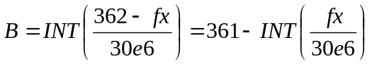
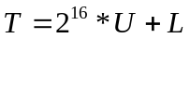
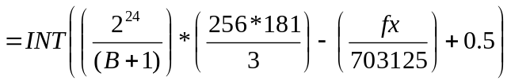
Example: fx = 9.3 Ghz = 9.3e9 Hz

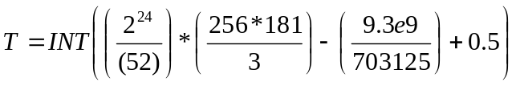

2) Given B, U, L

Find fx

Let:
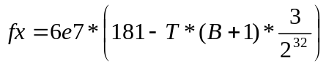
Example: B = 33 hexadecimal = 51 decimal

U = 2AAA hexadecimal = 10922 decimal

L = AAAB hex = 43691 decimal

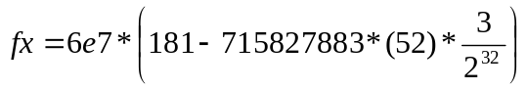= 9299999999.2734 Hz

Because of finite resolution, an exact frequency can not be attained. However, all frequencies should be accurate to within the Hz of the desired frequency.

DDS Address Decode:

Before a DDS Module can be accessed, the upper four bits of the Address Bus must be set to match that of the DDS Module. Inside the module, there is a 4 pin dip switch that is set according to the DDS Address. The DDS Module’s addresses range from 0x01 to 0x05 because currently, there are five DDS units. The bits on ADDR<6:9> are compared to these switch values. Upon a match and assertion, the DDS Module can be initialized and set as needed.

Q2334 DDS Initialization:

To initialize the DDS, one must set up all the needed register values. The registers, their values, and their purposes will now be discussed. The order of discussion will reflect the order of operation. This can be seen via the “Initialization of DDS at Address 0x01” Timing Diagram. Although the Q2334 has two built in DDS’s, only one is used.

Register(s) | Address(s) | Write Value(s) | Purpose(s)
SMC | 0x08 | 0x00 | Disable external MUX and Phase
PIRB | 0x07 – 0x04 | 0x00 | Clear PIRB Registers (4 Total)
APR | 0x0C | 0x00 | Reset Phase Accumulator
All DDS2 | 0x10 – 0x1F | 0x00 | Clear all DDS2 registers since it is not used

Q2334 DDS Programming:

To program the DDS, one must set up all needed register values. The registers, their values, and their purposes will now be discussed. The order of discussion will reflect the order of operation. This can be seen via the “Setup of DDS and PLL at Address 0x01” Timing Diagram.

The DDS1 is programmed in its simplest form. It is setup in order to output a single frequency that will not change until it is reprogrammed. The Data that is to be stored in the PIRA Registers is that of the value of T that was derived earlier in the “Equations” Section.

Register(s) | Address(s) | Write Value(s) | Purpose(s)
AMC | 0x0A | 0x0C | Non-inverted DAC Strobe, Offset Binary Output, Devote 2 bits to Noise Reduction Circuit
 |  | 0x0F | Same as above except, Disable Noise Reduction Circuit
PIRA | 0x0C | Data | Place Data bits that correspond to desired frequency
AHC | 0x0E | 0x00 | Activate PIRA values

Q3036 PLL Programming:

The PLL is easily programmed. All that needs to be done is to latch the value of B, or divide by the N counter value, into M<0:5>. The value of B can be found in the “Equations” Section above. This is the last operation that can be observed in the “Setup of DDS and PLL at Address 0x01” Timing Diagram. This is done by holding the Data to be latched on D<0:5>, and toggling both DS* and W*/R bits low. This operation uses a hardware latch that outputs and holds those Data values to the parallel input of the Q3036.

Timing Diagrams:

Initialization of DDS at Address 0x01

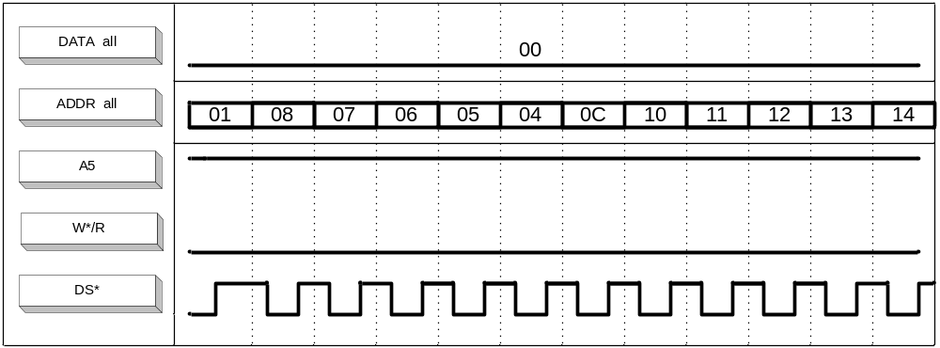

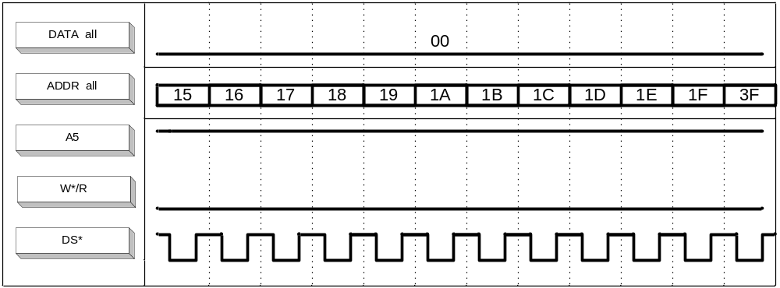

Setup of DDS and PLL at Address 0x01

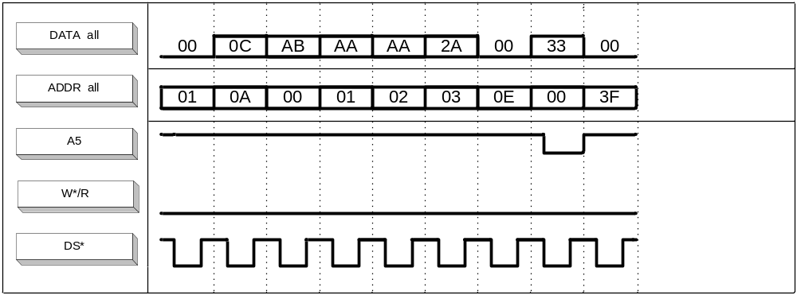

Part II: Stepped Attenuators:

New Stepped Attenuator Operation (Basic):

Refer to “New DDS/PLL Operation (Basic)” Section.

New Stepped Attenuator Operation (Advanced):

Addressing:

Contrary to the DDS/PLL Modules, it is required to have only one
Ether I/O 24 device to program both the fore and aft stepped attenuators. The Ether IO 24 board has an IP Address of 192.168.1.100. The reason for this is the backplane inputs for the fore and aft attenuators are all tied together. To program the fore attenuator, one must set the ADDR<3> bit to low. To program the aft, ADDR<3> is set to high. Instead of hardware, software is used to choose between the fore and aft attenuators.

Addressing Hardware:

The stepped attenuator backplane accepts up to 21 bits of inputs through a 96 pin Female connector. These bits include 11 Address bits, W/R* bit, D/S* bit, and 8 Data bits. Out of these inputs, the actual stepped attenuators required only 13 bits: 4 Address Bits, D/S bit, and 8 Data Bits in order to be programmed correctly. All other bits are set to low.

Ether IO 24 to 96 Pin Connector Pinout:

Pin Name/Function | Ether IO 24 Pin # | 96 Connector Pin#
Vcc | PA1,PB1,PC1*
D0 | PA9 | a17
D1 | PA8 | a18
D2 | PA7 | a19
D3 | PA6 | a20
D4 | PA5 | a21
D5 | PA4 | a22
D6 | PA3 | a23
D7 | PA2 | a24
A0 | PB9 | a1
A1 | PB8 | a2
A2 | PB7 | a3
A3 | PB6 | a4
A4 | PB5 | a5
A5 | PB4 | a6
A6 | PB3 | a7
A7 | PB2 | a8
A8 | PC9 | a9
A9 | PC8 | a10
A10 | PC7 | a11
W/R | PC6 | a15
DS | PC5 | a16
GND | PA10 | c1

*Note: PA = Port A, PB = Port B, PC = Port C

Hardware Operation:

There are two different attenuators for both the fore and the aft: the Agilent 8496H and the Agilent 8494H. The 8496H attenuator can only attenuate signals from
0-110 dB in steps of 10. The attenuator is composed of four sub-attenuators: 10dB,
20dB, and two 40dBs. The 8494H attenuator attenuates in the range of 0-11dB in
steps of 1. It is also composed of four sub-attenuators: 1dB, 2dB, and two 4dB’s. The test pulse is sent from the DDS Module into the stepped attenuator chassis where it goes through a Power Splitter and an Amplifier. The signal then goes through the 8496H first and then to the 8494H, where it is attenuated by a value chosen by the user.
The Ether I/O 24 board is connected to the backplane which houses the fore and aft circuit boards. Data is sent through the circuit and then goes out through the 96 pin connector which is connected to the 8496H. Once the signal is attenuated, it is transmitted out of the chassis and back into the receiver/exciter chassis.

8494H/8496H Programming:

To program the attenuators, one must send the correct bits at the correct time. The order of discussion will reflect the order of operation. This can be seen in the timing diagrams labeled, “Setup of Attenuators “. First, the D/S* bit is set to low in order for the ADDR<0:3> bits to be loaded in to the Decoder/Demultiplexer. Then the DATA<0:7> bits are entered into a Buffer where it is stored. When the D/S* bit is toggled to high, the positive edge triggered flip flop will be activated and the DATA<0:7> bits will be latched and loaded. Then, the Data bits will be sent to a Darlington Array, where it is then transferred to both the 8494H and 8496H attenuators.

Timing Diagrams:

Setup of Attenuators:
Programming Fore Attenuators to 10dB and Aft Attenuators to 20dB

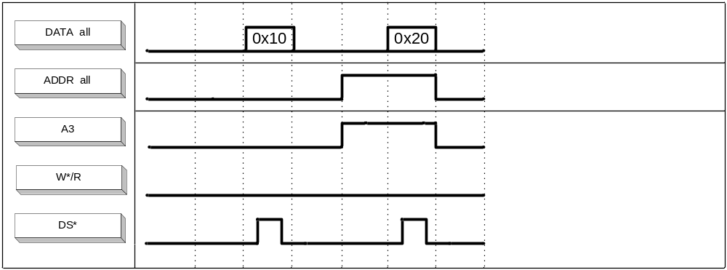

Part III: Trigger Mux

New Trigger Mux Operation (Basic):

Refer to “New DDS/PLL Operation (Basic)” Section.

New Trigger Mux Operation (Advanced):

Addressing:

Similar to the Stepped Attenuators, only one Ether I/O 24 device is needed to read and program both the fore and aft channels. There are seven channels for each radar: Channel 1-5, Pre knock, and the Test Pulse. The Ether IO 24 board that is used is the same as the stepped attenuators. Thus, the board has an IP Address of 192.168.1.100. The reason why only one board is needed is the backplane inputs for the fore and aft Trigger Mux’s are all tied together. To select the correct Trigger Mux/Relay Driver circuit board, A<3> is set to either low for the fore or high for the aft. Once the correct board is selected, it is necessary to select the correct channel. To select a fore channel, one must set the M<3> to low. To select the aft, M<3> is set to high. Instead of hardware, software is used to choose between the fore and aft channels.

Addressing Hardware:

The backplane of for the stepped attenuator chassis accepts up to 21 bits of inputs through a 96 pin Female connector. These bits include 11 Address bits, W/R* bit, D/S* bit, and 8 Data bits. Out of these inputs, the actual Trigger Mux requires only 13 bits: 4 Address bits, D/S* bit, and 8 Data bits. All the other bits are set to low.

Hardware Operation:

The main components involved in the Trigger Mux are chips that lie on the Trigger Mux/Relay Driver boards. Initially, both the fore and aft pulse signals are sent through a 37 pin connector. With 14 total signals coming in from the connector, only one is actually chosen and analyzed. Once a signal is chosen, data is programmed and sent through the Ether IO 24 board and the circuit board. After the data is sent, a sampled version of the selected signal is created. The signal then is sent to the power meter.

Trigger Mux Initialization:

To program the Trigger Mux, one must send the correct bits at the correct time. The order of discussion will reflect the order of operation. This can be seen in the timing diagrams labeled “Setup of Trigger Mux”. First, the Master Reset bit (MR*) is activated by setting the ADDR<0:3> bits to the appropriate logic levels. Next, the DATA<0;7> bits are set and loaded through the positive edged flip flop. These bits are set to where none of the available radar signals are chosen.

Trigger Mux Programming:

Once the Trigger Mux is initialized correctly, the Trigger Mux can now implement the user inputs. The value for the counter is loaded through through the DATA<0:7> bits and sent through to the 16-bit programmable counter. The counter contains 4 important bits: CP (Clock Pulse), MR* (Master Reset), XTR, and WE*. All these bits are controlled by setting ADDR<0:2> to either high or low. Next, the channel is selected also by setting DATA<0:7> to the bits representing the desired channel. These bits are sent through a MUX where the selection of the channel takes place. Once the channel is selected, the signal is sent to the counter and the countdown is started. During the countdowm is where the sampling of the channel signal occurs. An example of the important signals of the Trigger Mux is shown in the timing diagram labeled, “Example of Sampled Signal and Other Major Signals.”

Timing Diagrams:

Setup of Trigger Mux
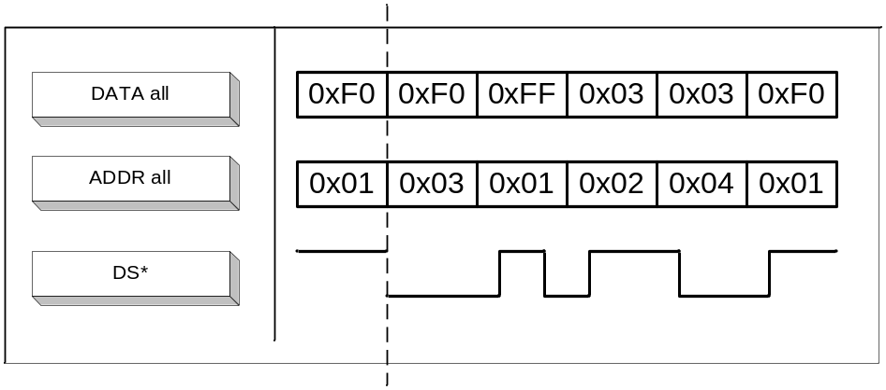
Example of Sampled Signal and Other Major Signals
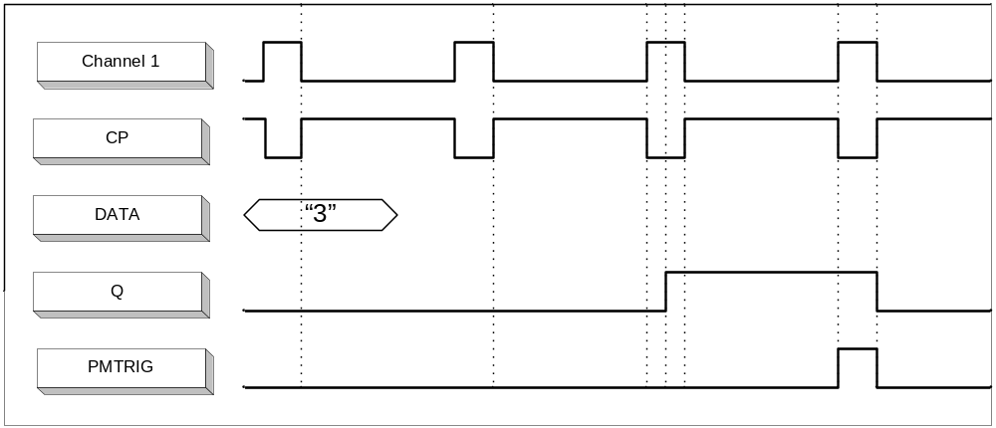

Part IV: Software:

Overview of Class Structure and Program Flow:

The code for programming the DDS Modules, Stepped Attenuators, and
Trigger Mux is written in C/C++ and organized into C++ classes. The reason for placing the code into classes is because the non-relational aspect between the contents of the different classes as well as keeping the code neatly organized into subdivisions. This way, in the future, it will be a lot easier to add or delete code.

A diagram of the class structure can be seen below:

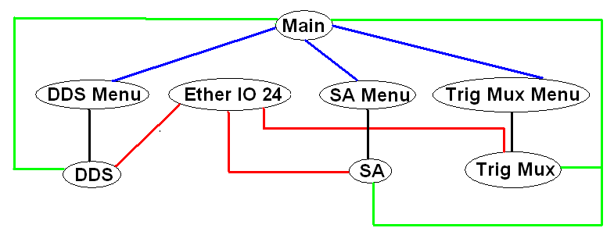

There are a total of eight classes: Main, Ether IO 24, DDS Menu, DDS, SA Menu, SA, TrigMux Menu, and TrigMux..

When the program starts, the user begins in the Main class. After the user chooses the chassis and which radar to program, the parameters are sent to the DDS, SA, or TrigMux class. These classes take the parameters and immediately calls the
Ether IO 24 class where communication of the board is established. Afterwards, the program returns to the Main class where Main calls the DDS Menu, SA Menu, or TrigMux Menu class. All three of these classes are menu interfaces to guide the user into which values are needed to program the chips inside the devices. When the necessary inputs are entered, the DDS Menu, SA Menu, or TrigMux Menu class will call functions within the DDS, SA, TrigMux class. These functions contain the hardcode which programs the Ether IO 24 boards to output certain bits. Hence, in order to for the functions to program the boards, they call the Ether IO 24 class each time they want to send data across. These bits are then sent into the chassis to program either the DDS, stepped attenuators, or Trigger Mux. Each class will be discussed further in detail in the following sections.

“Main” Class:

The Main class is a menu interface that will guide the user either into the DDS classes, the Stepped Attenuator (SA) classes, or Trigger Mux (TrigMux) classes. This class will start off asking the user whether to program the DDS, SA, or Trig Mux. After the user chooses, the program will ask the user to choose either the Fore or the Aft radars. Then the program will call the DDS, SA, or TrigMux class. In both cases, the Main class will send three parameters to each of the classes. For the DDS, Main will first create an array of DDS’s. Then Main will send the IP Address of the corresponding Ether IO 24 board, the Port Number of the board, and the DDS unit number. For the Attenuators, Main will send the IP Address of the board, the Port Number, and a number representing either the Fore or Aft radar. For the Trigger Mux, Main will send the same parameters as the attenuators.
When communication with the Ether IO 24 is established, the Main class calls the DDS Menu, the SA Menu, or the TrigMux Menu class. When Main calls
DDS Menu, two parameters are sent: an object of the DDS class called “dds” and the number of activated DDS units. When Main calls SA Menu, only an object of the SA class is sent through. Likewise, when Main calls TrigMux Menu, an object of the TrigMux class is sent through as well.

“Ether IO 24” Class:

The function of this class is mainly to establish communication to the Ether IO 24 board. Mainly, this class consists of functions and data to open the UDP/IP sockets and send and read data to and from the board. Thus, when called by the DDS, SA, or TrigMux class, it takes the IP Address and the Port Number and sets up the needed “bridge” between the user’s computer and the Ether IO 24 board.

DDS Classes:

“DDS” Class:

Immediately following the initial call from the Main class, the DDS class takes the three parameters (IP Address, Port Number, Number of DDS units) and calls the Ether IO 24 Class.
This class contains functions that consist of the “hardcode” of the whole program. It is where the real programming of the DDS Module takes place. When called from
DDS Menu, various functions can perform different tasks. These tasks involve initializing the registers of the Q2334 and Q3036 chips as well as loading the user inputted values into the registers. Since data is sent to the DDS via the Ether IO 24 board, each time data is sent, the Ether IO 24 class is called.

“DDS Menu” Class

After being called by the Main class, DDS Menu creates a menu interface that guides the user to which values and parameters to enter in order to program the DDS Modules. This class contains functions that create and modify a list of previously programmed values for each of the DDS units. The list is in the form of a text file called DDS_Data.txt. These values include the DDS unit number, the desired frequency, and the Noise Reduction option. Thus, the first thing that the DDS Menu class will do is call functions within the DDS class to initialize the registers inside the Q2334 and Q3036 chips as well as open DDS_Data.txt and load the previously programmed values into the registers of the two chips. DDS Menu will then continuously ask for the user to input the values and after each successful input, functions of DDS will again be called to load the registers with the new inputs and update the text file as well.

Stepped Attenuator Classes:

“SA” Class:

Immediately following the initial call from the Main class, the SA class takes the three parameters (IP Address, Port Number, Fore/Aft parameter) and calls the
Ether IO 24 class.
Similar to the DDS class, SA contains functions that perform the actual programming of the stepped attenuators. These functions take the user inputted attenuator value and set the corresponding Address and Data bits to program the attenuators. Each time the value is sent to the chassis, the Ether IO 24 class is called since data is sent through the Ether IO 24 devices.

“SA Menu” Class:

When called by the Main class, the SA class creates a menu interface that guides the user to which values and parameters to enter in order to program the stepped attenuators. This class continuously asks the user for the value of attenuation. Once it is entered, functions in the SA class are called and the attenuator value is loaded into the functions.

Trigger Mux Classes:

“TrigMux” Class:

Immediately following the initial call from the Main class, the TrigMux class takes the three parameters (IP Address, Port Number, Fore/Aft parameter) and calls the Ether IO 24 class.
Similar to the other two classes, TrigMux contains functions that perform the actual programming of the Trigger Mux. The functions take the desired channel and sampling rate and set the corresponding data bits to program the Trigger Mux and create the correct sampled signal. Because the radar devices (DDS, SA, TrigMux) control the Ether IO 24 boards and not vice versa, the Ether IO 24 class is called in order to send data through the board and into the chassis.

“TrigMux Menu” Class:

When the Main class calls, the TrigMux class creates a menu interface. The menu asks the user for important parameters and values that are needed to program the Trigger Mux correctly. These values include the desired channel number and sampling rate. Once the parameters are entered, functions in the TrigMux class are called and the parameters are loaded into the appropriate functions.

