Eldora ECB Test Pulse Data Merge

The new ECB will be controlled by the Processor PC. The Test Pulse program control will now by asynchronous with the Housekeeper so certain Test Pulse data fields will need to be inserted/merged into the housekeeping data stream after it has reached the Processor PC.

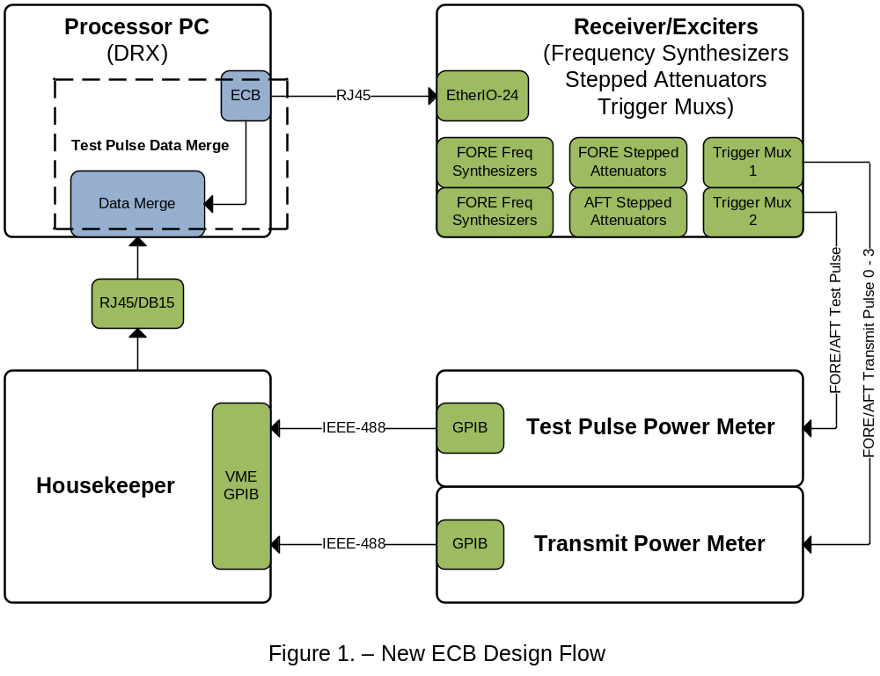

ECB Software Tasks
- Program Frequency Synthesizers
- Program Stepped Attenuators
- Program Trigger Muxes
- Merge needed ECB Data (Test Pulse & Transmit) into Housekeeping Data.

ECB Data (Test Pulse & Transmit) to be Merged

- Test Pulse Frequency Offset – test_pulse_freq (float)

Frequency offset of the test pulse from the transmit frequency of channel specified by Test Pulse Frequency Number. Set to ½ Nyquist Frequency.

frequency offset = 0.5 / (Interpulse Period 1 * 0.002) (½ Nyquist Freq)

- Test Pulse / Transmit Pulse Frequency Number – test_pulse_fnum (short)
  - test_pulse_fnum[0] – (unsigned char) (test pulse freq #)
  - test_pulse_fnum[1] – (unsigned char) (transmit freq #)

Byte 0 is the channel where Test Pulse resides.
Byte 1 is the channel where the transmit power (peak_power) was recorded from.

0 = Channel 1
1 = Channel 2
2 = Channel 3
3 = Channel 4

- Test Pulse Attenuation – test_pulse_atten (short)

Stepped Attenuator value used to attenuate the Test Pulse. Range = 0 – 120 dB.

ECB Operation

Information on the existing software classes, see ECB_Upgrade.doc

The programming of the ECB will take place during the initialization of the radar, prior to the start of the radar. Some areas will be re-programmed on a 10 second basis.

- Program Frequency Synthesizers

Each Receiver/Exciter (FORE & AFT) contains 5 digital frequency synthesizers. Four of synthesizers are for Channels 1-4 and one for the Test Pulse. The FORE Channels 1-4 will be programmed 1 time only during initialization and will be centered around 9.7 GHz. The AFT Channels 1-4 will be programmed 1 time only during initialization and will be centered around 9.6 GHz. The FORE & AFT Test Pulse will be initialized to a set offset from Channel 1 and will be stepped every 10 seconds to the next Channel as follows and eventually wrap back to Channel 1.

Start Radar: FORE Test Pulse = Channel 1 Frequency + Offset
AFT Test Pulse = Channel 1 Frequency + Offset
Wait 10 sec: FORE Test Pulse = Channel 2 Frequency + Offset
AFT Test Pulse = Channel 2 Frequency + Offset
Wait 10 sec: FORE Test Pulse = Channel 3 Frequency + Offset
AFT Test Pulse = Channel 3 Frequency + Offset
Wait 10 sec: FORE Test Pulse = Channel 4 Frequency + Offset
AFT Test Pulse = Channel 4 Frequency + Offset
Wait 10 sec: FORE Test Pulse = Channel 1 Frequency + Offset
AFT Test Pulse = Channel 1 Frequency + Offset

- Program Stepped Attenuators

Each Channel (FORE & AFT) will have a pre-defined associated attenuation value. The attenuators will be initialized to the Channel 1 values to match the Test Pulse Channel. Along with the stepping of the Test Pulse Frequency across each channel every 10 seconds, the stepped attenuators (FORE & AFT) will be re-programmed with value associated with that Channel.

- Program Trigger Muxes

There are 2 Trigger Muxes, one for the Transmit power meter and the other for the Test Pulse power meter. These will be initialized prior to startup and will not be changed. The Transmit Trigger Mux will be set to output the FORE Pre-Knock as the Transmit power meter trigger with a Divider value of 2. The Test Pulse Trigger Mux will be set to output the FORE Test Pulse as the Test Pulse power meter trigger with a Divider value of 2.

